Dear Customer,
Suffolk’s Libraries IPS Limited

County Library
Northgate Street
Ipswich, Suffolk, IP1 3DE

Tel: 01473 263838
Email: tutor.cards@suffolklibraries.co.uk
Web: www.suffolklibraries.co.uk

Date: 24th August 2015

As we undertake an evaluation of our services we would like your help in updating our library tutor card arrangements. Please help us to understand why you need this card and what you use it for by completing our online survey (link below)

Background to this survey

We have launched a new schools’ library offer for the school year 2015-2016. Our new service will be delivered by the Literacy, Books and Reading Team for Schools (formerly known as the Schools Library Service) and it will focus on reading for pleasure and literacy. This will form part of the wider services Suffolk Libraries offers children, families and schools.

We now operate Suffolk Libraries with 30% less funding than in the past; services for schools are not part of the free public library service and are funded by the income we earn from charging schools and colleges. There will be individual cards for teachers and for schools as part of the new service.

As part of this we are also reviewing the criteria for all the tutor cards in use and checking that they are only used by those who really need them.

Our records show that you have a tutor card in your name.
It would help us and you if you could complete this short survey by going to this link: https://www.surveymonkey.com/r/SLtutorcards
The deadline for completing this survey is 16/10/2015.
If we do not hear from you by this date we will assume you do not need a Tutor Card and will disable the card.
You are eligible for a free tutor card if:
- You lead a U3A group
- You lead a group affiliated to a learning organisation such as WEA
- You are registered with Ofsted as a tutor
- You run educational or community learning courses for adults
You are not eligible for a free tutor card if:
- You teach those aged between 0 and 18 years
- You are a home school tutor
If you believe you meet these criteria, or would like to discuss why you feel you are eligible you will need to contact us at tutor.card@suffolklibraries.co.uk and provide some supporting evidence.
Examples of suitable supporting evidence includes:
- Your Ofsted certificate/registration number
- Staff identification which shows you run an adult learning group
- Information about your U3A group for example, a current flyer (no more than 3 months old)
- Information about your WEA group for example, a current reading list
- Information about the educational or community learning course you provide
Please note, this review is not being carried out by local library staff. Please contact tutor.card@suffolklibraries.co.uk for any clarification or queries you may have.
If you are not eligible for a tutor card but are currently borrowing resources you will need to return them to us or asked for them to be transferred to a standard borrower card.
With best wishes,
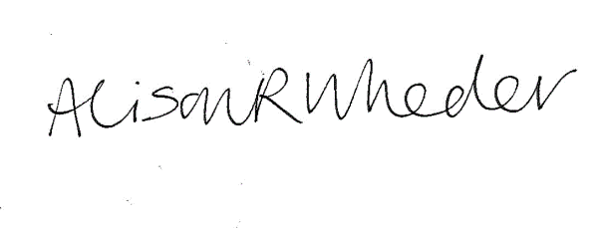

Alison Wheeler
General Manager

