
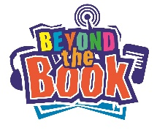

Author/Illustrator Research Activity
Name:
School:

Your task is to research a famous, prize winning author or illustrator. You can pick anyone who has won either the Carnegie OR Kate Greenway medal. You can find a list of winners at this website http://www.carnegiegreenaway.org.uk

Find out the following | Your answers
Name of Author
Their date of birth
What is their nationality?
Where were they born?
Which book by this author won the medal?
Did they collaborate with anyone (another author or an illustrator perhaps)?
Have they won any other awards?
Write down 5 of their other books that you might like to read | 1.  2.  3.  4.  5.
Did they do any other jobs before becoming an author?
Do they have a website? Write it down
Do they use twitter? What is their twitter name?
Have any of their books been made into a film?
If you were to interview this author, what questions would you ask them? | 1.  2.  3.

