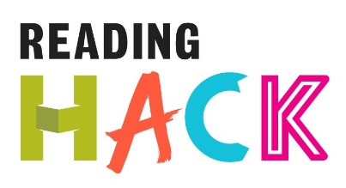
Blackout Poetry Hack
WHAT IS IT?
Blackout poetry rearranges and removes words to create a different meaning.
Create a completely new poem from previously published words. The reader is free to interpret your finished poem as they wish!
MORE DETAILS ABOUT THIS HACK
WHERE WILL IT HAPPEN?
You can do it where ever! You just need some old books, newspapers or any text you can find. You also need some marker pens (any colour dark enough to cover up text) and a pencil. An old picture frame to display your work looks great!

WHEN IS IT?
Anytime you want!
HOW?
Also known as newspaper blackout poetry, the author uses a permanent marker to cross out or eliminate whatever words they see as unnecessary or irrelevant to the effect he's seeking to create.
- Take the page of an old book
- Find some key words on the page that interest you. Circle them with pencil.
- Find some different words that link your key words together to form sentence(s)
- Use the marker pen to erase all the words you have NOT circled
- Read your poem out or frame it for a great piece of art!
