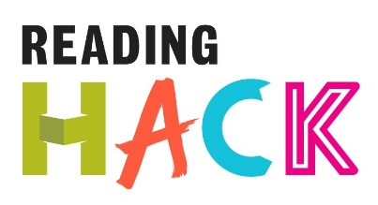

Comic/Manga Hack
WHAT IS IT?
Make a comic book panel in response to something you’ve read.
MORE DETAILS ABOUT THIS HACK
WHERE WILL IT HAPPEN?
You can do it where ever! You just need some paper, some comic templates (available on the internet), something to write with and maybe some colours.

WHEN IS IT?
Anytime you want!

HOW?
Make a comic book panel in response to something you’ve read.
This can be anything from a full blown novel or a blog, to a news article or even a tweet. The panel can be between two and four panels long, fill no more than one A4 page and can be made using paint, pens, paper collage, graphic design or anything else you can think of.
You can use images and words, or just images, but it must be inspired by something you’ve read.

