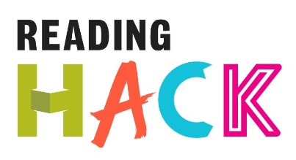

Top Trump Hack
WHAT IS IT?
Create your own set of Top Trump cards based on your favourite book characters! Choose any of your favourite book characters (heroes or villains!) and give their intelligence, bravery, temper and cunning a score. Then either draw your character or stick a printed image from the internet onto the card.
You could create the whole pack on your own or work as a team and each create eight cards. Then play the game using the usual Top Trumps rules!

MORE DETAILS ABOUT THIS HACK
WHERE WILL IT HAPPEN?
You can do it where ever! You just need the Top Trump template, some card, glue and something to write with.

WHEN IS IT?
Anytime you want!

HOW?
Download the template and fill in the character name, draw or stick a picture of the character onto the card template then give a number to the character qualities. All 4 numbers must add up to 150.
Cut each of your templates out and stick them on to some firm card or some old playing cards.
Play against your friends to see who wins!

