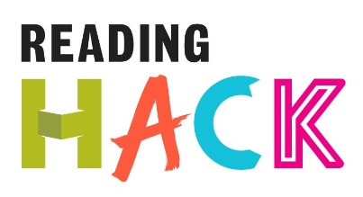

Creating a Hack – Part 1
WHAT IS IT?
Come up with a new Hack for you and your friends to try out!
HOW?
Write down 10 things you are interested in (be specific – dystopian books, Science Fiction, My Little Pony, Shakespeare, Ice Hockey, etc)
Then
Write down 10 activities you like taking part in (walking, stand-up comedy, board games, photography, vlogging, etc).

10 things I am interested in | 10 activities I like taking part in
1  2  3  4  5  6  7  8  9  10 | 1  2  3  4  5  6  7  8  9  10

Turn over when you have all the ideas written down.

Creating a Hack – Part 2
Look at the two lists and see if any combinations leap out at you (a stand up show based on My Little Pony maybe?!) Cut them up, put them in a hat and select some random combinations
Or

Look at the diagram below. Right your ideas on the lines – put the ones that are most important to you closer to the heart at the centre. Create a Hack by using these ideas, then add it to the Reading Hack Webisite!

