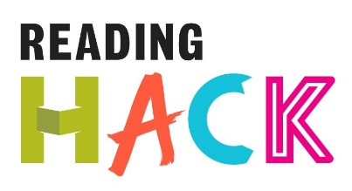
Minecraft Hack
WHAT IS IT?
Create the world of a novel in Minecraft
MORE DETAILS ABOUT THIS HACK
WHERE WILL IT HAPPEN?
You can do it wherever there is access to Minecraft.
WHEN IS IT?
Anytime you want!
HOW?
Select a passage from a book either one you know or from a first chapter.
- Recreate it in Minecraft using the creative mode
- Take screen shots or videos of your creation to share (press F2).

Use the mouse to look around and use the following keys on the keyboard:
You can select an item from the quick draw panel with the mouse's scroll wheel (or use the numbers on your keyboard), or press E and select something from the inventory.
You can also double tap the space bar to fly into the air. You'll stop flying when you release the space bar, and if you double tap it again you'll fall back to the ground.
Useful links
https://help.kano.me/hc/en-us/categories/200459892-Make-Minecraft

Key | Action
W | Forward
A | Left
S | Backward
D | Right
E | Inventory
Space | Jump
Double Space | Fly / Fall
Esc | Pause / Game menu
Tab | Release mouse cursor

