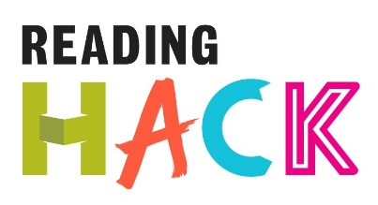

Story Cube Hack
WHAT IS IT?
Hack a classic children’s story by retelling it using story cubes. Story cubes have a different symbol on each side for you to use in your story. By taking the first few paragraphs of your favourite story and rolling the cubes out you could take the plot of your favourite story in a whole new random direction!

MORE DETAILS ABOUT THIS HACK
WHERE WILL IT HAPPEN?
You can do it where ever! You just need some paper, the start of any book, some story cubes (like Rory’s Story Cubes) and something to write with.

WHEN IS IT?
Anytime you want!

HOW?
The large boxes of story cubes are £10, the smaller sets are £4 and there is an app for £1.49. You can use the cubes in the order they were rolled but you could mix them up in any way you want or take a couple out to make it easier. There are loads of different packs of cubes available such as Batman, enchanted tales and sport. You could mix them all up.
You can also use an online story generator instead of buying the cubes.

