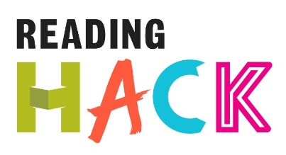
Green Screen Hack
WHAT IS IT?
Use green screen technology to mash up books! Take a selfie and put yourself into a famous movie based on a book or onto the front cover of your favourite novel!
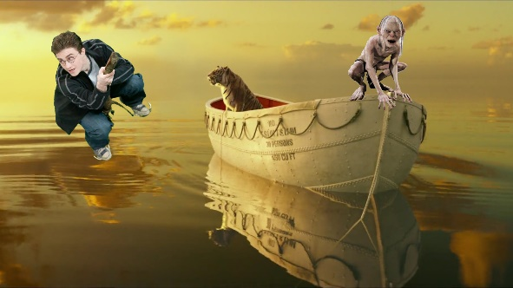
MORE DETAILS ABOUT THIS HACK
WHERE WILL IT HAPPEN?
Anywhere with an iPad/iPhone
WHEN IS IT?
Whenever you have access to the software.
HOW?
Download a green Screen app (£3.99) and get a green background (you can buy them off eBay for less than £5 or find a green wall).
Collect some background images from google or take pictures of your favourite book covers.
Take a picture of yourself in front of the green screen and then use the app to merge the two images together – the green screen will hopefully vanish and you will appear next to Harry Potter (or whoever…)
We used ‘Green Screen’ by Do Ink from the app store which can even do videos.
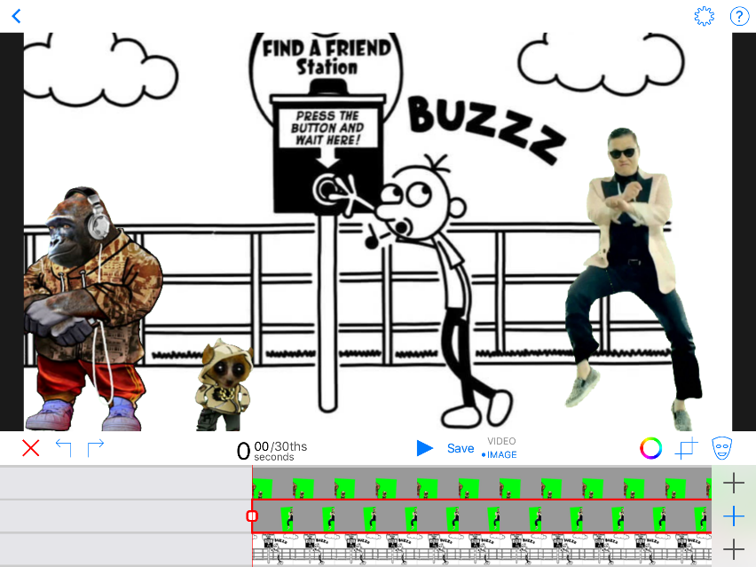
Click here to add the background image
Click these two for your green screen image(s)
These tools adjust the green screen blending, a cutting tool and an eraser for rubbing out any bits you don’t want.
Click save to export your image!

