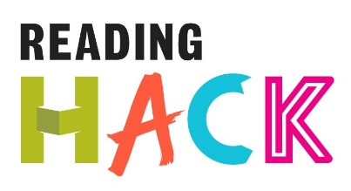
Poetry Jigsaw Hack

WHAT IS IT?
Hack a poem by cutting the text up and rearranging it! In this activity pairs of children are given a poem that has been cut up into words and phrases that they can put together again in their own way. The idea is not to reconstruct the original poem but to use the original poet’s material to create something new!
MORE DETAILS ABOUT THIS HACK
WHERE WILL IT HAPPEN?
Anywhere
WHEN IS IT?
Anytime you want, around National Poetry Day in October would be ideal! Some advance preparation is needed (about 20 minutes).
HOW?
In advance:
- Find a short poem, preferably between six and eight lines. It should not have a regular rhyme scheme.
- Photocopy the poem, then cut the words up. You can cut them up into either single words, a couple of words, or cut up leaving whole sentences intact. You can remove all the punctuation to make it more interesting. Keep one copy of the complete poem to compare results at the end.
- Put the cut up poem into an envelope.
In the session:
- Hand out the envelopes with the cut up poem inside
- Get people to arrange the words into their own poem. They can add punctuation!
- Share the results by reading your poem out
- Whoever is leading the session reads the original poem out.
You could then video your poems being read out and share them on social media. Maybe create a video using animation to go alongside your video!

Taken from The Poetry Toolkit: fool proof recipes for teaching poetry in the classroom created and distribute by The Poetry Trust. http://www.thepoetrytrust.org/poetry_toolkit/

