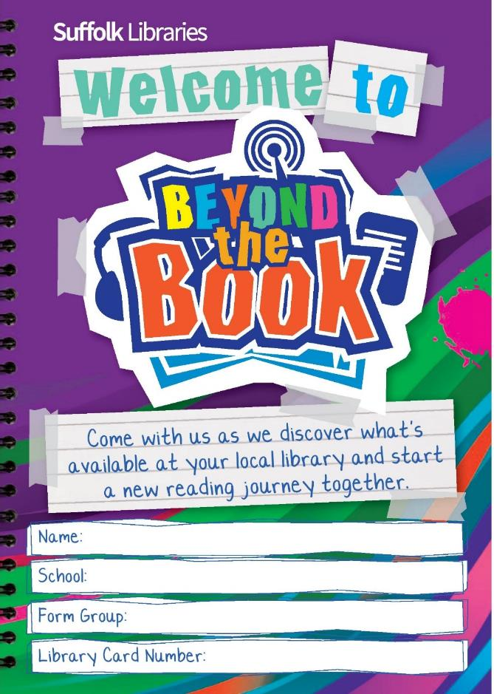 | Page 1 is an introduction to Beyond the Book.  Ask pupils to fill in their details on the Beyond the Book activity booklet. Their new library card number can be found on the back of their card above the barcode.
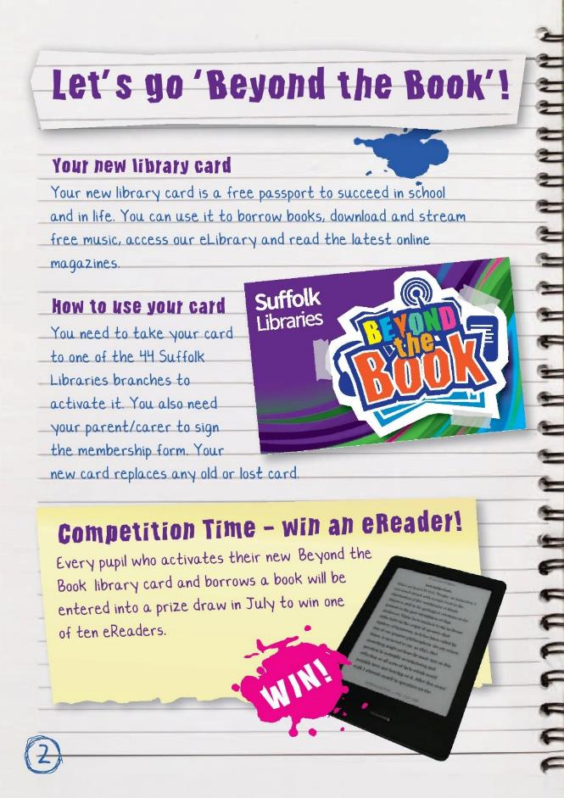 | Page 2 – Introduction to ‘Beyond the Book’.  To register/activate their new card:  • Pupils need to complete the joining form, have it signed by their parent/carer and take it to their local library to activate it.  • This is a brand new card only available to this year 7 group – no one else! Please emphasise this point.  • If pupils think they are already registered – ask them to still complete the form and take it to their local library. That way they can be entered into the prize draw (see below)  To find out which branch of Suffolk Libraries is the closest, use either of the following websites http://suffolklibraries.co.uk/branches  It can be fun to use the website below, type in a postcode and see which branch is closest to the school or home. http://www.findalibrary.org.uk  Points to get across:  • There are 44 bricks and mortar branches of Suffolk Libraries in Suffolk pupils can access.  • You can borrow a book from any Suffolk Library – not just the closest.  • You can also return books to any Suffolk Library.  • You can request a book to be sent from one branch of Suffolk Libraries to another for you to pick up.  • There are also 6 mobile library routes that can be accessed here  http://suffolklibraries.co.uk/community-services/mobile-libraries/  eReader competiton  Any pupil in year 7 who registers at their local library during this academic year will be entered into a prize draw to win one of 10 eReaders.
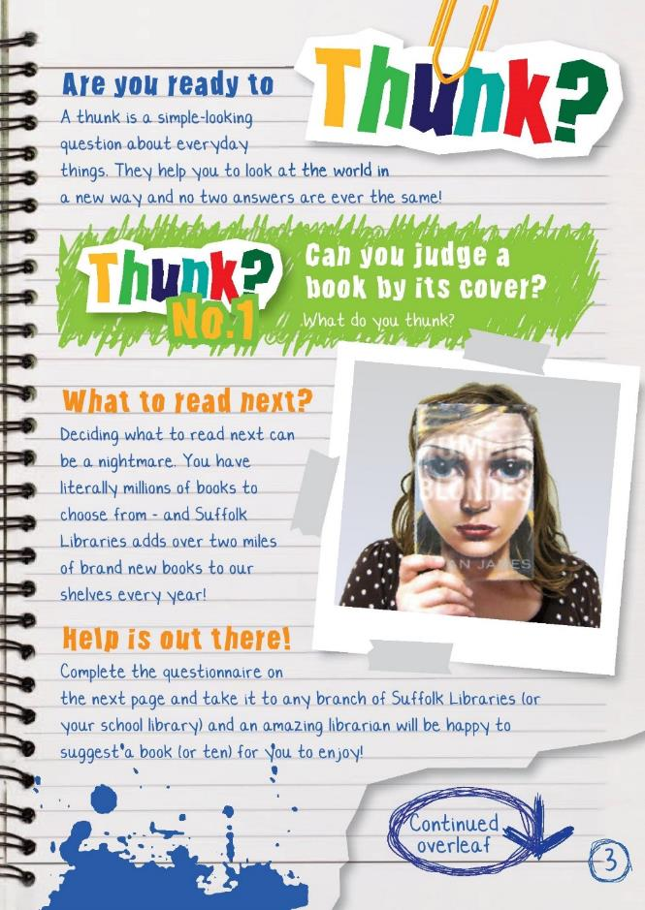 | Page 3 – Thunks/What to Read Next  Are you ready to thunk?  A thunk is a simple-looking question about everyday things. They help start discussions. There are 5 reading/literacy thunks throughout the booklet.  What to Read Next?  This is an activity for pupils to consider their reading journey, what books they enjoy and what books they might like to read in the future. It can be a great opportunity for discussion between staff and pupils.  Starter:  Each year Suffolk Libraries adds over two miles of new books to its library shelves. This can make it difficult to keep up with what new books to read!  To help pupils visualise this give an example of a place two miles from where your school is located.  It would also take Mo Farrah 8 minutes and 3 seconds to run along the two miles of books! (He is the current 2 mile indoor record holder).
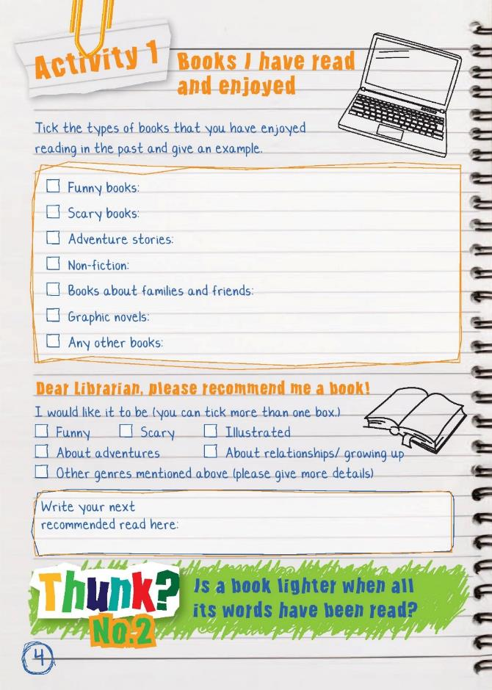 | Starter Continued;  Discussion points to introduce the activity. Talk about  • Introduce the word ‘genre’ – (a specific type of music, film, or writing)  • Share with the class what books you enjoyed as a child  • The books your own children enjoy (if applicable)  • The books you enjoy as an adult  • How you discover the books you read  • Emphasise the expert knowledge librarians have in recommending books.  Completing Booklet Activity 1  Part 1 – prior reading  • Ask pupils to tick the types of books they have read in the past and enjoyed  • Ask them to provide an example. Have some ready yourself.  Part 2 – future reading  • Ask pupils to think about what book(s) they would like to read in the future  • Will they stick to a genre they have previously enjoyed or try something new?  Plenary  • To find out who has chosen what ask for a show of hands as you read out the genres mentioned in part 2 (funny, scary, relationships/growing up, adventures, illustrated, other). What do you notice about what pupils would like to read (most/least popular)?  • Ask one pupil to read out their selections - can anyone in the class recommend a book for this pupil?  • Remind pupils that they can take this to a school librarian for a recommendation. The school librarian could then deliver the recommended books to the class the following week. They can also take it to any branch of Suffolk Libraries.
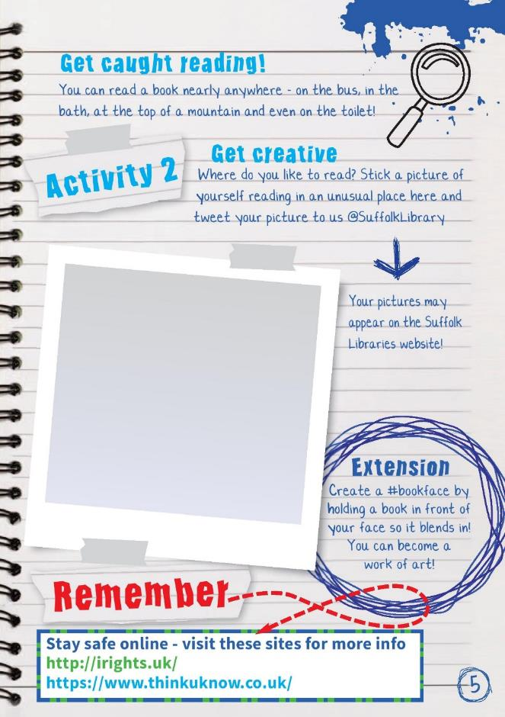 | Page 5 - Get Caught Reading  This is a fun activity that will get pupils thinking about books and their environment.  The idea is to take pictures of pupils reading in interesting locations that they wouldn’t normally consider as a place to read.  Starter  • Ask pupils to mind map/list locations they have read a book or have seen others reading (these may include to read, at home, in bed, on public transport, in the bath).  • As a class discuss the results – you could write them on the board and keep a tally to explore your class results.  Booklet Activity 2 – Get Caught Reading  The idea is for pupils to take a picture of themselves reading in an unusual place. It would be very powerful for staff to do the same to normalise reading for pupils (and fun!). This could be set as a homework or as part of a lesson if pupils are allowed to move around school  These pictures can be used in the following ways  • stuck into the activity books  • tweet picture to us @suffolklibrary (either by pupils or through the school twitter account)  • used as a display in the reception area of your school  • competition held for the most inventive  Things to consider  • This should be a fun task, pupils are not to put themselves at risk.  • The activity booklet has links to eSafety resources that pupils should be made aware of if they are online using social media.  Extension activity - create a ‘book face’  Inventive social media people have been positioning book covers in front of their own faces and taking a picture.  If done well, the results can be spectacular.  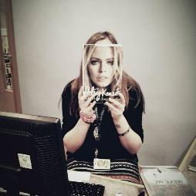  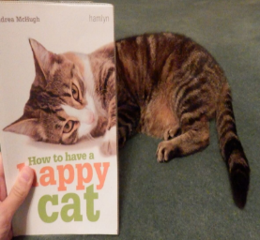  It is a great way for pupils to experience new books and browse– ask your school librarian to check stock for books with faces and other body parts on for pupils to look through then create their own pictures.
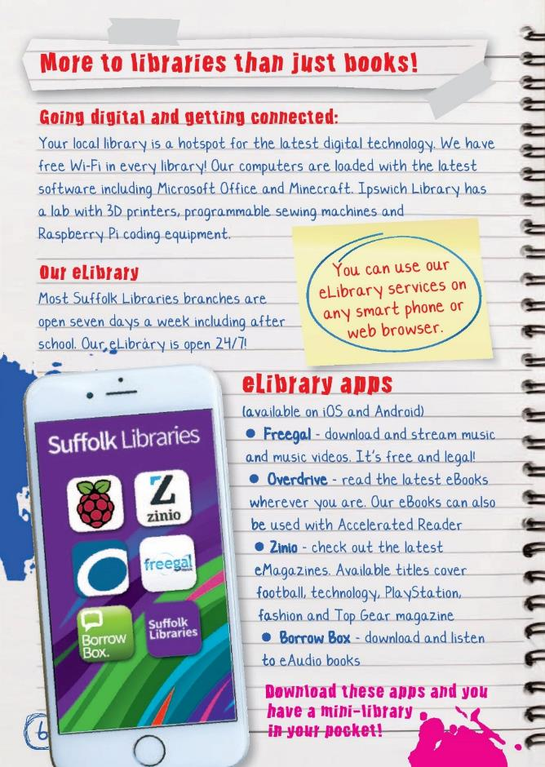 | Pages 6 and 7 - Digital Libraries  Read through the two pages which are an introduction to eLibrary services available from Suffolk Libraries culminating in an activity to design the library of the future.  Starter: eLibrary discussion points:  paper vs electronic  Divide the class into two groups – one group should come up with reasons why the printed book is better than the electronic version and the other half do the opposite. Share ideas afterwards.  Some ideas might be:  eBook:  Available 24/7  Easy, fast and cheap to send across the world  Able to store many books in a small space  Can adjust the size of text  Can be downloaded at home  Text can be translated quickly  Greater access to books in remote areas of the world  Does not use up a natural resources (wood)  Paper:  More titles available than eBooks  Does not require batteries to read  Last for a long time (13 leather bound books found in Nag Hammad in Egypt are an estimated 1,693 years old)  Can be dropped without damage  Can be read in the bath  Can be passed on to other people
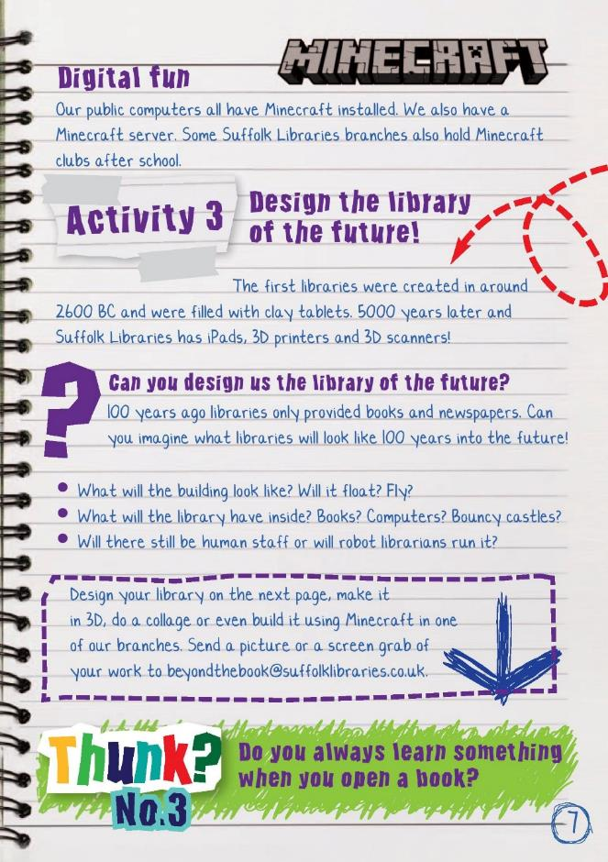 | Page 7: Booklet Activity 3: Design the library of the future!  This activity is to get pupils thinking creatively about what a library might look like in the future.  Some background information:  The first libraries were started around 2600BC in what is now modern day Iraq. They were filled with clay tablets recording transactions between traders. 5000 years later the new Library of Birmingham is the largest cultural space in Europe and looks quite different!  This activity can be completed using pens and paper, using CAD on a computer, a collage, in 3d, or even on Minecraft.  Pupils can include anything they like in their libraries as long as they can justify their decisions: There are no wrong answers.  It may be useful to discuss these two non-negotiables about libraries.  • Accessible for everyone in society  • Free to use  Please send pictures, screen grabs etc of the work to beyondthebook@suffolklibraries.co.uk
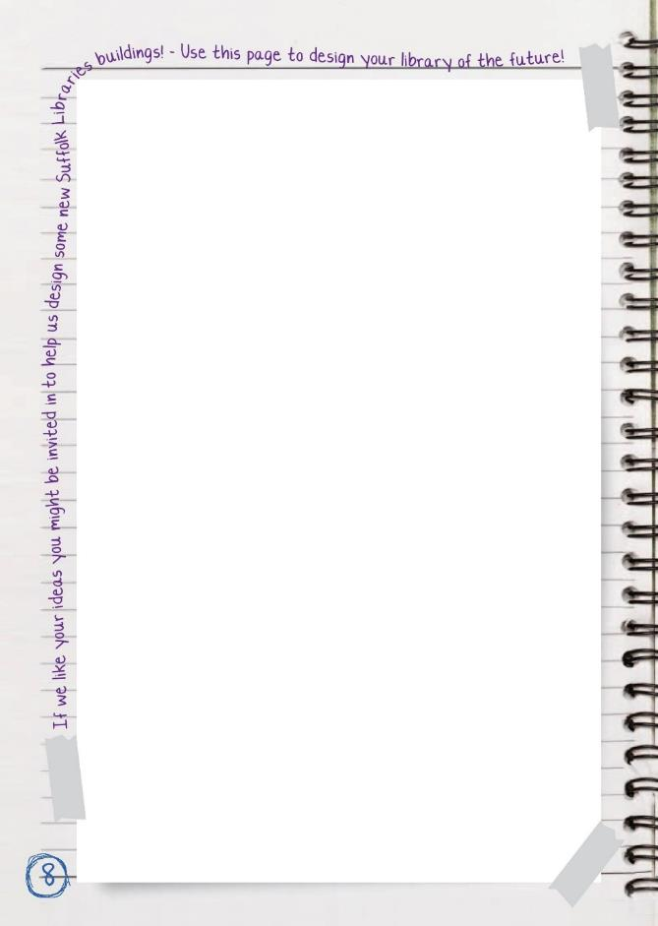 | Page 8: Booklet Activity 3: Design the library of the future!  This space can be used to design the library, make notes, etc
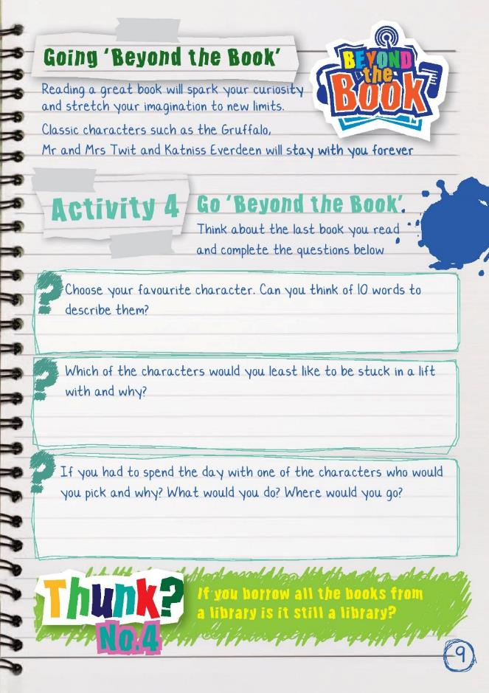 | Page 9 – Going ‘Beyond the Book’  This activity is designed to get pupils thinking about the fictional characters and worlds created by an author.  Starter: What are the ingredients for a great story?  As pupils to imagine they are creating a story sandwich – The bread acts as the beginning and the end of the story. What do you need to act as the filling?  • Characters  • Setting  • Plot  • Conflict  • Resolution  Discuss these as a class to ensure understanding. Can pupils decide which the most important ingredient is? Are characters more important than where the story is set?  Booklet Activity 4: Go ‘Beyond the Book’.  Ask pupils to think about the book they are reading and work through the questions.  Each of the questions could be expanded into fun activities such as  • Pupils read out their 10 describing words for others to guess the character  • Illustrating the pupil and character stuck in a lift  • Acting out being transported into the setting of the book and describing what each of the senses encounters  • Emailing or tweeting the questions to the author
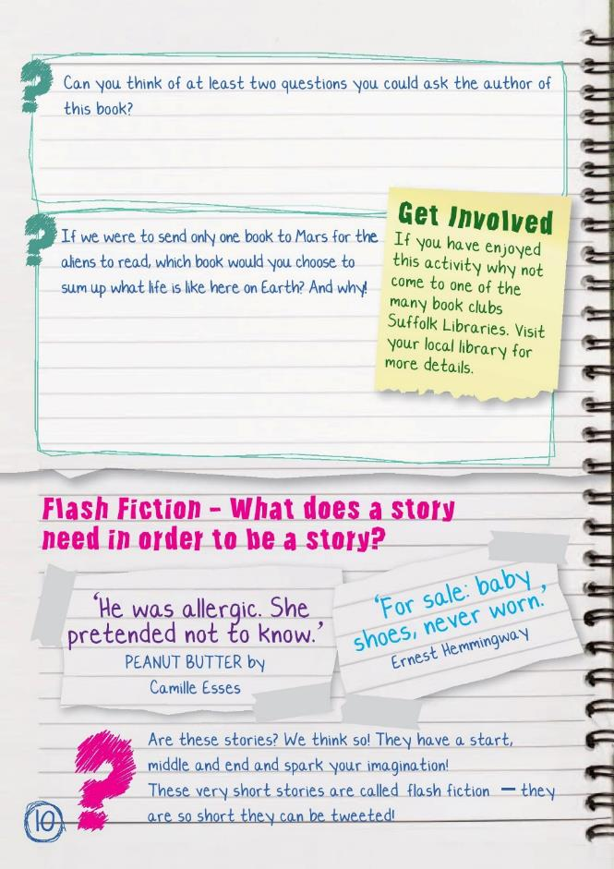 | Booklet Activity 4: continued  Extension:  We also interview authors on our blog and ask them the same final question about sending a book to Mars. Visit the link below and see what books they would send.  - Do any authors pick the same book or author?  - What reasons do they give for their choice?  http://suffolklibraries.co.uk/tag/beyond-the-book  A new author is featured each week. The following have appeared  Tanya Langdon (2015 Carnegie Winner), Hayley Long (2015 Costa nominee), Chris Priestly, Mike Revell (Stonebird), James Campbell, Sam Hay (Undead Pets), Jonathan Meres (World of Norm),  Page 10: Flash Fiction  This next section draws upon the work done in the last activity and is designed to get those creative juices flowing!  Starter: Discussion Points  Read the two very short stories out loud to the class.  • Ask the class to vote on whether they are indeed stories.  • Can one or two sentences tell a story?  • Do they have all of the ingredients for a successful story discussed in the previous activity- character, setting, plot, conflict, resolution?  • If not, does it matter? Are they interesting or fun?
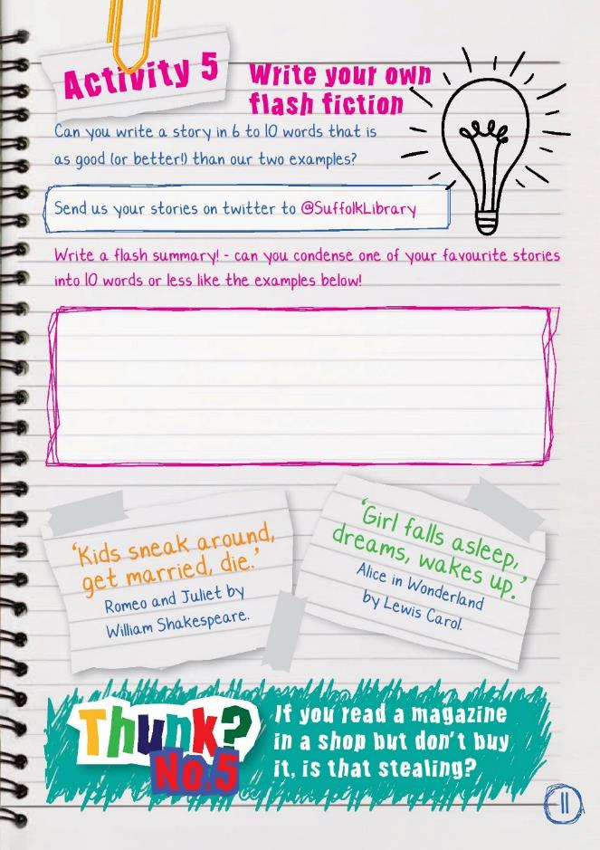 | Activity 5: Write your own flash fiction  Ideas for delivering in the classroom  Divide the class into groups and designate each group to answer one of the flash fiction questions below. Feedback as a whole class.  Think about the following and write some ideas down  • What does a story need in order to be a story?  • What questions do these stories leave you with?  • What do you think is happening beneath the surface of so few words?  • What genres would flash fiction be good for?  You could also  • Hold a flash fiction competition – use governors as a judging panel  • Create illustrated posters of their flash fiction stories  • Make them into promotional bookmarks  Extension activity – Micro summary  Pupils summarise the plot of a novel into less than 10 words – giving enough information to allow readers to correctly guess the title of the book. These could then be used for a class competition.  Teachers could suggest titles for pupils to do such as James and the Giant Peach, Wimpy Kid, Gangsta Granny etc.  Use the blank space to write out either the flash fiction or the micro summary  Completed work can be sent to Suffolk Libraries via twitter @SuffolkLibrary  Or to beyondthebook@suffolklibraries.co.uk  We will publish work on our website.
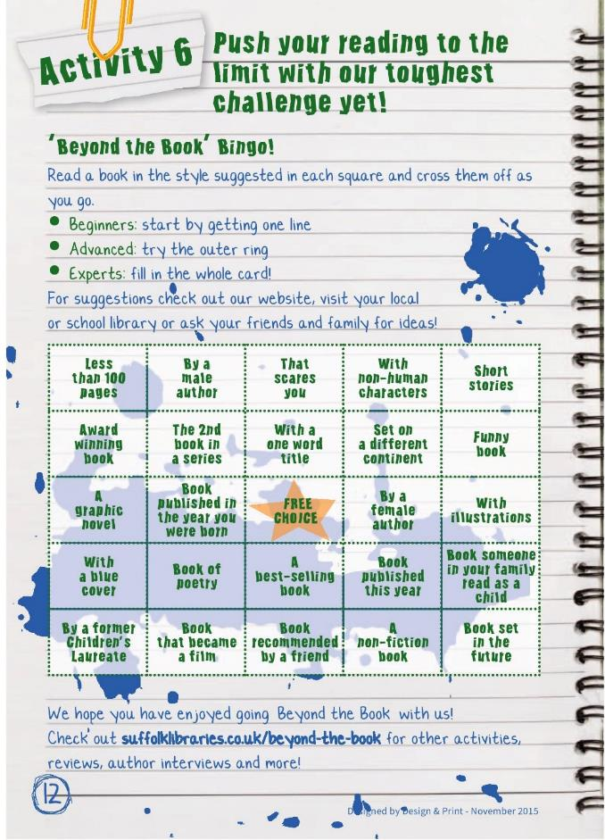 | Page 12: Activity 6 ‘Beyond the Book’ Bingo  Have pupils got what it takes to complete our super square?  The 25 squares on the bingo card all have a different theme/genre to expose pupils to a variety of books. Pupils cross off the themed squares as they go.  Encourage pupils to approach the ‘Reading Bingo’ card however they like:  • Beginners: start by getting one line  • Advanced: try the whole outside box on the card  • Experts: fill in the whole card!  Suggested classroom activities  - Assign each square to different individuals/groups to collate a list of books (one group looks for 10 books with a blue cover, another looks for books with less than 100 pages etc).  - OPAC library search – teach pupils how to search for books using the Suffolk Libraries online catalogue https://suffolk.spydus.co.uk (your own school library catalogue may also be online and useful).  - Link the bingo in with any school wide rewards (Vivo etc)  For further suggestions go to our website, go to your local or school library or ask your friends and family for ideas.

