
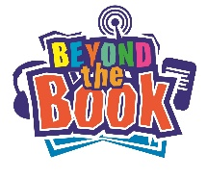
Go ‘Beyond the Book’

Your Name: Your School:
Reading a great book will spark your curiosity and stretch your imagination.
Think about the last great book you read and go ‘Beyond the Book’ by answering the following tricky questions – you might be surprised what happens!

What was the title of the book and who was it by? How did you find out about the book?
Can you explain in no more than 20 words the plot of the story? (This is tricky!)
Choose your favourite character. Can you think of 10 words to describe them?
Which of the characters would you least like to be stuck in a lift with and why?
If you had to spend the day with one of the characters who would you pick and why? What would you do? Where would you go?
You've been transported to a location in the story. What can you see, smell, hear, taste and touch?
Can you think of at least two questions you could ask the author of this book?

