**ADVANCE DIGITAL RADIOVISOGRAPHY IN DENTISTRY**

**A PROJECT REPORT**

***Submitted by***

**N. POOJA [REGISTER NO: 211417104186]**

***in partial fulfillment for the award of the degree***

***of***

**BACHELOR OF ENGINEERING**

**IN**

**COMPUTER SCIENCE AND ENGINEERING**

**PANIMALAR ENGINEERING COLLEGE, CHENNAI-600123.**

**ANNA UNIVERSITY: CHENNAI 600 025**

**APRIL 2021**

**ABSTRACT**

Radiovisiography (RVG) as the latest imaging technique in dentistry with the minimal radiation exposure of the patient and numerous possibilities to process the images has many advantages over classic radiography. The RadioVisioGraphy (RVG) imaging system commonly used in dentistry to take intraoral radiographs features the latest innovations in digital radiography, delivering the highest image resolution. The results are faster and better with no loss in image quality. The software is designed in such a way to make use of this images captured by the Radiovisography in a reliable, affordable and lesser time frame by applying the need and the thoughts of dentist and the patients.

1. **INTRODUCTION**
   1. **Overview**

Radiography X Ray Stand for Radiation and found in the Year 1895. Radiography is a imaging technique used to view the internal form of an object. Radiography is used as medical radiology (Diagnostics) and industrial radiology. Digital Radiography is the latest advancement over the Classical Radiography (Film Based X Rays) from the year 2006 and there comes the end of Film Based Radiology

**Comparison of B/W Film Based and Digital Radiography.**

***Film Based Imaging***

Film Based imaging consist of X Ray interaction with electrons in the film emulsion. Through the Clinical Processing we transform the latent image into a visible one. Film is a relatively inefficient radiation detector and, thus, requires relatively high radiation exposure.

***Digital Imaging***

Digital Imaging is the result of X Ray interaction with electrons in electronic sensor pixels. Conversion of analog data to digital data, computer processing, and display of the visible image on a computer screen.

**Types of Digital Radiography**

***Direct Digital Radiography***

* + Sensors is Placed in Patients Mouth
  + Exposed to Radiation
  + Sensor Captures Radiographic Image
  + Transit Image to Computer Monitor using software’s
  + Image appears on the screen within a minute

***Indirect Digital Radiography***

* + Existing X Ray Film Digitized Using CCD Camera
  + Scan to Images
  + Digitized display to the Monitor

**Types of Digital Image receptor**

* *CCD (Charge Coupled Devices)*
* *CMOS (Common Metal Oxide Sensors – Alternative for CCD used for Active Pixel)*
* *PSP (Photo simulated Phosphor Plate)*
* *Computed Tomography ( CT) – 3D Images – Advancement of the above all receptor.*

**Digital Image Processing and Image Storage**

Image processing involves Image restoration, Image Enhancement, Image Analysis, Image compression. The File Size of the images varies considerably ranging from 200 KB to 6 MB. So the Software is designed and developed to reduce the Image Storage.

**Advantages of Digital Imaging**

* + Enhancement of Images
  + 3D Reconstruction
  + Filtration
  + Storage
  + Time
  + Environmental Friendly
  + Tele-Radiology
  + Dark Room is no Longer Needed
  + Dose Reduction & Patient Education

**Disadvantage of Dental Imaging**

* + Cost
  + Medico legal
  + Cross infection Control
  + Sensor Dimensions.
  1. **Problem Definitions**

The increasing demand for radiology services and the limited resources of radiologists have led to a long waiting time for radiology results. Increased radiology turnaround time will cause radiology services become delay, which can affect patient’s complaint. To overcome the problem of delay problem, availability, and affordability for diagnostic radiology services, there needs to be a rapid change in dentistry for the delivery in radiology services.

1. **LITERATURE SURVEY**

**The Advance Indications and Use of this Radiovisography (RVG) in the field of Dentistry is as follows**

* + **Detection of Tumors**
  + **Detection of hard Tissues**
  + **For Implants analysis**
  + **Detection of Carries and Periodontal Diseases**

1. **SYSTEM ANALYSIS**
   1. **Existing System**

Before modeling the current radiology service process, the entire process of Dental diagnostic radiology services is examined. The entire process information obtained from direct observations and verified by the Dentistry through interviews. The waiting time at radiology service is categorized into two parts, namely the system turnaround time and radiology turnaround time. The waiting time from the radiology “examination request” activity is made by the referral doctor until finally given to the radiology department. The administrative processes outside of radiology is defined as the system turnaround time, while the time from conducting the radiology examination until the availability of “expertise to be given to the patient” or the referral doctor is defined as the radiology turnaround time. The difference between these two categories is that the system turnaround time does not depend on radiology unit performance, while radiology turnaround time is high dependent on the availability and performance of radiologists and radiographers. As-is process and to-be process simulations are performed using Lynxvision software. A set of random numbers will be selected in each replication and used in estimating the probability distribution function in the simulation of the radiology service process. The entire process time included in the radiology service process simulation will be a time span using a uniform distribution so that every possible outcome has the same probability of occurring. Validation of the as-is model is done by using faces and event validity to ensure the as-is process model is made according to the current radiology service process.

* 1. **Proposed System**

The objectives of business process reengineering and the information system design of the to-be process are determined after gathering the weaknesses of the radiology service process. To-be process is designed to provide fast service with good quality for hospital radiology services. The to-be system used by the parties involved in radiology services, such as referral doctors, radiographers, and radiologists with information systems designed to be limited to the radiology unit. There are several ways that can be done in making improvements for business processes in a company, such as benchmarking, ESIA (Eliminate, Simplify, Integrate, Automate), and BPR Best Practice. The improvement of radiology business process system are made by considering the results of simulations and discussions conducted with relevant stakeholders which can be seen in Table 1.

Table 1: Proposed Solution

|  |  |  |
| --- | --- | --- |
| No | Improvement | Description |
| 1 | Design a neat storage area | Dividing the storage place of images and the results that have not finished yet in alphabetical order, month, and year. |
| 2 | Enhanced the features of RIS | Optimizing the use of Radiology Information System (RIS) to increase the effectiveness of radiographers and radiologists |
| 3 | Changing imaging modalities from CR to DR | Simplify radiographers’ work by replacing Computed Radiography (CR) into Digital Radiography (DR) to provide quality improvement and speed up the radiological examination process |
| 4 | Using PACS | Picture Archiving and Communication System (PACS) is a technology that integrated with various imaging modalities to provides storage and easy access |

* 1. **Requirement Analysis and Specification**
     1. **Input Requirements**

A specification of the essential subject matter, business objects, entities, and classes that are germane to the product. It might take the form of a first-cut class model, an object model, or a domain model.

* + 1. **Output Requirements**

Specifies the amount of time available to complete specified tasks. These requirements often refer to response times. They can also refer to the product’s ability to operate at a speed suitable for the intended environment.

* + 1. **Functional Requirements**

A specification for each functional requirement. As with all types of requirements, use the requirements shell. Each functional requirement should have a fit criterion or a test case. In any event, the fit criterion is the benchmark to allow the tester to determine whether the implemented product has met the requirement.

**SYSTEM ARCHITECTURE**

**Architecture Overview**

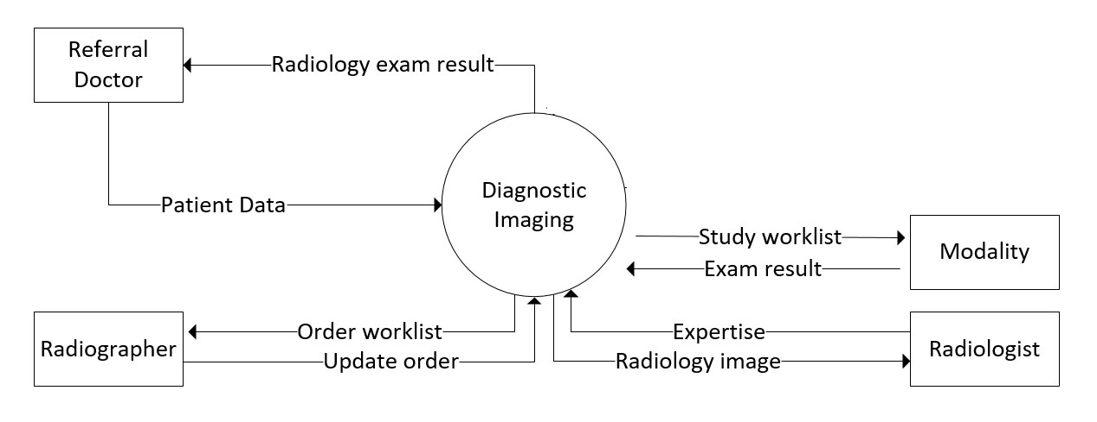

**Program Design Language**

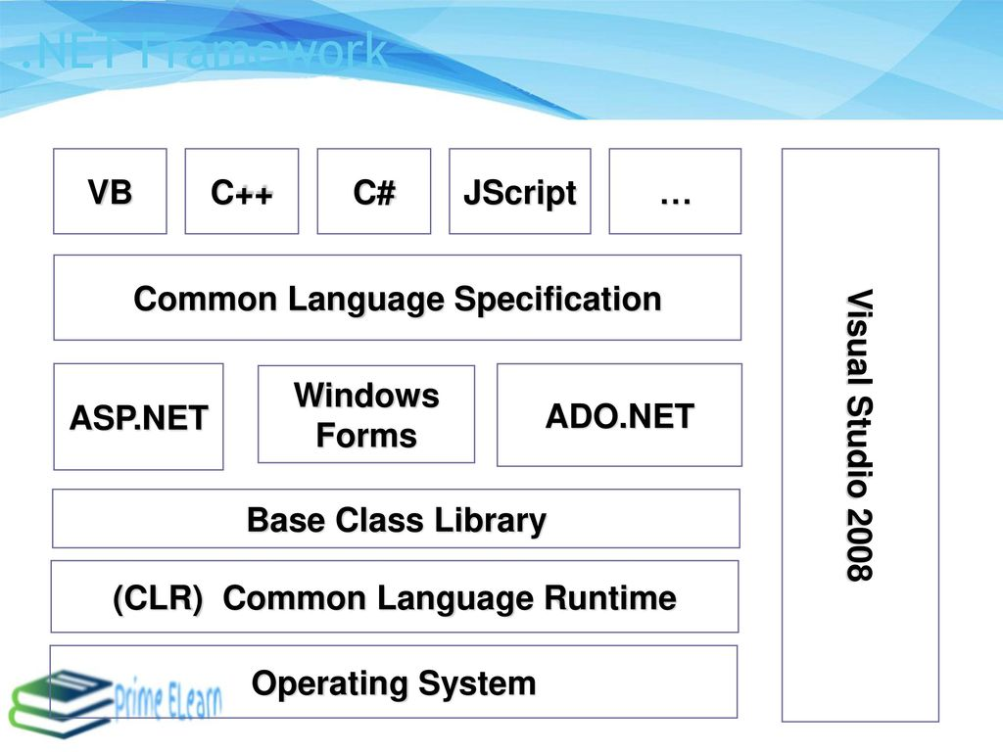

**CONCLUSION**

**Conclusion and Future Enhancement**

The reduction in average overall time for this combination of improvements is 83%, with a reduction in average working time of 12% and a reduction in average waiting time by 97%.

By applying Intra Oral Sensor (RVG) technique the time for diagnostic procedure is much shorter in comparison with traditional dental radiography enabling archiving and follow-up the presented case in the course of time. The results are faster and better with no loss in image quality.

**REFERENCES**.

* Dhia Ayu Salsabila1, Muhammad Dachyar from Department of Industrial Engineering, Universitas Indonesia, Depok - The Hospital Radiology Service Redesign, By Using Business Process Re-engineering and Information Systems Approach (2020) pp 3623-3631
* L. Keaver, C. O’Meara, M. Mukhtar, and C. McHugh, "Providing Nutrition Care to Patients with Chronic Disease: An Irish Teaching Hospital Healthcare Professional Study", Journal of Journal of Biomedical Education, vol. 2018, (2018), pp. 1–7.
* M. Lopreite and M. Mauro, "The Effects of Population Ageing on Health Care Expenditure: A Bayesian VAR Analysis Using Data from Italy", Journal of Health Policy, vol. 121, no. 6, (2017), pp. 663–674.
* L. Borgermans, Y. Marchal, L. Busetto, et al., "How to Improve Integrated Care for People with Chronic Conditions: Key Findings from EU FP-7 Project INTEGRATE and Beyond", Journal of International Journal of Integrated Care, vol. 17, no. 4, (2017), pp. 1–12.
* E. OZCETE, B. BOYDAK, M. ERSEL, S. KIYAN, I. UZ, and O. CEVRIM, "Comparison of Conventional Radiography and Digital Computerized Radiography in Patients Presenting to Emergency Department", Journal of Turkish Journal of Emergency Medicine, vol. 15, no. 1, (**2015**), pp. 8–12.
* L. Brandenburg, P. Gabow, and G. Steele, "Innovation and Best Practices in Health Care Scheduling - Discussion Paper", Journal of Institute of Medicine, (2015).
* V. Saliba, H. Legido-Quigley, R. Hallik, A. Aaviksoo, J. Car, and M. McKee, "Telemedicine across Borders: A Systematic Review of Factors That Hinder or Support Implementation", Journal of International Journal of Medical Informatics, vol. 81, no. 12, (2012), pp. 793–809.
* J.W.M. Hoe, "Service Delivery and Service Quality in Radiology", Journal of Journal of the American College of Radiology, vol. 4, no. 9, (**2007**), pp. 643–651.