

User Guide

Charla Live Chat Extension adds the necessary scripts for Charla widget to appear on your site. Once the extension is installed on your Magneto instance, you will need to add your property id from Magento backend using the following steps:

1. Login to your Magento backend after installing the plugin.
2. Browser to Stores ➡ Configuration
3. Click on Charla ➡Widget Settings
4. Add the property id as in the screenshot below, and click on Save Config.

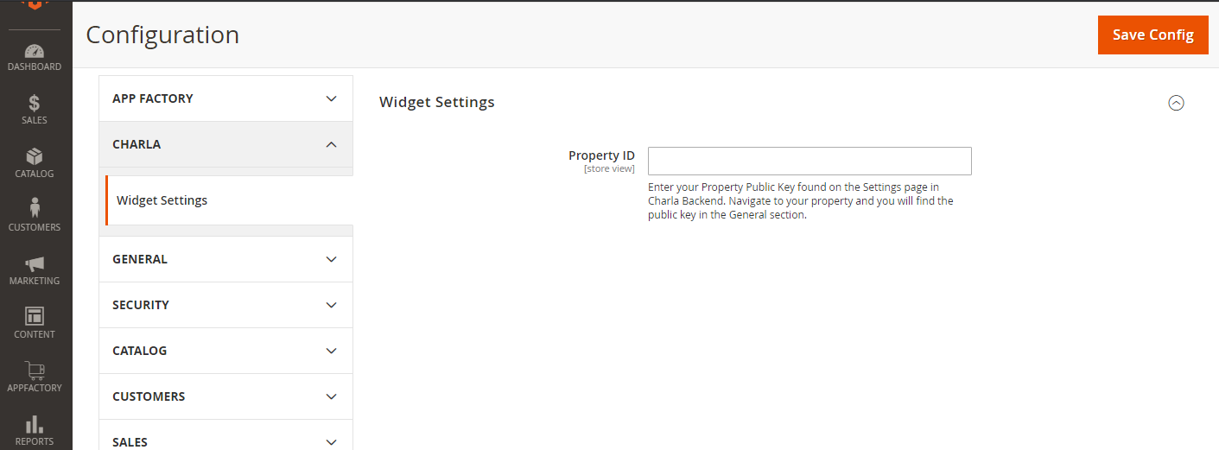

1. You’re done. Navigate to your homepage and you will see Charla Widgtet.