**ONLINE VOTING SYSTEM**

**Web Technology Project Synopsis**



Submitted by:

Anmol Arora Kritika Singh Jayant Singh Amethia

19102110 19102079 19102021

A4 A3 A1

Submitted to:

**Dr. Naveen Kumar Gupta**

*Department OF CSE & IT*

**TITLE**

**Secure E-voting Website**

**Problem Statement**

In these organized times when we can have everything online, voting is still a nuisance for a country as big as India, thus we plan to make it easier for eligible Indians to vote, thereby hoping an increase in percentage of voters in India, dedicated to betterment of our nation.

**Aims & Objective**

* An increase in percentage of voters in India
* Dedicated to betterment of our nation.

**Introduction**

“ONLINE VOTING SYSTEM” is an online voting technique. It is based on the other online services like “ONLINE RESERVATION SYSTEM” .In this system people who have citizenship of INDIA and whose age is above 18 years of any sex can give his\her vote online without going to any polling booth. There is a DATABASE which is maintained by the ELECTION COMMISION OF INDIA in which all the names of voter with complete information is stored.

**Working**

Voter has to fill a registration form to register himself\herself. All the entries is checked by the DATABASE which has already all information about the voter. If all the entries are correct then a USER ID and PASSWORD is given to the voter, by using that ID and PASSWORD he\she can use his\her vote. If conditions are wrong then that entry will be discarded.

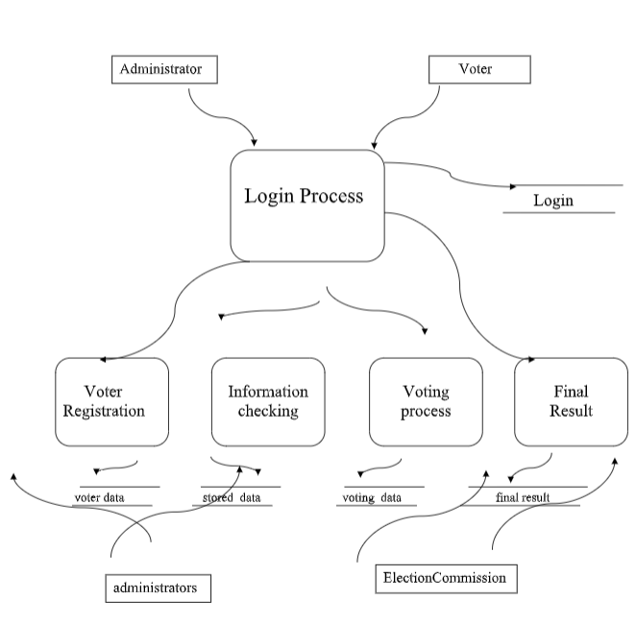

**Libraries and Requirements**

**Design**

1. HTML
2. CSS
3. JavaScript

**Functionality**

1. Java Script
2. PHP
3. MYSQL

**Reference**

* <https://getbootstrap.com/>
* <https://www.tutorialspoint.com/php/index.htm>
* <https://www.w3schools.com/php/>