**Project Report Milestone 1**

After the first phase of the project, this is what we have.

**Public GitHub repository**

[**https://github.com/JonathanPedersen1/PROSJEKTG1**](https://github.com/JonathanPedersen1/PROSJEKTG1)

**Team**

Mikkel Nathaniel Lindtveidt Johannessen (Project manager, Scheduling, Database)

Torjus Westeng Bakken (Back-End)

Patrick Borgen (Front-end, JavaScript(JS))

Jonathan Angell Pedersen (Front-end(HTML, CSS) & user guide)

Aleksander Borgen Hagland (JavaScript, Front-end)

Vetle Holte Gare (Back-end)

**Project Charter**

Planning: Research, acquiring potential stakeholders, resource management, delegating tasks, set up GitHub repository, Define objectives (such as what we want to achieve with our project), write a team-contract, create a timeline and write down milestones, risk assessment,

Executing: create a mock-up, develop content such as images, text and videos, programming (in html, sql, css, javascript, c or java), each person programs with their preferred language, breaks are important, implement GitHub, unit and integration testing, address and resolve issues and write it down in the report.

Closing: Close repositories, run and test (validate code), get approval, provide documentation and finish the report, provide user guide, and celebrate completion.

Project requirements: Website must promote sustainable programming, must be responsive, in our case with HTML, CSS and JavaScript, offer prototypes in figma, offer a contact form and FAQ section, should be visually appealing and sustainable, research and content creation, a home and about page, it should be functional and well organized,

**Product Backlog Table**

As a user, I would want the website to promote sustainable programming practices so that I can learn and adopt environmentally friendly coding methods. Acceptance Criteria: Educational blogs and resources on sustainable practices are available and easy to access.

As a user, I need a website that caters towards me and my disabilities (Universal design). Acceptance Criteria: Contains colour blind mode, dark mode, Website follows Gestalt guidelines to enable easier reading. We would like a simplified user interface with more icons, and less text.

As a user, I am interested in a contact form and FAQ section so that I can easily reach out for inquiries or find answers to common questions. Acceptance Criteria: Contact form allows submission and FAQ section provides clear, concise answers to common questions.

As a user, I want the website to be functional and well-organized so that I can easily navigate through the content. Acceptance Criteria: All pages are accessible, and the site structure is intuitive.

**WBS**

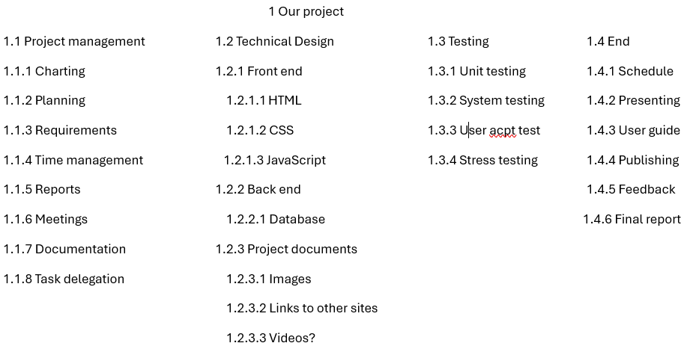

**GanttChart (Easier to check the one uploaded to GitHub Repository)**

