**Notes Eyvinds masters thesis.**

Abbreviations

|  |
| --- |
| **AP**I Application Programming Interface. |
| **AT** Attention, referring to instructions often used to control a modem. |
| **ATR** Acoustic Telemetry Receiver. |
| **CE** Coverage Enhancement. |
| **CoAp** Constrained Application Protocol. |
| **CPU** Central Processing Unit. |
| **CS** Chip Select. |
| **cSLIM** Cellular Synchronisation and Lora Interface Module. |
| **CSS** Chirp Spread Spectrum. |
| **DK** Development Kit. |
| **DRX** Discontinuous Reception. |
| **DUNE** DUNE: Unified Navigation Environment. |
| **e-ink** electronic ink. |
| **Eb** Energy per bit. |
| **ECAD** Electronic Computer Aided Design. |
| **ECL** Extended Coverage Level, same as CE-level. |
| **eDRX** Extended Discontinuous Reception. |
| **EVI** External Event Interrupt Input. |
| **FRAM** Ferromagnetic Random Access Memory. |
| **GNSS** Global Navigation Satellite System. |
| **GPIO** General purpose input/output. |
| **GPS** Global Positioning System. |
| **GSM** Global System for Mobile Communications. |
| **GW** Gateway. |
| **HTTP** Hypertext Transfer Protocol. |
| **I2C** Inter-integrated circuit, serial communication bus. |
| **ID** Identi_cation. |
| **IMC** Inter Module Connect. |
| **IoF** Internet of Fish. |
| **IoT** Internet of Things. |
| **IP**  Internet Protocol. |
| **ISM** Industrial, Scienti_c, Medical. |
| **ITU** International Telecommunication Union. |
| **JSON**  JavaScript Object Notation. |
| **LCD**  Liquid crystal display. |
| **LED**  Light Emitting Diode. |
| **LLC** Logic level converter. |
| **LoRa**  Modulation technique. |
| **LoRaWAN** LPWAN Standard using LoRa modulation. |
| **LPSAN**  Low Power Short Area Network. |
| **LPWAN** Low Power Wide Area Network. |
| **LTE**  Long Term Evolution. |
| **LTE-M** Long Term Evolution Machine Type Communication. |
| **MAC**  Medium Access Control. |
| **MCU** Microcontroller unit. |
| **MIC**  Message Integrity Check. |
| **MQTT**  Message Queuing Telemetry Transport. |
| **NB-IoT** Narrowband Internet of Things. |
| **OLED** Organic Light Emitting Diode. |
| **OPC**  Open Protocols Coding. |
| **PCB**  Printed Circuit Board. |
| **PPM**  Pulse Per Minute. |
| **PPS**  Pulse PerSecond. |
| **PSM** Power Saving Mode. |
| **QoS**  Quality of Service. |
| **RAM**  Random Access Memory. |
| **RF**  Radio Frequency. |
| **RTC**  Real Time Clock. |
| **RTOS**  Real-Time Operating System. |
| **RX** Receive. |
| **SCM**  Supply Chain Management. |
| **SDK**  Software Development Kit. |
| **SF** Spreading Factor. |
| **SIM** Subscriber Identity Module. |
| **SiP** System in Package. |
| **SLIM** Synchronisation and Lora Interface Module. |
| **SMD** Surface Mounted Device. |
| **SNR**  Signal to Noise Ratio. |
| **SPI**  Serial Peripheral Interface, serial communication bus. |
| **SSH**  Secure Shell. |
| **SSL**  Secure Sockets layer. |
| **STM**  State Machine. |
| **TAU**  Tracking Area Update. |
| **TCP**  Transmission Control Protocol. |
| **TDoA**  Time Difference of Arrival. |
| **TLS**  Transport Layer Security. |
| **TTL**  Transistor-transistor logic. |
| **TX**  Transmit. |
| **UART**  Universal Asynchronous Receiver-Transmitter, serial communication standard. |
| **UDP** User Datagram Protocol. |
| **uSD**  micro SD(secure digital). |
| **UTC**  Coordinated Universal Time. |
| **VPN**  Virtual Private Network. |

**1.2 Previous work**

Jølsgård addresses previous master and PhD thesis where energy consumption of IoT devices and other solution have been tested.

# Chapter 2 Background information

## Hardware

**Acoustic tags**small sound-emitting device. Consists of a battery, modulator, and transmitter and often one or multiple sensors gathering data transmitted in the acoustic message.   
The messages are modulated, using **differential pulse position modulation,** containing the tag-ID and potentially sensor data.

**ATR Acoustic Telemetry Receiver**  
A **hydrophone** specifically designed to receive and decode signals from acoustic tags. ATR transforms the acoustic signals to electrical energy. Made from piezoelectric element, producing small electrical signals when applied to pressure. Can be omnidirectional, receiving signals from all directions, or unidirectional, receiving signals from a single direction.

**The ARM Coretex-M micoprocessor**The Cortex-M series developed by ARM is a collection of 32-bit microprocessor architectures. ARM does not produce MCU themselves, but sells their design on the same architecture, reducing time to marked and development cost.

**nRF91 Series and nRF9160 microcontroller**The nRF91 series is Nordic Semiconductors collection of low-power cellular devices.  
The first device released in the series is the nRF9160 System in Package (SiP), featuring a modem with LTE capability, an RF multiband radio and incorporating the ARM Cortex M-33 CPU architecture. The SiP has 1MB of flash, 256kB of RAM, 32GPIOs, analog Interfaces and four digital interfaces that support SPI, I2C and UART. Needs external power source, SIM card and antenna.   
**The nRF9160 supports both LTE-M and NB-IoT with eeDRX and PSM power-saving modes.** And the floor current if the LTE connection is in the range of a few uA when using the power-saving mode.

**nRF9160 Development Kit (DK)**Dedicated NB-IoT and LTE-M antenna, a GPS antenna and a 2.4GHz antenna and can be used with a range of connected IoT applications. (short-range wireless protocols Bluetooth, openThread and Mesh and long-range connectivity with NB-IoT and LTE-M)  
  
Uses a nRF52840 board controller and can connect and disconnect the nRF9160 SiP to external peripherals on the development kit. Includes LEDs, buttons, switches, external memory and UART logging capabilities.  
Uses internal voltageregulators and a Segger J-Link Debugger and enables programming and power through a USB interface. In addition, 10-pin debug headers are available for access using an SWD interface.

**LoRa gateway**A LoRa gateway is a network router equipped with a LoRa concentrator (receiver/transmitter module) to convert packets between a LoRaWab and another network interface such as Ethernet, GSM of WiFi. In other words, it receives LoRa messages over LoRaWAN and forward the messages to a server through the internet.

**Server**  
The MQTT Broker is running at a virtual server provided by the IT department at NTNU named otter01.it.ntnu.no. Accessed through SSH and NTNU-user credentials. Can be used with NTNUs VPN tunnel (Cisco AnyConnect).

### PCB Hardware

**Voltage regulators**  
**LINEAR:** the input voltage must be higher than the required output voltage. Simple, cheap and give little noise to the surrounding circuitry. Not very power-efficient, especially when there is a gap between input and output power.  
**Switching:** Highly efficient, able to step up (boost), step down (buck) and invert voltages with ease. Often require more external components than linear ones, resulting in more costly solutions. Causes noise due to ripple on the switching rate. Hence care must be taken when designing devices with noise-sensitive components. (Applies to RF-enabled devices).

**Display**  
LCD and OLED uses LEDs to display information, either by having the LEDs providing backlight (LCD) or illuminating the pixels themselves (OLED) – Continuous power drawn while the display is active.  
e-ink displays uses electronic int to display information only drawing power when changing the display and keeping pixel color on power loss. Power effective!

**Logic level converters**Logic level converters are regularly used to connect devices with different TTL levels   
(transistor-transistor-logic). Common is conversion between the three standard voltage levels 5V, 3.0-3.3V and 1.8V. Some devices are powered down during operation while being connected to pins at the microcontroller used by other devices, therefor, logic level converters with enable pins are added to the SPI lines before powered-off devices to ensure tri-state operation.

## Software

**Zephyr RTOS**

Open-source real-time operating system for resource-constrained embedded devices. Linux foundation**. Kconfig, Makefile and defconfig** configuration, the Linux build system provides a portable operating system, supporting devices and board across multiple architectures. Including ARM-cortex based Arduinos, EFM32s from silicon Labs and nRF-devices from Nordic.  
**Kconfig** is a configuration and build system developed for the Linux kernel as it mitigated to Git. Kconfig provides configuration options for the developer without having to change any source code. The Kconfig configuration is converted to a header file (.h) that can be tested and included at build-time.  
**Device Trees** are hierarchical structures used to describe a device’s hardware. The device tree file describes hardware available on the current board and default values of configuration parameters. The device tree consists of two types of files: **source file** and **bindings**, where source files contain the device tree itself, while bindings describe the content of the device tree, for example, data types.   
Device trees are overruled by .overlay files.  
In addition to hardware support, the RTOS has a kernel providing e.g. threading, interrupt, timers and scheduling, operating system services including debugging, logging peripheral drivers, networking and a watchdog, and application services.

**Server Software**  
The IoF server software consists of a fronted and backend written in Python. The backend receives MQTT messages from the SLIM gateways, unpacking the messages and storing them in a database. In the newest version the messages from the gateway is packed in JSON format.

**DUNE: Unified Navigation Environment**  
described as a “runtime environment for unmanned systems on-board software It is used to write generic embedded software at the hart of the system. e.g., code or control, navigation, communication, sensor, and actuator access. In addition, it provides an operating systems and architecture-independent platform abstractions layer, written in C++, enchancing portability among differen CPU architectures and operating systems.”   
DUNE is divided into tasks communicating with each other through IMC(Inter Module Connect)-messages. The IMC messages are provided in XML-format, which can be ported to C++ bindings. Moreover, IMC messages can be exchanged between vehicles and systems on the DUNE network using numerous transports, e.g., UDP, TCP, Serial, GSM, Irdium and more.

Communication technology and protocols

**Fish tag acoustic protocols**Some protocols support over a million unique IDs and other support 256. Existing protocols can be “R64K”, “R256”, “S64K”, DS256” for example. OPC is a newer protocol that allows transmitters and receivers from different manufacturers to work together.

**IoF message format**Divided into header and payload. The payload specifies the acoustic receiver ID, message content and UTC timestamp for the first message in the payload. The payload contains one or more acoustic detection and acoustic receiver sensor data frames or the buoy controller status frame.   
  
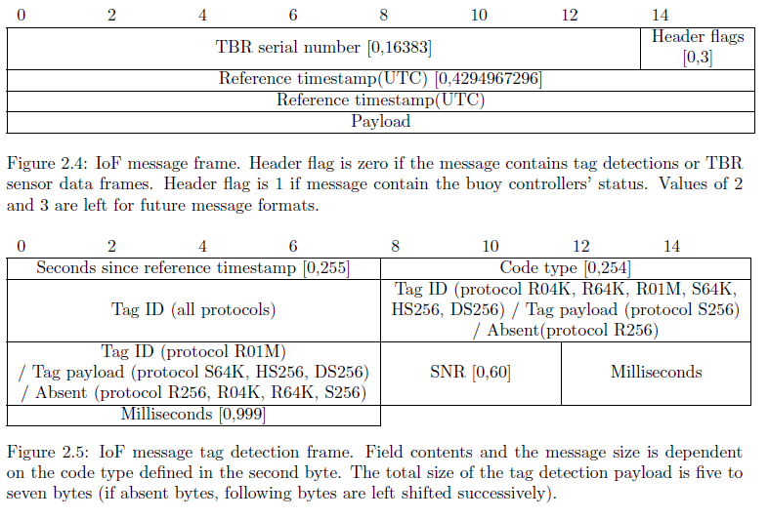 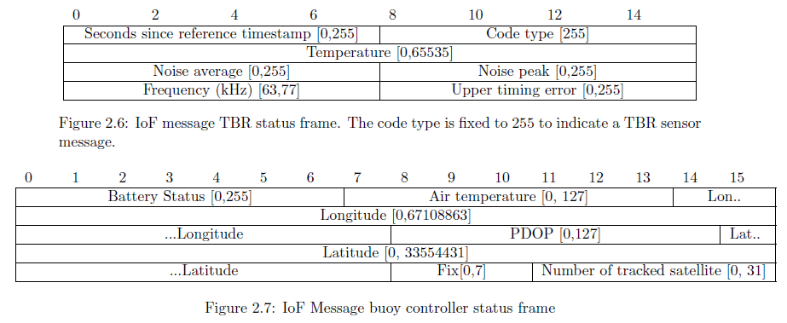

**Transmission from sea buoy to the mainland (LPWAN)**  
As the buoy should be easy to deploy, and sustain long battery life, a LPWAN technology is appropriate. There are multiple technologies, but we will focus on LoRa and NB-IoT) being the two that has shown momentum and probably will have a large share of the marked.

**Communication technology basics**  
Communication technology terms:

* **Receiver sensitivity** is the amount of power required to demodulate a signal. Higher receiver sensitivity will increase the range of the wireless link and increase robustness.
* **Energy per bit (EB)** is the amount of energy requires to send a single bit.
* **Thermal noise spectral density (No)** is the noise power per unit of bandwidth and is expressed as power over frequency (watt/Hz)
* **Eb/No ratio** is a term used to describe the link-performance at a given data rate.The better the Eb/No ratio, the better receiver sensitivity at a given data rate.
* **Spectral Efficiency** is the amount of data that can be transmitted in a single link. It can be defined as eta = (R/BW)/K, where R: Bit rate, BW: Bandwidth, K: cluster size
* **The Shannon-Hartley theorem** describes the maximum error-free digital data that can be transmitted over a communication channel with specified bandwidth and the presence of noise. I = BW*log_2(1+S/N)

**Energy efficiency metrics**  
When measuring energy efficiency in IoT applications, Santiago and Dr. Arockiam presents the following most common aspects:

1. **Energy pr. Bit**
2. **Energy per reported event,** i.e, the energy spent to report one single event.
3. **Delay/energy tradeoff** i.e, the importance of reporting events in (near) real-time compared to the energy usage.
4. **Network lifetime,** i.e., the time the device is able to fulfill its task. This includes both the lifetime of the device itself as well as the infrastructure needed to fulfill the task, e.g., network infrastructure or servers.

Zanaj et al presents the additional aspects:

1. **Battery lifetime** How long the device can live without replacing the battery.
2. **Duty cycle** i.e., the time of which the node is active on the network (either transmitting or listening) compared to the overall lifetime.

**Issues in IoT energy conservations**Santiago and Dr.Arockiam summarizes the issues to energy on IoT in the five keypoints:

* **Idle listeing** is the state where a node (end device) is awaiting ready to transmit or receive data while not doing any of those.
* **Collision** occurs when the node receives multiple transmissions at the same time. As the transmissions interfere with each other, none of the received data can be used.
* **Overhearing** occurs in dense sensor networks where neighboring nodes receive and process information that is of no use to the node.
* **Protocol overhead** results in extra energy usage. Reduction of protocol header information will reduce the amount of data transmitted and processed and reduce energy consumption.
* **Traffic fluctuation** occurs when multiple nodes are active at the same time, resulting in congestion or long delays.

**NB-IoT**Narrowband Internet of Things NB-IoT, is a cellular wireless technology standard. Introduced in release 13 of the 3GPP project, introducing low power wide area network (LPWAN) to the cellular network standard. The protocol offer direct communication between the low-power end-device and a TCP/IP connected server, or another IoT device through base stations and infrastructure provided by cellular network operators.  
Maximum payload size for NB-IoT is 1600 Bytes, while the peak data rate is 66Kbps.

**NB-IoT power saving features.**Increased battery lifetime operations are one of the key features of LPWANs.   
NB-IoT supports two power-saving features: Extended discontinuous Reception (eDRX) and Power Saving Mode (PSM).

**eDRX** is an extension to the regular DRX that is used by other LTW networks. eDRX allows the device to be unreachable for a longer time (5-2621 secounds) before listening to the network. A device in eDRX mode is still quite receptacle to data while limiting the energy consumption.

**PSM** – The device can set timers that are forwarded to the network: Periodic Tracking Area Update(TAU) and active time. A network accepting this configuration, means that the device can sleep for a given time (up to 14 days) before reattaching is necessary. During the sleep interval, the device is not able to receive packets., however the network will know when the device will be reachable and available for receiving packages.

**LoRa**   
LoRa – Long Range specifies a physical layer standard owned by Semtech, using Chirp Spread spectrum (CSS) modulation to transmit data over large distancec. CSS symbols have four important parameters: Spreading factors (SF), the minimal and maximum frequency (fmin, fmax) in the frequency band and the starting frequency. Starting frequency f0 is calculated based on the symbol being sent- the raw chirp fc(t) can be described as in equation (see thesis page 31).

Limited 30s/day and 10 downlink messages per 24hour (The Things Network) other networks exists Altibox and Last_Mile.

Note: SF spread factor = number of raw bits to be encoded into one symbol.

Device class:

* Class A: enable uplink and downlink transmissions. Downlink can only occur after an uplink transmission. The end device listens to the network in two short receive windows after the uplink transmission. If no message is received, the end device goes offline until the next uplink transmission.
* Class B: Extend class A devices by adding scheduled receive windows. The device then listens to the network for downlink transmissions at regular intervals.
* Class C: Extend class A devices by listening to the network when not transmitting. In other words, the end device is always reachable unless performing an uplink transmission.

**MQTT**   
Message queueing Telemetry Transport is a lightweight publish/subscribe messaging transport protocol. Small code footprint and limited network bandwidth, support bidirectional communication, and contain mechanisms for unreliable networks. This includes: messages delivered at least once, delivered exactly once and a “fire and forget” config without fault detection.   
built on top of TCP. Using MQTT, the device will typically retain a connection to the broker at all times, but this is not required for sensor networks (MQTT-SN).

The frame consists of three main parts: Fixed header, variable header and the payload.

