Part1 Initial setup of Samba4

Sudo apt update
Sudo apt upgrade
Sudo apt dist-upgrade
Sudo nano /etc/fstab
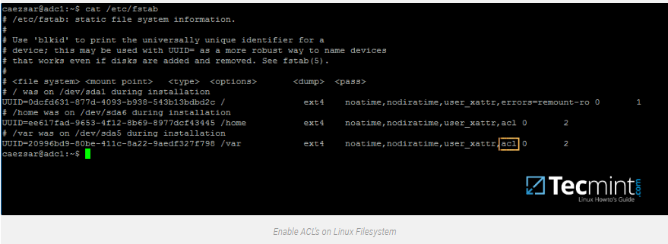
sudo apt-get install samba krb5-user krb5-config winbind libpam-winbind libnss-winbind
EXAMPE.LAN
Example.lan
Example.lan
sudo systemctl stop samba-ad-dc.service smbd.service nmbd.service winbind.service
sudo systemctl disable samba-ad-dc.service smbd.service nmbd.service winbind.service
sudo mv /etc/samba/smb.conf /etc/samba/smb.conf.initial
sudo samba-tool domain provision --use-rfc2307 --interactive
sudo mv /etc/krb5.conf /etc/krb5.conf.initial
sudo ln -s /var/lib/samba/private/krb5.conf /etc/
$ sudo systemctl start samba-ad-dc.service
$ sudo systemctl status samba-ad-dc.service
$ sudo systemctl enable samba-ad-dc.service
sudo netstat –tulpn| egrep ‘smbd|samba’
sudo samba-tool domain level show
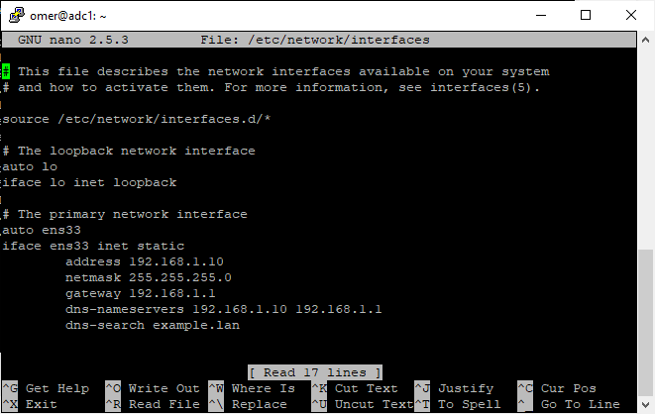

Part 2 Managing users etc
Sudo samba-tool user add faa
Sudo samba-tool group addmembers “Domain Admins” faa
sudo samba-tool domain passwordsettings set --complexity=off
sudo samba-tool domain passwordsettings set --history-length=0
sudo samba-tool domain passwordsettings set –max-pwd-age=0
sudo samba-tool domain passwordsettings set –min-pwd-age=0
sudo samba-tool domain passwordsettings set –min-pwd-length=4
sudo nano /etc/samba/smb.conf
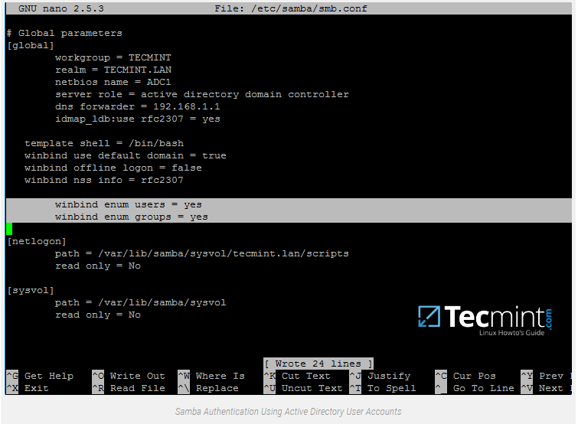
Voeg ook het volgende toe (onder [global]) zodat later je geen LDAP wachtwoord too weak error krijgt bij ldapsearch;
ldap server require strong auth = no
Testparm
Sudo pam-auth-update
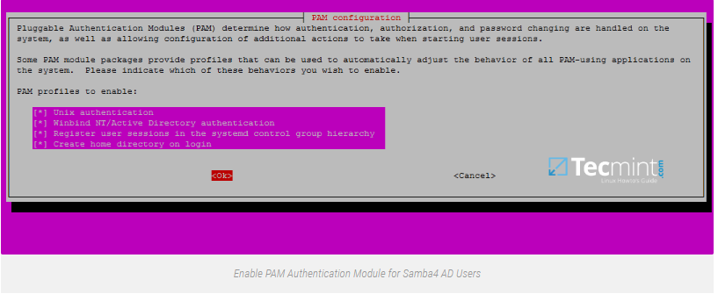
Sudo nano /etc/nsswitch.conf
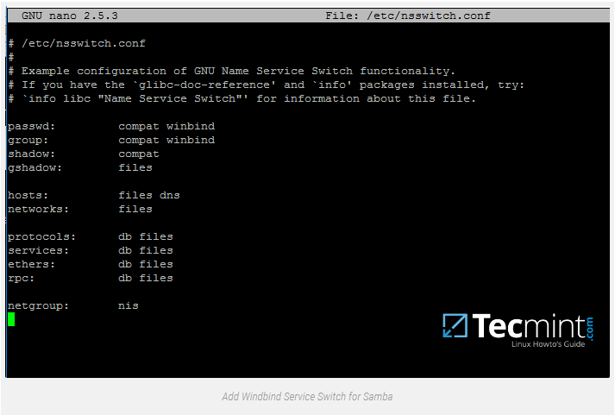
Sudo nano etc/pam.d/common-password
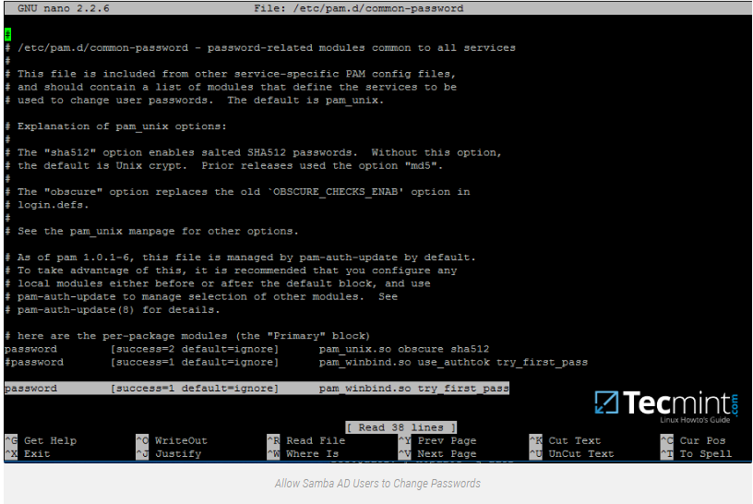
Sudo systemctl disable winbind.service
Sudo systemctl stop winbind.service
Su – faa
Logout
Sudo usermod -aG sudo ‘EXAMPLE\faa’
Sudo nano /etc/sudoers
%EXAMPLE\example\ admins ALL=(ALL:ALL) ALL
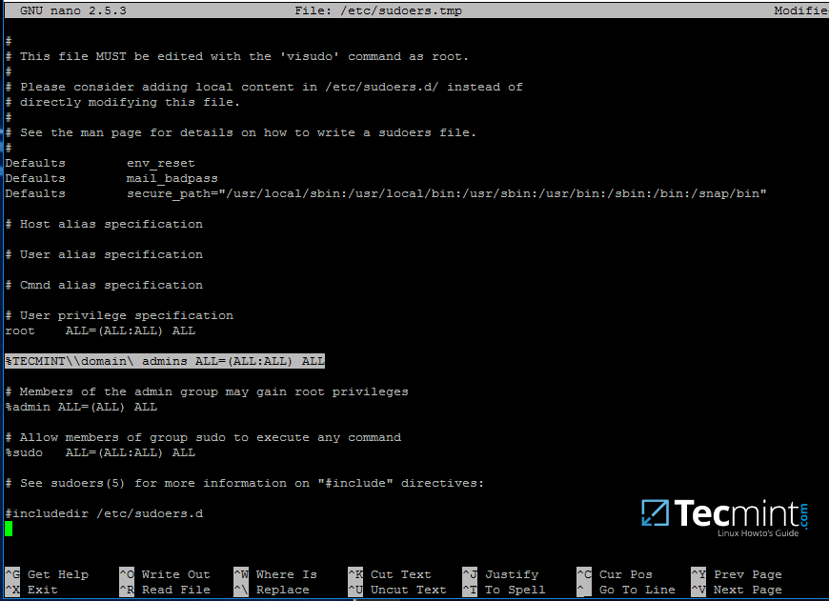

Part 3
Sudo apt install ntp ntpdate
Sudo nano /etc/ntp.conf
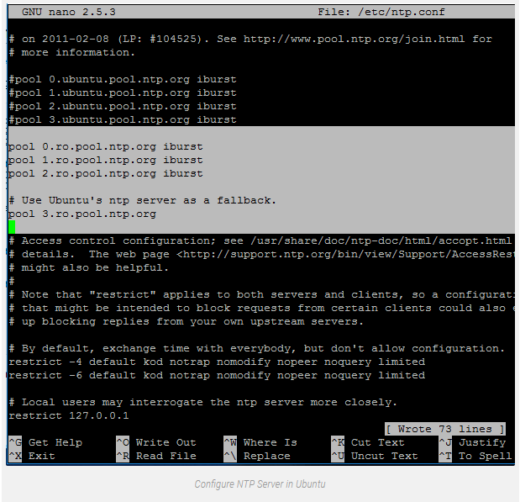
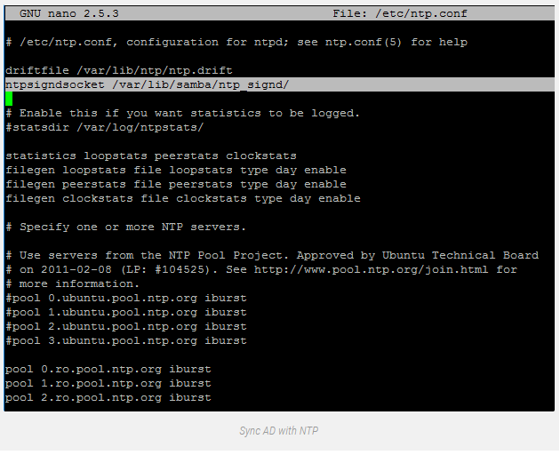
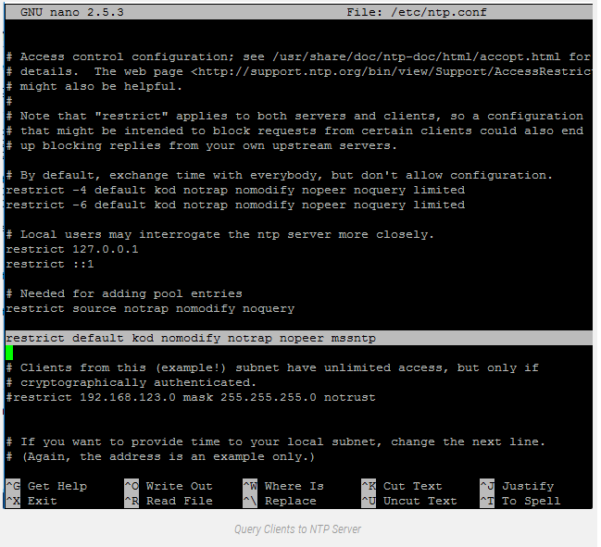
$ sudo chown root:ntp /var/lib/samba/ntp_signd/
$ sudo chmod 750 /var/lib/samba/ntp_signd/
$ sudo systemctl restart ntp
$ sudo netstat -tulpn | grep ntp
ntpq -p
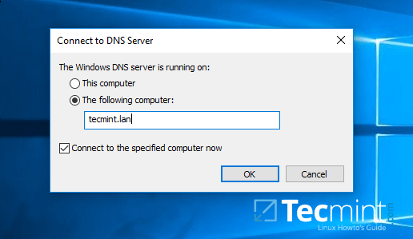
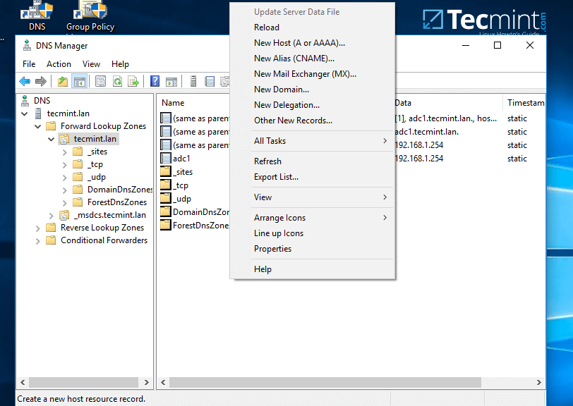
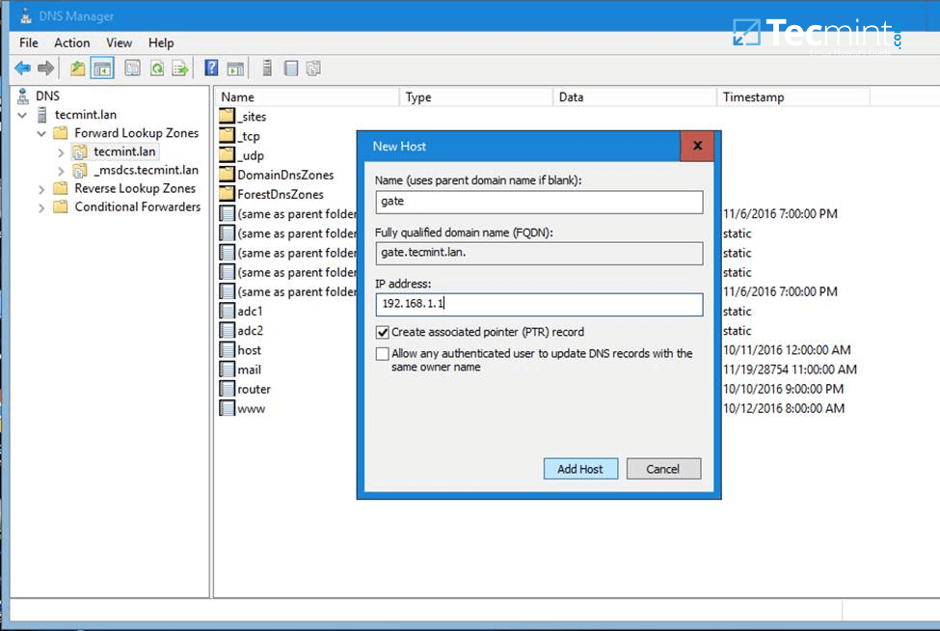
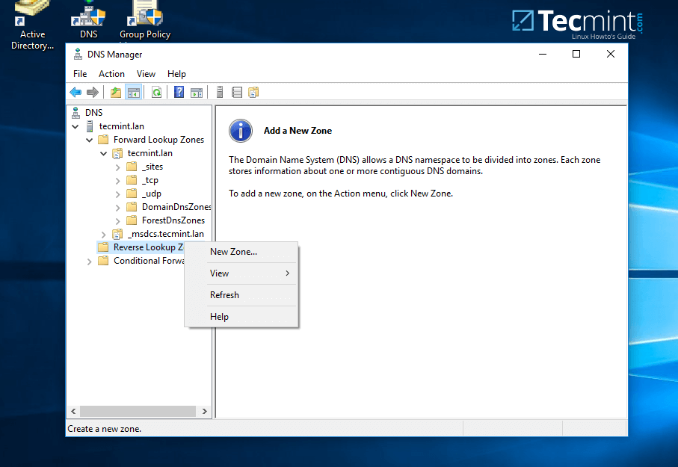
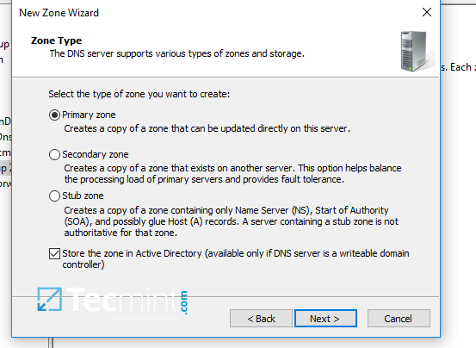
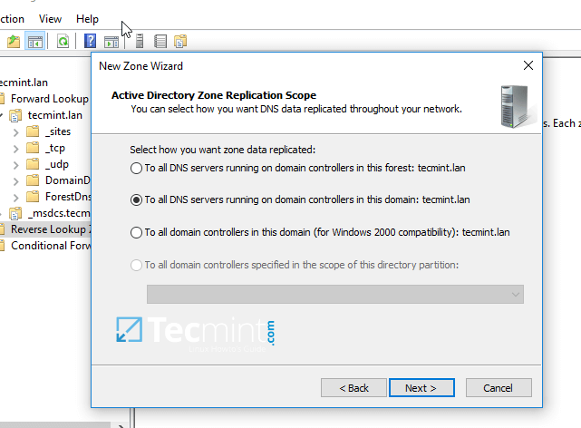
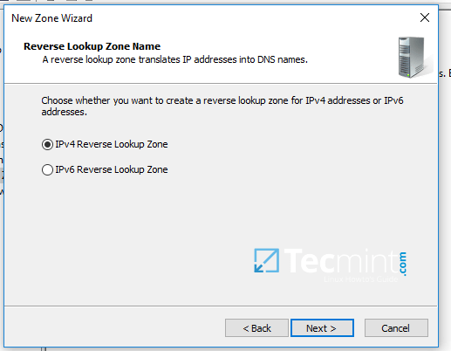
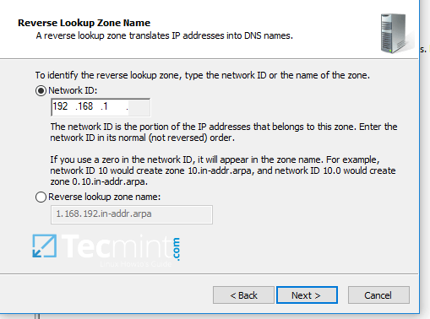
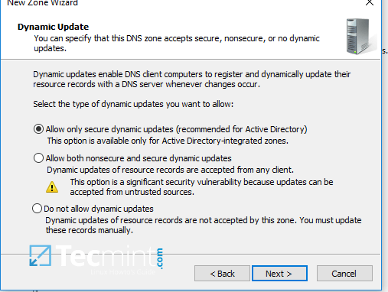
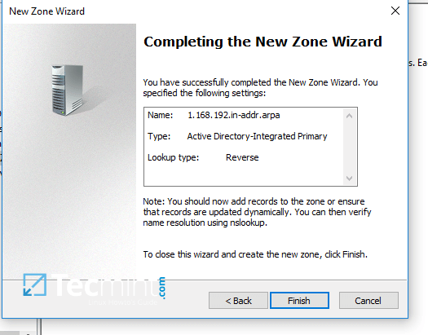

Part 4 CentOS iRedMail installatie
nmtui
Yum update
Yum install nano
Hostnamectl set-hostname mail.example.lan
Sudo nano /etc/hosts
127.0.0.1 mail.example.lan mail localhost localhost.localdomain
yum install bzip2 net-tools bash-completion wget
Wget https://github.com/iredmail/iRedMail/releases/download/1.0/iRedMail-1.0.tar.gz
Tar xzvf i<press tab>
Cd i<press tab>
Ls
Bash iRedMail.sh
10. On the first welcome prompt hit on Yes to proceed further with the installation.
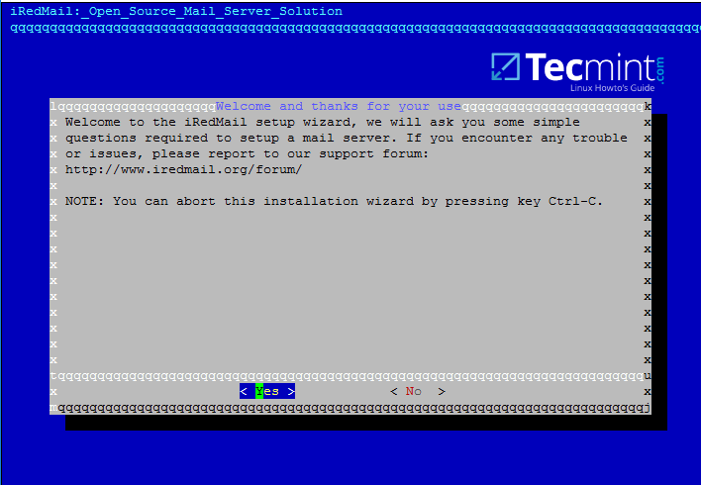
iRedMail Setup Wizard
11. Next, choose the location where all the mail will be stored. The default directory that iRedMail uses to store mailboxes is /var/vmail/ system path.
If this directory is located under a partition with enough storage to host mail for all your domain accounts then hit on Next to continue.
Otherwise change the default location with a different directory in case if you’ve configured a larger partition dedicated to mail storage.
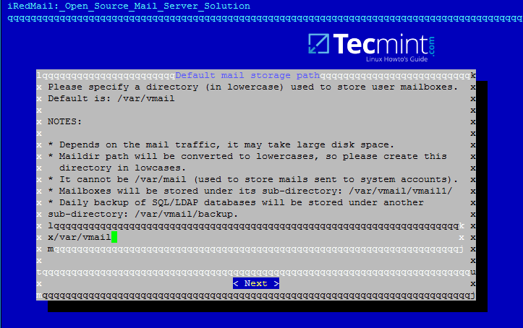
iRedMail Mail Storage Path
12. On the next step choose the frontend web server through which you will interact with iRedMail. iRedMail administration panel will be completely disabled later, so we will use the frontend web server only to access accounts mail via Roundcube web panel.
If you don’t have thousands of mail accounts per hour accessing the webmail interface you should go with Apache web server do to its flexibility and easy management.
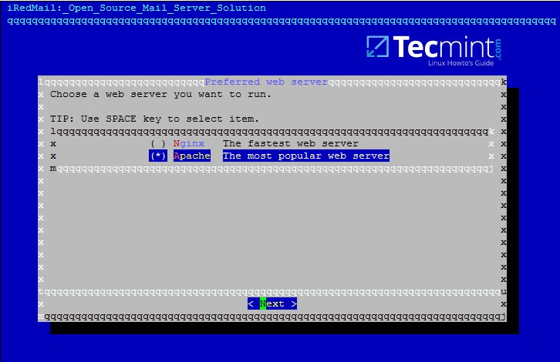
iRedMail Preferred Web Server
13. On this step choose OpenLDAP backend database for compatibility reasons with Samba4 domain controller and hit Next to continue, although we won’t use this OpenLDAP database later once we’ll integrate iRedMail to Samba domain controller.
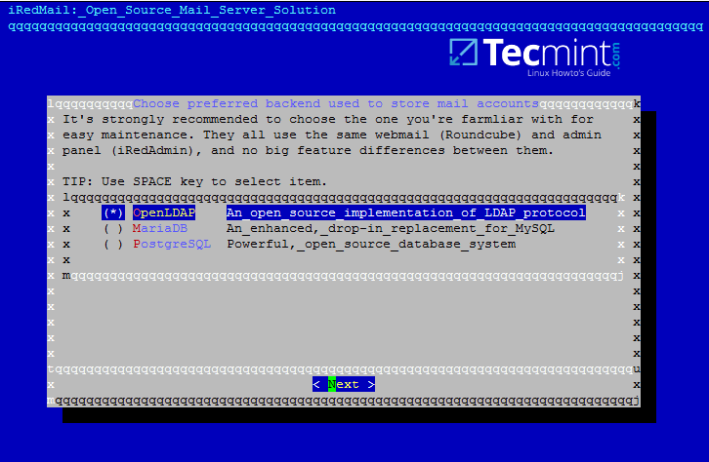
iRedMail LDAP Backend
14. Next, specify your Samba4 domain name for LDAP suffix as illustrated on the image below and hit Next to continue.
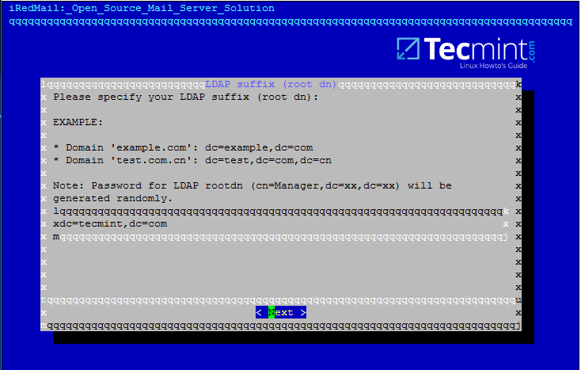
iRedMail LDAP Suffix
15. On the next prompt enter your domain name only and hit Next to move on. Replace tecmint.lan value accordingly.
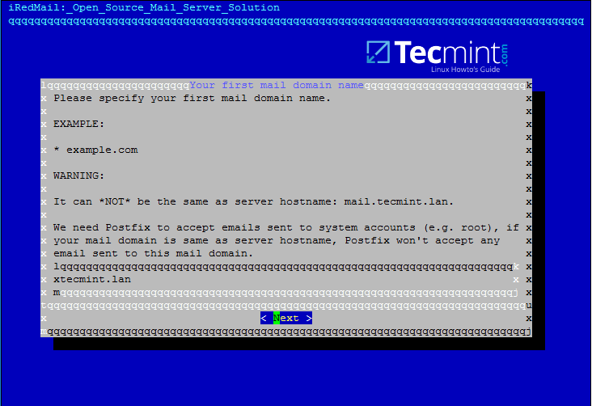
iRedMail Mail Domain
16. Now, setup a password for postmaster@yourdomain.tld administrator and hit Next to continue.
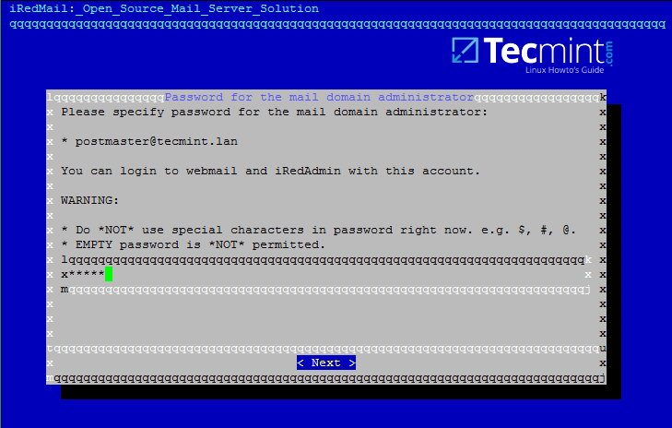
iRedMail Mail Domain Administrator
17. Next, choose from the list the optional components you want to integrate with your mail server. I strongly recommend to install Roundcube in order to provide a web interface for domain accounts to access mail, although Roundcube can be installed and configured on a different machine for this task in order to free mail server resources in case of high loads.
For local domains with restricted internet access and especially while we’re using domain integration the other components are not very useful, except Awstats in case you need mail analysis.
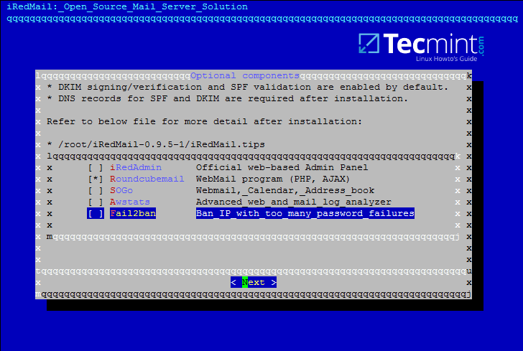
iRedMail Optional Components

iRedMail Integratie

nmtui
systemctl restart networking.service
yum install ntpdate
ntpdate adc1.example.lan
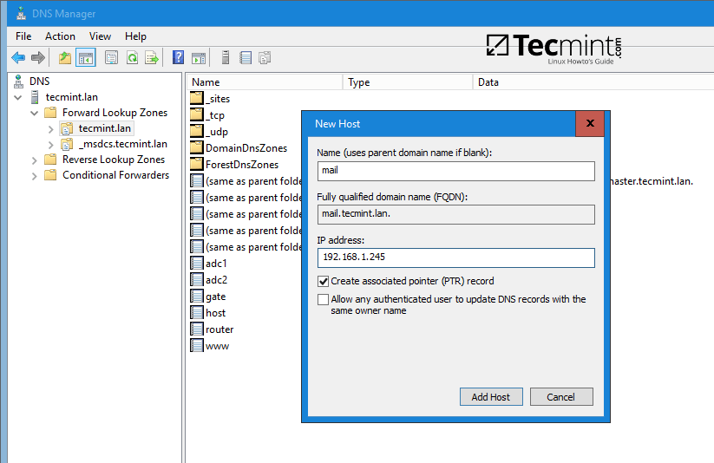
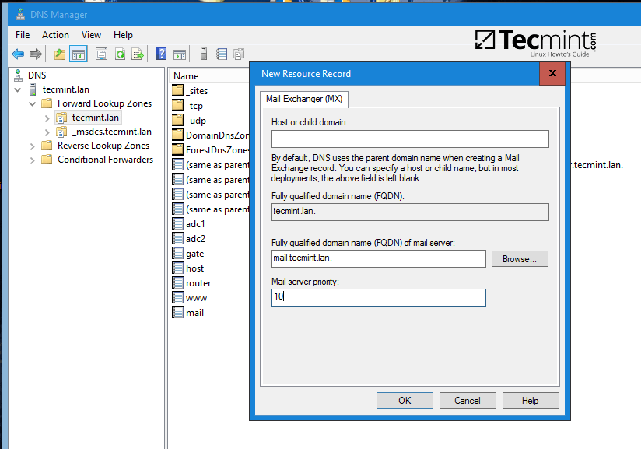
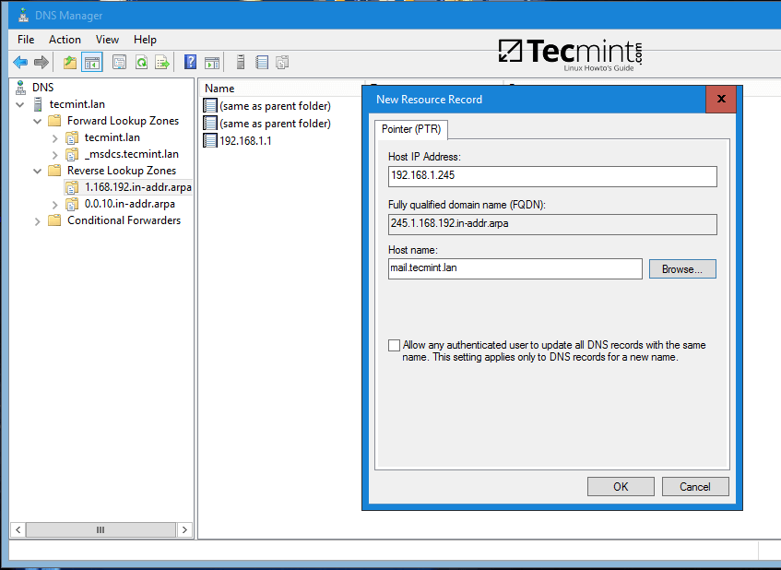
Yum install bind-utils
Host example.lan
Host mail.example.lan
Host 192.168.1.15
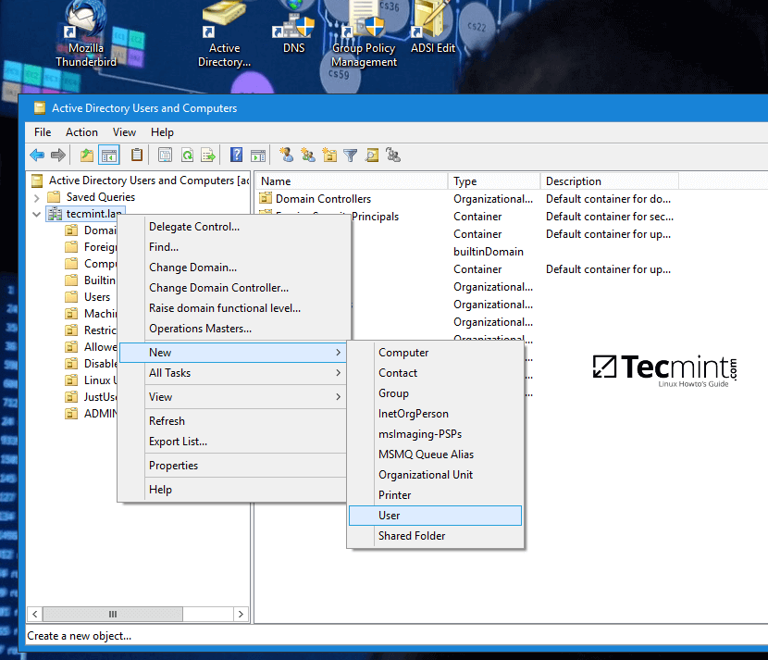
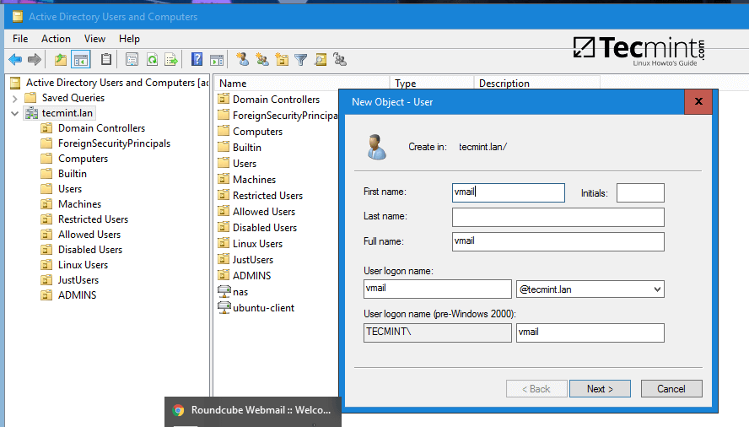
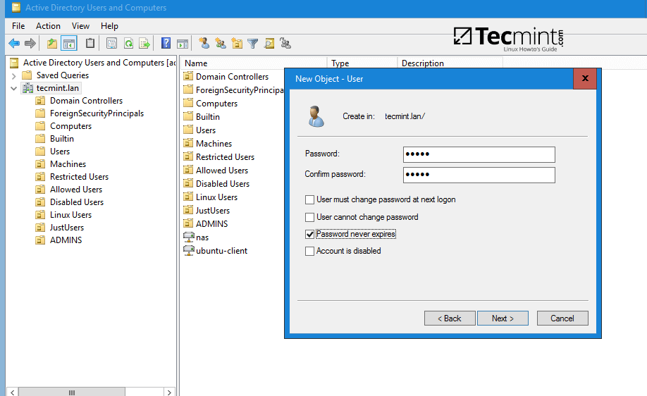
ldapsearch -x -h example.lan -D 'vmail@example.lan' -W -b 'cn=users,dc=example,dc=lan'
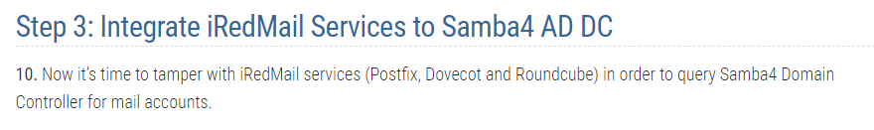
# postconf -e virtual_alias_maps=' '
# postconf -e sender_bcc_maps=' '
# postconf -e recipient_bcc_maps=' '
# postconf -e relay_domains=' '
# postconf -e relay_recipient_maps=' '
# postconf -e sender_dependent_relayhost_maps=' '
# postconf -e smtpd_sasl_local_domain='example.lan' #Replace with your own domain
# postconf -e virtual_mailbox_domains='example.lan' #Replace with your own domain
# postconf -e transport_maps='hash:/etc/postfix/transport'
# postconf -e smtpd_sender_login_maps='proxy:ldap:/etc/postfix/ad_sender_login_maps.cf' # Check SMTP senders
# postconf -e virtual_mailbox_maps='proxy:ldap:/etc/postfix/ad_virtual_mailbox_maps.cf' # Check local mail accounts
# postconf -e virtual_alias_maps='proxy:ldap:/etc/postfix/ad_virtual_group_maps.cf' # Check local mail lists
# cp /etc/postfix/transport /etc/postfix/transport.backup # Backup transport conf file
# echo "example.lan dovecot" > /etc/postfix/transport # Add your domain with dovecot transport
# cat /etc/postfix/transport # Verify transport file
# postmap hash:/etc/postfix/transport
server_host = example.lan
server_port = 389
version = 3
bind = yes
start_tls = no
bind_dn = vmail@example.lan
bind_pw = Kurnaz1@
search_base = dc=example,dc=lan
scope = sub
query_filter = (&(userPrincipalName=%s)(objectClass=person)(!(userAccountControl:1.2.840.113556.1.4.803:=2)))
result_attribute= userPrincipalName
debuglevel = 0
server_host = example.lan
server_port = 389
version = 3
bind = yes
start_tls = no
bind_dn = vmail@example.lan
bind_pw = Kurnaz1@
search_base = dc=example,dc=lan
scope = sub
query_filter = (&(objectclass=person)(userPrincipalName=%s))
result_attribute= userPrincipalName
result_format = %d/%u/Maildir/
debuglevel = 0
server_host = example.lan
server_port = 389
version = 3
bind = yes
start_tls = no
bind_dn = vmail@example.lan
bind_pw = Kurnaz1@
search_base = dc=Kurnaz1@,dc=lan
scope = sub
query_filter = (&(objectClass=group)(mail=%s))
special_result_attribute = member
leaf_result_attribute = mail
result_attribute= userPrincipalName
debuglevel = 0
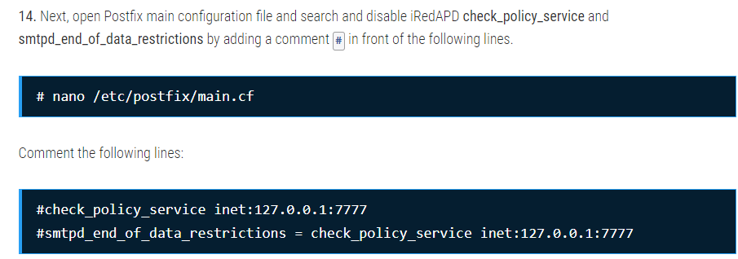
# postmap -q faa@example.lan ldap:/etc/postfix/ad_virtual_mailbox_maps.cf
# postmap -q faa@example.lan ldap:/etc/postfix/ad_sender_login_maps.cf
# postmap -q linux_users@example.lan ldap:/etc/postfix/ad_virtual_group_maps.cf
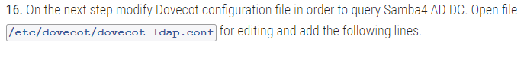
hosts = example.lan:389
ldap_version = 3
auth_bind = yes
dn = vmail@example.lan
dnpass = Kurnaz1@
base = dc=example,dc=lan
scope = subtree
deref = never
user_filter = (&(userPrincipalName=%u)(objectClass=person)(!(userAccountControl:1.2.840.113556.1.4.803:=2)))
pass_filter = (&(userPrincipalName=%u)(objectClass=person)(!(userAccountControl:1.2.840.113556.1.4.803:=2)))
pass_attrs = userPassword=password
default_pass_scheme = CRYPT
user_attrs = =home=/var/vmail/vmail1/%Ld/%Ln/Maildir/,=mail=maildir:/var/vmail/vmail1/%Ld/%Ln/Maildir/
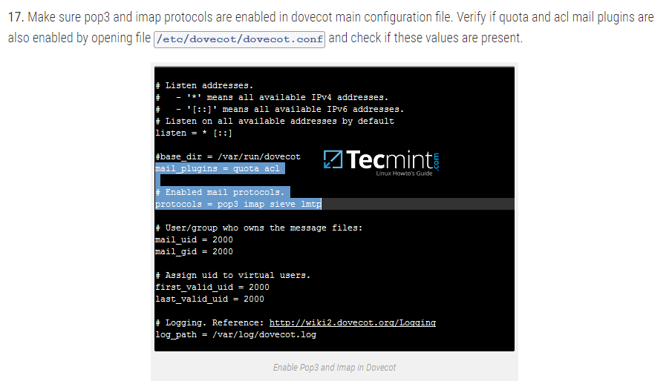
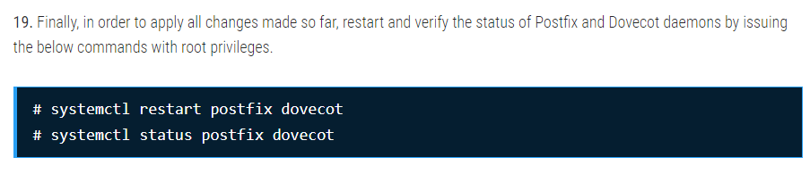
Yum install nc
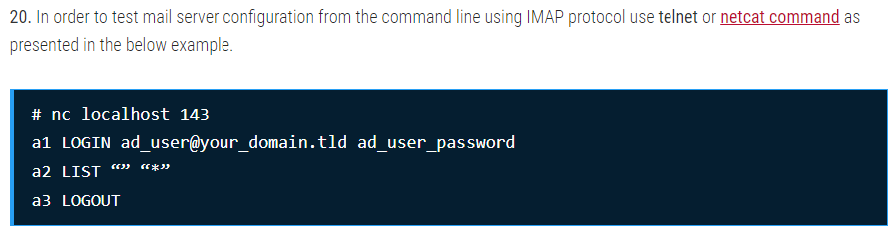

Part hoevele dan ook

Maak nieuw user
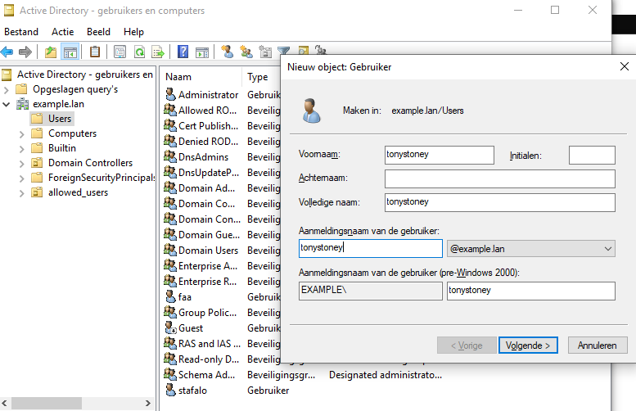

Geef het email adres
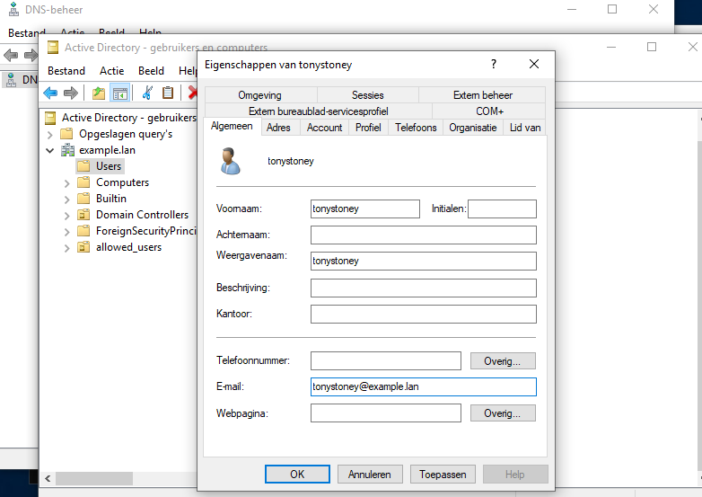
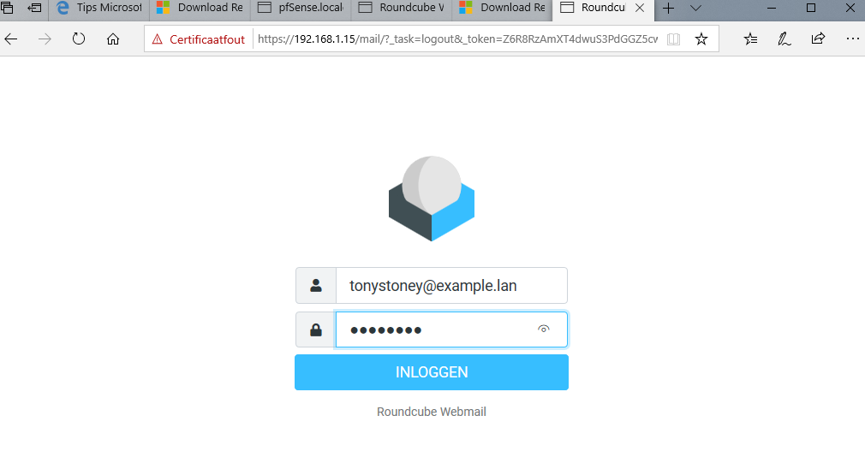

Part 5 2de AD DC installeren
Alvast de DNS Records maken
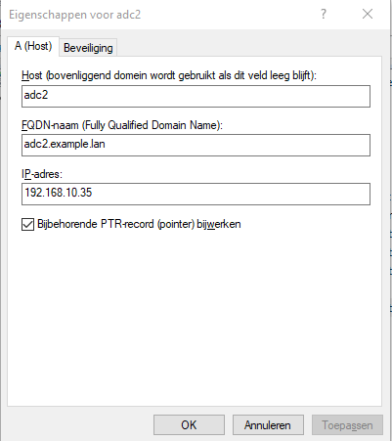
Reverse
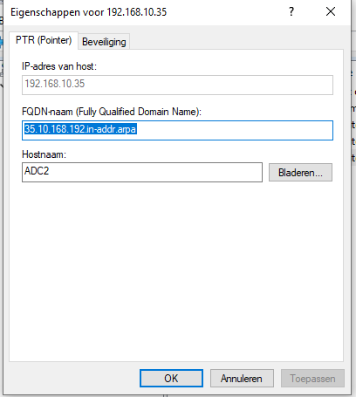
Sudo nano /etc/network/interfaces
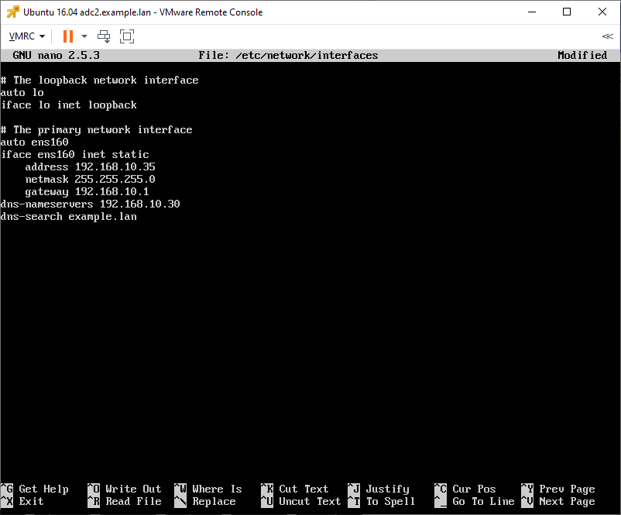
Cat /etc/resolv.conf
Sudo nano /etc/hosts
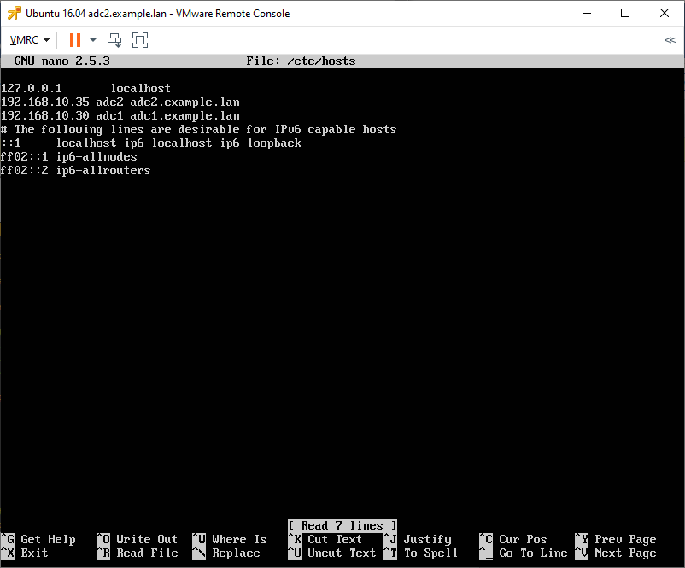
Sudo apt install ntpdate
Ntpdate adc1.example.lan
Sudo apt-get install samba krb5-user krb5-config winbind libpam-winbind libnss-winbind
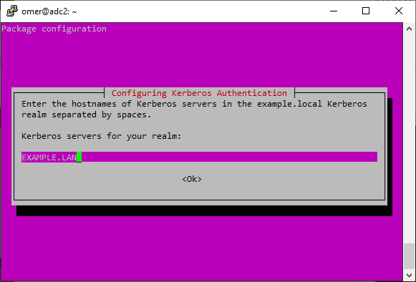
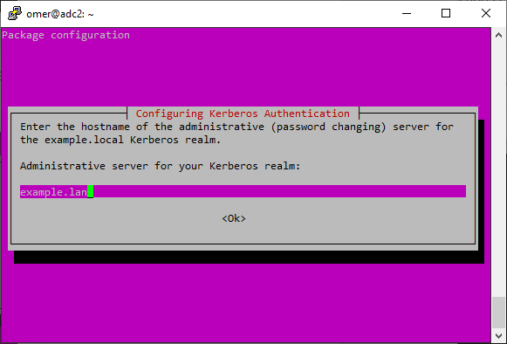
Kinit administrator@EXAMPLE.LAN
Klist
# sudo systemctl stop samba-ad-dc smbd nmbd winbind
# sudo mv /etc/samba/smb.conf /etc/samba/smb.conf.initial
Sudo samba-tool domain join example.lan DC -U "administrator"
samba-tool domain join example.lan DC -U"faa"
sudo nano /etc/samba/smb.conf
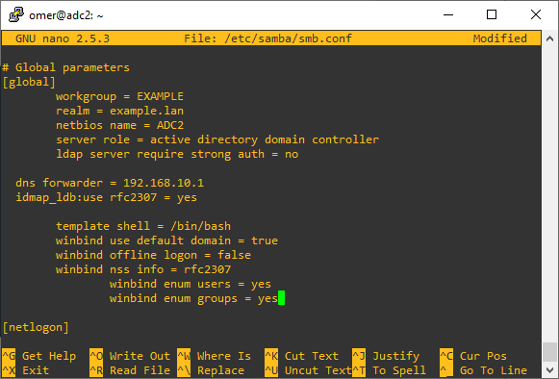
---------------------
Voeg zeker het volgende toe;
ldap server require strong auth = no
dns forwarder = 192.168.1.1
idmap_ldb:use rfc2307 = yes

template shell = /bin/bash
winbind use default domain = true
winbind offline logon = false
winbind nss info = rfc2307
winbind enum users = yes
winbind enum groups = yes
sudo systemctl restart samba-ad-dc
sudo samba-tool drs showrepl
# sudo mv /etc/krb5.conf /etc/krb5.conf.initial
# sudo ln -s /var/lib/samba/private/krb5.conf /etc/
# cat /etc/krb5.conf
Kinit administrator
Klist
Host example.lan
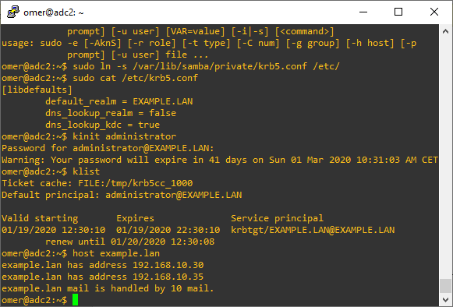
Het testen of het wel degelijk repliceert, maak je gewoon een nieuwe user aan via RSAT en zien of het ook op 2de DC te zien is
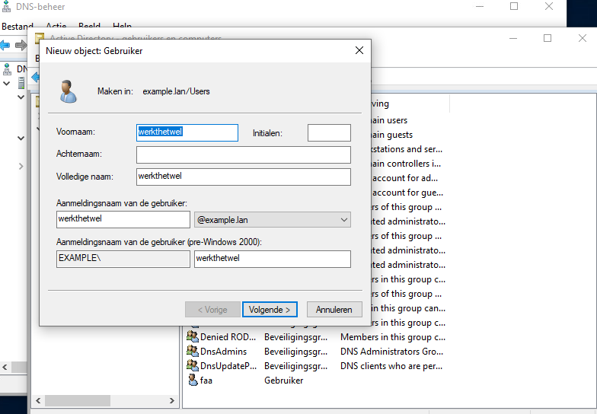
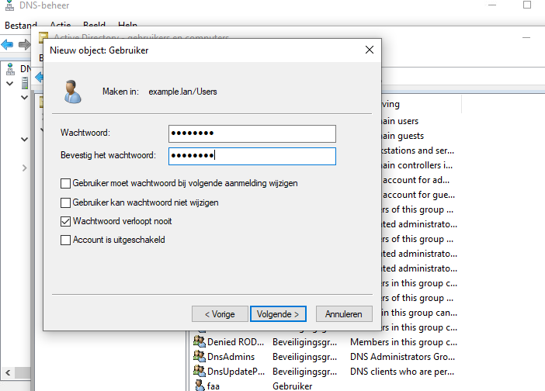

Nu eens ADC2 gaan en het volgende;
sudo samba-tool user list
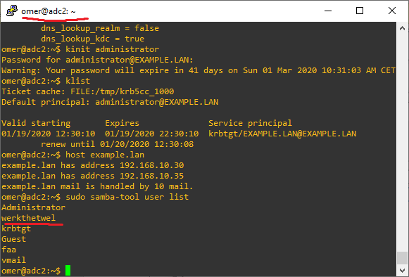

Part 7 verdere optimalisaties via SysVol Replication
Sudo apt install ntp
Nano /etc/ntp.conf
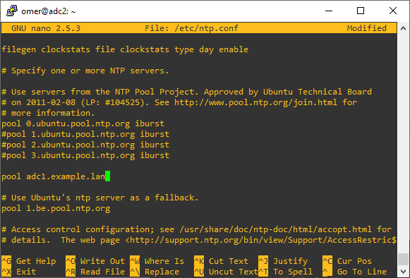
restrict source notrap nomodify noquery mssntp
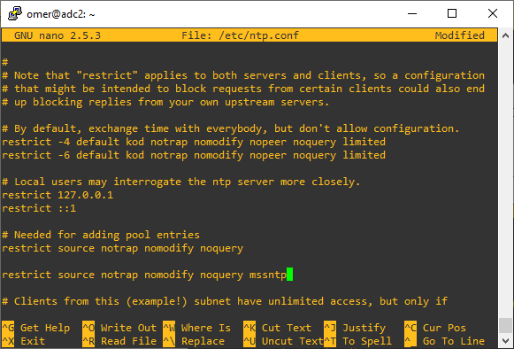
ntpsigndsocket /var/lib/samba/ntp_signd/
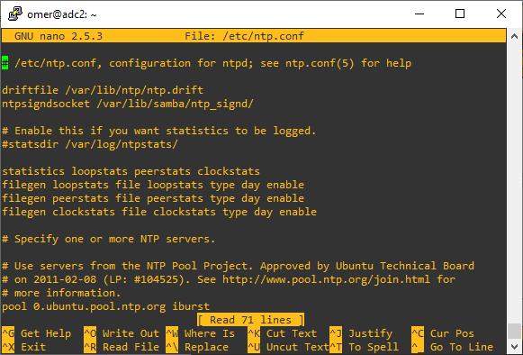
Sudo systemctl restart ntp
Sudo ntpq -p
Ga naar de 1ste DC voor mij is het ADC1
Omdat er standaard geen root passwoord is, moeten we eerst een root pass instellen zodanig dat we de root kunnen gebruiken voor SSH (die we nodig hebben om de key te kunnen transferen van ADC1 -> ADC2)
Sudo su
Passwd
<kies pass>
sudo nano /etc/ssh/sshd_config
PermitRootLogin yes
#StrictModes yes (doe er een comment ervoor)
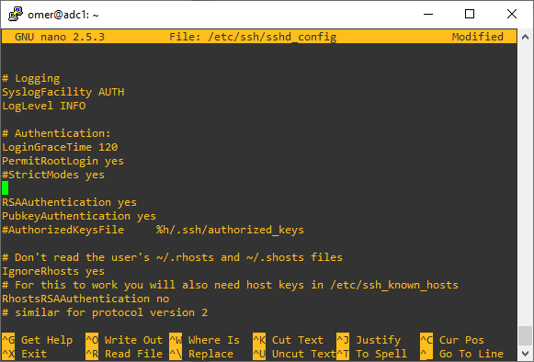
Sudo systemctl restart sshd
Ga naar de 2de DC voor mij is het ADC2
Sudo su
Passwd
<kies pass>
sudo nano /etc/ssh/sshd_config
PermitRootLogin yes
#StrictModes yes (doe er een comment ervoor)
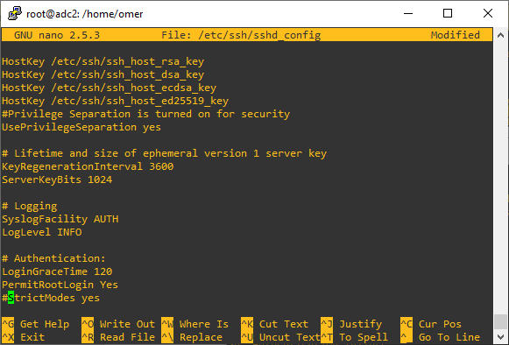
Sudo systemctl restart sshd
Ga terug naar de 1ste DC
Kijk of je kunt inloggen via SSH van ADC1 naar ADC2
Sudo ssh root@adc2
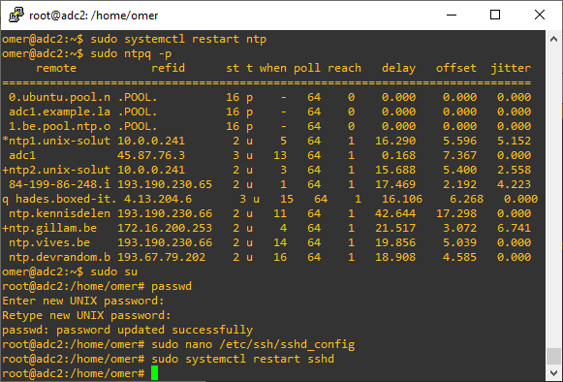
Exit
Nu de Key kopieren vanuit ADC1 naar ADC2
Sudo ssh-keygen -t RSA
///Geen Passphrase kiezen///
Sudo ssh-copy-id root@adc2
Sudo ssh root@adc2
Exit
rsync --dry-run -XAavz --chmod=775 --delete-after --progress --stats /var/lib/samba/sysvol/ root@adc2:/var/lib/samba/sysvol/
rsync -XAavz --chmod=775 --delete-after --progress --stats /var/lib/samba/sysvol/ root@adc2:/var/lib/samba/sysvol/
Op de 2de DC; ADC2
Sudo ls -lah /var/lib/samba/sysvol/your_domain/Policies
Op de 1ste DC; ADC1
export VISUAL=nano; crontab -e
Voeg het ergens toe, alles is al commented dus.
*/5 * * * * rsync -XAavz --chmod=775 --delete-after --progress --stats /var/lib/samba/sysvol/ root@adc2:/var/lib/samba/sysvol/ > /var/log/sysvol-replication.log 2>&1
# samba-tool ntacl sysvolcheck
# samba-tool ntacl sysvolreset

Part 8 Ubuntu Client Domein joining

Sudo hostnamectl set-hostname ubuntudesktopnaam
Verwijs DNS naar de DC’s en schakel automatisch DNS uit
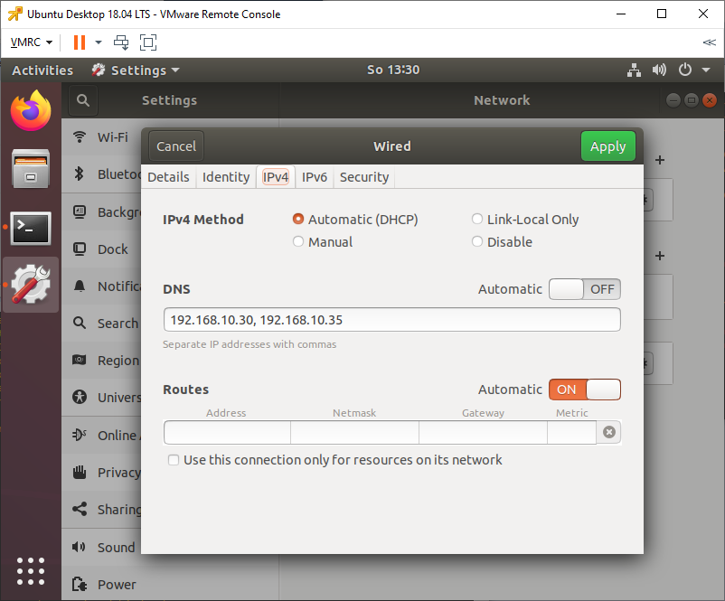
Zet Adapter uit en aan
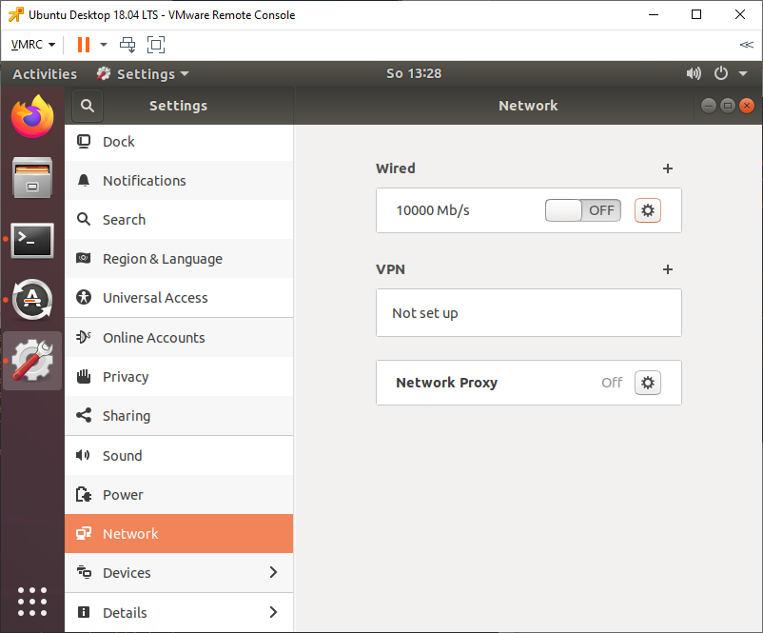
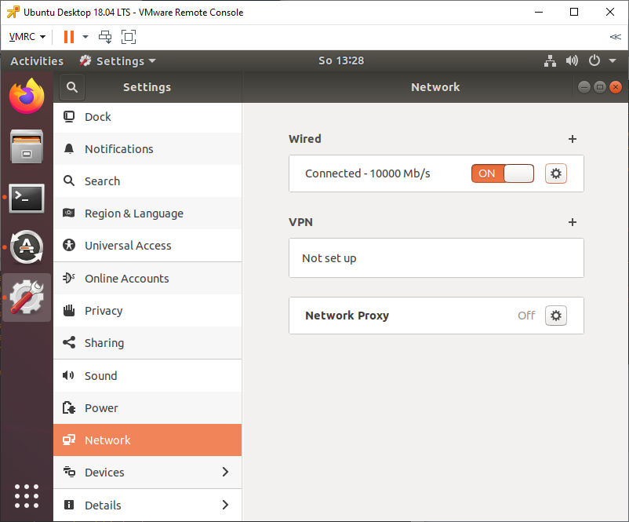
Desnoods reboot gewoon.
$ sudo apt-get install ntpdate
$ sudo ntpdate your_domain_name
$ sudo apt install adcli realmd krb5-user samba-common-bin samba-libs samba-dsdb-modules sssd sssd-tools libnss-sss libpam-sss packagekit policykit-1
sudo nano /etc/sssd/sssd.conf
[nss]
filter_groups = root
filter_users = root
reconnection_retries = 3

[pam]
reconnection_retries = 3

[sssd]
domains = example.lan
config_file_version = 2
services = nss, pam
default_domain_suffix = EXAMPLE.LAN

[domain/EXAMPLE.lan]
ad_domain = example.lan
krb5_realm = EXAMPLE.LAN
realmd_tags = manages-system joined-with-samba
cache_credentials = True
id_provider = ad
krb5_store_password_if_offline = True
default_shell = /bin/bash
ldap_id_mapping = True
use_fully_qualified_names = True
fallback_homedir = /home/%d/%u
access_provider = ad

auth_provider = ad
chpass_provider = ad
access_provider = ad
ldap_schema = ad
dyndns_update = true
dyndns_refresh_interval = 43200
dyndns_update_ptr = true
dyndns_ttl = 3600
sudo chmod 700 /etc/sssd/sssd.conf
sudo nano /etc/realmd.conf

[active-directory]
os-name = Linux Ubuntu
os-version = 18.04

[service]
automatic-install = yes

[users]
default-home = /home/%d/%u
default-shell = /bin/bash

[example.lan]
user-principal = yes
fully-qualified-names = no
sudo nano etc/samba/smb.conf
workgroup = EXAMPLE
client signing = yes
client use spnego = yes
kerberos method = secrets and keytab
realm = EXAMPLE.LAN
security = ads
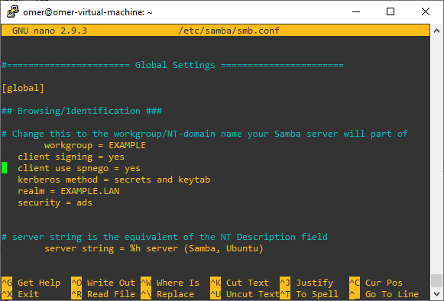
Sudo testparm
Sudo kinit administrator@EXAMPLE.LAN
Sudo Klist
$ sudo realm discover -v EXAMPLE.LAN
$ sudo realm list
$ sudo realm join EXAMPLE.LAN -U administrator -v
$ sudo net ads join -k
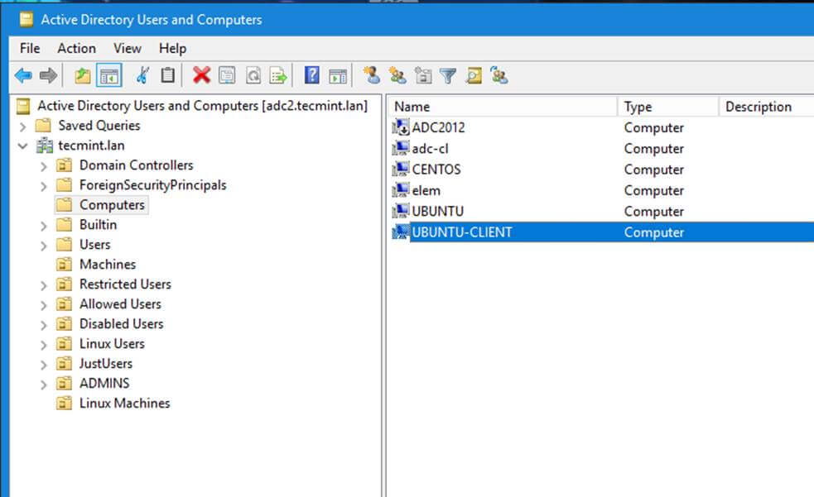
Sudo pam-auth-update
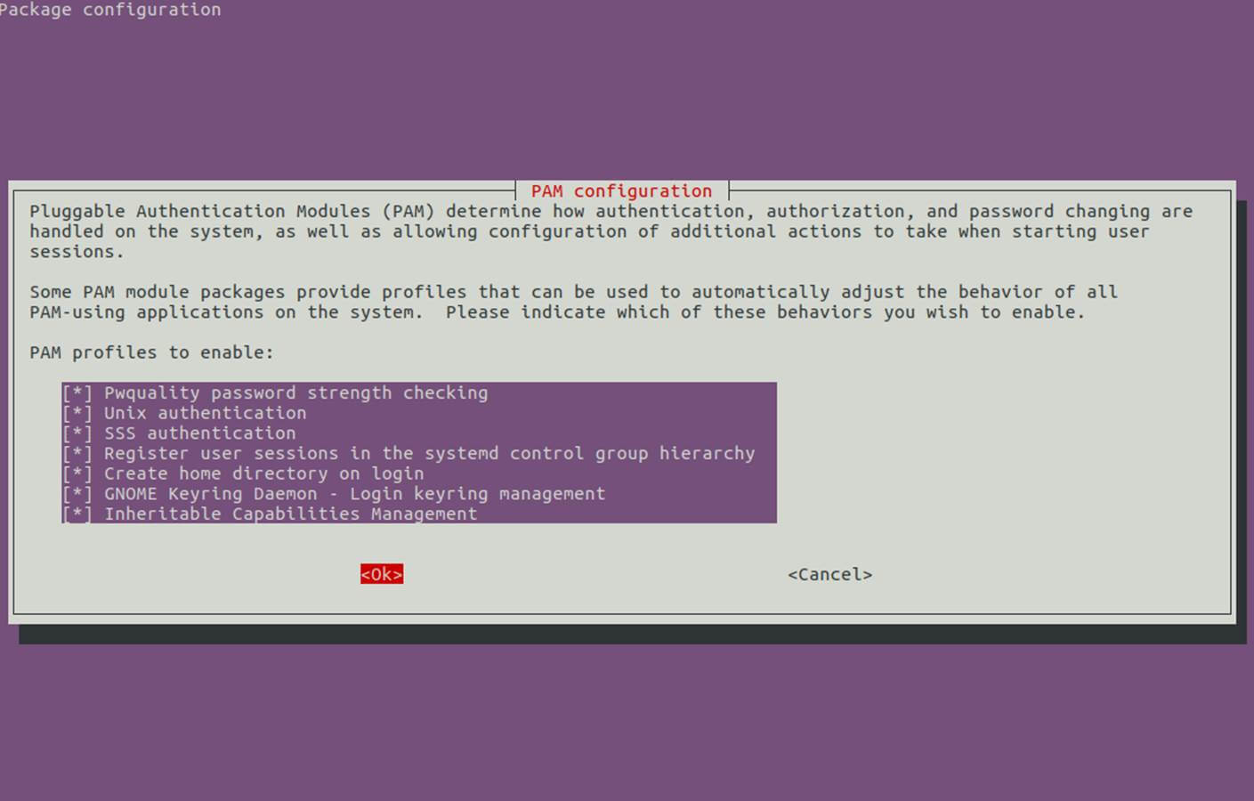
Scroll na onder als je ze niet allemaal ziet met de pijltjes
Sudo nano /etc/pam.d/common-account
VOEG TOE:
session required pam_mkhomedir.so skel=/etc/skel/ umask=0022
sudo nano /etc/pam.d/common-password

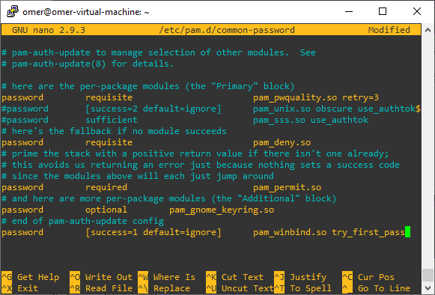
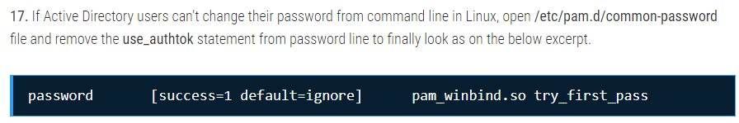
Gewoon toevoegen en nergens anders aankomen in /etc/pam.d/common-password
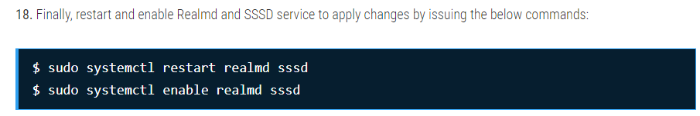
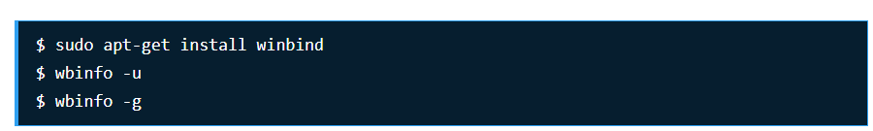
Su – faa
Exit

Sudo nano /etc/pam.d/common-session
session required pam_unix.so
session optional pam_winbind.so
session optional pam_sss.so
session optional pam_systemd.so
session required pam_mkhomedir.so skel=/etc/skel/ umask=0077

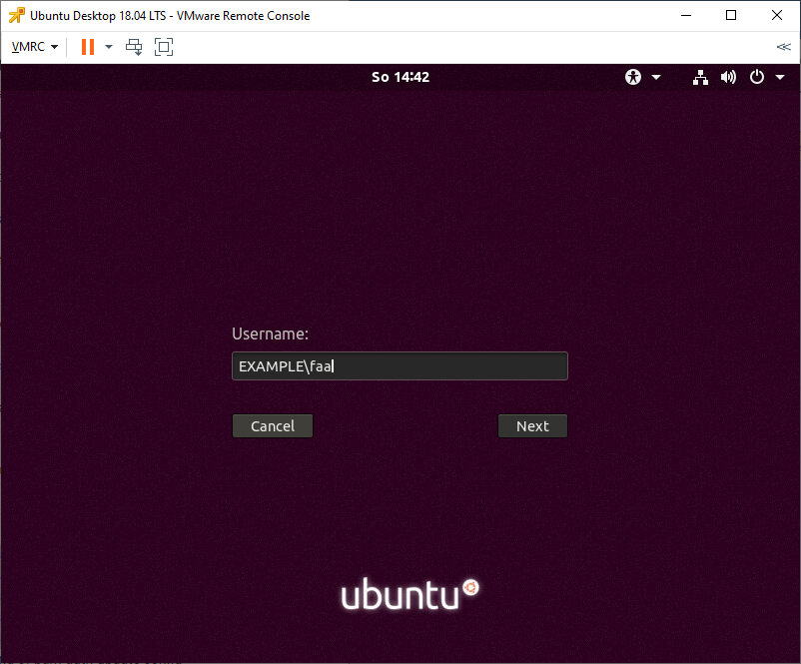
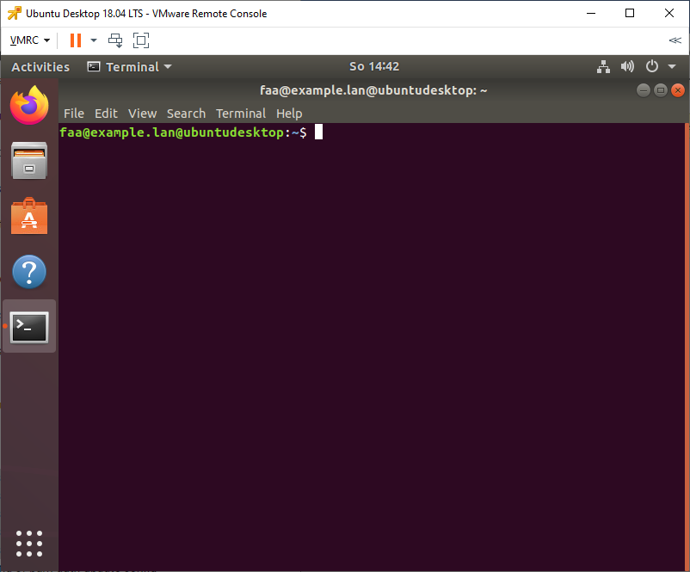

Part 8 Mapped network drive

# sudo mkdir /nas
# sudo chmod -R 775 /nas
# sudo chown -R root:"domain users" /nas
# sudo ls -lah | grep nas
Sudo nano /etc/samba/smb.conf

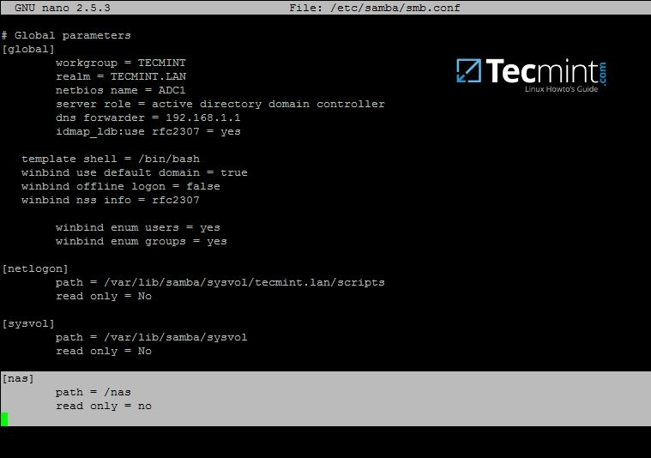
Sudo systemctl restart samba-ad-dc.service
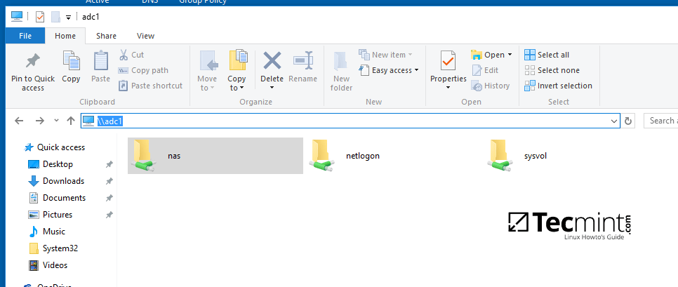
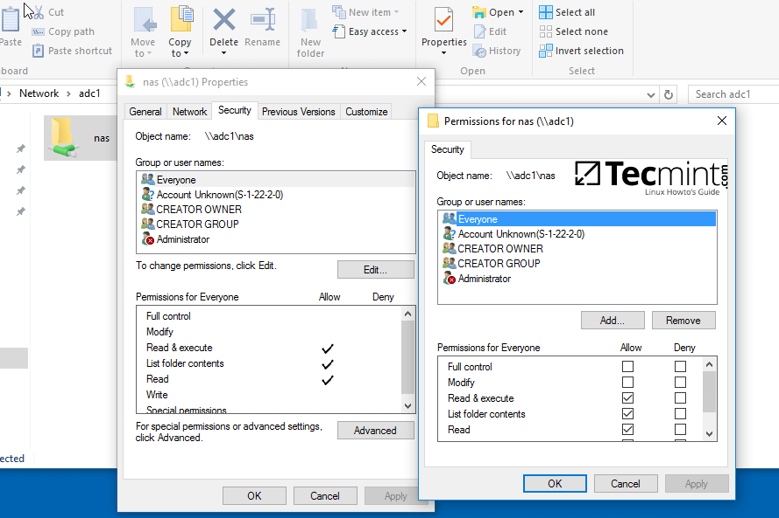
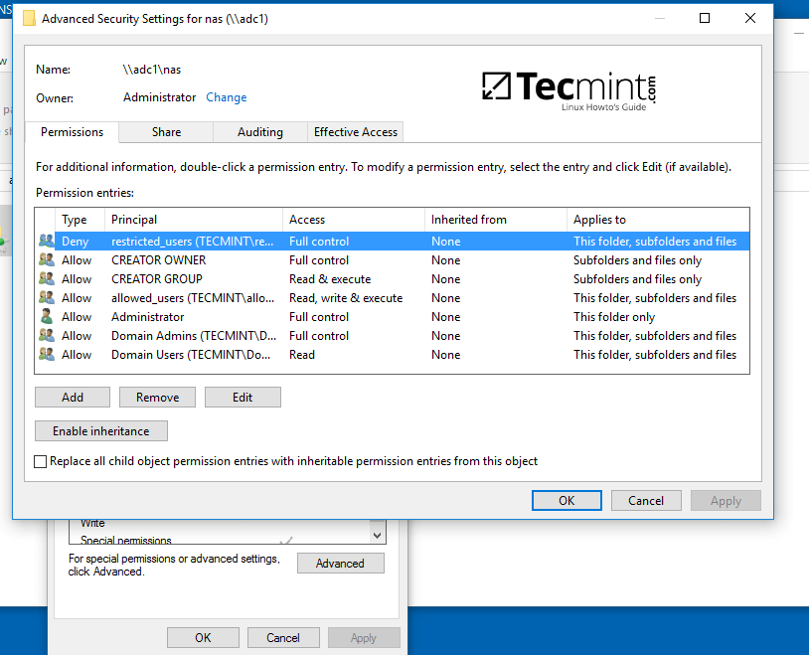
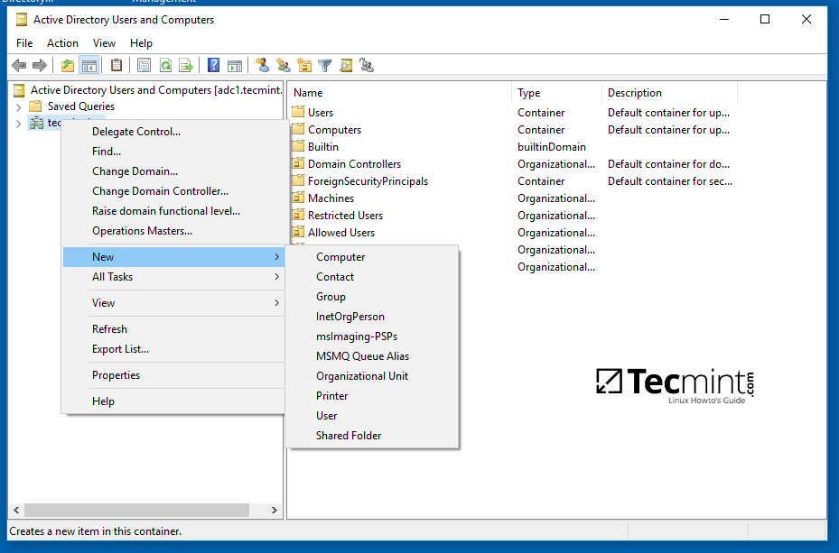
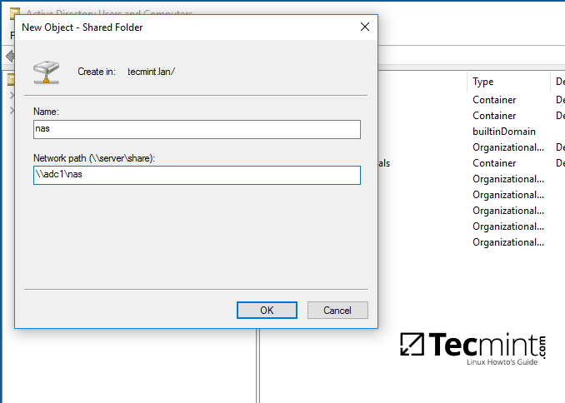
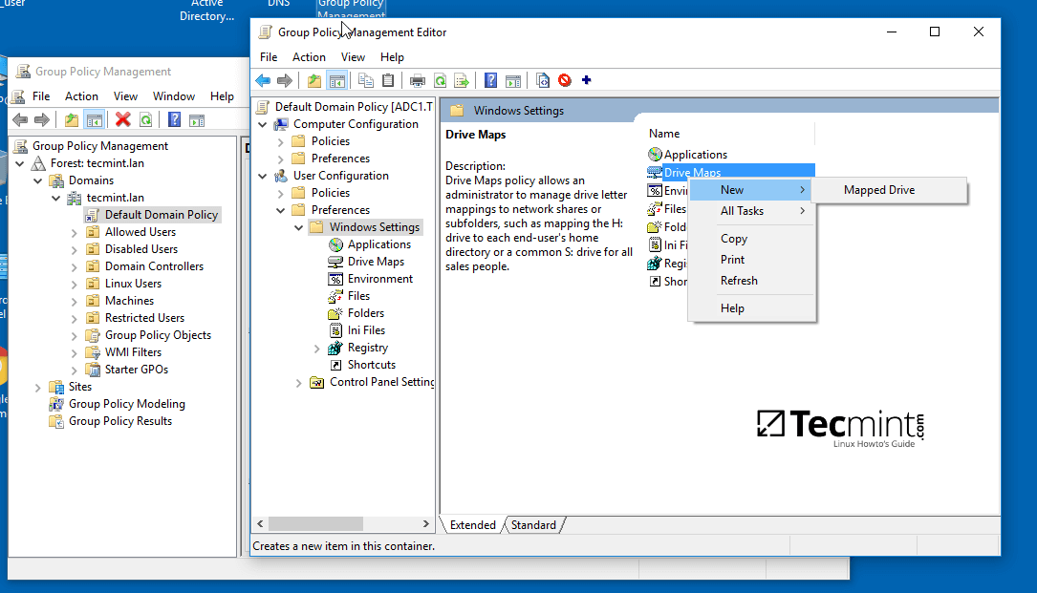
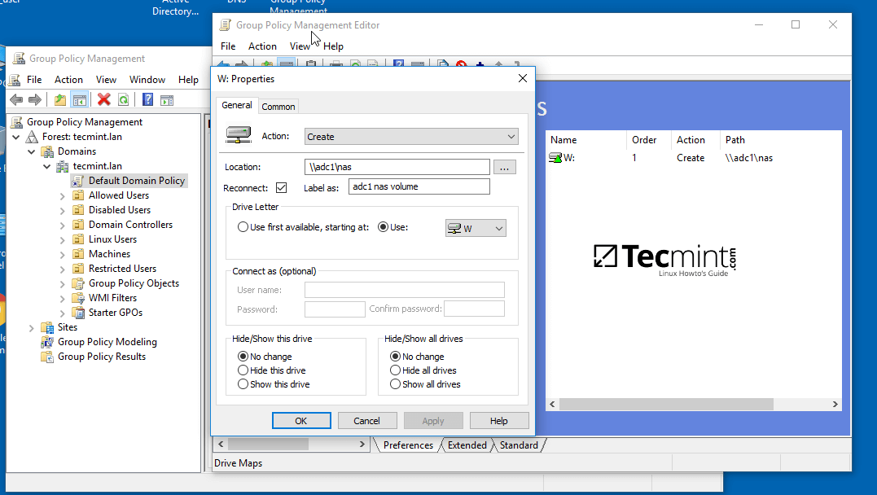
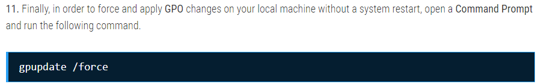
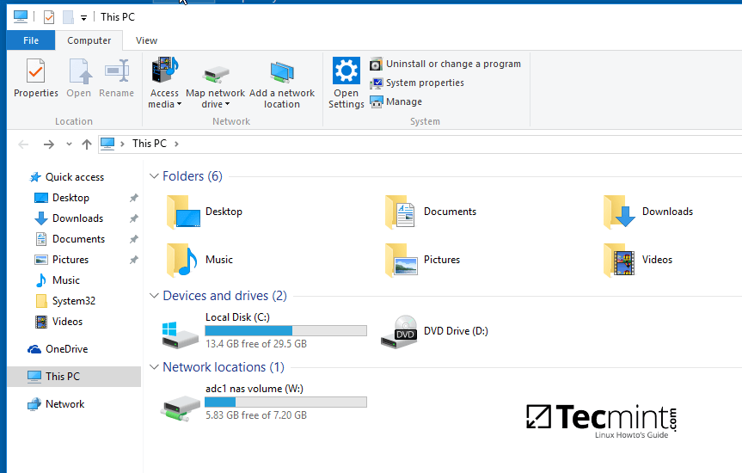

Toegang krijgen op Linux clients

Sudo apt install smbclient cifs-utils
Smbclient -L \adc1 -U%
Sudo smbclient //adc1/nas -U faa
Sudo mount //adc1/nas /mnt -o username=faa
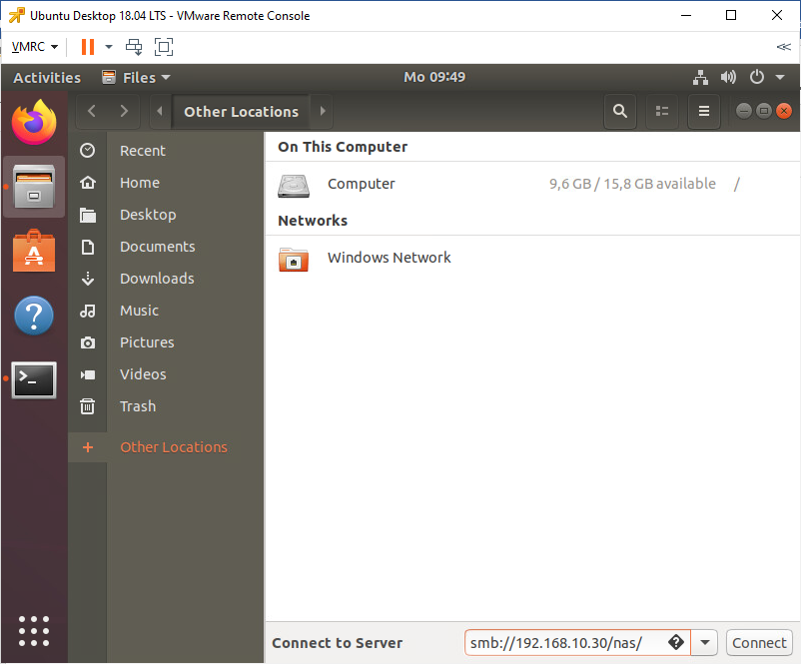
Inloggen met administrator

sFTP Server lid maken van AD

sudo nano hostnamectl set-hostname sftp
sudo nano /etc/network/interfaces
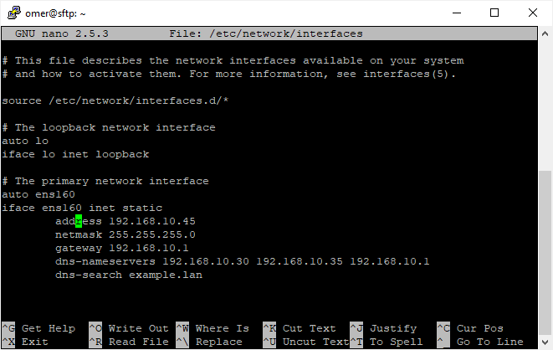
Sudo systemctl restart networking.service
Sudo apt install ntpdate
Sudo ntpdate examplsudo apt-get install samba krb5-config krb5-user winbind libpam-winbind libnss-winbinde.lan
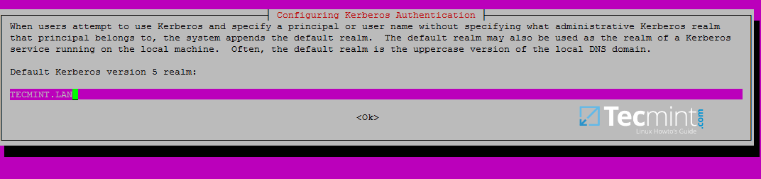
Kinit administrator@EXAMPLE.LAN
Klist
Sudo mv /etc/samba/smb.conf /etc/samba/smb.conf.initial
Sudo nano /etc/samba/smb.conf
[global]
workgroup = EXAMPLE
realm = EXAMPLE.LAN
netbios name = ubuntu
security = ADS
dns forwarder = 192.168.10.1
ldap server require strong auth = no

idmap config * : backend = tdb
idmap config *:range = 50000-1000000

template homedir = /home/%D/%U
template shell = /bin/bash
winbind use default domain = true
winbind offline logon = false
winbind nss info = rfc2307
winbind enum users = yes
winbind enum groups = yes
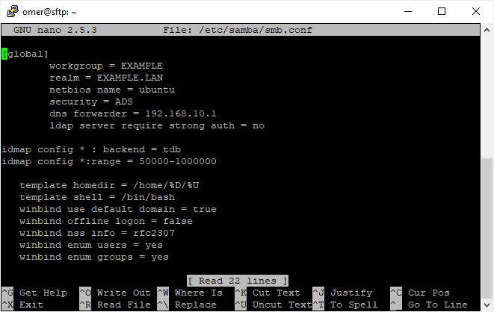
s
$ sudo systemctl restart smbd nmbd winbind
$ sudo systemctl stop samba-ad-dc
$ sudo systemctl enable smbd nmbd winbind
Sudo net ads join -U administrator
Sudo nano /etc/nsswitch.conf
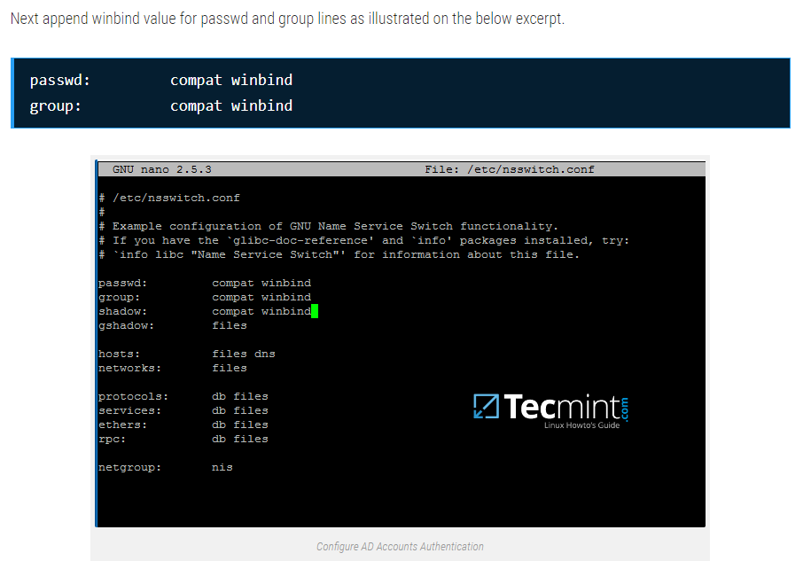
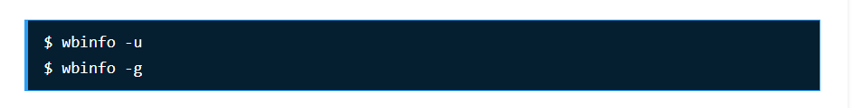
Sudo pam-auth-update
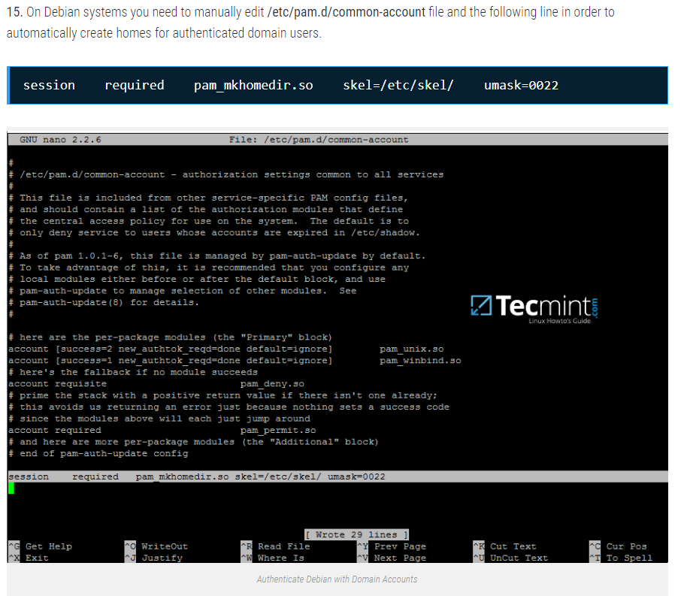
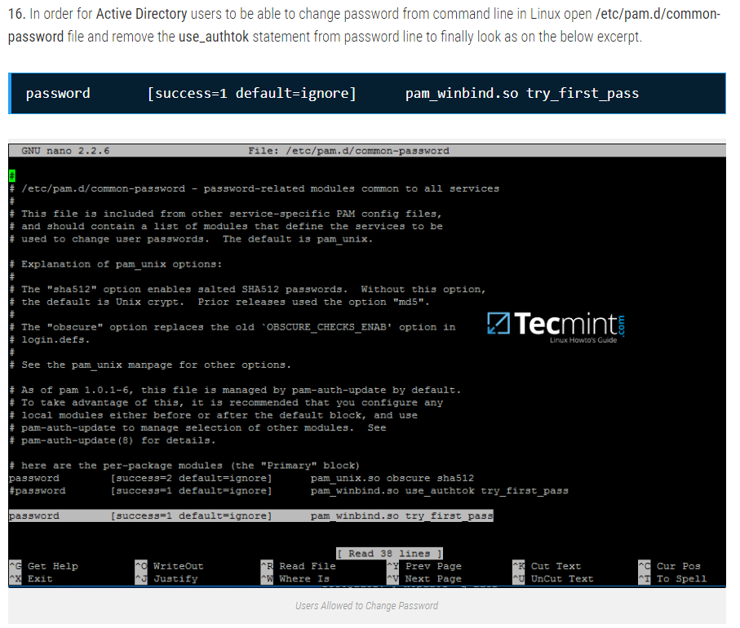

Part 9 SFTP installeren
Sudo useradd faaftp
Sudo mkdir -p /var/sftp/uploads
Sudo chown root:root /var/sftp
Sudo chmod 755 /var/sftp
Sudo chown faaftp:faaftp /var/sftp/uploads
Sudo nano /etc/ssh/sshd_config
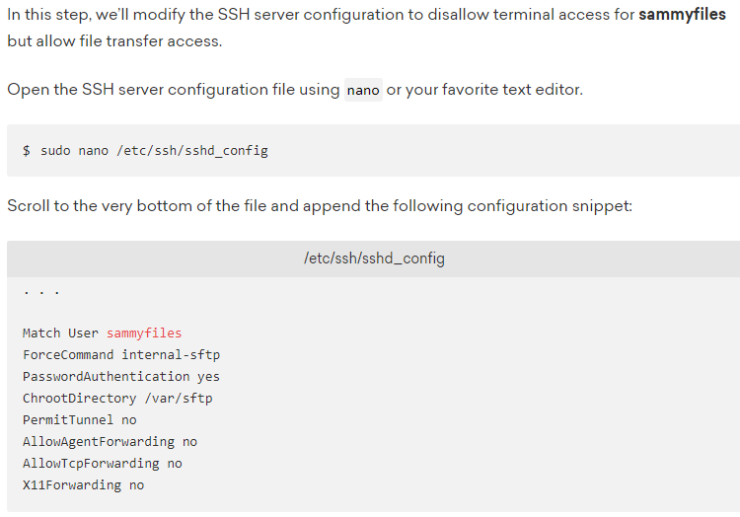
Ssh faaftp@localhost
Zou niet moeten werken, omdat de user ‘faaftp’ alleen maar kan inloggen via sftp
Sftp faaftp@localhost

