**Figure 1. Accelerated Failure Time model for survival of Dutch dairy cows**

**Factors ± Survival time Time Ratios ∀**

**(weeks and days) (with 95% CI)**

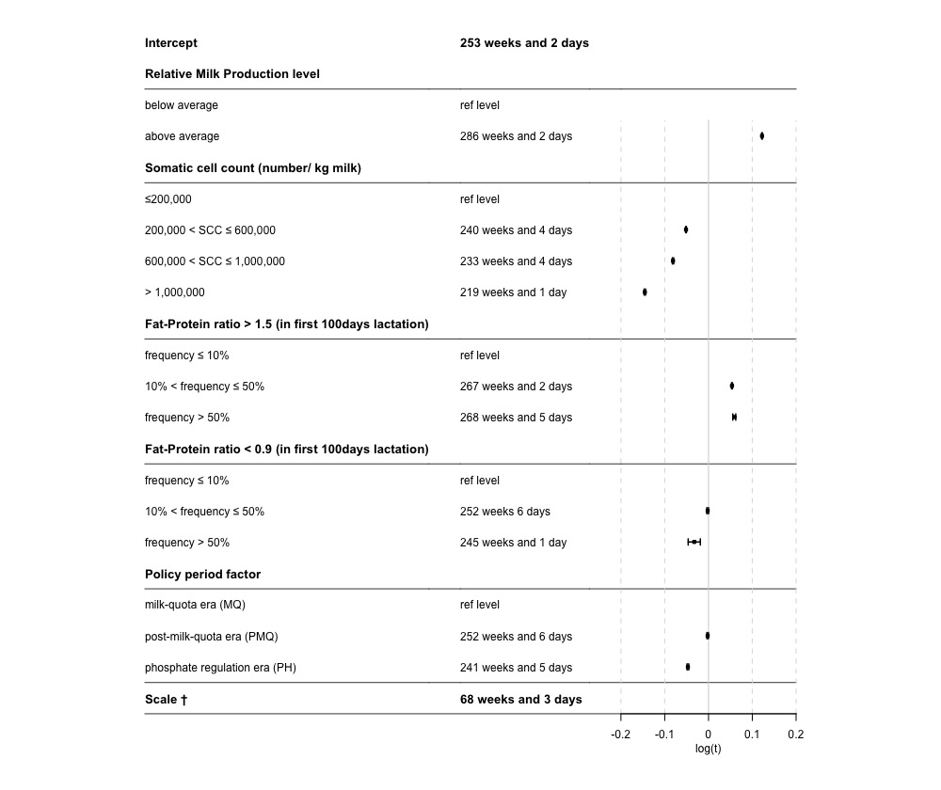

± Corrected for Parity and rolling average of Inseminations. Note: Interaction effects not displayed in the figure

**∀**Time ratios are on log scale. elog(t) = time to event in weeks.

**†** Scale is the scale parameter/ Std Deviation of underlying log-normal distribution