**PHASE-4**

**AIR QUALITY MONITORING USING IoT**

**Introduction**

Air pollution poses a significant threat to public health and the environment worldwide. It is caused by various factors, including industrial emissions, vehicular exhaust, and natural sources. To address this critical issue, IoT-based air quality management has emerged as a powerful solution.

1)An IoT-based air quality monitoring system is an ideal solution that can provide real-time data and insights about the air quality in a particular area.

2)The quality of the air we breathe is a critical factor in our overall well being and the health of our planet. Poor air quality can have detrimental effect on health, ecosystem, and even economic productivity. With the rise of urbanization and industrialization, monitoring and managing air quality have become increasingly important.

3)traditional air quality monitoring systems often consist of stationary monitoring stations that provide periodic data at limited locations. These system have limitations in term of spatial coverage and real time data availability. This is where IoT based air quality monitoring comes under play.

**Objective:**

Real-time data collection.

Data accuracy and precision.

Data accessibility.

Alerting and warnings.

Historical data storage.

Geospatial mapping.

Integration with weather data.

Promoting environmental compliance.

Educating the public.

Supporting research and collaboration.

Cost-efficiency and scalability.

Energy-efficient solutions.

Data security and interoperability.

Public engagement.

**Components Required**

ESP32

Nova PM Sensor SDS011

0.96’ SPI OLED Display Module

DHT11 Sensor

MQ-7 Sensor

Jumper Wires

**Sensors**

**Nova PM Sensor SDS011**

The SDS011 Sensor is a very recent Air Quality Sensor developed by Nova Fitness. It works on the principle of laser scattering and can get the particle concentration between 0.3 to 10μm in the air. This sensor consists of a small fan, air inlet valve, Laser diode, and photodiode. The air enters through the air inlet where a light source (Laser) illuminates the particles and the scattered light is transformed into a signal by a photodetector. These signals are then amplified and processed to get the particle concentration of PM2.5 and PM10. We previously used Nova PM Sensor with Arduino to calculate the concentration of PM10 & PM2.5.

SDS011 Sensor Specifications:

Output: PM2.5, PM10

Measuring Range: 0.0-999.9μg/m3

Input Voltage: 4.7V to 5.3V

Maximum Current: 100mA

Sleep Current: 2mA

Response Time: 1 second

Serial Data Output Frequency: 1 time/second

Particle Diameter Resolution:≤0.3μm

Relative Error: 10%

Temperature Range: -20~50°C

**0.96’ OLED Display Module**

OLED (Organic Light Emitting Diode) is a kind of Light Emitting Diode that is made using organic compounds that excites when the electric current is allowed to flow through them. These organic compounds have their own light hence they don’t require any backlight circuitry like normal LCDs. Because of this reason, OLED display technology is power efficient and widely used in Televisions and other display products.

**Air Quality Index Calculation**

The AQI in India is calculated based on the average concentration of a particular pollutant measured over a standard time interval (24 hours for most pollutants, 8 hours for carbon monoxide and ozone). For example, the AQI for PM2.5 and PM10 is based on 24-hour average concentration and AQI for Carbon Monoxide is based on 8-hour average concentration). The AQI calculations include the eight pollutants that are PM10, PM2.5, Nitrogen Dioxide (NO2), Sulphur Dioxide (SO2), Carbon Monoxide (CO), ground-level ozone (O3), Ammonia (NH3), and Lead (Pb). However, all of the pollutants are not measured at every location.

Based on the measured 24-hour ambient concentrations of a pollutant, a sub-index is calculated, which is a linear function of concentration (e.g. the sub-index for PM2.5 will be 51 at concentration 31 µg/m3, 100 at concentration 60 µg/m3, and 75 at a concentration of 45 µg/m3). The worst sub-index (or maximum of all parameters) determines the overall AQI.

**Circuit Diagram**

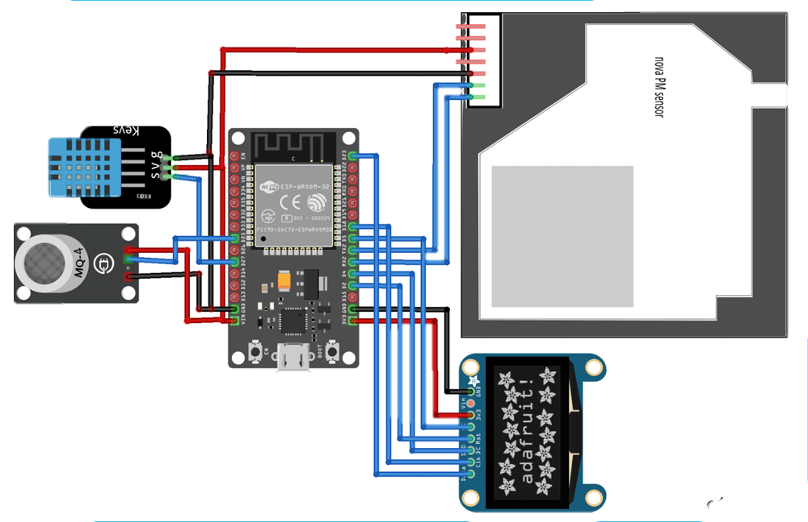

CODE:

import machine

import time

import dht

import urequests

from umqtt.simple import MQTTClient

from machine import I2C, Pin

from machine import ADC, SPI

# DHT11 sensor

dht_pin = Pin(14, Pin.IN, Pin.PULL_UP) # DHT11 sensor pin

dht_sensor = dht.DHT11(dht_pin)

# MQ7 sensor

mq_pin = Pin(33, Pin.IN) # MQ7 sensor analog pin

# Nova SDS011 sensor

uart = machine.UART(1, tx=17, rx=16, baudrate=9600, txbuf=256)

uart.init(9600, bits=8, parity=None, stop=1)

# OLED display

i2c = I2C(scl=Pin(22), sda=Pin(21))

oled = ssd1306.SSD1306_I2C(128, 64, i2c)

# MQTT configuration

mqtt_server = "mqtt.eclipse.org"

mqtt_topic = "your_topic" # Replace with your MQTT topic

mqtt_client_id = "esp32_air_quality_monitor"

mqtt_client = MQTTClient(mqtt_client_id, mqtt_server)

def read_dht():

dht_sensor.measure()

temperature = dht_sensor.temperature()

humidity = dht_sensor.humidity()

return temperature, humidity

def read_mq():

mq_value = ADC(mq_pin).read()

return mq_value

def read_sds011():

data = uart.read(10)

if data[0] == 0xAA and data[1] == 0xC0:

pm25 = (data[3] * 256 + data[2]) / 10.0

pm10 = (data[5] * 256 + data[4]) / 10.0

return pm25, pm10

return None

def send_data_to_mqtt(temperature, humidity, mq_value, pm25, pm10):

data = {

"temperature": temperature,

"humidity": humidity,

"mq_value": mq_value,

"pm25": pm25,

"pm10": pm10

}

mqtt_payload = ujson.dumps(data)

mqtt_client.connect()

mqtt_client.publish(mqtt_topic, mqtt_payload)

mqtt_client.disconnect()

def display_data_on_oled(temperature, humidity, mq_value, pm25, pm10):

oled.fill(0)

oled.text("Temp: {:.1f} C".format(temperature), 0, 0)

oled.text("Humidity: {:.1f}%".format(humidity), 0, 12)

oled.text("MQ Value: {}".format(mq_value), 0, 24)

oled.text("PM2.5: {:.1f}".format(pm25), 0, 36)

oled.text("PM10: {:.1f}".format(pm10), 0, 48)

oled.show()

while True:

try:

temperature, humidity = read_dht()

mq_value = read_mq()

pm25, pm10 = read_sds011()

if pm25 is not None and pm10 is not None:

send_data_to_mqtt(temperature, humidity, mq_value, pm25, pm10)

display_data_on_oled(temperature, humidity, mq_value, pm25, pm10)

time.sleep(60) # Adjust the delay as needed

except Exception as e:

print("An error occurred:", e)

time.sleep(10)

WEB PLATFORM EXECUTION:

Adafruit IO Setup

Adafruit IO is an open data platform that allows you to aggregate, visualize, and analyze live data on the cloud. Using Adafruit IO, you can upload, display, and monitor your data over the internet, and make your project IoT enabled. You can control motors, read sensor data, and make cool IoT applications over the internet using Adafruit IO.

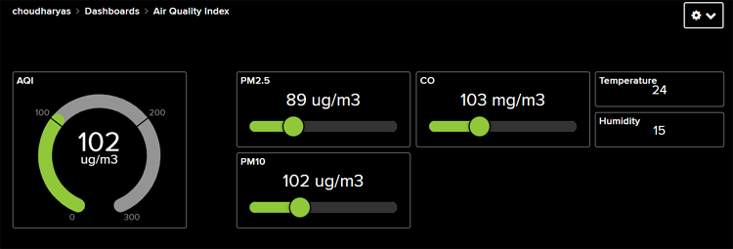

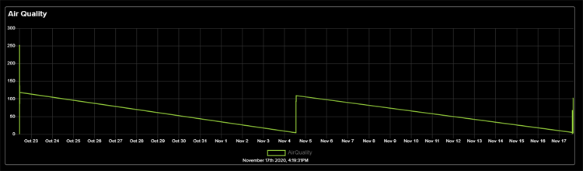

APPLICATION:

1)Monitor air in urban areas to ensure it is safe to breathe.

2)Detect haramful substance like CO2, Green house gases and volatile organic compounds.

3)inform farmers about best time of plant or harvest based on air quality.

CONCLUSION:

In conclusion, IoT-based air quality management is a promising approach to combat air pollution. By leveraging sensors, data analytics, and connectivity, it offers real-time monitoring, data-driven decision-making, and improved public health. However, challenges such as data accuracy, privacy, and security must be addressed for its widespread adoption. With ongoing technological advancements, IoT is poised to play a crucial role in creating a cleaner and healthier environment for future generations.