**PHASE-5**

**AIR QUALITY MONITORING USING IoT**

**Introduction**

Air pollution poses a significant threat to public health and the environment worldwide. It is caused by various factors, including industrial emissions, vehicular exhaust, and natural sources. To address this critical issue, IoT-based air quality management has emerged as a powerful solution.

1)An IoT-based air quality monitoring system is an ideal solution that can provide real-time data and insights about the air quality in a particular area.

2)The quality of the air we breathe is a critical factor in our overall well being and the health of our planet. Poor air quality can have detrimental effect on health, ecosystem, and even economic productivity. With the rise of urbanization and industrialization, monitoring and managing air quality have become increasingly important.

3)traditional air quality monitoring systems often consist of stationary monitoring stations that provide periodic data at limited locations. These system have limitations in term of spatial coverage and real time data availability. This is where IoT based air quality monitoring comes under play.

**Objective:**

* Real-time data collection.
* Data accuracy and precision.
* Data accessibility.
* Alerting and warnings.
* Historical data storage.
* Geospatial mapping.
* Integration with weather data.
* Promoting environmental compliance.
* Educating the public.
* Supporting research and collaboration.
* Cost-efficiency and scalability.
* Energy-efficient solutions.
* Data security and interoperability.
* Public engagement.

**IOT SENSOR WORK:**

1)GAS SENSORS: these sensors detects specific gases like carbon dioxide (CO2), carbon monoxide (CO), nitrogen dioxide (NO2), sulphur dioxide (SO2), ozone(O3), and volatile organic compounds (VOCs).

2)Particulate matter sensors: It measures the concentration of airborne particles.

3)environmental sensors: in addition to pollutants these sensors measure environmental parameters such as temperature, humidity, atmospheric pressure, and GPS coordinates.

**DATA COLLECTION:**

1)IoT sensors continuously collect data from their surroundings. they may use various detection principles, including optical, electrochemical and laser based methods depending on the pollutant being measured.

**WIRELESS CONNECTIVITY:**

1)IoT sensors are equipped with wireless communication modules to transmit data to a central server or cloud platform.

**POWER EFFICIENCY:**

1)IoT based air quality sensors are designed to be low power devices enabling long term deployment without frequent battery replacements.

**LOCATION BASED MONITORING:**

1)sensors are often deployed at strategic location including urban areas, traffic intersections, industrial zones and residential area to capture variation in air quality.

**DATA INTEGRATION:**

1)the collected data is integrated into a centralized database allowing for easy access , storage , and analysis.

**REAL TIME MONITORING:**

**1)**IoT sensors provide real time data enabling immediate response to air quality fluctuations or pollution events.

**REMOTE MANAGEMENT:**

1)these sensors can be remotely configured and managed, reducing the need for physical maintenance

**DATA ANALITICS:**

1)Data from IoT based sensor can be analyzed to identify trends correlations and patterns supporting informed decision making and policy development .

**PUBLIC ACCESS:**

1)some air quality monitoring networks offer public access to real time data through web portals or mobile app , fostering transperancy and community awareness.

**ALERTS AND NOTIFICATIONS:**

1)when air quality reaches predefined thresholds or deteriorates significantly IoT based system can send alert and notifications to relevant authorities or the public.

**SCALABILITY:**

1)IoT based air quality monitoring networks can easily scale by adding more sensors to cover large geographical areas.

**FLOW CHART:**

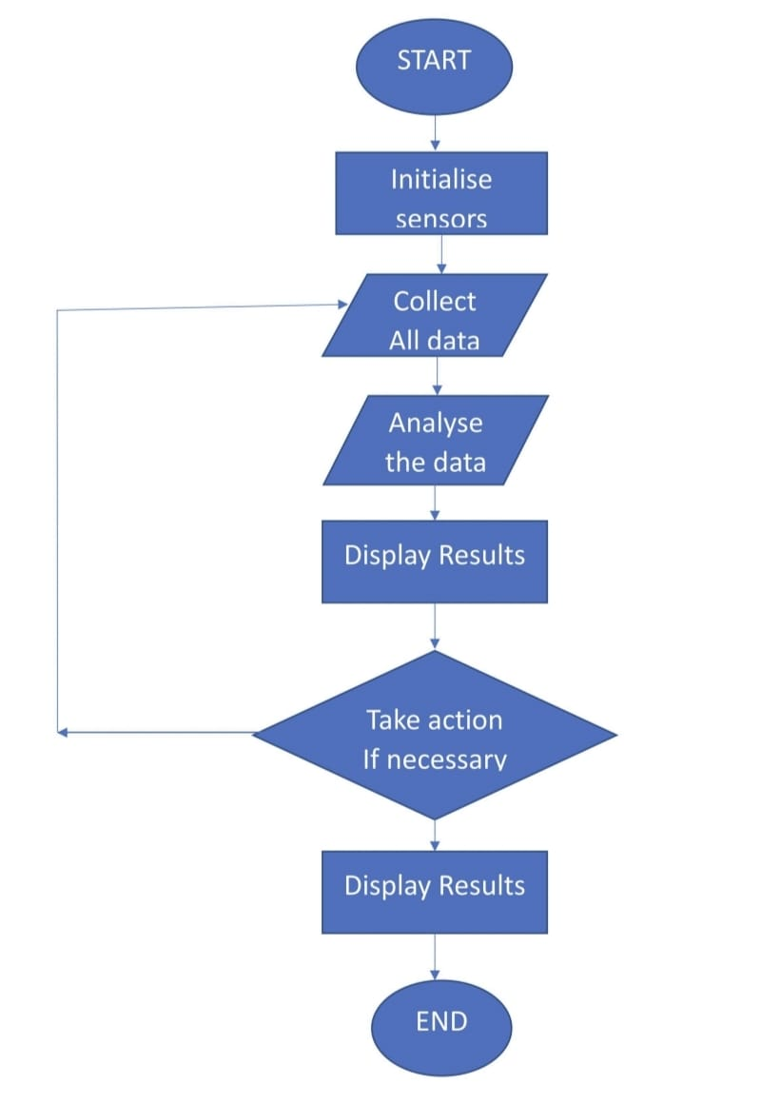

**STEPS FOR FLOWCHART:**

STEP 1: Start the program.

STEP2:Turn on the Gas ,Temperature and Humidity sensors.

STEP3:Collect the data:

1)Read gas concentration.

2)Measure temperature and humidity level.

STEP4: Analyse the data:

1)Check if gas concentration is within safe limits.

2)Check if temperature and humidity is within comfort range.

STEP5:Display results

1) Show gas concentration on display

2) Show temperature value on display.

3) Show humidity percentage.

STEP6:Take action (if necessary) :

1)If gas concentration is high , activate alarm or ventilation.

2)if temperature is too high or low ,adjust heating or cooling system.

3)if humidity is too high or low , activate dehumidifier or humidifier .

STEP7: wait for a set time.

STEP8:Repeat 3-7 continuously.

STEP9:END the program.

**BLOCK DIAGRAM:**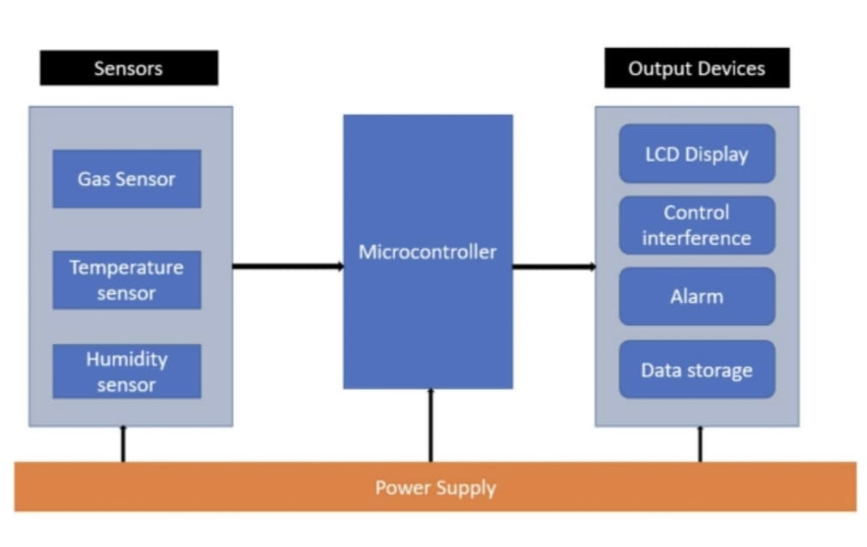

**BLOCK DIAGRAM DESCRIPTION:**

1)Microcontroller/Main Processing Unit:

This is the brain of the system , collecting data from sensors and process it and managing output actions and displays.

2)sensors:

Gas sensor: Connects to the microcontroller and detects specific gases.

Temperature Sensor: Connects to the microcontroller to measure temperature.

Humidity Sensor: connects to the microcontroller to measure humidity.

3)Communication Interface:

Enables the microcontroller to communicate with external devices or a computer . This can be Wi-Fi , Bluetooth, or wired connections like USB or Ethernet.

4)Display :

Shows real time data readings, alerts or system status.

5)Alarm/Notification system:

This can be an audible alarm , LED indicator ,or any other signaling device that alerts the user when air quality goes outside the desired range.

6)Power supply:

Provides power to the entire system . this could be batteries , solar panels , or a direct power source.

7)Data storage:

Where the data can be logged for historical analysis . This could be an SD card ,onboard memory or cloud storage.

8)Control Buttons/interface:

Allows the user to interact with the system , set threshold ,or view historical data.

**Components Required**

ESP32

Nova PM Sensor SDS011

0.96’ SPI OLED Display Module

DHT11 Sensor

MQ-7 Sensor

Jumper Wires

**Sensors**

**Nova PM Sensor SDS011**

The SDS011 Sensor is a very recent Air Quality Sensor developed by Nova Fitness. It works on the principle of laser scattering and can get the particle concentration between 0.3 to 10μm in the air. This sensor consists of a small fan, air inlet valve, Laser diode, and photodiode. The air enters through the air inlet where a light source (Laser) illuminates the particles and the scattered light is transformed into a signal by a photodetector. These signals are then amplified and processed to get the particle concentration of PM2.5 and PM10. We previously used Nova PM Sensor with Arduino to calculate the concentration of PM10 & PM2.5.

SDS011 Sensor Specifications:

Output: PM2.5, PM10

Measuring Range: 0.0-999.9μg/m3

Input Voltage: 4.7V to 5.3V

Maximum Current: 100mA

Sleep Current: 2mA

Response Time: 1 second

Serial Data Output Frequency: 1 time/second

Particle Diameter Resolution:≤0.3μm

Relative Error: 10%

Temperature Range: -20~50°C

**0.96’ OLED Display Module**

OLED (Organic Light Emitting Diode) is a kind of Light Emitting Diode that is made using organic compounds that excites when the electric current is allowed to flow through them. These organic compounds have their own light hence they don’t require any backlight circuitry like normal LCDs. Because of this reason, OLED display technology is power efficient and widely used in Televisions and other display products.

**Air Quality Index Calculation**

The AQI in India is calculated based on the average concentration of a particular pollutant measured over a standard time interval (24 hours for most pollutants, 8 hours for carbon monoxide and ozone). For example, the AQI for PM2.5 and PM10 is based on 24-hour average concentration and AQI for Carbon Monoxide is based on 8-hour average concentration). The AQI calculations include the eight pollutants that are PM10, PM2.5, Nitrogen Dioxide (NO2), Sulphur Dioxide (SO2), Carbon Monoxide (CO), ground-level ozone (O3), Ammonia (NH3), and Lead (Pb). However, all of the pollutants are not measured at every location.

Based on the measured 24-hour ambient concentrations of a pollutant, a sub-index is calculated, which is a linear function of concentration (e.g. the sub-index for PM2.5 will be 51 at concentration 31 µg/m3, 100 at concentration 60 µg/m3, and 75 at a concentration of 45 µg/m3). The worst sub-index (or maximum of all parameters) determines the overall AQI.

**Circuit Diagram**

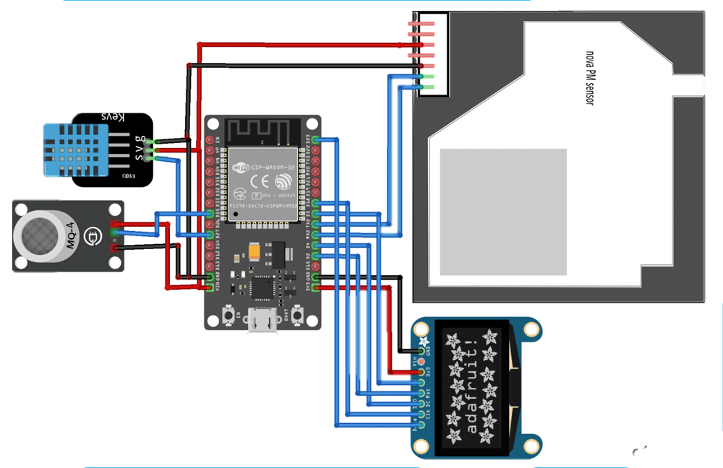

**CODE:**

import machine

import time

import dht

import urequests

from umqtt.simple import MQTTClient

from machine import I2C, Pin

from machine import ADC, SPI

# DHT11 sensor

dht_pin = Pin(14, Pin.IN, Pin.PULL_UP) # DHT11 sensor pin

dht_sensor = dht.DHT11(dht_pin)

# MQ7 sensor

mq_pin = Pin(33, Pin.IN) # MQ7 sensor analog pin

# Nova SDS011 sensor

uart = machine.UART(1, tx=17, rx=16, baudrate=9600, txbuf=256)

uart.init(9600, bits=8, parity=None, stop=1)

# OLED display

i2c = I2C(scl=Pin(22), sda=Pin(21))

oled = ssd1306.SSD1306_I2C(128, 64, i2c)

# MQTT configuration

mqtt_server = "mqtt.eclipse.org"

mqtt_topic = "your_topic" # Replace with your MQTT topic

mqtt_client_id = "esp32_air_quality_monitor"

mqtt_client = MQTTClient(mqtt_client_id, mqtt_server)

def read_dht():

dht_sensor.measure()

temperature = dht_sensor.temperature()

humidity = dht_sensor.humidity()

return temperature, humidity

def read_mq():

mq_value = ADC(mq_pin).read()

return mq_value

def read_sds011():

data = uart.read(10)

if data[0] == 0xAA and data[1] == 0xC0:

pm25 = (data[3] * 256 + data[2]) / 10.0

pm10 = (data[5] * 256 + data[4]) / 10.0

return pm25, pm10

return None

def send_data_to_mqtt(temperature, humidity, mq_value, pm25, pm10):

data = {

"temperature": temperature,

"humidity": humidity,

"mq_value": mq_value,

"pm25": pm25,

"pm10": pm10

}

mqtt_payload = ujson.dumps(data)

mqtt_client.connect()

mqtt_client.publish(mqtt_topic, mqtt_payload)

mqtt_client.disconnect()

def display_data_on_oled(temperature, humidity, mq_value, pm25, pm10):

oled.fill(0)

oled.text("Temp: {:.1f} C".format(temperature), 0, 0)

oled.text("Humidity: {:.1f}%".format(humidity), 0, 12)

oled.text("MQ Value: {}".format(mq_value), 0, 24)

oled.text("PM2.5: {:.1f}".format(pm25), 0, 36)

oled.text("PM10: {:.1f}".format(pm10), 0, 48)

oled.show()

while True:

try:

temperature, humidity = read_dht()

mq_value = read_mq()

pm25, pm10 = read_sds011()

if pm25 is not None and pm10 is not None:

send_data_to_mqtt(temperature, humidity, mq_value, pm25, pm10)

display_data_on_oled(temperature, humidity, mq_value, pm25, pm10)

time.sleep(60) # Adjust the delay as needed

except Exception as e:

print("An error occurred:", e)

time.sleep(10)

WEB PLATFORM EXECUTION:

Adafruit IO Setup

Adafruit IO is an open data platform that allows you to aggregate, visualize, and analyze live data on the cloud. Using Adafruit IO, you can upload, display, and monitor your data over the internet, and make your project IoT enabled. You can control motors, read sensor data, and make cool IoT applications over the internet using Adafruit IO.

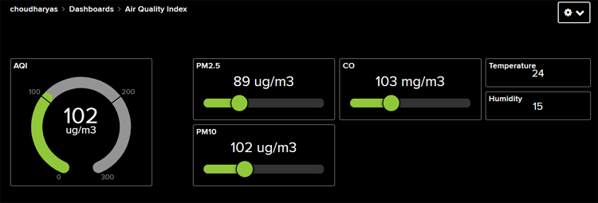

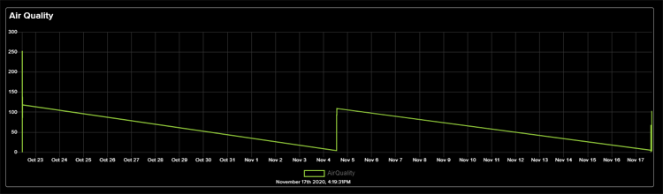

**APPLICATION:**

1)Monitor air in urban areas to ensure it is safe to breathe.

2)Detect haramful substance like CO2, Green house gases and volatile organic compounds.

3)inform farmers about best time of plant or harvest based on air quality.

**CONCLUSION:**

In conclusion, IoT-based air quality management is a promising approach to combat air pollution. By leveraging sensors, data analytics, and connectivity, it offers real-time monitoring, data-driven decision-making, and improved public health. However, challenges such as data accuracy, privacy, and security must be addressed for its widespread adoption. With ongoing technological advancements, IoT is poised to play a crucial role in creating a cleaner and healthier environment for future generations.