EXPERIMENT-03
ID3 Decision Tree Algorithm: Dataset-Based Python Programs
Name: Vetrivel.R Reg.No: 192513027
- Demonstrate the working of the decision tree based ID3 algorithm. Use an appropriate data set for building the decision tree and apply this knowledge to classify a new sample.

Problem 1: Playing Tennis

Aim
To demonstrate the ID3 decision tree algorithm on the PlayTennis dataset stored in a CSV file and classify a new weather sample.

Procedure
- Save the training examples in playtennis_data.csv with the class label in the last column.
- Run the Python program from the same folder as the CSV file.
- Read the CSV file and calculate the entropy of the class column.
- Calculate the information gain of every attribute and choose the attribute with the highest gain as the root node.
- Split the data on that attribute and repeat the process on each branch until a branch contains only one class.
- Print the decision tree and use it to classify a new sample.

Dataset File / Input
File name: playtennis_data.csv
The CSV file contains a header row followed by these training examples:
Outlook | Temperature | Humidity | Wind | PlayTennis
Sunny | Hot | High | Weak | No
Sunny | Hot | High | Strong | No
Overcast | Hot | High | Weak | Yes
Rain | Mild | High | Weak | Yes
Rain | Cool | Normal | Weak | Yes
Rain | Cool | Normal | Strong | No
Overcast | Cool | Normal | Strong | Yes
Sunny | Mild | High | Weak | No
Sunny | Cool | Normal | Weak | Yes
Rain | Mild | Normal | Weak | Yes
Sunny | Mild | Normal | Strong | Yes
Overcast | Mild | High | Strong | Yes
Overcast | Hot | Normal | Weak | Yes
Rain | Mild | High | Strong | No

Code
import json
import numpy as np
import pandas as pd

df = pd.read_csv("playtennis_data.csv")
target = df.columns[-1]

def entropy(col):
p = col.value_counts(normalize=True)
return -(p * np.log2(p)).sum()

def gain(d, a):
return entropy(d[target]) - sum(len(s) / len(d) * entropy(s[target]) for _, s in d.groupby(a))

def id3(d, attrs):
if d[target].nunique() == 1: # pure node -> leaf
return d[target].iloc[0]
if not attrs: # no attributes left -> majority class
return d[target].mode()[0]
best = max(attrs, key=lambda a: gain(d, a)) # attribute with highest gain
return {best: {v: id3(s, [a for a in attrs if a != best]) for v, s in d.groupby(best)}}

def classify(tree, x):
while isinstance(tree, dict):
a = next(iter(tree))
tree = tree[a].get(x[a], "Unknown")
return tree

attrs = list(df.columns[:-1])
print("Information Gain:", {a: round(float(gain(df, a)), 3) for a in attrs})
tree = id3(df, attrs)
print("Decision Tree:", json.dumps(tree, indent=2))

new = {"Outlook": "Sunny", "Temperature": "Cool", "Humidity": "High", "Wind": "Strong"}
print("New sample:", new)
print("Prediction:", classify(tree, new))

Output
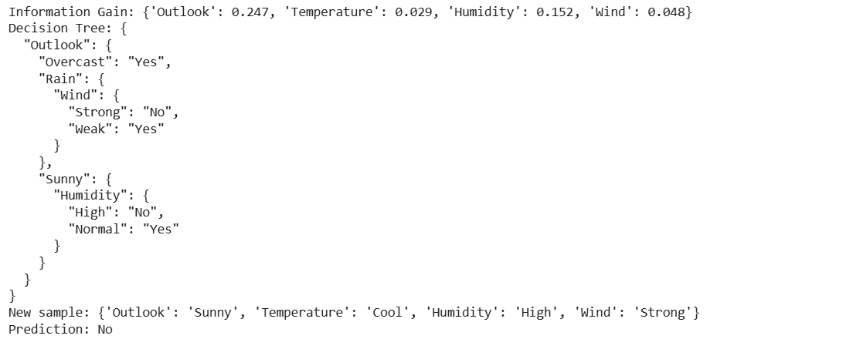

Result
Outlook has the highest information gain (0.247), so it becomes the root node. Overcast always leads to Yes, Sunny is split on Humidity and Rain is split on Wind. The new sample (Sunny, Cool, High, Strong) follows Outlook = Sunny and Humidity = High, so it is classified as PlayTennis = No.

Problem 2: Buying a Computer

Aim
To build an ID3 decision tree for a computer-purchase dataset stored in a CSV file and use it to classify a new customer.

Procedure
- Save the training examples in computer_data.csv with the class label in the last column.
- Run the Python program from the same folder as the CSV file.
- Read the CSV file and calculate the entropy of the class column.
- Calculate the information gain of every attribute and choose the attribute with the highest gain as the root node.
- Split the data on that attribute and repeat the process on each branch until a branch contains only one class.
- Print the decision tree and use it to classify a new sample.

Dataset File / Input
File name: computer_data.csv
The CSV file contains a header row followed by these training examples:
Age | Income | Student | CreditRating | BuysComputer
Youth | High | No | Fair | No
Youth | High | No | Excellent | No
Youth | Medium | No | Fair | Yes
Middle | Low | No | Fair | Yes
Middle | Medium | No | Excellent | No
Senior | Medium | No | Fair | Yes
Senior | Low | No | Excellent | No
Youth | Medium | Yes | Fair | Yes
Youth | Low | Yes | Excellent | Yes
Middle | Low | Yes | Fair | Yes
Middle | Medium | Yes | Excellent | Yes
Senior | Low | Yes | Fair | Yes
Senior | Medium | Yes | Excellent | Yes
Middle | High | Yes | Excellent | Yes

Code
import json
import numpy as np
import pandas as pd

df = pd.read_csv("computer_data.csv")
target = df.columns[-1]

def entropy(col):
p = col.value_counts(normalize=True)
return -(p * np.log2(p)).sum()

def gain(d, a):
return entropy(d[target]) - sum(len(s) / len(d) * entropy(s[target]) for _, s in d.groupby(a))

def id3(d, attrs):
if d[target].nunique() == 1: # pure node -> leaf
return d[target].iloc[0]
if not attrs: # no attributes left -> majority class
return d[target].mode()[0]
best = max(attrs, key=lambda a: gain(d, a)) # attribute with highest gain
return {best: {v: id3(s, [a for a in attrs if a != best]) for v, s in d.groupby(best)}}

def classify(tree, x):
while isinstance(tree, dict):
a = next(iter(tree))
tree = tree[a].get(x[a], "Unknown")
return tree

attrs = list(df.columns[:-1])
print("Information Gain:", {a: round(float(gain(df, a)), 3) for a in attrs})
tree = id3(df, attrs)
print("Decision Tree:", json.dumps(tree, indent=2))

new = {"Age": "Senior", "Income": "Low", "Student": "No", "CreditRating": "Fair"}
print("New sample:", new)
print("Prediction:", classify(tree, new))

Output
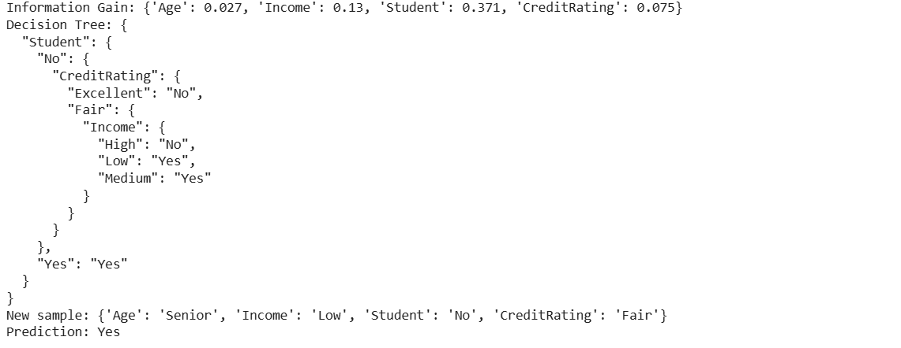

Result
Student has the highest information gain (0.371) and is the root node: every student buys a computer. Non-students are split on CreditRating (Excellent gives No) and then on Income when the rating is Fair. The new sample (Senior, Low, No, Fair) follows Student = No, CreditRating = Fair and Income = Low, so it is classified as BuysComputer = Yes.

Problem 3: Loan Approval

Aim
To apply the ID3 algorithm to a loan-approval dataset stored in a CSV file and classify a new applicant.

Procedure
- Save the training examples in loan_data.csv with the class label in the last column.
- Run the Python program from the same folder as the CSV file.
- Read the CSV file and calculate the entropy of the class column.
- Calculate the information gain of every attribute and choose the attribute with the highest gain as the root node.
- Split the data on that attribute and repeat the process on each branch until a branch contains only one class.
- Print the decision tree and use it to classify a new sample.

Dataset File / Input
File name: loan_data.csv
The CSV file contains a header row followed by these training examples:
Income | CreditScore | Employment | Property | LoanApproved
High | Good | Salaried | Yes | Yes
High | Good | SelfEmployed | No | Yes
Medium | Good | Salaried | Yes | Yes
Medium | Good | Unemployed | No | No
Low | Good | Salaried | No | Yes
High | Average | Salaried | Yes | Yes
Medium | Average | SelfEmployed | No | No
Low | Average | Salaried | No | No
High | Poor | Salaried | Yes | No
Medium | Poor | SelfEmployed | No | No
Low | Poor | Unemployed | No | No
Medium | Average | Salaried | No | Yes
Low | Good | Unemployed | No | No
High | Average | SelfEmployed | No | Yes

Code
import json
import numpy as np
import pandas as pd

df = pd.read_csv("loan_data.csv")
target = df.columns[-1]

def entropy(col):
p = col.value_counts(normalize=True)
return -(p * np.log2(p)).sum()

def gain(d, a):
return entropy(d[target]) - sum(len(s) / len(d) * entropy(s[target]) for _, s in d.groupby(a))

def id3(d, attrs):
if d[target].nunique() == 1: # pure node -> leaf
return d[target].iloc[0]
if not attrs: # no attributes left -> majority class
return d[target].mode()[0]
best = max(attrs, key=lambda a: gain(d, a)) # attribute with highest gain
return {best: {v: id3(s, [a for a in attrs if a != best]) for v, s in d.groupby(best)}}

def classify(tree, x):
while isinstance(tree, dict):
a = next(iter(tree))
tree = tree[a].get(x[a], "Unknown")
return tree

attrs = list(df.columns[:-1])
print("Information Gain:", {a: round(float(gain(df, a)), 3) for a in attrs})
tree = id3(df, attrs)
print("Decision Tree:", json.dumps(tree, indent=2))

new = {"Income": "Medium", "CreditScore": "Good", "Employment": "SelfEmployed", "Property": "Yes"}
print("New sample:", new)
print("Prediction:", classify(tree, new))

Output
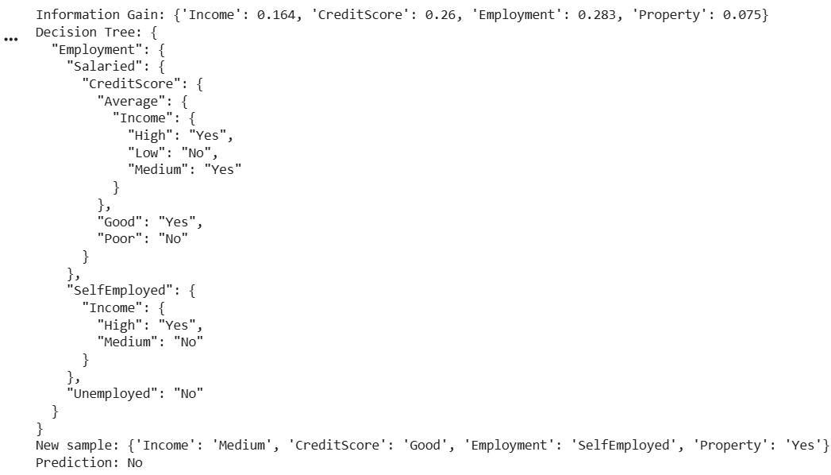

Result
Employment has the highest information gain (0.283) and is the root node. Unemployed applicants are rejected, salaried applicants are decided by CreditScore (and by Income when the score is Average), and self-employed applicants are decided by Income. The new sample (Medium, Good, SelfEmployed, Yes) follows Employment = SelfEmployed and Income = Medium, so it is classified as LoanApproved = No.

Problem 4: Student Result

Aim
To build an ID3 decision tree that predicts whether a student passes or fails from attendance and study details stored in a CSV file, and classify a new student.

Procedure
- Save the training examples in student_data.csv with the class label in the last column.
- Run the Python program from the same folder as the CSV file.
- Read the CSV file and calculate the entropy of the class column.
- Calculate the information gain of every attribute and choose the attribute with the highest gain as the root node.
- Split the data on that attribute and repeat the process on each branch until a branch contains only one class.
- Print the decision tree and use it to classify a new sample.

Dataset File / Input
File name: student_data.csv
The CSV file contains a header row followed by these training examples:
Attendance | Assignments | StudyHours | PreviousResult | Result
High | Done | High | Good | Pass
High | Pending | Low | Poor | Pass
High | Done | Medium | Poor | Pass
High | Pending | Medium | Good | Pass
High | Done | Low | Good | Pass
Low | Done | High | Good | Pass
Low | Done | Low | Poor | Pass
Low | Pending | Medium | Good | Fail
Low | Pending | Low | Poor | Fail
Low | Pending | High | Good | Fail
Low | Done | Medium | Poor | Pass
Low | Pending | High | Poor | Fail

Code
import json
import numpy as np
import pandas as pd

df = pd.read_csv("student_data.csv")
target = df.columns[-1]

def entropy(col):
p = col.value_counts(normalize=True)
return -(p * np.log2(p)).sum()

def gain(d, a):
return entropy(d[target]) - sum(len(s) / len(d) * entropy(s[target]) for _, s in d.groupby(a))

def id3(d, attrs):
if d[target].nunique() == 1: # pure node -> leaf
return d[target].iloc[0]
if not attrs: # no attributes left -> majority class
return d[target].mode()[0]
best = max(attrs, key=lambda a: gain(d, a)) # attribute with highest gain
return {best: {v: id3(s, [a for a in attrs if a != best]) for v, s in d.groupby(best)}}

def classify(tree, x):
while isinstance(tree, dict):
a = next(iter(tree))
tree = tree[a].get(x[a], "Unknown")
return tree

attrs = list(df.columns[:-1])
print("Information Gain:", {a: round(float(gain(df, a)), 3) for a in attrs})
tree = id3(df, attrs)
print("Decision Tree:", json.dumps(tree, indent=2))

new = {"Attendance": "High", "Assignments": "Pending", "StudyHours": "Low", "PreviousResult": "Good"}
print("New sample:", new)
print("Prediction:", classify(tree, new))

Output
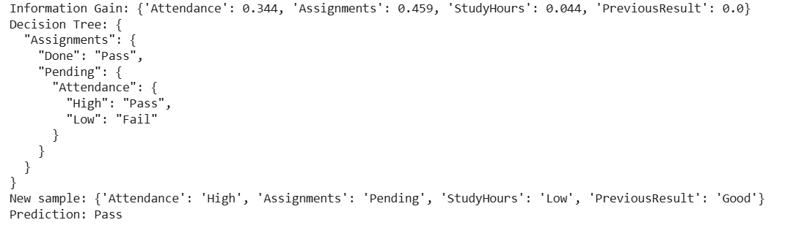

Result
Assignments has the highest information gain (0.459) and is the root node. Students with completed assignments pass; when assignments are pending, Attendance decides (High gives Pass, Low gives Fail). StudyHours and PreviousResult are not needed in the tree. The new sample (High, Pending, Low, Good) is classified as Result = Pass.

Problem 5: Mushroom Edibility

Aim
To apply the ID3 algorithm to a mushroom-edibility dataset stored in a CSV file and classify a new mushroom sample.

Procedure
- Save the training examples in mushroom_data.csv with the class label in the last column.
- Run the Python program from the same folder as the CSV file.
- Read the CSV file and calculate the entropy of the class column.
- Calculate the information gain of every attribute and choose the attribute with the highest gain as the root node.
- Split the data on that attribute and repeat the process on each branch until a branch contains only one class.
- Print the decision tree and use it to classify a new sample.

Dataset File / Input
File name: mushroom_data.csv
CapColor | Odor | Gills | Ring | Edible
Brown | NoSmell | Broad | Yes | Yes
White | NoSmell | Narrow | Yes | Yes
Red | Foul | Broad | No | No
Brown | Foul | Narrow | No | No
White | Almond | Broad | Yes | Yes
Red | NoSmell | Narrow | No | Yes
Brown | Almond | Narrow | Yes | Yes
White | Foul | Broad | Yes | No
Red | Almond | Broad | No | Yes
Brown | NoSmell | Narrow | No | Yes
White | Foul | Narrow | No | No
Red | Foul | Narrow | Yes | No
The CSV file contains a header row followed by these training examples:

Code
import json
import numpy as np
import pandas as pd

df = pd.read_csv("mushroom_data.csv")
target = df.columns[-1]

def entropy(col):
p = col.value_counts(normalize=True)
return -(p * np.log2(p)).sum()

def gain(d, a):
return entropy(d[target]) - sum(len(s) / len(d) * entropy(s[target]) for _, s in d.groupby(a))

def id3(d, attrs):
if d[target].nunique() == 1: # pure node -> leaf
return d[target].iloc[0]
if not attrs: # no attributes left -> majority class
return d[target].mode()[0]
best = max(attrs, key=lambda a: gain(d, a)) # attribute with highest gain
return {best: {v: id3(s, [a for a in attrs if a != best]) for v, s in d.groupby(best)}}

def classify(tree, x):
while isinstance(tree, dict):
a = next(iter(tree))
tree = tree[a].get(x[a], "Unknown")
return tree

attrs = list(df.columns[:-1])
print("Information Gain:", {a: round(float(gain(df, a)), 3) for a in attrs})
tree = id3(df, attrs)
print("Decision Tree:", json.dumps(tree, indent=2))

new = {"CapColor": "Brown", "Odor": "Foul", "Gills": "Broad", "Ring": "Yes"}
print("New sample:", new)
print("Prediction:", classify(tree, new))

Output
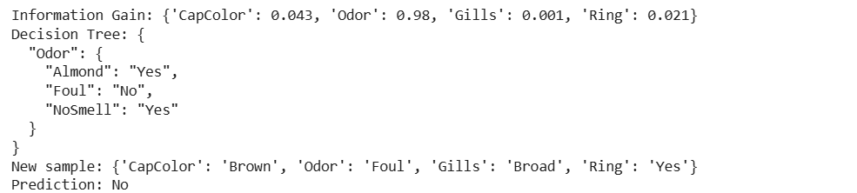

Result
Odor has by far the highest information gain (0.98), so one split classifies every training example: Foul gives No, while Almond and NoSmell give Yes. The new sample (Brown, Foul, Broad, Yes) is classified as Edible = No.

