Faculty of Computing and Information Technology Course Code: PROG8590 Relational Databases

Midterm Exam

**STUDENT NAME: VETRI VELAN ANANDAN**

**STUDENT ID: 8979936**

**DATE: 15-10-2024**

*Question 1:*

--1. Write a query that list the ProductID, Name, Color, and listPrice of all products without null values in color.

---**Sort your output result to show products with higher listprice first. [2 pts]

*Answer:*

SELECT [ProductID],[Name],[Color],[ListPrice]

FROM [Production].[Product]p

WHERE p.Color IS NOT NULL

ORDER BY p.ListPrice DESC

*Question 2:*

*Write a query to list all products with a name starting with* ***h*** *and ending with* ***e****.****[2 pts]***

**Answer:**

SELECT [Name], [ProductID]

FROM [Production].[Product] p

WHERE p.Name LIKE 'h%e'

*Question 3:*

*Where did the racing socks go? List the product name and the customer First name and last name for all customers who ordered ProductModel 'Racing Socks'.*

*Answer:*

SELECT pm.[Name], p.[FirstName], p.[LastName]

FROM [Production].[ProductModel] pm

LEFT JOIN [Person].[Person] p

ON pm.rowguid = p.rowguid

WHERE [Name] = 'Racing Socks'

*Question 4:*

*Write a query to display all sales persons with the same bonus. Your query must show the BusinessEntityID, TerritoryID and bonus.* ***[4 pts]***

*\*\* Filter your results to NOT include bonus with value zero.*

*\*\* Table: [Sales].[SalesPerson]*

*Answer:*

SELECT s.[BusinessEntityID] , s.[TerritoryID],s.[Bonus], sp.[BusinessEntityID], sp.[TerritoryID], sp.[Bonus]

FROM [Sales].[SalesPerson] s

JOIN [Sales].[SalesPerson] sp

ON s.Bonus = sp.Bonus

WHERE s.[Bonus] > 0

Question 5:

Find the list of employees with the highest pay rate in each pay frequency. Show the business ID, the rate and the pay frequency. **[4 pts]**

**\*\*** Table: [HumanResources].[EmployeePayHistory]

Answer:

SELECT [BusinessEntityID], [Rate], [PayFrequency]

FROM [HumanResources].[EmployeePayHistory] p

WHERE [Rate] = ( SELECT MAX([Rate])

FROM [HumanResources].[EmployeePayHistory] ph

WHERE p.[PayFrequency] = ph.[PayFrequency] )

ORDER BY[PayFrequency]

Question 6:

Write a query to list the BusinessEntityID and Rate of employees with a pay rate less than average employee rate.

** Use **subquery** to answer the question. **[4 pts]**

**\*\*** Table: HumanResources. EmployeePayHistory

Answer:

SELECT[BusinessEntityID],[Rate]

FROM [HumanResources].[EmployeePayHistory] e

WHERE e.[Rate]< ( SELECT AVG(Rate)

FROM [HumanResources].[EmployeePayHistory]);

Question 7:

Find the list of persons without a credit card. Show their Id, first Name and last Name.

** Tables: [Person].[Person] AND [Sales].[PersonCreditCard] **[3 pts]**

Answer:

SELECT[FirstName],[LastName], pc.[BusinessEntityID]

FROM [Person].[Person] p

LEFT JOIN [Sales].[PersonCreditCard] pc

ON p.BusinessEntityID = pc.BusinessEntityID

WHERE [CreditCardID] is NULL

Question 8:

Find the province name with the lowest tax rate. **[4 pts]**

** Table: [Person].[StateProvince] AND [Sales].[SalesTaxRate]

Answer:

SELECT TOP 1 p.[Name], s.[TaxRate]

FROM[Person].[StateProvince] p

LEFT JOIN [Sales].[SalesTaxRate] s

ON p.StateProvinceID = s.StateProvinceID

WHERE [TaxRate] IS NOT Null

ORDER BY s.[TaxRate] ASC

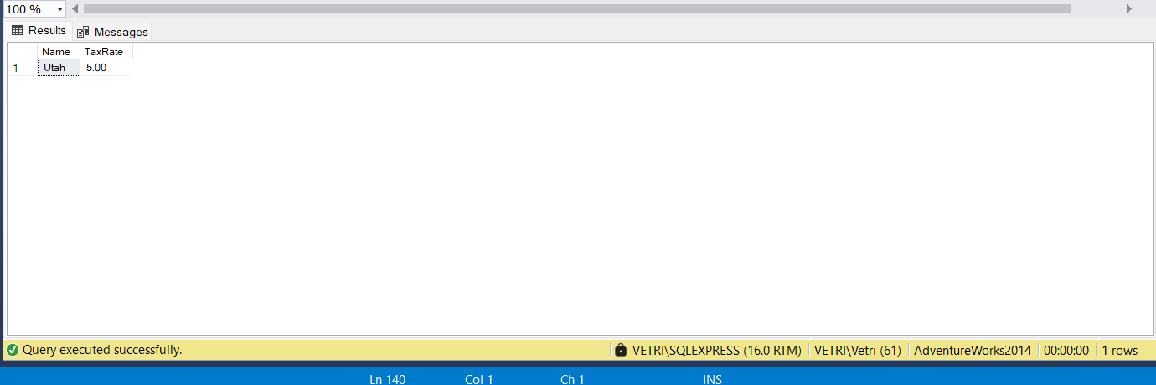

Question 9:

Modify the quantity to 5 for the ShoppingCartId: 14951 **[3 pts]**

** Table: [Sales].[ShoppingCartItem]

Answer:

UPDATE [Sales].[ShoppingCartItem]

SET Quantity =5

WHERE [ShoppingCartID] = 14951

Question 10:

Answer:

SET IDENTITY_INSERT [Sales].[ShoppingCartItem]ON;

INSERT INTO [Sales].[ShoppingCartItem] ([ShoppingCartItemID], [ShoppingCartID], [Quantity], [ProductID], [DateCreated], [ModifiedDate])

VALUES (9, 20623, 2, 882, GETDATE(), GETDATE());

SELECT [ShoppingCartItemID], [ShoppingCartID], [Quantity], [ProductID], [DateCreated],[ModifiedDate]

FROM[Sales].[ShoppingCartItem]

WHERE [ShoppingCartItemID] = 9

Question 11:

Remove all rows from the table [Sales].[ShoppingCartItem] **[3 pts]**

Answer:

DELETE FROM [Sales].[ShoppingCartItem]

SELECT *

FROM [Sales].[ShoppingCartItem]

