This document will help to give steps to get notification whenever the service principle going to expiry in azure portal.

Required Resources:
- Automation Account
- Log Analytics workspace
- Azure monitor (Need to create the alerts)
- Action group (get email notification)
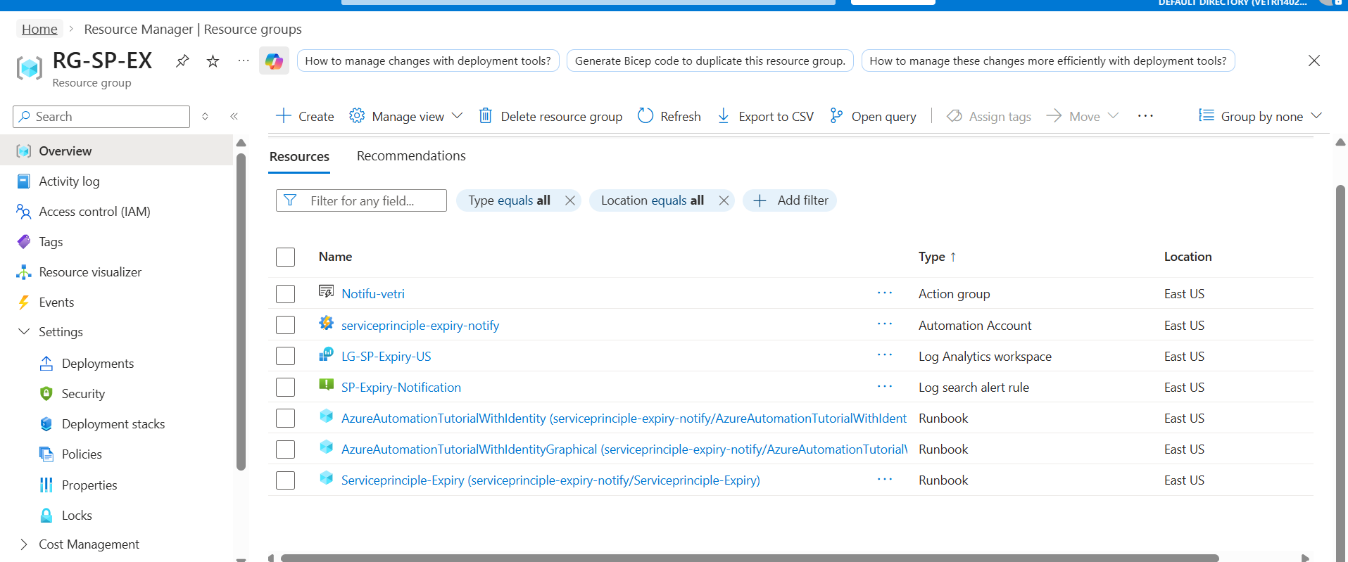

Automation Account:
Created the Automation account and enable identity (System assigned identity)
(Runtime Environment power shell 5.1)

1. Azure Automation + Managed Identity (Graph Access)
✔ Your understanding:
“Create Automation Account → Runbook → PowerShell script → enable Managed Identity”
👉 Correct — but one important detail:
You’re not accessing Azure Resource Graph, you are accessing Microsoft Graph API (for App Registrations).
🧩 Step-by-step: Enable & Grant Access
🔹 Step 1: Enable Managed Identity
- Go to Automation Account
- Click → Identity
- Under System Assigned
- Turn → ON
- Click Save
👉 Now Azure creates an identity (service principal)

🔹 Step 2: Use below commands to provide the permission to system assigned identity which is enabled on automation account.
All this command used to provide the access to system assigned indentity which you enabled on Automation account.

1) az automation account show \
--name <AUTOMATION_ACCOUNT_NAME> \
--resource-group <RESOURCE_GROUP> \
--query identity.principalId \
-o tsv

Save the output like this: MI_OBJECT_ID=<output>

2) az ad sp list --display-name "Microsoft Graph" --query "[0].id" -o tsv

Save the output like this: GRAPH_SP_ID=<output>

3) az ad sp show --id $GRAPH_SP_ID --query "appRoles[?value=='Application.Read.All' && contains(allowedMemberTypes, 'Application')].id" -o tsv

Save the output like this: APP_ROLE_ID=<output>

4) az rest --method POST \
--uri "https://graph.microsoft.com/v1.0/servicePrincipals/$MI_OBJECT_ID/appRoleAssignments" \
--headers "Content-Type=application/json" \
--body "{
\"principalId\": \"$MI_OBJECT_ID\",
\"resourceId\": \"$GRAPH_SP_ID\",
\"appRoleId\": \"$APP_ROLE_ID\"
}"

Validation:
=============

az rest --method GET \
--uri "https://graph.microsoft.com/v1.0/servicePrincipals/$MI_OBJECT_ID/appRoleAssignments"

az ad sp show --id 10e4cd3b-e6ab-4438-a62d-e55d164e4c9b \
--query "appRoles[?id=='9a5d68dd-52b0-4cc2-bd40-abcf44ac3a30']"
# To Provide the Graph access to Automation account, Once Automation account created execute below commands to get access.

az rest --method PUT \
--uri "https://management.azure.com/subscriptions/<Subscription_ID>/resourceGroups/<Resourcegroup_name>/providers/Microsoft.Automation/automationAccounts/serviceprinciple-expiry-notify/modules/Microsoft.Graph.Authentication?api-version=2023-11-01" \
--body '{
"properties": {
"contentLink": {
"uri": "https://www.powershellgallery.com/api/v2/package/Microsoft.Graph.Authentication"
}
}
}'

az rest --method PUT \
--uri "https://management.azure.com/subscriptions/<Subscription_ID>/resourceGroups/<Resourcegroup_name>/providers/Microsoft.Automation/automationAccounts/serviceprinciple-expiry-notify/modules/Microsoft.Graph.Applications?api-version=2023-11-01" \
--body '{
"properties": {
"contentLink": {
"uri": "https://www.powershellgallery.com/api/v2/package/Microsoft.Graph.Applications"
}
}
}'

# To check the status of above command
az rest --method GET \
--uri "https://management.azure.com/subscriptions/<Subscription_ID>/resourceGroups/<Resourcegroup_name>/providers/Microsoft.Automation/automationAccounts/serviceprinciple-expiry-notify/modules/Microsoft.Graph.Authentication?api-version=2023-11-01" \
--query "properties.provisioningState"
==================================================================================
Once access provided, Create the RUN Book and use below script to check the status. Before need o create the Log Analytics workspace.
For the script refer script files (script)

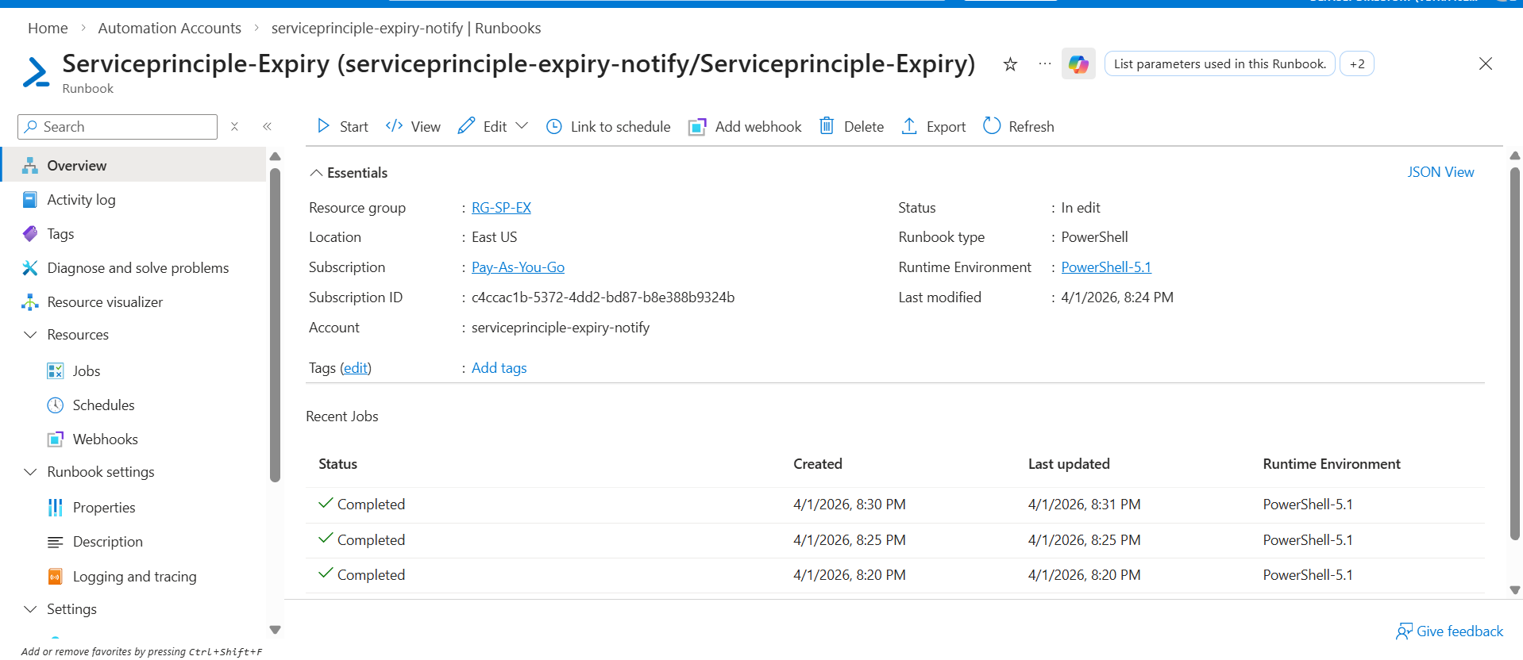
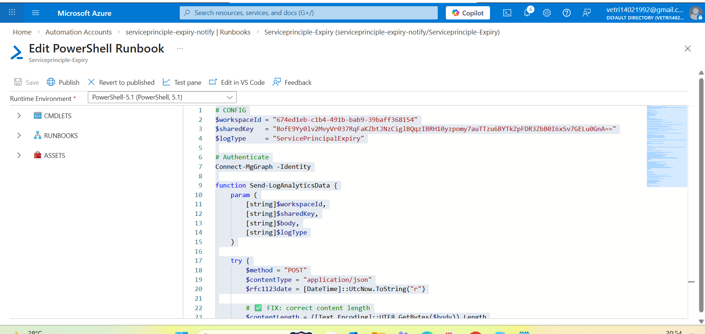

====================================================================================================================================================================
  - Log Analytics WorkSpace

