(Title of the Project work)
Predictive Model: Deepfake Detection

Introduction
Deepfake technology has rapidly evolved, leading to the creation of highly realistic synthetic media. While this technology has potential positive applications, it also poses risks such as misinformation and identity fraud. This project aims to develop a deep learning-based solution for detecting deepfake videos using advanced architectures like ResNext and LSTM. The approach leverages transfer learning to extract key features from video frames, followed by sequence analysis using LSTM for classification.
Data
The dataset used for training and evaluating the deepfake detection models consists of:
- Real and Deepfake Videos: Collected from public deepfake datasets such as FaceForensics++, DFDC, and Celeb-DF.
- Frame Extraction: Videos are broken down into frames to train the deep learning model.
- Preprocessing: Face detection and alignment are performed to focus on facial regions for better accuracy.
Methodology
The deepfake detection model follows a two-stage process:
- Feature Extraction (ResNext CNN):
  - A pretrained ResNext convolutional neural network (CNN) extracts feature embeddings from video frames.
  - These embeddings capture essential spatial patterns to differentiate real and fake faces.
- Sequence Learning (LSTM):
  - The extracted features are passed through a Long Short-Term Memory (LSTM) network.
  - LSTM analyzes temporal dependencies across frames to detect inconsistencies in motion and facial expressions.
Execution
To run the project, follow these steps:
- Install Dependencies: Ensure required Python libraries such as TensorFlow/PyTorch, OpenCV, and Django are installed.
- Run the Django Application: Use the command docker-compose up to deploy the containerized application.
- Upload a Video: Users can upload a video file, and the trained model will analyze and classify it as real or deepfake.
- View Results: The results, including confidence scores, are displayed on the web interface.

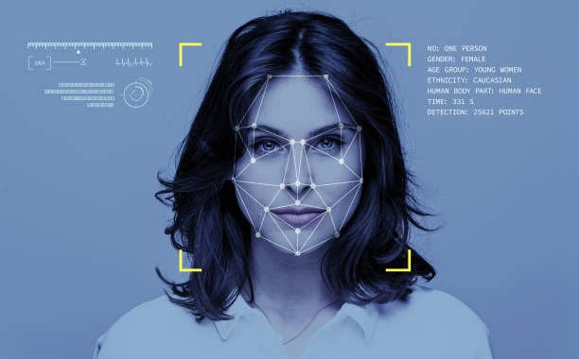
Result
The deepfake detection models have demonstrated high accuracy in detecting fake videos. There are the results for different model variations. The model effectively identifies deepfake videos with high precision by leveraging ResNext for feature extraction and LSTM for sequence analysis.

