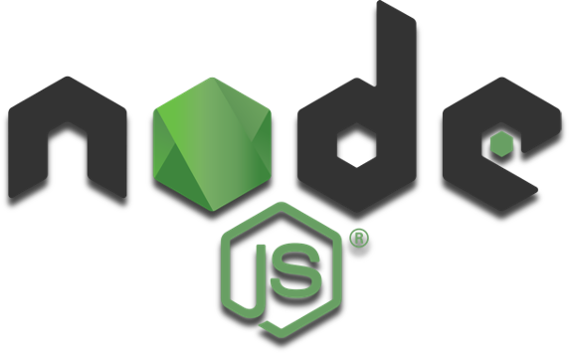


Passport
Engineering Code

- Get the Code
Clone or download code. In this case from the Monash Coding Bootcamp repository hosted on GitLab.

- Have a Peek in VS Code
Open the code in VS Code and familiarise yourself with the folder layout and contents
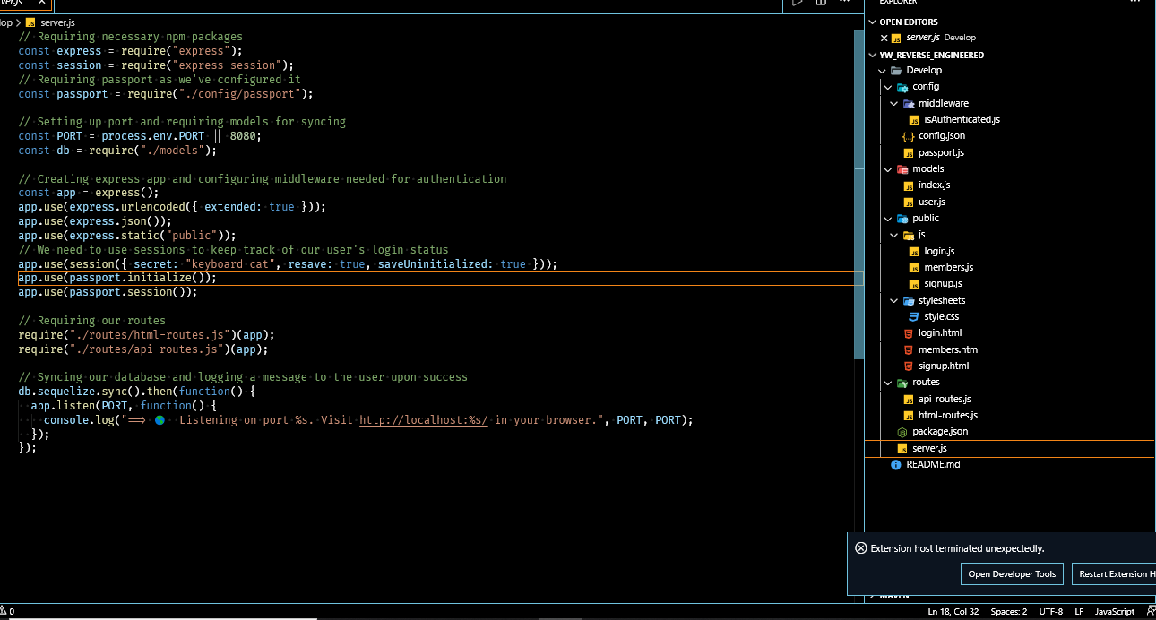
- Get Co-dependant
Check that you have a package.JSON file and then open the terminal and download your Node Dependencies by running NPM Install “npm i” or “npm install”. Check for any errors downloading the modules.
- Tell us your secrets!

Go to the config.json file and add your password in the password text fields

Open the server.js file in the terminal and run “node server.js”
address any errors that occur.. for example in the javascript code: I modified the index.js files I updated the variables 'sequelize' and 'model' to have the prefix 'let' instead of const as these errors arose when I ran the server.js file.

open my sql and connect to your local connection
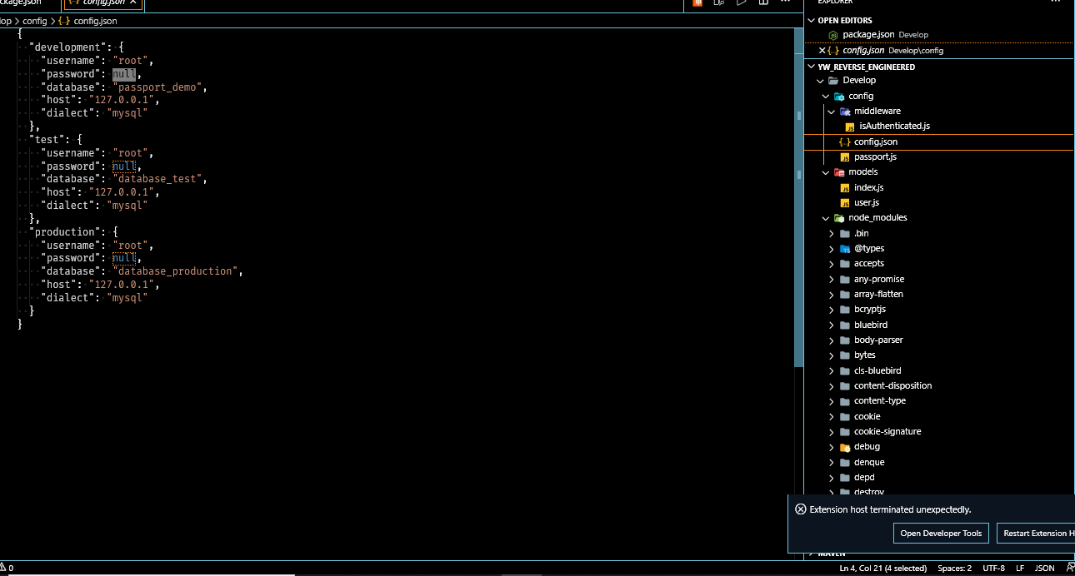
node server.js to make local connection
create and run sql scripts to create the three databases required
run node server.js
check local connection – click link test site create login, login logout, login
check users table to confirm user has saved to database
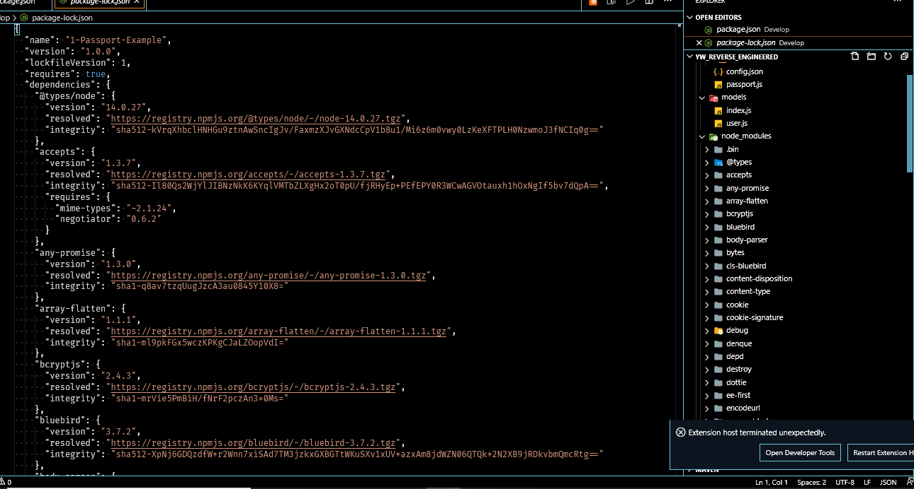
Inside `server.js` you will need to set up your port number (if not satisfied with the default). You can add Heroku port now out of habit if you wish to avoid doing it in the future. Below is a snapshot of the initial setup.

Keynotes
- Express.urlencoded: will parse incoming requests and replaces the need to use the body-parser package with express. In this example, extended true means that the queryString library is passed but if you only want the queryString without the library then set extended to false.
- Express.JSON(): parses incoming requests as JSON and is required for express.urlencoded to work.
- Express.static(“public”): allows express to access files within the “public” folder.

Conclusion: Open up your terminal inside your project file and type, `Node server.js`. If everything works you should then get the reply “You are now connected to localhost: #” and the link to the browser. You are now connected to localhost:8080

sign up page

Config folder

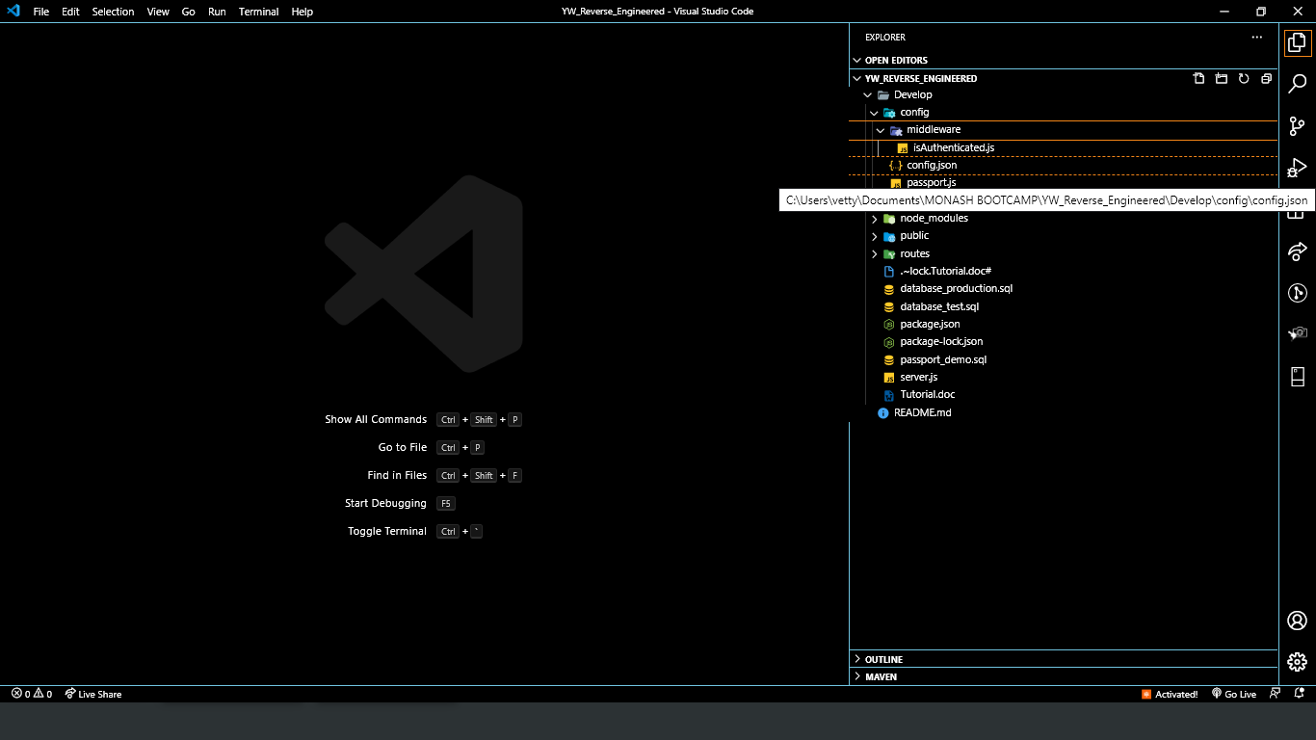

“Express()”, Express, https://expressjs.com/en/api.html#express

