UDC 519.816:004.94
A multi-criteria model for allocating free cash flow in personal financial planning: a computational study and norm-anchored criteria normalization
V. M. Evdokimov
National University of Science and Technology MISIS,
4 Leninskiy Prospekt, Moscow, 119049, Russia
E-mail: m2201058@edu.misis.ru, ORCID: 0009-0004-8821-8414
Abstract. This paper proposes and studies a multi-criteria model that supports a recurring household decision: how to split free monthly cash flow between early debt repayment, a liquidity reserve, and savings goals. The model combines several components into a single decision cycle. It generates allocation alternatives by discretizing the available resource into fixed shares, screens loans for early repayment against an opportunity-cost rate threshold, scores goal attainment with category and urgency weights, enforces a feasibility cascade based on liquidity and debt-load constraints, forecasts cash flows with simple exponential smoothing accompanied by Monte-Carlo interval estimation, and ranks the feasible alternatives by an additive utility function whose weights encode the user's risk profile. A computational study runs the model on three demonstration profiles — over-indebted, typical, and comfortable — under three liquidity-threshold regimes. The study reveals a degeneracy in the original criteria specification: the resource and liquidity criteria, both computed from the unallocated remainder, are nearly collinear (their correlation across alternatives exceeds 0.999), so the ranking collapses toward reserve-only allocations regardless of the risk profile, while sample-range min-max normalization inflates economically negligible criterion differences to the full unit interval. The paper then introduces a refinement: the resource criterion becomes a forecast of next-period free cash flow, which embeds the forecasting block directly into the utility function; the liquidity criterion switches to a stock-based measure; and normalization is anchored to financial norms — the regulatory debt-service-to-income ceiling and liquidity-stock benchmarks — instead of the sample range. Under the refined model, recommendations differentiate monotonically across risk profiles: conservative profiles build the reserve, active profiles fund goals, and the aggressive profile additionally prepays expensive debt. Rankings remain stable under small weight perturbations, the protective cascade still produces corrective output on the over-indebted profile, and a full decision cycle completes in under two milliseconds, which supports interactive use.
Keywords: multi-criteria decision making, decision support, simple additive weighting, criteria normalization, cash-flow forecasting, Monte-Carlo method, personal finance, computational experiment
Introduction
The quality of everyday financial decisions directly affects household resilience, savings, and the ability to reach long-term goals [Lusardi, Mitchell, 2014]. A growing range of financial products and digital channels multiplies the alternatives that must be compared by rates, terms, and risks, while most users keep their information about income, expenses, and obligations fragmented [Blokhina et al., 2025; Malyonkina, Ponyaeva, 2024]. Digital personal-finance services are developing rapidly [Gomber et al., 2017; Kachanova, Plaksa, 2025], yet their functionality mostly reduces to transaction tracking and expense visualization: a formalized procedure for choosing an action — where to direct this month's free funds — is typically absent from mass-market products.
The need for such a procedure has empirical support. An anonymous online survey conducted by the author (385 responses collected, 322 valid after an attention check) showed that, despite a declared inclination toward rational calculation, only 10% of respondents actually relied on computation in a concrete allocation situation, 63% decided based on emotional comfort or anxiety, and 84% viewed the idea of an algorithmic advisor positively on the condition that its logic is transparent. The condition matters: in high-stakes settings, interpretable models are preferable to post-hoc explanations of black boxes [Rudin, 2019], and the quality of an explanation determines user trust in a recommendation [Miller, 2019; Arrieta et al., 2020].
Multi-criteria decision analysis, systematically applied in finance [Hwang, Yoon, 1981; Zopounidis, Doumpos, 2002], provides the methodological basis for formalizing such problems. Among ranking methods, simple additive weighting (SAW), rooted in additive utility theory [Fishburn, 1967], stands out for combining simplicity, computational efficiency, and — critically for this domain — full transparency: the contribution of each criterion to an alternative's score is explicit [Velasquez, Hester, 2013]. Ratio-based diagnostics of household financial state were developed in [Lytton et al., 1991] and consolidated into consensus benchmarks in [Greninger et al., 1996]; the regulatory ceiling on debt load is set by the central bank [Bank of Russia, 2018]. Exponential smoothing [Hyndman et al., 2002] and Monte-Carlo simulation [Metropolis, Ulam, 1949] serve to assess the stability of future states. At the same time, multi-criteria rankings are known to be sensitive to the choice of normalization procedure [Jain et al., 2005; Vafaei et al., 2018] — an aspect that, as shown below, turns out to be decisive for the class of models considered here.
The novelty of this work lies not in the individual methods, each of which is known, but in their integration into a single free-cash-flow allocation model and in the results of its computational study. The contributions are: (1) a complete multi-criteria model comprising alternative generation, an opportunity-cost screening filter for early repayment, weighted goal scoring, and a feasibility cascade; (2) a computational demonstration that the natural criteria specification is degenerate — the resource and liquidity criteria are collinear and min-max normalization is pathological, which biases the ranking toward reserve allocations regardless of user preferences; (3) a refinement — a forecast-based resource criterion that embeds the forecasting block into the utility function, a stock-based liquidity criterion, and norm-anchored normalization — that restores meaningful differentiation of recommendations across risk profiles; (4) evidence that the protective constraints retain their behavior and that the ranking is stable under weight perturbations. Personal finance serves as the application domain; the scheme itself — detected criteria collinearity followed by norm-based anchoring of scales — transfers to other resource-allocation problems.
1. Classes of algorithmic approaches and method selection
Algorithmic cores of digital personal-finance tools fall into six classes that differ in the balance of adaptivity and explainability (Table 1). Rules and heuristics are transparent but express trade-offs between competing directions poorly; scoring models reduce a multidimensional situation to a single number; forecasting models improve justification but do not by themselves choose an action; optimization formulations are rigorous, yet their solutions are hard to explain to users without special training. A hybrid scheme — rules as feasibility constraints, a forecast as a criterion source, and multi-criteria ranking as the choice mechanism — combines the strengths of these classes at the cost of higher demands on module coordination; as Section 3 shows, coordinating the criteria is precisely the non-trivial part of the problem.
Table 1. Classes of algorithmic approaches to decision support in personal finance
Approach class | Strengths | Limitations
Rules and heuristics | Transparent logic, low complexity | Weak adaptivity, poor handling of multiple criteria
Scoring models | Compactness, easy monitoring | Reduction to a single number, debatable weights
Cash-flow forecasting | Captures dynamics and uncertainty | Does not choose an action, needs history
Multi-criteria choice | Formalizes trade-offs, tunable preferences | Sensitive to scales and normalization
Optimization models | Rigor, reproducibility | Hard to explain, assumption-dependent
Hybrid (rules + forecast + ranking) | Balance of explainability and quality | Module coordination, demanding testing

2. Mathematical model
2.1. Input data and state metrics
Input data are aligned to a monthly time step. In period t, let income transactions i_{k}, expense transactions e_{j}, and the current balance B_{t} be given. The set of credit obligations O = {(P_{l}, r_{l}, T_{l}, B_{l}^{loan})} specifies, for each loan l, the monthly annuity payment, the annual rate, the remaining term, and the principal balance. The set of goals G = {(T_{s}^{tgt}, C_{s}, τ_{s}, c_{s})} specifies, for each goal s, the target amount, the current savings, the months to deadline, and the category. User parameters include the liquidity threshold L_{min}, the debt-load ceiling D_{max}, the benchmark rate r_{bench}, and the risk profile. The net cash flow and the free resource of the period are
CF_{t} = ∑ i_{k} − ∑ e_{j}, (1)
R_{t} = CF_{t} − ∑ P_{l}. (2)
The current state is characterized by the liquidity ratio and the debt load:
L_{t} = R_{t} / (∑ e_{j} + ∑ P_{l}), (3)
D_{t} = ∑ P_{l} / ∑ i_{k}. (4)
Metric (3) expresses what share of the month's total mandatory payments is covered by the free resource and is interpreted as the operational safety margin of the budget; the norm L_{min} = 0.30 follows the ratio system of [Greninger et al., 1996]. Metric (4) is the debt-service-to-income ratio; the ceiling D_{max} = 0.40 corresponds to the regulatory threshold [Bank of Russia, 2018]. The conditions CF_{t} > 0 and R_{t} > 0 are necessary for the model to apply: when they fail, the model does not pick the “least bad” allocation but issues a corrective recommendation about structural budget revision (fail-loud principle).
2.2. Cash-flow forecasting
Income and expense series are forecast with simple exponential smoothing [Hyndman et al., 2002]:
ŷ_{t+1} = α y_{t} + (1 − α) ŷ_{t}, 0 < α < 1, (5)
where α = 0.3 places moderate trust in the latest observation, which is typical for monthly financial series. Forecast uncertainty is assessed by Monte-Carlo simulation [Metropolis, Ulam, 1949]: N = 1000 scenarios are generated around the point forecast with noise whose variance equals the sample variance of smoothing residuals; the scenarios yield the median and the 95% interval over horizons h = 1, …, 3 months. In the original model specification, the forecasting block is purely diagnostic — it estimates the risk of a resource deficit; Section 3.3 integrates it directly into the utility function.
2.3. Alternative generation and the early-repayment rate filter
An allocation alternative is a triple a = (x_{d}, x_{r}, x_{g}) of amounts directed, respectively, to early debt repayment, to the liquidity reserve, and to goals, subject to x_{d} + x_{r} + x_{g} = max(R_{t}, 0) and non-negativity. The set of alternatives is generated by discretizing the shares with step 0.2, which by the stars-and-bars scheme yields 21 variants — from “all to early repayment” to “all to goals”. The discretization step balances coverage against cognitive load: every alternative remains explainable to the user in terms of shares.
The amount x_{d} is distributed across loans by the highest-rate-first strategy [Bach, 2004; Amar et al., 2011] with an additional economic filter: early repayment applies only to obligations whose rate is no lower than the opportunity cost of placing the funds
O^{tgt} = {l ∈ O : r_{l} ≥ r_{bench}}, (6)
where r_{bench} = 0.14 is a benchmark return on savings instruments (the parameter is revised as market conditions change). If all loans are cheaper than the threshold, the x_{d} component is redirected to goals: a ruble placed at a higher rate is economically more productive than a ruble that repays cheap debt. After partial repayment, the annuity payment is recomputed for the unchanged term, which reduces the total payment by δP(a) and consequently lowers the debt load D_{t}(a).
2.4. Goal attainment with categories and urgency
Goals carry category weights: investment in income growth — 3.0 (the priority of human-capital investment [Becker, 1964]), safety — 2.0, material goals — 1.0, emotional goals — 0.5. Goal urgency grows as the deadline approaches:
u_{s} = max(1, 12 / max(τ_{s}, 1)). (7)
The amount x_{g} is distributed across active goals in proportion to the product of category weight and urgency, with the constraint of not saving beyond the target amount; any surplus is redistributed by the same proportion. The weighted goal attainment for alternative a is
S_{t}(a) = ∑_{s} (C_{s} + ΔC_{s}(a)) w_{s} u_{s} / ∑_{s} T_{s}^{tgt} w_{s} u_{s}, (8)
where ΔC_{s}(a) is the contribution to goal s under the alternative. Metric (8) lies in the unit interval by construction and is interpreted as the share of the weighted goal total already covered by savings.
2.5. Feasibility constraints
An alternative is feasible if the state remains in the safe zone after applying it:
L_{t}(a) ≥ L_{min}, D_{t}(a) ≤ D_{max}, R_{t}(a) ≥ 0, (9)
where the metrics are recomputed for the allocation: the liquidity numerator decreases by the amounts directed out of the resource, and the denominator decreases by δP(a). Constraint checking is prioritized as a cascade — debt load first, then liquidity, then non-negativity of the remainder — so critical constraints are resolved before any discretionary choice. An empty feasible set is treated as a diagnosis: the model reports which constraint is violated and why, instead of returning the formally “best” infeasible alternative.
2.6. Normalization, aggregation, and risk profiles
Before aggregation, the heterogeneous criteria are mapped to the unit interval. The natural and widely used choice is min-max normalization over the current feasible set [Jain et al., 2005]:
x̂(a) = (x(a) − min x) / (max x − min x). (10)
The integral utility of an alternative is the additive aggregation [Fishburn, 1967] with the debt-load term inverted, since its reduction is preferred:
U(a) = w_{R} R̂(a) + w_{L} L̂(a) + w_{D} (1 − D̂(a)) + w_{S} Ŝ(a), ∑ w = 1; a = arg max U(a*). (11)
The weights encode the user's financial strategy and are set by one of five risk profiles (Table 2); the balanced profile is the default. The explicit utility function makes the model tunable without changing the algorithm and explainable: for any recommendation, the contribution of each criterion can be shown.
Table 2. Risk profiles and criterion weights
Profile | w_{R} (resource) | w_{L} (liquidity) | w_{D} (debt) | w_{S} (goals)
Conservative | 0.20 | 0.45 | 0.25 | 0.10
Moderate | 0.20 | 0.35 | 0.25 | 0.20
Balanced | 0.25 | 0.30 | 0.25 | 0.20
Active | 0.30 | 0.20 | 0.20 | 0.30
Aggressive | 0.35 | 0.10 | 0.15 | 0.40

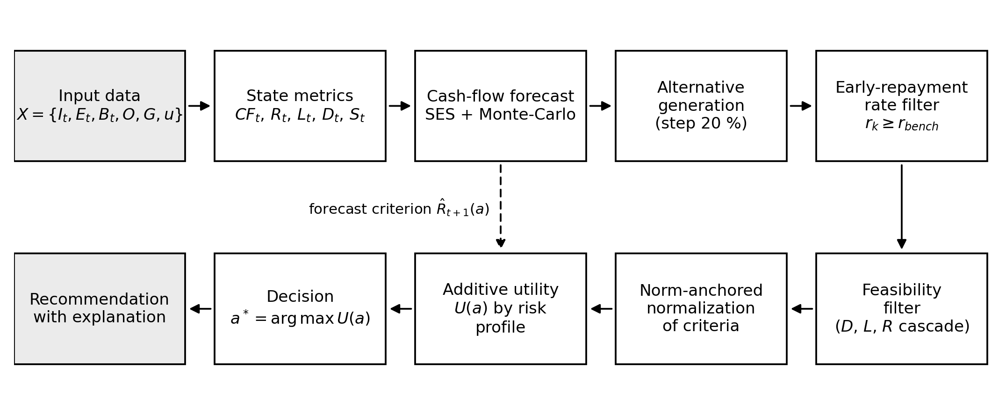
Fig. 1. The decision cycle. The dashed arrow marks the integration of the forecasting block into the utility function (the refinement of Section 3.3)
3. Computational study
3.1. Experimental design and demonstration profiles
The model is implemented in Python (the experiment source code is available on request; see Additional information). The study uses three demonstration profiles covering qualitatively different state zones (Table 3): profile A — over-indebted (debt load above the regulatory ceiling), profile B — typical (liquidity near the L_{min} threshold), profile C — comfortable (substantial free resource). Profiles B and C each include three goals of different categories (a safety reserve, professional retraining, a vacation) and loans with different rates, of which the mortgage (8.5%) fails filter (6) at r_{bench} = 0.14, while the consumer loans (19–27%) pass. For each profile, three liquidity-threshold regimes L_{min} ∈ {0; 0.15; 0.30} and five risk profiles were examined; ranking stability was tested by perturbing each weight of the balanced profile by ±0.05 with renormalization (eight perturbations).
Table 3. Demonstration profiles (amounts in rubles per month)
Metric | A (over-indebted) | B (typical) | C (comfortable)
Income ∑ i_{k} | 90,000 | 135,000 | 167,000
Expenses ∑ e_{j} | 40,000 | 60,000 | 36,500
Payments ∑ P_{l} | 38,299 | 33,622 | 30,327
Loans (rate) | card (27%), consumer (22%) | card (27%), consumer (22%), mortgage (8.5%) | consumer (19%), mortgage (8.5%)
Free resource R_{t} | 11,701 | 41,378 | 100,173
Liquidity L_{t} | 0.149 | 0.442 | 1.499
Debt load D_{t} | 0.426 | 0.249 | 0.182
Balance B_{t} | 30,000 | 90,000 | 150,000

3.2. Behavior of the original criteria specification
On profile A, the feasible set is empty under every threshold regime: the debt load exceeds D_{max} = 0.40, and even directing the entire resource to early repayment lowers it only to 0.413. The model correctly refuses to choose and issues a corrective recommendation to reduce the debt load — the protective cascade works as designed.
On profiles B and C, the ranking degenerates (Table 4). Tightening the liquidity threshold monotonically shrinks the feasible set (from 19 to 3 alternatives on profile B), yet the optimal alternative is the same for all five risk profiles: “the entire resource to the reserve”. The only exception is the aggressive profile on the comfortable profile C at L_{min} = 0.30. The ranking is formally stable — all eight weight perturbations preserve the optimum — but here stability is a symptom rather than a virtue: the ranking is insensitive to user preferences as well.
Table 4. Original specification: feasible-set size and the number of distinct optima across the five risk profiles
Profile | L_{min} = 0 | L_{min} = 0.15 | L_{min} = 0.30
A | infeasible (fail-loud diagnosis) | infeasible | infeasible
B | 19 alternatives; 1 optimum (0/100/0) | 10; 1 optimum (0/100/0) | 3; 1 optimum (0/100/0)
C | 17; 1 optimum (0/100/0) | 15; 1 optimum (0/100/0) | 14; 2 optima

The causes of the degeneracy follow from criterion analysis. First, the resource and liquidity criteria in the original specification are computed from the same quantity — the unallocated remainder: the numerator of L_{t}(a) coincides with R_{t}(a), while the denominator is nearly constant across alternatives. Their sample correlation over the 21 alternatives is 0.9998 (profile B) and 0.99979 (profile C): two of the four criteria are effectively one, and the combined weight of “keeping the funds” reaches 0.45–0.65 depending on the risk profile. Second, min-max normalization (10) stretches any criterion range — including an economically negligible one — to the full unit interval: early repayment changes profile C's debt load only from 0.182 to 0.157, yet after normalization this difference weighs as much as the full resource range. The sensitivity of multi-criteria rankings to the normalization procedure is known in the literature [Vafaei et al., 2018]; here it is amplified by criteria collinearity and produces a systematic bias.
3.3. Refinement: a forecast-based resource criterion, stock liquidity, and norm-anchored normalization
The proposed refinement preserves the model structure — the alternative set, the rate filter, the weighted goals, and the constraint cascade (9) remain unchanged — and modifies only the criteria specification in aggregation (11). Three changes remove the identified defects.
First, the resource criterion is replaced by a forecast of next-period free cash flow:
R̂_{t+1}(a) = Î_{t+1} − Ê_{t+1} − (∑ P_{l} − δP(a)), (12)
where Î_{t+1} and Ê_{t+1} are the forecasts (5) of the income and expense series. The criterion stops rewarding fund retention: the current balance does not enter (12), and early repayment raises the future resource through lower payments. The forecasting block, which served only a diagnostic function in the original model, thereby becomes part of the utility function.
Second, the liquidity criterion switches from flow to stock:
L^{stk}(a) = (B_{t} + x_{r}) / (∑ e_{j} + ∑ P_{l} − δP(a)), (13)
i.e., it measures the number of months of mandatory payments covered by the accumulated stock of funds — an alternative-dependent analogue of the basic liquidity ratio [Greninger et al., 1996]. Now the reserve component x_{r} — and only it — improves this criterion, which removes the collinearity: each allocation direction primarily improves its own criterion (early repayment — the future resource and the debt load, the reserve — the liquidity stock, goals — goal attainment).
Third, normalization is anchored not to the sample range but to meaningful scale anchors: the forecast resource (12) is normalized by the forecast net flow Î_{t+1} − Ê_{t+1} (the share of the future flow that remains free); the stock (13) — by the upper liquidity-stock norm of six months [Greninger et al., 1996]; the debt load — by the regulatory ceiling D_{max} [Bank of Russia, 2018]; goal attainment (8) already lies in the unit interval. All normalized values are clipped to the unit interval. Norm-anchored normalization has three consequences: economically small criterion differences remain small after normalization; the scales do not depend on the composition of the alternative set, which rules out rank reversal when it changes; and every normalized value is interpretable to the user in terms of accepted financial norms, which directly supports the explainability requirement.
3.4. Results of the refined model
On the same profiles and at the same threshold L_{min} = 0.30, the refined model behaves qualitatively differently (Table 5, Fig. 2). On the comfortable profile C, recommendations differentiate monotonically with risk appetite: the conservative, moderate, and balanced profiles build the reserve; the active profile directs 60% of the resource to goals; the aggressive profile additionally prepays the consumer loan (19% per annum) — the only obligation that passes filter (6) — while the mortgage (8.5%) is correctly excluded from early repayment as cheaper than the alternative placement of funds. On the typical profile B, where only three feasible alternatives survive the constraint cascade, differentiation is expectedly weaker: the conservative profile chooses the pure reserve, the others — the reserve with partial goal funding. This illustrates a general property of the model: in the constrained zone, the decision is driven mostly by the protective constraints; in the comfortable zone — by user preferences. Profile A still receives a corrective recommendation.
Table 5. Refined model: optimal alternatives (early repayment / reserve / goals, % of the resource) at L_{min} = 0.30
Risk profile | B (typical) | C (comfortable)
Conservative | 0 / 100 / 0 | 0 / 100 / 0
Moderate | 0 / 80 / 20 | 0 / 100 / 0
Balanced | 0 / 80 / 20 | 0 / 100 / 0
Active | 0 / 80 / 20 | 0 / 40 / 60
Aggressive | 0 / 80 / 20 | 20 / 20 / 60

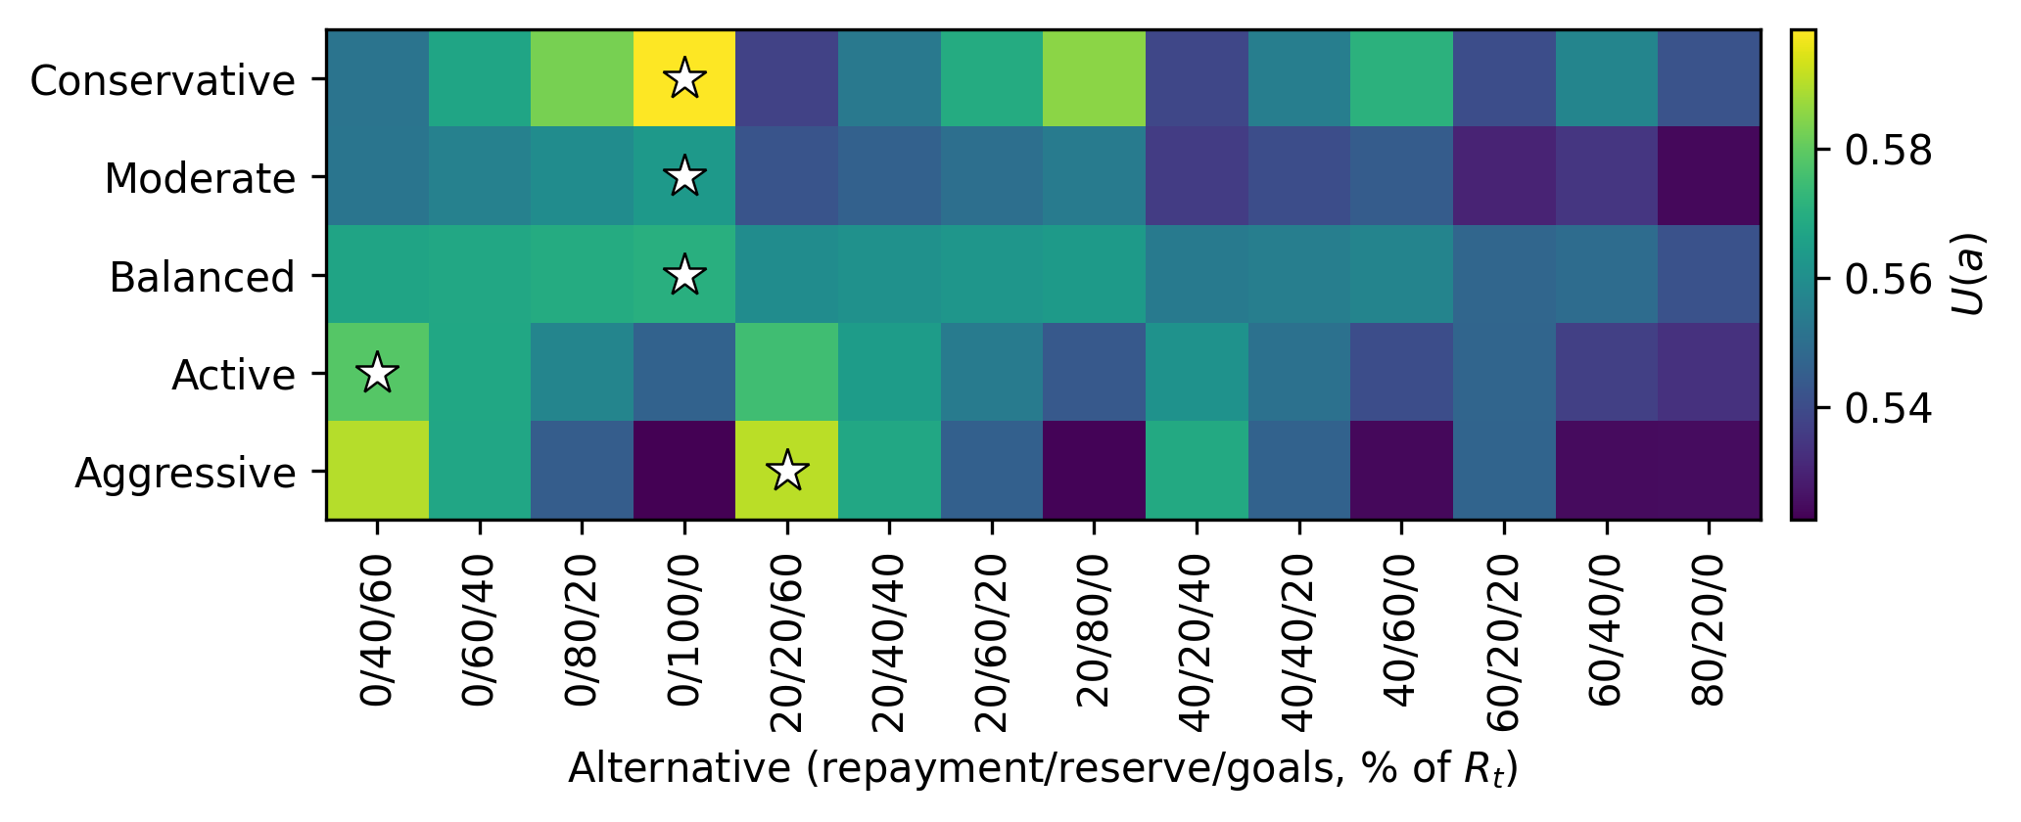
Fig. 2. Utility U(a) of profile C's feasible alternatives across the five risk profiles (refined model). The star marks the profile's optimal alternative. The viridis colormap remains monotone in monochrome print
Ranking stability was tested by perturbing the balanced profile's weights by ±0.05. On profile B, the optimum survives all eight perturbations. On profile C, it survives six of eight; in two cases (lowering the liquidity weight or raising the goal weight by 0.05), the optimum switches to the structurally adjacent alternative “0/40/60” with a utility difference below 0.007. This behavior is boundary-like rather than chaotic: the balanced profile of a comfortable user sits near the border between the “reserve” and “goals” zones, and a small preference shift moves the recommendation into the neighboring zone. For practice this implies showing the user not only the optimum but also the alternatives closest in utility.
3.5. The forecasting block and computational efficiency
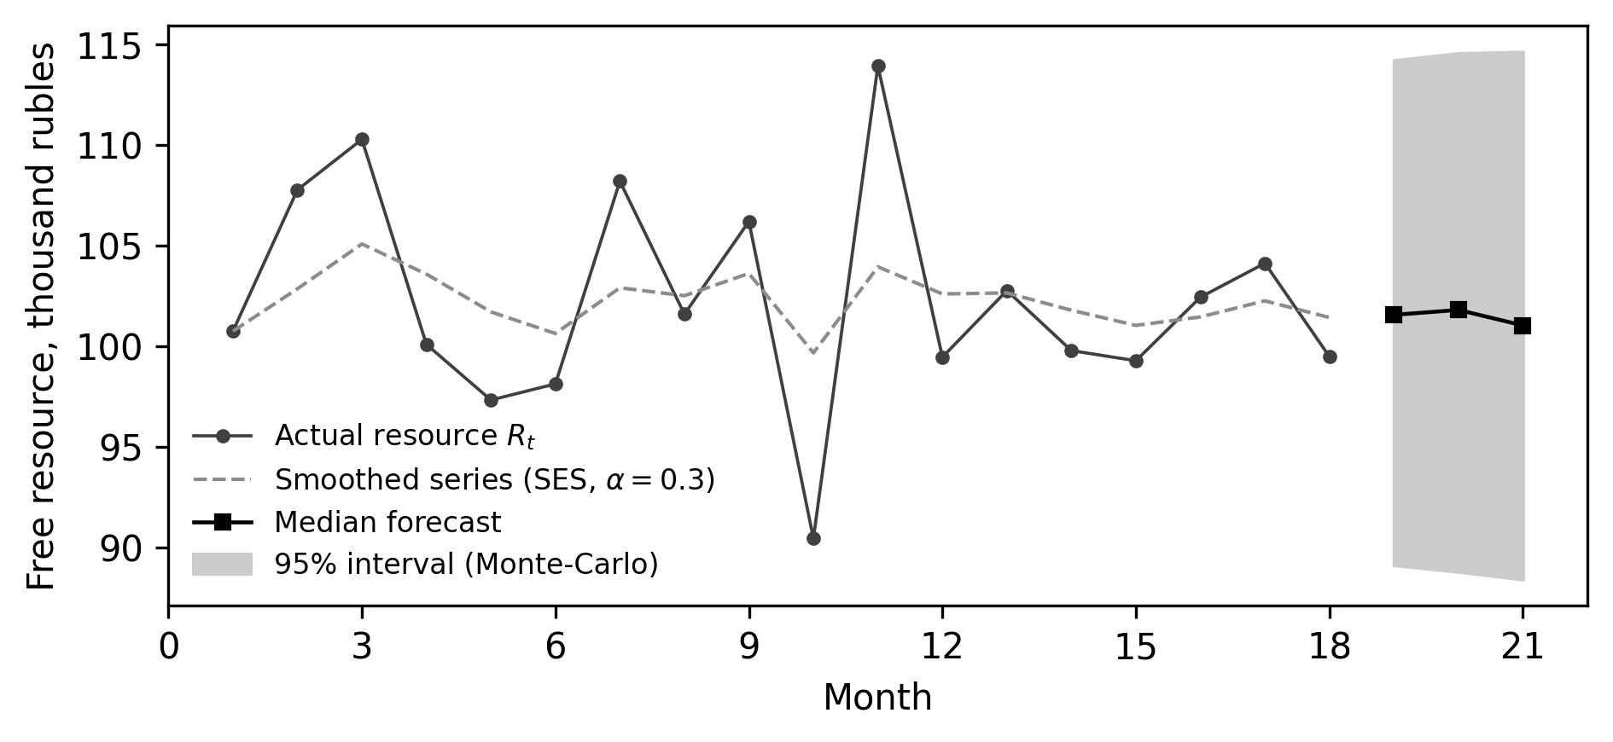
Fig. 3. Forecast of profile C's free resource: the smoothed series, the median forecast, and the 95% interval over 1000 Monte-Carlo scenarios
Figure 3 illustrates the stochastic forecast of profile C's free resource on a synthetic 18-month series: the three-month median is 101.0 thousand rubles with a 95% interval from 88.4 to 114.6 thousand rubles. The interval estimate serves two purposes: in criterion (12) — through the point forecast, and in the explanation of a recommendation — as an honest characterization of uncertainty (“with 95% probability, your free resource in three months will be between … and …”). The computational complexity of the cycle is linear in the numbers of alternatives, obligations, and scenarios; in the Python implementation, a full cycle — generating and evaluating 21 alternatives, the filters, normalization, and ranking for five profiles — takes 0.7 ms, and the stochastic forecast (1000 scenarios, three-month horizon) takes 0.9 ms. The total is under two milliseconds per decision, which comfortably supports interactive use, including instant recomputation when the user changes weights or inputs.
4. Discussion
The main methodological result is that the “natural” criteria specification — resource and liquidity computed from the unallocated remainder plus min-max normalization — looks correct and passes functional testing on typical scenarios, yet systematically degenerates the ranking. The defect is invisible at the level of individual formulas and is revealed only by a computational study of the model as a whole: criteria collinearity (correlation above 0.999) and the normalization-driven stretching of negligible ranges jointly reduce the multi-criteria problem to a single-criterion one. This argues for mandatory computational studies of decision-support models before deployment — functional correctness is not enough.
The proposed norm-based anchoring of scales appears transferable beyond this problem: wherever meaningful norms exist for the criteria (regulatory thresholds, industry benchmarks), normalizing to them is preferable to the sample range — it preserves the economic scale of differences, removes the dependence on the composition of alternatives, and makes normalized values interpretable. The latter property connects directly to the explainability requirement [Rudin, 2019; Miller, 2019]: the user sees scores as “shares of a norm” rather than arbitrary units.
The limitations of this work define its development directions. First, the study uses demonstration profiles that systematically cover qualitatively different state zones; longitudinal validation on real user data is a separate study. Second, the risk-profile weights are set expertly; eliciting them from user preferences (for example, via pairwise comparisons) and calibrating the boundaries of recommendation-switching zones require a controlled user experiment. Third, the forecasting block is limited to simple exponential smoothing; series with seasonality and structural shifts call for more expressive models, while keeping interval uncertainty estimates. Fourth, the threshold rate of the early-repayment filter is a constant and should be updated from market data. Finally, the model is deterministic with respect to goal categories; automatic transaction categorization and the architectural organization of the software implementation are separate problems and are not considered here.
Conclusion
This paper formulated a multi-criteria model for allocating a user's free cash flow between early debt repayment, a liquidity reserve, and savings goals: alternative generation by share discretization, an early-repayment filter based on an opportunity-cost rate threshold, weighted goal scoring with categories and urgency, a feasibility cascade over liquidity and debt load, stochastic cash-flow forecasting, and additive criteria aggregation by risk profile.
A computational study on three demonstration profiles under three liquidity-threshold regimes revealed the degeneracy of the original criteria specification: the collinearity of the resource and liquidity criteria (correlation above 0.999) combined with min-max normalization biases the ranking toward reserve allocations regardless of the risk profile. The proposed refinement — a forecast-based resource criterion that embeds the forecasting block into the utility function, a stock-based liquidity criterion, and norm-anchored normalization — restores meaningful differentiation: conservative profiles build the reserve, active profiles fund goals, and the aggressive profile additionally prepays expensive debt, with the opportunity-cost filter correctly excluding the cheap mortgage from early repayment. The ranking is stable under small weight perturbations, the protective cascade retains its corrective behavior on the over-indebted profile, and a full computation cycle takes under two milliseconds.
Comparison with known results confirms the general finding in the literature that the normalization procedure substantially affects multi-criteria rankings [Jain et al., 2005; Vafaei et al., 2018] and sharpens it for resource-allocation problems: with collinear criteria, sample-based normalization does not merely reorder alternatives — it systematically degenerates the problem. Future work includes eliciting weights from user preferences, longitudinal validation on real data, extending the forecasting block, and calibrating the norm anchors of the scales from market data.
Additional information
Acknowledgements. The author thanks I. S. Bondarenko (NUST MISIS) for supervising the work within which this study was carried out.
Funding. This research received no external funding.
Conflict of interest. The author declares no conflict of interest.
Data and code availability. The source code of the model and of the computational experiment, reproducing all tables and figures, as well as the anonymized data of the survey mentioned in the Introduction, are available from the author on reasonable request.
References
Amar M., Ariely D., Ayal S., Cryder C. E., Rick S. I. Winning the battle but losing the war: the psychology of debt management // Journal of Marketing Research. — 2011. — Vol. 48, SPL. — P. S38–S50. DOI: 10.1509/jmkr.48.SPL.S38.
Arrieta A. B., Díaz-Rodríguez N., Del Ser J. et al. Explainable artificial intelligence (XAI): concepts, taxonomies, opportunities and challenges toward responsible AI // Information Fusion. — 2020. — Vol. 58. — P. 82–115. DOI: 10.1016/j.inffus.2019.12.012.
Bach D. The Automatic Millionaire: a powerful one-step plan to live and finish rich. — New York: Broadway Books, 2004. — 272 p.
Bank of Russia. Ordinance No. 4892-U of 31 August 2018 on types of assets and risk-weight add-ons. — Moscow: Bank of Russia, 2018 (in Russian).
Becker G. S. Human capital: a theoretical and empirical analysis, with special reference to education. — New York: Columbia University Press, 1964. — 187 p.
Blokhina I. M., Ayvazyan N. S., Kazakova L. V., Fedosova Yu. V. Features of personal finance management in modern conditions // Estestvenno-gumanitarnye issledovaniya. — 2025. — No. 3 (59). — P. 624–629 (in Russian).
Fishburn P. C. Methods of estimating additive utilities // Management Science. — 1967. — Vol. 13, No. 7. — P. 435–453. DOI: 10.1287/mnsc.13.7.435.
Gomber P., Koch J.-A., Siering M. Digital finance and FinTech: current research and future research directions // Journal of Business Economics. — 2017. — Vol. 87. — P. 537–580. DOI: 10.1007/s11573-017-0852-x.
Greninger S. A., Hampton V. L., Kitt K. A., Achacoso J. A. Ratios and benchmarks for measuring the financial well-being of families and individuals // Financial Services Review. — 1996. — Vol. 5, No. 1. — P. 57–70. DOI: 10.1016/S1057-0810(96)90027-X.
Hwang C. L., Yoon K. Multiple attribute decision making: methods and applications. — Berlin: Springer-Verlag, 1981. — 259 p.
Hyndman R. J., Koehler A. B., Snyder R. D., Grose S. A state space framework for automatic forecasting using exponential smoothing methods // International Journal of Forecasting. — 2002. — Vol. 18, No. 3. — P. 439–454. DOI: 10.1016/S0169-2070(01)00110-8.
Jain A., Nandakumar K., Ross A. Score normalization in multimodal biometric systems // Pattern Recognition. — 2005. — Vol. 38, No. 12. — P. 2270–2285. DOI: 10.1016/j.patcog.2005.01.012.
Kachanova L. S., Plaksa M. A. Customization of personal finance information products as a means of household economic security // Ekonomika i predprinimatelstvo. — 2025. — No. 6 (179). — P. 1417–1425 (in Russian).
Lusardi A., Mitchell O. S. The economic importance of financial literacy: theory and evidence // Journal of Economic Literature. — 2014. — Vol. 52, No. 1. — P. 5–44. DOI: 10.1257/jel.52.1.5.
Lytton R. H., Garman E. T., Porter N. M. How to use financial ratios when advising clients // Financial Counseling and Planning. — 1991. — Vol. 2. — P. 3–23.
Malyonkina T. M., Ponyaeva E. V. Digitalization of personal finance management // Mnogourovnevoe obshchestvennoe vosproizvodstvo: voprosy teorii i praktiki. — 2024. — No. 1 (42). — P. 77–81 (in Russian).
Metropolis N., Ulam S. The Monte Carlo method // Journal of the American Statistical Association. — 1949. — Vol. 44, No. 247. — P. 335–341. DOI: 10.1080/01621459.1949.10483310.
Miller T. Explanation in artificial intelligence: insights from the social sciences // Artificial Intelligence. — 2019. — Vol. 267. — P. 1–38. DOI: 10.1016/j.artint.2018.07.007.
Rudin C. Stop explaining black box machine learning models for high stakes decisions and use interpretable models instead // Nature Machine Intelligence. — 2019. — Vol. 1. — P. 206–215. DOI: 10.1038/s42256-019-0048-x.
Vafaei N., Ribeiro R. A., Camarinha-Matos L. M. Data normalisation techniques in decision making: case study with TOPSIS method // International Journal of Information and Decision Sciences. — 2018. — Vol. 10, No. 1. — P. 19–38. DOI: 10.1504/IJIDS.2018.090667.
Velasquez M., Hester P. T. An analysis of multi-criteria decision making methods // International Journal of Operations Research. — 2013. — Vol. 10, No. 2. — P. 56–66.
Zopounidis C., Doumpos M. Multi-criteria decision aid in financial decision making: methodologies and literature review // Journal of Multi-Criteria Decision Analysis. — 2002. — Vol. 11, No. 4–5. — P. 167–186. DOI: 10.1002/mcda.333.
Author information
Vasilii M. Evdokimov — Department of Automated Control Systems, National University of Science and Technology MISIS, 4 Leninskiy Prospekt, Moscow, 119049, Russia; e-mail: m2201058@edu.misis.ru; ORCID: 0009-0004-8821-8414.

