Eliciting and Prioritising Requirements for an Explainable Personal-Finance Decision-Support System: An Empirical Study of Stated versus Revealed Decision Behaviour
Vasilii M. Evdokimov
National University of Science and Technology MISIS (NUST MISIS), Moscow, Russia
ORCID: 0009-0004-8821-8414 · m2201058@edu.misis.ru
Abstract
Personal-finance decision-support systems (DSS) are proliferating, yet adoption depends less on algorithmic sophistication than on whether a system matches how people actually decide and whether it earns their trust. This paper reports a requirements-engineering study that derives and prioritises requirements for an explainable personal-finance DSS from a quantitative survey of 385 respondents (322 valid after attention-check filtering). The method combines descriptive statistics, hypothesis testing with effect sizes and Holm correction for multiplicity, a stated-versus-revealed behavioural probe, a factor diagnostic of a four-criteria decision battery, and thematic coding of open responses. We observe a pronounced intention–action gap: 46% of respondents state that they allocate money by rational calculation, but in a concrete decision task only 10% actually computed a trade-off while 63% decided emotionally. Demand for an automated advisor is high (84%) but conditional on transparency (67% require a numeric explanation; 61% require a transparent algorithm), and trust collapses from explanation (74–79%) to autonomous money movement (16%). Debt presence is strongly associated with the repay-versus-save dilemma (Cramér's V = 0.62). From these findings we derive a catalogue of functional and non-functional requirements and prioritise them with RICE and MoSCoW, producing a transparency-first, 'external System 2' design whose central requirement is to compute the allocation and explain it at the moment of decision. We report threats to validity and lessons for instrument design.
Keywords: requirements engineering; empirical software engineering; decision-support systems; personal finance; explainability; user study; RICE; MoSCoW.
1. Introduction
Decisions about how to allocate disposable income — between repaying debt, building a liquidity reserve and funding goals — are made repeatedly by almost every adult, and their cumulative effect over years is large. These decisions are also unusually sensitive to error: a misallocation can leave a household short of liquidity or deepen its debt burden. A growing class of personal-finance applications and fintech services aims to support such decisions, but in practice most of them display retrospective statistics rather than recommend a next step, and the recommendations they do offer are rarely explained.
The difficulty is only partly technical. Two non-technical factors dominate adoption. First, behaviour: people frequently intend to decide rationally yet fall back on intuition at the moment of choice. Second, trust: a recommendation that cannot be inspected is easily dismissed, especially when it concerns money. Requirements for such systems, however, are often derived top-down from domain assumptions rather than from evidence about how users actually behave and what would make them rely on an automated advisor.
This paper addresses that gap. We treat the construction of a personal-finance DSS as a requirements-engineering problem and derive its requirements empirically, from a survey of 385 respondents (322 valid). The study has two distinctive features for software engineering. First, it pairs stated preferences with a revealed-behaviour probe, exposing an intention–action gap that reframes the system's core purpose. Second, it treats explainability not as a feature but as a non-functional precondition for adoption, and shows quantitatively how user trust depends on it. The target system is kept anonymous throughout; this is a study of method and evidence, not a product description.
We investigate four research questions:
- RQ1. How do individuals currently manage personal-finance allocation, and which tools and methods do they use?
- RQ2. Is there a gap between stated (intended) rational decision-making and revealed behaviour in a concrete task?
- RQ3. Which functional and non-functional requirements for a DSS can be derived from user pains and expectations, and how should they be prioritised?
- RQ4. What conditions govern user acceptance of an automated financial advisor, in particular regarding explainability and autonomy?
The remainder of the paper is organised as follows. Section 2 reviews background and related work. Section 3 describes the study design. Section 4 reports results by research question. Section 5 derives and prioritises the requirements. Section 6 discusses threats to validity, and Section 7 concludes.
2. Background and Related Work
Requirements elicitation through surveys and questionnaires is a standard technique in requirements engineering, valued for reach and comparability, and limited by self-report bias and shallow coverage [7, 8, 16]. Our design follows the empirical-software-engineering tradition of pairing elicitation with explicit validity analysis [16, 17], and augments self-report with a behavioural probe to mitigate the best-known weakness of surveys.
The behavioural framing draws on dual-process theory, which distinguishes fast, intuitive judgement from slow, deliberate reasoning [1], and on the intention–behaviour gap documented in social psychology, whereby stated intentions translate only weakly into action [2, 3]. In the financial domain, this gap motivates interventions that lower the effort of the deliberate path [15]. We use these ideas not to model users but to interpret an observed discrepancy and to motivate a design that performs the computation on the user's behalf.
Acceptance and trust are treated through the technology-acceptance literature [6] and research on trust in automation, which shows that appropriate reliance depends on transparency and on the match between perceived and actual system capability [4]. Work on explanation in artificial intelligence stresses that useful explanations are contrastive and audience-appropriate [5]. These results justify our decision to elevate explainability to a non-functional requirement and to bound the system's autonomy. For prioritisation we use two widely adopted schemes: MoSCoW categorisation [10] and RICE scoring, complementing the qualitative ordering with a reach–impact–confidence–effort estimate.
3. Study Design
3.1. Objectives and research questions
The objective was to obtain an evidence base for the requirements of a personal-finance DSS, covering current practice (RQ1), the stated–revealed behaviour gap (RQ2), derived and prioritised requirements (RQ3), and acceptance conditions (RQ4). The study is observational and cross-sectional.
3.2. Instrument
Data were collected with an online questionnaire of 77 items (62 substantive questions; the remainder matrix sub-items and service fields). The instrument comprised blocks on current financial management; perceived pains and expectations; a four-criteria importance battery (disposable resource, liquidity, debt burden, safety); a behavioural case task contrasting stated and revealed decision-making; attitudes towards an automated advisor and its acceptable degree of autonomy; willingness to pay; and demographics. An attention check ('select seven stars') was embedded to identify inattentive submissions.
3.3. Sample and data cleaning
The questionnaire received 385 responses. After removing 63 submissions that failed the attention check, 322 valid responses remained; submissions collected before the attention check was introduced and otherwise consistent were retained. Because the instrument was extended during data collection and the closed questions were mandatory, the valid base size varies by item rather than reflecting dropout; the representativeness of the later cohort was checked against the earlier one. Three sub-blocks (the criteria battery, the behavioural case and the AI-trust items) rest on approximately 19 responses and are reported as preliminary.
3.4. Analysis
Descriptive statistics summarise practice, pains and expectations. Associations were tested with the chi-square test and reported with Cramér's V as an effect size [11, 14]; no p-value is reported without an accompanying effect size, and the Holm step-down procedure was applied to control the family-wise error rate across multiple comparisons [12]. The stated–revealed comparison contrasts the proportion claiming rational calculation with the proportion that actually computed in the case task. The internal structure of the four-criteria battery was examined with Cronbach's alpha [13]. Open responses were coded thematically. Finally, findings were mapped to candidate requirements, which were prioritised with RICE and MoSCoW [10]. One planned block — a drag-and-drop ranking of criteria — produced only five valid permutations out of nineteen because of the form's interaction mechanics and was excluded from analysis; we return to this as a methodological lesson in Section 6.
4. Results
4.1. RQ1 — Current practice
Most respondents rely on passive, retrospective tools: 70.1% use the statistics built into their banking application, 23.1% keep notes on their phone, 20.3% use a spreadsheet and 18.7% use a dedicated budgeting application; 11.4% use nothing at all and 7% use AI assistants (Figure 1). The dominant theme in open responses about abandoning previous tools was that they 'only show statistics' and provide no next step. Current practice is therefore oriented towards looking back at spending rather than deciding what to do with money that remains.
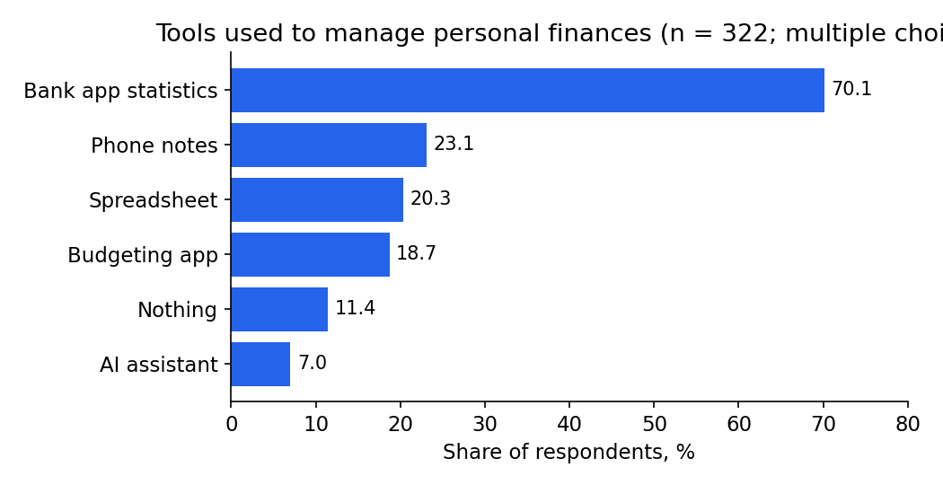
Figure 1. Tools used to manage personal finances (multiple choice).
4.2. RQ2 — The intention–action gap
When asked how they decide where to direct money, 46% described a rational, calculated approach. In a concrete case task — answered by a smaller behavioural sub-sample — only 10% actually performed a calculation, while 63% reported deciding on emotion, a gap of 36 percentage points between stated and revealed behaviour (Figure 2). The pattern is consistent with dual-process accounts [1]: deliberate reasoning is claimed in the abstract but is displaced by fast, intuitive judgement at the moment of decision. This is the study's central finding, and although the revealed-behaviour probe is indicative rather than definitive, it is corroborated by the large-sample demand for transparency (Section 4.4) and reframes the system's purpose: the value of a DSS here is less to inform a calculation the user would otherwise perform than to perform the calculation on the user's behalf and present the result at the moment of hesitation — an 'external System 2'.
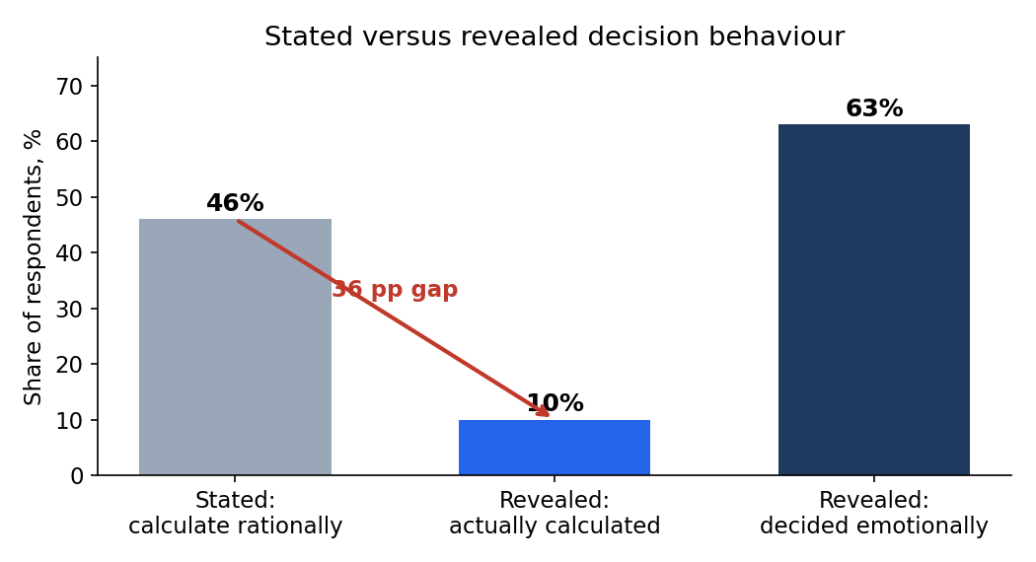
Figure 2. The intention–action gap: a rational approach is claimed far more often than it is enacted.
4.3. RQ3 — Pains and expectations
The single strongest expectation was visibility of disposable cash flow: how much money remains after all obligatory payments was the top must-have (61%) and ranked highest under RICE scoring. Beyond it, 62% wanted to compare alternatives, 48% wanted to see the consequences of a choice in advance, and 38% wanted a predictive warning of an impending shortfall. The most cited pains were an overloaded interface and not knowing where to start, a predictive 'funds will be insufficient' concern (32%), and the absence of any explanation of the advice given (22%). On the preferred form of advice, 59% favoured a visualisation or comparison, 45% wanted concrete numbers, and 19% wanted a single short action — a split that argues for layering rather than choosing one format.
4.4. RQ4 — Acceptance conditions
Demand for an automated advisor was high (84%) but explicitly conditional: 67% said they would trust it only if it explained its reasoning with numbers, and 61% only if the algorithm were transparent. Acceptance also depended sharply on autonomy. Trust was high for an advisor that computes or explains (74–79%) but collapsed to 16% for one that decides and moves money by itself (Figure 3), implying a recommend-and-confirm interaction rather than an autopilot.
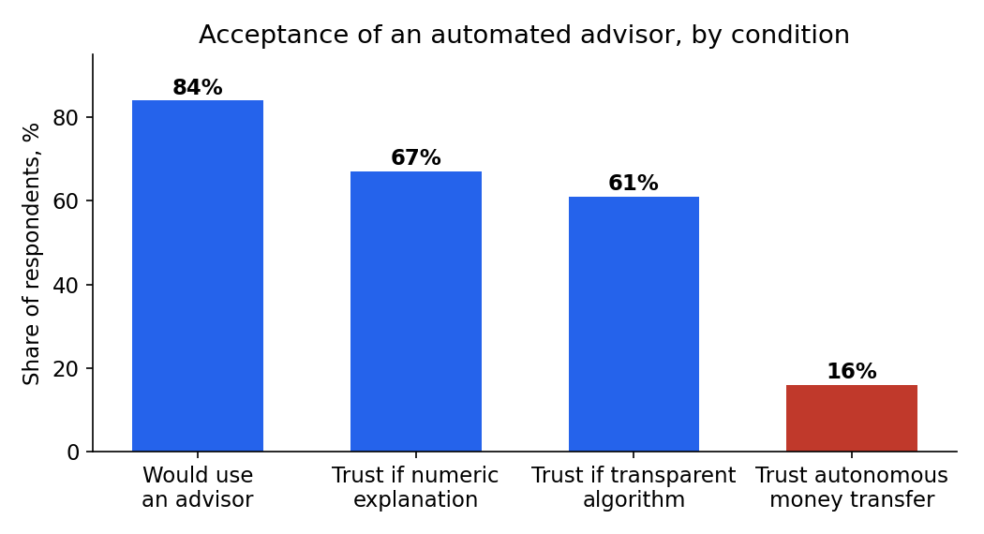
Figure 3. Acceptance is conditional on transparency and collapses when the system acts autonomously.
Two debt-related results are notable. The presence of debt was strongly associated with experiencing the repay-versus-save dilemma (Cramér's V = 0.62), and 40% of respondents with debt reported facing it; debtors were also significantly more anxious about missing a payment. Finally, the four-criteria importance battery returned a low Cronbach's alpha (0.632). Rather than indicating an unreliable scale, this is consistent with the criteria measuring largely independent constructs — empirical support for treating them as separate, independently weighted dimensions rather than collapsing them into one score. Willingness to pay was modest: 54% would pay no more than 200 RUB per month, a constraint with direct consequences for the business model.
5. From Findings to Requirements
Three design principles follow directly from the evidence and govern the requirements below. First, transparency is a precondition, not an embellishment: demand for an advisor is high but conditional on numeric, inspectable explanations (Section 4.4). Second, the system should act as an external System 2 — it should perform the computation and present the result at the moment of decision, because users intend to calculate but do not (Section 4.2). Third, it should advise and wait for confirmation rather than act autonomously, because trust in autonomous money movement is very low (Section 4.4).
Table 1 lists the functional (FR) and non-functional (NFR) requirements derived from the findings, each traced to its supporting evidence and prioritised with MoSCoW. RICE scoring was applied in parallel; the requirement to surface disposable cash flow scored highest (RICE 1.83) and, together with the explainability requirement, anchors the minimum viable product. The catalogue is deliberately transparency-first: the explanation of a recommendation is itself a Must-have requirement, not an optional addition to a recommender.
Table 1. Requirements derived from the study, with supporting evidence and MoSCoW priority.
Requirement | Type | Key empirical evidence | Priority
Compute and surface disposable cash flow (income − expenses − obligatory payments) as the primary screen | FR | Top expectation (61% must-have); highest-ranked item under RICE (1.83) | Must
Generate an allocation recommendation across debt repayment, reserve and goals | FR | Core unmet need: 'does not tell me where to put the money' (open responses) | Must
Explain each recommendation: the underlying calculation, the compared alternatives, and why others were rejected | FR/NFR | 'Does not explain the logic of advice' — pain for 22%; 67% trust only with a numeric explanation; 61% require a transparent algorithm | Must
Let the user compare the top alternatives, not only the best one | FR | 62% want to compare alternatives | Should
Provide 'what-if' scenarios with instant recomputation of indicators | FR | 48% want to see consequences of a choice in advance | Should
Raise a predictive 'funds will be insufficient' alert before a due payment | FR | Pain for 32%; expectation for 38% | Should
Give a direct, explained 'repay-vs-save' verdict | FR | Strongest association in the data (debt ↔ dilemma, V = 0.62); 40% of debtors faced it | Should
Trigger a recommendation at the moment income arrives | FR | Intention–action gap: computation is needed at the moment of hesitation | Should
Segmented onboarding with layered advice (verdict → numbers → visual) | FR | Format preferences split: 59% visual, 45% numeric, 19% short action | Should
Risk-based payment reminders (only on real risk) | FR | Debtors fear missed payments (H4); but notifications are the 3rd irritant (25%) | Could
Minimal cognitive load: one key indicator and one action per screen | NFR | 'Overloaded interface' and 'do not know where to start' are top irritants | Must
Human-in-the-loop: never move money autonomously | NFR | Trust collapses from explain/compute (74–79%) to autonomous transfer (16%) | Must
Reproducibility and determinism of every recommendation | NFR | Transparency precondition; auditability of advice | Must
Affordability / freemium model | NFR | 54% willing to pay ≤ 200 RUB per month | Could
Autonomous financial actions | — | Lowest trust (16%); out of scope by design | Won't (now)
The prioritisation makes the dependency structure explicit. The Must-have set establishes the trust foundation — a single, clearly explained disposable-cash-flow figure, an explained recommendation, low cognitive load and a human-in-the-loop guarantee — and consists largely of exposing computation the engine can already perform rather than of new algorithms. The Should-have set addresses the strongest specific pains: the repay-versus-save verdict (the largest effect in the data), the predictive shortfall alert, what-if scenarios and the moment-of-decision trigger. Could-have and Won't-have items reflect either weak demand under a tight willingness-to-pay ceiling or the explicit autonomy boundary.
6. Validity and Scope
The design controls the principal validity concerns. The central finding — the intention–action gap — is established not by self-report alone but by contrasting stated approach with revealed behaviour in a concrete task, with inattentive respondents removed by an attention check; any residual desirability bias would inflate the stated-rational figure and thus widen rather than create the gap. The behavioural probe is answered by a smaller sub-sample and is therefore indicative, but it converges with the large-sample demand for transparency. Associations are reported with effect sizes and the family-wise error rate is controlled with the Holm procedure, so the reported relationships are conservative.
The four-criteria battery returned a low Cronbach's alpha (0.632), which we read as evidence that the criteria capture largely independent constructs rather than as low reliability; confirming this with a confirmatory factor analysis on a larger sample is a natural next step. The study draws on a longitudinal real-world evidence base and on a focused first segment of respondents — younger, capital-city users with modest income and small debts — for whom the design is directly applicable; extending the evidence to debt-bearing households is the main aim of the planned second wave. A drag-and-drop ranking block was excluded after its interaction mechanics produced inconsistent permutations, which motivates the instrument-design recommendation to favour pairwise comparison or fixed-budget point allocation.
7. Conclusion
We derived and prioritised requirements for an explainable personal-finance decision-support system from an empirical study of 385 respondents (322 valid), combining descriptive and inferential statistics with a stated-versus-revealed behavioural probe. The central result is an intention–action gap — 46% claim to calculate, 10% actually do — which reframes the system as an external System 2 that performs the computation and presents the result at the moment of decision. Acceptance of such a system is high but conditional on transparency and on bounded autonomy, which we therefore encode as non-functional preconditions. The resulting transparency-first requirement set, prioritised with RICE and MoSCoW, places an explained disposable-cash-flow recommendation at the centre of the minimum viable product.
For software engineering practice, the study illustrates the value of pairing requirements elicitation with a behavioural probe and of treating explainability as a first-class requirement in decision-support systems. Future work includes a second survey wave that broadens the sample to debt-bearing households, enlarges the under-powered sub-blocks, replaces the invalidated ranking instrument, and confirms the independence of the four decision criteria through confirmatory factor analysis.
Acknowledgements
The author thanks I. S. Bondarenko for scientific supervision.
Declarations
Funding: none. Conflicts of interest: the author declares no conflict of interest. Data availability: the anonymised survey data are available from the author on reasonable request.
References
- Kahneman D. Thinking, Fast and Slow. New York: Farrar, Straus and Giroux, 2011.
- Sheeran P. Intention–behavior relations: A conceptual and empirical review. European Review of Social Psychology, 2002, vol. 12, no. 1, pp. 1–36.
- Sheeran P., Webb T. L. The intention–behavior gap. Social and Personality Psychology Compass, 2016, vol. 10, no. 9, pp. 503–518.
- Lee J. D., See K. A. Trust in automation: Designing for appropriate reliance. Human Factors, 2004, vol. 46, no. 1, pp. 50–80.
- Miller T. Explanation in artificial intelligence: Insights from the social sciences. Artificial Intelligence, 2019, vol. 267, pp. 1–38.
- Davis F. D. Perceived usefulness, perceived ease of use, and user acceptance of information technology. MIS Quarterly, 1989, vol. 13, no. 3, pp. 319–340.
- Sommerville I. Software Engineering. 10th ed. Harlow: Pearson, 2015.
- Pohl K. Requirements Engineering: Fundamentals, Principles, and Techniques. Berlin: Springer, 2010.
- Glinz M. On non-functional requirements. Proc. 15th IEEE International Requirements Engineering Conference (RE'07), 2007, pp. 21–26.
- Clegg D., Barker R. Case Method Fast-Track: A RAD Approach. Wokingham: Addison-Wesley, 1994.
- Cohen J. Statistical Power Analysis for the Behavioral Sciences. 2nd ed. Hillsdale: Lawrence Erlbaum, 1988.
- Holm S. A simple sequentially rejective multiple test procedure. Scandinavian Journal of Statistics, 1979, vol. 6, no. 2, pp. 65–70.
- Cronbach L. J. Coefficient alpha and the internal structure of tests. Psychometrika, 1951, vol. 16, no. 3, pp. 297–334.
- Cramér H. Mathematical Methods of Statistics. Princeton: Princeton University Press, 1946.
- Thaler R. H., Benartzi S. Save More Tomorrow: Using behavioral economics to increase employee saving. Journal of Political Economy, 2004, vol. 112, no. S1, pp. S164–S187.
- Hofmann H. F., Lehner F. Requirements engineering as a success factor in software projects. IEEE Software, 2001, vol. 18, no. 4, pp. 58–66.
- Wohlin C., Runeson P., Höst M., Ohlsson M. C., Regnell B., Wesslén A. Experimentation in Software Engineering. Berlin: Springer, 2012.

