Problem on compiling egl / opengl sample applications with sunxi-mali library

1. sunxi-mali
https://github.com/linux-sunxi/sunxi-mali.git

2. compiling opengl sample applications with sunxi-mali library

Follow below link to create a sample application.
https://people.freedesktop.org/~idr/OpenGL_tutorials/02-GLSL-hello-world.html#frag-shader

see the source file in
https://github.com/vewe-richard/openwrt-orange-pi.git
multilangs/c/hellofunc.c

compiling by command,
make V=s package/helloworld/{clean,compile}

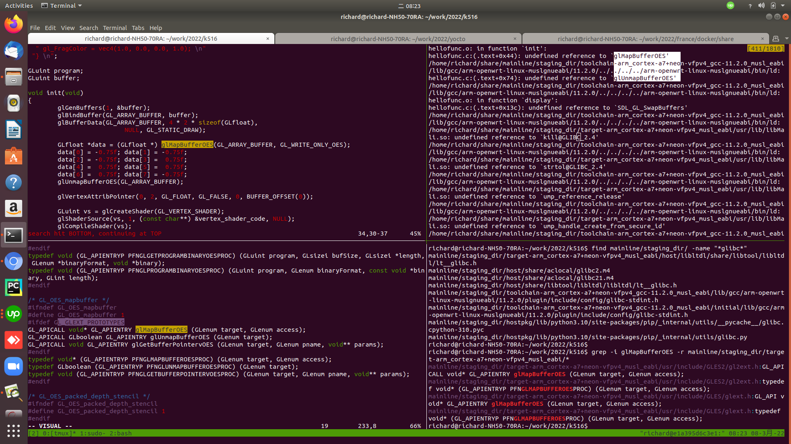
see the picture.
Left-UP window: the c code follow the tutorial, highlight calling to glMapBufferOES()
Left-Down window: prototype of glMapBufferOES(), here you see, it depends on definition of GL_GLEXT_PROTOTYPES
Right-UP window: compiling pass, but link stage failed, due to undefined reference to glMapBufferOES
Right-Down window: Can find glMapBufferOES() in header files, but not in binary.
This means, tutorial use GL_GLEXT_PROTOTYPES, but the mali library does not contain it.

3. compiling egl sample applicaton with sunxi-mali library

Follow below link to create a sample application.
https://forums.developer.nvidia.com/t/egl-without-x11/58733

see the source file in
https://github.com/vewe-richard/openwrt-orange-pi.git
multilangs/c/egltutorial.c

compiling by command,
make V=s package/helloworld/{clean,compile}

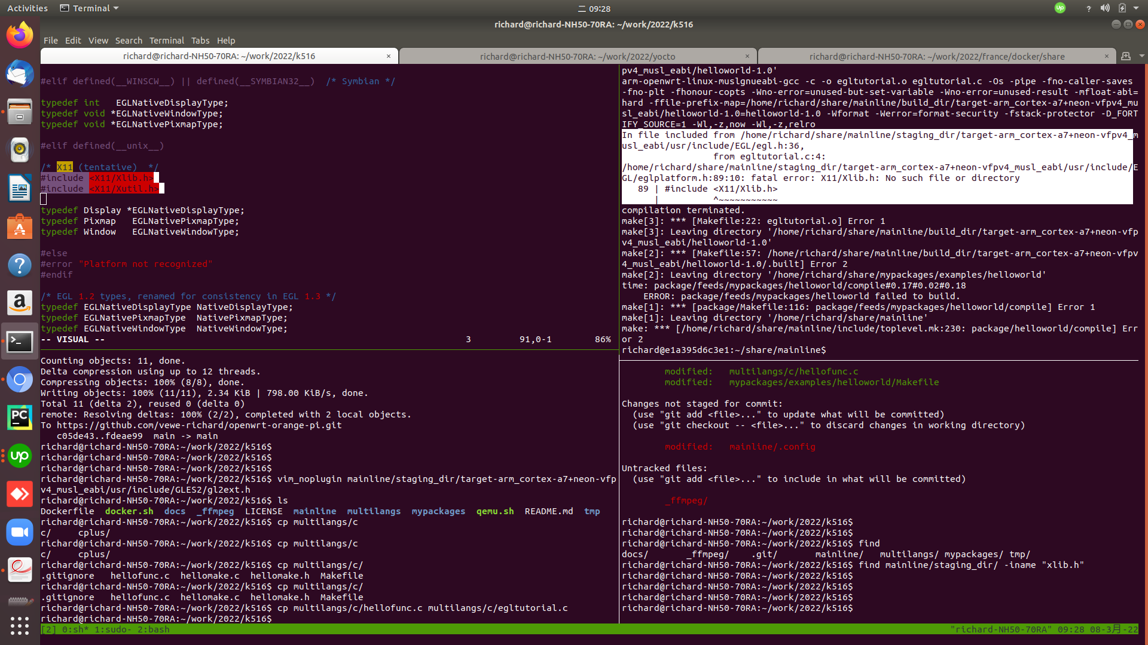

It means, old egl.h in sunx-mali package depends on x11 header files,
But latest egl in https://github.com/mesa3d/mesa/ can exclude x11 from depending list.

