The English++ Book
Three words a line - for kids, and for everyone

Learn three words a line. Run it like a game. Build real Windows programs.
For English++ Studio 3
What is inside
Part 1: Start Here 6
1. How to Read This Book 7
2. Hello! 9
3. Your First Program 12
4. The Three Words 16
5. How to Read a Root 22
Part 2: The Basics 27
6. Names and Values 28
7. Printing 36
8. Math 40
9. Text 49
10. Yes, No and Tests 54
11. If and Otherwise 57
12. Loops 65
13. More Ways With Text 76
Part 3: Many Things 79
14. Lists 80
15. Asking a List 89
16. Maps 92
17. Other Collections 96
Part 4: Your Own Words 103
18. Functions 104
19. Functions in a Name 114
20. Lists and Functions Together 117
21. More About Functions 122
22. Any Kind 126
23. Your Own Kinds of Things 129
24. Children 138
25. More Kinds of Your Own 146
Part 5: Power Tools 150
26. Pointers 151
27. More Tricks for Your Classes 157
28. Bits and Huge Numbers 160
29. When Things Go Wrong 163
30. Checks and Tests 169
31. Talking With Your Program 173
32. Files 177
33. The Clock 183
34. At the Same Time 186
35. Threads That Talk 192
36. Groups and Other Files 195
37. The World Outside 198
38. Bytes, Codes and Other Computers 201
39. Any C++, Any Library 205
Part 6: Projects 215
40. Project: Guess the Number 216
41. Project: A Shopping List That Remembers 220
42. Project: A Pet Shop 226
43. Project: Catch the Stars 232
Part 7: Looking Things Up 239
44. The Studio's Tools 240
45. When the Studio Says Something 243
46. Better Than C++ 252
47. Words People Use 255
48. Answers 257
49. The Cheat Sheet 276
50. The Whole Chart 279
Part 8: English++ Classic 294
51. English++ Classic 295
52. Classic: Hello! 296
53. Your First Program 298
54. Notes for People 299
55. Boxes for Things 300
56. Changing Things 302
57. Doing Math 303
58. Words and Letters 304
59. Asking Questions: If 305
60. Doing Things Again: Loops 307
61. Choosing by Value: Check 309
62. Collections: Many Things in One 310
63. Your Own Functions 312
64. Functions in Boxes 313
65. Your Own Kinds of Things: Boxx 314
66. When Things Go Wrong 316
67. Waiting and Time 317
68. Talking With Your Program 318
69. Saving to Files 319
70. Talking to the World 320
71. The Box World 322
72. Many Files 323
73. Teaching English++ New Words 324
74. Libraries: Superpowers 325
75. Three Forms: Regular, Compressed and Blueprint 331
76. Blueprints: Programs You Can See 332
77. C++ Overpowered: Real C++ You Can See 336
78. English++ Studio 349
79. Extra Powers 351
80. A Whole Game 353
Classic Appendix A. Every Word and Its Code 354
Classic Appendix B. The Standard Library 360
Classic Appendix C. The Libraries' Words 365
Classic: Words to Know 369

Part 1: Start Here
What a program is, your very first program, and how to read the words.

1. How to Read This Book
This book teaches you how to write programs in English++.
You don't need to know anything first. If you can read this sentence, you can start.
Read the chapters in order. Each chapter uses what the one before it taught. Later on, when you just want to look something up, go to the last part of the book.

The colored boxes
You'll see these boxes all through this book. Here they are.
A purple box is a program. You can type it into the Studio and run it.
out prn "Hello!"
A dark box shows what the program prints on the screen.
Hello!
Every program in this book was built and run when the book was made. If the dark box says a program prints Hello!, then it prints Hello!
When a program asks a question, the answer you type is shown in yellow:
name get "What is your name? "
out prn "Hello, @name!"
What is your name? Ada
Hello, Ada!
Tip! A yellow box is a helpful hint.

Try it! A green box is something for you to do. Trying things is the best way to learn. The answers are in the chapter called Answers, near the back of the book.

Watch out! A red box warns you about a mistake that many people make.

Sometimes this book shows a program with a mistake in it, on purpose. Then you can see what the Studio says about it. The pale red box is the program, and the words under it are the Studio's real words:
x is 6 7
The Studio says: Line 1: This line has 4 words. Every line has exactly 3: who, the root, and what. Text with spaces goes in quotes, and & joins values into one word: add&1&2.

Mistakes are normal. Everybody makes them, all day long. The Studio finds them and tells you how to fix them.

Say it out loud
Programs look strange at first. It helps to read them out loud. So when a program shows something new, this book often puts a table after it. The table tells you how to say each line.
Line | Say it
out prn "Hello!" | Print Hello on the screen.

Try it. Say the words on the right while you look at the words on the left. After a while, you will read programs the way you read this page.

You don't have to remember it all
English++ has about 280 words in all. Don't try to learn them by heart.
You will use about 20 of them all the time, and those will stick by themselves. For the others, the letters of the word tell you what it means. The Studio can also show you what any word means. You only have to point at it.
The word Studio in this book means English++ Studio. It is the program you use to write your own programs.

2. Hello!
A program is a list of things for a computer to do. The computer does them one at a time, from the top of the list to the bottom.
English++ is a language for writing those lists. Every line in it has exactly three words.
Here is a whole program:
out prn "Hello, V!"
Hello, V!
That's it. Those three words are the program.
Word | What it means
out | the screen
prn | print a line
"Hello, V!" | what to print

Text between quote marks counts as one word, even if it is long.

Every line is three things
Every line, in every program, tells the computer three things: who, what it does, and what with.
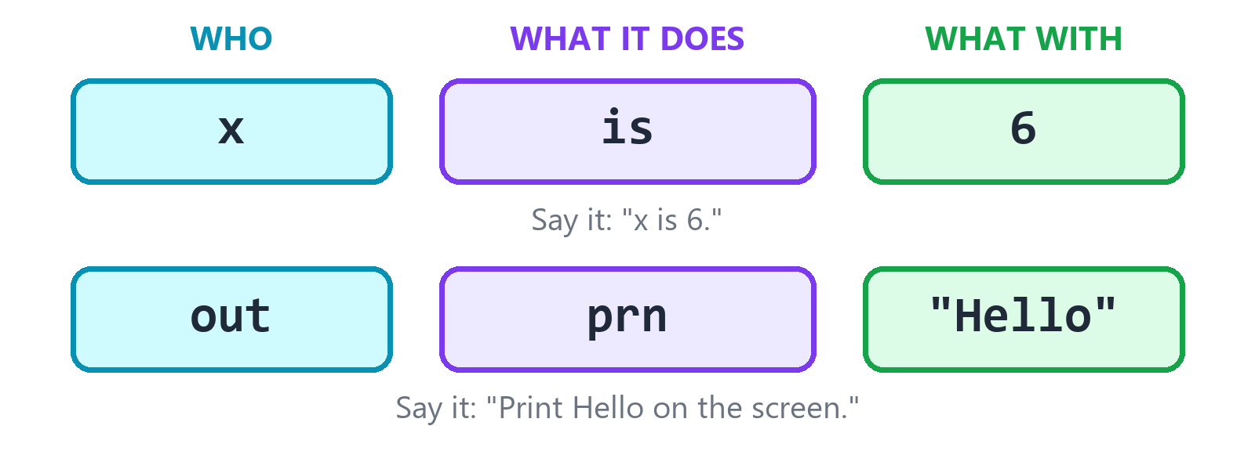
Every line has three spots. Each spot holds one word.
So there are always three spots. You always know where to look.
Here is a program with three lines. That means three small jobs, one after the other:
x is 6
x add 1
out prn x
7
Line | Say it
x is 6 | x is 6.
x add 1 | Add 1 to x.
out prn x | Print x on the screen.

First x is 6. Then x becomes 7. Then the program prints 7.

Words made of letters that mean something
In Hebrew, words are built from roots of three letters, and readers fill in the vowels themselves. English++ works the same way.
The middle word of a line is called a root. Almost every root has three letters:
- The first letter says which family the root belongs to.
- The other two letters say which one it is.
So igt is i + gt. The letter i means if, and gt means greater than. Put them together and you get if greater than. When you know the letters, you know the word. A whole chapter shows you how that works, very soon.

It really is C++
C++ is the language that big games and big apps are written in. It is powerful, but it is full of odd marks, and it's hard to learn.
Every line of English++ turns into a line of C++ when you run your program:
You write | The C++ it turns into
x is 6 | int x = 6;
x add 1 | x += 1;
x igt 3 | if (x > 3) {
out prn x | std::cout << x << std::endl;

You never have to look at the C++. But you can if you want to. The Studio shows it to you, side by side with your program.
This means two things. Your programs are real C++ programs, so most of them run about as fast as C++ written by hand. (The chapter Better Than C++ has the numbers, and shows where C++ is still faster.) And look at what you never have to type: curly brackets, round brackets, semicolons, commas, colons and dots.

What you learned
New idea | What it means
program | a list of things for a computer to do
a line | exactly three words: who, what it does, what with
root | the middle word: a family letter and two more letters
C++ | the language every English++ program turns into

Try it! Read this line out loud, using the table above to help: out prn "I can read this!". What will it print?

3. Your First Program
Let's make a real program. It takes about one minute.

Make a project
A project is a folder that holds your program.
- Open English++ Studio.
- Click New Project.
- Pick Console App. A console app is a program that talks to you with words.
- Look at the Form box. Leave it on English++, the one that says three words on every line.
- Type a name for your project, like MyFirstProgram.
- Click Create.
The Studio makes the program for you, in a file called main.epp. It looks like this:
note Hello V: your first English++ program. Press Run (F5).
out prn "Hello, V!"

Run it
Press the F5 key. (Or click the Run button. It does the same thing.)
Look at the Output panel at the bottom of the window. It says:
Hello, V!
You did it! You just ran a real program. Your words turned into C++, and the C++ turned into something your computer can run.
Try it! Change the words between the quote marks to your own name, like "Hello, Sam!". Press F5 again. The Output panel will show your new words.

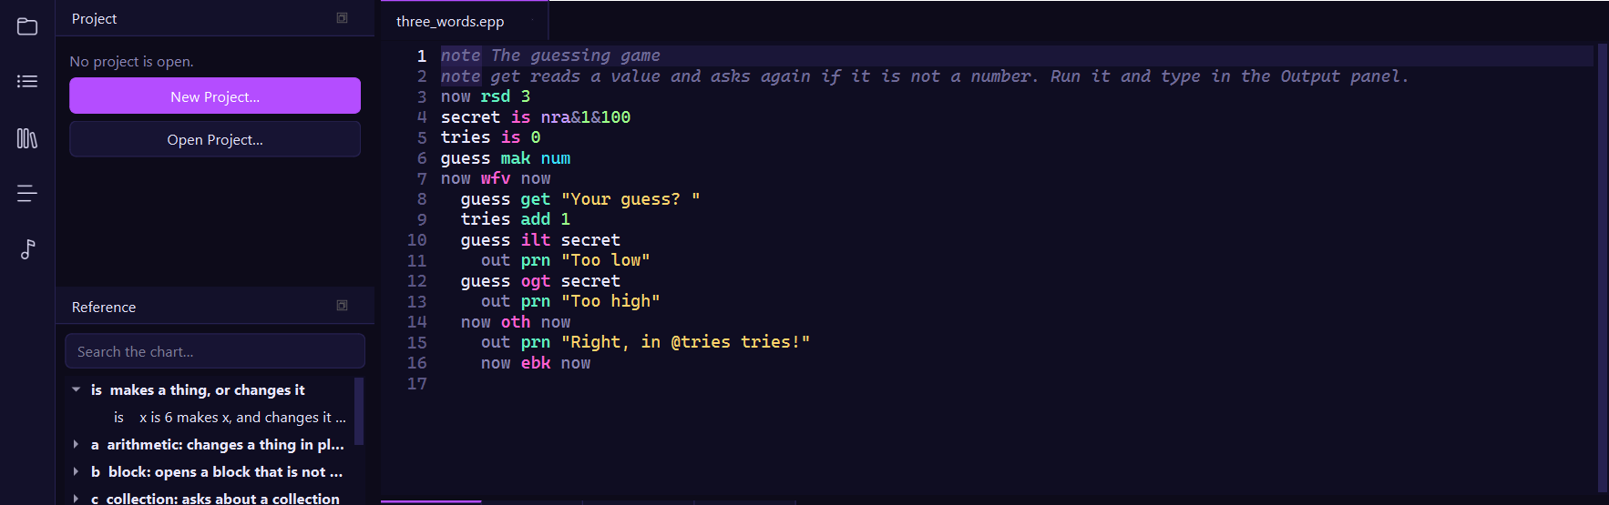
The Studio. Your program is in the middle, and the Reference panel on the left has every word.

Add more lines
A program can have as many lines as you like. Each one runs after the one above it.
out prn "One"
out prn "Two"
out prn "Three"
One
Two
Three
Try it! Put the lines in a different order and press F5. What changes?

Notes
A line that starts with the word note is for people. The computer skips it. Use notes to say what your program is for, or to remind yourself of something.
note This program counts to two.
out prn 1
note Now the second one.
out prn 2
1
2
A note is the only kind of line that can be as long as you like, because it isn't a statement. It's not telling the computer to do anything.
Tip! Press Ctrl+/ to turn a line into a note, or back again. It's a handy way to switch a line off for a while without deleting it.

Save your work
Press Ctrl+S to save. The Studio also saves your program each time you run it, so your work won't get lost.

Make a program you can share
Pressing F5 runs your program inside the Studio. You can also make a program that runs by itself, on any Windows computer. That is called an .exe file.
Press Ctrl+Shift+B, or choose Build > Build .exe.
The Studio puts your .exe in a folder called bin, inside your project. To go there, choose Build > Open the Program's Folder. Double-click your .exe to run it. To share it, send a friend the whole bin folder, because your .exe needs the other files next to it. Your friend doesn't need the Studio.

What the Studio does for you
The Studio helps you all the time. Try each of these:
Do this | And this happens
Point at any word | It tells you what the word means, letter by letter.
Type a word and a space | A list shows what can come next. The best ones are first.
Press Tab | It takes the first thing on the list.
Press Enter after a line that opens a block | The next line moves in by itself.
Make a mistake | A red line shows up as you type. Point at it to see how to fix it.

Later in the book, the chapter called The Studio's Tools shows you everything else it can do.

What you learned
Key | What it does
F5 | runs your program
Ctrl+S | saves your program
Ctrl+/ | turns a line into a note, or back
Ctrl+Shift+B | builds an .exe that runs by itself

4. The Three Words
You know that every line has three spots. This chapter shows you what can go in each spot, and what to do when a spot has nothing to say.

The three spots
Spot | Its name | What goes there | Example
first | who | the thing the line is about | x
middle | the root | what happens | add
last | what | the value or thing it uses | 1

A line with more or fewer than three words is a mistake:
x is 6 7
The Studio says: Line 1: This line has 4 words. Every line has exactly 3: who, the root, and what. Text with spaces goes in quotes, and & joins values into one word: add&1&2.

out prn
The Studio says: Line 1: This line has 2 words. Every line has exactly 3: who, the root, and what. If there is nothing to say in a spot, fill it with now, like now ebk now.

What counts as one word
Spaces split a line into words. So a word can't have a space in it, except for text in quote marks.
This is one word | Why
6 | a number
2.5 | a number with a point in it
x | a name
"Hello there, my friend" | text in quote marks is one word, spaces and all
a+b*2 | math with no spaces is one word

Here's a line with math in it. The math has no spaces, so the line still has three words:
a is 2
b is 3
c is a+b
out prn c
5
Watch out! Math with spaces around the marks is a mistake. c is a + b has five words. Write c is a+b.

When there is nothing to say
Sometimes a spot has nothing to say. Then you fill it with the word now. It means nothing goes here.
n is 0
now wfv now
n add 1
now ebk n==3
out prn n
3
Don't worry about all of that yet. Just look at now wfv now. wfv means while forever. It doesn't need a who, and it doesn't need a what. But a line must have three words, so both spots say now.

Lines inside lines
Some roots open a block. A block is a group of lines that belong together. The lines of a block are moved to the right. That is called indenting.
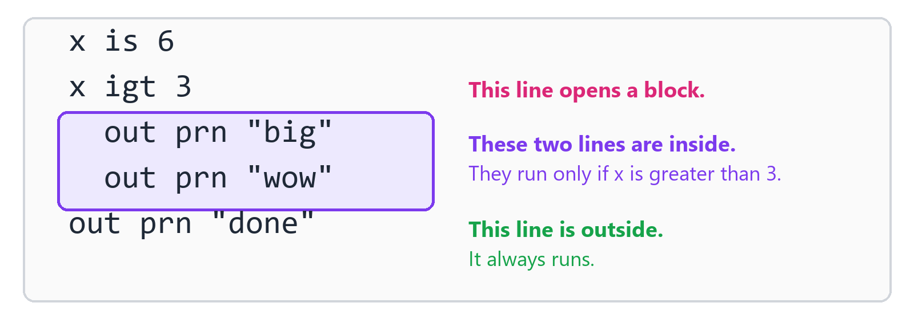
Lines that move in belong to the line above them.
x is 6
x igt 3
out prn "big"
out prn "wow"
out prn "done"
big
wow
done
Line | Say it
x is 6 | x is 6.
x igt 3 | If x is greater than 3, do these:
out prn "big" | Print big.
out prn "wow" | Print wow.
out prn "done" | Then print done, no matter what.

The first line that moves back out is not in the block. That's all there is to it. Nothing marks the end of a block except that the lines stop being moved in.
Tip! Two spaces is the usual amount to move in. The Studio moves the next line in for you when you press Enter after a line that opens a block. Press Shift+Tab to move back out.

Marks you never write
C++ has a lot of marks. English++ doesn't have them at all. Here's what you do instead:
C++ uses | English++ does this
{ } curly brackets | moves the lines in
( ) round brackets | does one step on each line
, commas | puts & between values: add&1&2
: colons | nothing at all: the root says it opens a block
; semicolons | nothing at all: a line ends where it ends
[ ] square brackets | uses @ for a position: scores@0
. dots | uses @ to reach inside: rex@speed

If you type one of those marks by accident, the Studio tells you what to write instead:
x is 6;
The Studio says: Line 1: English++ has no semicolons. A line ends where it ends.

out prn(x)
The Studio says: Line 1: English++ has no round brackets. Make a step for the part inside: t is a+b, then x is t*c. To call something, use &: add&1&2.

The one dot you can write is the point inside a number, like 2.5.

@ and &
Inside a word, two marks do all the work.
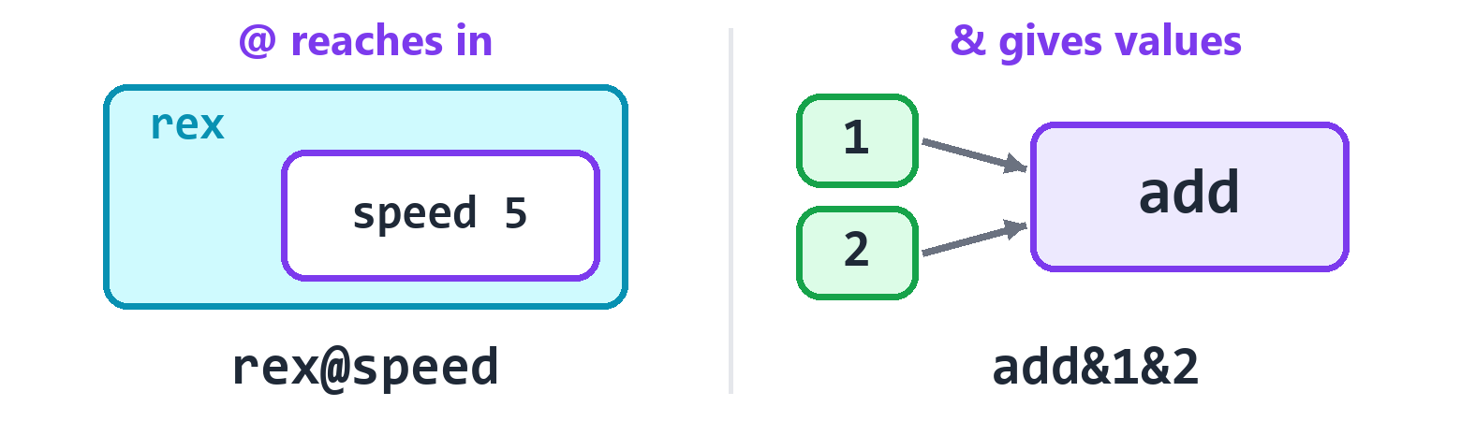
@ reaches into something. & hands values to something.
@ reaches in. You can read it as of, or as at.
You write | Say it
rex@speed | the speed of rex
scores@0 | scores at position 0
vec@num | a vector of numbers

& gives values. You can read it as with, or as and.
You write | Say it
add_up&1&2 | run add_up with 1 and 2
1&2&3 | 1 and 2 and 3

A word can only hold one run of a function, because the values go to the end of the word. If you need two, use two lines.
You'll see lots of these. Here's one with both marks:
scores is 90&72&85
out prn scores@0
out prn nsq&16
90
4
Line | Say it
scores is 90&72&85 | scores is 90 and 72 and 85.
out prn scores@0 | Print scores at position 0.
out prn nsq&16 | Print the square root of 16.

What you learned
New idea | What it means
now | fills a spot that has nothing to say
block | lines that are moved in, under a line that opens a block
@ | reaches in: of, or at
& | gives values: with, or and

Try it! Write a program with a name called pets, set to 3. Add 2 to it, then print it. It should print 5.

5. How to Read a Root
This chapter is short, and it may be the most useful one in the book. When you finish it, you will be able to read words you have never seen.

The first letter is the family
Each root's first letter tells you its family. There are 21 families:
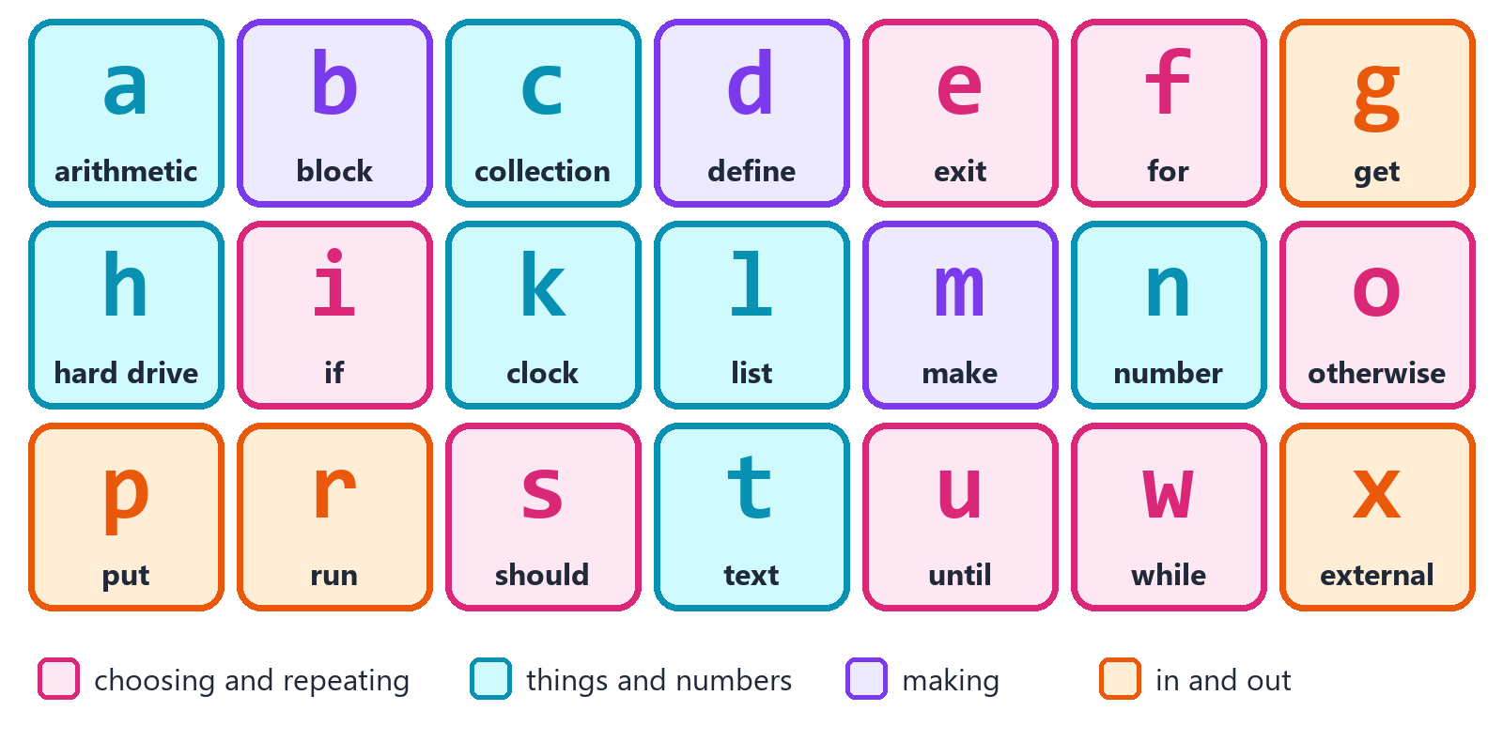
The 21 families. The first letter of a word tells you its family.
You already met one. add starts with a, for arithmetic. That's the family that changes a number.
Letter | Family | What the family does
a | arithmetic | changes a thing in place
b | block | opens a block that is not a loop or an if
c | collection | asks a question about a list
d | define | gives a new thing its name
e | exit | leaves or ends something
f | for | repeats, counting or walking through
g | get | reads something in
h | hard drive | works with files and folders
i | if | runs some lines if a test passes
k | clock | tells the date and the time
l | list | changes a list
m | make | makes a new thing
n | number | works out a number
o | otherwise | tries again after an if
p | put | writes something out
r | run | runs threads and other programs
s | should | checks that something is true
t | text | works with text
u | until | ends a block when a test passes
w | while | repeats some lines while a test passes
x | external | reaches C++ and the world outside the program

There is no j, q, v, y or z family. You don't need them.

The other two letters are the job
The last two letters say which job in that family. Here is the clever part: two letters mean the same thing everywhere.
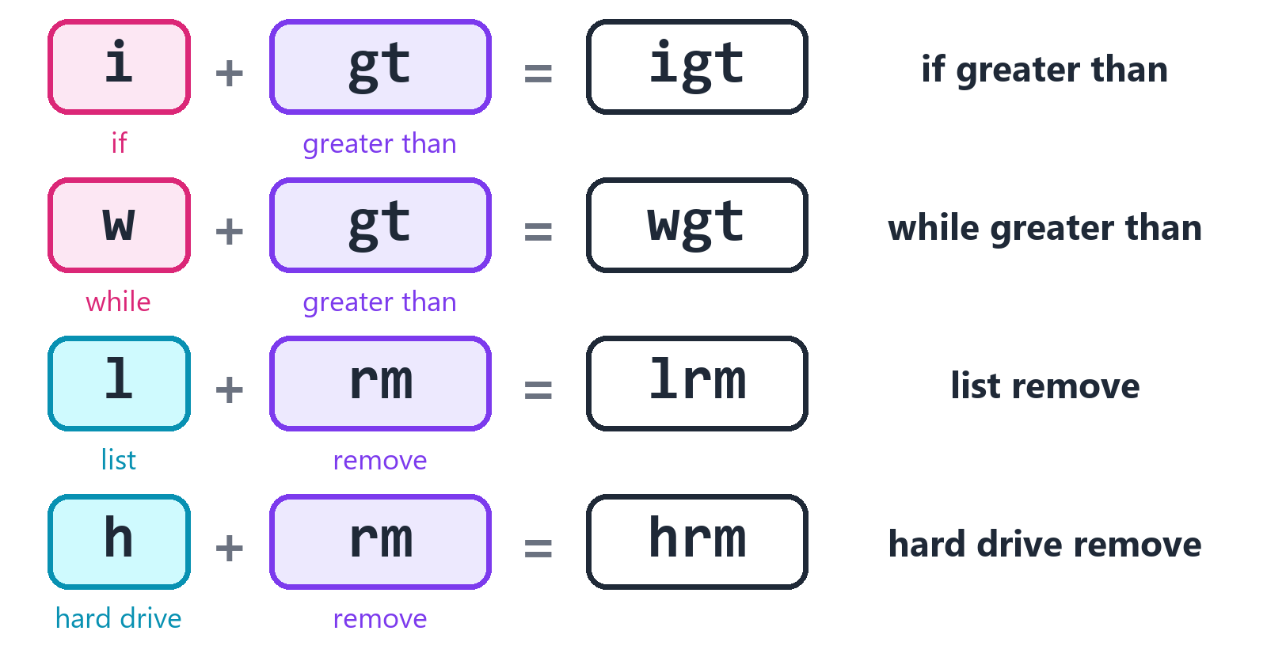
A family and a job make a word.
gt always means greater than. rm always means remove. It doesn't matter which family they are in.
So if you know that so means sort, then you know what lso does. It sorts a list. And you know cso too. It gives you a sorted copy of a list.
Pair | It means | You can see it in
rm | remove | lrm hrm
so | sort | lso cso
rv | reversed | lrv crv trv
mk | make | hmk dmk
sz | size | tsz hsz
ln | lines | wln gln hln tln
mx | the biggest | nmx cmx
mn | the smallest | nmn cmn
hs | has | chs ths

The Studio's own tests check this rule. There are no exceptions.

The six pairs that compare
Six pairs compare two things. You will use them all the time, so they are worth learning.
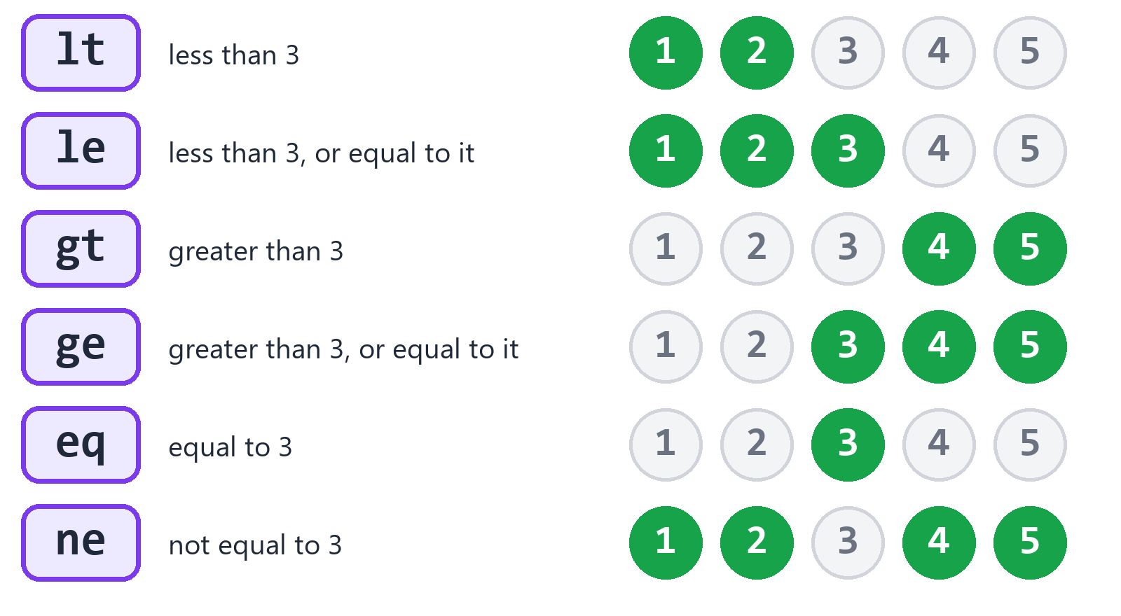
Each pair compared with 3. The green numbers are the ones that pass.
Pair | Say it | Math mark
eq | equal | ==
ne | not equal | !=
lt | less than | <
le | less than or equal | <=
gt | greater than | >
ge | greater than or equal | >=

Now look what happens when you put them after a family letter. These families all use the same six pairs:
Family | What it does | With gt
i | if | igt: if greater than
o | otherwise, if | ogt: otherwise, if greater than
w | while | wgt: while greater than
u | until | ugt: until greater than
s | should | sgt: should be greater than
f | for | fgt: count down while greater than

You learned six letters and six pairs, and you already know about 36 words!

Read these
Cover the right side of this table with your hand. Read each word on the left. Then look.
Word | The letters | It means
ieq | i + eq | if equal
wne | w + ne | while not equal
sge | s + ge | should be greater than or equal
ole | o + le | otherwise, if less than or equal
ult | u + lt | until less than
hrm | h + rm | hard drive: remove a file
tuc | t + uc | text: uppercase
nsq | n + sq | number: square root

Try it! What do these mean? ilt, wge, seq, lrv. The answers are at the back, but try first.

Three more things
There is one word that doesn't follow the pattern: is. It has only two letters, and you already know it. You use it so often that it deserves to be short.
Roots aren't the only words made this way. Words that go in the first or third spot use the same families. nsq&16 is the square root of 16, and tsz&name is the size of a name. You will meet those soon.
And what about a word that isn't in the chart at all? It's a name you made yourself, or a C++ function that somebody else made. English++ works out which one it is.

What you learned
New idea | What it means
family | the first letter of a word
job | the other two letters
the rule | two letters mean one thing, everywhere
eq ne lt le gt ge | the six pairs that compare

Part 2: The Basics
Boxes, printing, math, text, choices and loops. With these, you can already write real programs.

6. Names and Values
Programs have to remember things: a score, a name, how many lives are left. This chapter shows you how.

A name is a box with a label
Think of a box with a label on it. The label is the name. What's inside the box is the value.
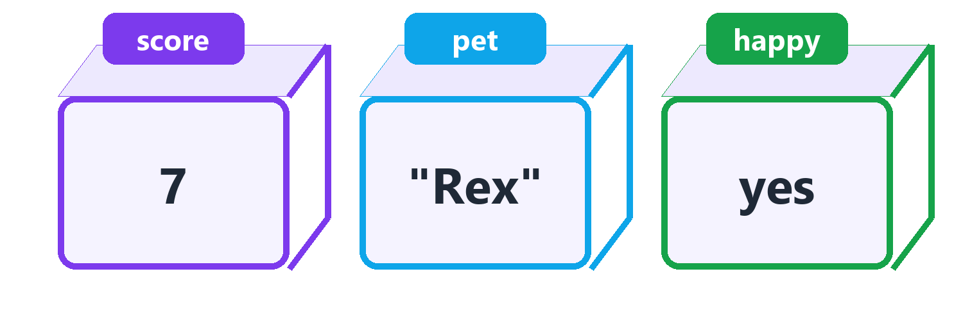
Three boxes. Each one has a name, and a value inside.
The word is makes a box and puts a value in it:
score is 7
pet is "Rex"
happy is yes
out prn score
out prn pet
out prn happy
7
Rex
yes
Line | Say it
score is 7 | score is 7.
pet is "Rex" | pet is Rex.
happy is yes | happy is yes.
out prn score | Print what's in score.

See how out prn score printed 7, and not the word score? When a word has no quote marks, it means the box. When it has quote marks, it means those letters.
score is 7
out prn score
out prn "score"
7
score

Changing a value
The first time you use is, it makes the box. After that, it changes what's inside.
x is 6
out prn x
x is 7
out prn x
6
7
A box holds only one value. The new one replaces the old one.
You can also use a box's value to make a new one:
apples is 3
pears is apples+2
out prn pears
5

Five kinds of value
Every value has a kind. Here are the five you will use the most.
Kind | It holds | Examples
num | a whole number | 7 0 -3
dec | a decimal: a number with a point | 2.5 0.1
txt | text: words in double quote marks | "Ada" "Hi there"
ltr | one letter, in single quote marks | 'A' 'z'
yno | a yes or no | yes nay

Yes, it's nay and not no. That keeps every word three letters long.
You don't have to say which kind you want. The value already shows it, so English++ works it out:
age is 7
price is 2.5
name is "Ada"
first is 'A'
ready is yes
out prn age
out prn price
out prn name
out prn first
out prn ready
7
2.5
Ada
A
yes
A box keeps its kind for its whole life. If it starts out holding a number, it can't hold text later. English++ stops you, because it would almost always be a mistake:
x is 6
x is "six"
The Studio says: Line 2: x is a whole number, so it can't take a text. To read a number out of text use tnm&s.

The same goes for a whole number and a decimal. If x holds a whole number, it has no room for what comes after the point. In C++, the .5 would just quietly vanish. Here you get told:
x is 6
x is 2.5
The Studio says: Line 2: x is a whole number, so 2.5 would lose what is after its point. Make x a decimal from the start, or say so: num&x.

If you know you'll need a decimal, start with a decimal:
x is 6.0
x is 2.5
out prn x
2.5

Good names
A name is made of letters, numbers and the _ mark. It starts with a letter.
Good names | Why they are good
score | it says what it holds
lives_left | _ joins two words
player2 | numbers are fine after the first letter

Small letters and capital letters are different, so Score and score are two different names.
A few names are taken:
yes is 6
The Studio says: Line 1: yes is a word the language keeps for itself. Pick another name.

class is 6
The Studio says: Line 1: class is a word C++ keeps for itself, and English++ is C++ underneath. Pick another name.

Two groups of names are taken. One is the eight special words of English++, which you'll meet in this book. The other is the words that C++ keeps for itself. If you pick one, the Studio tells you right away.
Tip! Choose names that say what they hold. A year from now, lives_left will still make sense. x won't.

Starting empty
Sometimes you know the kind but not the value yet. mak makes a box of a kind, and leaves it empty.
score mak num
name mak txt
ready mak yno
out prn score
out prn "[@name]"
out prn ready
0
[]
nay
Line | Say it
score mak num | Make score, a whole number.
name mak txt | Make name, a text.
ready mak yno | Make ready, a yes or no.

A new box always starts as zero, empty or nay. It never holds junk. That matters. In C++, a new number can hold any old junk left in the computer's memory. That causes some of the strangest bugs there are.

More kinds of number
Most of the time you only need num and dec. The others are for special jobs.
Kind | It holds | Use it when
num | a whole number, up to about 2 billion | almost always
big | a whole number, up to about 9 billion billion | numbers get huge
sml | a small whole number, up to 32 thousand | you have millions of them
pos | a whole number that can't go below 0 | it can never be negative
byt | a whole number from 0 to 255 | you're working with raw data
dec | a decimal | almost always, for decimals
flo | a smaller decimal, less exact | a graphics library asks for it

stars mak big
stars is 9000000000
tiny mak sml
tiny is 30000
count mak pos
count is 12
level mak byt
level is 200
half mak flo
half is 0.5
out prn stars
out prn tiny
out prn count
out prn level
out prn half
9000000000
30000
12
200
0.5

Changing the kind of a value
Sometimes you have a value of one kind and you need it as another. Write the new kind, then &, then the value. Think of it as make this into.
You write | Say it | You get
num&2.9 | 2.9 as a whole number | 2
dec&3 | 3 as a decimal | 3
txt&42 | 42 as text | "42"
ltr&65 | letter number 65 | 'A'
yno&0 | 0 as a yes or no | nay
big&5 | 5 as a big number | 5
flo&0.5 | 0.5 as a small decimal | 0.5

out prn num&2.9
out prn dec&3
out prn txt&42
out prn ltr&65
out prn yno&0
out prn big&5
out prn flo&0.5
2
3
42
A
nay
5
0.5
num&2.9 gives 2, not 3. It doesn't round. It cuts off what's after the point. Chapter Math shows you how to round.

Things that never change
Some values should never change, like the number of days in a week. mkn makes a constant: a box that is sealed shut.
DAYS mkn 7
out prn DAYS
7
If you try to change it, English++ stops you:
DAYS mkn 7
DAYS is 8
The Studio says: Line 2: DAYS is a constant, so it can't change.

People often write constants in CAPITAL letters, so they stand out. You don't have to.

What you learned
Word | Say it | Example
is | is | x is 6
mak | make, of this kind | x mak num
mkn | make a constant | DAYS mkn 7
yes nay | yes and no | ready is nay
num&x | x as a whole number | y is num&2.9

Try it! Make a box called cookies that holds 12. Make a sealed box called FRIENDS that holds 3. Make each by dividing cookies by friends. Print each. It should print 4.

7. Printing
You've been printing since page one. Here is everything else that printing can do.

prn and put
prn prints something, then goes to a new line. put prints it and stays on the same line.
out put "one "
out put "two "
out prn "three"
out prn "four"
one two three
four
Use put when you want to build one line from a few pieces.
Root | Say it | Then
prn | print a line | goes to the next line
put | put it there | stays on the same line

Values inside text
Put @ in front of a name, inside text, and its value goes there.
name is "Ada"
age is 36
out prn "@name is @age years old."
Ada is 36 years old.
This works for anything you can print, and it can reach inside things too:
scores is 90&72
out prn "The first score is @scores@0."
out prn "All of them: @scores"
The first score is 90.
All of them: [90, 72]
To print an @ mark itself, write it twice:
out prn "Mail me @@ home."
Mail me @ home.

Printing a few things at once
Join values with &, and they print with a space between them:
name is "Ada"
age is 36
out prn name&age
out prn name&age&"years"
Ada 36
Ada 36 years

Marks inside text
A few marks need a backslash in front of them, inside text:
You write | You get
\" | a double quote mark
\n | a new line
\t | a jump to the next tab stop
\\ | one backslash

out prn "She said \"hello\"."
out prn "line one\nline two"
out prn "a\tb"
out prn "C:\\games"
She said "hello".
line one
line two
a b
C:\games

Everything can print
C++ can't print a list, and it can't print your own kinds of things. You have to write that part yourself. In English++, everything just prints.
What you print | What you see
a whole number or a decimal | 7 or 2.5
a text | Ada
a letter | A
a yes or no | yes or nay
a list | [1, 2, 3]
a map | {Ada: 36, Bob: 41}
a set | {1, 2, 3}
a pair | (1, 2)
one of your own kinds | Dog(name: Rex, age: 3)

You'll meet these as we go along.

Printing problems
err is another way to the screen. It's for problems. In the Studio, these go to the Output panel like everything else. But when somebody runs your .exe from a command line, they can tell the problems apart from the answers.
err prn "That file is missing."
That file is missing.
Word | What it means
out | the screen
err | the screen, for problems

Neat columns
Two text words help you line things up. tfx shows a decimal with the number of places you choose. tpa pads a text with spaces, so it fills a width.
price is 2.5
out prn tfx&price&2
name is tpa&"Ada"&6
out prn "[@name]"
2.50
[Ada ]

What you learned
You write | Say it
out prn x | print x, and go to the next line
out put x | print x, and stay on this line
err prn x | print x as a problem
"@x" | the value of x, inside text
"@@" | an @ mark, inside text
out prn a&b | print a and b, with a space between them

Try it! Make food hold your favorite food. Make one line that prints: I like pizza a lot. Use your own food, with @ inside the text.

8. Math
Computers are very good at math. In this chapter you make yours do some.

Changing a number
The a family changes a thing in place. It starts with the value in the box, and it leaves the answer in the same box.
x is 10
x add 5
out prn x
x asb 3
out prn x
x aml 2
out prn x
x adv 4
out prn x
15
12
24
6
Line | Say it | x becomes
x add 5 | Add 5 to x. | 15
x asb 3 | Subtract 3 from x. | 12
x aml 2 | Multiply x by 2. | 24
x adv 4 | Divide x by 4. | 6

Two more do a little extra. amd keeps the remainder after dividing. apw raises to a power.
x is 17
x amd 5
out prn x
y is 2.0
y apw 10
out prn y
2
1024
17 divided by 5 is 3, with 2 left over. So x amd 5 leaves 2. And 2 to the power of 10 means ten 2s multiplied together, which is 1024.

Math inside a word
You can also write math in the third spot. It's one word, so it has no spaces.
a is 2
b is 3
total is a+b
out prn total
out prn a*b
out prn 10-a
5
6
8
Mark | What it does
+ | add
- | subtract
* | multiply
/ | divide
% | the remainder

Times and divide happen first, just like at school:
y is 1+2*3
out prn y
7
2 times 3 is 6, and 1 plus 6 is 7.

One step at a time
There are no brackets in English++. In math, you would write (1+2)*4 to do the adding first. Here you make a step:
sum is 1+2
area is sum*4
out prn area
12
Every step gets a name. So later, anyone can see what each part means.
area is (1+2)*4
The Studio says: Line 1: English++ has no round brackets. Make a step for the part inside: t is a+b, then x is t*c. To call something, use &: add&1&2.

Whole numbers and decimals
When you divide two whole numbers, you get a whole number. What's left over is thrown away.
out prn 7/2
out prn 7.0/2
out prn 7%2
3
3.5
1
If one of them is a decimal, you get a decimal. So 7/2 is 3, but 7.0/2 is 3.5. To keep the leftover as its own number, use %.
x is 7
y is x/0
The Studio says: Line 2: I can't divide by zero. Use a number that isn't zero.

Dividing by zero makes no sense. English++ stops you when it can see the zero. When it can't see it, because the zero comes from a box, the program stops on that line when it runs.

Number words
The n family works out numbers for you. Write the word, then &, then what it needs. They don't change anything. They just give you an answer to use.
out prn nsq&16
out prn npw&2&10
out prn nab&-5
out prn nmx&3&8
out prn nmn&3&8
4
1024
5
8
3
You write | Say it | You get
nsq&16 | the square root of 16 | 4
npw&2&10 | 2 to the power of 10 | 1024
nab&-5 | the size of -5, without its sign | 5
nmx&3&8 | the biggest of 3 and 8 | 8
nmn&3&8 | the smallest of 3 and 8 | 3

Rounding
There are four ways to turn a decimal into a whole number.
out prn nro&2.5
out prn ndn&2.9
out prn nup&2.1
out prn nwh&-2.9
3
2
3
-2
You write | Say it | You get
nro&2.5 | rounded to the nearest | 3
ndn&2.9 | rounded down | 2
nup&2.1 | rounded up | 3
nwh&-2.9 | just the whole part | -2

Keeping a number in bounds
nkb keeps a number between two others. It's great for things like keeping a player on the screen.
out prn nkb&5&0&10
out prn nkb&50&0&10
out prn nkb&-2&0&10
5
10
0

Whole number facts
You write | Say it | You get
ngd&12&18 | the biggest number that divides both | 6
nmu&4&6 | the smallest number both divide into | 12
nfc&5 | 5 times 4 times 3 times 2 times 1 | 120
npe&7 | is 7 a prime number? | yes
nhi | the highest whole number | 2147483647

out prn ngd&12&18
out prn nmu&4&6
out prn nfc&5
out prn npe&7
out prn nhi
6
12
120
yes
2147483647

Shapes and angles
Most of these are for when you draw things or move things around. You don't need them until you do. Angles are in radians: a half turn is npi radians, which is about 3.14.
You write | Say it | You get
npi | pi | 3.14159
ncr&27 | the cube root of 27 | 3
nhy&3&4 | the long side of a right triangle | 5
nsn&0 | the sine of 0 | 0
nco&0 | the cosine of 0 | 1
ntn&0 | the tangent of 0 | 0
nas&0 | the arc sine of 0 | 0
nac&1 | the arc cosine of 1 | 0
nat&0 | the arc tangent of 0 | 0
nep&0 | e to the power of 0 | 1
nlg&1 | the natural log of 1 | 0
nlx&100 | the log, base ten, of 100 | 2

out prn npi
out prn ncr&27
out prn nhy&3&4
out prn nsn&0
out prn nco&0
out prn ntn&0
out prn nas&0
out prn nac&1
out prn nat&0
out prn nep&0
out prn nlg&1
out prn nlx&100
3.14159
3
5
0
1
0
0
0
0
1
0
2

Random numbers
Games need dice. nra gives a random whole number, from the first number up to the second. nrz does the same for decimals.
die is nra&1&6
out prn die
chance is nrz&0&1
out prn chance
Each time you run this, it prints something new. So this book can't show you what it will say.
Sometimes you want the same random numbers every time, so a game can be tested. rsd sets the seed: the number that starts the random numbers off. The same seed always gives the same numbers.
now rsd 7
first is nra&1&100
now rsd 7
second is nra&1&100
first seq second
out prn "They match!"
They match!
(first seq second means first should equal second. If it doesn't, the program stops. A later chapter tells you all about it.)

Working with bits
You can skip this part. Come back when you're curious.
Inside the computer, every whole number is made of bits: tiny switches that are on or off. 6 is 110 in bits: on, on, off. And 3 is 011: off, on, on.
The rest of the a family works on the bits directly.
Root | Say it | Example | x becomes
and | keep the bits that are on in both | x and 3, when x is 6 | 2
aor | turn on the bits that are on in either | x aor 3, when x is 6 | 7
axr | keep the bits that are on in just one | x axr 3, when x is 6 | 5
asl | push all the bits left | x asl 2, when x is 6 | 24
asr | push all the bits right | x asr 1, when x is 6 | 3
ant | flip every bit of the value | x ant 0, for any x | -1

x is 6
x and 3
out prn x
x is 6
x aor 3
out prn x
x is 6
x axr 3
out prn x
x is 6
x asl 2
out prn x
x is 6
x asr 1
out prn x
x ant 0
out prn x
2
7
5
24
3
-1

What you learned
Family | What it does | Example
a | changes a number in place | x add 5
n | gives you an answer | y is nsq&16

Here are the marks for math in a word: + - * / %. There are no spaces, and no brackets.
Try it! A pizza has 8 slices. There are 3 friends. Use / to find how many slices each friend gets, and % to find how many are left over. It should print 2, then 2.

9. Text
Text means words, sentences and letters. Programs use text all the time, so the t family has many words for it. You don't need to remember them. Come back to this chapter when you need one.

Joining text
The + mark joins text.
first is "Ada"
last is "Lovelace"
whole is first+" "+last
out prn whole
Ada Lovelace
Text can only join with text. C++ would quietly do something strange with "a"+1, and it wouldn't even tell you. English++ stops you:
line is "n is "+1
The Studio says: Line 1: I can't add text and a whole number. Turn the number into text first: "a"+txt&x.

So turn the number into text first, with txt&:
n is 42
line is "n is "+txt&n
out prn line
n is 42

Text and numbers
You write | Say it | You get
txt&42 | 42 as text | "42"
tnm&"7" | the whole number in "7" | 7
tdc&"2.5" | the decimal in "2.5" | 2.5
tfx&3.14159&2 | 3.14159 with 2 decimal places | "3.14"

back is tnm&"7"
out prn back+1
half is tdc&"2.5"
out prn half*2
out prn tfx&3.14159&2
8
5
3.14

Size and letters
tsz tells you how many letters a text has. @ reaches one letter. The first letter is at position 0, not 1.
word is "Hello"
out prn tsz&word
out prn word@0
out prn word@4
5
H
o

Changing how it looks
These don't change the text in the box. They give you a new text.
You write | Say it | You get
tuc&"Hi there" | in uppercase | HI THERE
tlc&"Hi there" | in lowercase | hi there
ttc&"hi there" | in title case | Hi There
tti&" hi " | trimmed: no spaces at the ends | hi
trv&"abc" | reversed | cba
tpa&"hi"&5 | padded to 5 letters | hi and 3 spaces

t is "Hi there"
out prn tuc&t
out prn tlc&t
out prn ttc&"hi there"
out prn tti&" hi "
out prn trv&"abc"
pad is tpa&"hi"&5
out prn "[@pad]"
HI THERE
hi there
Hi There
hi
cba
[hi ]

Looking inside text
You write | Say it | You get
ths&t&"lo" | does t have "lo" in it? | yes or nay
tbg&t&"He" | does t begin with "He"? | yes or nay
ted&t&"lo" | does t end with "lo"? | yes or nay
tps&t&"l" | where is the first "l" in t? | a position

t is "Hello"
out prn ths&t&"lo"
out prn tbg&t&"He"
out prn ted&t&"x"
out prn tps&t&"l"
out prn tps&t&"z"
yes
yes
nay
2
-1
When tps can't find it, it gives -1, because -1 is never a real position.

Taking text apart
You write | Say it | You get
tcu&t&0&5 | part of t: from position 0, 5 letters | "Hello"
trp&t&"World"&"You" | t with "World" replaced by "You" | "Hello You"
twd&t | the words of t | a list of texts
tsp&t&"," | t split at each comma | a list of texts
tln&t | the lines of t | a list of texts

t is "Hello World"
out prn tcu&t&0&5
out prn trp&t&"World"&"You"
out prn twd&t
out prn tsp&"a,b,c"&","
out prn tln&"one\ntwo"
Hello
Hello You
[Hello, World]
[a, b, c]
[one, two]

Finding patterns
Sometimes you don't want a certain word. You want any word shaped a certain way, like any number or anything that looks like an email. A pattern describes the shape. This kind of pattern is also called a regular expression.
In a pattern | It means
[0-9] | any one digit
[a-z] | any one small letter
+ | one or more of the thing before it
. | any one letter at all
* | any number of the thing before it, even none

You write | Say it | You get
tmt&t&"[0-9]+" | does t have a part with this shape? | yes or nay
tma&t&"[0-9]+" | all the parts of t that match | a list of texts
trx&t&"[0-9]+"&"#" | t with each match replaced by # | a new text

out prn tmt&"a2"&"[0-9]+"
out prn tmt&"ab"&"[0-9]+"
out prn tmt&"a2"&"^[0-9]+$"
t is "I have 2 cats and 10 fish"
out prn tma&t&"[0-9]+"
out prn trx&t&"[0-9]+"&"some"
yes
nay
nay
[2, 10]
I have some cats and some fish
The third line needs a closer look. ^ means the start of the text, and $ means the end of the text. So ^[0-9]+$ asks for digits from the start to the end, and "a2" doesn't have that.

What you learned
You want to | Use
join texts | a+b
turn a number into text | txt&n
turn text into a number | tnm&s or tdc&s
know the size | tsz&s
reach one letter | s@0
split into words | twd&s
look something up | the chart at the back of the book

Try it! Make name hold your name. Print it in uppercase. Then print how many letters it has.

10. Yes, No and Tests
Before a computer can make a choice, it needs something to decide on. That's a test: a question with the answer yes or no.

Comparing
Here are the marks that compare two things. Each one makes a test.
Mark | Say it | Example | Answer
== | is equal to | 3==3 | yes
!= | is not equal to | 3!=3 | nay
< | is less than | 2<3 | yes
<= | is less than or equal to | 3<=3 | yes
> | is greater than | 2>3 | nay
>= | is greater than or equal to | 2>=3 | nay

The answer is a value, just like a number. You can put it in a box and print it:
age is 7
old_enough is age>=6
out prn old_enough
out prn age==8
yes
nay
Line | Say it
old_enough is age>=6 | old_enough is: is age greater than or equal to 6?
out prn age==8 | Print: is age equal to 8?

Watch out! One = is not the same as two. In a test, use ==. When you want to change a box, you already have a word for that: is.

Comparing text
Text can be compared too. < means comes first in the alphabet.
name is "Ada"
out prn name=="Ada"
out prn name!="Bob"
out prn "apple"<"pear"
yes
yes
yes
Capital letters count as different, so "ada"=="Ada" is nay. If you don't care about capitals, compare tlc&name instead.

And, or, not
You can join tests into a bigger test.
Mark | Say it | It passes when
&& | and | both tests pass
|| | or | at least one test passes
! | not | the test does not pass

age is 7
tall is yes
out prn age>5&&tall
out prn age>9||tall
out prn !tall
yes
yes
nay
The mark for or is two bars. You'll find the bar on your keyboard, above the Enter key. Hold Shift to type it.
Line | Say it
out prn age>5&&tall | Print: is age greater than 5, and is tall yes?
out prn age>9||tall | Print: is age greater than 9, or is tall yes?
out prn !tall | Print: is tall not yes?

Watch out! A test that compares three things, like 1<x<5, is a mistake. Write 1<x&&x<5.

x is 3
ok is 1<x<5
The Studio says: Line 2: Compare one pair at a time. a<b<c doesn't do what it looks like: write a<b&&b<c.

Yes and no as values
You can use a box that holds a yes or no anywhere you'd use a test. And yno& turns a number into yes or no. Zero is nay, and everything else is yes.
door_open is nay
out prn door_open
out prn !door_open
out prn yno&5
out prn yno&0
nay
yes
yes
nay

What you learned
Mark | Say it
== != | equal, not equal
< <= | less, less or equal
> >= | greater, greater or equal
&& | and
|| | or
! | not

Try it! Make x hold 6. Print whether x is even. A number is even when its remainder after dividing by 2 is 0, so the test is x%2==0.

11. If and Otherwise
Now your programs can make choices. This is where they start to feel clever.

If
Roots that start with i mean if. The lines under one, moved in, run only if the test passes. If it doesn't pass, the program skips them.
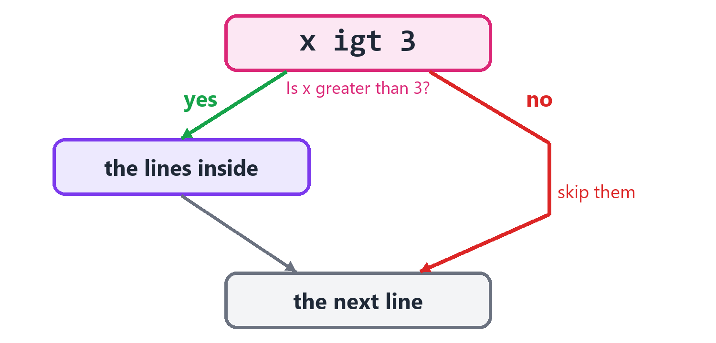
If the test passes, the lines inside run. If not, the program skips them.
x is 6
x igt 3
out prn "big"
out prn "done"
big
done
Line | Say it
x igt 3 | If x is greater than 3, do this:
out prn "big" | Print big.
out prn "done" | Then print done, no matter what.

Now change x to 2, and the test doesn't pass:
x is 2
x igt 3
out prn "big"
out prn "done"
done
Here are all six of the if roots. You already know the pairs:
Root | Say it | Example | It passes when x is
ieq | if equal | x ieq 3 | 3
ine | if not equal | x ine 3 | anything but 3
ilt | if less than | x ilt 3 | less than 3
ile | if less or equal | x ile 3 | 3, or less
igt | if greater than | x igt 3 | more than 3
ige | if greater or equal | x ige 3 | 3, or more

x is 3
x ieq 3
out prn "equal"
x ine 3
out prn "not equal"
x ile 3
out prn "less or equal"
x ige 3
out prn "greater or equal"
equal
less or equal
greater or equal
They work on text too:
name is "Ada"
name ieq "Ada"
out prn "Hi, Ada!"
Hi, Ada!

Otherwise
Often you want to do one thing or another. oth means all the other times. It goes right after the if, at the same indent.
x is 2
x igt 3
out prn "big"
now oth now
out prn "small"
small
Line | Say it
x igt 3 | If x is greater than 3, do this:
out prn "big" | Print big.
now oth now | Otherwise, do this:
out prn "small" | Print small.

Otherwise, if
Roots that start with o mean otherwise, if. They ask another question when the first one fails. You can have as many as you like.
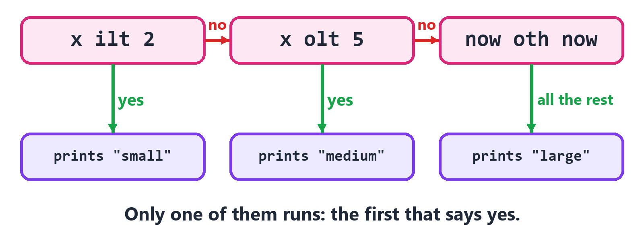
The program tries each test in turn, and stops at the first that passes.
x is 4
x ilt 2
out prn "small"
x olt 5
out prn "medium"
now oth now
out prn "large"
medium
Line | Say it
x ilt 2 | If x is less than 2, do this:
x olt 5 | Otherwise, if x is less than 5, do this:
now oth now | Otherwise, do this:

Only one of the three blocks ever runs. The computer checks from the top, and stops at the first test that passes.
Here are all of the o roots:
Root | Say it
oeq | otherwise, if equal
one | otherwise, if not equal
olt | otherwise, if less than
ole | otherwise, if less or equal
ogt | otherwise, if greater than
oge | otherwise, if greater or equal
oth | otherwise: all the other times

age is 13
age ilt 13
out prn "a child"
age oeq 13
out prn "just turned teen"
age ole 19
out prn "a teen"
age oge 100
out prn "wow"
age ogt 60
out prn "over sixty"
age one 50
out prn "a grown-up"
now oth now
out prn "exactly fifty"
just turned teen
An otherwise has to come right after an if block. If it doesn't, the Studio tells you:
x is 4
out prn x
now oth now
out prn "large"
The Studio says: Line 3: oth means otherwise, so it needs an if right above it, at the same indent.

Watch out! Be careful about the order. A test higher up gets the first chance. If you test x ilt 10 before x ilt 5, the second test can never win.

Blocks inside blocks
A block can have another block inside it. Each one moves in further.
sunny is yes
warm is nay
sunny ieq yes
warm ieq yes
out prn "Go swimming!"
now oth now
out prn "Bring a coat."
now oth now
out prn "Stay in and code."
Bring a coat.
The indent shows which otherwise goes with which if.

Bigger tests
You can put a whole test in the first spot, with ieq yes to ask if it passes.
x is 6
name is "Ada"
x>3&&name=="Ada" ieq yes
out prn "both"
x%2 ieq 0
out prn "even"
both
even
Line | Say it
x>3&&name=="Ada" ieq yes | If x is greater than 3 and the name is Ada, do this:
x%2 ieq 0 | If the remainder of x divided by 2 is 0, do this:

Choosing a value
Sometimes you just want one value or another. iff does that in one word. iff&test&a&b gives you a if the test passes, and b if it doesn't.
x is 6
size is iff&x>3&"big"&"small"
out prn size
big
You write | Say it
iff&x>3&"big"&"small" | If x is greater than 3, "big". If not, "small".

Choosing by value
When you are checking one value against many others, there's a neater way. bsw means switch: it picks a value to check. bcs means case: it's one possible value. bdf means default: all the others.
day is 6
day bsw now
now bcs 6&7
out prn "the weekend"
now bcs 1
out prn "Monday"
now bdf now
out prn "a work day"
the weekend
Line | Say it
day bsw now | Check the value of day.
now bcs 6&7 | If it's 6 or 7, do this:
now bcs 1 | If it's 1, do this:
now bdf now | If it's anything else, do this:

Each case ends by itself. In C++ you have to remember to write break at the end of each case, or the next one runs too. It's a very common bug. In English++, it can't happen.

What you learned
You want to say | Write
if x is more than 3 | x igt 3
otherwise, if x is less than 2 | x olt 2
otherwise | now oth now
check one value against many | x bsw now, then now bcs 1
anything else | now bdf now
this value or that value | iff&test&a&b

Try it! Make score hold a number from 0 to 100. Print "A" if it is 90 or more, "B" if it is 80 or more, and "Try again" for anything else.

12. Loops
A loop does something again and again. Computers never get bored, so this is where they get really useful.

Counting
flt means for, less than. It counts for you.
i flt 3
out prn i
0
1
2
Line | Say it
i flt 3 | Count with i, while i is less than 3:
out prn i | Print i.

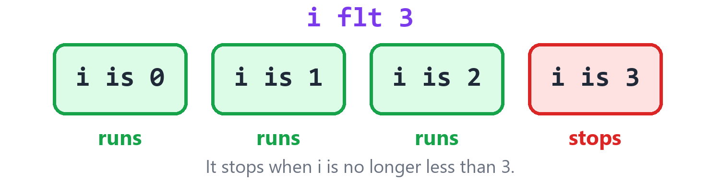
i starts at 0 and goes up by 1 each time. It stops when the test fails.
It makes i for you, and it starts at 0. Why 0, and not 1? Because positions in a list start at 0, as you'll see in the next chapter, and the two work together nicely.
So if you want something done 3 times, write i flt 3. It runs when i is 0, 1 and 2. That's three times.
fle means for, less or equal. It includes the last number.
i fle 3
out prn i
0
1
2
3
And fne means for, not equal. It counts up until i reaches the number.
i fne 2
out prn i
0
1

Starting somewhere else
To start from another number, make the counter first:
k is 1
k fle 3
out prn k
1
2
3

Counting down
fgt and fge count down. They need a counter that you made first, because they have to know where to start.
count is 3
count fgt 0
out prn count
out prn "Blast off!"
d is 2
d fge 0
out prn d
3
2
1
Blast off!
2
1
0
Root | Say it | Counts | Stops when
flt | for, less than | up | it reaches the number
fle | for, less or equal | up | it passes the number
fne | for, not equal | up | it reaches the number
fgt | for, greater than | down | it reaches the number
fge | for, greater or equal | down | it passes the number

While
Sometimes you don't know how many times you'll need. Roots that start with w mean while. They repeat for as long as the test passes.
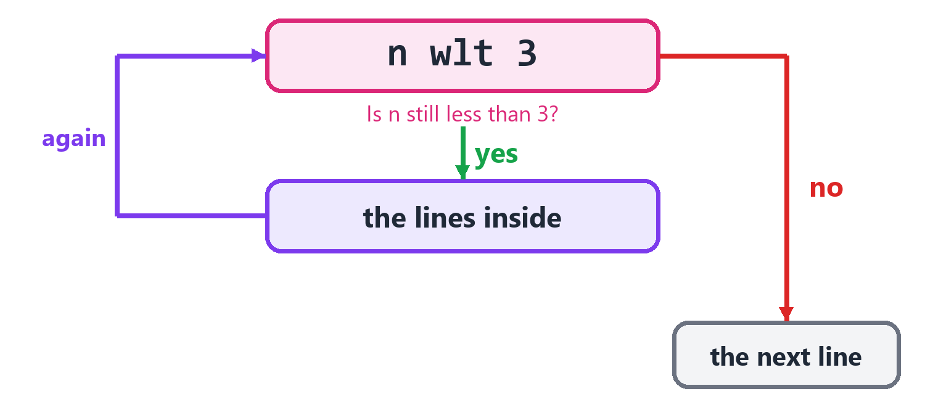
While the test passes, the lines inside run again and again.
n is 1
n wlt 100
n aml 2
out prn n
128
Line | Say it
n is 1 | n is 1.
n wlt 100 | While n is less than 100, do this:
n aml 2 | Multiply n by 2.
out prn n | Print n.

It goes 1, 2, 4, 8, 16, 32, 64, 128. Then the test fails, because 128 isn't less than 100.
Here are all of the while roots:
Root | Say it
weq | while equal
wne | while not equal
wlt | while less than
wle | while less or equal
wgt | while greater than
wge | while greater or equal
wfv | while forever

a is 0
a weq 0
a is 1
b is 0
b wne 2
b add 1
c is 0
c wle 2
c add 1
d is 5
d wgt 2
d asb 1
e is 5
e wge 2
e asb 1
out prn a&b&c&d&e
1 2 3 2 1
Watch out! A while loop has to change something, or else its test will never fail. A loop with n wlt 100 that never changes n goes round forever. Your program looks stuck. If that happens, press Shift+F5 to stop it.

Forever, until you leave
wfv means while forever. It never stops by itself. So you leave from inside it with ebk, which means exit by breaking out.
n is 0
now wfv now
n add 1
n ieq 3
now ebk now
out prn n
3
Testing and then breaking is so common that ebk can do it in one line. Its third word can be a test:
n is 0
now wfv now
n add 1
now ebk n==3
out prn n
3
Line | Say it
now wfv now | Forever, do this:
now ebk n==3 | Break out of the loop if n equals 3.

Skipping one turn
enx means go on to the next turn. The program skips the rest of the block, and the loop goes on.
i flt 5
i enx i==1
now ebk i==3
out prn i
0
2
Line | Say it
i flt 5 | Count with i, while i is less than 5:
i enx i==1 | Go on to i's next turn if i equals 1.
now ebk i==3 | Break out if i equals 3.
out prn i | Print i.

When i is 0, it prints. When i is 1, it skips to the next turn. When i is 2, it prints. When i is 3, it leaves.

Leaving two loops at once
A loop can have another loop inside it:
row flt 2
seat flt 3
out put "*"
out prn ""
***
***
In C++, a break only leaves the loop it's in. To leave two, you need an extra box and an extra test. In English++, you say which loop by its counter's name:
a flt 3
b flt 3
a*b ieq 2
a ebk now
out prn a*10+b
out prn "done"
0
1
2
10
11
done
Line | Say it
a*b ieq 2 | If a times b is 2, do this:
a ebk now | Break out of the a loop.

a ebk now leaves the a loop, which also leaves everything inside it. And a enx now goes on to a's next turn.

Walking through things
fea means for each. It walks through a list, one thing at a time. A list is many values in a row, and the next chapter is all about them. You'll use this loop more than any other.
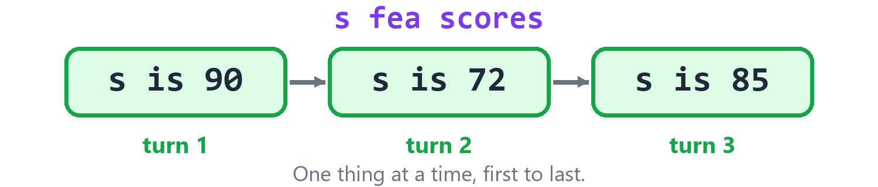
fea gives you each thing in turn, from first to last.
scores is 90&72&85
s fea scores
out prn s
90
72
85
Line | Say it
s fea scores | For each s in scores, do this:
out prn s | Print s.

It walks through the letters of a text too:
letter fea "abc"
out prn letter
a
b
c

Do this, until
The loops so far test first, then run. bdo runs first and tests afterward. So its lines always run at least once. A root that starts with u, for until, ends it. That root goes at the same indent as bdo.
n is 0
now bdo now
n add 2
n uge 6
out prn n
6
Line | Say it
now bdo now | Do this:
n add 2 | Add 2 to n.
n uge 6 | Until n is greater than or equal to 6.

Here are all of the until roots:
Root | Say it
ueq | until equal
une | until not equal
ult | until less than
ule | until less or equal
ugt | until greater than
uge | until greater or equal

a is 0
now bdo now
a add 1
a ueq 2
b is 0
now bdo now
b add 1
b une 0
c is 3
now bdo now
c asb 1
c ult 2
d is 3
now bdo now
d asb 1
d ule 2
e is 0
now bdo now
e add 1
e ugt 1
out prn a&b&c&d&e
2 1 1 2 2
Use bdo when you need to do something before you can test it, like asking a question and then checking the answer. Forgetting the until is a mistake:
now bdo now
out prn 1
The Studio says: Line 1: A do block ends with until, at the same indent: x ueq 3.

Which loop should I use?
You want to | Use
do something a number of times | i flt 10
go through a list | x fea list
keep going while something is true | n wlt 100
do it once first, then check | now bdo now and n uge 6
keep going until something inside says stop | now wfv now and now ebk now

What you learned
Root | Say it
flt | count up, while less than
fea | for each
wlt | while less than
wfv | while forever
ebk | break out of the loop
enx | go on to the next turn
bdo and uge | do this, until

Try it! Print the 5 times table: 5, 10, 15, and so on, up to 50. Use i fle 10, and start i at 1.

Try it! Use flt inside flt to print a triangle of stars with 4 rows. The first row has 1 star, and the last row has 4.

13. More Ways With Text
Text can do a few more tricks. These words are all in the t family. They give you an answer and leave your text alone.

Repeating and counting
tre means text: repeated. tct means text: count. It counts how many times a small piece is in a bigger text.
out prn tre&"ha"&3
song is "la la la"
out prn tct&song&"la"
hahaha
3

What kind of letter is it?
These three ask about one letter.
You write | Say it | You get
tdg&c | is c a digit? | yes or nay
tlr&c | is c a letter? | yes or nay
tws&c | is c white space, like a space or a tab? | yes or nay

This program walks through some text and sorts out its letters.
s is "Room 12"
letters is 0
digits is 0
spaces is 0
c fea s
tlr&c ieq yes
letters add 1
tdg&c ieq yes
digits add 1
tws&c ieq yes
spaces add 1
out prn letters
out prn digits
out prn spaces
4
2
1

Filling in a pattern
tfa means text: filled in. You give it a pattern with holes in it, and then the values to put in the holes. Each {} is a hole.
name is "Ada"
score is 9
out prn tfa&"{} has {} points"&name&score
out prn tfa&"{:.2f}"&3.14159
out prn tfa&"[{:>5}]"&42
out prn tfa&"[{:<5}]"&42
Ada has 9 points
3.14
[ 42]
[42 ]
A hole can say how it wants its value to look.
Hole | What it does
{} | puts the value in
{:.2f} | a decimal with 2 numbers after the point
{:>5} | makes room for 5, and pushes the value to the right
{:<5} | makes room for 5, and pushes the value to the left

Tip! Room for 5 makes columns line up. That's how you print a tidy table.

What kind is this?
ttp means text: type. It tells you what kind a thing is, as text.
x is 5
y is "hi"
out prn ttp&x
out prn ttp&y
num
txt
Try it! Print a line of 20 dashes with tre. Then use tfa to print a name and an age on one line.

Part 3: Many Things
Lists, maps and other ways to keep many things together.

14. Lists
A box holds one thing. A list holds many things, in a row. High scores, names of players, cards in a deck: they all go in lists. C++ calls this kind of list a vector, so its kind is written vec.

Making a list
Join values with &, and you've made a list.
scores is 90&72&85
out prn scores
[90, 72, 85]
Line | Say it
scores is 90&72&85 | scores is 90 and 72 and 85.

Positions
Every thing in a list has a position. The first one is at position 0.
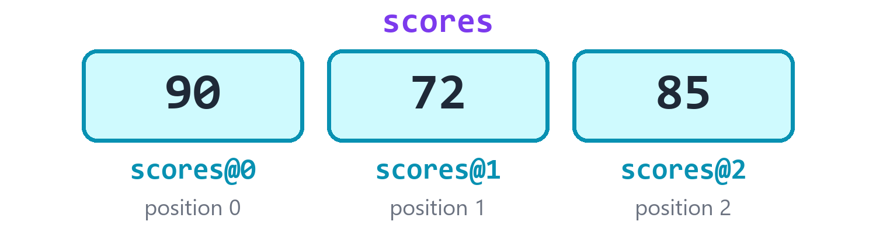
Three things in a row. The positions start at 0.
@ reaches a position:
scores is 90&72&85
out prn scores@0
out prn scores@2
scores@1 is 75
out prn scores
90
85
[90, 75, 85]
Line | Say it
out prn scores@0 | Print scores at position 0.
scores@1 is 75 | scores at position 1 is 75.

Watch out! The first position is 0, so the last position is one less than the size. A list of 3 things has positions 0, 1 and 2. Everybody gets this wrong sometimes.

If you ask for a position that isn't there, your program stops. It shows you the line and tells you what went wrong:
scores is 90&72&85
out prn scores@0
out prn scores@9
90
The program stopped on line 3:
out prn scores@9
It used a position that is not in the collection or text.
In C++, this would read whatever happened to be in the computer's memory. Your program would go on with a wrong number. That's one of the worst kinds of bug, because it can hide for years.
A position can be a box:
scores is 90&72&85
i is 1
out prn scores@i
72
Watch out! @ holds on tight. scores@i+1 means scores at i, plus 1. It doesn't mean scores at i+1. To reach the next position, make a step first: next is i+1, then scores@next.

How many?
cct counts what's in a list.
scores is 90&72&85
out prn cct&scores
last is cct&scores
last asb 1
out prn scores@last
3
85

Starting with an empty list
To start with nothing in the list, use mak and the kind vec@num. Say it as a vector of numbers. Any kind can go after the @.
scores mak vec@num
names mak vec@txt
out prn scores
out prn names
scores add 90
scores add 72
names add "Ada"
out prn scores
out prn names
[]
[]
[90, 72]
[Ada]
add puts something on the end of a list. It's the same root as adding to a number. Adding means making it bigger, either way.

Changing a list
The l family changes a list.
Root | Say it | Example | What happens
add | add to the end | v add 4 | 4 goes on the end
lin | insert | v lin 0&9 | at position 0, 9 goes in
lrm | remove this value | v lrm 3 | every 3 comes out
ldx | remove this position | v ldx 0 | what's at position 0 comes out
lpl | pop the last | v lpl now | the last one comes out
lso | sort | v lso now | smallest to biggest
lrv | reverse | v lrv now | back to front
luq | unique | v luq now | sorts it, and takes out repeats
lsu | shuffle | v lsu now | a random order
lfl | fill | v lfl 0 | every place holds 0
lrs | resize | v lrs 5 | now it has 5 places
lwp | wipe | v lwp now | it's empty

Let's watch them work, one at a time.
v is 5&3&9
v add 4
out prn v
v lin 0&8
out prn v
v lrm 3
out prn v
v ldx 0
out prn v
v lpl now
out prn v
[5, 3, 9, 4]
[8, 5, 3, 9, 4]
[8, 5, 9, 4]
[5, 9, 4]
[5, 9]
Line | Say it | The list is now
v add 4 | Add 4 to the end of v. | 5 3 9 4
v lin 0&8 | In v, at position 0, insert 8. | 8 5 3 9 4
v lrm 3 | From v, remove the value 3. | 8 5 9 4
v ldx 0 | From v, remove position 0. | 5 9 4
v lpl now | From v, pop the last one. | 5 9

These put things in order:
v is 5&3&9&3
v lso now
out prn v
v lrv now
out prn v
v luq now
out prn v
[3, 3, 5, 9]
[9, 5, 3, 3]
[3, 5, 9]
And these change its size, or everything in it:
v is 1&2&3
v lfl 7
out prn v
v lrs 5
out prn v
v lrs 2
out prn v
v lwp now
out prn v
[7, 7, 7]
[7, 7, 7, 0, 0]
[7, 7]
[]
lsu shuffles a list, like a deck of cards. So what it prints is different each time:
cards is 1&2&3&4&5
cards lsu now
out prn cards

Walking through a list
You met fea in the last chapter. It's how you visit each thing in a list.
names is "Ada"&"Bob"&"Cy"
name fea names
out prn "Hello, @name!"
Hello, Ada!
Hello, Bob!
Hello, Cy!
Tip! fea is also the fastest way through a list. Reading by position, like v@i, checks that the position is there each time. fea doesn't have to.

If you need the position too, count with flt:
names is "Ada"&"Bob"
i flt cct&names
out prn "@i: @names@i"
0: Ada
1: Bob
fea can change the things in a list as it goes, because each one is the thing, and not a copy:
scores is 1&2&3
s fea scores
s aml 10
out prn scores
[10, 20, 30]
But you can't add to a list or remove from it while you're walking through it. That would be like moving the stairs while you're walking up them. In C++ it might crash, or it might not. Here you find out right away:
scores is 1&2&3
s fea scores
scores add 4
The Studio says: Line 3: You can't change scores while fea is walking through it: C++ would read memory that is gone. Walk through a copy: copy is scores.

Lists inside lists
A list can hold lists. That gives you a grid, like a game board.
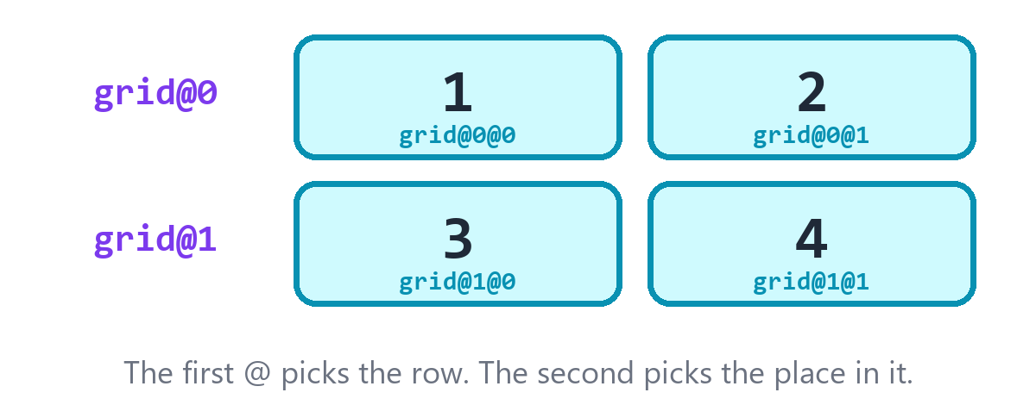
A list of two lists makes a grid.
grid mak vec@vec@num
grid add 1&2
grid add 3&4
out prn grid
out prn grid@1@0
grid@1@0 is 9
out prn grid
[[1, 2], [3, 4]]
3
[[1, 2], [9, 4]]
Line | Say it
grid mak vec@vec@num | Make grid, a vector of vectors of numbers.
out prn grid@1@0 | Print grid at row 1, place 0.

What you learned
You want to | Write
make a list | v is 1&2&3
make an empty list | v mak vec@num
reach a position | v@0
know the size | cct&v
add to the end | v add 4
take out a value | v lrm 3
sort it | v lso now
visit each one | x fea v

Try it! Make a list of 5 numbers. Sort it. Print the first one and the last one.

Try it! Make an empty list of texts. Add three of your friends' names. Print "Hello" to each one, using fea.

15. Asking a List
The l family changes a list. The c family asks a list questions. It never changes anything. It just gives you an answer.

Adding up
You write | Say it | For 2, 4, 6 you get
cct&v | how many | 3
csm&v | the sum: all of them added | 12
cpd&v | the product: all of them multiplied | 48
cmx&v | the biggest | 6
cmn&v | the smallest | 2

v is 2&4&6
out prn cct&v
out prn csm&v
out prn cpd&v
out prn cmx&v
out prn cmn&v
3
12
48
6
2

The middle of a list
These tell you what's typical in a list of numbers.
You write | Say it | What it means
cav&v | the average | add them up, and divide by how many
cme&v | the median | the one in the middle, once they're sorted
cde&v | the standard deviation | how spread out they are

v is 2&4&9
out prn cav&v
out prn cme&v
w is 2&4&6
out prn cde&w
5
4
1.63299

Looking for something
You write | Say it | What you get
chs&v&9 | does v have a 9? | yes or nay
chm&v&9 | how many 9s does v have? | a number
cps&v&9 | where is the first 9? | a position, or -1
cfr&v | the first one | a value
cla&v | the last one | a value
cra&v | a random one | a value

v is 5&9&2&9
out prn chs&v&9
out prn chs&v&7
out prn chm&v&9
out prn cps&v&9
out prn cps&v&7
out prn cfr&v
out prn cla&v
yes
nay
2
1
-1
5
9
cra picks one at random, which is perfect for games. So this program prints something different each time:
snacks is "apple"&"plum"&"pear"
out prn cra&snacks

Getting a changed copy
The l words change the list itself. These give you a new list, and leave the old one just as it was.
You write | Say it
cso&v | a sorted copy of v
crv&v | a reversed copy of v
ctx&v&", " | v, joined into one text, with ", " between

v is 3&1&2
out prn cso&v
out prn crv&v
out prn v
names is "Ada"&"Bob"&"Cy"
out prn ctx&names&", "
[1, 2, 3]
[2, 1, 3]
[3, 1, 2]
Ada, Bob, Cy
Tip! ctx and tsp are opposites. tsp splits a text into a list. ctx joins a list into a text.

What you learned
You want | Use | Say it
the size | cct&v | count
the total | csm&v | sum
the biggest | cmx&v | max
the smallest | cmn&v | min
the average | cav&v | average
to know if it has one | chs&v&x | has
a sorted copy | cso&v | sorted

Try it! Make a list of test scores: 70, 85, 90, 60. Print the average, the best and the worst.

16. Maps
A list finds things by position. A map finds things by name.
Think of a dictionary. You look up a word, and you find its meaning. The word is called the key, and what you find is called the value.
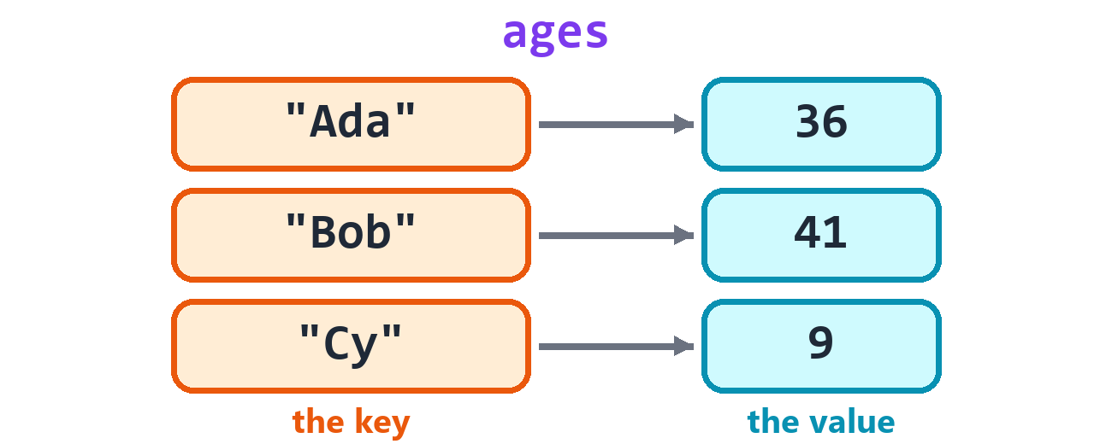
Each key leads to its value.

Making a map
Say which kinds it holds. map@txt@num means a map from texts to numbers.
ages mak map@txt@num
ages@"Ada" is 36
ages@"Bob" is 41
out prn ages
out prn ages@"Ada"
{Ada: 36, Bob: 41}
36
Line | Say it
ages mak map@txt@num | Make ages, a map from texts to numbers.
ages@"Ada" is 36 | ages at "Ada" is 36.
out prn ages@"Ada" | Print ages at "Ada".

You can also start a map with map&, and go on with add:
ages is map&"Ada"&36
ages add "Bob"&41
out prn ages
{Ada: 36, Bob: 41}

Is it in there?
Ask with chs before you read a key that may not be there.
ages mak map@txt@num
ages@"Ada" is 36
out prn chs&ages&"Ada"
out prn chs&ages&"Zed"
yes
nay
Watch out! Reading a key that isn't in the map adds it to the map, with a zero value. It doesn't warn you. So check with chs when it matters.

ages mak map@txt@num
out prn ages@"Zed"
out prn ages
0
{Zed: 0}
That zero is handy, though. Here is a program that counts words, and it's only a few lines:
counts mak map@txt@num
text is "the cat and the dog and the fish"
word fea twd&text
counts@word add 1
out prn counts
{and: 2, cat: 1, dog: 1, fish: 1, the: 3}
Line | Say it
word fea twd&text | For each word in the words of text, do this:
counts@word add 1 | Add 1 to counts at that word.

Taking one out
lrm removes a key. cct counts the keys. lwp wipes them all.
ages is map&"Ada"&36
ages add "Bob"&41
ages lrm "Ada"
out prn ages
out prn cct&ages
ages lwp now
out prn ages
{Bob: 41}
1
{}

Walking through a map
fea with two names, joined by &, gives you each key and its value. A map keeps its keys in order, from smallest to biggest.
ages mak map@txt@num
ages@"Bob" is 41
ages@"Ada" is 36
name&age fea ages
out prn "@name is @age"
Ada is 36
Bob is 41
Line | Say it
name&age fea ages | For each name and age in ages, do this:

cky gives you a list of the keys, and cvl gives you a list of the values:
ages mak map@txt@num
ages@"Ada" is 36
ages@"Bob" is 41
out prn cky&ages
out prn cvl&ages
[Ada, Bob]
[36, 41]

A faster map
hsh is another kind of map, called a hash map. It's usually faster when it gets big. But it keeps its keys in no special order. So use map, unless your program is too slow.
ages mak hsh@txt@num
ages@"Ada" is 36
out prn ages@"Ada"
out prn chs&ages&"Ada"
36
yes

What you learned
You want to | Write
make a map | m mak map@txt@num
store something | m@"Ada" is 36
read something | m@"Ada"
ask if a key is there | chs&m&"Ada"
remove a key | m lrm "Ada"
visit them all | k&v fea m
get all the keys | cky&m
get all the values | cvl&m

Try it! Make a map from food names to prices. Add three foods. Walk through it and print each one, like: apple costs 2.

17. Other Collections
Lists and maps will do nearly everything you need. But a few other kinds are perfect for certain jobs. A collection is any kind that holds many things.
Kind | Say it | It's good for
set | a set | keeping each thing only once
bag | a hash set | the same, usually faster, in no order
stk | a stack | the last thing in is the first thing out
que | a queue | the first thing in is the first thing out
hep | a heap | always getting the biggest thing
lst | a linked list | adding at both ends
dqu | a deque | adding at both ends, and reaching any position
arr | an array | a size that never changes
par | a pair | two things together
tup | a tuple | a few things together
opt | a maybe | a value that may not be there
alt | one of several | a value that can be one of a few kinds

Set: each thing once
A set keeps each thing only once, and keeps them in order. It's the fastest way to ask have I seen this before?
seen mak set@txt
seen add "cat"
seen add "dog"
seen add "cat"
out prn seen
out prn cct&seen
out prn chs&seen&"dog"
seen lrm "cat"
out prn seen
{cat, dog}
2
yes
{dog}
We added "cat" twice, but it's only in there once.
A bag works the same way, but in no special order. It's usually faster when it's big.
seen mak bag@num
seen add 5
seen add 5
out prn cct&seen
1

Stack and queue
These two are about who goes next.
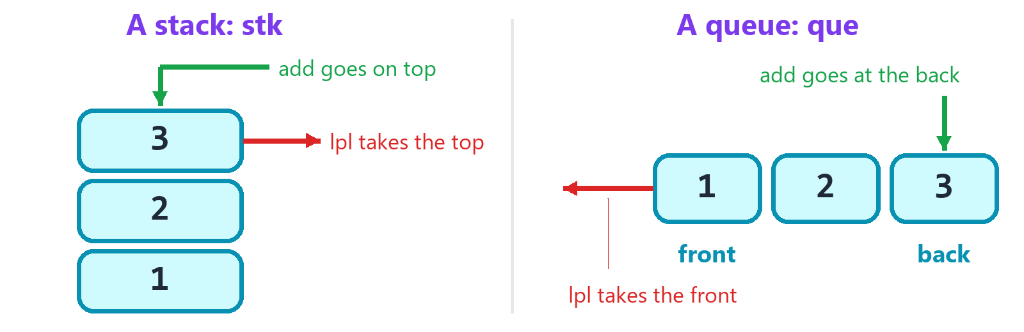
A stack is a pile of plates. A queue is a line at the store.
A stack is like a pile of plates. You put a plate on top, and you take a plate from the top. @top looks at the top one. lpl takes it off.
plates mak stk@num
plates add 1
plates add 2
plates add 3
out prn plates@top
plates lpl now
out prn plates@top
out prn cct&plates
3
2
2
A queue is like a line at the store. New people go at the back, and the front person goes next. @front looks at the front one, and lpl takes it out.
line mak que@txt
line add "Ada"
line add "Bob"
out prn line@front
line lpl now
out prn line@front
Ada
Bob
Watch out! You can't print a whole stack or queue. They only let you see the next thing, because that's the point of them. English++ tells you if you try.

plates mak stk@num
plates add 1
out prn plates
The Studio says: Line 3: A stack or a queue can only be read from one end. Print its top: s@top.

Heap: the biggest first
A heap always gives you its biggest thing, however you added them. It's perfect for a to-do list where the most important thing goes first.
jobs mak hep@num
jobs add 3
jobs add 9
jobs add 5
out prn jobs@top
jobs lpl now
out prn jobs@top
9
5

Adding at both ends
A normal list is slow at adding to its front, because everything has to shuffle along to make room. A lst and a dqu are quick at both ends. lpf pops the first one.
line mak dqu@num
line add 2
line add 3
line lin 0&1
out prn line
line lpf now
out prn line
out prn line@0
[1, 2, 3]
[2, 3]
2
A lst is the same idea, but you can't reach a position in it with @. You have to walk through it.
line mak lst@num
line add 2
line add 3
line lpf now
out prn line
[3]

Array: a size that never changes
An arr holds a set number of things, and that number never changes. You put its kind first, and then its size. It starts filled with zeros.
days mak arr@num@7
days@0 is 5
out prn days
out prn cct&days
[5, 0, 0, 0, 0, 0, 0]
7

Pair: two things
A par holds two things. You reach them with first and second. par& makes one.
spot is par&3&4
out prn spot
out prn spot@first
out prn spot@second
named mak par@txt@num
named@first is "Ada"
named@second is 36
out prn named
(3, 4)
3
4
(Ada, 36)

Tuple: a few things
A tup holds as many things as you like, of any kinds. To open one up, give each part a name, joined with &:
person is tup&"Ada"&36&yes
name&age&ok is person
out prn name
out prn age
out prn ok
Ada
36
yes
You'll see this again soon, when a function gives back two answers at once.

Maybe: a value that may not be there
Sometimes there's no answer. If you search for a word and it isn't there, what do you give back? An opt can hold a value, or it can hold nothing at all. nil means nothing.
found mak opt@num
found ieq nil
out prn "nothing yet"
out prn found@value_or&0
found is 7
found ine nil
out prn found@value
nothing yet
0
7
Line | Say it
found mak opt@num | Make found, a maybe-number. It starts with nothing in it.
found ieq nil | If found holds nothing, do this:
out prn found@value_or&0 | Print the value of found, or 0 if it holds nothing.
found is 7 | found holds 7.
found ine nil | If found doesn't hold nothing, do this:
out prn found@value | Print the value in found.

opt& makes one straight away: x is opt&7.

One of several kinds
An alt holds one value, which can be any of the kinds you list. Here it's a number or a text.
thing mak alt@num@txt
thing is 5
out prn thing
thing is "five"
out prn thing
out prn thing@txt
5
five
five
thing@txt says the text in thing. If it holds a number at the time, your program stops and says so.

What you learned
You want | Use | Add with | Next one with
each thing once | set or bag | add
last in, first out | stk | add | @top, then lpl
first in, first out | que | add | @front, then lpl
the biggest first | hep | add | @top, then lpl
both ends | dqu or lst | add, lin | lpf, lpl

Try it! Use a set to find out how many different letters there are in the word "banana". (Use fea to walk through the text and add to put each letter in.) It should print 3.

Part 4: Your Own Words
Make your own functions, and your own kinds of things.

18. Functions
So far you've used words that English++ gave you. Now you'll make your own.
A function is a little machine with a name. You give it some values. It does some work. It may give you something back.
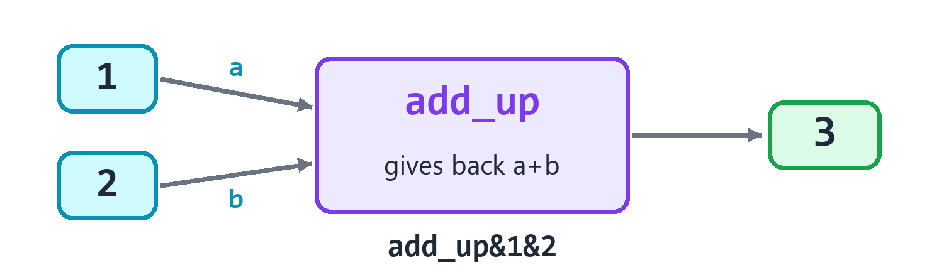
A function takes values in, and gives an answer back.

Making a function
out prn add_up&1&2
add_up dfn num
a dpm num
b dpm num
add_up ert a+b
3
Three new roots, all easy to read:
Line | Say it
add_up dfn num | Define a function called add_up. It gives back a number.
a dpm num | It takes a parameter called a, a number.
b dpm num | It takes a parameter called b, a number.
add_up ert a+b | add_up returns a+b.
out prn add_up&1&2 | Print what add_up gives with 1 and 2.

A parameter is a box that gets filled in when somebody uses the function. dfn is define function, dpm is define parameter, and ert is exit, returning this.
Look at where the function is written. It comes after the line that uses it. In C++, you have to get the order right, or write an extra line called a prototype. In English++, the order never matters. Put your functions wherever you like. Most people put them at the bottom.
You can use it as often as you want:
x is add_up&1&2
y is add_up&x&10
out prn y
add_up dfn num
a dpm num
b dpm num
add_up ert a+b
13
Watch out! A word holds only one run of a function. You can't write add_up&add_up&1&2&10. Do it in two steps, as in the program above. Each step gets a name, so it's easier to read too.

Functions that give nothing back
Some functions just do a job. They say now instead of a kind. To run one, put its name in the middle spot and its values in the last spot.
now hello "Ada"
now hello "Bob"
hello dfn now
who dpm txt
out prn "Hello, @who!"
Hello, Ada!
Hello, Bob!
Line | Say it
now hello "Ada" | Now, run hello with "Ada".
hello dfn now | Define a function called hello. It gives back nothing.

If it takes more than one value, join them with &. If it takes none, write now.
now greet "Ada"&3
now beep now
greet dfn now
who dpm txt
times dpm num
i flt times
out prn "Hi, @who!"
beep dfn now
out prn "Beep!"
Hi, Ada!
Hi, Ada!
Hi, Ada!
Beep!

Leaving early
ert leaves the function straight away. In a function that gives back nothing, write ert now.
now check_age 5
now check_age 20
check_age dfn now
age dpm num
age ilt 13
out prn "Too young."
check_age ert now
out prn "Welcome!"
Too young.
Welcome!

Starting values
Give a parameter a value instead of a kind, and that value is used if nobody gives one.
now hello "Ada"
now hello "Bob"&"Hi"
hello dfn now
who dpm txt
word dpm "Hello"
out prn "@word @who"
Hello Ada
Hi Bob

When you get it wrong
The Studio checks every function and every use of it, before anything runs. Here are mistakes it catches:
Too few values, or too many:
out prn add_up&1
add_up dfn num
a dpm num
b dpm num
add_up ert a+b
The Studio says: Line 1: add_up takes 2 values, but it was given 1.

The wrong kind of value:
out prn add_up&1&"two"
add_up dfn num
a dpm num
b dpm num
add_up ert a+b
The Studio says: Line 1: add_up wants a whole number for b, but "two" is a text.

Forgetting to give something back:
out prn six&
six dfn num
x is 6
The Studio says: Line 3: six promises to give back a whole number, but it never does. Add a line: six ert ...

Your names can't be the same as a root:
add dfn num
a dpm num
add ert a
The Studio says: Line 1: add is a root, so it can't be a function's name: lines would read it as the root. Pick another name.

Names stay inside
A box you make inside a function belongs to that function. It's gone when the function ends. Other functions can't see it.
now make_it now
out prn secret
make_it dfn now
secret is 5
The Studio says: Line 2: I don't know secret yet. Make it first, like secret is 0.

It works the other way too. A function can't see a box made in the main part of your program. You have to hand it in, with dpm:
x is 1
out prn get_x&
get_x dfn num
get_x ert x
The Studio says: Line 5: x belongs to the main program, so get_x can't see it. Hand it in with dpm, or make it with mgl.

The same is true of any block. A box made inside a block lasts until the block ends. bbl opens a block just for that:
x is 1
now bbl now
y is 2
out prn x+y
out prn x
3
1

Boxes everyone can see
mgl makes a global: one box that every function can see. Put it at the top level, not inside a function.
now score_up 2
now score_up 3
out prn score
score mgl 0
score_up dfn now
n dpm num
score add n
5
Tip! Use globals only when you have to. When any function can change a box, it gets hard to tell which one did it. Passing values in and getting answers back is easier to follow.

A copy, or the real thing
A function gets its own copy of what you give it. If it changes the copy, your box doesn't change.
But when you write ref@ in front of the kind, the function gets the real thing.
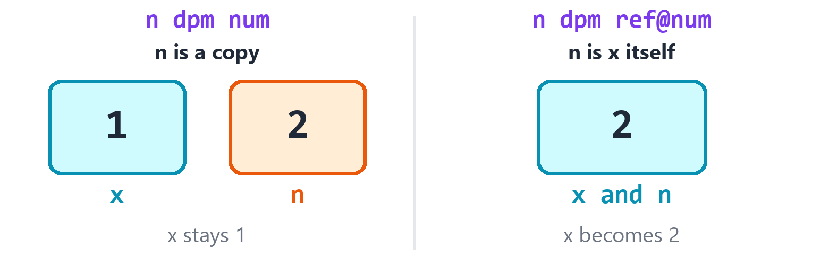
A copy is a second box. A ref is the same box.
x is 1
now try_copy x
out prn x
now try_ref x
out prn x
try_copy dfn now
n dpm num
n add 1
try_ref dfn now
n dpm ref@num
n add 1
1
2
see@ gets the real thing, too, but only to look at. It can't change it. Use it for big things like long lists, so nothing has to be copied:
scores is 1&2&3
out prn top_of&scores
top_of dfn num
v dpm see@vec@num
top_of ert cmx&v
3
If you try to change something you only have a see@ of, the Studio stops you:
scores is 1&2&3
now wipe_it scores
wipe_it dfn now
v dpm see@vec@num
v lwp now
The Studio says: Line 6: v is only a look at the real thing (see@), so it can't change. To change it, take it with ref@.

Kind of parameter | Say it | It can change yours? | It copies?
n dpm num | a copy | no | yes
n dpm ref@num | the real thing | yes | no
n dpm see@num | a look at the real thing | no | no

A second name for a box
mrf gives a box a second name. Both names mean the same box. mlo does the same, but the second name can only look.
x is 1
also mrf x
also add 1
out prn x
peek mlo x
x add 1
out prn peek
2
3

Two answers at once
A function can give back two things or more. Say so with tup@, then give each answer a name when you use it.
q&r is divide&17&5
out prn "@q, with @r left over"
divide dfn tup@num@num
a dpm num
b dpm num
whole is a/b
rest is a%b
divide ert whole&rest
3, with 2 left over
Line | Say it
q&r is divide&17&5 | q and r are what divide gives with 17 and 5.
divide ert whole&rest | divide returns whole and rest.

A function that uses itself
A function can run itself. It's called recursion. It has to have a way to stop, or it would go on forever.
out prn factorial&5
factorial dfn num
n dpm num
n ile 1
factorial ert 1
smaller is factorial&n-1
factorial ert n*smaller
120
factorial&5 is 5 times factorial&4, which is 4 times factorial&3, and so on down to 1.

What you learned
You write | Say it
add_up dfn num | define a function that gives back a number
hello dfn now | define a function that gives back nothing
a dpm num | it takes a number, called a
word dpm "Hi" | it takes a text, called word, with a starting value
add_up ert a+b | return a+b
add_up&1&2 | run it, and use the answer
now hello "Ada" | run it, and use no answer
n dpm ref@num | it takes the real thing
score mgl 0 | make a global

Try it! Write a function called twice that takes a number and gives back two times that number. Print twice&21.

Try it! Write a function called biggest that takes a list of numbers and gives back the biggest one, without using cmx. (Hint: use fea, and keep the biggest one so far in a box.)

19. Functions in a Name
A function can go in a box, just like a number. Then you can hand it to other functions. This sounds strange, but it lets you say very big things in very few lines.

A function inside a function
dlm makes a function inside another function, or anywhere in your program. People call it a lambda.
twice dlm num
n dpm num
twice ert n*2
out prn twice&21
42
It's written just like dfn. There's one big difference: it can see the boxes around it.
bonus is 100
plus_bonus dlm num
n dpm num
plus_bonus ert n+bonus
out prn plus_bonus&5
105
A dfn function couldn't see bonus. A dlm function can.

Handing a function to a list
Now the good part. These words take a list and a function:
You write | Say it | You get
cft&v&f | v, filtered by f | a new list, with only what f says yes to
cmp&v&f | v, each one through f | a new list, with what f gives for each one
v lso f | sort v, using f to compare | v, in a new order

v is 1&5&2&8
big dlm yno
n dpm num
big ert n>2
out prn cft&v&big
[5, 8]
Line | Say it
big dlm yno | Define a function called big. It gives back a yes or no.
big ert n>2 | It returns: is n greater than 2?
out prn cft&v&big | Print v, filtered by big.

Here's cmp. It runs a function on each thing in a list:
v is 1&2&3
square dlm num
n dpm num
square ert n*n
out prn cmp&v&square
[1, 4, 9]
And here's lso, with a function that says what comes first:
v is 3&1&2
bigger_first dlm yno
a dpm num
b dpm num
bigger_first ert a>b
v lso bigger_first
out prn v
[3, 2, 1]
In C++, each of these takes many more marks. Here it's a few short lines, and you can read it.

The kind of a function
Functions have a kind too. It's fun@. After it comes the kind it gives back, and then the kinds it takes. fun@num@txt means a function that gives a number and takes a text.
With it, a box can hold a function, or a parameter can take one:
say_size mak fun@num@txt
sizer dlm num
s dpm txt
sizer ert tsz&s
say_size is sizer
out prn say_size&"hello"
out prn run_twice&sizer
run_twice dfn num
f dpm fun@num@txt
a is f&"one"
b is f&"three"
run_twice ert a+b
5
8
You write | It means
fun@num | gives a number, and takes nothing
fun@num@txt | gives a number, and takes a text
fun@yno@num@num | gives a yes or no, and takes two numbers

What you learned
You write | Say it
f dlm num | define a function in a name, that gives back a number
cft&v&f | keep what f says yes to
cmp&v&f | put each one through f
v lso f | sort v, using f
fun@num@txt | the kind of a function

Try it! Make a list of words. Use cft with a function that says yes to words longer than 3 letters. Print what's left.

20. Lists and Functions Together
Now that you can keep a function in a name, you can hand it to a list. The list uses it to answer harder questions.

Does it pass?
These three take a list and a function that says yes or nay.
You write | Say it | You get yes if
cea&v&f | does each one pass? | all of them pass
can&v&f | does any pass? | at least one passes
cnn&v&f | does none pass? | not one passes

scores is 70&85&92
passed dlm yno
n dpm num
passed ert n>80
out prn cea&scores&passed
out prn can&scores&passed
out prn cnn&scores&passed
nay
yes
nay

Rolling up a list
crl means count: rolled up. It starts with a value, and it uses your function to roll each item into it, one at a time. Here it starts at 1, then multiplies by 2, by 3 and by 4.
v is 2&3&4
times dlm num
a dpm num
b dpm num
times ert a*b
out prn crl&v&1&times
24

Walking two lists at once
czp means zip. It joins two lists like the two sides of a zip, so you get one from each at a time. cnu means numbered. It gives each item a number, starting from 0.
names is "Ada"&"Bo"
ages is 10&12
n&a fea czp&names&ages
out prn "@n is @a"
k&n fea cnu&names
out prn "@k: @n"
Ada is 10
Bo is 12
0: Ada
1: Bo

Two lists, one answer
You write | Say it | You get
cun&a&b | in either | everything from both, once each
cbt&a&b | in both | what they share
cot&a&b | only in the first | what a has and b doesn't

a is 1&2&3
b is 2&3&4
out prn cun&a&b
out prn cbt&a&b
out prn cot&a&b
[1, 2, 3, 4]
[2, 3]
[1]

A part of a list
ccu means cut. Give it where to start and how many you want. If you leave out how many, you get the rest. crg means range. It makes a list by counting. You can give it a step.
v is 5&6&7&8&9
out prn ccu&v&1&2
out prn ccu&v&3
out prn crg&0&5
out prn crg&0&10&2
[6, 7]
[8, 9]
[0, 1, 2, 3, 4]
[0, 2, 4, 6, 8]

Finding by halves
When a list is sorted, you don't have to look at every item. Open it in the middle, see which half you need, and do it again. That's how you find a word in a dictionary. cbf says if a value is there, and cpb says where it is.
sorted is 2&4&6&8&10
out prn cbf&sorted&6
out prn cbf&sorted&7
out prn cpb&sorted&6
yes
nay
2
Watch out! The list has to be sorted first. If it isn't, these give wrong answers and don't say so.

Groups, and lists of lists
cgr means group. Your function gives each item a label, and you get a map of the labels and what went with them. cjn does the other thing: it joins a list of lists into one list.
words is "ant"&"bee"&"ape"
first dlm ltr
w dpm txt
first ert w@0
g is cgr&words&first
k&list fea g
out prn "@k: @list"
one is 1&2
two is 3&4
lists mak vec@vec@num
lists add one
lists add two
out prn cjn&lists
a: [ant, ape]
b: [bee]
[1, 2, 3, 4]

Two more ways to change a list
lrw means rotated. The first items go around to the end. lss sorts a list and keeps things that tie in the order they were. The s is for stable.
cards is 1&2&3&4
cards lrw 1
out prn cards
names is "Bo"&"Al"&"Cy"&"Di"
shorter dlm yno
a dpm txt
b dpm txt
x is tsz&a
y is tsz&b
shorter ert x<y
names lss shorter
out prn names
[2, 3, 4, 1]
[Bo, Al, Cy, Di]
All four names are the same length, so they all tie and stay where they were. A plain lso could have moved them.

The smallest on top
A heap keeps its biggest item on top, as you saw. mhp means make: heap, the low way. It keeps the smallest on top, and that's usually what you want for a list of jobs to do next.
jobs mak mhp@num
jobs add 5
jobs add 1
jobs add 3
out prn jobs@top&
jobs lpl now
out prn jobs@top&
1
3
Try it! Make a list of numbers. Use crl to add them all up, starting at 0. Then use cea to ask if they are all above 0.

21. More About Functions
Here are some things a function can do that you haven't seen yet.

Any number of values
If the last parameter is a list, it takes all the values that are left over. So you can hand the function as many as you like.
out prn add_all&1&2&3&4
out prn add_all&5
add_all dfn num
xs dpm vec@num
add_all ert csm&xs
10
5

A name that stays
The names in a function usually go away when it ends. msv means make: saved. It makes a name that stays between calls. It only starts once, on the first call.
out prn tick&
out prn tick&
out prn tick&
tick dfn num
n msv 0
n add 1
tick ert n
1
2
3

A function with its own copies
A function in a name can see the names around it. dlm uses those names themselves. dlv takes its own copies when it's made. Then what it does stays inside it.
x is 1
copy dlv num
x add 1
copy ert x
out prn copy&
out prn copy&
out prn x
2
3
1

A function for compile time
dcx makes a function that C++ can work out while it builds your program. The answer is ready before your program even starts.
out prn square&5
square dcx num
n dpm num
square ert n*n
25

One value at a time
Some lists are too long to make. All the even numbers, for one. A generator hands out one value at a time, and it only runs as far as you ask. Its kind is gnr@num. eyd means exit: yield. It hands over a value and waits there until you ask for the next one.
n fea evens&
out prn n
n igt 4
now ebk now
evens dfn gnr@num
i is 0
now wfv now
evens eyd i
i add 2
0
2
4
6
That loop in evens would go on forever. It doesn't matter, because it only runs when the fea asks for one more.

Cleaning up
bdr means block: deferred. Its lines don't run where you wrote them. They run when the block around them ends, however it ends. So you can put the cleaning up next to the setting up, and you can't forget it.
now bdr now
out prn "this comes last"
out prn "this comes first"
this comes first
this comes last
If you have several, they run in the opposite order to the way you wrote them. The last one in is the first one out.
Try it! Write a function with msv that says how many times it has been called. Call it three times.

22. Any Kind
Say you've written a function that finds the bigger of two numbers. Now you want the same thing for decimals, and for text. Do you have to write it three times? No.

A kind that gets filled in later
dtp makes a stand-in for a kind. Write it right above the function that uses it. When somebody runs the function, English++ fills in the real kind.
out prn biggest&3&9
out prn biggest&2.5&1.5
out prn biggest&"apple"&"pear"
T dtp now
biggest dfn T
x dpm T
y dpm T
x igt y
biggest ert x
biggest ert y
9
2.5
pear
Line | Say it
T dtp now | T is a kind that gets filled in later.
biggest dfn T | Define biggest. It gives back a T.
x dpm T | It takes x, a T.

The name T is only a habit. You could say Thing, as long as it starts with a capital letter.
C++ calls this a template. And when a template goes wrong in C++, you can get pages and pages of error messages. In English++, you get one sentence.

A class for any kind
It works for your own kinds of things too. You'll learn about those in the next chapter. Here's a taste:
n mak Box@num
n@item is 7
out prn n@item
s mak Box@txt
s@item is "hello"
out prn s@item
T dtp now
Box dst now
item dfd T
7
hello
Box@num means a Box of numbers. Now you can see that vec@num works the same way. A vector is just a box of things, with a kind filled in.

any: let it work out the kind
The word any is a quick way to take a value of any kind, for one parameter.
now show 5
now show "five"
show dfn now
x dpm any
out prn "It is: @x"
It is: 5
It is: five

What you learned
You write | Say it
T dtp now | T is a kind that gets filled in later
x dpm T | x is a T
Box@num | a Box, with T filled in as num
x dpm any | x can be any kind

Try it! Write a function called show_twice that takes a value of any kind and prints it two times.

23. Your Own Kinds of Things
A number is a kind of thing. So is a text. Now you'll make your own kinds of things: a Dog, a Player, a Spaceship.

A class is a plan
A class is a plan for a kind of thing. It says what each one has, and what each one can do. Then you can make as many as you like from that plan.
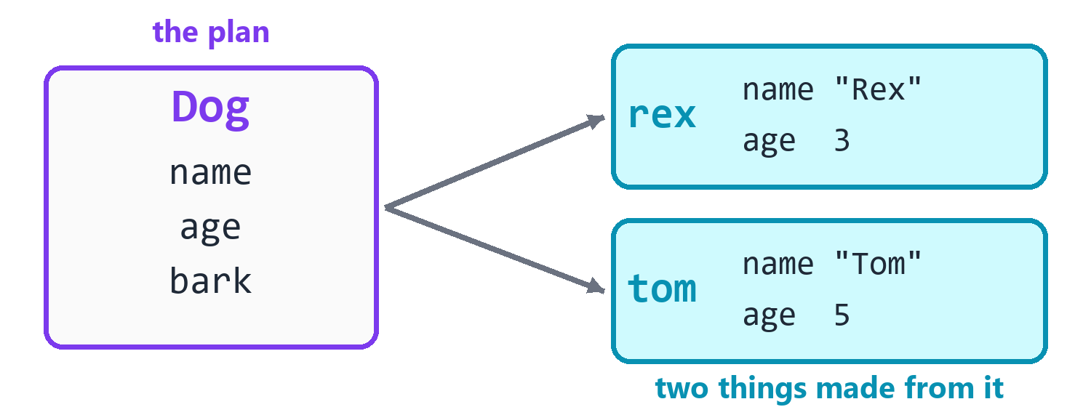
One plan, and two things made from it.
dcl makes a class. Inside it, dfd gives it fields: the things it has. And dfn gives it functions: the things it can do. A function inside a class is often called a method.
rex mak Dog
rex@name is "Rex"
rex bark now
out prn rex
Dog dcl now
name dfd txt
age dfd 3
bark dfn now
out prn "@name says woof!"
Rex says woof!
Dog(name: Rex, age: 3)
Line | Say it
rex mak Dog | Make rex, a Dog.
rex@name is "Rex" | The name of rex is "Rex".
rex bark now | rex, bark, now.
out prn rex | Print rex.
Dog dcl now | Define a class called Dog.
name dfd txt | It has a field called name, a text.
age dfd 3 | It has a field called age, which starts at 3.
bark dfn now | It has a function called bark.

Look at the line out prn rex. It printed the whole dog, with all of its fields. In C++, you have to write that by hand for every class.
The class can go anywhere in your file, just like a function. Most people start its name with a capital letter.

Many from one plan
Each thing has its own fields. Changing one doesn't change the others.
rex mak Dog
tom mak Dog
rex@name is "Rex"
tom@name is "Tom"
rex@age is 9
out prn rex
out prn tom
Dog dcl now
name dfd txt
age dfd 3
Dog(name: Rex, age: 9)
Dog(name: Tom, age: 3)

Functions that use the fields
Inside a function of a class, you can use the fields by name. A function can give back a value, like any other.
rex mak Dog
out prn rex@dog_years
rex grow 2
out prn rex@dog_years
Dog dcl now
age dfd 3
grow dfn now
more dpm num
age add more
dog_years dfn num
dog_years ert age*7
21
35
Line | Say it
out prn rex@dog_years | Print the dog years of rex.
rex grow 2 | rex, grow, with 2.
age add more | Add more to this dog's age.

Setting things up when it's made
dmk is a function that runs by itself when a thing is made. People call it a constructor. It lets you set up the fields right away.
a mak Dog&"Rex"
b mak Dog&"Tom"&5
out prn a
out prn b
Dog dcl now
name dfd txt
age dfd 1
Dog dmk now
n dpm txt
y dpm 1
name is n
age is y
Dog(name: Rex, age: 1)
Dog(name: Tom, age: 5)
Line | Say it
a mak Dog&"Rex" | Make a, a Dog, with "Rex".
Dog dmk now | When a Dog is made, do this:
n dpm txt | It takes n, a text.
y dpm 1 | It takes y, which starts at 1.

You can also make a thing with is, which is often neater. English++ can see that it's a Dog:
rex is Dog&"Rex"
out prn rex
Dog dcl now
name dfd txt
Dog dmk now
n dpm txt
name is n
Dog(name: Rex)

slf: this one
slf means this very thing, the one the function is working on. It's useful when a parameter has the same name as a field:
s mak Spot&3
out prn s@x
Spot dcl now
x dfd 0
Spot dmk now
x dpm num
slf@x is x
3
In slf@x is x, the slf@x means this thing's field, and the plain x means the parameter.

Secrets
Some things should be kept private. dsc makes a secret field. Only the class's own functions can use it, and it never prints.
acct mak Bank
acct pay_in 50
out prn acct@balance
out prn acct
Bank dcl now
owner dfd "Ada"
money dsc 0
pay_in dfn now
n dpm num
n igt 0
money add n
balance dfn num
balance ert money
50
Bank(owner: Ada)
If somebody tries to reach the secret from outside, the Studio stops them:
acct mak Bank
acct@money is 1000000
Bank dcl now
money dsc 0
The Studio says: Line 2: money is a secret in Bank, so it can only be used inside it.

This is the point of secrets. The only way to change the money is through pay_in, and pay_in makes sure the number is good. So nobody can break the rule by accident.
dhd makes a hidden function. It's the same idea: only the class's own functions can run it.
r mak Robot
r start now
Robot dcl now
start dfn now
now warm_up now
out prn "Ready!"
warm_up dhd now
out prn "Warming up..."
Warming up...
Ready!

Functions that promise not to change anything
dkn makes a constant function. It promises not to change any field, and the Studio holds it to that. People reading your class can see at a glance that it's safe to call.
b mak Box
out prn b@area
Box dcl now
w dfd 2
h dfd 3
area dkn num
area ert w*h
6
Box dcl now
w dfd 2
grow dkn now
w add 1
The Studio says: Line 4: grow is a constant function (dkn), so it can't change w.

Things the whole class shares
Usually each thing has its own fields. dsh makes a shared field: there's one for the whole class. Here it counts how many dogs have been made. dsf makes a shared function, which belongs to the class and not to any one thing. You reach both through the class's name.
a mak Dog
b mak Dog
out prn Dog@made
out prn Dog@report&
Dog dcl now
made dsh 0
Dog dmk now
made add 1
report dsf txt
report ert "Dogs so far: "+txt&made
2
Dogs so far: 2
Line | Say it
made dsh 0 | All dogs share a field called made, which starts at 0.
report dsf txt | The class has a shared function called report. It gives back text.
out prn Dog@made | Print made, of the Dog class.
out prn Dog@report& | Print what report gives, with no values.

The & on its own means run it. A shared function needs it when it takes no values, so it can't be mixed up with a field.

When a thing is destroyed
dds runs by itself when a thing goes away. It's the opposite of dmk. Things go away when the block they were made in ends.
now bbl now
t mak Torch
out prn "using it"
out prn "done"
Torch dcl now
Torch dmk now
out prn "on"
Torch dds now
out prn "off"
on
using it
off
done
This is very handy. You can't forget to clean up, because it happens by itself. A file that closes itself works this way.

Comparing things
Two things of the same kind compare with ==, and it checks every field. You don't have to write anything.
a mak Dog
b mak Dog
out prn a==b
b@age is 9
out prn a==b
Dog dcl now
age dfd 3
yes
nay

What you learned
You write | Say it
Dog dcl now | define a class
age dfd 3 | it has a field
bark dfn now | it can do this
Dog dmk now | when one is made, do this
Dog dds now | when one goes away, do this
rex mak Dog | make one
rex@age | the age of rex
rex bark now | rex, do bark
slf@x | this thing's x
pin dsc 0 | a secret field
think dhd now | a hidden function
area dkn num | a function that promises not to change anything
made dsh 0 | a field the whole class shares
report dsf txt | a function the whole class shares

Try it! Make a class called Player, with a field name and a field score that starts at 0. Give it a function win that adds 10 to the score. Make a Player, run win twice, and print the player. It should show a score of 20.

24. Children
A Dog is an Animal. A Cat is an Animal too. They both have a name, and they both eat. It would be silly to write those parts twice.
So you write them once, in a class called Animal. Then you say that a Dog is a child of Animal. It gets everything an Animal has, without writing it again.
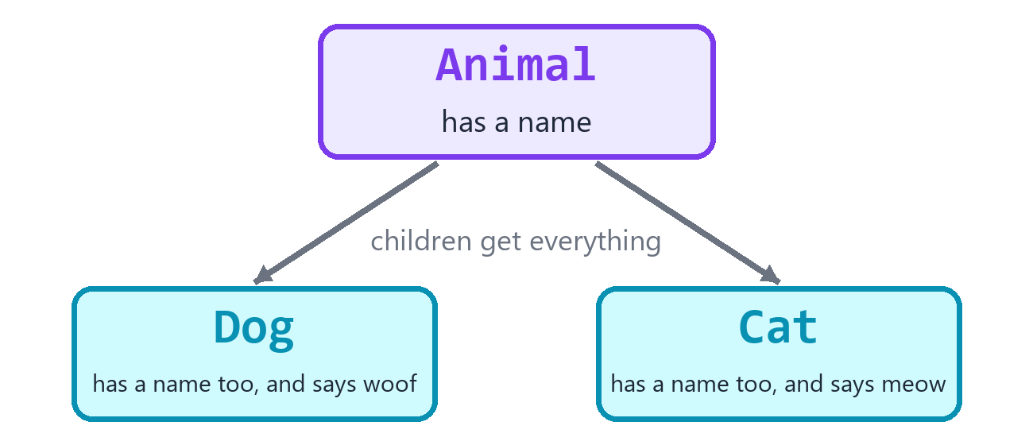
Children get everything their parent has.

Making a child
The third word of dcl is the parent.
d mak Dog
d@name is "Rex"
d eat now
d bark now
out prn d
Animal dcl now
name dfd "?"
eat dfn now
out prn "@name is eating."
Dog dcl Animal
tricks dfd 2
bark dfn now
out prn "@name says woof!"
Rex is eating.
Rex says woof!
Dog(name: Rex, tricks: 2)
Line | Say it
Animal dcl now | Define a class called Animal.
Dog dcl Animal | Define a class called Dog. A Dog is an Animal.

A Dog has its own tricks and bark. And it also has name and eat, from its parent.
The parent can be written after the child. English++ puts them in the order that C++ needs.

Family secrets
A secret field can only be seen by its own class. Not even its children can see it. dfm makes a family field: its own class and all its children can use it, but nobody else can. dfy does the same for a function.
d mak Dog
out prn d@report
Animal dcl now
energy dfm 5
rest dfy now
energy add 1
Dog dcl Animal
report dfn num
now rest now
report ert energy
6
What it is | Who can use it
dfd, dfn | everyone
dfm, dfy | the class and its children
dsc, dhd | only the class itself

Making the parent first
If the parent has a dmk that takes values, the child has to give them. dbs hands values to the parent. Write it first thing in the child's dmk.
d mak Dog&"Rex"
out prn d
Animal dcl now
name dfd txt
Animal dmk now
n dpm txt
name is n
out prn "An animal is made."
Dog dcl Animal
tricks dfd 0
Dog dmk now
given dpm txt
now dbs given
out prn "A dog is made."
An animal is made.
A dog is made.
Dog(name: Rex, tricks: 0)
Line | Say it
now dbs given | Make the parent part, with given.

The parent always gets made first. That way, a child's dmk can trust that the parent's fields are ready.
If there are two parents, name the one you mean: Animal dbs given. Yes, a class can have two parents, joined with &: Dog dcl Animal&Friend.
d mak Dog&"Rex"
out prn d@name
out prn d@hugs
Animal dcl now
name dfd txt
Animal dmk now
n dpm txt
name is n
Friend dcl now
hugs dfd 3
Dog dcl Animal&Friend
Dog dmk now
given dpm txt
Animal dbs given
Rex
3

Doing things differently
Dogs and cats both make a sound, but not the same sound. dvr says a child can redo this function. dov is how a child redoes it.
a mak Animal
d mak Dog
out prn a@sound
out prn d@sound
Animal dcl now
sound dvr txt
sound ert "..."
Dog dcl Animal
sound dov txt
sound ert "Woof"
...
Woof
Line | Say it
sound dvr txt | Define sound, a function that children may redo.
sound dov txt | Redo sound, for this class.

dmb goes further. It says every child has to redo this. So it has no body. A class with a dmb can't be made by itself, because a part of it is missing.
c mak Circle
out prn c@area
Shape dcl now
area dmb dec
Circle dcl Shape
r dfd 2.0
area dov dec
area ert npi*r*r
12.5664
s mak Shape
Shape dcl now
area dmb dec
The Studio says: Line 1: Shape can't be made by itself, because area still has to be redone (dmb). Make a child that redoes it.

A list of different animals
Here's why all this matters. A list can hold Dogs and Cats together, and each one uses its own version of the function.
Each one needs its own memory, so the list holds own pointers, and mwn makes them. The chapter on pointers tells you all about those. For now, read vec@own@Animal as a list of animals.
pets mak vec@own@Animal
d mwn Dog
pets add d
c mwn Cat
pets add c
p fea pets
out prn p@sound
Animal dcl now
sound dmb txt
Dog dcl Animal
sound dov txt
sound ert "Woof"
Cat dcl Animal
sound dov txt
sound ert "Meow"
Woof
Meow
The loop doesn't know or care which kind each one is. It just asks for a sound, and each animal gives its own. This is one of the most useful ideas in programming. It has a long name: polymorphism. It means many shapes.

What you learned
You write | Say it
Dog dcl Animal | a Dog is an Animal
Dog dcl Animal&Friend | a Dog has two parents
now dbs given | make the parent part, with given
energy dfm 5 | a field the family can use
rest dfy now | a function the family can use
sound dvr txt | children may redo this
sound dov txt | redo it here
area dmb dec | every child must redo this

Try it! Make a class Shape with area dmb dec. Make two children: Square with a side, and Circle with a radius. Put one of each in a vec@own@Shape, and print each area.

25. More Kinds of Your Own
Classes do most of the work. A few smaller things are handy for special jobs.

Choices
Sometimes a thing can only be one of a few choices: north, south, east or west. den makes a list of choices. People call it an enum.
Mood den happy&sad&sleepy
m is Mood@happy
out prn m
m ieq Mood@happy
out prn "Smile!"
m is Mood@sleepy
m bsw now
now bcs happy
out prn "Yay"
now bcs sad
out prn "Oh no"
now bcs sleepy
out prn "Zzz"
happy
Smile!
Zzz
Line | Say it
Mood den happy&sad&sleepy | Define Mood: it's happy, sad or sleepy.
m is Mood@happy | m is the happy choice of Mood.
now bcs happy | If it's happy, do this:

Why not just use text, like "happy"? Because a typing mistake in text is still text, and the program goes on. A typing mistake in a choice gets caught right away:
Mood den happy&sad
m is Mood@hapy
The Studio says: Line 2: Mood has no choice called hapy. Its choices: happy, sad. Did you mean happy?

It even prints by name. In C++, a choice like this prints as a number, or not at all.

Structs
dst makes a struct. It's a lot like a class. People use it for simple things that are mostly just fields, like a point on the screen. A struct can be made with its values right away, in order:
a is Spot&1&2
out prn a
out prn a@y
Spot dst now
x dfd 0
y dfd 0
Spot(x: 1, y: 2)
2
A struct can have functions and parents too, the same as a class. It's mostly a way to tell the reader that this one is simple.

Math with your own kinds
dop says what a math mark does to your own kind. Then you can add two Spots, just as if they were numbers.
a is Spot&1&2
b is Spot&3&4
c is a+b
out prn c
Spot dst now
x dfd 0
y dfd 0
+ dop Spot
o dpm see@Spot
r is Spot&x+o@x&y+o@y
+ ert r
Spot(x: 4, y: 6)
Line | Say it
+ dop Spot | Define what + does. It gives back a Spot.
o dpm see@Spot | It takes the other Spot, just to look at.
r is Spot&x+o@x&y+o@y | r is a Spot, with x plus o's x, and y plus o's y.
+ ert r | + returns r.

You can do this for + - * / % == != < > <= >=. If you make <, then a list of your things can be sorted:
v mak vec@Card
v add Card&7
v add Card&2
v lso now
out prn v
Card dst now
rank dfd 0
< dop yno
o dpm see@Card
< ert rank<o@rank
[Card(rank: 2), Card(rank: 7)]

Short names for kinds
dal gives a kind a shorter name. It's the same kind, just easier to read. People call it an alias.
Row dal vec@num
Grid dal vec@Row
g mak Grid
g add 1&2
out prn g
[[1, 2]]
Line | Say it
Row dal vec@num | Row is another name for a vector of numbers.

Unions
You'll almost never need this one. dun makes a union. It looks like a struct, but all of its fields share the same memory. So it can only hold one at a time. It saves a tiny bit of memory, and programs that talk directly to hardware sometimes need it. It doesn't print by itself.
b mak Both
b@whole is 65
out prn b@whole
Both dun now
whole dfd num
part dfd dec
65

What you learned
You write | Say it
Mood den happy&sad | define a list of choices
Mood@happy | one of the choices
Spot dst now | define a simple class
+ dop Spot | define what + does
Row dal vec@num | a short name for a kind
Both dun now | fields that share memory

Try it! Make a list of choices called Color, with red, green and blue. Make a box that holds one of them, and use bsw to print something different for each.

Part 5: Power Tools
Pointers, problems, tests, the keyboard, files, the clock, threads and the world outside your program.

26. Pointers
You can write a lot of good programs without pointers. But sooner or later, you'll meet them. In C++ they cause more trouble than anything else. English++ makes them much safer.

What a pointer is
Every box lives somewhere in the computer's memory. A pointer is a box that holds the place of another box. It points at it.
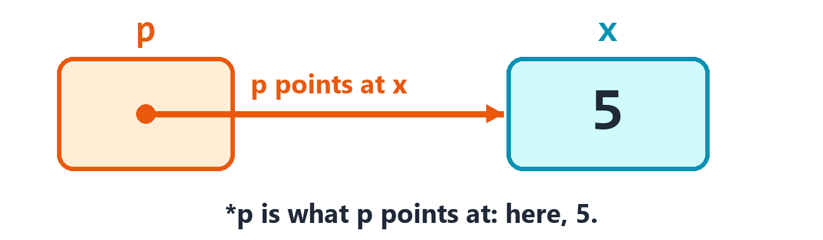
p points at x. Through p, you can reach x.
mpt makes a pointer. A * in front of the pointer's name means what it points at.
x is 5
p mpt x
out prn *p
*p is 7
out prn x
5
7
Line | Say it
x is 5 | x is 5.
p mpt x | Make p, a pointer to x.
out prn *p | Print what p points at.
*p is 7 | What p points at is 7.
out prn x | Print x.

We never touched x. But x changed, because p points at it.
A pointer can point at something else later:
a is 1
b is 2
p mpt a
out prn *p
p mpt b
out prn *p
1
2
To reach a field through a pointer, just use @. English++ can tell it's a pointer. In C++ you'd have to write a different mark, ->.
rex mak Dog
p mpt rex
p@age is 5
out prn rex@age
Dog dst now
age dfd 3
5

Pointing at nothing
A pointer can point at nothing. That's written nil. A new pointer starts as nil, so you can test for it.
q mak ptr@num
q ieq nil
out prn "q points at nothing"
x is 5
q mpt x
q ine nil
out prn *q
q points at nothing
5
ptr@num means a pointer to a number.
If you use a nil pointer, your program stops and tells you where:
q mak ptr@num
out prn "before"
out prn *q
before
The program stopped on line 3:
out prn *q
It tried to use something that is not there: a pointer to nothing, or a position far outside a collection.
In C++, this makes a program crash with no explanation at all. It's one of the most common crashes in the world.

Making things that outlive their block
A box made inside a block is gone when the block ends. Sometimes you need a thing to stay around. mwn makes a thing with one owner. When the owner goes away, the thing is cleaned up by itself. So nothing is ever left behind.
now bbl now
t mwn Torch
t@name is "big"
out prn t@name
out prn "the block is over"
Torch dcl now
name dfd txt
Torch dds now
out prn "cleaned up"
big
cleaned up
the block is over
Line | Say it
t mwn Torch | Make t, a Torch that t owns.

Its kind is own@Torch, and there can only be one owner. To hand it to someone else, use mmv, which means move. After that, the old box holds nothing.
a mwn Torch
a@name is "big"
b mmv a
out prn b@name
a ieq nil
out prn "a holds nothing now"
Torch dcl now
name dfd txt
big
a holds nothing now
When you add an own pointer to a list, English++ moves it for you. That's what you saw in the Children chapter.
mmv works on other things too. Moving a long list is much faster than copying it, because nothing has to be copied:
v is 1&2&3
w mmv v
out prn w
[1, 2, 3]

Sharing
msh makes a thing that many owners can share. It's cleaned up when the last owner goes away. Its kind is shr@Torch. Each copy of the pointer is another owner, and @use_count tells you how many there are.
a msh Torch
out prn a@use_count
b is a
out prn a@use_count
b@name is "shared"
out prn a@name
Torch dcl now
name dfd txt
1
2
shared
To hand a shared pointer to a function, say its kind: shr@Torch. While the function runs, it's one more owner.
a msh Torch
a@name is "big"
now show_it a
out prn a@use_count
show_it dfn now
t dpm shr@Torch
out prn t@name
out prn t@use_count
Torch dcl now
name dfd txt
big
2
1
Kind | Say it | How many owners?
own@Torch | an owned pointer | one
shr@Torch | a shared pointer | many
ptr@Torch | a plain pointer | none: it just points

Doing it by hand
mnw makes a thing that nobody owns. It stays until you remove it yourself with edl, which means exit: delete. C++ calls these new and delete. Use them only when a C++ library asks you to. If you forget edl, that memory is lost until your program ends.
p mnw Torch
p@name is "hand made"
out prn p@name
now edl p
p ieq nil
out prn "p is nil now"
Torch dcl now
name dfd txt
hand made
p is nil now
edl also sets the pointer to nil, so it can't be used again by mistake. C++ doesn't do that, and it's a famous source of bugs.

What you learned
You write | Say it
p mpt x | make p, a pointer to x
*p | what p points at
p@age | the age of what p points at
nil | nothing
q mak ptr@num | make q, a pointer to a number
t mwn Torch | make a Torch with one owner
t msh Torch | make a Torch with many owners
b mmv a | move a into b
p mnw Torch | make a Torch by hand
now edl p | delete it by hand

Try it! Make a number x, and a pointer p to it. Use the pointer to add 1 to x. (Write *p add 1.) Then print x.

27. More Tricks for Your Classes
Your classes can act even more like the kinds that come with the language.

Reached by position
An operator called at lets your class be reached with @, the way a list is. It gives back a reference, so you can change what's there too.
r mak Row
r@1 is 4
out prn r@1
Row dcl now
v dfd arr@num@4
at dop ref@num
i dpm num
at ert v@i
4

Called like a function
An operator called call lets a thing be called with &. Here a is a thing that remembers a number and adds it.
a mak Adder&5
out prn a&3
Adder dst now
k dfd 0
call dop num
n dpm num
call ert n+k
8

Adding to it
dop also takes +=, and the marks like it. That's what add uses on your own kinds.
d mak Dot
d add 3
d add 4
out prn d@x
Dot dst now
x dfd 0
+= dop ref@Dot
o dpm num
x add o
+= ert slf
7

What is it really?
A pointer to an Animal might really be pointing at a Dog. ptr@Dog&p asks. It gives you a pointer to the Dog, or nil if it isn't one.
pet mnw Dog
other mnw Animal
p mak ptr@Animal
p is pet
dog is ptr@Dog&p
out prn dog@speak&
none is ptr@Dog&other
out prn none==nil
now edl pet
now edl other
Animal dcl now
speak dvr txt
speak ert "?"
Dog dcl Animal
speak dov txt
speak ert "woof"
woof
yes

A field of a few bits
dbb makes a field that only takes a few bits. It saves room when you have lots of small things.
f mak Flags
f@ok is 1
f@level is 5
out prn f@ok
out prn f@level
Flags dst now
ok dbb 1
level dbb 3
1
5

Taking a thing over
Moving is faster than copying, as you saw with mmv. A parameter of kind tkn@Kept says: hand me this thing to keep. The tkn is for taken. It lets a class say how to be moved.
k mak Kept
w mmv k
out prn w@x
Kept dcl now
x dfd 0
Kept dmk now
x is 1
Kept dmk now
o dpm tkn@Kept
x is o@x+1
2
The first dmk made k, so its x is 1. The second one made w, and it added 1 so you can see that it ran.
Try it! Make a class that holds a number. Give it a call operator that multiplies what it's given by that number.

28. Bits and Huge Numbers
Every number in a computer is made of bits: tiny switches that are on or off. Most of the time you don't need to think about them. But when you do, English++ lets you reach them.

Working with bits
You met the roots that change a number's bits in place, like and and asl. These words do the same jobs, and give you the answer as a value.
You write | Say it | A bit of the answer is on if
nnd&a&b | bit and | it's on in both
nor&a&b | bit or | it's on in either
nxr&a&b | bit xor | it's on in just one
nnt&a | bit not | it's off in a
nsl&a&2 | shift left | every bit moves up 2 places
nsr&a&2 | shift right | every bit moves down 2 places

a is 6
b is 3
out prn nnd&a&b
out prn nor&a&b
out prn nxr&a&b
out prn nnt&a
out prn nsl&a&2
out prn nsr&a&1
2
7
5
-7
24
3
6 is 110 in bits and 3 is 011, so only the middle bit is on in both. That's 010, which is 2.
Tip! Shifting left by 1 doubles a number. Shifting right by 1 halves it, and drops what's left over.

How big is it?
nsz means number: size. It tells you how many bytes a thing takes. A byte is 8 bits. nlw means number: lowest. It's the lowest whole number a num can hold. pbg is a whole number that can't go below 0. It uses all 64 bits for the number, so it can go up to about 18 billion billion.
x is 5
y mak big
out prn nsz&x
out prn nsz&y
out prn nlw
huge mak pbg
huge is 18446744073709551615
out prn huge
4
8
-2147483648
18446744073709551615

A number of any size
A num stops at about 2 billion, and a big stops at about 9 billion billion. hug doesn't stop. It's a whole number that can be as long as your computer's memory. C++ doesn't have anything like it.
x mak hug
x is 1
i is 2
i wle 25
x aml i
i add 1
out prn x
15511210043330985984000000
That's 25 x 24 x 23, and so on, all the way down to 1. A big couldn't hold it. Try it with 100, and it prints 158 digits.
To make a huge number from text, write hug&"123456789012345678901234567890". To get one back as a big, write big&x. And x apw 100 raises it to a power.
x is hug&"123456789012345678901234567890"
x add 1
out prn x
y is hug&2
y apw 100
out prn y
123456789012345678901234567891
1267650600228229401496703205376

Complex numbers
cpx is a complex number, which has two parts. It's the kind of number you'll meet if you study electricity or fractals. Don't worry if you haven't yet.
p mak cpx&1.0&2.0
q mak cpx&3.0&4.0
r is p+q
out prn r@real&
out prn r@imag&
4
6
Try it! Use hug to work out 2 to the power of 200. How many digits does it have? Turn it into text with txt&x, and use tsz to count them.

29. When Things Go Wrong
Things go wrong. A file is missing. Somebody types a word when you asked for a number. Good programs expect this, and handle it. In this chapter you'll learn how.

Two kinds of mistake
When | What it is | What happens
before it runs | a mistake in your program | a red line, and the Studio tells you
while it runs | something goes wrong along the way | the program stops, and says why

The Studio catches the first kind as you type. The second kind can only show up when your program runs. It can depend on what the person types, or on what's in a file.

When a program stops
When something impossible happens, your program stops. It shows you the line, in the language you wrote it in. Here are the things that can stop a program.
A position that isn't there:
v is 1&2&3
i is 5
out prn v@i
The program stopped on line 3:
out prn v@i
It used a position that is not in the collection or text.
Dividing by a zero that it couldn't see coming:
n is 0
out prn 10/n
The program stopped on line 2:
out prn 10/n
It divided a whole number by zero.
A function that never stops running itself:
out prn forever&1
forever dfn num
n dpm num
next is forever&n+1
forever ert next+1
The program stopped on line 5:
next is forever&n+1
A function kept calling itself and never stopped.
C++ just crashes, or goes on with a wrong answer. It doesn't tell you the line, because the C++ line isn't one you wrote.

Trying and catching
btr means try these lines. bch means catch a problem. If anything in the try block goes wrong, the program jumps to the catch block, instead of stopping.
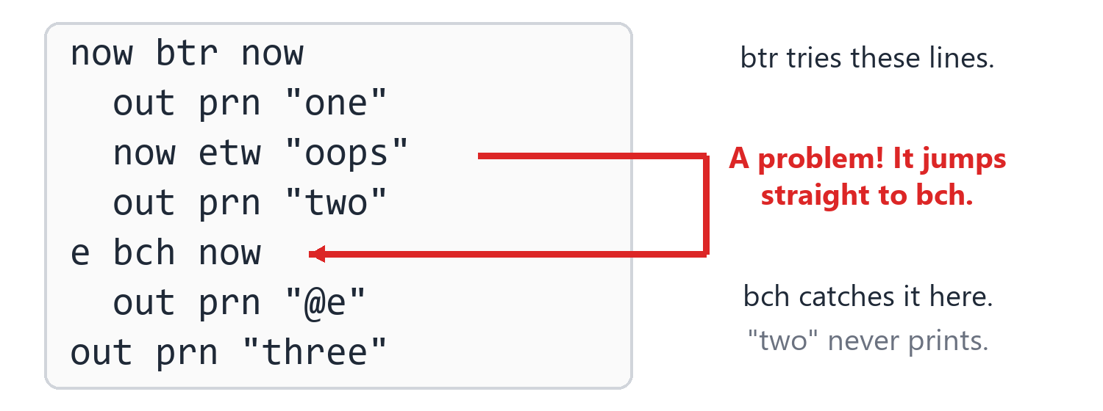
When a problem comes up, the program jumps straight to bch.
now btr now
out prn "one"
n is tnm&"not a number"
out prn "two"
e bch now
out prn "That was not a number."
out prn "three"
one
That was not a number.
three
Line | Say it
now btr now | Try these lines:
n is tnm&"not a number" | n is the number in "not a number". That's a problem!
e bch now | Catch the problem, and call it e:

See how "two" never printed? The moment there's a problem, the rest of the block is skipped. And "three" did print, because the catch took care of the problem and the program went on.

What the problem says
Put the problem's name in text, with @, and you'll see what it says. e@what gives you the same words, as a text.
now btr now
v is 1&2
out prn tnm&"oops"
e bch now
out prn "caught: @e"
caught: invalid stoi argument

Making your own problems
etw means exit by throwing a problem. Use it when your function finds something it can't handle. The nearest catch gets it.
now btr now
now set_age -3
out prn "not reached"
e bch now
out prn "caught: @e"
set_age dfn now
age dpm num
age ilt 0
now etw "An age can't be below zero."
out prn "Age set."
caught: An age can't be below zero.
If nobody catches it, the program stops and shows you where it was thrown:
now etw "something went wrong"
The program stopped on line 1:
now etw "something went wrong"
The problem: something went wrong

Catching one kind of problem
A problem can be a thing you made, with its own fields. Put the kind in the third spot of bch to catch only that kind.
now btr now
now etw Late&5
e bch Late
out prn "Late by @e@mins minutes"
Late dst now
mins dfd 0
Late by 5 minutes
You can have more than one bch. The first one that fits catches the problem.
You write | It catches
e bch Late | only a Late problem
e bch now | a problem made from text, and any problem from C++ itself
now bch now | absolutely anything, but with no name to read it by

now btr now
now etw "plain"
x bch Late
out prn "it was late"
now bch now
out prn "something else went wrong"
Late dst now
mins dfd 0
something else went wrong
To pass a problem on to the next catch out, write now etw now inside a bch.
now btr now
now btr now
now etw "bad"
e bch now
out prn "I saw it first."
now etw now
e bch now
out prn "Then me: @e"
I saw it first.
Then me: bad

Ending the program yourself
ext ends the program right away. Its third word is a number that the program gives back to whatever started it. 0 means all went well, and anything else means something went wrong.
out prn "Bye."
now ext 0
out prn "not reached"
Bye.
Your whole program also gives back a number, when it reaches the end. It's 0, unless you say otherwise with main ert 1. main is the name C++ uses for the part of your program that isn't inside a function.
out prn "All done."
main ert 0
All done.

What you learned
You write | Say it
now btr now | try these lines
e bch now | catch a problem, and call it e
e bch Late | catch only a Late problem
now etw "bad" | throw a problem
now etw now | pass this problem on
now ext 0 | end the program, now
main ert 0 | end the program, from its top level

Try it! Use tnm on the text "abc". Catch the problem, and print "Please use only digits."

30. Checks and Tests
How do you know your program works? You could run it and look. But as your programs grow, that gets slow, and you'll miss things. A better way is to let the program check itself.

Should
Roots that start with s mean should. A line that starts with one says what should be true. If it's true, nothing happens. If it isn't, the program stops and shows you both values.
x is 3
x seq 3
x sgt 2
out prn "All the checks passed."
All the checks passed.
Line | Say it
x seq 3 | x should equal 3.
x sgt 2 | x should be greater than 2.

Here's what happens when one is wrong:
x is 3
x seq 4
out prn "not reached"
Line 2: x seq 4 is not right: the first is 3, and the second is 4.
Here are all of the should roots. You know these pairs by now:
Root | Say it
seq | should equal
sne | should not equal
slt | should be less than
sle | should be less or equal
sgt | should be greater than
sge | should be greater or equal

a is 2
a sne 3
a slt 3
a sle 2
a sge 2
out prn "Fine."
Fine.
Tip! Put a check wherever you're sure about something, like "This list can't be empty here." If you're wrong, you'll find out right away. That's much better than ten minutes later, when things have gone strange.

Tests
A test is a block that checks one thing. bts makes one, with a name. A test doesn't run when you press F5. It runs when you choose Build > Run Tests.
Then the tests run instead of your program, and you get a report.
out prn add_up&1&2
now bts "adding small numbers"
a is add_up&1&2
a seq 3
now bts "adding negative numbers"
a is add_up&-1&-2
a seq -3
add_up dfn num
a dpm num
b dpm num
add_up ert a+b
Build > Run Tests shows:
test: adding small numbers
passed
test: adding negative numbers
passed
2 of 2 tests passed.
And pressing F5 runs the program as usual, skipping the tests:
out prn add_up&1&2
now bts "adding small numbers"
a is add_up&1&2
a seq 3
add_up dfn num
a dpm num
b dpm num
add_up ert a+b
3
When a test fails, the report tells you which one and why. The other tests still run, so you see everything that's wrong at once.
now bts "this one is wrong"
x is 2+2
x seq 5
now bts "this one is right"
x is 2+2
x seq 4
Build > Run Tests shows:
test: this one is wrong
Line 3: x seq 5 is not right: the first is 4, and the second is 5.
FAILED
test: this one is right
passed
1 of 2 tests passed.
C++ has no tests of its own. You have to go and find a library, and set it up. In English++, they're simply there.
Tip! When you find a bug, write a test that shows it, before you fix it. Then you'll see the test pass when you fix the bug, and the bug can never sneak back.

What you learned
You write | Say it
x seq 3 | x should equal 3
x sgt 2 | x should be greater than 2
now bts "name" | a test with this name
Build > Run Tests | run all the tests

Try it! Write a function is_even that gives back yes if a number is even. Write two tests for it: one for 4, and one for 7. Choose Run Tests.

31. Talking With Your Program
So far, your programs have talked and you have listened. Now they can ask you things.

Asking a question
get reads an answer. The third word is the question to ask.
name get "What is your name? "
out prn "Hello, @name!"
What is your name? Ada
Hello, Ada!
Line | Say it
name get "What is your name? " | Get name, by asking this question.

When you run this in the Studio, the program waits. Look at the bottom of the Output panel for a box that says Type an answer for the running program. Click in it, type your answer and press Enter.

Asking for a number
If the box doesn't exist yet, get makes a text. To get a number, make the box first. Then get knows what you want.
age mak num
age get "How old are you? "
next is age+1
out prn "Next year you will be @next."
How old are you? 9
Next year you will be 10.
And what if somebody types a word instead of a number? In C++, the program goes wrong in strange ways, and most beginners never work out why. English++ just asks again:
age mak num
age get "How old are you? "
out prn "You are @age."
How old are you? nine
Please type a number.
How old are you? 9
You are 9.
It does the same for a yes or no:
ready mak yno
ready get "Are you ready? "
out prn ready
Are you ready? maybe
Please answer yes or no.
Are you ready? yes
yes

Getting a whole line
get reads one word. So if you ask for a name and somebody types Ada Lovelace, you only get Ada. gln means get a line. It reads the whole line, spaces and all.
story gln "Tell me something: "
out prn "You said: @story"
Tell me something: I like cats a lot
You said: I like cats a lot
Root | Say it | It reads
get | get | one word, or one number
gln | get a line | a whole line, with its spaces

Asking with no question
The word inp means the keyboard. Use it as the third word when you don't need to ask anything out loud.
out prn "Type two numbers."
a mak num
b mak num
a get inp
b get inp
out prn a+b
Type two numbers.
3
4
7

Reading until there's no more
wln means while there are lines. It repeats once for every line it can read. This is how you read lots of input.
line wln inp
out prn tuc&line
one
ONE
two
TWO
This matters most with files, as you'll see in the next chapter. In the Studio, the keyboard never runs out, so press Shift+F5 to stop this program.
When there's nothing more to read, a program that's waiting on get stops by itself. It doesn't loop forever asking a question that nobody can answer.

A small conversation
Here's all of that working together:
name get "What is your name? "
age mak num
age get "How old are you? "
age ilt 13
out prn "Hi, @name! You're still a kid."
now oth now
years is age-13
out prn "Hi, @name! You stopped being a kid @years years ago."
What is your name? Ada
How old are you? 36
Hi, Ada! You stopped being a kid 23 years ago.

What you learned
You write | Say it
name get "Name? " | ask, and get one word
age mak num, then age get "Age? " | ask, and get a number
line gln "Say something: " | ask, and get a whole line
a get inp | get a value with no question
line wln inp | while there are lines:

Try it! Ask for two numbers and print their sum.

Try it! Ask for a word, then print it backward with trv.

32. Files
When a program ends, everything in its boxes is gone. To keep something for next time, you put it in a file on the hard drive.
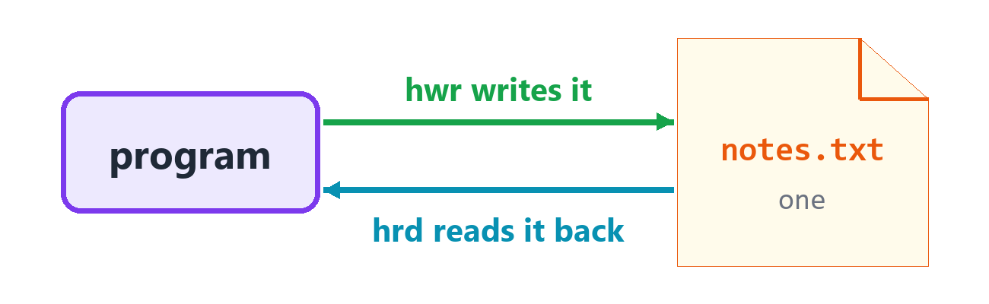
Your program can write a file, and read it back later.

Writing and reading a whole file
h is the hard drive family. hwr writes a whole file. The file's name goes first, and the text goes last.
"notes.txt" hwr "Remember the milk.\n"
out prn hrd&"notes.txt"
"notes.txt" hrm now
Remember the milk.
Line | Say it
"notes.txt" hwr "Remember the milk.\n" | In notes.txt, write this.
out prn hrd&"notes.txt" | Print what's read from notes.txt.
"notes.txt" hrm now | Remove notes.txt from the hard drive.

The \n marks the end of a line. If the file was already there, hwr replaces everything in it. To add to the end of a file, use hap, which means append.
name is "notes.txt"
name hwr "one\n"
name hap "two\n"
out prn hln&name
name hrm now
[one, two]
hln reads a file's lines into a list. It's the easiest way to read a file.
Watch out! hwr and hap write exactly what you give them. They don't add a line end for you. So don't forget the \n.

Is it there?
hex tells you if a file is there. hsz tells you its size, counted in bytes. A byte is about one letter.
name is "notes.txt"
out prn hex&name
name hwr "hello"
out prn hex&name
out prn hsz&name
name hrm now
out prn hex&name
nay
yes
5
nay
If you try to read a file that isn't there, that's a problem, and you can catch it:
now btr now
out prn hrd&"missing.txt"
e bch now
out prn "I can't read that file."
I can't read that file.

Folders
You write | Say it
"box" hmk now | make a folder called box
"a.txt" hcp "b.txt" | copy a.txt to b.txt
"a.txt" hmv "b.txt" | move a.txt to b.txt (or rename it)
hls&"box" | the names of the files in box
"box" hrm now | remove box, and everything in it

"box" hmk now
"box/a.txt" hwr "hi"
"box/a.txt" hcp "box/b.txt"
"box/b.txt" hmv "box/c.txt"
out prn hls&"box"
"box" hrm now
out prn hex&"box"
[a.txt, c.txt]
nay
Watch out! hrm removes a folder and everything in it, for good. It doesn't go to the recycle bin. So be careful what you point it at!

A file name with no folder means the folder your program runs in. When you press F5 in the Studio, that's your project's folder.

Writing a bit at a time
hwr writes everything at once. When you have a lot to write, it's better to open the file, write a piece at a time, and close it. mfo means make a file for output. Then you print to the file, just as you print to the screen.
f mfo "notes.txt"
f prn "alpha"
f prn "beta"
f put "gam"
f prn "ma"
f close now
out prn hln&"notes.txt"
"notes.txt" hrm now
[alpha, beta, gamma]
Line | Say it
f mfo "notes.txt" | Make f, a file to write, called notes.txt.
f prn "alpha" | In f, print a line.
f close now | Close f.

A file also closes itself at the end of the block where you opened it. It's good to close it yourself when you want to read it again straight away, as this program does.

Reading a bit at a time
mfi means make a file for input. Then wln reads it line by line, and gln and get read from it, just like from the keyboard.
"notes.txt" hwr "first line\n7 8\nlast line\n"
f mfi "notes.txt"
top gln f
out prn top
a mak num
b mak num
a get f
b get f
out prn a+b
rest gln f
line wln f
out prn line
f close now
"notes.txt" hrm now
first line
15
last line
Line | Say it
f mfi "notes.txt" | Make f, a file to read, called notes.txt.
top gln f | Get a whole line from f, into top.
a get f | Get a number from f, into a.
rest gln f | Get the rest of that line.
line wln f | While there are lines in f:

Handing a file to a function
The kind of a file to write is ofs, and the kind of a file to read is ifs. A function has to take the real file, with ref@, because a file can't be copied.
f mfo "log.txt"
now note_it f&"started"
now note_it f&"finished"
f close now
g mfi "log.txt"
now show_all g
g close now
"log.txt" hrm now
note_it dfn now
file dpm ref@ofs
what dpm txt
file prn "- @what"
show_all dfn now
file dpm ref@ifs
line wln file
out prn line
- started
- finished
You can also make an empty file box, and open it later, with mak:
f mak ofs
f open "later.txt"
f prn "hi"
f close now
out prn hrd&"later.txt"
"later.txt" hrm now
hi

What you learned
You write | Say it
"a.txt" hwr "hi" | write the whole file
"a.txt" hap "hi" | add to the end of the file
hrd&"a.txt" | read the whole file
hln&"a.txt" | read its lines into a list
hex&"a.txt" | does it exist?
hsz&"a.txt" | how big is it?
"a.txt" hrm now | remove it
"box" hmk now | make a folder
"a" hcp "b" | copy
"a" hmv "b" | move
hls&"box" | list a folder
f mfo "a.txt" | open a file to write
f mfi "a.txt" | open a file to read

Try it! Write a program that keeps a count in a file called count.txt. If the file is there, read the number. Add 1. Write it back. Print it. Each time you run the program, the number goes up.

33. The Clock
The k family tells the date and the time. It's k for clock, because c was already taken by collections.

The date and the time
These words take no values, so you just write the word. What they print depends on when you run them, so this book shows you only an example.
You write | Say it | It could give
kda | today's date | 2026-11-02
ktm | the time now | 14:05:09
kwk | the day of the week | Monday
kyr | the year | 2026
kmo | the month | 11
kdy | the day of the month | 2
khr | the hour | 14
kmi | the minute | 5
kse | the second | 9

out prn kda
out prn ktm
out prn kwk
out prn kyr
out prn kmo
out prn kdy
out prn khr
out prn kmi
out prn kse
The hours go from 0 to 23, and the months go from 1 to 12. These are plain numbers, so you can do math with them:
born is 2015
age is kyr-born
age sgt 0
hour is khr
hour ilt 12
out prn "Good morning!"
now oth now
out prn "Good day!"

How long did it take?
Two words tell you how long your program has been running.
You write | Say it
kms | whole milliseconds since the start
kel | seconds since the start, as a decimal

A millisecond is a thousandth of a second.
rwt means run: wait. It makes your program wait for a number of milliseconds.
start is kms
now rwt 50
took is kms-start
took sge 40
out prn "That took a moment."
out prn kel>0
That took a moment.
yes
Line | Say it
start is kms | start is the milliseconds so far.
now rwt 50 | Now, wait 50 milliseconds.
took is kms-start | took is the milliseconds so far, minus start.

You'll use kms like this whenever you want to know how fast something is. Here's how you'd time a loop:
start is kms
total is 0
i flt 1000000
total add 1
took is kms-start
out prn "I counted to @total in @took milliseconds."
And rwt is good for making things happen slowly enough to see:
n is 3
n fgt 0
out prn n
now rwt 100
out prn "Go!"
3
2
1
Go!

What you learned
You write | Say it
kda | today's date
ktm | the time now
kms | milliseconds since the start
kel | seconds since the start
now rwt 100 | wait 100 milliseconds

Try it! Print "Good morning!", "Good afternoon!" or "Good evening!", depending on the hour.

34. At the Same Time
Your computer has several cores. Each one can do its own work at the same moment. So far, your programs have done one thing at a time. Here's how to do many.

Threads
A thread is a part of your program that runs at the same time as the rest. mtd starts one. rjn waits for it to finish. The word join means the two parts become one again.
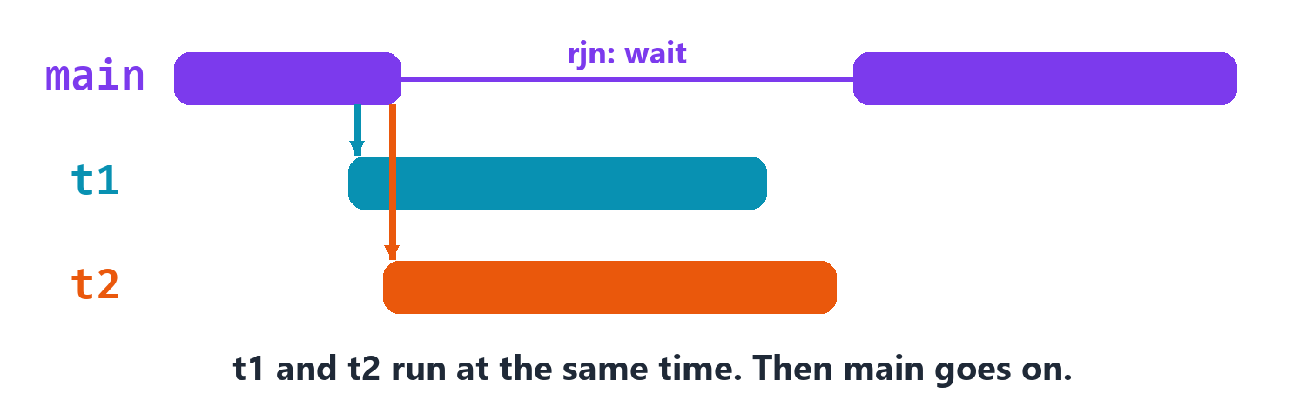
Each thread runs on its own. rjn waits for it.
t mtd count_to&3
t rjn now
out prn "All done."
count_to dfn now
n dpm num
i flt n
out prn i
0
1
2
All done.
Line | Say it
t mtd count_to&3 | Make t, a thread that runs count_to with 3.
t rjn now | Wait for t to finish.

Watch out! Every thread must be waited for with rjn, or let go with rdt. If you forget, your program stops when the thread's box goes away. C++ does the same.

rdt means run: detach. It lets the thread go on by itself, and your program doesn't wait for it. If your program ends first, the thread just stops.
t mtd say_hi&"there"
t rdt now
now rwt 300
out prn "bye"
say_hi dfn now
who dpm txt
out prn "hi @who"
hi there
bye
You can keep threads in a list. When you add one, it moves into the list, because a thread can't be copied.
workers mak vec@thd
i flt 3
t mtd do_nothing&i
workers add t
w fea workers
w rjn now
out prn cct&workers
do_nothing dfn now
n dpm num
3

Sharing safely
Here's the danger. If two threads change the same number at the same moment, they can get in each other's way. Each one reads the number, adds 1, and writes it back. Sometimes both read the same number, so one of the adds is lost. And it only happens sometimes, which makes it very hard to find.
atm fixes this for one number. An atomic number can't be interrupted. Each change is finished before the next one starts.
total mak atm@num
t1 mtd count_up&total
t2 mtd count_up&total
t1 rjn now
t2 rjn now
out prn total@load
count_up dfn now
c dpm ref@atm@num
i flt 1000
c add 1
2000
Line | Say it
total mak atm@num | Make total, an atomic number.
c dpm ref@atm@num | It takes c: the real atomic number.
out prn total@load | Print the value of total.

Taking turns
For anything bigger than one number, you need a mutex. A mutex is like the only key to a room. A thread takes the key, does its work and gives the key back. If another thread wants in, it waits.
blk opens a block that holds the key. The key goes back by itself when the block ends. So you can't forget, even if there's a problem.
names mak vec@txt
guard mak mtx
t1 mtd add_name&names&guard&"Ada"
t2 mtd add_name&names&guard&"Bob"
t1 rjn now
t2 rjn now
out prn cct&names
add_name dfn now
list dpm ref@vec@txt
m dpm ref@mtx
who dpm txt
m blk now
list add who
2
Line | Say it
guard mak mtx | Make guard, a mutex.
m blk now | Lock m for these lines:

Getting an answer later
A thread doesn't give an answer back. msy does. It runs a function on the side, and hands you a future: a promise of an answer. When you ask with @get, it gives you the answer, and waits for it if it has to.
answer msy slow_add&1&2
out prn "I can do other things now."
out prn answer@get
slow_add dfn num
a dpm num
b dpm num
now rwt 20
slow_add ert a+b
I can do other things now.
3
Line | Say it
answer msy slow_add&1&2 | Make answer, by running slow_add on the side, with 1 and 2.
out prn answer@get | Print the answer, when it's ready.

The kind of answer here is fut@num: a future number. You can write it yourself, to keep many of them in a list:
results mak vec@fut@num
i flt 3
r msy square&i
results add r
r fea results
out prn r@get
square dfn num
n dpm num
square ert n*n
0
1
4

The easy way: every core at once
fpr means for, in parallel. It's written just like fea. But it spreads the work across every core of your computer, without any threads for you to manage. So a big job can finish many times sooner.
v is 1&2&3&4
sum mak atm@num
n fpr v
sum add n
out prn sum@load
10
The turns run in no special order, and they can happen at the same moment. So anything they share must be an atm, or locked with a mtx. If each turn only changes its own item, there's nothing to worry about:
v is 1&2&3&4
n fpr v
n aml 10
out prn v
[10, 20, 30, 40]

What you learned
You write | Say it
t mtd work&5 | start a thread
t rjn now | wait for it
t rdt now | let it go
n mak atm@num | a number threads can share
m mak mtx | a key that one thread can hold
m blk now | hold the key for these lines
a msy work&5 | run it on the side, for an answer later
a@get | wait for the answer
n fpr v | for each, on every core

Try it! Use fpr to multiply every number in a list of 10 numbers by itself. Print the list.

35. Threads That Talk
Threads can get in each other's way if they share things. So it's often better if they pass things to each other, the way you pass notes in class.

Channels
A channel is a pipe between threads. One thread puts values in, and another takes them out. Make one with chn@num. C++ has nothing like it.
You write | Say it
c mak chn@num | Make c, a channel of whole numbers.
c add 5 | Send 5 down the channel.
x is c@get& | Wait for a value, and take it.
c close now | Say there's nothing more to come.
n fea c | Take values until it's closed and empty.

c mak chn@num
t mtd feed&c
total is 0
n fea c
total add n
t rjn now
out prn total
feed dfn now
c dpm ref@chn@num
i flt 5
c add i+1
c close now
15
You don't need a lock here. The channel does all of that for you.
chn@num&2 makes a channel that holds 2 at most. If it's full, sending waits until there's room. That stops a fast thread from racing far ahead of a slow one.

Waiting for something to be true
cnd is a condition. A thread can sleep on it until another thread wakes it up. Inside a lock, cv wait g&ready lets go of the lock and sleeps until ready says yes. cv notify_one now wakes up one thread that's waiting.
ready is nay
g mak mtx
cv mak cnd
go dlm now
g blk now
ready is yes
cv notify_one now
w mtd go
check dlm yno
check ert ready
g blk now
cv wait g&check
w rjn now
out prn ready
yes

One for each thread
mtl makes a name at the top level, and each thread gets one of its own. If one thread changes it, the others don't see that.
seen add 1
out prn seen
v mtd show
v rjn now
out prn seen
seen mtl 0
show dfn now
seen add 5
out prn seen
1
5
1
Try it! Make two threads that each send 3 numbers down one channel. Add them up in the main program. You'll need to know when both have finished before you close the channel.

36. Groups and Other Files
As a program grows, it gets harder to keep track of everything. This chapter shows you how to keep things tidy.

Groups
dgr puts names together in a group. Two groups can use the same name, and they won't get mixed up. C++ calls this a namespace. You reach inside a group with @.
out prn geo@area&3
out prn cash@area&3
geo dgr now
area dfn num
side dpm num
area ert side*side
cash dgr now
area dfn txt
code dpm num
area ert "region @code"
9
region 3
Line | Say it
geo dgr now | Define a group called geo.
out prn geo@area&3 | Print what area, in geo, gives with 3.

A group can hold functions, classes and choices:
b mak zoo@Bear
out prn b@name
m is zoo@Mood@calm
out prn m
out prn zoo@open_at&8
zoo dgr now
Mood den calm&wild
Bear dcl now
name dfd "Ted"
open_at dfn txt
hour dpm num
open_at ert "Open at @hour"
Ted
calm
Open at 8

A program in two files
When a file gets long, split it up. xim means external: import. It brings in another file's definitions. Then it's as if they had been written in this file.
The file tools.epp:
note Things that many programs can use.
twice dfn num
n dpm num
twice ert n*2
Pet dst now
name dfd "?"
now xim "tools.epp"
out prn twice&21
p mak Pet
out prn p
42
Pet(name: ?)
Line | Say it
now xim "tools.epp" | Now, import tools.epp.

Put the name of the file in quote marks, starting from the folder that your program is in. You can bring in the same file twice, and it only counts once.
In C++, you'd have to write a header file, and say everything twice: once in the header, and once in the real file. In English++, there's no such thing. You write it once.

Where things can go
English++ reads your whole program before it starts, so definitions can go anywhere. But most people like this order:
- Notes that say what the program is for
- xlb, xic and xim lines
- The main part of the program
- Functions
- Classes

What you learned
You write | Say it
geo dgr now | define a group
geo@area&3 | run area, in geo, with 3
zoo@Bear | the kind Bear, in zoo
now xim "tools.epp" | bring in another file's definitions

Try it! Make a group called shout, with a function that takes a text and gives it back in uppercase. Print shout@say&"hello".

37. The World Outside
Your program doesn't have to stay in its own little world. It can run other programs, read the settings of the computer, and fetch pages from the web. The x family (external) and the r family (run) reach outside.

Running another program
rcm means run a command. It's the same as typing something into the Windows command prompt.
now rcm "echo Hello from Windows"
Hello from Windows
xcm does the same, but it gives you what the command printed, as text, so your program can use it. And xcd gives you the number the command ended with, which tells you if it worked. 0 means all went well.
said is xcm&"echo hello"
out prn tuc&said
out prn xcd&"exit 3"
HELLO
3
You write | Say it | You get
now rcm "dir" | run this command | it prints on the screen
xcm&"dir" | what this command prints | a text
xcd&"dir" | what this command ends with | a number

Watch out! Be careful with these words. A command can do anything you could do by hand, including deleting your files. Never run a command made from something a stranger typed.

Words given to your program
You can start a program with some extra words after its name, like mygame easy loud. xag gives you those words as a list.
out prn cct&xag
w fea xag
out prn w
0
Run from the Studio, there aren't any. To try it, build your .exe and run it from the command prompt, with some words after its name.

Settings of the computer
Windows keeps some settings in environment values. xev reads one by name. If it isn't set, you get an empty text.
out prn xev&"SURELY_NOT_SET"
where is xev&"USERPROFILE"
size is tsz&where
out prn size>0
yes
The first line prints an empty line, because nothing is set by that name. USERPROFILE is your own folder on Windows.

The web
xwb fetches a web page and gives you its text. It's that simple. It uses a tool called curl, which comes with Windows 10 and 11.
online is nay
online ieq yes
page is xwb&"http://example.com"
out prn tsz&page
out prn "Done."
Done.
The test around it is there so that this book can be checked without the internet. Change nay to yes to try it.

What you learned
You write | Say it
now rcm "dir" | run a command
xcm&"dir" | what a command prints
xcd&"dir" | what a command ends with
xag | the words given to your program
xev&"PATH" | an environment value
xwb&"http://..." | the text of a web page

Try it! Use xcm&"echo %TIME%" to ask Windows for the time. Use tcu to print only the hours, which are the first two letters.

38. Bytes, Codes and Other Computers
Here are more ways to reach outside your program. Some are about files and the clock. The rest are about talking to other programs.

Files of bytes
A text file holds letters. Some files, like pictures, hold plain numbers from 0 to 255. Those numbers are bytes. hby means hard disk: write bytes. hrb means hard disk: read bytes.
bytes mak vec@byt
bytes add byt&1
bytes add byt&200
"bytes.bin" hby bytes
back is hrb&"bytes.bin"
out prn cct&back
out prn num&back@1
"bytes.bin" hrm now
2
200

Very small times and pretty dates
kns is a clock that counts in nanoseconds. A nanosecond is a billionth of a second. kfa means clock: filled in. Give it a pattern, and it fills in the date and time. %Y is the year, %m is the month and %d is the day.
start is kns
total is 0
i flt 1000
total add i
stop is kns
out prn stop>=start
year is kfa&"%Y"
out prn tsz&year
yes
4

Codes and fingerprints
xha gives a text a hash. A hash is like a fingerprint: the same text always gives the same one, and it's a different one for any other text. You can't get the text back from it. This one is called SHA-256.
xbe turns text into base 64, which uses only plain letters and numbers, so it's safe to send anywhere. xbd turns it back.
out prn xha&"abc"
code is xbe&"hello"
out prn code
out prn xbd&code
ba7816bf8f01cfea414140de5dae2223b00361a396177a9cb410ff61f20015ad
aGVsbG8=
hello

JSON
JSON is how programs on the web often pass things to each other. It's text that looks like lists and maps. tjs means text: JSON. It reads the text into a jsn, a value you can reach into. To make one yourself, start with mak.
j is tjs&"{\"name\": \"Ada\", \"pets\": [\"Rex\", \"Tom\"]}"
out prn j@"name"@text&
p is j@"pets"
out prn p@size&
out prn p@0@text&
j@"age" is 36
out prn num&j@"age"
n mak jsn
n add 1
n add "two"
out prn n
Ada
2
Rex
36
[1,"two"]
You write | Say it
j@"name" | Reach into it by name.
j@0 | Reach into it by position.
num&x, dec&x, x@text& | Read a value out.
j@has&"age" | Does it have this name?
j@"age" is 36 | Change it, or add it.

If the text has a mistake in it, you get a problem you can catch, and it says which line.

Talking to another program
A server waits for someone to connect. A socket is one end of a connection. srv and sck are their kinds. This program plays both parts: a thread connects to the server, and they say hello. srv&0 asks for any free door. A door is called a port.
door mak srv&0
p is door@port&
t mtd client&p
c is door@next&
out prn c@line&
c send "hi yourself\n"
c close now
t rjn now
client dfn now
p dpm num
c mak sck&"127.0.0.1"&p
c send "hello there\n"
out prn c@line&
hello there
hi yourself
You write | Say it
l mak srv&8080 | Listen on door 8080 of this computer.
c is l@next& | Wait for someone to connect.
c mak sck&"example.com"&80 | Connect to another computer.
c send "hi\n" | Send some text.
c@line& | Wait for a line, and read it.
c@all& | Read until the other end has finished.

127.0.0.1 always means this computer. A server only listens on this computer unless you ask for more, which keeps it safe. To listen on the network too, write srv&8080&"0.0.0.0".

Sending something to a web page
xpo means outside: post. xwb reads a page, and xpo sends some text to one and gives you its answer. A web page might not answer, so catch the problem. Nobody is listening at this address, so this program ends up in bch.
now btr now
answer is xpo&"http://127.0.0.1:1/form"&"name=Ada"
out prn answer
e bch now
out prn "nobody answered"
nobody answered
Try it! Use xha to print the fingerprints of "cat" and "cats". How much do they look alike?

39. Any C++, Any Library
English++ is C++ underneath. So you can use C++ libraries with the same three words, and nothing extra has to be written to connect them. This chapter shows you how, and it also lists the few things you need a line of C++ for.

Using C++ directly
xic means external: include. It brings in a C++ header. After that, you reach C++ names with @, the way C++ uses :: and dots.
now xic "<vector>"
v mak std@vector@int
v push_back 3
v push_back 4
out prn v@size&
n is std@stoi&"12"
out prn n+1
2
13
Line | Say it
now xic "<vector>" | Now, include the C++ header called vector.
v mak std@vector@int | Make v, a C++ vector of ints.
v push_back 3 | v, push_back, with 3.
out prn v@size& | Print what v's size function gives.
n is std@stoi&"12" | n is what std::stoi gives with "12".

A name that isn't a root works like a function. It goes in the middle spot: v push_back 3. Its values go after &, as in std@stoi&"12". A & on its own means run it with no values.

Writing a line of C++
xpp puts a line of C++ right into your program, as it is. xgl puts a line outside of every function, where C++ keeps its global things. You'll rarely need them. But if you ever find something that English++ can't say, you can always say it in C++.
now xgl "int fromCpp = 5;"
now xpp "fromCpp = fromCpp * 2;"
now xpp "std::cout << fromCpp << std::endl;"
10
Line | Say it
now xgl "int fromCpp = 5;" | Put this C++ outside every function.
now xpp "..." | Put this C++ right here.

xus means external: using. It's the same as using namespace std; in C++. It lets the C++ lines you write skip the std:: part.
now xic "<vector>"
now xus std
now xpp "vector<int> v = {7, 8};"
now xpp "cout << v.back() << endl;"
8

The C++ View
Want to see how it works? Open the C++ View panel in the Studio. It shows the C++ that your program turns into. When you click on a line of your program, the C++ for that line lights up.
It's a great way to learn C++, if you ever want to. It's all there, one line at a time.

Libraries
A library is a bag of new functions that somebody else wrote. The Studio comes with five of them, and it knows how to build with them. xlb turns one on.
Library | What it's for
raylib | games and windows: the easiest place to start
sdl | games and windows
sfml | games and windows
opengl | 3D graphics
qt | apps with buttons and menus

You can add more with Libraries > Add External Library.
Here's a whole window, with a ball that bounces. It uses raylib's own functions, called directly. Nobody had to write anything special to connect English++ to raylib.
now xlb raylib
now InitWindow 800&450&"Bouncing ball"
now SetTargetFPS 60
x is 400.0
dx is 4.0
WindowShouldClose& weq nay
x add dx
x ilt 20
dx is 4.0
x ogt 780
dx is -4.0
now BeginDrawing now
now ClearBackground RAYWHITE
now DrawCircle x&225&20&RED
now EndDrawing now
now CloseWindow now
Line | Say it
now xlb raylib | Now, use the raylib library.
now InitWindow 800&450&"Bouncing ball" | Open a window: 800 wide, 450 high, with this title.
now SetTargetFPS 60 | Draw 60 pictures a second.
WindowShouldClose& weq nay | While the window isn't closing, do this:
x add dx | Move the ball.
x ilt 20 | If it hits the left wall, go right.
x ogt 780 | Otherwise, if it hits the right wall, go left.
now BeginDrawing now | Start drawing this picture.
now ClearBackground RAYWHITE | Wipe it clean.
now DrawCircle x&225&20&RED | Draw a circle: at x and 225, size 20, red.
now EndDrawing now | Show the picture.
now CloseWindow now | Close the window.

A game is really just this: a loop that moves things and draws them, 60 times a second.
To use a library's own header by hand, write its name in quotes with xic: now xic "raylib.h". The word xlb does that for you, and it also tells the Studio what to link. You'll find all of raylib's functions in its own guide, on raylib's website.

A library's functions
Use a library's functions by their own names:
You want to | Write
run a function | now InitWindow 800&450&"Hello"
run one that takes no values | now BeginDrawing now
keep its answer | left is IsKeyDown&KEY_LEFT
run one in a word, with no values | WindowShouldClose&
use a constant | RED, KEY_LEFT

A library's classes
A library's classes work just like your own. Here is a small library in a header file. A header next to your program can be included by its name.
The file shop.h:
#pragma once
class Bag {
public:
explicit Bag(int start = 0) : sum(start) {}
void fill(int x) { sum += x; }
int total() const { return sum; }
int open = 1;
private:
int sum = 0;
};
namespace shop {
class Till {
public:
void ring(int price) { money += price; }
int money = 0;
};
inline int tax(int price) { return price / 10; }
}
now xic "shop.h"
b mak Bag
b fill 5
out prn b@total&
b@open is 9
out prn b@open
c mak Bag&10
out prn c@total&
t mak shop@Till
t ring 4
out prn t@money
out prn shop@tax&50
bags mak vec@Bag
bags add b
bags add c
x fea bags
out prn x@total&
now show_it c
show_it dfn now
g dpm Bag
out prn g@total&
5
9
10
4
5
5
10
10
Line | Say it
b mak Bag | Make b, a Bag.
b fill 5 | b, fill, with 5.
out prn b@total& | Print what b's total function gives.
b@open is 9 | The open field of b is 9.
c mak Bag&10 | Make c, a Bag, with 10.
t mak shop@Till | Make t, a Till from the shop namespace.
out prn shop@tax&50 | Print what tax, in shop, gives with 50.
bags mak vec@Bag | Make bags, a list of Bags.
g dpm Bag | It takes g, a Bag.

So @ goes inside a namespace too: shop@Till is shop::Till in C++. A namespace's name starts with a small letter. A & on its own means run it with no values, so b@total& runs total, and b@open reads a field.
is works too, and it's handy when you are making something from a function: d is Bag&20 or u is shop@open_till&.
Here it is with real libraries. raylib's kinds are plain names:
now xlb raylib
now InitWindow 800&450&"Hello"
now SetTargetFPS 60
pos mak Vector2
pos@x is 400.0
pos@y is 225.0
tint mak Color&255&0&0&255
cam mak Camera2D
cam@zoom is 1.0
WindowShouldClose& weq nay
pos@x add 1
now BeginDrawing now
now ClearBackground RAYWHITE
now BeginMode2D cam
now DrawCircleV pos&20&tint
now EndMode2D now
now EndDrawing now
now CloseWindow now
SFML keeps its kinds in a namespace called sf:
now xlb sfml
now xpp "sf::RenderWindow window(sf::VideoMode({800, 600}), \"Hello\");"
dot mak sf@CircleShape&50.0
dot setFillColor sf@Color@Red
spot is sf@Vector2f&100.0&100.0
dot setPosition spot
window@isOpen& weq yes
now xpp "while (const auto event = window.pollEvent()) { if (event->is<sf::Event::Closed>()) window.close(); }"
window clear sf@Color@Black
window draw dot
window display now
Two lines in that program are C++, because they use curly brackets. That's what xpp is for. A thing made in a line of C++, like window, can be used in the lines around it.

Children of a library's class
Your own class can be a child of a library's class:
now xgl "class Bag { public: virtual int weight() const { return 1; } virtual ~Bag() = default; int open = 1; };"
s mak Sack
out prn s@weight&
out prn s@open
Sack dcl Bag
weight dkn num
weight ert 5
5
1
If a function has const at the end of it in C++, redo it with dkn. If it doesn't, redo it with dov.

A library that isn't in the Studio
Do you have a library from somewhere else? Choose Libraries > Add External Library. Give it a name, and fill in its main header, its include folder, and its .lib and .dll files. After that, it works like the others: now xlb yourname.

When you need a line of C++
English++ can't see inside a library, so C++ checks those parts. A mistake there gets C++'s error message, on the right line. A few things need a small change:
If this happens | Do this
The function has the same name as a root, like add, get or put | Write it in C++: now xpp "shelf.put(3);"
You want to make a value and hand it over in one line | Use a step: spot is sf@Vector2f&100.0&100.0, then dot setPosition spot
You want a kind that's inside a class, like sf@Event@Closed | Use is to make it, or a line of C++. As a kind, the second @ means of.
You want a thing the library itself made, like std::cout | Use std@cout for C++'s own, or a line of C++ for any other
You print a library's thing, and C++ says it can't | Print its fields instead

File > English++ Examples has more programs to look at and change. They go all the way up to a game with classes and a window. The chapter Project: Catch the Stars goes through that game, line by line.

What you learned
You write | Say it
now xic "<vector>" | include a C++ header
now xus std | use a C++ namespace
v push_back 3 | run a C++ function of v
std@stoi&"12" | run a C++ function, in a word
now xpp "..." | a line of C++, right here
now xgl "..." | a line of C++, outside every function
now xlb raylib | use a library
b mak Bag | make a library's class
t mak shop@Till | make a class from a namespace
b fill 5 | run its function
b@open | read its field
now xic "shop.h" | include a header next to your program

Try it! Change the ball program so the ball also moves up and down. You'll need a y and a dy, and two more tests.

Part 6: Projects
Four real programs, built one step at a time.

40. Project: Guess the Number
You know enough now to make real programs. These projects build them one step at a time. Type each step into the Studio, and run it, before you go on to the next one. That's how programmers really work: a small step, a run, and another small step.
The first one is a game. The computer picks a secret number, and you try to guess it.

Step 1: Pick a secret number
Start small. Just pick a number, and print it to see that it works.
secret is nra&1&100
out prn secret
Line | Say it
secret is nra&1&100 | secret is a random number from 1 to 100.

Run it a few times. You should see a different number each time.

Step 2: Ask for one guess
Now ask for a guess. Make the box first, so that get knows it wants a number.
secret is nra&1&100
guess mak num
guess get "Your guess? "
out prn "You said @guess."
Your guess? 50
You said 50.

Step 3: Say if it's right
Three things can happen. The guess can be too low, too high or just right. That's an if, an otherwise if and an otherwise.
secret is 42
guess mak num
guess get "Your guess? "
guess ilt secret
out prn "Too low"
guess ogt secret
out prn "Too high"
now oth now
out prn "Right!"
Your guess? 50
Too high
Notice that we set secret to 42 for now. When you're testing, it helps if things don't change every time you run.

Step 4: Keep asking
The player should keep guessing until they get it. We don't know how many tries it will take, so we use wfv, and leave with ebk when the guess is right.
secret is 42
guess mak num
now wfv now
guess get "Your guess? "
guess ilt secret
out prn "Too low"
guess ogt secret
out prn "Too high"
now oth now
out prn "Right!"
now ebk now
Your guess? 50
Too high
Your guess? 25
Too low
Your guess? 42
Right!
Everything that repeats moved in, under now wfv now. Making a box stayed outside, because we only need to make it once.

Step 5: Count the tries
Make one box to count with, add 1 for each guess, and report it at the end.
secret is 42
tries is 0
guess mak num
now wfv now
guess get "Your guess? "
tries add 1
guess ilt secret
out prn "Too low"
guess ogt secret
out prn "Too high"
now oth now
out prn "Right, in @tries tries!"
now ebk now
Your guess? 50
Too high
Your guess? 25
Too low
Your guess? 42
Right, in 3 tries!

Step 6: Make it a real game
Now put the random number back. To test this, we'll make the random numbers the same each time with rsd, the seed. Take that line out when you play for real.
note The guessing game
now rsd 3
secret is nra&1&100
tries is 0
guess mak num
now wfv now
guess get "Your guess? "
tries add 1
guess ilt secret
out prn "Too low"
guess ogt secret
out prn "Too high"
now oth now
out prn "Right, in @tries tries!"
now ebk now
That's a complete game, in 15 lines. Each line is three words, apart from the note. And if somebody types a word instead of a number, get just asks again. You didn't have to write anything for that.
Try it! Tell the player when they're close. If the guess is within 5 of the secret, print "Getting warm!". (Hint: nab&guess-secret gives you how far away they are.)

Try it! Give the player only 7 tries. If they run out, print the secret number and end the game.

Try it! After the game ends, ask if they want to play again. Put the whole game inside another loop.

41. Project: A Shopping List That Remembers
This program keeps a shopping list. You can add things, take things off and see the list. And here's the clever part: when you run it again tomorrow, the list is still there, because it's saved in a file.

Step 1: A list and a menu
Start with what you know: a list and a loop that asks what to do.
items mak vec@txt
now wfv now
what get "add, list or quit? "
what ieq "quit"
now ebk now
what ieq "add"
thing get "What to add? "
items add thing
what ieq "list"
out prn items
out prn "Bye!"
add, list or quit? add
What to add? milk
add, list or quit? list
[milk]
add, list or quit? quit
Bye!
Each answer gets its own if. And when what is "quit", ebk leaves the loop.

Step 2: Taking things off
Add one more choice. chs checks that the thing is on the list before we say it's gone.
items is "milk"&"eggs"
what get "add, drop, list or quit? "
what ieq "drop"
thing get "What to drop? "
has is chs&items&thing
has ieq yes
items lrm thing
out prn "Gone."
now oth now
out prn "That's not on the list."
out prn items
add, drop, list or quit? drop
What to drop? eggs
Gone.
[milk]

Step 3: Show the list nicely
Printing [milk, eggs] works, but a real list has one thing on each line, with numbers. A function is the place for that.
items is "milk"&"eggs"
now show items
show dfn now
list dpm see@vec@txt
list ieq vec@txt&
out prn "The list is empty."
show ert now
i flt cct&list
number is i+1
out prn "@number. @list@i"
1. milk
2. eggs
Line | Say it
list dpm see@vec@txt | It takes list: a look at a vector of texts.
list ieq vec@txt& | If list equals an empty vector of texts, do this:
number is i+1 | Positions start at 0, but people count from 1.
out prn "@number. @list@i" | Print the number, then the thing at position i.

Step 4: Saving to a file
Saving is easy: one line per thing. ctx joins a list into one text, and we put a line end between them.
items is "milk"&"eggs"
now save items
out prn hrd&"shopping.txt"
"shopping.txt" hrm now
save dfn now
list dpm see@vec@txt
"shopping.txt" hwr ctx&list&"\n"
milk
eggs

Step 5: Loading from the file
Loading is easier still. hln reads a file's lines into a list. The file won't exist the very first time, so we check first with hex.
"shopping.txt" hwr "milk\neggs\n"
items is load&
out prn items
"shopping.txt" hrm now
out prn load&
load dfn vec@txt
hex&"shopping.txt" ieq nay
load ert vec@txt&
load ert hln&"shopping.txt"
[milk, eggs]
[]
Line | Say it
load dfn vec@txt | Define load. It gives back a vector of texts.
hex&"shopping.txt" ieq nay | If the file doesn't exist, do this:
load ert vec@txt& | Return an empty list.
load ert hln&"shopping.txt" | Return the lines of the file.

Step 6: The whole program
Now put it all together. It loads when it starts, and it saves each time the list changes. To check this program for the book, the file gets removed at the end. In your own program, leave that line out so the list stays.
note A shopping list that remembers.
LIST_FILE mgl "shopping.txt"
items is load&
now wfv now
what get "add, drop, list or quit? "
what ieq "quit"
now ebk now
what ieq "add"
thing get "What to add? "
items add thing
now save items
what ieq "drop"
thing get "What to drop? "
has is chs&items&thing
has ieq yes
items lrm thing
now save items
now oth now
out prn "That's not on the list."
what ieq "list"
now show items
out prn "Bye!"
LIST_FILE hrm now
load dfn vec@txt
hex&LIST_FILE ieq nay
load ert vec@txt&
load ert hln&LIST_FILE
save dfn now
list dpm see@vec@txt
text is ctx&list&"\n"
LIST_FILE hwr text+"\n"
show dfn now
list dpm see@vec@txt
cct&list ieq 0
out prn "The list is empty."
show ert now
i flt cct&list
number is i+1
out prn "@number. @list@i"
add, drop, list or quit? list
The list is empty.
add, drop, list or quit? add
What to add? milk
add, drop, list or quit? add
What to add? eggs
add, drop, list or quit? list
1. milk
2. eggs
add, drop, list or quit? drop
What to drop? milk
add, drop, list or quit? list
1. eggs
add, drop, list or quit? quit
Bye!
Look at how it's built. The main part is short, and it reads like a list of what the program does. The details are in three little functions, each with a clear job. Almost every good program looks like this.
Watch out! get reads one word, so ice cream comes in as just ice. To allow spaces, change thing get to thing gln. There's one catch. After get, the rest of that line is still waiting to be read, so use gln for the menu too.

Try it! Add a choice called "clear", which wipes the whole list with lwp.

Try it! Sort the list each time before showing it. Use cso, so the saved order doesn't change.

42. Project: A Pet Shop
This project uses classes, children and a list of different things, all together. It's a small shop with dogs and cats. Each pet gets hungry, and each one makes its own sound.

Step 1: One pet
Start with one class. A pet has a name and a hunger level.
p mak Pet&"Rex"
out prn p
Pet dcl now
name dfd txt
hunger dfd 0
Pet dmk now
n dpm txt
name is n
Pet(name: Rex, hunger: 0)

Step 2: Things a pet can do
A pet can wait, which makes it hungrier. It can eat, which makes it less hungry. nmx stops the hunger from going below zero.
p mak Pet&"Rex"
p wait now
p wait now
out prn p@hunger
p feed 5
out prn p@hunger
Pet dcl now
name dfd txt
hunger dfd 0
Pet dmk now
n dpm txt
name is n
wait dfn now
hunger add 2
feed dfn now
food dpm num
hunger is nmx&hunger-food&0
4
0
Line | Say it
hunger is nmx&hunger-food&0 | hunger is the biggest of hunger minus food, and 0.

Step 3: Different kinds of pet
A Dog and a Cat are both Pets, but they make different sounds. So the class Pet says that every child must have a sound, with dmb. Each child redoes it, with dov. And dbs hands the name to the parent.
d mak Dog&"Rex"
c mak Cat&"Tom"
out prn d@sound
out prn c@sound
out prn c@name
Pet dcl now
name dfd txt
Pet dmk now
n dpm txt
name is n
sound dmb txt
Dog dcl Pet
Dog dmk now
n dpm txt
now dbs n
sound dov txt
sound ert "Woof"
Cat dcl Pet
Cat dmk now
n dpm txt
now dbs n
sound dov txt
sound ert "Meow"
Woof
Meow
Tom

Step 4: A shop full of pets
Now the shop. It holds a list of pets of any kind. Each pet needs its own memory, so the list holds own@Pet, and mwn makes each one.
shop mak vec@own@Pet
d mwn Dog&"Rex"
shop add d
c mwn Cat&"Tom"
shop add c
p fea shop
name is p@name
sound is p@sound
out prn "@name says @sound"
Pet dcl now
name dfd txt
Pet dmk now
n dpm txt
name is n
sound dmb txt
Dog dcl Pet
Dog dmk now
n dpm txt
now dbs n
sound dov txt
sound ert "Woof"
Cat dcl Pet
Cat dmk now
n dpm txt
now dbs n
sound dov txt
sound ert "Meow"
Rex says Woof
Tom says Meow

Step 5: The whole shop
Here's everything together. The days go by, the pets get hungry, and when a pet's hunger reaches 6, it gets fed. Hungry pets make their sound.
note A little pet shop
shop mak vec@own@Pet
d mwn Dog&"Rex"
shop add d
c mwn Cat&"Tom"
shop add c
day fle 3
today is day+1
out prn "Day @today"
p fea shop
p wait now
now look_after p
out prn "The shop is closed."
look_after dfn now
pet dpm see@own@Pet
name is pet@name
hunger is pet@hunger
hunger ige 6
sound is pet@sound
out prn " @name says @sound, and gets fed."
pet feed 6
now oth now
out prn " @name is fine, with hunger @hunger."
Pet dcl now
name dfd txt
hunger dfd 0
Pet dmk now
n dpm txt
name is n
wait dfn now
hunger add 2
feed dfn now
food dpm num
hunger is nmx&hunger-food&0
sound dmb txt
Dog dcl Pet
Dog dmk now
n dpm txt
now dbs n
sound dov txt
sound ert "Woof"
Cat dcl Pet
Cat dmk now
n dpm txt
now dbs n
sound dov txt
sound ert "Meow"
Day 1
Rex is fine, with hunger 2.
Tom is fine, with hunger 2.
Day 2
Rex is fine, with hunger 4.
Tom is fine, with hunger 4.
Day 3
Rex says Woof, and gets fed.
Tom says Meow, and gets fed.
Day 4
Rex is fine, with hunger 2.
Tom is fine, with hunger 2.
The shop is closed.
Adding a new kind of pet is easy now. Write a class for it, and add one to the list. The loop doesn't change at all, because it only knows about Pets. That's what makes classes so useful in big programs.
Try it! Add a third kind of pet, a Bird, with its own sound.

Try it! Give Dog its own hunger. Dogs eat a lot, so make wait add 3 for a dog. (Hint: mark wait with dvr in Pet. Then redo it in Dog with dov.)

43. Project: Catch the Stars
Now for a real game in a window. Stars fall from the sky. You move a paddle with the arrow keys, and catch as many as you can.
The Studio can open this game for you. Choose File > English++ Examples, pick 24 Catch the stars, and click Open. Let's see how it's made.
To make your own from nothing: create a new project, and pick raylib App instead of Console App. Then replace what's there with the code from this chapter.

Every game is a loop
Every game does the same three things, 60 times a second:
- Read the keys.
- Move everything.
- Draw everything.
Here's the smallest game there is. It opens a window, and it does nothing until you close it.
now xlb raylib
now InitWindow 800&600&"Catch the stars"
now SetTargetFPS 60
WindowShouldClose& weq nay
now BeginDrawing now
now ClearBackground BLACK
now EndDrawing now
now CloseWindow now
Line | Say it
now xlb raylib | Use the raylib library.
now InitWindow 800&600&"Catch the stars" | Open a window: 800 wide, 600 high.
now SetTargetFPS 60 | Draw 60 pictures a second.
WindowShouldClose& weq nay | While the window isn't closing, do this:
now BeginDrawing now | Start this picture.
now ClearBackground BLACK | Wipe it clean, in black.
now EndDrawing now | Show the picture.
now CloseWindow now | Close the window.

On the screen, positions are counted from the top left. So x goes up as you move right, and y goes up as you move down. The bottom of this window has a y of 600.

Step 1: The player
The player is a class. It has a position, it can move and it can draw itself.
now xlb raylib
now InitWindow 800&600&"Catch the stars"
now SetTargetFPS 60
player mak Player
WindowShouldClose& weq nay
player move now
now BeginDrawing now
now ClearBackground BLACK
player draw now
now EndDrawing now
now CloseWindow now
Player dcl now
x dfd 400.0
move dfn now
left is IsKeyDown&KEY_LEFT
left ieq yes
x asb 6
right is IsKeyDown&KEY_RIGHT
right ieq yes
x add 6
draw dfn now
now DrawRectangle x-40&560&80&16&SKYBLUE
Line | Say it
player move now | Tell the player to move.
player draw now | Tell the player to draw itself.
left is IsKeyDown&KEY_LEFT | left is: is the left arrow key down?
x asb 6 | Subtract 6 from x.
now DrawRectangle x-40&560&80&16&SKYBLUE | Draw a rectangle: at x-40 and 560, 80 wide, 16 high, sky blue.

Run it, and press the arrow keys. It's already a thing you can control!

Step 2: A star
A star has a position and a speed. Three jobs make it work. reset puts it back above the top of the window, at a random place. fall moves it down. draw draws it.
now xlb raylib
now InitWindow 800&600&"Catch the stars"
now SetTargetFPS 60
s mak Star
s reset now
WindowShouldClose& weq nay
s fall now
now BeginDrawing now
now ClearBackground BLACK
s draw now
now EndDrawing now
now CloseWindow now
Star dcl now
x dfd 0.0
y dfd 0.0
speed dfd 2.0
reset dfn now
x is nra&10&790
y is nra&-300&0
speed is 1+nrz&1&4
fall dfn now
y add speed
y igt 600
now reset now
draw dfn now
now DrawCircle x&y&6&GOLD
Line | Say it
x is nra&10&790 | x is a random number from 10 to 790.
y is nra&-300&0 | y is a random number above the window.
speed is 1+nrz&1&4 | speed is 1 plus a random decimal from 1 to 4.
y igt 600 | If it fell off the bottom, do this:
now reset now | Start again from the top.

Step 3: Many stars
One star isn't much of a game. A list holds many, and fea moves and draws them all.
now xlb raylib
now InitWindow 800&600&"Catch the stars"
now SetTargetFPS 60
stars mak vec@Star
i flt 8
s mak Star
s reset now
stars add s
WindowShouldClose& weq nay
s fea stars
s fall now
now BeginDrawing now
now ClearBackground BLACK
s fea stars
s draw now
now EndDrawing now
now CloseWindow now
Star dcl now
x dfd 0.0
y dfd 0.0
speed dfd 2.0
reset dfn now
x is nra&10&790
y is nra&-300&0
speed is 1+nrz&1&4
fall dfn now
y add speed
y igt 600
now reset now
draw dfn now
now DrawCircle x&y&6&GOLD

Step 4: The whole game
The last thing is to catch them. A star asks if it's been caught, and it needs to know where the player is. It's caught if it's low enough, and if it's within 50 of the player. nab gives how far apart they are, without caring which side it's on.
And we keep a score. Here's the whole game:
note Catch the stars
note A small game with classes and a window: move with the left and right arrows.
now xlb raylib
now InitWindow 800&600&"Catch the stars"
now SetTargetFPS 60
player mak Player
stars mak vec@Star
i flt 8
s mak Star
s reset now
stars add s
score is 0
WindowShouldClose& weq nay
player move now
s fea stars
s fall now
hit is s@caught_by&player@x
hit ieq yes
score add 1
s reset now
now BeginDrawing now
now ClearBackground BLACK
player draw now
s fea stars
s draw now
now DrawText "Score: @score"&10&10&24&WHITE
now EndDrawing now
now CloseWindow now
Player dcl now
x dfd 400.0
move dfn now
left is IsKeyDown&KEY_LEFT
left ieq yes
x asb 6
right is IsKeyDown&KEY_RIGHT
right ieq yes
x add 6
draw dfn now
now DrawRectangle x-40&560&80&16&SKYBLUE
Star dcl now
x dfd 0.0
y dfd 0.0
speed dfd 2.0
reset dfn now
x is nra&10&790
y is nra&-300&0
speed is 1+nrz&1&4
fall dfn now
y add speed
y igt 600
now reset now
caught_by dfn yno
px dpm dec
near is nab&x-px
caught_by ert y>550&&near<50
draw dfn now
now DrawCircle x&y&6&GOLD
Line | Say it
hit is s@caught_by&player@x | hit is: was s caught by the player at x?
score add 1 | Add 1 to the score.
s reset now | Send that star back to the top.
now DrawText "Score: @score"&10&10&24&WHITE | Draw the score: at 10 and 10, size 24, white.
caught_by ert y>550&&near<50 | Return: is it low enough, and is it near enough?

Look at the main loop again. It reads almost like a description of the game. The player moves. Each star falls. If it's caught, add to the score. Then draw everything.
Try it! Stop the player from leaving the window. Use x is nkb&x&40&760 at the end of move.

Try it! Make it harder. Each time the score goes up, make all the stars a little faster.

Try it! Add a star that takes away a point if you catch it. Draw it in red. (Hint: give Star a field that says if it's a bad one.)

Where to go next
You've made four real programs. Here's how to keep getting better.
Change things. Open any of the 24 programs in File > English++ Examples. Change a number and see what happens. Break it on purpose and read what the Studio says. You can't hurt anything.
Write small programs. One short program a day will teach you more than reading ten books. Here are some ideas:
Make this | You'll use
a quiz with five questions, and a score | get, ieq, add
a dice game: who rolls the highest? | nra, igt
a diary that saves what you type | gln, hap, kda
a program that counts the words in a file | hln, twd, map
a calculator that asks for two numbers and a mark | get, bsw or ieq
a list of your friends' birthdays | map, hwr, hln
a snake game, in a window | xlb, vec, a class or two

Look things up. Part 7 of this book has the Studio's tools, what its messages mean, and every word in the language. The Studio's Reference panel has them too.
Read the C++ View. When you're ready, open it and watch what your programs turn into. You already know the ideas. C++ is just a harder way of writing them down.

Part 7: Looking Things Up
The Studio's tools, what its messages mean, the answers, and every word in the language.

44. The Studio's Tools
The Studio does a lot of work for you. This chapter is a tour. You don't have to learn it all at once. Try one new thing each time you sit down.

The parts of the window
Part | Where it is | What it's for
the editor | in the middle | where you write your program
Output | at the bottom | what your program prints, and the box for your answers
Problems | at the bottom | every mistake, in a list
C++ View | at the bottom | the C++ that your program turns into
Project | on the left | the files in your project
Outline | on the left | the functions and classes in this file
Libraries | on the left | the libraries you can use
Reference | on the left | every word in English++
Music | on the left | music to code to, made by the Studio itself

Click an icon on the far left to show or hide a panel on the left. Ctrl+B hides that whole side, and Ctrl+J hides the bottom. Ctrl+K, then Z, hides everything but your code. If the window ever gets in a mess, choose View > Reset Layout.

Writing code
Key | What it does
Tab | takes the first suggestion, when the list is open
Ctrl+Space | shows the suggestions
Enter | starts a new line, and moves it in after a line that opens a block
Shift+Tab | moves a line back out
Ctrl+/ | turns a line into a note, or back again
Ctrl+D | makes a copy of this line
Alt+Up, Alt+Down | moves a line up or down
Ctrl+Shift+K | deletes this line
Shift+Alt+F | tidies up the whole file
Ctrl+Z, Ctrl+Y | undo, redo

Finding your way around
Key | What it does
Point at a word | shows you what it means, letter by letter
F12 | jumps to where a name is made
Shift+F12 | lists every place a name is used
F2 | renames something, everywhere it's used
Ctrl+F | finds something in this file
Ctrl+H | finds and replaces
Ctrl+Shift+F | finds something in every file of your project
Ctrl+G | goes to a line, by its number
Ctrl+Shift+P | the Command Palette: search for anything the Studio can do

Tip! When you forget which key does something, press Ctrl+Shift+P and type what you want. It lists every command, with its key.

Running and building
Key | What it does
F5 | runs your program
Shift+F5 | stops your program
Ctrl+Shift+B | builds an .exe
Build > Run Tests | runs your tests, instead of your program
Build > Open the Program's Folder | shows you where the .exe went
Build > Clean Build Files | deletes the build files, to start fresh

When your program asks a question, type your answer in the box under the Output panel, and press Enter.

The Reference panel
The Reference panel holds the whole chart. Open a family to see its words, or type in the search box. Double-click a word to put it in your program.

Looking up what's wrong
When you make a mistake, three things happen:
- A red line shows up under it, as you type.
- Point at the red line, and the Studio tells you what's wrong and how to fix it.
- The Problems panel lists all your mistakes. Double-click one to jump to it.
Because the Studio finds mistakes as you type, you can fix them before you even run.

Making it yours
Do this | To change
View > Theme | the colors: there are 7 themes
Ctrl+= and Ctrl+- | the size of the text
Ctrl+, | the settings
F11 | full screen
Ctrl+Alt+P | play or pause the music
Ctrl+Alt+Right | the next song

Help
Key | What it does
F1 | opens this book
Help > Keyboard Shortcuts | lists every key
File > English++ Examples | opens one of 24 ready-made programs

45. When the Studio Says Something
The Studio tells you about every mistake, in plain words, on the right line. Here are the ones you'll see most often, and what to do about them. All of them are the Studio's real words.

The shape of a line
Every line has three words. This is the mistake you'll make most, especially at first.
x is 1 2
The Studio says: Line 1: This line has 4 words. Every line has exactly 3: who, the root, and what. Text with spaces goes in quotes, and & joins values into one word: add&1&2.

Too many words. Did you mean one word, like 1&2?
out prn
The Studio says: Line 1: This line has 2 words. Every line has exactly 3: who, the root, and what. If there is nothing to say in a spot, fill it with now, like now ebk now.

Too few words. Fill the empty spot with now, or say what's missing.
x is a + b
The Studio says: Line 1: This line has 5 words. Every line has exactly 3: who, the root, and what. Write math with no spaces: x is a+b.

Math can't have spaces in it. Write x is a+b.

Marks that don't belong
Typing C++ out of habit? The Studio tells you what to write instead.
x is 1,2
The Studio says: Line 1: English++ has no commas. Use & between values: add&1&2.

x is v[0]
The Studio says: Line 1: English++ has no square brackets. Use @ for a position: scores@0.

x is rex.age
The Studio says: Line 1: English++ has no dots, except inside a number like 2.5. Use @ to reach inside something: rex@speed. A file name goes in quotes.

x igt {
The Studio says: Line 1: English++ has no curly brackets. The lines under a block, indented, are its body.

Names
x is y
The Studio says: Line 1: I don't know y yet. Make it first, like y is 0.

You used a name before you made it. Check the spelling, or make it first.
count is 1
out prn coutn
The Studio says: Line 2: I don't know coutn yet. Make it first, like coutn is 0. Did you mean count?

When a name is almost right, the Studio guesses what you meant.
x is 1
x prt 1
The Studio says: Line 2: I don't know prt. The middle word is a root, like igt or prn, or the name of a function. Did you mean ert? Words starting with p are about put: it writes something out.

That word isn't a root. The Studio looks for a word that's close, and tells you what the family is about.
x mak nmu
The Studio says: Line 1: I don't know the kind nmu. Did you mean num? Kinds look like num, dec, txt, ltr, yno, vec@num, map@txt@num, or a class's name.

That kind doesn't exist. It's probably a typing slip.
now is 1
The Studio says: Line 1: now is a word the language keeps for itself. Pick another name.

class is 1
The Studio says: Line 1: class is a word C++ keeps for itself, and English++ is C++ underneath. Pick another name.

Some names are taken. Pick another one.

Moving lines in
x is 1
x igt 0
out prn x
The Studio says: Line 2: Nothing is inside this igt. Indent the lines that belong to it.

You opened a block, and put nothing in it. Move in the lines that belong to it.
x is 1
y is 2
The Studio says: Line 2: This line is indented, but no block is open. Only the lines under an if, a loop, a function or a class are indented.

You moved a line in, but there's no block to be part of.
x is 1
x igt 0
y is 2
z is 3
The Studio says: Line 4: This line doesn't line up with the lines above it. Use the same spaces as the other lines of the block.

The lines of a block have to line up with each other.
D dcl now
out prn 1
The Studio says: Line 2: A class holds fields and functions. Put this line inside a function: prn can't be here.

A class only holds fields and functions. Running code goes inside a function.

Kinds of values
x is 1
x is "a"
The Studio says: Line 2: x is a whole number, so it can't take a text. To read a number out of text use tnm&s.

A box keeps its kind. Make a new box, or change the kind on purpose: tnm&s reads a number out of text.
x is 6
x add 0.5
The Studio says: Line 2: x is a whole number, so 0.5 would lose what is after its point. Make x a decimal from the start.

A whole-number box can't hold 6.5. Start it as x is 6.0.
x is "a"+1
The Studio says: Line 1: I can't add text and a whole number. Turn the number into text first: "a"+txt&x.

Text only joins with text. Use txt&.
x is 1
x ieq "a"
out prn x
The Studio says: Line 2: I can't compare a whole number with a text. To turn a number into text use txt&x, and to read a number out of text use tnm&s.

A number can't be compared with text. They're never equal, so this is surely a mistake.

Functions
f dfn num
a dpm num
f ert a
out prn f&1&2
The Studio says: Line 4: f takes 1 value, but it was given 2.

Count the values. It's looking for one, and you gave it two.
f dfn num
a dpm num
f ert a
out prn f&"x"
The Studio says: Line 4: f wants a whole number for a, but "x" is a text.

It wanted a number.
f dfn num
out prn 1
The Studio says: Line 1: f promises to give back a whole number, but it never does. Add a line: f ert ...

You promised to give back a number, with f dfn num, and you never did.
f dfn num
f ert "a"
The Studio says: Line 2: f promises to give back a whole number, but "a" is a text.

You promised a number, and tried to give back text.
f dfn now
f ert 1
The Studio says: Line 2: f gives back nothing. To give something back, say what kind on its first line.

You promised to give back nothing, with f dfn now, and you tried to give back a value. Change now to the kind you want to give back.
f dfn num
g ert 1
The Studio says: Line 2: ert starts with the name of the function it leaves. This one is f: f ert ...

ert starts with the name of the function it's leaving.
x is 1
f dfn num
f ert x
The Studio says: Line 3: x belongs to the main program, so f can't see it. Hand it in with dpm, or make it with mgl.

The main part of your program and your functions keep their boxes apart. Hand the value in with dpm, or make a global with mgl.
f dfn now
g dfn now
out prn 1
The Studio says: Line 2: A function can't be made inside another function. Make it at the top level, or use dlm for a function kept in a name.

Functions go at the top level. To have one inside another, use dlm.

Classes
D dcl now
age dfd 1
d mak D
out prn d@agee
The Studio says: Line 4: D has no agee. Did you mean age? It has: age.

It tells you which fields there are, and guesses which one you meant.
D dcl now
p dsc 1
d mak D
out prn d@p
The Studio says: Line 4: p is a secret in D, so it can only be used inside it.

That's a secret. Add a function to the class that does what you need.

Blocks that need a partner
now oth now
out prn 1
The Studio says: Line 1: oth means otherwise, so it needs an if right above it, at the same indent.

An oth needs an if right above it, at the same indent. Check how far the lines are moved in.
now btr now
out prn 1
out prn 2
The Studio says: Line 1: A try block needs a catch right after it: e bch now.

Every try needs a catch straight after it.
now ebk now
The Studio says: Line 1: ebk leaves a loop, but no loop is around this line.

You can only break out of a loop. There isn't one here.

Danger the Studio saves you from
These are bugs that C++ lets you write. The Studio stops you.
f dfn ref@num
x is 1
f ert x
The Studio says: Line 3: x dies when f ends, so a reference to it would point at nothing. Give back a copy instead.

x is gone when the function ends. In C++, this gives you a pointer to nothing, and your program goes wrong much later on. Give back a copy instead, with f dfn num.
v is 1&2
n fea v
v add n
The Studio says: Line 3: You can't change v while fea is walking through it: C++ would read memory that is gone. Walk through a copy: copy is v.

Changing a list while walking through it can crash in C++, sometimes. Walk through a copy, or build a new list.
a is 1
b is a<2<3
The Studio says: Line 2: Compare one pair at a time. a<b<c doesn't do what it looks like: write a<b&&b<c.

In C++, this compiles and gives the wrong answer. Here it's a mistake. Write a<2&&2<3.

When your program stops while it's running
These aren't mistakes that the Studio can see before it runs. They depend on what happens when the program runs. When one comes up, your program shows you the line, and says one of these things:
It says | What to look for
It used a position that is not in the collection or text. | A position too big, or less than 0. Check it against cct&v.
It tried to use something that is not there | A pointer holding nil, with no q ine nil test before it.
It divided a whole number by zero. | The number you divided by is 0. Check it first with n ine 0.
A function kept calling itself and never stopped. | A function that runs itself, with no way to stop.
It looked at an item of an empty collection. | cfr&v or cla&v on an empty list. Check cct&v first.
It asked for the value of an optional that has none. | x@value when x holds nil. Check x ine nil first.
The problem: ... | An etw that no bch caught, with what it said.

When you don't know what's going on, print things! Put out prn x in your program to see what's in a box. It's the oldest trick there is, and programmers use it every day.

46. Better Than C++
How do we know that English++ is better than C++? We measured it.
Here are the same jobs, written in English++ and in C++. They follow the same rules, print exactly the same thing, and run on the same computer. In each pair of numbers, the left number is English++, and the right number is C++. A control mark is one of those marks you never have to type in English++: curly brackets, round brackets, semicolons and so on.
Job | Lines | Letters | Control marks | Build
classes | 28 vs 35 | 351 vs 721 | 0 vs 107 | 0.49 s vs 1.16 s
count words | 6 vs 17 | 114 vs 308 | 0 vs 42 | 0.65 s vs 1.28 s
errors | 8 vs 16 | 101 vs 256 | 0 vs 41 | 0.38 s vs 0.90 s
files | 10 vs 24 | 108 vs 443 | 0 vs 80 | 0.93 s vs 1.99 s
fizzbuzz | 10 vs 15 | 88 vs 226 | 0 vs 45 | 0.35 s vs 0.99 s
formula | 7 vs 9 | 75 vs 143 | 0 vs 19 | 0.32 s vs 0.97 s
hello | 1 vs 5 | 16 vs 70 | 0 vs 10 | 0.31 s vs 0.87 s
leave two loops | 6 vs 15 | 48 vs 196 | 0 vs 34 | 0.35 s vs 0.99 s
primes | 13 vs 17 | 130 vs 234 | 0 vs 39 | 0.47 s vs 1.08 s
print a list | 5 vs 17 | 68 vs 378 | 0 vs 74 | 0.86 s vs 1.19 s
print an object | 7 vs 16 | 69 vs 254 | 0 vs 34 | 0.67 s vs 1.05 s
sorting | 12 vs 17 | 119 vs 357 | 0 vs 67 | 0.53 s vs 1.16 s
threads | 10 vs 18 | 115 vs 300 | 0 vs 59 | 0.38 s vs 1.12 s
All 13 tasks | 123 vs 221 | 1402 vs 3886 | 0 vs 651 | 6.69 s vs 14.75 s

That's about half the lines, about a third of the typing, and no control marks at all. It builds more than three times as fast, because the Studio reads the C++ library once and keeps it. When they run, English++ is a little slower: all 13 jobs together took 0.474 seconds, and C++ took 0.420. Starting up accounts for most of that.
The programs, and the script that measures them, are kept with the Studio's source code, in a folder called benchmarks. So the test can be run again at any time.

Things C++ just doesn't do
In C++ | In English++
Use a number you forgot to fill: it reads junk | Everything starts as zero or empty
Go past the end of a list: it reads other memory | It stops and shows you the line
"a"+1: it quietly reads the wrong memory | A mistake, in plain words
Change a list while walking through it: a crash, maybe | A mistake, in plain words
Forget a break in a switch: the next case runs too | Each case ends by itself
Write headers, and put things in the right order | The order never matters
Leave two loops at once: you need a flag | a ebk now
Print a list or an object: write it yourself | out prn it
Test your code: find a library | now bts "name"
Pages of template errors | One sentence, on the right line

What the safety checks cost
Each time you read a position like v@i, your program first checks that the position is there. That's what stops it with a clear message, instead of letting it read the wrong memory. But a check takes time. In a loop that does almost nothing else, you can see the cost.
The loop | Plain C++ | With the checks | How much slower
add up a list, by position | 3.1 ms | 5.9 ms | about 1.9 times
walk a 2D grid, by position | 1.2 ms | 3 ms | about 2.3 to 2.7 times
write to a list, by position | 4.9 ms | 5.5 ms | about 10%
read the letters of a text | 5 to 6 ms | 6.1 ms | up to about 20%
jump around a list at random | 114 ms | 114 ms | no difference
walk a list with fea | 3 ms | 2.6 ms | no extra cost

A ms is a millisecond: a thousandth of a second. The lists have 10 million things in them, and the grid has 4 million. These were measured in C++ with the same checks switched on. The program is benchmarks/tight_loops.cpp, in the Studio's source code.
So how much does this matter?
- Most programs won't notice. The extra cost above was about 3 milliseconds for 10 million reads.
- Some programs will. Image processing, physics and big grids do this kind of loop all day long, so there it can matter.
- Use `fea` when you can. It doesn't read by position, so it has no extra cost.
- You can't turn the checks off. The Studio has no setting for that, and they cover the whole program, even lines of C++ written with xpp. For a loop that must be as fast as possible, use fea, or C++ pointers in an xpp line.

Where C++ is ahead
To be fair, C++ does win at a few things:
- A formula with brackets is one line in C++, and a few lines in English++, because a line here is one thought.
- An English++ program starts about 5 milliseconds later.
- A loop that only reads positions can take 2 to 2.7 times as long, because of the checks.
- C++ works on every kind of computer, and it has decades of outside tools. The Studio builds for Windows.
And since English++ turns into C++, you can always drop down to C++ when you need something else. See the chapter Any C++, Any Library.

47. Words People Use
Programmers have a lot of special words. When you read about programming, you'll see these. This table tells you what they mean, and what they're called in English++.
Word | What it means | In English++
argument | a value you hand to a function | add_up&1&2
array | a row of things that can't change size | arr@num@5
base 64 | a way to write anything in plain letters and numbers | xbe, xbd
bit | a tiny switch that is on or off | nnd, nsl
boolean | a value that's yes or no | yno
bug | a mistake in a program
build | turn a program into an .exe | Ctrl+Shift+B
byte | 8 bits: a number from 0 to 255 | byt
channel | a pipe that threads pass values through | chn@num
class | a plan for a kind of thing | dcl
comment | a line for people, which the computer skips | note
compile | turn a program into something a computer can run | F5 does this
constant | a value that can't change | mkn
constructor | what runs when a thing is made | dmk
crash | when a program stops because of a problem
debug | find and fix mistakes
destructor | what runs when a thing goes away | dds
enum | a list of choices | den
exception | a problem that jumps to a catch | etw, bch
field | something a thing has | dfd
float | a number with a point in it | dec, flo
function | a little machine with a name | dfn
generator | a function that hands out one value at a time | gnr@num, eyd
global | a box that every function can see | mgl
hash | a fingerprint of some text | xha
header | a C++ file that says what's in another file | xic
IDE | a program for writing programs | the Studio
inheritance | a child getting what its parent has | Dog dcl Animal
int, integer | a whole number | num
JSON | text that programs use to pass lists and maps | jsn, tjs
lambda | a function kept in a name | dlm
library | a bag of functions somebody else wrote | xlb
loop | doing something again and again | flt, fea, wlt
map | finding a value by its key | map
memory | where the computer keeps your boxes while it runs
method | a function inside a class | dfn, inside a class
mutex | a lock that lets one thread in at a time | mtx
namespace | a group of names | dgr
null | nothing, for a pointer | nil
object | one thing made from a class | rex mak Dog
operator | a mark that does something, like + | dop
override | a child's own version of a function | dov
parameter | a box that a function fills from what it's given | dpm
pointer | a box that holds the place of another box | mpt
polymorphism | each kind of thing doing a job its own way | dvr, dov
port | a numbered door on a computer | srv&8080
private | can only be used inside the class | dsc, dhd
recursion | a function that runs itself
reference | another name for the same box | ref@, mrf
regular expression | a pattern for finding text | tmt, tma, trx
return | give an answer and leave the function | ert
run | make the computer do what a program says | F5
server | a program that waits for others to connect | srv
socket | one end of a connection between programs | sck
statement | one line of a program
string | text | txt
struct | a simple class | dst
template | a kind that gets filled in later | dtp
thread | a part of a program that runs at the same time | mtd
type | the kind of a value | num, txt, and so on
variable | a box with a name | is
vector | a list that can grow | vec

48. Answers
Here are answers to the green boxes. There's usually more than one right way to do something. If yours prints the right thing, then it's right, even if it doesn't look like this. Each of these programs was run when this book was made.

Hello!
out prn "I can read this!" says: Print "I can read this!" on the screen. So it prints:
I can read this!

The Three Words
pets is 3
pets add 2
out prn pets
5

How to Read a Root
Word | It means
ilt | if less than
wge | while greater than or equal
seq | should equal
lrv | list: reversed

Names and Values
cookies is 12
FRIENDS mkn 3
each is cookies/FRIENDS
out prn each
4

Printing
food is "pizza"
out prn "I like @food a lot."
I like pizza a lot.

Math
slices is 8
friends is 3
out prn slices/friends
out prn slices%friends
2
2

Text
name is "Ada"
out prn tuc&name
out prn tsz&name
ADA
3

Yes, No and Tests
x is 6
out prn x%2==0
yes

If and Otherwise
score is 85
score ige 90
out prn "A"
score oge 80
out prn "B"
now oth now
out prn "Try again"
B

Loops
The 5 times table:
i is 1
i fle 10
out prn i*5
5
10
15
20
25
30
35
40
45
50
The triangle of stars. Each row has one more star than the one before. Since star starts at 0, star fle row runs one more time than the row's number:
row flt 4
star fle row
out put "*"
out prn ""
*
**
***
****

More Ways With Text
out prn tre&"-"&20
out prn tfa&"{} is {}"&"Ada"&10
--------------------
Ada is 10

Lists
v is 5&2&9&1&7
v lso now
out prn cfr&v
out prn cla&v
1
9
friends mak vec@txt
friends add "Ada"
friends add "Bob"
friends add "Cy"
f fea friends
out prn "Hello, @f!"
Hello, Ada!
Hello, Bob!
Hello, Cy!

Asking a List
scores is 70&85&90&60
out prn cav&scores
out prn cmx&scores
out prn cmn&scores
76.25
90
60

Maps
prices mak map@txt@num
prices@"apple" is 2
prices@"plum" is 3
prices@"pear" is 4
food&cost fea prices
out prn "@food costs @cost"
apple costs 2
pear costs 4
plum costs 3

Other Collections
letters mak set@ltr
c fea "banana"
letters add c
out prn cct&letters
3

Functions
out prn twice&21
twice dfn num
n dpm num
twice ert n*2
42
v is 3&9&4
out prn biggest&v
biggest dfn num
list dpm see@vec@num
best is list@0
x fea list
x igt best
best is x
biggest ert best
9

Functions in a Name
words is "cat"&"horse"&"dog"&"zebra"
longer dlm yno
w dpm txt
size is tsz&w
longer ert size>3
out prn cft&words&longer
[horse, zebra]

Lists and Functions Together
v is 3&4&5
plus dlm num
a dpm num
b dpm num
plus ert a+b
out prn crl&v&0&plus
above dlm yno
n dpm num
above ert n>0
out prn cea&v&above
12
yes

More About Functions
out prn calls&
out prn calls&
out prn calls&
calls dfn num
n msv 0
n add 1
calls ert n
1
2
3

Any Kind
now show_twice 5
now show_twice "hi"
show_twice dfn now
x dpm any
out prn x
out prn x
5
5
hi
hi

Your Own Kinds of Things
p mak Player
p@name is "Ada"
p win now
p win now
out prn p
Player dcl now
name dfd txt
score dfd 0
win dfn now
score add 10
Player(name: Ada, score: 20)

Children
shapes mak vec@own@Shape
s mwn Square&2.0
shapes add s
c mwn Circle&1.0
shapes add c
x fea shapes
out prn x@area
Shape dcl now
area dmb dec
Square dcl Shape
side dfd 1.0
Square dmk now
given dpm dec
side is given
area dov dec
area ert side*side
Circle dcl Shape
r dfd 1.0
Circle dmk now
given dpm dec
r is given
area dov dec
area ert npi*r*r
4
3.14159

More Kinds of Your Own
Color den red&green&blue
c is Color@green
c bsw now
now bcs red
out prn "Stop"
now bcs green
out prn "Go"
now bcs blue
out prn "Sky"
Go

Pointers
x is 5
p mpt x
*p add 1
out prn x
6

More Tricks for Your Classes
t mak Times&3
out prn t&5
Times dst now
k dfd 0
call dop num
n dpm num
call ert n*k
15

Bits and Huge Numbers
x is hug&2
x apw 200
s is txt&x
out prn tsz&s
61

When Things Go Wrong
now btr now
n is tnm&"abc"
out prn n
e bch now
out prn "Please use only digits."
Please use only digits.

Checks and Tests
now bts "4 is even"
r is is_even&4
r seq yes
now bts "7 is not even"
r is is_even&7
r seq nay
is_even dfn yno
n dpm num
is_even ert n%2==0
Build > Run Tests shows:
test: 4 is even
passed
test: 7 is not even
passed
2 of 2 tests passed.

Talking With Your Program
a mak num
b mak num
a get "First number? "
b get "Second number? "
out prn a+b
First number? 3
Second number? 4
7
word get "Give me a word: "
out prn trv&word
Give me a word: stressed
desserts

Files
name is "count.txt"
n is 0
hex&name ieq yes
text is hrd&name
n is tnm&text
n add 1
name hwr txt&n
out prn n
1
It printed 1, because this was its first run. Run it again and it will print 2.

The Clock
hour is khr
hour ilt 12
out prn "Good morning!"
hour olt 18
out prn "Good afternoon!"
now oth now
out prn "Good evening!"

At the Same Time
v is 1&2&3&4&5&6&7&8&9&10
n fpr v
n is n*n
out prn v
[1, 4, 9, 16, 25, 36, 49, 64, 81, 100]

Threads That Talk
There's more than one way. The easy way is to wait for both threads with rjn, and close the channel after that. This channel has no limit, so sending never has to wait.
c mak chn@num
a mtd feed&c&1
b mtd feed&c&10
a rjn now
b rjn now
c close now
total is 0
n fea c
total add n
out prn total
feed dfn now
c dpm ref@chn@num
k dpm num
i flt 3
c add k
33

Groups and Other Files
out prn shout@say&"hello"
shout dgr now
say dfn txt
s dpm txt
say ert tuc&s
HELLO

The World Outside
t is xcm&"echo %TIME%"
out prn tcu&t&0&2

Bytes, Codes and Other Computers
out prn xha&"cat"
out prn xha&"cats"
77af778b51abd4a3c51c5ddd97204a9c3ae614ebccb75a606c3b6865aed6744e
d936608baaacc6b762c14b0c356026fba3b84e77d5b22e86f2fc29d3da09c675
They don't look alike at all. That's the point of a hash: one small change gives a whole new fingerprint.

Any C++, Any Library
now xlb raylib
now InitWindow 800&450&"Bouncing ball"
now SetTargetFPS 60
x is 400.0
y is 225.0
dx is 4.0
dy is 3.0
WindowShouldClose& weq nay
x add dx
y add dy
x ilt 20
dx is 4.0
x ogt 780
dx is -4.0
y ilt 20
dy is 3.0
y ogt 430
dy is -3.0
now BeginDrawing now
now ClearBackground RAYWHITE
now DrawCircle x&y&20&RED
now EndDrawing now
now CloseWindow now

Project: Guess the Number
Getting warm:
secret is 42
guess mak num
now wfv now
guess get "Your guess? "
away is nab&guess-secret
away ieq 0
out prn "Right!"
now ebk now
away ile 5
out prn "Getting warm!"
guess ilt secret
out prn "Too low"
now oth now
out prn "Too high"
Your guess? 50
Too high
Your guess? 44
Getting warm!
Too high
Your guess? 42
Right!
Only 7 tries. A box called won remembers how it ended, for the test after the loop. Here, the player runs out of tries:
secret is 42
won is nay
guess mak num
tries is 0
tries wlt 7
tries add 1
guess get "Your guess? "
guess ieq secret
won is yes
now ebk now
won ieq yes
out prn "Right, in @tries tries!"
now oth now
out prn "Out of tries! It was @secret."
Your guess? 1
Your guess? 2
Your guess? 3
Your guess? 4
Your guess? 5
Your guess? 6
Your guess? 7
Out of tries! It was 42.
Playing again. The whole game goes into a function, and a loop runs it:
now wfv now
now play_game now
again get "Play again? "
now ebk again=="no"
out prn "Thanks for playing!"
play_game dfn now
secret is 2
guess mak num
now wfv now
guess get "Your guess? "
now ebk guess==secret
out prn "Right!"
Your guess? 2
Right!
Play again? yes
Your guess? 1
Your guess? 2
Right!
Play again? no
Thanks for playing!

Project: A Shopping List That Remembers
Clearing the list:
items is "pear"&"apple"
what get "add, clear, list or quit? "
what ieq "clear"
items lwp now
out prn items
add, clear, list or quit? clear
[]
Sorting only what you show. cso makes a sorted copy, so items stays as it was:
items is "pear"&"apple"
sorted is cso&items
now show sorted
out prn items
show dfn now
list dpm see@vec@txt
i flt cct&list
number is i+1
out prn "@number. @list@i"
1. apple
2. pear
[pear, apple]

Project: A Pet Shop
Here's a Bird. And here's a Dog with its own version of wait, so it gets hungry faster:
shop mak vec@own@Pet
d mwn Dog&"Rex"
shop add d
b mwn Bird&"Kiwi"
shop add b
p fea shop
p wait now
name is p@name
sound is p@sound
hunger is p@hunger
out prn "@name says @sound, with hunger @hunger"
Pet dcl now
name dfd txt
hunger dfd 0
Pet dmk now
n dpm txt
name is n
wait dvr now
hunger add 2
sound dmb txt
Dog dcl Pet
Dog dmk now
n dpm txt
now dbs n
wait dov now
hunger add 3
sound dov txt
sound ert "Woof"
Bird dcl Pet
Bird dmk now
n dpm txt
now dbs n
sound dov txt
sound ert "Tweet"
Rex says Woof, with hunger 3
Kiwi says Tweet, with hunger 2

Project: Catch the Stars
Here's the whole game, with all three changes. The player stays in the window. The stars speed up with the score. And every third star is a bad one, in red, that takes away a point.
now xlb raylib
now InitWindow 800&600&"Catch the stars"
now SetTargetFPS 60
player mak Player
stars mak vec@Star
i flt 9
s mak Star
s@bad is i%3==0
s reset now
stars add s
score is 0
WindowShouldClose& weq nay
player move now
s fea stars
s fall score
hit is s@caught_by&player@x
hit ieq yes
s@bad ieq yes
score asb 1
now oth now
score add 1
s reset now
now BeginDrawing now
now ClearBackground BLACK
player draw now
s fea stars
s draw now
now DrawText "Score: @score"&10&10&24&WHITE
now EndDrawing now
now CloseWindow now
Player dcl now
x dfd 400.0
move dfn now
left is IsKeyDown&KEY_LEFT
left ieq yes
x asb 6
right is IsKeyDown&KEY_RIGHT
right ieq yes
x add 6
x is nkb&x&40&760
draw dfn now
now DrawRectangle x-40&560&80&16&SKYBLUE
Star dcl now
x dfd 0.0
y dfd 0.0
speed dfd 2.0
bad dfd nay
reset dfn now
x is nra&10&790
y is nra&-300&0
speed is 1+nrz&1&4
fall dfn now
score dpm num
extra is score/10
y add speed+extra
y igt 600
now reset now
caught_by dfn yno
px dpm dec
near is nab&x-px
caught_by ert y>550&&near<50
draw dfn now
bad ieq yes
now DrawCircle x&y&6&RED
now oth now
now DrawCircle x&y&6&GOLD

49. The Cheat Sheet
These are the words you'll use most of the time. Most programs need little else.

Making and changing
You write | Say it
x is 6 | x is 6
x mak num | make x, an empty whole number
v mak vec@num | make v, an empty list of numbers
LIMIT mkn 100 | make a constant
x add 1 | add 1 to x
x asb 1 | subtract 1 from x
x aml 2 | multiply x by 2
x adv 2 | divide x by 2

Printing and asking
You write | Say it
out prn x | print x, and go to the next line
out put x | print x, and stay on this line
name get "Name? " | ask, and get an answer

Choosing
You write | Say it
x ieq 3 | if x equals 3
x ine 3 | if x doesn't equal 3
x igt 3 | if x is greater than 3
x ilt 3 | if x is less than 3
x olt 3 | otherwise, if x is less than 3
now oth now | otherwise

Repeating
You write | Say it
i flt 10 | count with i, while it's less than 10
x fea v | for each x in v
x wlt 10 | while x is less than 10
now wfv now | forever
now ebk now | break out of the loop
now enx now | go on to the next turn

Lists
You write | Say it
v is 1&2&3 | v is 1 and 2 and 3
v@0 | v at position 0
v add 4 | add 4 to the end of v
v lrm 4 | remove 4 from v
v lso now | sort v
cct&v | how many in v

Functions and classes
You write | Say it
f dfn num | define f, which gives back a number
f dfn now | define f, which gives back nothing
a dpm num | it takes a, a number
f ert a+1 | f returns a+1
y is f&1 | y is what f gives with 1
now f 1 | run f with 1
Dog dcl now | define a class
age dfd 3 | it has a field
Dog dmk now | when one is made, do this
rex mak Dog | make one
rex@age | the age of rex
rex bark now | rex, bark

Marks
Mark | What it does | Example
@ | reaches in: of, or at | rex@age, v@0
& | gives values: with, or and | f&1&2, 1&2&3
+ - * / % | math, with no spaces | x is a+b*2
== != < <= > >= | compares | ok is x>3
&& and || | and, or | x>3&&y<2
! | not | !ready
now | nothing goes here | now wfv now
"@x" | the value of x, inside text | "Hi @name"

50. The Whole Chart
This is every word in English++. The chart is frozen: a word never changes what it means, so what you learn here stays true.
Remember the rule. The first letter is the family, and the other two letters are the job. So you can usually work out what a word means, even before you look it up.

a: arithmetic
Changes a thing in place.
Word | Says | Example
add | add | score add 10
asb | subtract | lives asb 1
aml | multiply | cost aml 2
adv | divide | cost adv 2
amd | remainder | n amd 10
apw | power | x apw 2
and | bit and | flags and 6
aor | bit or | flags aor 1
axr | bit xor | flags axr 3
asl | shift left | bits asl 2
asr | shift right | bits asr 1
ant | bit not | bits ant mask

b: block
Opens a block that is not a loop or an if.
Word | Says | Example
btr | try | now btr now
bch | catch | e bch now
bdo | do | now bdo now
bsw | switch | day bsw now
bcs | case | now bcs 1
bdf | default | now bdf now
blk | lock | guard blk now
bbl | scope | now bbl now
bdr | when this block is over | now bdr now
bts | test | now bts "adding"

c: collection
Asks about a collection.
Word | Says | Example
cct | count | cct&scores
csm | sum | csm&scores
cpd | product | cpd&scores
cmx | the biggest | cmx&scores
cmn | the smallest | cmn&scores
cav | average | cav&scores
cme | median | cme&scores
cde | standard deviation | cde&scores
cps | position of | cps&scores&7
chs | has | chs&scores&7
chm | how many of | chm&scores&7
cfr | the first | cfr&scores
cla | the last | cla&scores
cky | the keys of | cky&ages
cvl | the values of | cvl&ages
cso | sort | cso&scores
crv | reversed | crv&scores
cft | filtered by a function | cft&scores&big
cmp | each one through a function | cmp&scores&twice
ctx | joined into a text | ctx&names&", "
cra | random | cra&cards
cea | each | cea&scores&big
can | any passes | can&scores&big
cnn | none passes | cnn&scores&big
crl | rolled up by a function | crl&scores&0&plus
czp | zipped | czp&names&ages
cnu | numbered | cnu&names
cun | union | cun&a&b
cbt | in both | cbt&a&b
cot | only in the first | cot&a&b
ccu | part of | ccu&scores&1&2
cbf | found by halves | cbf&sorted&7
cpb | position by halves | cpb&sorted&7
cgr | group | cgr&words&first_letter
cjn | join | cjn&lists
crg | counted | crg&0&10&2

d: define
Gives a new thing its name.
Word | Says | Example
dfn | function | add_up dfn num
dcx | function for compile time | square dcx num
dpm | parameter | a dpm num
dcl | class | Dog dcl Animal
dst | struct | Point dst now
dun | union | U dun now
den | enum | Mood den happy&sad
dgr | group | geo dgr now
dlm | lambda | twice dlm num
dlv | lambda with its own copies | tick dlv num
dtp | type | T dtp now
dal | alias | Row dal vec@num
dfd | field | age dfd 3
dbb | field of a few bits | ready dbb 1
dsc | secret field | pin dsc num
dfm | family field | x dfm num
dsh | shared | count dsh 0
dmk | make | Dog dmk now
dbs | base | now dbs given
dds | when destroyed | Dog dds now
dvr | virtual | speak dvr txt
dmb | must be redone | area dmb dec
dov | override | speak dov txt
dsf | shared function | make dsf num
dhd | hidden function | think dhd now
dfy | family function | grow dfy now
dkn | constant | area dkn dec
dop | operator | + dop Spot

e: exit
Leaves or ends something.
Word | Says | Example
ert | return | add_up ert a+b
ebk | break | now ebk now
enx | next | i enx x<0
etw | throw | now etw "bad"
edl | delete | now edl p
ext | exit | now ext 0
eyd | yield | evens eyd i*2

f: for
Repeats, counting or walking through.
Word | Says | Example
flt | less than | i flt 10
fle | less or equal | i fle 10
fgt | greater than | i fgt 0
fge | greater or equal | i fge 0
fne | not equal | i fne 10
fea | each | n fea scores
fpr | parallel | n fpr scores

g: get
Reads something in.
Word | Says | Example
get | get | age get "Age? "
gln | lines | line gln inp

h: hard drive
Works with files and folders.
Word | Says | Example
hwr | write | "a.txt" hwr "hello"
hap | append | "a.txt" hap "more"
hrm | remove | "a.txt" hrm now
hmk | make | "out" hmk now
hcp | copy | "a" hcp "b"
hmv | move | "a" hmv "b"
hby | write bytes | "a.bin" hby bytes
hrd | read the whole file | hrd&"a.txt"
hln | lines | hln&"a.txt"
hex | exists | hex&"a.txt"
hsz | size | hsz&"a.txt"
hls | the files in the folder | hls&"."
hrb | read bytes | hrb&"a.bin"

i: if
Runs the lines under it when the test passes.
Word | Says | Example
ieq | equal | x ieq 3
ine | not equal | x ine 3
ilt | less than | x ilt 3
ile | less or equal | x ile 3
igt | greater than | x igt 3
ige | greater or equal | x ige 3
iff | if, as a value | iff&a>b&a&b

k: clock
Tells the date and the time.
Word | Says | Example
kel | elapsed seconds | kel
kms | milliseconds since the start | kms
kda | today's date | kda
ktm | the time now | ktm
kyr | the year | kyr
kmo | the month | kmo
kdy | the day of the month | kdy
khr | the hour | khr
kmi | the minute | kmi
kse | the second | kse
kwk | the day of the week | kwk
kns | nanoseconds since the start | kns
kfa | filled in | kfa&"%Y-%m-%d"

l: list
Changes a collection.
Word | Says | Example
lrm | remove | scores lrm 7
ldx | remove position | scores ldx 0
lin | insert | scores lin 0&9
lpl | pop last | scores lpl now
lpf | pop first | line lpf now
lso | sort | scores lso now
lrv | reversed | scores lrv now
lsu | shuffle | cards lsu now
lwp | wipe | scores lwp now
lfl | fill | grid lfl 0
luq | unique | names luq now
lrs | resize | scores lrs 10
lss | sort, keeping ties in order | people lss by_age
lrw | rotated | cards lrw 1

m: make
Makes a new variable.
Word | Says | Example
mak | make | scores mak vec@num
mkn | constant | LIMIT mkn 100
mgl | global | score mgl 0
mpt | pointer | p mpt x
mrf | reference | r mrf x
mlo | look-only reference | r mlo x
mnw | new | p mnw Dog
mwn | owned | d mwn Dog
msh | shared | d msh Dog
mtd | thread | t mtd work&5
msy | async | t msy work&5
mfi | file in | f mfi "a.txt"
mfo | file out | f mfo "a.txt"
mmv | move | y mmv x
msv | kept between calls | calls msv 0
mtl | one for each thread | seen mtl 0

n: number
Works out a number.
Word | Says | Example
nab | absolute value | nab&x
nsq | square root | nsq&16
ncr | cube root | ncr&27
nro | rounded | nro&2.5
ndn | round down | ndn&2.5
nup | round up | nup&2.5
nwh | whole part | nwh&2.5
npw | power | npw&2&10
nmx | the biggest | nmx&a&b
nmn | the smallest | nmn&a&b
nkb | kept between | nkb&x&0&10
nsn | sine | nsn&x
nco | cosine | nco&x
ntn | tangent | ntn&x
nas | arc sine | nas&x
nac | arc cosine | nac&x
nat | arc tangent | nat&x
nlg | natural log | nlg&x
nlx | log base ten | nlx&100
nep | e to the power | nep&1
nhy | hypotenuse | nhy&3&4
ngd | greatest common divisor | ngd&12&18
nmu | least common multiple | nmu&4&6
nra | random | nra&1&6
nrz | random decimal | nrz&0&1
nfc | factorial | nfc&5
npe | is prime | npe&7
npi | pi | npi
nhi | highest whole number | nhi
nlw | lowest whole number | nlw
nnd | bit and | nnd&a&b
nor | bit or | nor&a&b
nxr | bit xor | nxr&a&b
nsl | shift left | nsl&a&2
nsr | shift right | nsr&a&2
nnt | bit not | nnt&a
nsz | size | nsz&x

o: otherwise
Tries again after an if.
Word | Says | Example
oeq | equal | x oeq 3
one | not equal | x one 3
olt | less than | x olt 3
ole | less or equal | x ole 3
ogt | greater than | x ogt 3
oge | greater or equal | x oge 3
oth | the others | now oth now

p: put
Writes something out.
Word | Says | Example
prn | print a line | out prn "Hello"
put | put | out put "Hi "

r: run
Runs threads and other programs.
Word | Says | Example
rjn | join | t rjn now
rdt | detach | t rdt now
rwt | wait | now rwt 100
rcm | command | now rcm "dir"
rsd | seed | now rsd 7

s: should
Checks something, and stops if it is wrong.
Word | Says | Example
seq | equal | x seq 3
sne | not equal | x sne 3
slt | less than | x slt 3
sle | less or equal | x sle 3
sgt | greater than | x sgt 3
sge | greater or equal | x sge 3

t: text
Works with text.
Word | Says | Example
tsz | size | tsz&name
tuc | uppercase | tuc&name
tlc | lowercase | tlc&name
tti | trimmed | tti&name
trv | reversed | trv&name
tps | position of | tps&name&"a"
trp | replaced | trp&s&"a"&"b"
tcu | part of | tcu&s&0&3
tsp | split | tsp&s&","
twd | words | twd&s
tln | lines | tln&s
ths | has | ths&s&"a"
tbg | begins with | tbg&s&"a"
ted | ends with | ted&s&"a"
tnm | the number in | tnm&"42"
tdc | the decimal in | tdc&"2.5"
tfx | with decimal places | tfx&x&2
tpa | padded | tpa&s&10
ttc | title case | ttc&s
tmt | matches pattern | tmt&s&"a+"
tma | all matches | tma&s&"a+"
trx | pattern replaced | trx&s&"a+"&"b"
tre | repeated | tre&"ab"&3
tct | count | tct&s&"a"
tdg | is a digit | tdg&c
tlr | is a letter | tlr&c
tws | is white space | tws&c
tfa | filled in | tfa&"{} of {}"&1&2
ttp | type | ttp&x
tjs | read as JSON | tjs&text

u: until
Ends a do block when the test passes.
Word | Says | Example
ueq | equal | x ueq 3
une | not equal | x une 3
ult | less than | x ult 3
ule | less or equal | x ule 3
ugt | greater than | x ugt 3
uge | greater or equal | x uge 3

w: while
Repeats the lines under it while the test passes.
Word | Says | Example
weq | equal | x weq 3
wne | not equal | x wne 3
wlt | less than | x wlt 3
wle | less or equal | x wle 3
wgt | greater than | x wgt 3
wge | greater or equal | x wge 3
wfv | forever | now wfv now
wln | lines | line wln f

x: external
Reaches C++ and the world outside the program.
Word | Says | Example
xic | include | now xic "raylib.h"
xlb | library | now xlb raylib
xim | import | now xim "tools.epp"
xus | using | now xus std
xpp | C++ here | now xpp "int a = 1;"
xgl | global | now xgl "int a = 1;"
xag | words given to the program | xag
xev | an environment value | xev&"PATH"
xcm | command | xcm&"dir"
xcd | a command's exit code | xcd&"dir"
xwb | a web page's text | xwb&"http://example.com"
xpo | a web page's answer to a text | xpo&"http://example.com"&"hello"
xha | SHA-256 hash | xha&"abc"
xbe | as base 64 | xbe&"abc"
xbd | from base 64 | xbd&"YWJj"

Kinds
Word | What it is
num | a whole number
big | a big whole number
sml | a small whole number
pos | a positive whole number
byt | a byte
pbg | a big positive whole number
hug | a whole number of any size
dec | a decimal
flo | a small decimal
cpx | a complex number
txt | a text
ltr | a letter
yno | a yes or no
any | any kind: C++ works it out
vec | a vector
lst | a linked list
dqu | a deque
arr | an array: arr@num@5
stk | a stack
que | a queue
hep | a priority queue
mhp | a priority queue with the smallest on top
map | a map: map@txt@num
hsh | a hash map
set | a set
bag | a hash set
par | a pair
tup | a tuple
opt | a maybe-value
alt | one of several kinds
own | an owned pointer
shr | a shared pointer
ptr | a pointer
ref | a reference
see | a look-only reference
tkn | a thing handed over to keep
fun | a function: fun@num@txt gives a num and takes a txt
mtx | a mutex
atm | an atomic
thd | a thread
fut | an async result
gnr | values worked out one at a time
chn | a channel between threads
cnd | a condition threads wait on
ifs | a file to read
ofs | a file to write
jsn | a JSON value
sck | a network connection
srv | a network server

Special words
Word | What it means
now | fills a spot when there is nothing to say
nil | nothing: a pointer to nothing, or a maybe-value with no value
yes | true
nay | false
out | the screen
err | the screen, for problems
inp | the keyboard
slf | the thing this method is working on

Part 8: English++ Classic
The earlier form of the language, written in whole sentences.

51. English++ Classic
The rest of this book is about English++ Classic, the earlier form of the language, written in whole English sentences. It still works exactly as it did, and it's where the Blueprint form comes from.
New programs should use the three-word form you just learned.
Classic files end in .englishpp, and three-word files end in .epp. You pick the form in the New Project window.

52. Classic: Hello!
Hi there! This part of the book teaches English++ Classic. English++ is a way to tell a computer what to do, using English words.
A list of things for a computer to do is called a program. When you write a program, you are a programmer. So by the end of this book, you will be a programmer!
Here is a whole program in English++:
print "Hello, V!"
It tells the computer to show the words Hello, V! That's it. You can read it out loud, and you know what it does. Every English++ program is like that: you can read it like a story.
Tip! English++ programs become real C++ programs. C++ is the language big games and apps are made with. So the things you make are real, grown-up programs.

What you need
You need English++ Studio. The Studio is the place where you write, run and build English++ programs. English++ always lives inside the Studio.
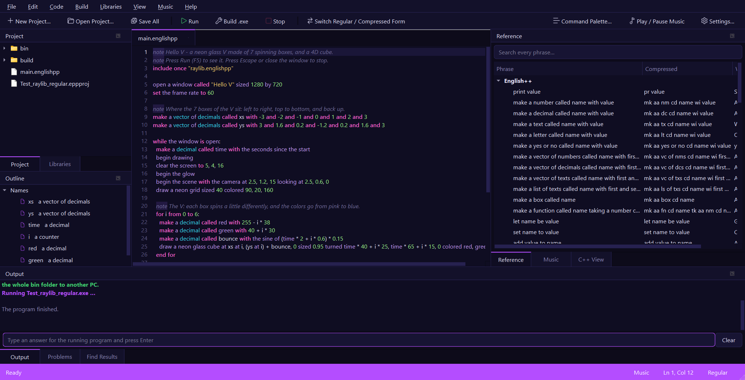
English++ Studio: your program in the middle, helpers all around it.

53. Your First Program
Let's make your first program, step by step.
- Open English++ Studio.
- Click New Project.
- Pick Console App. A console app talks to you with words.
- Give your project a name, like MyFirstProgram, and click Create.
The Studio makes a program for you. It looks like this:
note Hello V - your first English++ program.
note Press Run (F5) to see it say hello. Change the words and run it again!
print "Hello, V!"
Now press the Run button (or the F5 key). Look at the Output window at the bottom. It says:
Hello, V!
You did it! You ran a program.
Try it! Change the words between the quote marks to your own name, like "Hello, Sam!". Press F5 again.

The quote marks
Words between quote marks "like this" are called text. The computer shows text exactly as you wrote it. Without quote marks, the computer thinks a word is part of the program.

54. Notes for People
A line that starts with note is for people, not for the computer. The computer skips it.
note This program says hello three times.
print "Hello!"
print "Hello again!"
note The next line is the last one.
print "Goodbye!"
Use notes to explain your program to a friend - or to yourself, next week!

55. Boxes for Things
Programs need to remember things: a score, a name, how many lives are left. English++ keeps each thing in a little box with a name on it.
Each box has a name and holds one thing.
You make a box like this:
make a number called score with 7
print score
This makes a box called score with the number 7 inside. Then print score shows what is inside: 7.

Kinds of things
Every box holds one kind of thing:
Kind | What it holds | Example
a number | a whole number | make a number called lives with 3
a decimal | a number with a dot | make a decimal called price with 2.5
a text | words in quote marks | make a text called pet with "Rex"
a letter | one letter in small quotes | make a letter called grade with 'A'
a yes or no | yes or no | make a yes or no called happy with yes

make a number called lives with 3
make a decimal called price with 2.5
make a text called pet with "Rex"
make a letter called grade with 'A'
make a yes or no called happy with yes
print lives and price and pet and grade and happy
The word and lets one print show many things, with spaces between them.
Tip! Grown-ups call these boxes variables. A name can use letters, numbers and _ (like top_score), but it cannot start with a number.

Boxes that never change
If a box should never change, make it constant:
make a constant number called days_in_a_week with 7
print days_in_a_week

56. Changing Things
To put something new in a box, use set:
make a number called score with 0
set score to 10
print score
set score to score + 5
print score
set score to score + 5 means: take what is in score, add 5, and put the answer back in score. Now it holds 15.
Adding is so common that it has its own short way:
make a number called coins with 2
add 3 to coins
print coins

Let
let makes a box and lets English++ work out what kind it is:
let speed be 12
let name be "Ada"
print name and speed

57. Doing Math
The computer is very fast at math.
You write | It means
+ | add
- | take away
* | times
/ | divide
( ) | do this part first

print 2 + 3
print 10 - 4
print 6 * 7
print (1 + 2) * 3

Whole numbers and decimals
Dividing whole numbers gives a whole number: 7 / 2 is 3 (the bit left over is dropped). If you want 3.5, use a decimal:
print 7 / 2
print 7.0 / 2

Math helpers
English++ knows many math words:
print the square root of 81
print the absolute value of -5
print the number pi with 3 decimal places
make a number called roll with a random number from 1 to 6
print "You rolled" and roll
Try it! Run the last program a few times. Is the dice roll different each time?

58. Words and Letters
You can join texts with +:
make a text called first with "Super"
make a text called second with "star"
print first + second
To join a number to a text, turn the number into text with as text:
make a number called age with 7
print "I am " + (age as text) + " years old."
Here are some things English++ can do with words:
make a text called word with "hello"
print the uppercase version of word
print the length of word

59. Asking Questions: If
Programs can make choices. if asks a question. When the answer is yes, the lines under it happen.
make a number called score with 12
if score is more than 10:
print "Great score!"
end if
The lines inside the if are moved to the right with two spaces. When the if is done, write end if.
Tip! In the Studio, when you type a line that ends with a colon (:) and press Enter, the Studio moves the next line in for you and writes the end line for you too.

Otherwise
otherwise says what to do when the answer is no:
make a number called score with 7
if score is more than 10:
print "big"
otherwise if score is more than 5:
print "medium"
otherwise:
print "small"
end if

Questions you can ask
You write | It is yes when
a is b | a and b are the same
a is not b | a and b are different
a is more than b | a is bigger
a is less than b | a is smaller
a is more than or equal to b | a is bigger or the same
a is less than or equal to b | a is smaller or the same
n is even | n is 2, 4, 6, ...
n is odd | n is 1, 3, 5, ...

You can join questions with and, or and not:
make a number called age with 8
make a yes or no called has_ticket with yes
if age is more than 6 and has_ticket:
print "You can ride!"
end if

A short if
When there is just one thing to do, an if can fit on one line, with a comma:
make a number called n with 4
if n is even, print "even!"

60. Doing Things Again: Loops
Computers never get bored. A loop does something again and again.

Repeat
repeat 3 times:
print "Hip hip hooray!"
end repeat

Counting
for i from 1 to 5:
print i
end for
for i from 10 down to 0 by 5:
print i
end for

While
while keeps going as long as the answer is yes:
make a number called rocket with 5
while rocket is more than 0:
print rocket
set rocket to rocket - 1
end while
print "Blast off!"

Repeat until
make a number called n with 0
repeat:
add 2 to n
until n is more than 5
print n

Stopping early
break stops a loop. continue skips to the next turn.
make a number called n with 0
repeat forever:
add 1 to n
if n is 3, continue
if n is more than 5, break
print n
end repeat
Try it! Make a loop that prints the 7 times table: 7, 14, 21, ...

61. Choosing by Value: Check
When there are many choices for one value, check is neat and tidy:
make a number called day with 2
check day:
if it is 1:
print "Monday"
if it is 2 or 3:
print "Tuesday or Wednesday"
otherwise:
print "another day"
end check

Choices
You can make your own list of choices:
Choices called Weather: sunny, rainy, and snowy
make a Weather called today with rainy
if today is rainy, print "Take an umbrella!"

62. Collections: Many Things in One
Sometimes you need lots of things, like all the scores in a game. A vector is a row of boxes that can grow.
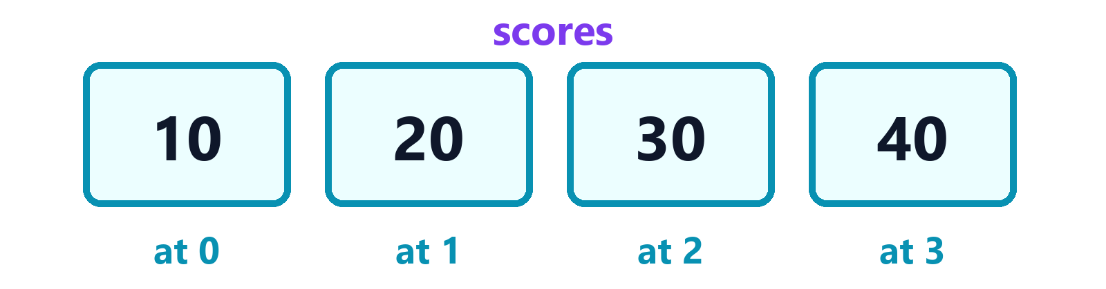
A vector: boxes in a row. The first one is number 0.
make a vector of numbers called scores with 10 and 20
add 30 to scores
print scores
print the count of scores
print scores at 0
The first item is at 0, the next is at 1, and so on.

For each
for each visits every item:
make a vector of texts called pets with "cat" and "dog" and "fish"
for each pet in pets:
print "I love my" and pet
end for

Sorting
make a vector of numbers called scores with 5 and 3 and 8 and 1
sort scores
print scores

More kinds of collections
Collection | What it is like
a vector | a row of boxes that can grow
a list | a chain you can add to at both ends
a map | a dictionary: look things up by a key
a set | a bag where each thing appears only once
a stack | a pile of plates: take from the top
a queue | a line at the shop: first in, first out

make a map from texts to numbers called ages with "bob" as 9 and "amy" as 7
set ages at "zoe" to 8
print ages at "amy"
if ages has "bob", print "bob is here"
for each name and age in ages:
print name and "is" and age
end for
make a stack of texts called plates
push "red" onto plates
push "blue" onto plates
print the top of plates
take the top off plates
print the top of plates
make a queue of numbers called line
add 5 to line
add 6 to line
print the front of line
take the front off line
print the front of line

63. Your Own Functions
A function is a little program with a name. You make it once, and use it again and again. Make one with define:
define cheer:
print "Go team!"
print "Yay!"
end cheer
call cheer
call cheer

Giving a function something
A function can take things to work on, and give back an answer:
define double_it taking a number called x giving back a number:
give back x * 2
end double_it
print call double_it with 21
define greet taking a text called who and a number called times:
repeat times times:
print "Hello," and who
end repeat
end greet
call greet with "Mia" and 2
Tip! give back ends the function and hands the answer to whoever called it. Grown-ups call it return.

64. Functions in Boxes
A function can live in a box, just like a number:
make a function called twice taking a number called n giving back a number: give back n * 2
print call twice with 21
make a vector of numbers called scores with 4 and 15 and 8
apply twice to every item in scores
print scores
Functions in boxes can help with collections:
make a number called limit with 10
make a function called is_big taking a number called n giving back a yes or no: give back n is more than limit
make a vector of numbers called scores with 4 and 15 and 8 and 23
print the items of scores where is_big
print the number of items in scores where is_big

65. Your Own Kinds of Things: Boxx
You can invent your own kind of thing, like a Dog or a Spaceship. You describe it with Boxx:
Boxx called Dog:
has a text called name
has a number called age with 1
when made taking a text called given:
set name to given
end when made
can bark:
print name and "says woof!"
end bark
end Dog
make a Dog called rex with "Rex"
rex bark
print the age of rex
- has gives it things to remember (grown-ups say fields).
- can gives it things it can do (grown-ups say methods). To make it do one, write its name and then the method: rex bark.
- when made runs when a new one is made.

Families of things
A kind of thing can use another kind and get all of its powers:
Boxx called Animal:
has a text called name
when made taking a text called given:
set name to given
end when made
can introduce:
print "I am" and name
end introduce
end Animal
Boxx called Cat uses Animal:
when made taking a text called given:
start as an Animal with given
end when made
can purr:
print "purr..."
end purr
end Cat
make a Cat called tom with "Tom"
tom introduce
tom purr

66. When Things Go Wrong
Sometimes something goes wrong while a program runs. try catches the problem so the program can carry on:
try:
print "trying"
complain "something broke"
print "never printed"
if it fails:
print "caught:" and the problem
end try
complain stops with a problem. the problem tells you what it was.

When a program makes a mistake
If a program makes a mistake while it runs - like asking for item 5 of a list that only has 3 - it stops and tells you exactly where, in plain English:
make a vector of numbers called scores with 1 and 2 and 3
print "before"
print scores at 5
before
The program stopped on line 3:
print scores at 5
It used a position that is not in the collection or text.
The Studio also jumps to that line and underlines it. It works for dividing by zero, for a function that calls itself forever, for a pointer to nothing, and for a complain that nobody caught. Many languages just crash, or quietly keep going with a wrong answer. English++ tells you the line.
Tip! If you make a mistake while typing, the Studio draws a wavy red line under it and says what is wrong in plain English. Point at the red line to read it.

67. Waiting and Time
wait makes the program pause:
print "Ready..."
wait 1 seconds
print "Go!"
print "That took" and the seconds since the start and "seconds"

68. Talking With Your Program
A program can ask you questions with ask. Type your answer in the line under the Output window and press Enter.
make a text called name
ask "What is your name?" into name
make a number called age
ask "How old are you?" into age
print "Hi" and name and "- next year you will be" and age + 1

69. Saving to Files
A program can write words into a file, and read them back later:
write "Hello from my program!" to "note.txt"
make a text called message
read "note.txt" into message
print message

70. Talking to the World
English++ comes with tools for the things programs often need.

Web pages
make a text called page with the text of the web page "https://example.com"
print the length of page
download the web page "https://example.com" to the file "example.html"

Other programs
print the output of the command "echo Hello from Windows"
print the exit code of the command "exit 3"
print the environment value "OS"

Patterns
A pattern describes the shape of some text. [0-9]+ means "one or more digits":
if the text "2026-11-01" matches the pattern "^[0-9]{4}-[0-9]{2}-[0-9]{2}$", print "that is a date"
print the matches of the pattern "[0-9]+" in "a1 b22 c333"
print a copy of "too many spaces" with the pattern " +" replaced by " "

Tables of data (CSV files)
print the csv cells in "name,age,city"
make a vector of texts called row with "Ada" and "36" and "London, UK"
print the csv line of row

Numbers and dates
make a vector of numbers called scores with 2 and 4 and 4 and 4 and 5 and 5 and 7 and 9
print the median of scores
print the standard deviation of scores
print the factorial of 10
if the number 97 is prime, print "97 is prime"
print "Today is" and the day of the week

Fast, too
English++ turns into C++, so it runs as fast as C++. Counting the prime numbers below one million takes English++ about 0.1 seconds. The same program in Python takes about 9 seconds.

71. The Box World
English++ has a little 3D world built in. Make boxes, show them, and move them:
make a box called hero
make a box called coin
show hero
show coin
paint hero red
paint coin gold
when hero touches coin, play sound "ding"
wait 1 seconds
move hero by 2, 0, 0
spin hero by 45
grow coin by big
say "You found the coin!"
When this program runs, a window opens with your boxes in it.
Doing word | What happens
show / hide | the box appears / disappears
move hero by x, y, z | the box slides
spin hero by 90 | the box turns
grow hero by 2 | the box gets bigger (shrink makes it smaller)
paint hero red | red, blue, green, gold, purple, white, black, pink, orange, cyan
say "hi" | words appear on the screen

Keys and the mouse
make a box called hero
show hero
when the right key is pressed, move hero by 1, 0, 0
when the mouse is clicked, paint hero pink
A when line says what happens, after a comma, each time the thing happens.

72. Many Files
Big programs can be split into many files. include brings in another file:
include "helpers.englishpp"
include once makes sure a file is only brought in one time, even if many files ask for it. That is how you use libraries:
include once "raylib.englishpp"

73. Teaching English++ New Words
You can teach English++ new words! A phrase says what some English means in C++:
phrase "say hooray" means "std::cout << \"Hooray!\" << std::endl;"
say hooray
say hooray
A phrase can have holes, written with curly brackets. Each hole is filled in when you use the phrase:
phrase "the double of {x:num}" gives back a number means "({x}) * 2"
print the double of 21
This is exactly how libraries teach English++ their words. Libraries are just files full of phrases!

74. Libraries: Superpowers
A library is a bag of new words made by other people. English++ Studio comes with five libraries already inside. To use one, put an include line at the top of your program - or click Use in This File in the Libraries panel.
Library | What it is great for
raylib | windows, 2D and 3D drawing, glow, neon glass, a 4D cube
SDL 3 | fast 2D drawing, keys and the mouse
SFML 3 | smooth shapes and text
OpenGL | real 3D drawing, one corner at a time
Qt 6 | real desktop apps with buttons and text boxes

raylib: the Hello V program
When you make a raylib App project, the Studio gives you this program. It draws a glowing V made of 7 spinning glass boxes, and a 4D cube!
note Hello V - a neon glass V made of 7 spinning boxes, and a 4D cube.
include once "raylib.englishpp"
open a window called "Hello V" sized 1280 by 720
set the frame rate to 60
make a vector of decimals called xs with -3 and -2 and -1 and 0 and 1 and 2 and 3
make a vector of decimals called ys with 3 and 1.6 and 0.2 and -1.2 and 0.2 and 1.6 and 3
while the window is open:
make a decimal called time with the seconds since the start
begin drawing
clear the screen to 5, 4, 16
begin the glow
begin the scene with the camera at 2.5, 1.2, 15 looking at 2.5, 0.6, 0
draw a neon grid sized 40 colored 90, 20, 160
for i from 0 to 6:
make a decimal called red with 255 - i * 38
make a decimal called green with 40 + i * 30
draw a neon glass cube at xs at i, ys at i, 0 sized 0.95 turned time * 40 + i * 25, time * 65 + i * 15, 0 colored red, green, 255
end for
draw a 4D cube at 8.5, 0.9, 0 sized 2.2 turned time * 35 colored 0, 230, 255
finish the scene
finish the glow
draw the text "Hello V" at 40, 30 sized 56 colored 255, 255, 255
finish drawing
end while
close the window
The Hello V program running.
Here is how it works:
- while the window is open is the game loop. It runs about 60 times every second. Each time, it draws one picture, called a frame.
- begin drawing and finish drawing wrap each frame.
- begin the glow and finish the glow make everything in between shine.
- begin the scene sets up a 3D camera: where it is, and what it looks at.
- The for loop draws the 7 boxes of the V. Each box turns a little more as time goes by.
- A 4D cube has an extra direction that our eyes cannot see. The program turns it through that direction, so it seems to turn inside out!
Try it! Change 40 in time * 40 to 200. The boxes spin faster!

SDL
include once "sdl.englishpp"
open an SDL window called "My SDL Window" sized 640 by 360
while the SDL window is open:
clear the SDL window to 12, 14, 30
draw an SDL rectangle at 100, 100 sized 120 by 80 colored 255, 120, 60
draw the SDL text "Hello from SDL!" at 100, 40 sized 24 colored 255, 255, 255
show the SDL frame
end while
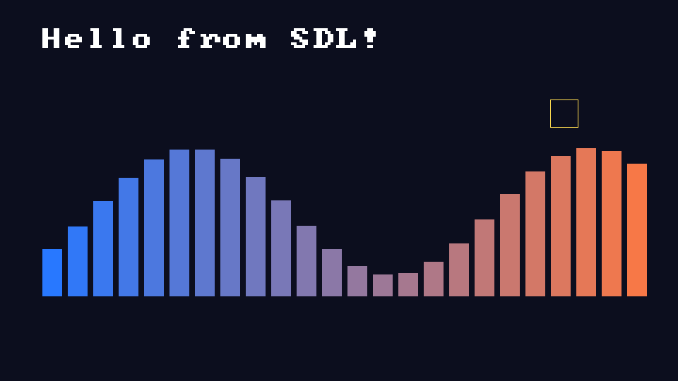
The SDL example that comes with the Studio.

SFML
include once "sfml.englishpp"
open an SFML window called "My SFML Window" sized 640 by 360
while the SFML window is open:
clear the SFML window to 8, 10, 24
draw an SFML circle at 320, 180 sized 60 colored 255, 200, 60
draw the SFML text "Hello from SFML!" at 20, 20 sized 32 colored 255, 255, 255
show the SFML frame
end while

The SFML example: planets going around a sun.

OpenGL
include once "opengl.englishpp"
open an OpenGL window called "My OpenGL Window" sized 640 by 360
while the OpenGL window is open:
clear the OpenGL window to 10, 12, 28
put the OpenGL camera 5 away
turn the OpenGL drawing by the OpenGL time * 60 around 1, 1, 0
draw an OpenGL cube sized 1.5
show the OpenGL frame
end while

The OpenGL example: a spinning rainbow cube and a triangle.

Qt
include once "qt.englishpp"
define say_hi:
set the Qt label "answer" to "Hello, " + the text in the Qt text box "name" + "!"
end say_hi
make a Qt window called "My App" sized 400 by 260
add a Qt title saying "Hello from Qt!"
add a Qt text box called "name"
add a Qt button called "hi" saying "Say hi"
add a Qt label called "answer" saying ""
connect the Qt button "hi" to say_hi
start the Qt app
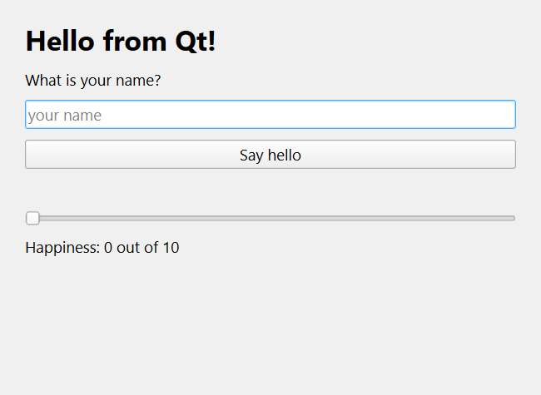
The Qt example: a real desktop app.

Adding a library from the internet
Any C++ library can join English++. In the Studio, click Libraries > Add External Library, pick the library's files, and the Studio makes a phrase file for it. Then teach it words with phrase lines, just like in the last chapter.

75. Three Forms: Regular, Compressed and Blueprint
English++ comes in three forms that mean exactly the same thing.
- Regular is what you have seen in this book: whole English words.
- Compressed writes every keyword with just 2 or 3 letters. It is quick to type once you know it.
- Blueprint draws the program as boxes joined by wires. The next chapter shows how.
Here is the same program in the first two forms:
make a number called score with 7
if score is more than 5:
print "big"
end if
The same program, compressed:
mk aa nm cd score wi 7
if score is mr th 5:
pr "big"
end if
Words that already have 2 or 3 letters (like if, is, to, end) stay the same. Names you make (like score) stay the same too. Regular files end in .englishpp, and compressed files end in .epc.
In the Studio, click Switch Regular / Compressed Form (or press Ctrl+Alt+C) to turn a file into the other form and back. Nothing about the program changes. The full list of codes is in Appendix A at the back of this book.
Tip! When you make a new project, you can pick Regular, Compressed or Blueprint, or C++ Overpowered: real C++ as a blueprint, which has its own chapter. Point at any compressed word in the Studio to see what it means.

76. Blueprints: Programs You Can See
The third form of English++ is the Blueprint. A blueprint is your program drawn as a picture: every line is a box called a node, and wires join the nodes together. You can build a whole program this way, without typing a single line, and it is still English++.
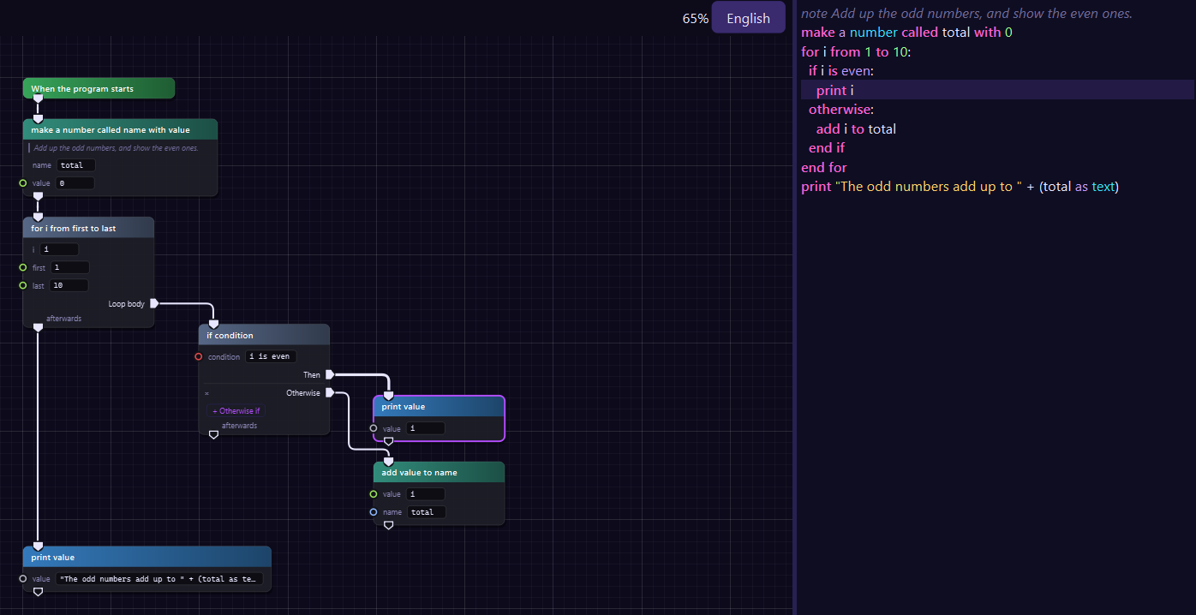
A blueprint. The English++ it makes is on the right.
Here is the program in that picture, in the regular form:
note Add up the odd numbers, and show the even ones.
make a number called total with 0
for i from 1 to 10:
if i is even:
print i
otherwise:
add i to total
end if
end for
print "The odd numbers add up to " + (total as text)
2
4
6
8
10
The odd numbers add up to 25

Reading a blueprint
- Each node is one line of your program. Its colored title says what it does, and its rows are the holes of the line: type in the box, or wire a value into the pin.
- White wires show what runs next. A program runs from top to bottom, starting at the green When the program starts node. A node is run from the white pin on its top, and its bottom pin says what runs afterwards.
- A node that holds other lines (like if, for, while and define) has a white pin on its right for each part: Then, Otherwise, Loop body and more. The nodes wired there are inside it.
- Colored wires carry values into the holes. Each kind of value has its own color: green for numbers, pink for words, red for yes or no.
- A node with a red outline has a mistake. Point at it to read what is wrong.
- A node that is see-through is not part of the program yet. Wire it in!
The panel on the right shows the English++ your blueprint makes, line by line. Click a node and its lines light up. Click a line and its node lights up.

Making a blueprint
When you make a new project, pick Blueprint as the form. Or turn any file into a blueprint: click the form name at the bottom right of the Studio and pick Blueprint (or press Ctrl+Alt+B). Turning it back into the regular form gives you exactly the same program. Blueprint files end in .epb.

Adding nodes
Press Space (or right-click the empty space) to open the node list. Type a few words, like print or for each, and press Enter.
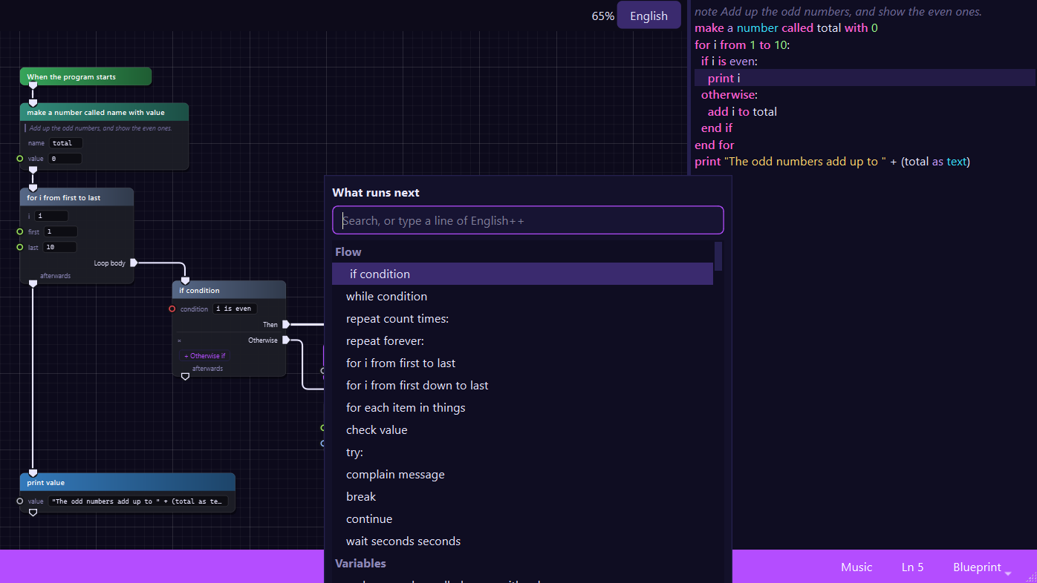
The node list: every phrase English++ knows, ready to search.
- If a node is chosen, the new node runs right after it.
- Drag a wire from a pin and let go in empty space: the node list opens, and the new node comes already wired.
- Type a whole line of English++ in the search box, like print "Hi", and press Enter: it becomes its node, already filled in.
- Values has numbers, words and yes or no. Variables has a Get and a Set node for every name you made.
- A library's phrases are in the list too. Using one adds include once to your program by itself.

Wiring
Drag from one pin to another to wire them. White pins join steps, and colored pins carry values. To take a wire away, hold Alt and click its pin.

Typing in pins
Click a box to type in it. Press Tab to go to the next box, and Enter when you are done. A yes or no box flips when you click it.

Names
Choose a node and press F12 to jump to where a name it uses was made. Shift+F12 shows every line that uses the name, and F2 gives the name a new name everywhere. Ctrl+H replaces words in the boxes.
Tip! A blueprint is still English++. The words in the panel on the right are what the Studio builds, so a blueprint runs exactly like the same program typed in words.

Keys for blueprints
Keys | What they do
Space | add a node
Delete | take away the chosen nodes
Ctrl+D | make a copy of the chosen nodes
Ctrl+C, Ctrl+V | copy and paste (pasting English++ words makes nodes)
Ctrl+Z, Ctrl+Y | undo and redo
Wheel | zoom in and out
Right-drag | move around
F | see the whole program
Alt+click | take away a pin's wires
F12 | go to where the chosen node's name was made
F2 | rename a name everywhere
Ctrl+F, Ctrl+H | find a node, and replace words in the boxes

77. C++ Overpowered: Real C++ You Can See
English++ turns into C++ when it is built. C++ is the language that games, browsers and whole operating systems are written in. C++ Overpowered lets you work in real C++ itself, as a blueprint.
Every node is real C++. Any C++ file opens as a blueprint, and the blueprint writes back exactly the same C++: every space, every note, every line. Nothing is ever left out. If a part of a file is something the blueprint does not draw as its own kind of node, it becomes a gray C++ code node that keeps it exactly as it was written.
Every node is a small glowing orb with a few words of its code beside it, like lives = 3 or i <= 10. The steps run down a line from orb to orb, like stations on a train map, and the inside of a loop or an if branches off to the right.
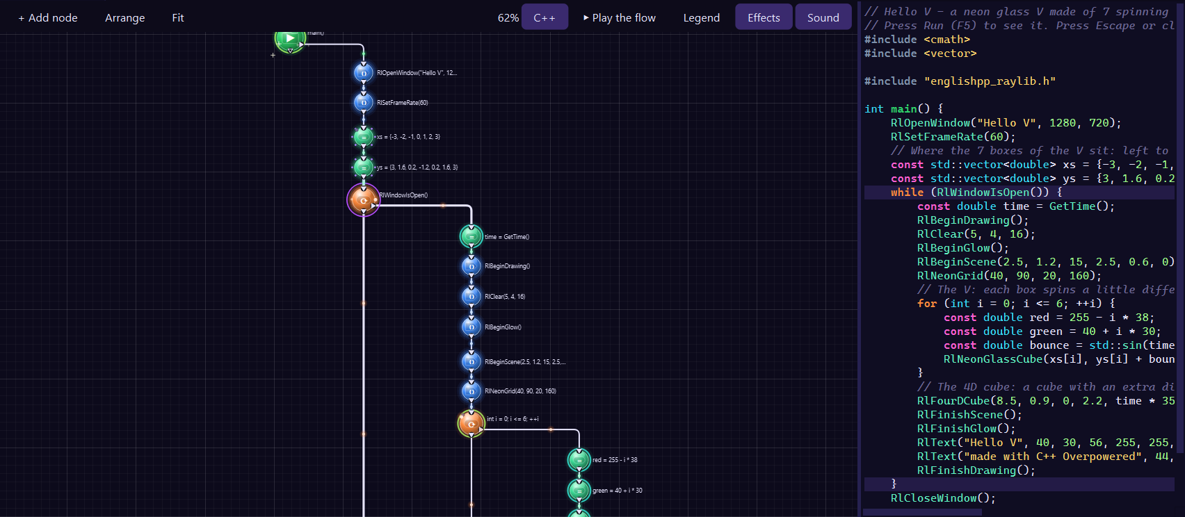
The Hello V program, in C++, as orbs.

Colors, shapes, lights and sounds
In C++ Overpowered, every kind of step has its own color, its own badge, its own shape drawn inside its orb, its own light and its own sound. Once you know them, you can see what a program does before you read a single word, and you can even hear it.
What it is | Color | Shape inside | Light | Sound
main: the program starts here | green | tab | sparkles | a fanfare
a function | purple | tab | pulses | a bell
a variable: int total = 0; | mint green | capsule | none | a pluck
setting a variable: total += i; | light mint | capsule | none | a strum
a call: draw(); | blue | arrow | none | a blip
printing: std::cout | sky blue | arrow | none | a chirp
if and else | pink-red | diamond | blinks | ding-dong
switch | magenta | octagon | blinks | ding-dong
a loop: for, while, do | orange | capsule | lights circle it | notes going up
return | gold | arrow down | flickers | a swoop
try and catch | amber | shield | flickers | a chime
throw a problem | red | lightning bolt | flickers | a zap
class and struct | cyan | hexagon | shimmers | a crystal
enum | lime | hexagon | shimmers | a crystal
namespace | teal | frame | shimmers | a hum
#include | gray-blue | tag | none | a tick
break and continue | peach | tag | none | a tick
C++ code, kept as written | gray | box | none | a blip

Pointers have orbs of their own too: *p (the value a pointer points to), &x (where a value lives), p->x (a member through a pointer) and delete. Values have colors: green for numbers, pink for words, orange for letters and red for true or false. Light particles flow along the wires, the way the program goes.

Rings: what type it is
The ring around an orb tells you the type of what it makes or gives back: a variable's type, or what a function gives back. Its color is the kind of value, and its pattern says how the value is held.
The ring | What it means
solid green | int: a whole number
solid teal | double: a number with a point
solid red | bool: true or false
solid orange | char: one letter
solid pink | std::string: words
beads | a list, map, set or array
solid cyan | a thing made from a class
dashes and an arrow | a pointer, like int (two arrows for int
a double ring | a reference, like int&
a triple ring | a value being moved, like int&&
rivets | a smart pointer, like std::unique_ptr
dash-dot | a function kept in a name, like a lambda
a rainbow | auto: the type of its value
no ring | void: a function that gives back nothing

So a function that gives back an int has a green ring, and a pointer to an int has a green ring of dashes with an arrow pointing out.
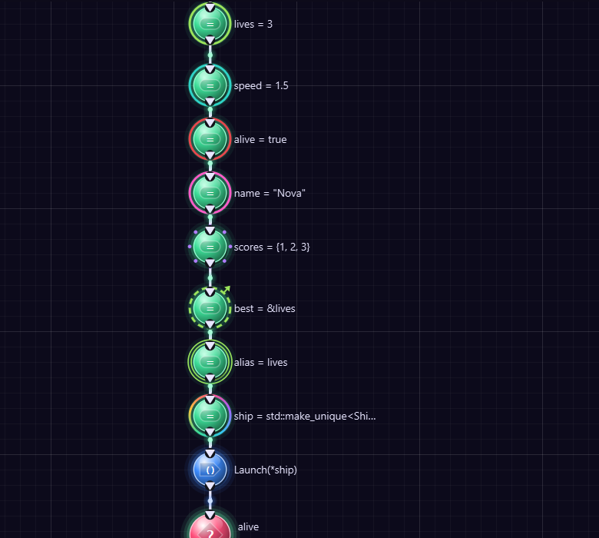
Rings: an int, a double, a bool, words, a list of beads, a pointer, a reference, and auto.

Small until you need more
An orb stays small, so you can see a whole program at once. Point at an orb for a moment and it opens: its boxes fan out around it in a circle, one for each part of its code. A new orb opens by itself so you can fill it in. Type in a box and press Enter, and the orb shrinks again.
To change several values, double-click the orb: it stays open, even when the mouse moves away, and a pin shows above it. Change as many boxes as you like. Double-click it again, click its pin, or press Escape, and it closes.
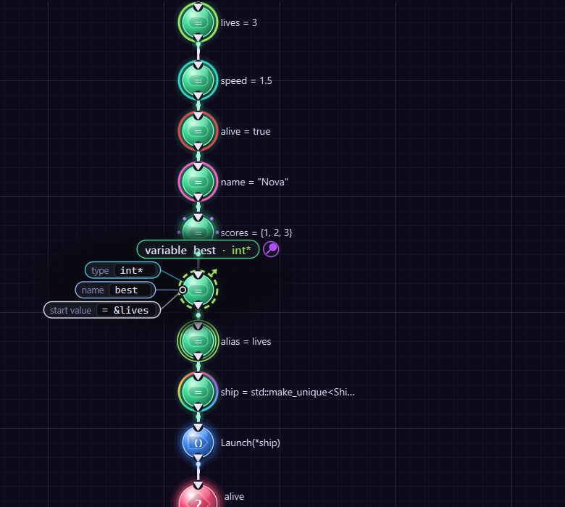
An orb kept open with a double-click: its type, its name and its start value, in a circle around it. The pin over it says it stays open.
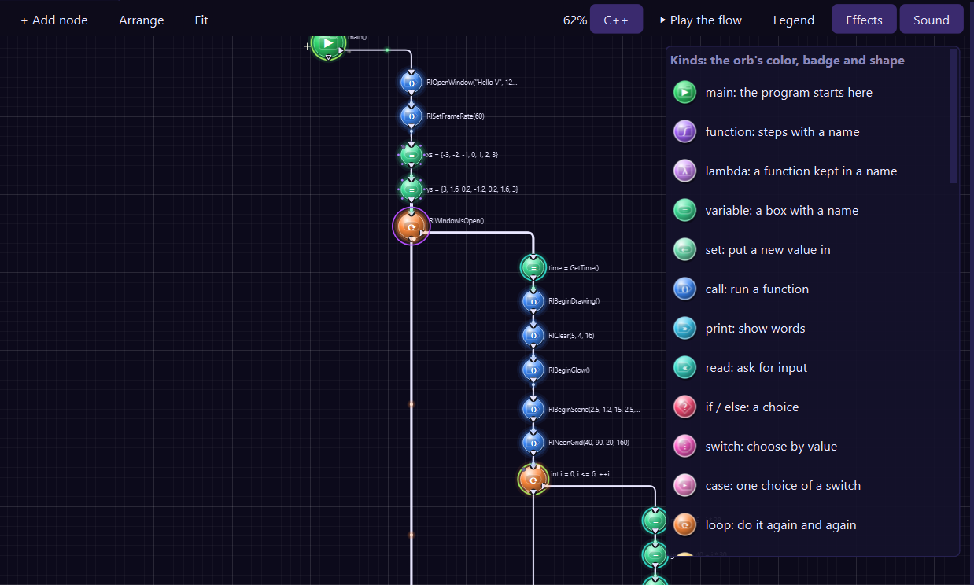
The Legend button shows every kind. Click a row to hear its sound and light up those nodes.
- Play the flow lights up the steps one by one, in the order they run, each with its sound. Watch a loop go round and round!
- Legend shows the table above inside the Studio.
- Effects turns the lights and particles on and off, and Sound does the same for the sounds.

Just say it
You do not have to know any C++ to write C++ here. Press Space, say what you want in a few words, and press Enter. As you type, the list shows It means, with the C++ your words will make.
You say | The Studio writes
print Hello there | std::cout << "Hello there" << '\n';
print numbers | a loop that prints every number in the list
print Score: {score} | the words, then the value of score
score = 7 | int score = 7;
speed = 2.5 | double speed = 2.5;
title = The End | std::string title = "The End";
numbers = 1, 2, 3 | std::vector<int> numbers = {1, 2, 3};
add 3 to score | score += 3;
add 4 to numbers | numbers.push_back(4);
sort numbers | std::sort(numbers.begin(), numbers.end());
repeat 5 | for (int i = 0; i < 5; ++i)
for i from 1 to 10 | for (int i = 1; i <= 10; ++i)
for each n in numbers | for (const auto& n : numbers)
if score is more than 5 | if (score > 5)
ask name | makes name, then asks for it
function hello | void hello()
class Robot | class Robot, ready to fill in
done | the next step goes after the loop or the if

Look at what you did not have to do: no quotes around words, no types, no semicolons, no #include lines and no std:: anywhere.
And if you do know C++, just write it. A line that ends with ; or { is real C++, and it stays exactly as you typed it.

The boring parts do themselves
- Every new step joins your program. You do not wire it in. A step goes right after the one you clicked, or at the end of main. A function or a class goes above main, where C++ needs it.
- A step goes inside what you just made. After an if or a loop, the next step goes inside it. Say done and the next one goes after it.
- #include lines appear by themselves, as soon as a step needs one.
- Names never clash. Pick Make a list of numbers twice, and the second one is called numbers2. Rename something, and every place that uses it changes too.
- Boxes understand what you mean. Type Hello in a print box: it prints the word. Type the name of a variable: it prints its value. Type 3.5 into a variable and its type becomes double. Type x is more than 3 in an if and it writes x > 3.
- Mistakes come in plain words. Instead of "undeclared identifier", the Studio says there is nothing with that name yet.
- The orbs arrange themselves, until you drag one to a place of your own. Arrange tidies them again.

It guesses what comes next
Press Space, and the top of the list is What next?: what you will probably want, using the real names in your program. Just made a list called scores? It offers Print scores, Go through scores, Add an item to scores and Sort scores. In a loop or an if, it also offers to be done with it.
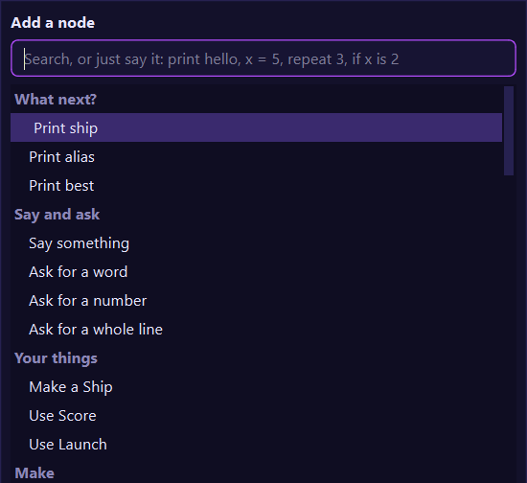
Press Space: first what comes next, then every step in plain words.
Click a box, and a list shows what fits there: the variables you can use right now, the types in plain words, and more. Pick one with a click, or with the arrow keys and Enter.
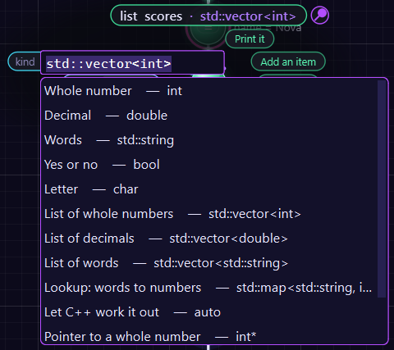
Click a box and pick what fits. No typing, and no looking up how to write std::vector.

One click does it
An open orb has buttons for what you can do with that thing, right there on its right side.
On | The buttons do this
a list | Print it, Add an item, Each item, Sort it, Print how many
a variable | Print it, and more that fit its type
a function | Use it: calls it from main
a class | Make one: makes an object from it in main
an if or a loop | Add a step inside

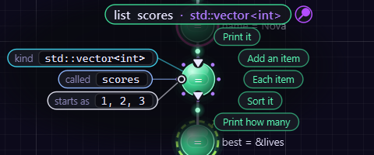
A list, open: its boxes on the left and its buttons on the right. Print it writes the whole loop for you.
To put a step between two others, click the wire between them and say what you want, or drag an orb onto the wire.
Try it! Press Space and say numbers = 3, 1, 2. Point at its orb and click Sort it, then Print it. Press Run. You made a program that sorts a list, and it has real C++ in it that you never had to write.

A program made from nodes
Here is a C++ program you can make without knowing any C++. It adds up the numbers from 1 to 10.
#include <iostream>
int main() {
int total = 0;
for (int i = 1; i <= 10; ++i) {
total += i;
}
std::cout << total << '\n';
return 0;
}
55
- Make a new project and pick C++ Overpowered as the form.
- Press Space, say total = 0, and press Enter.
- Press Space, say for i from 1 to 10, and press Enter.
- Press Space, say add i to total, and press Enter. It goes inside the loop by itself.
- Press Space, say done, and press Enter.
- Press Space, say print total, and press Enter. Then press Run (F5).

Examples to learn from
The Studio comes with 32 C++ examples, from your first program to a small game. Click C++ Examples on the Welcome page (or Help > C++ Overpowered Examples), pick one, and it opens as a blueprint in a project of its own, ready to run. Change it as much as you like: the example itself stays as it was.
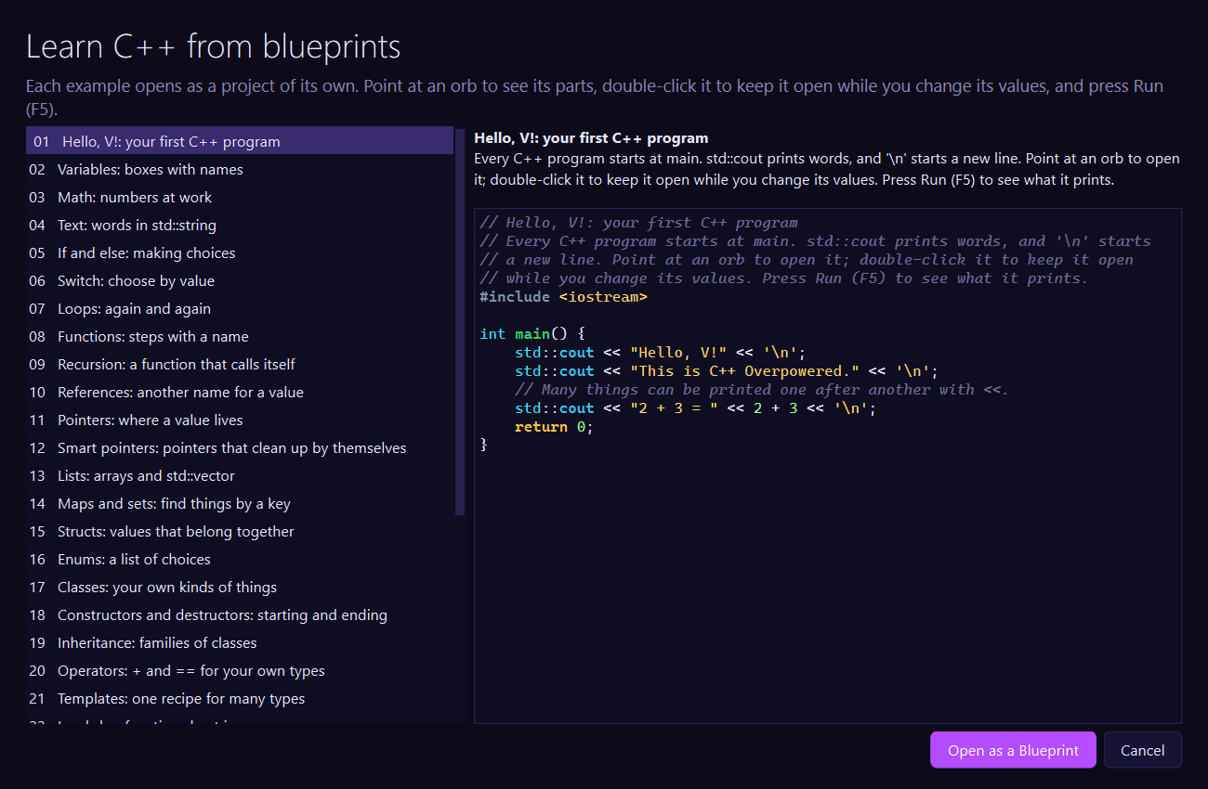
The C++ examples: pick one, read what it shows, and open it as a blueprint.
Examples | What they show
1 to 4 | printing, variables, math, and words
5 to 7 | choices with if and switch, and loops
8 to 10 | functions, recursion, and references
11 and 12 | pointers, and smart pointers
13 to 16 | lists, maps and sets, structs, and enums
17 to 20 | classes, constructors, inheritance, and operators
21 to 26 | templates, lambdas, exceptions, namespaces, static and constexpr, and algorithms
27 to 30 | files, random numbers and time, maybe-values, and threads
31 and 32 | windows with raylib: a bouncing ball, and a game where you catch the stars

Try it! Open example 17, Classes. Double-click the orb of account.Deposit(25), change 25 to 1000, and press Run.

Adding nodes
Press Space to open the node list. You can scroll it, or type a few words to search it. It has everything, in plain words:
- What next?: what you will probably want now.
- Say and ask, and Your things: the functions and classes your own program made.
- Make, Change, Choose and Repeat: variables, lists, if, switch and loops.
- Functions, Classes and Problems (try, catch and throw).
- Values, Math and logic, the Standard library, Libraries (every function of raylib and of the Studio's libraries) and C++. These groups stay closed until you click them or search for something in them, so the list stays short.
Type a whole line of C++ in the search box, like std::cout << "Hi";, and press Enter: it becomes its node, already filled in.

Values as nodes
Point at an orb, then click one of its boxes to type in it: plain words, or C++ like i <= 10. Press Tab to go to the next box. Or right-click a box's pin and pick Open it up into nodes: the math becomes its own nodes, an operator node with the values wired into it, and the C++ stays exactly the same.

Visual C++ checks as you go
While you work, the Studio asks Visual C++ to check your program. A node with a mistake gets a red outline. Point at it to read what Visual C++ says. Fix it, and the outline goes away.

Any C++, any library
C++ Overpowered is not a smaller C++. Classes, templates, lambdas, pointers, namespaces, exceptions and the whole standard library all work, because it is C++. To use a C++ library, #include its header and its functions are yours. Other .cpp files and headers in your project's folder are built together with the program.

Text or blueprint
Click the form name at the bottom right of the Studio to switch between C++ Overpowered (the blueprint, a .cpb file) and C++ (the same program as text, a .cpp file). Both give exactly the same C++.
In the C++ text, the words have the colors of their nodes: if is the color of an if node, for the color of a loop. The Studio closes your braces, finds C++ words as you type, and Format Document puts every line in its place.
Tip! Every blueprint key works here too: F12, Shift+F12, F2, Ctrl+D, Ctrl+Z and the rest.

78. English++ Studio
The Studio has everything you need to make programs. Here are its best tricks.

IntelliSense: the Studio helps you type
As you type, the Studio guesses what comes next and shows it in gray, right after your cursor. Press Tab to take it. The holes become placeholders: type over the first one, press Tab, type the next one.
A list of ideas also pops up. Use the arrow keys to pick one, then press Enter or Tab. Press Ctrl+Space to see ideas any time.

Run and Build
- Run (F5) builds your program and runs it, with output in the Output window.
- Build .exe (Ctrl+Shift+B) makes a real Windows program in your project's bin folder. Double-click it to run it without the Studio. Copy the whole bin folder to share it with a friend!
- Stop (Shift+F5) stops a running program.

Panels
Panel | What it does
Project | the files in your project
Outline | every box, function and Boxx in your file
Libraries | the libraries, their examples and their phrases
Reference | every phrase English++ knows; double-click one to add it
Problems | mistakes, and where they are
Output | what your program prints, and a line to answer its questions
C++ View | the C++ your program turns into
Music | music to code to!

Seven themes
Pick a look in View > Theme: Midnight Neon, Dark Studio, Daylight, Sandstone, Forest Night, Bubblegum and High Contrast.

Music and the Beat Maker
The Music panel plays 32 songs made by the Studio itself, in seven styles: Lo-Fi, Synthwave, Chiptune, House, Hip-Hop, Ambient and Drum & Bass. They are all original and free to use. You can also add your own music files, and load or save playlists.
The Beat Maker makes a brand new beat every time you click Make a Beat. Pick a style, a tempo and how much swing you want. You can even save your beat as a WAV file.

Handy keys
Keys | What they do
F5 | run
Ctrl+Shift+B | build an .exe
Tab | take the gray guess, or go to the next placeholder
Ctrl+Space | show ideas
Ctrl+/ | turn lines into notes and back
F12 | go to where a name was made
F2 | rename a name everywhere
Ctrl+F | find
Ctrl+Shift+P | find any command
Ctrl+Alt+B | switch to the Blueprint form
Ctrl+Alt+P | play or pause music

79. Extra Powers
These are for when you are ready for more.

Groups
A Group keeps related things together (grown-ups say namespace):
Group called shapes:
define area taking a number called side giving back a number:
give back side * side
end area
end shapes
print call area from shapes with 5

Pointers and references
A pointer remembers where another box is. A reference is a second name for the same box:
make a number called count with 5
make a pointer to a number called p
point p at count
print the value p points to
make a reference to a number called r for count
set r to 12
print count

Threads
A thread lets the computer do two things at the same time:
make an atomic number called counter with 0
define work taking an atomic number called total and a number called times:
repeat times times: add 1 to total
end work
start a thread called one doing work with counter and 1000
start a thread called two doing work with counter and 1000
wait for one to finish
wait for two to finish
print counter

Code lines
A line that starts with code: is plain C++. It is the secret door to anything C++ can do:
code: std::cout << "This line is C++!" << std::endl;

80. A Whole Game
Let's put it all together: a guessing game!
note The guessing game: find the secret number from 1 to 100.
make a number called secret with a random number from 1 to 100
make a number called guess with 0
make a number called tries with 0
print "I am thinking of a number from 1 to 100."
while guess is not secret:
ask "Your guess?" into guess
add 1 to tries
if guess is less than secret:
print "Higher!"
otherwise if guess is more than secret:
print "Lower!"
end if
end while
print "You got it in" and tries and "tries!"
if tries is less than or equal to 7, print "Amazing!"
Read it out loud. You can understand every line - and so can the computer.
Well done. You are an English++ programmer now!

Classic Appendix A. Every Word and Its Code
Every keyword of English++ and its code in the compressed form. Words of 2 or 3 letters are their own code. These codes never change.
Word | Code | Word | Code
a | aa | milliseconds | mls
able | ab | minute | mn
absolute | abs | month | mo
add | add | more | mr
added | ad | mouse | ms
an | an | move | mv
and | and | multiple | mu
anything | any | multiply | mlt
app | app | must | mst
append | ap | mutex | mt
apply | apl | name | nam
arc | arc | natural | na
around | ar | neon | nen
array | ary | new | new
as | as | no | no
ask | ask | normal | nr
at | at | not | not
atomic | atm | note | nt
average | av | nothing | nth
away | aw | now | now
back | bk | number | nm
base | bs | numbers | nms
be | be | odd | odd
begin | bg | of | of
between | bt | off | off
big | big | once | onc
bigger | bi | onto | on
biggest | bgs | open | op
black | bl | OpenGL | ogl
blank | bln | optional | opt
blue | blu | or | or
box | box | orange | orn
boxes | bxs | otherwise | ow
boxx | bxx | outline | ot
break | brk | output | ou
button | btn | over | ov
by | by | padded | pd
byte | byt | page | pg
bytes | bye | paint | pa
call | cl | pair | pai
called | cd | part | prt
camera | cam | passes | ps
can | can | path | pth
case | ca | pattern | pat
ceiling | ce | per | per
cells | cel | phrase | phr
centered | cn | pi | pi
check | chk | pieces | pc
choices | ch | pink | pnk
circle | crc | place | pl
clear | clx | places | pls
clicked | clc | play | ply
close | cls | point | pt
code | co | pointer | ptr
color | col | pointers | pn
colored | clr | pointing | po
comes | cm | points | pts
command | com | position | pst
common | cmn | positive | pos
complain | cmp | possible | psb
connect | con | power | pw
constant | cns | pressed | prs
contain | cot | prime | prm
contains | coa | print | pr
continue | cnt | priority | prr
copies | cp | problem | prb
copy | cpy | product | prd
corner | cr | program | prg
cosine | cs | purple | pu
count | ct | push | psh
counting | cou | put | put
create | crt | Qt | qt
csv | csv | queue | qu
cube | cb | random | rnd
cubed | cu | rate | ra
current | crn | read | rd
cyan | cy | rectangle | rct
date | dt | red | red
day | day | reference | ref
decimal | dc | remainder | rm
decimals | dcs | remember | re
define | df | remembered | rmm
delete | dl | remove | rmv
deque | dq | rename | rn
destroy | ds | repeat | rp
destroyed | de | replaced | rpl
deviation | dvt | results | rs
digit | dg | reverse | rv
divide | dv | reversed | rvr
divided | di | root | rt
divisor | dvs | rounded | ro
do | do | run | run
does | doe | say | say
doing | dng | saying | syg
down | dn | scene | scn
download | dwn | screen | scr
draw | dw | SDL | sdl
drawing | drw | second | sc
duplicates | dp | seconds | scs
e | eaa | secret | se
each | ec | secretly | sec
else | el | seed | sd
empty | em | set | set
end | end | SFML | sfm
ends | en | shape | shp
environment | env | shared | shr
equal | eq | shares | sha
even | ev | show | sh
every | evr | shrink | shi
exists | ex | shuffle | shf
exit | ext | since | si
exponential | exp | sine | sn
extension | exe | size | siz
factorial | fc | sized | sz
fails | fa | slider | sld
false | fls | small | sm
family | fm | smaller | sml
file | fl | smallest | sma
files | fi | some | so
fill | fil | sort | sr
finish | fin | sorted | srt
finished | fii | sound | snd
first | fst | space | sp
floor | flr | spawn | spn
folder | fo | spell | spl
folders | fos | sphere | sph
follow | flw | spin | spi
following | fol | split | spt
for | for | square | sq
forever | fev | squared | sqr
frame | frm | squares | sqs
frames | fra | stack | stc
from | fr | standard | stn
front | frn | start | st
full | fu | starting | str
function | fn | starts | sts
functions | fns | stop | stp
give | gv | subtract | sb
given | gi | sum | sum
gives | gvs | swap | sw
giving | gvg | take | ta
glass | gls | taking | tk
glow | glw | tangent | tn
glowing | gl | text | tx
go | go | texts | txs
gold | gld | than | th
greatest | gr | the | the
green | grn | them | thm
grid | grd | thread | thr
group | grp | ticked | tc
grow | grw | time | tm
has | has | times | tms
header | he | tiny | ti
height | hg | title | tt
hide | hd | to | to
hour | hr | today | td
huge | hu | top | top
hypotenuse | hy | touches | tch
if | if | triangles | tr
in | in | trimmed | trm
include | inc | true | tru
input | inp | try | try
insert | ins | turn | tu
into | ito | turned | trn
is | is | unique | un
it | it | unordered | unr
item | itm | until | ut
items | its | up | up
joined | jn | uppercase | upr
kept | kp | use | use
key | key | uses | us
keys | ky | using | usn
label | lbl | value | vl
larger | lr | values | vls
last | lst | vector | vc
least | le | vectors | vcs
length | lng | version | vr
less | les | wait | wt
let | let | waits | wts
letter | lt | was | was
letters | lts | web | web
line | ln | week | wk
lines | lns | when | wn
list | ls | where | whr
lists | lss | while | wh
lock | lc | white | wht
log | log | whole | whl
looking | lk | width | wd
lowercase | lw | window | wnd
made | md | with | wi
make | mk | without | wth
map | map | words | wr
matches | ma | write | wrt
means | mns | x | xaa
median | me | y | yaa
message | mss | year | yr
millisecond | ml | yes | yes

Classic Appendix B. The Standard Library
These phrases are ready to use in every program. A word in a phrase like x or c is a hole: put a value or a name there. gives back says what kind of answer the phrase has (void means it is an instruction that gives nothing back).
Phrase | Gives back
the square root of x | double
the cube root of x | double
the absolute value of x | same:x
the sine of x | double
the cosine of x | double
the tangent of x | double
the arc sine of x | double
the arc cosine of x | double
the arc tangent of y over x | double
the arc tangent of x | double
the natural log of x | double
the log base 10 of x | double
the log base 2 of x | double
the exponential of x | double
the floor of x | double
the ceiling of x | double
the rounded value of x | double
the whole part of x | double
the remainder of x divided by y | double
the hypotenuse of a and b | double
the power of x to y | double
the smaller of a and b | num:a,b
the larger of a and b | num:a,b
the bigger of a and b | num:a,b
the value of x kept between lo and hi | num:x,lo
the greatest common divisor of a and b | same:a
the least common multiple of a and b | same:a
the number pi | double
the number e | double
the biggest possible number | int
the smallest possible number | int
the biggest possible big number | ll
the biggest possible decimal | double
the smallest possible decimal | double
a random number from a to b | int
a random decimal from a to b | double
a random item from c | elem:c
a random yes or no | bool
the seconds since the start | double
the milliseconds since the start | ll
the time now | string
the date today | string
the current year | int
the file f exists | bool
the folder f exists | bool
the size of the file f | ll
the text in the file f | string
the lines of the file f | vec:string
the files in the folder d | vec:string
the current folder | string
the input is finished | bool
the length of s | int
the uppercase version of c | char
the lowercase version of c | char
the uppercase version of s | string
the lowercase version of s | string
the trimmed version of s | string
the reversed version of s | string
the reversed version of c | same:c
a sorted copy of c | same:c
the first n letters of s | string
the last n letters of s | string
the letters of s from i to j | string
the part of s starting at i with n letters | string
the position of x in s | int
the position of v in c | int
the words in s | vec:string
the lines in s | vec:string
the pieces of s split by sep | vec:string
the texts in c joined with sep | string
a copy of s with a replaced by b | string
the text made of n copies of c | string
the text of x | string
the number in s | int
the decimal in s | double
the big number in s | ll
the letter code of c | int
the letter with code n | char
the size of c | int
the first item in c | elem:c
the last item in c | elem:c
the top of s | elem:s
the front of q | elem:q
the back of q | elem:q
the sum of c | elem:c
the product of c | elem:c
the average of c | double
the biggest in c | elem:c
the smallest in c | elem:c
the number of times v is in c | int
the keys of m | vec:key:m
the values of m | vec:val:m
the value in o | elem:o
the value in o or else d | elem:o
the number of items in c where f | int
every item in c passes f | bool
some item in c passes f | bool
no item in c passes f | bool
the items of c where f | vec:elem:c
the results of f for every item in c | vecret:f
the output of the command c | string
the exit code of the command c | int
the text of the web page u | string
the environment value n | string
the words given to the program | vec:string
the current month | int
the current day of the month | int
the current hour | int
the current minute | int
the current second | int
the day of the week | string
the name of the month | string
the seconds since 1970 | ll
the median of c | double
the standard deviation of c | double
the factorial of n | ll
the number n is prime | bool
the name of the file f | string
the extension of the file f | string
the folder of the file f | string
the full path of f | string
the folders in the folder d | vec:string
the csv cells in s | vec:string
the csv line of c | string
the text s padded to n letters | string
the title case version of s | string
the text t matches the pattern p | bool
the matches of the pattern p in t | vec:string
a copy of t with the pattern p replaced by r | string
sort c | void
sort c from biggest to smallest | void
sort c | void
sort c from biggest to smallest | void
reverse c | void
reverse c | void
shuffle c | void
fill c with v | void
fill c counting up from v | void
remove duplicates from c | void
sort c using f | void
sort c using f | void
apply f to every item in c | void
do f for every item in c | void
remove the items from c where f | void
remove the items from c where f | void
swap a and b | void
remove v from c | void
remove v from c | void
remove the item at i from c | void
remove the last item from c | void
remove the first item from c | void
insert v into c at i | void
empty c | void
clear c | void
push v onto s | void
take the top off s | void
take the front off q | void
append x to the file f | void
delete the file f | void
delete the folder f | void
create the folder d | void
copy the file a to b | void
rename the file a to b | void
ask q into x | void
ask for x | void
print a blank line | void
set the random seed to n | void
wait for t to finish | void
complain msg | void
stop the program with code n | void
stop the program | void
run the command c | void
download the web page u to the file f | void
write the lines c to the file f | void

Classic Appendix C. The Libraries' Words

OpenGL (include once "opengl.englishpp")
Phrase | Gives back
open an OpenGL window called t sized w by h
the OpenGL window is open | a yes or no
close the OpenGL window
the OpenGL time | a decimal
show the OpenGL frame
clear the OpenGL window to r, g, b
put the OpenGL camera d away
move the OpenGL drawing by x, y, z
turn the OpenGL drawing by a around x, y, z
remember the OpenGL drawing place
go back to the remembered OpenGL drawing place
set the OpenGL color to r, g, b
begin OpenGL triangles
begin OpenGL squares
begin OpenGL lines
put an OpenGL corner at x, y, z
finish the OpenGL shape
draw an OpenGL cube sized s
the OpenGL k key is down | a yes or no

Qt 6 Widgets (include once "qt.englishpp")
Phrase | Gives back
make a Qt window called t sized w by h
start the Qt app
close the Qt app
show a Qt message saying t
add a Qt title saying t
add a Qt label called n saying t
add a Qt button called n saying t
add a Qt text box called n
add a Qt slider called n from a to b
add a Qt check box called n saying t
connect the Qt button n to f
connect the Qt slider n to f
the text in the Qt text box n | a text
set the Qt label n to t
set the Qt text box n to t
the value of the Qt slider n | a number
the Qt check box n is ticked | a yes or no

raylib (include once "raylib.englishpp")
Phrase | Gives back
open a window called t sized w by h
the window is open | a yes or no
close the window
set the frame rate to f
the window width | a decimal
the window height | a decimal
the frame time | a decimal
the frames per second | a decimal
begin drawing
finish drawing
clear the screen to r, g, b
draw the text t at x, y sized s colored r, g, b
draw the text t at x, y sized s
draw the text t at x, y
the width of the text t sized s | a decimal
draw a rectangle at x, y sized w by h colored r, g, b
draw a rounded rectangle at x, y sized w by h colored r, g, b
draw a circle at x, y sized s colored r, g, b
draw a line from x1, y1 to x2, y2 colored r, g, b
draw the frames per second at x, y
begin the scene with the camera at x, y, z looking at tx, ty, tz
finish the scene
draw a cube at x, y, z sized s colored r, g, b
draw a cube at x, y, z sized s turned ax, ay, az colored r, g, b
draw a sphere at x, y, z sized s colored r, g, b
draw a grid sized n
draw a glowing line from x1, y1, z1 to x2, y2, z2 colored r, g, b
draw a neon glass cube at x, y, z sized s turned ax, ay, az colored r, g, b
draw a neon grid sized n colored r, g, b
draw a 4D cube at x, y, z sized s turned a colored r, g, b
begin the glow
finish the glow
the k key is down | a yes or no
the k key was pressed | a yes or no
the mouse x | a decimal
the mouse y | a decimal
the mouse button is down | a yes or no
the mouse was clicked | a yes or no

SDL 3 (include once "sdl.englishpp")
Phrase | Gives back
open an SDL window called t sized w by h
the SDL window is open | a yes or no
close the SDL window
the SDL window width | a decimal
the SDL window height | a decimal
the SDL time | a decimal
clear the SDL window to r, g, b
draw an SDL rectangle at x, y sized w by h colored r, g, b
draw an SDL outline at x, y sized w by h colored r, g, b
draw an SDL line from x1, y1 to x2, y2 colored r, g, b
draw an SDL point at x, y colored r, g, b
draw the SDL text t at x, y sized s colored r, g, b
show the SDL frame
the SDL k key is down | a yes or no
the SDL mouse x | a decimal
the SDL mouse y | a decimal
the SDL mouse button is down | a yes or no

SFML 3 (include once "sfml.englishpp")
Phrase | Gives back
open an SFML window called t sized w by h
the SFML window is open | a yes or no
close the SFML window
the SFML time | a decimal
clear the SFML window to r, g, b
draw an SFML circle at x, y sized s colored r, g, b
draw an SFML rectangle at x, y sized w by h colored r, g, b
draw an SFML rectangle centered at x, y sized w by h turned a colored r, g, b
draw an SFML line from x1, y1 to x2, y2 colored r, g, b
draw the SFML text t at x, y sized s colored r, g, b
show the SFML frame
the SFML k key is down | a yes or no
the SFML mouse x | a decimal
the SFML mouse y | a decimal
the SFML mouse button is down | a yes or no

Classic: Words to Know
Word | What it means
program | A list of things for a computer to do.
run | Make the computer do what the program says (F5).
build | Turn a program into an .exe file that runs on its own.
variable | A box with a name that holds one thing (made with make or let).
kind | What sort of thing a box holds: a number, a decimal, a text, a letter, a yes or no.
text | Words between quote marks.
loop | Doing something again and again (repeat, while, for).
function | A little program with a name, made with define.
Boxx | Your own kind of thing, with things it has and things it can do.
collection | Many things kept together: a vector, list, map, set, stack or queue.
library | A bag of new words other people made, like raylib or Qt.
phrase | A pattern of words and the C++ it means.
compressed form | English++ with every keyword written as a 2 or 3 letter code.
C++ | The grown-up language every English++ program turns into.
IntelliSense | The Studio guessing what you will type next (Tab takes the guess).

