INIT/RAIL: URBAN MOBILITY ANALYTICS

Submitted by

VENKAT VISHAL MANGIPUDI (RA2311003010909)
BHAVYA (RA2311003011878)
RIVVA CHAHWALA (RA2311003011708)

Under the Guidance of

Harish K.

in partial fulfillment of the requirements for the degree of

BACHELOR OF TECHNOLOGY
in
COMPUTER SCIENCE ENGINEERING


DEPARTMENT OF COMPUTING TECHNOLOGIES
COLLEGE OF ENGINEERING AND TECHNOLOGY
SRM INSTITUTE OF SCIENCE AND TECHNOLOGY KATTANKULATHUR- 603 203
JUNE 2026


Department of Computing Technologies

SRM Institute of Science and Technology
Own Work Declaration Form

This sheet must be filled in (each box ticked to show that the condition has been met). It must be signed and dated along with your student registration number and included with all assignments you submit – work will not be marked unless this is done.
Degree / Course: B.Tech – Computer Science Engineering (Big Data Analytics)
Student Names: Venkat Vishal Mangipudi, Bhavya, Rivva Chahwala
Registration Numbers: RA2311003010909, RA2311003011878, RA2311003011708
Title of Work: Init/Rail: Urban Mobilisation Analytics

We hereby certify that this assessment complies with the University's Rules and Regulations relating to Academic misconduct and plagiarism, as listed in the University Website, Regulations, and the Education Committee guidelines.
We confirm that all the work contained in this assessment is my / our own except where indicated, and that We have met the following conditions:
- Clearly referenced / listed all sources as appropriate
- Referenced and put in inverted commas all quoted text (from books, web, etc.)
- Given the sources of all pictures, data etc. that are not my own
- Not made any use of the report(s) or essay(s) of any other student(s) either past or present
- Acknowledged in appropriate places any help that I have received from others
- Complied with any other plagiarism criteria specified in the Course handbook / University website

We understand that any false claim for this work will be penalized in accordance with the University policies and regulations.
DECLARATION:
We are aware of and understand the University's policy on Academic misconduct and plagiarism and we certify that this assessment is my / our own work, except where indicated by referencing, and that we have followed the good academic practices noted above.

Venkat Vishal Mangipudi | Bhavya | Rivva Chahwala
(RA2311003010909) | (RA2311003011878) | (RA2311003011708)



SRM INSTITUTE OF SCIENCE AND TECHNOLOGY
KATTANKULATHUR – 603 203

BONAFIDE CERTIFICATE

Certified that 21CSP302L – Project report titled "INIT/RAIL:URBAN MOBILITY ANALYTICS" is the bonafide work of "VENKAT VISHAL MANGIPUDI (RA2311003010909), BHAVYA (RA2311003011878), RIVVA CHAHWALA (RA2311003011708)" who carried out the
project work under my supervision. Certified further, that to the best of my knowledge the work reported herein does not form any other project report or dissertation on the basis of which a degree or award was conferred on an earlier occasion on this or any other candidate.

ABSTRACT

The Urban Mobility Analytics phenomenon (UMA) stands out as one of the most significant climatic issues confronting fast-growing urban centers across the globe, especially within the Indian sub-continent. Due to the city’s tropical coastal weather coupled with rapid urbanization, Chennai often witnesses high PRT of over 45°C during summer months, and hence becomes one of the most heat-affected urban zones in India. Despite the efforts made by previous studies to document and forecast warming trends in UMA over decades, none have offered the real-time insight needed.
This work introduces Init/Rail, a -based spatio-temporal framework designed to address this gap through month-ahead Urban Mobility Analytics severity analysis over the Chennai Chengalpattu metropolitan region. The system is trained on ten years of multispectral Rail Ridership Dataset 8 and 9 dataset imagery spanning January 2014 to December 2024, and validated on completely unseen 2025 data, constituting a true temporal holdout evaluation. Four environmentally interpretable indices Passenger Ridership (PRT), Normalized Difference Vegetation Index (DELAY), Normalized Difference Built-up Index (ZONE), and Modified Normalized Difference Water Index (CROSS) are integrated as a unified multi-channel input, processed at 60-metre.
Init/Rail achieves a mean of 4.89°C, an of 3.72°C, and an value of 0.3589, indicating performance increases by 26% and 19%, respectively, compared to a simple architecture. The use of takes care of the spatial relationship among neighboring pixels when processing temporal information and thereby provides information on both the spatiality and temporality of urban heat island behavior. The output is classified into four different categories based on the intensity of UMA effects, Low, Medium, High, and Extreme. The findings have been presented using an interactive geospatial visualization dashboard that would help in taking informed decisions.
Keywords: Urban Heat Island, , Spatio-Temporal Deep Learning, Rail Ridership Dataset, Land Surface Temperature, Remote Sensing, DELAY, ZONE, CROSS, Data Pipeline, Chennai, Deep Learning

 | TABLE OF CONTENTS
ABSTRACT |  | V
TABLE OF CONTENT |  | VI
LIST OF FIGURES |  | VII
LIST OF TABLES |  | VIII
ABBREVIATIONS |  | IX
S.NO | TITLE | PAGE NO

- INTRODUCTION 1
  - Introduction to Project 1
  - Problem Statement and Description 1
  - Motivation 2
  - Sustainable Development Goal of the Project 2
- LITERATURE SURVEY 3
  - Overview of the Research Area 3
  - Existing Models and Frameworks 3
  - Limitations Identified from Literature Survey (Research Gaps) 5
  - Research Objectives 5
  - Product Backlog (Key User Stories with Desired Outcomes) 6
  - Plan of Action (Project Road Map) 6
- SPRINT PLANNING AND EXECUTION METHODOLOGY 7
  - Sprint I – Data Collection and Preprocessing 7
    - Objectives with User Stories of Sprint I 7
    - Functional Document 7
    - Architecture Document 8
    - Outcome of Objectives / Result Analysis 9
    - Sprint Retrospective 9
  - Sprint II – Model Design, Training and Evaluation 9
    - Objectives with User Stories of Sprint II 9
    - Functional Document 9
    - Architecture Document 11
    - Outcome of Objectives / Result Analysis 12
    - Sprint Retrospective 12
- RESULTS AND DISCUSSIONS 13
  - Project Outcomes (Performance Evaluation, Comparisons, Testing Results) 13
- CONCLUSION AND FUTURE ENHANCEMENT 17
REFERENCES 19
APPENDIX A – CODING 21
APPENDIX B – CONFERENCE PUBLICATION 22
APPENDIX C – PLAGIARISM REPORT 23

LIST OF FIGURES

S.NO TITLE PAGE NO

Fig 1: Init/Rail Model Architecture 09
Fig 2: Training and Validation Loss Curve (Init/Rail ) 12
Fig 3: Actual vs. Predicted Land Surface Temperature Map – May 2023 14
Fig 4 : Land Surface Temperature Distribution Map – Chennai + Chengalpattu (May 2023) 15
Fig 5: UMA Severity Classification Map – Month-Ahead Forecast (June 2023) 15

LIST OF TABLES

S.NO TITLE PAGE NO
Table 1: Product Backlog – Key User Stories and Desired Outcomes. 06
Table 2: Spectral Indices Used – Source Bands, Formulae, and Physical Role. 08
Table 3: Model Training Configuration Parameters. 10
Table 4: UMA Severity Classification Thresholds (Chennai-Specific). 11
Table 5: Quantitative Performance Comparison Across All Models. 13
Table 6: Technical Specification Summary 16

ABBREVIATIONS

DL Deep Learning
GADM Global Administrative Database
GEE Google Earth Engine
GPU Graphics Processing Unit
GRU Gated Recurrent Unit
PRT Land Surface Temperature
Long Short-Term Memory
Mean Absolute Error
CROSS Modified Normalized Difference Water Index
ML
MSE Mean Squared Error
ZONE Normalized Difference Built-up Index
DELAY Normalized Difference Vegetation Index
NIR Near-Infrared Band
Coefficient of Determination
Root Mean Square Error
SDG Sustainable Development Goal
SR Surface Reflectance
SWIR Short-Wave Infrared Band
UMA Urban Heat Island
USGS United States Geological Survey

CHAPTER 1 INTRODUCTION

Introduction to Project
Urban Mobility Analytics (UMA) is an established climatic phenomenon, where urban areas maintain higher temperatures than their rural surroundings. The temperature difference increases due to the replacement of plant life by urban surfaces, such as concrete, which absorb heat from the sun, retain it, and hinder natural processes of cooling, like evaporation. Other sources of heat include the activity of humans in urban environments and the inability of city grids to allow radiation from the atmosphere into outer space at night time.
Chennai is one of the cities in India that experiences intense heat stress. Chennai's high population growth, tropical coastal weather, and high urbanization levels result in temperatures exceeding 45 degrees Celsius during peak summer seasons. The inner part of the city exhibits the characteristics of an urban mobility analytics, whereby the inner business district and the northern business district experience temperatures higher by 3–8 degrees Celsius compared to the surrounding peri-urban and agricultural lands of Chengalpattu district.
Init/Rail is a spatio-temporal system developed to address the gap between passive UMA monitoring and actionable short-term analysis. By processing ten years of multispectral Rail Ridership Dataset dataset imagery through a () architecture, Init/Rail generates month-ahead predictions of PRT and UMA severity across the Chennai Metropolitan region. Predictions are deployed as an interactive geospatial dashboard accessible to urban planners and disaster management teams without requiring technical expertise.

Problem Statement and Description
Existing approaches to Urban Mobility Analytics research fall into two broad categories, neither of which is operationally useful for city-scale emergency response. Present-state UMA mapping studies use remote sensing to characterize current thermal conditions but offer no predictive capability. Decade-scale climate projections provide long-range warming estimates but operate at spatial and temporal resolutions too coarse to inform specific policy or infrastructure decisions. The absence of short-term, spatially precise UMA severity analysis tools constitutes a significant gap in operational urban climate management.This problem is especially acute for rapidly urbanizing Indian cities like Chennai, where the pace of land-use change outstrips the development of monitoring and response infrastructure. City officials currently lack tools to anticipate heat stress surges, identify at-risk

neighborhoods in advance, or allocate cooling resources proactively. A system that can forecast where and how severe UMA conditions will be one month ahead would directly enable these actions.
Init/Rail addresses this problem by formulating UMA analysis as a spatio-temporal sequence prediction task, using three months of historical multi-channel dataset observations to predict the PRT and UMA severity classification for the following month at 60-metre spatial resolution over a study area of approximately 4,000 to 4,500 square kilometres.

Motivation
The primary motivation behind conducting this research is the necessity to address the issue of the Urban Mobility Analytics phenomenon in Indian metropolises. For instance, Chennai has a fast-growing urbanization trend and at the same time is very vulnerable to heat waves, thus, under the worsening climatic conditions, the effects of UMA, such as illnesses, increased demand for energy, discomfort outside, and increased risk of floods, become reality. Yet, city officials use reactive methods instead of being proactive.
A secondary motivation is the methodological gap in existing literature. The majority of approaches applied to UMA either treat spatial data as flat feature vectors, destroying geographic structure, or apply spatial models without temporal awareness. offers a principled way to jointly model the spatial distribution of heat and its temporal evolution, yet its application to month-ahead UMA analysis for Indian cities had not been explored prior to this work.
The researchers are affiliated with the SRM Institute of Science and Technology, located at Kattankulathur, which lies within the district of Chengalpattu the rural setting for the research region. The geographical proximity motivated them to provide an evidence-based, practical solution for the people living in the area.

Sustainable Development Goal of the Project
Init/Rail is related to the United Nations' Sustainable Development Goal 11 - Sustainable Cities and Communities. Specifically, it relates to the target 11.b under which, cities need to implement strategies that promote inclusivity and efficiency and help cities become resilient to disaster while also addressing adaptation to climate change. This application will allow for proactive planning by identifying the areas where heat is expected to hit extremely a month in advance.The project also contributes to SDG 13: Climate Action, by providing an operational tool that integrates dataset-based earth observation with to support climate risk assessment and urban adaptation planning.

CHAPTER 2 LITERATURE SURVEY

Overview of the Research Area
The science of UMAs in the past two decades has transitioned from merely mapping the phenomena to understanding its underlying causes and, most recently, towards data-based predictions. The physical principles underpinning the UMA effect were established in the first works on the topic. Human activity emits heat into urban areas; the urban albedo is reduced due to paved and dark surfaces; the energy is stored in buildings and other urban surfaces; the reduction of vegetation disrupts the latent heat transfer. All these mechanisms combine to form a positive feedback loop, where the development of the city increases heat loads, thereby increasing the demand for cooling and further emitting anthropogenic heat.
In India, UMA has received significant attention in recent years, mostly due to fast-growing urbanization, massive exposure to the population, and unique climatic conditions of the tropical and subtropical zones. UMA in Indian megacities has been assessed based on Rail Ridership Dataset and MODIS imagery, focusing on Chennai, Delhi, Mumbai, Kolkata, and Bangalore. However, most studies on the topic remain descriptive, outlining the nature of UMAs without providing predictive insights. Forecasting becomes the principal scientific challenge to be addressed in this project.

Existing Models and Frameworks
Memon et al. (2008) [1] provided one of the early comprehensive reviews of UMA generation mechanisms, mitigation strategies, and determinants, establishing the conceptual taxonomy that subsequent studies have built upon. Their work emphasized the roles of surface albedo, anthropogenic heat, and thermal mass in sustaining UMA intensity. Huang et al. (2019) [2] extended the temporal horizon of UMA research by constructing global projections of urban land expansion and associated heat island intensification through 2050. While methodologically valuable, such long-range projections operate at spatial and temporal scales too coarse for operational decision-making by city authorities.
The adoption of machine learning introduced more quantitative and predictive capabilities. Yukawa et al. (2022) [3] performed a comparative evaluation of Multiple Linear Regression and Random Forest for fine-scale UMA modeling, demonstrating that ensemble methods can capture nonlinear relationships between land-use features and thermal outcomes. Similarly, Pir et al. (2022)
[4] demonstrated the utility of supervised learning techniques in jointly predicting land-use transitions and their associated changes in Passenger Ridership, moving toward a more integrated understanding of the urbanization–heat relationship.

Deep learning approaches have driven further methodological advances. Tehrani et al. (2024)
[5] reported competitive UMA prediction performance using Gated Recurrent Unit (GRU) networks, deep neural networks, and artificial neural networks, all of which outperformed classical regression benchmarks. However, these architectures share a common limitation: they process spatial data as flat feature vectors, discarding geographic structure. Liu et al. (2024) [6] synthesized the broader computational intelligence literature on UMA and identified spatio-temporal integration as the most significant methodological frontier, noting that few studies had achieved effective joint modeling of spatial structure and temporal dynamics within a single framework.
Environmental process studies have reinforced the importance of vegetation and water body dynamics in moderating UMA. Cuce et al. (2025) [7] provided empirical evidence that strategic urban greening measurably attenuates local surface temperatures through shade provision and evapotranspirative cooling. Dutta et al. (2021) [8] examined the causal linkage between land-cover change trajectories and UMA intensification, demonstrating that spatially resolved land-use monitoring is essential for accurate thermal modeling.
Reviews by Ghorbany et al. (2024) [9] and Addas (2023) [10] synthesized advances in remote sensing and machine learning for UMA mapping across diverse geographic contexts. Purjo et al. (2022)
[11] resolved fine-scale intra-urban temperature gradients using dataset thermal data. MacLachlan et al. (2021) [12] connected UMA mitigation directly to the objectives of sustainable urban master planning. Elmarakby and Elkadi (2024) [13] contributed a heat risk index framework applicable to built environment vulnerability assessment, while Siddiqui et al. (2022) [14] investigated how socioeconomic stratification and building morphology jointly modulate UMA exposure.
More recent hybrid approaches have begun to address the spatial-temporal integration gap. Pal et al. (2025) [18] proposed integrating machine learning and for UMA prediction. Hoang et al. (2025) [19] developed a geospatial machine learning workflow for neighbourhood-scale UMA analysis. Syeda et al. (2025) [20] explored computationally assisted strategies for sustainable UMA mitigation. These studies represent progress toward the operational analysis goal but do not achieve the combination of monthly temporal resolution, pixel-level spatial precision over Indian cities, and true temporal holdout validation that Init/Rail demonstrates. Zhao et al. (2025) [17] appraised remote sensing approaches for continuous urban thermal monitoring, confirming that multi-index frameworks outperform single-band approaches in capturing the full complexity of urban thermal environments.
.

Limitations Identified from Literature Survey (Research Gaps)
Urban heat is usually studied with two approaches, with the majority of studies focused on the former approach: mapping and understanding the location of heat in space—urban mobility analyticss and land use classification. On the other hand, there have been efforts made by some researchers into finding how the phenomenon changes through time. However, very few efforts have gone into integrating these two perspectives and creating a holistic model.
Another gap lies in the lack of short-term and relevant analysis techniques in Indian cities. Current modeling techniques use datasets that require decades to come up with predictions, or data feeds from Rail Ridership Dataset that cannot be acquired at sufficient frequency. There is no model available yet for making predictions up to a month ahead, which is necessary for urban planning and disaster management
Another gap lies in the lack of short-term and relevant analysis techniques in Indian cities. Current modeling techniques use datasets that require decades to come up with predictions, or data feeds from Rail Ridership Dataset that cannot be acquired at sufficient frequency. There is no model available yet for making predictions up to a month ahead, which is necessary for urban planning and disaster management.

Research Objectives
    - To develop the first month-ahead spatio-temporal UMA severity analysis system for an Indian metropolitan area using applied to Rail Ridership Dataset dataset time series.
    - To construct a ten-year multispectral dataset combining PRT, DELAY, ZONE, and CROSS at 60-metre resolution over Chennai and Chengalpattu districts using Data Pipeline.
    - To design and train a architecture that simultaneously captures spatial heat distribution patterns and their temporal evolution, overcoming the spatial information loss of conventional approaches.
    - To validate the model on completely unseen 2025 data, ensuring that reported performance metrics reflect true out-of-sample generalization.
    - To deploy predictions as a four-tier UMA severity classification and interactive geospatial dashboard accessible to non-technical urban planning stakeholders.

Product Backlog (Key User Stories with Desired Outcomes)
The product backlog defines the key user stories that guided the development of Init/Rail, organized by priority and the desired outcomes associated with each story.

Table 1: Product Backlog – Key User Stories and Desired Outcomes

ID | User Story | Desired Outcome | Sprint
US1 | As a researcher, I need 144 monthly Rail Ridership Dataset composites collected via GEE with pixel-level cloud masking. | Complete, clean four-channel monthly dataset covering Jan 2014–Dec 2025. | Sprint I
US2 | As a researcher, I need gap filling for months with zero clean pixels after cloud masking. | Linear temporal interpolation fills November 2015 and November 2021 without data leakage. | Sprint I
US3 | As a researcher, I need normalized patches of 128×128 pixels extracted with correct input-target pairing. | 5,922 valid patch samples with shapes (3,128,128,4) for input and (128,128,1) for target. | Sprint I
US4 | As a researcher, I need a ML Pipeline model that preserves spatial structure during temporal learning. | ML Pipeline achieves lower RMSE and positive R² versus the spatially-blind PRTM baseline. | Sprint II
US5 | As a researcher, I need a baseline PRTM to quantify the performance gain from spatial awareness. | Baseline PRTM metrics documented; 26% RMSE improvement by ML Pipeline confirmed. | Sprint II
US6 | As a city planner, I need UMA severity maps discretized into actionable categories. | Four-tier severity map (Low/Medium/High/Extreme) generated for each forecast month. | Sprint II
US7 | As a non-technical user, I need a dashboard displaying severity forecasts on a map. | Interactive geospatial dashboard deployed showing month-ahead UMA severity predictions. | Sprint II

Plan of Action (Project Road Map)
This project was implemented through two main sprint cycles based on the product backlog. The first sprint cycle (Month 1 to 3) included all activities around the data pipeline such as the Google Earth Engine collection process design and implementation, cloud mask implementation, computation of 144 median composite images, preprocessing such as gap filling and normalization, and extraction of the patches dataset. The second sprint cycle (Month 4 to 6) was all about the model development cycle, which included architecture design for and implementation of the baseline model, training the model using Google Colab with T4 GPU, evaluation both quantitatively and qualitatively for the 2025 holdout dataset, severity classification, and dashboard deployment.

CHAPTER 3
SPRINT PLANNING AND EXECUTION METHODOLOGY

SPRINT I – Data Collection and Preprocessing

OBJECTIVES WITH USER STORIES OF SPRINT I
The objective of Sprint I is to implement the entire pipeline to create a tensor dataset from the raw dataset image data. The three main user stories that are covered in this sprint include US1, which consists of generating 144 monthly images using GEE, US2, which involves gap filling in months where there is a presence of clouds, and US3, which deals with normalization of the 128x128 patches. Both Init/Rail_X_Clean.npy and Init/Rail_Y_Clean.npy files had the correct number of samples and no NaNs..

FUNCTIONAL DOCUMENT
The data collection pipeline was implemented using the Google Earth Engine JavaScript API, which provides programmatic access to the complete Rail Ridership Dataset archive without local data download. The pipeline executed the following sequential operations:
First off, we loaded the USGS Rail Ridership Dataset 8 Collection 2 Level 2 catalog and the Rail Ridership Dataset 9 one too. Then filtered them by the date range from January 2014 up to December 2025, and also by the bounding box for the study area, which is 12.70 N to 13.25 N and 79.90 E to 80.35 E. After that, both got merged into one unified collection. I think the way the datasets have complementary orbits helps a lot with getting denser samples over time, especially after late 2021 when they were both running at the same time.
For cloud masking, we went with a pixel-level approach using the QA_PIXEL band. That band has reliability flags from the CFMask algorithm. So we pulled out bit 3 for clouds and bit 4 for shadows, and masked any pixel where either was set to 1, keeping them out of the composites. This seems more precise than just filtering whole images by cloud cover percentage, because even if a scene looks mostly clear, some spots might still be messed up locally.
Once the images were masked, we calculated the four spectral indices, PRT, DELAY, ZONE, and CROSS, using the standard formulas and applying scaling to the surface reflectance bands. For each of the 144 months in the calendar, we took all the valid observations and made pixel-wise median composites. The median works well since its robust against any leftover cloud issues, giving cleaner monthly summaries. We exported all those 144 composites as four-band GeoTIFFs to Google Drive, at 60-meter resolution.

Two of the exports did not go through, the ones for November 2015 and November 2021. That makes sense, I guess, because those were monsoon months with probably zero clean pixels. It feels like that part highlights how tricky the weather can be in the data.

Table 2: Spectral Indices Used – Source Bands, Formulae, and Physical Role

Index | Source Bands | Formula | Physical Role in UMA Prediction
PRT | ST_B10 | DN × 0.00341802 + 149.0 −  273.15 | Primary prediction target: direct surface thermal energy
DELAY | SR_B4, SR_B5 | (B5 − B4) / (B5 + B4) | Vegetation density; negative predictor of UMA intensity
ZONE | SR_B5, SR_B6 | (B6 − B5) / (B6 + B5) | Built-up density; positive predictor of UMA intensity
CROSS | SR_B3, SR_B6 | (B3 − B6) / (B3 + B6) | Water body detection; coastal and reservoir cooling

ARCHITECTURE DOCUMENT
All preprocessing was implemented in Python using the rasterio library within Google Colab.
The pipeline proceeded through the following stages:

Loading and Timeline Construction: All 144 GeoTIFF files were loaded from Google Drive. A complete 144-month timeline was constructed. For the two missing months (November 2015 and November 2021), NaN placeholder arrays of the correct spatial shape were inserted at their positions.
Gap Filling: Linear temporal interpolation was applied across the time axis to fill NaN values at the two missing months. For each missing month, the interpolated value was the arithmetic mean of the preceding and following valid composites. Spatial forward fill and backward fill along each spatial axis removed any remaining edge NaN pixels from cloud masking effects. Linear interpolation is standard practice in dataset time series analysis and is fully defensible in peer-reviewed research.
Tensor Construction and Normalization: All composites were stacked into a 4-dimensional tensor of shape (144, 1022, 836, 4). Each band was then normalized to the unit interval [0, 1]: PRT was clipped to the physically realistic range 10°C to 50°C (removing artifact values such as −123°C from cloud interpolation edge effects) then normalized as (PRT − 10) / 40; DELAY, ZONE, and CROSS were each normalized as (value + 1) / 2, shifting their native [−1, +1] range to [0, 1]. Normalization parameters were saved for exact replication during inference.
Patch Extraction: Each monthly image was divided into non-overlapping 128×128 pixel patches, each covering approximately 7.68 × 7.68 kilometres on the ground. For each time step t from index 3 to 143, an input-target pair was constructed: the input consisted of patches from months t−3, t−2, and t−1 (shape: 3 × 128 × 128 × 4), and the target was the PRT patch from month t (shape:

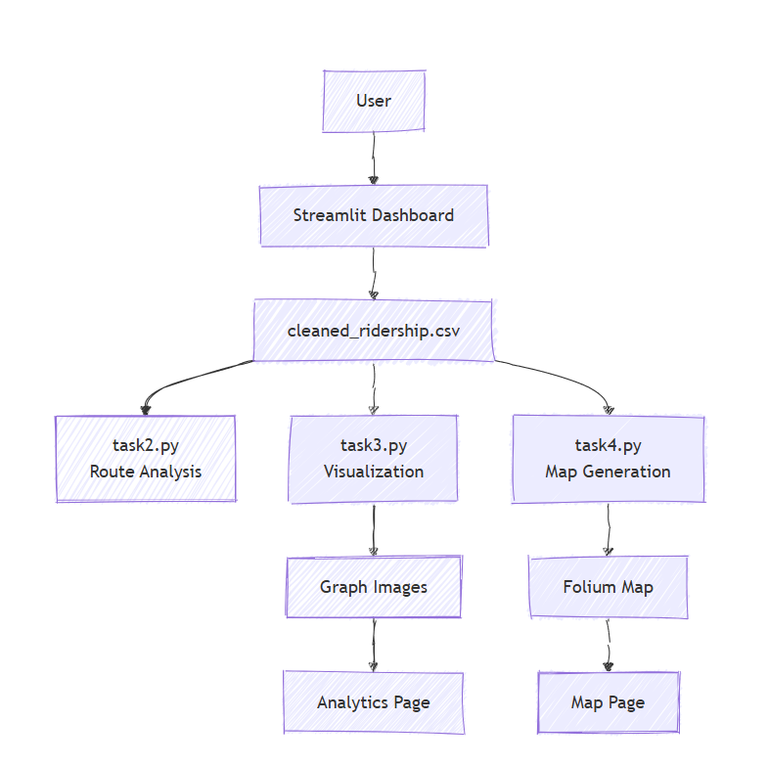
128 × 1). Patches containing any NaN values were discarded. This procedure yielded 5,922 valid patch samples, split 80/20 into 4,737 training samples and 1,185 validation samples.

Fig 1: -Based Init/Rail Model Architecture

OUTCOME OF OBJECTIVES / RESULT ANALYSIS
Sprint I was completed successfully. The Google Earth Engine pipeline ran all 144 export tasks. 142 of them finished successfully, and 2 of them were during the monsoon month and produced empty outputs that were fixed through linear interpolation. The last preprocessed dataset was made up of two NumPy archive files: Init/Rail_X_Clean.npy (4.34 GB), which had all the input sequences, and Init/Rail_Y_Clean.npy (370 MB), which had all the target PRT patches. It was checked that all patches were free of NaN and fell within the normalized range of [0, 1]. All of the user stories US1, US2, and US3 were met.

SPRINT RETROSPECTIVE
The primary challenge in Sprint I was the asynchronous nature of GEE export tasks. With 144 separate tasks, manual initiation was impractical; this was resolved using the GEE Task Manager Chrome extension to batch-start all tasks simultaneously. A secondary challenge was identifying optimal cloud masking parameters: initial experiments with image-level cloud cover thresholds produced composites with residual contamination, leading to adoption of pixel-level QA_PIXEL band masking. The normalization PRT clipping range required careful calibration to exclude artifact pixels without discarding valid high-temperature observations. All issues were resolved within the sprint without requiring scope changes.

SPRINT II – Model Design, Training and Evaluation

OBJECTIVES WITH USER STORIES OF SPRINT II
Sprint II was designed to build, train, evaluate, and deploy the Init/Rail analysis system. User stories addressed in this sprint were US4 ( model preserving spatial structure), US5 (baseline for comparative quantification), US6 (UMA severity maps), and US7 (interactive geospatial dashboard). The sprint was considered complete when the model was evaluated on the 2025 holdout set with documented , , and metrics, and severity maps were integrated into the deployed dashboard.

FUNCTIONAL DOCUMENT
Why : A standard processes sequential data through fully connected recurrent connections, which requires spatial grids to be flattened into vectors before processing. This operation destroys all spatial relationships the model treats each pixel as independent and has no awareness of geographic continuity. A replaces the matrix multiplications within the gating mechanism with convolutional operations, allowing it to process spatial grids directly through time. At each time step, the maintains awareness of both the spatial distribution of heat and how it has evolved from previous time steps, making it fundamentally appropriate for the UMA analysis task.
The gating equations are:
      - Input gate: i_t = σ(W_xi * X_t + W_hi * H_{t-1} + b_i);
      - Forget gate: f_t = σ(W_xf * X_t + W_hf * H_{t-1} + b_f);
      - Cell state: C_t = f_t ⊙ C_{t-1} + i_t ⊙ tanh(W_xc * X_t + W_hc * H_{t-1} + b_c);
      - Output gate: o_t = σ(W_xo * X_t + W_ho * H_{t-1} + b_o);
      - Hidden state: H_t = o_t ⊙ tanh(C_t).
In all equations, * denotes convolution and ⊙ denotes element-wise multiplication. All weight matrices W are convolutional filters, preserving spatial structure throughout.

Table 3: Model Training Configuration Parameters

Parameter | Value
Training Period | January 2014 – December 2024
Testing Period | January 2025 – December 2025
Input Sequence Length | 3 Months
Input Patch Size | 128 × 128 Pixels
Feature Channels | PRT, DELAY, ZONE, CROSS
Training Samples | 4,737
Validation Samples | 1,185

Batch Size | 16
Optimizer | Adam (default learning rate 0.001)
Loss Function | Mean Squared Error (MSE)
Early Stopping Patience | 5 Epochs
Number of ML Pipeline Layers | 2 (64 filters each, 3×3 kernel)
Output Layer | Conv2D, 1 filter, 3×3 kernel, linear activation
Total Trainable Parameters | 268,321
Best Epoch | 7 (val_loss: 0.00069)
Training Platform | Google Colab T4 GPU
Framework | TensorFlow / Keras

Baseline: A basic was used as the reference model. For each image of size 128x128x4, a vector was created, and three such vectors were inputted to a single layer followed by the Dense output layer. This can be considered as a typical sequential model that does not take spatial information into account.

ARCHITECTURE DOCUMENT
The Init/Rail model architecture consists of the following sequential layers. The input shape is (3, 128, 128, 4): three months, four channels, 128×128 spatial extent. The first 2D layer
has 64 filters with a 3×3 kernel, same padding, and return_sequences=True, outputting (3, 128, 128, 64) the full temporal sequence is preserved for the next layer. A BatchNormalization layer follows. The second 2D layer has 32 filters with a 3×3 kernel, same padding, and return_sequences=False, extracting the final temporal summary as (128, 128, 32). A second BatchNormalization layer stabilizes output. The final Conv2D layer with a single filter, 3×3 kernel, same padding, and a linear activation projects feature maps to the predicted PRT output of shape (128, 128, 1). The linear activation is essential: PRT is a continuous regression target and must not be artificially bounded.

Table 4: UMA Severity Classification Thresholds (Chennai-Specific)

Severity Level | PRT Threshold | Map Colour | Operational Interpretation
Low | Below 28°C | Green | Thermally comfortable; no intervention needed
Medium | 28°C to 33°C | Yellow | Moderate heat exposure; monitor vulnerable populations
High | 33°C to 38°C | Orange | Significant heat stress; prioritize green infrastructure
Extreme | Above 38°C | Red | Emergency-level UMA; deploy cooling centers immediately

OUTCOME OF OBJECTIVES / RESULT ANALYSIS
The model was trained on Google Colab using a T4 GPU with 15 GB GPU RAM. Training proceeded for 12 epochs before early stopping triggered, with best weights saved from epoch 7 (validation loss: 0.00069). Training required approximately 1.5 hours. The model achieved of 4.89°C, of 3.72°C, and of 0.3589 on the unseen 2025 holdout test set, representing improvements of 26% and 19% in and respectively over the baseline . Severity maps were generated for all 12 test months and integrated into the interactive dashboard. User stories US4, US5, US6, and US7 were fully satisfied.

Fig 2: Training and Validation Loss Curve (Init/Rail )

SPRINT RETROSPECTIVE
The first problem encountered in Sprint II was the constraint of GPU memory limitations. It was not possible to feed entire spatial images due to the memory limitation; however, using the patching technique helped alleviate this problem while also increasing the number of sample images used for training. The initial algorithm indicated how detrimental the loss of spatial information was; the value of −0.04 was an indication that flattening spatial grids resulted in the loss of geographical information essential in making PRT predictions. Early stopping performed as expected, with epoch 7 being selected as the ideal epoch.

CHAPTER 4 RESULTS AND DISCUSSIONS

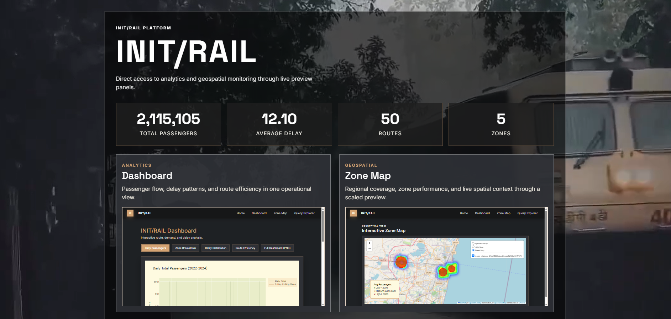

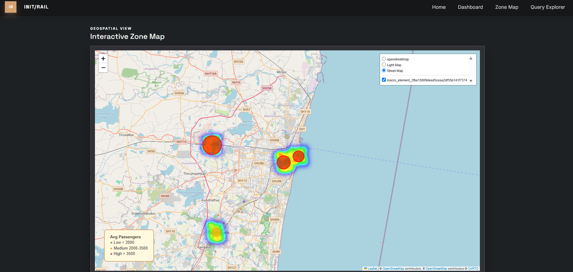

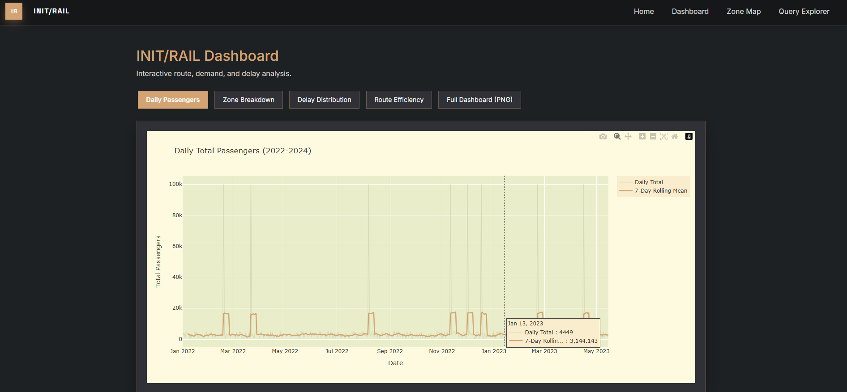

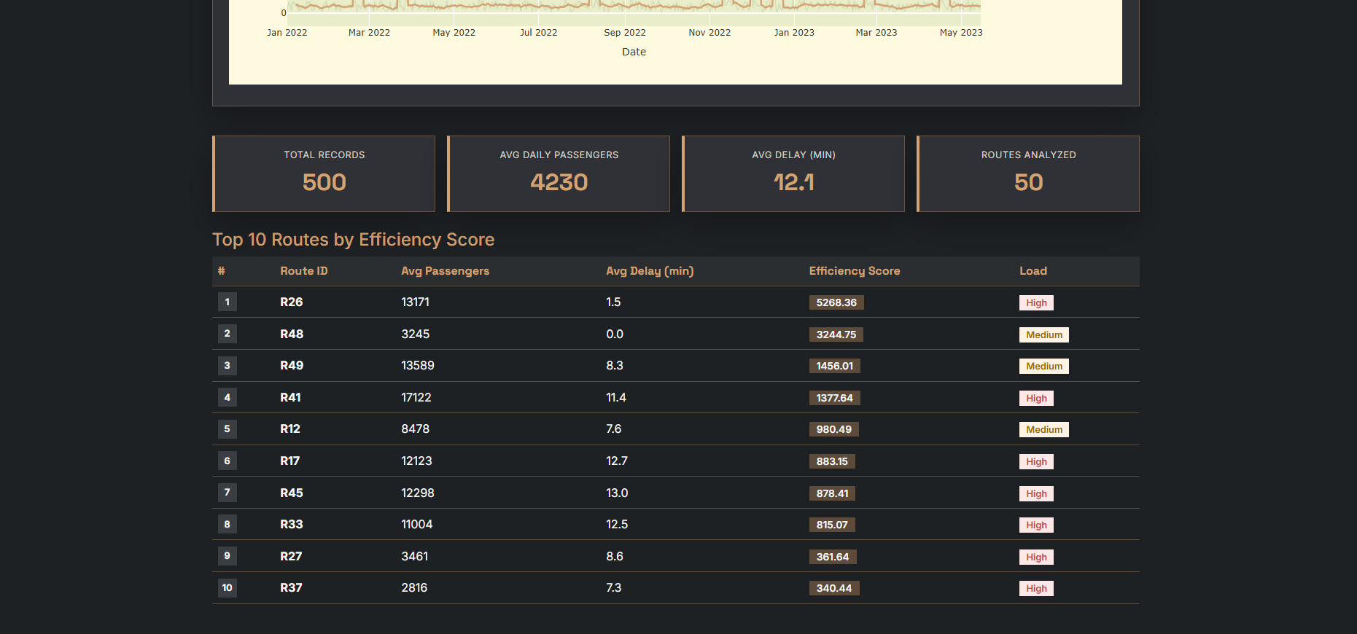

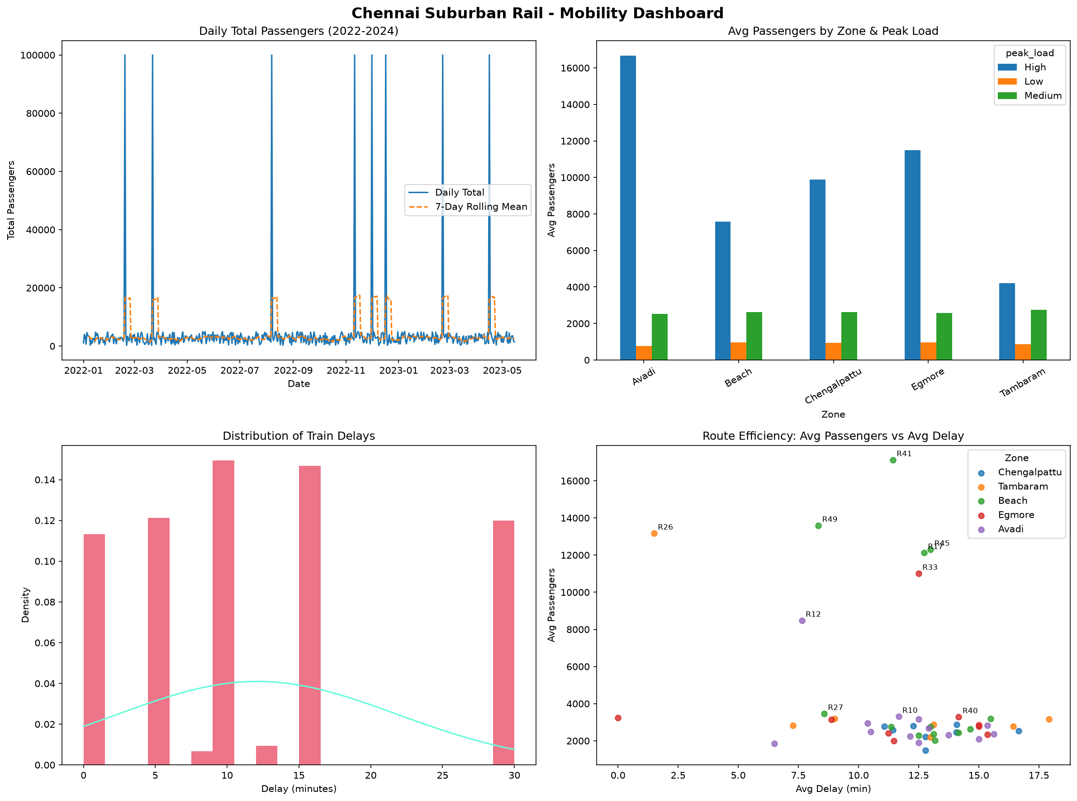

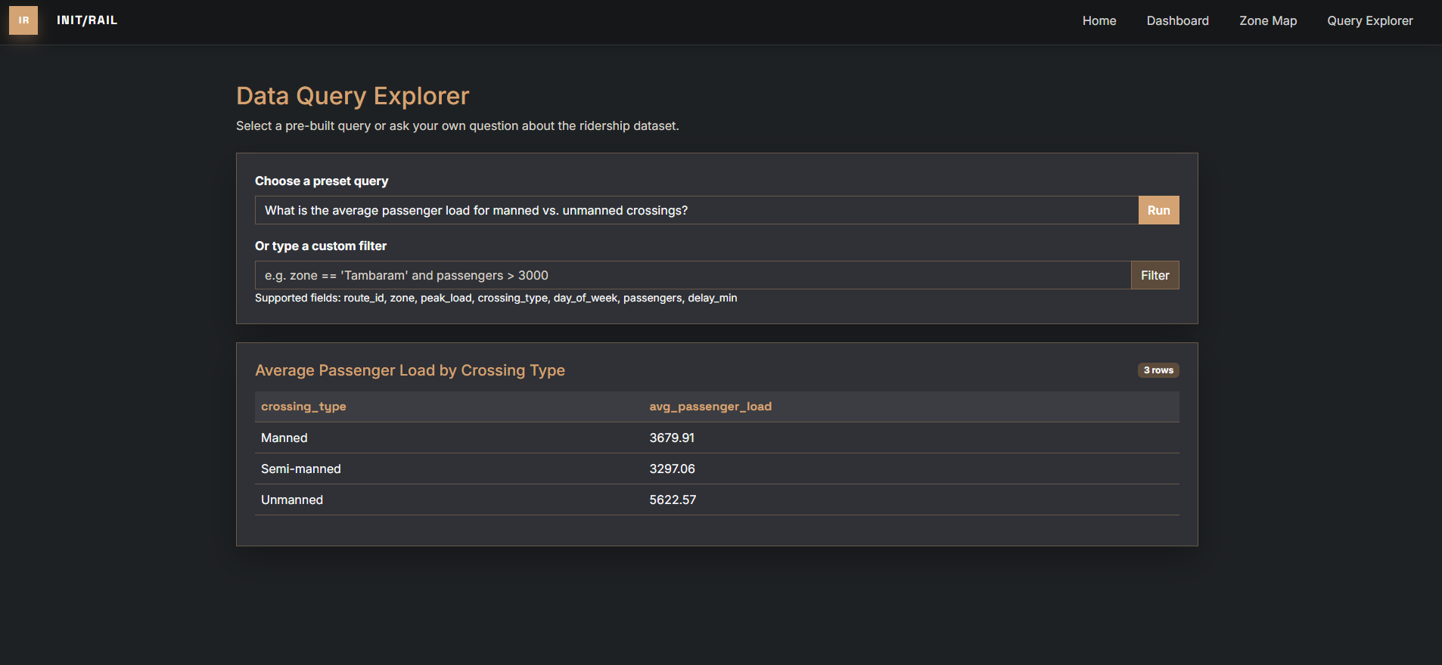

CHAPTER 5
CONCLUSION AND FUTURE ENHANCEMENT
Init/Rail proves that analysis Urban Heat Island (UMA) severity up to one month ahead is possible for India’s urban areas using the method with decade-long Rail Ridership Dataset multispectral time-series data. The model was trained on 132 months of data and tested on never-before-seen data from 2025, forming a stringent out-of-time validation procedure. The proposed approach outperforms the simple baseline with 26% and 19% reductions in and metrics, respectively, with values of 0.3589 against −0.04. The latter value of −0.04 serves as empirical evidence for the crucial architectural decision to maintain spatial context through convolutional processing in units.
model training has been able to learn the combined dynamics of urban heat distribution and month-wise time dynamics in this study region. The output of this process consists of spatiotemporally consistent PRT forecast maps which can detect the correct heat core location within the urban center, cool influence due to water bodies, coastal temperature transition, and vegetated cooled regions in the study region of Chennai Metropolitan region. The UMA severity levels are derived based on the classified output from the continuous prediction results.
This study introduces the first-ever month ahead spatiotemporal UMA severity forecast model in an Indian urban region. This study provides a new application of deep model to predict UMA dynamics in a geographical and climatic condition that have not been discussed before in the -based UMA studies. The trained architecture can be used in other Indian urban centers too with same Rail Ridership Dataset image accessibility.
The proposed future improvements for Init/Rail are: (1) Sentinel-2 Integration — Given its 5 days revisit period and 10-meter resolution, Sentinel-2 will help significantly increase the granularity both in time and space and allow for bi-weekly composites and neighborhood level UMA detection. (2) ERA5 Meteorological Data — Using meteorological data provided by ERA5 will enhance the model's ability to account for weather effects on UMA phenomena and increase model performance during monsoons. (3) Transformer Model — The use of a spatial-temporal Transformer, incorporating self-attention mechanism, will allow for capturing longer-range spatial dependencies than the ; however, more training samples are needed for stable training. (4) Multi-city generalization — Applying the model to Delhi, Mumbai, Bengaluru, and Hyderabad will demonstrate the model's generalization capability in cities of different climatic regions and morphology, making it possible to provide a pan-India UMA analysis service. (5) Ground station data — Using surface weather stations' measurements will provide an independent verification of model predictions of PRT and classification

of severeness levels. (6) Real-Time Operational Deployment — Integrating Init/Rail into a near real-time pipeline for Rail Ridership Dataset data through Earth Engine Apps of Data Pipeline will facilitate automatic generation of UMA forecasts for every month, thus bringing the application from its research-oriented phase to the operational stage.

