**NAVIGATION AND CONTROL OF AN AUTONOMOUS GROUND VEHICLE-INTEGRATED SMART GOLF TROLLEY**

**JEFF LEE JIE HUA**

**A project report submitted in partial fulfilment of the**

**requirements for the award of Bachelor of Mechatronics**

**Engineering with Honours**

**Lee Kong Chian Faculty of Engineering and Science**

**Universiti Tunku Abdul Rahman**

**September 2023**

**DECLARATION**

I hereby declare that this project report is based on my original work except for citations and quotations which have been duly acknowledged. I also declare that it has not been previously and concurrently submitted for any other degree or award at UTAR or other institutions.

|  |  |  |
| --- | --- | --- |
| Signature | : |  |
| Name | : | Jeff Lee Jie Hua |
| ID No. | : | 2002005 |
| Date | : | 18th September 2023 |

**APPROVAL FOR SUBMISSION**

I certify that this project report entitled **“NAVIGATION AND CONTROL OF AN AUTONOMOUS GROUND VEHICLE-INTEGRATED SMART GOLF TROLLEY”** was prepared by **JEFF LEE JIE HUA** has met the required standard for submission in partial fulfilment of the requirements for the award of Bachelor of Mechatronics Engineering with Honours at Universiti Tunku Abdul Rahman.

Approved by,

|  |  |  |
| --- | --- | --- |
| Signature | : |  |
| Supervisor | : | Ts. Dr. Loo Joo Ling |
| Date | : | 18th September 2023 |

|  |  |  |
| --- | --- | --- |
| Signature | : |  |
| Co-Supervisor | : | Ir. Dr. Danny Ng Wee Kiat |
| Date | : | 18th September 2023 |

The copyright of this report belongs to the author under the terms of the copyright Act 1987 as qualified by Intellectual Property Policy of Universiti Tunku Abdul Rahman. Due acknowledgement shall always be made of the use of any material contained in, or derived from, this report.

© 2023, Jeff Lee Jie Hua. All right reserved.

TABLE OF CONTENTS

TABLE OF CONTENTS i

LIST OF TABLES iii

LIST OF FIGURES iv

LIST OF SYMBOLS / ABBREVIATIONS v

LIST OF APPENDICES vi

**CHAPTER**

1 INTRODUCTION 1

1.1 General Introduction 1

1.2 Importance of the Study 3

1.3 Problem Statement 5

1.4 Aim and Objectives 7

1.5 Scope and Limitation of the Study 7

2 LITERATURE REVIEW 8

2.1 Introduction 8

2.2 Automated Guided Vehicle (AGV) 10

2.3 Benefits of Electric Golf Trolley 13

2.3.1 Smart Golf Trolley 16

2.3.2 Navigation Software 20

2.3.3 Recent Development of Sensors and Navigation 22

2.4 Summary 25

3 METHODOLOGY AND WORK PLAN 26

3.1 Introduction 26

3.1.1 Work Plan 27

3.2 Requirement/ Specification/ Standards (Optional) 29

3.2.1 Mechanical Components in Smart Golf Trolley 29

3.2.2 Electronic and Electrical Components in Smart Golf Trolley 30

3.2.3 Programming in Smart Golf Trolley 33

3.2.4 Following Mode 34

3.2.5 Testing and Analysis 35

3.3 Summary 35

4 PREMINARY RESULTS 37

4.1 Introduction 37

4.2 Blynk Connection 37

4.3 ROS Algorithm 39

4.4 Summary 40

5 PROBLEMS AND RECOMMENDED SOLUTIONS (OPTIONAL) 41

5.1 Problems encountered. 41

5.2 Recommended Solutions 41

REFERENCES

APPENDICES 47

LIST OF TABLES

Table 2 The Health and Performance Benefits of Using an Electric Golf Trolley 13

Table 3 Gantt Chart 26

LIST OF FIGURES

Figure 1.1 The Guided-Vehicle System of a Distribution Centre. 1

Figure 1.2 AGV with Forks for Object Transportation. 2

Figure 1.3 2-Wheel Golf Trolley 4

Figure 1.4 3-Wheel Golf Trolley 4

Figure 2.1 Mini Outdoor Golf Course at Home 9

Figure 2.2 Lidar Mapping 17

Figure 2.3 Titan Series 18

Figure 2.4 Zalpha Series 18

Figure 2.5 Zetha Series 18

Figure 2.6 Smart White Cane System Architecture 23

Figure 2.7 Block Diagram of Luggage Tracking System 24

Figure 2.8 Smart Luggage Proteus Simulation Circuit 24

Figure 3.1 Smart Golf Trolley Development Flow Chart 27

[Figure 3.2 Limit Switch Bumper Installation 30](https://utarict-my.sharepoint.com/personal/jefflee0530_1utar_my/Documents/Desktop/FYP1/LKCFES-FYP-Progress-Report-Template-R8-6%20(1).docx#_Toc145936851)

[Figure 3.3 2 Channels 10Amp 5V-30V DC Motor Driver 31](https://utarict-my.sharepoint.com/personal/jefflee0530_1utar_my/Documents/Desktop/FYP1/LKCFES-FYP-Progress-Report-Template-R8-6%20(1).docx#_Toc145936852)

[Figure 3.4 Motor Rotary Encoder E38S6G5-400B-G24N 31](https://utarict-my.sharepoint.com/personal/jefflee0530_1utar_my/Documents/Desktop/FYP1/LKCFES-FYP-Progress-Report-Template-R8-6%20(1).docx#_Toc145936853)

[Figure 3.5 Ultrasonic Sensor HC-SR04 31](https://utarict-my.sharepoint.com/personal/jefflee0530_1utar_my/Documents/Desktop/FYP1/LKCFES-FYP-Progress-Report-Template-R8-6%20(1).docx#_Toc145936854)

[Figure 3.6 Installation of Ultrasonic Sensor 32](https://utarict-my.sharepoint.com/personal/jefflee0530_1utar_my/Documents/Desktop/FYP1/LKCFES-FYP-Progress-Report-Template-R8-6%20(1).docx#_Toc145936855)

[Figure 3.7 Accelerometer and Gyroscope Sensor 32](https://utarict-my.sharepoint.com/personal/jefflee0530_1utar_my/Documents/Desktop/FYP1/LKCFES-FYP-Progress-Report-Template-R8-6%20(1).docx#_Toc145936856)

[Figure 3.8 Cytron GY-NEO6MV2 Flight Control GPS Module 33](https://utarict-my.sharepoint.com/personal/jefflee0530_1utar_my/Documents/Desktop/FYP1/LKCFES-FYP-Progress-Report-Template-R8-6%20(1).docx#_Toc145936857)

Figure 4.1 Blynk Webpage Dashboard 38

Figure 4.2 Mobile Dashboard 38

Figure 4.3 ROS Virtual Machine 39

Figure 4.4 ROS TurtleSim 40

LIST OF SYMBOLS / ABBREVIATIONS

AGV Automated Guided Vehicles

AMR Autonomous Mobile Robot

F&B Food & Beverage

GPS Global Positioning System

GSM Global System for Mobile Communications

GUI Graphic User Interface

MRPT Mobile Robot Programming Toolkit

OROCOS Open-Real-time Control System

PID Proportional-Integral-Derivative

ROS Robot Operating System

SMS Sports Marketing Survey

YARP Yet Another Robot Platform

## INTRODUCTION

### General Introduction

Automated guided vehicles (AGV) are commonly used in Industrial 4.0 such as manufacturing plants, warehouses, distribution centres and transshipment terminals. Figure 1.1. below shows a mapping of multiple AGV operating in a distribution centre where guided vehicles move around the specific area to load and unload items. To implement AGVs in a distribution centre, multiple factors are taken into account to design and control processes of each of the AGV such as guide-path design, number of vehicles required estimation, vehicle scheduling, battery management, idle-vehicle positioning, vehicle routing and deadlock resolution. There are multiple levels of development of the AGV design and control. In the highest level of strategic level involved in guide-path design. This stage is crucial as it will affect decision on other levels of development such as tactical level which involves in estimating number of vehicles, scheduling vehicles, positioning idle vehicles and managing battery-charging scheme for each of the vehicles. Last but not least, at the final stage of development includes operational level such as the vehicle routing and deadlock resolution (Le-Anh & De Koster, 2006).

Figure 1.1 The Guided-Vehicle System of a Distribution Centre (Le-Anh & De Koster, 2006)

In order to consider a vehicle as automated guided vehicle, it has to satisfy certain requirements in terms of hardware and software. An AGV needs a vehicle casing to allow installation of motors, motor drivers, IPC, sensors, supporting profiles, loading platform to ensure carried loads will not fall off during the transportation, UI/UX screen to control the vehicle operation, control panels, motherboards, I/O ports, power supply system and safety features such as emergency button. On the other hand, AGV requires a navigation software to design the track or trackless guided path. Navigation software is also needed to connect all sensors and roving components on the AGV so that the vehicle can position itself accurately on the designed path in a physical environment, on addition, it is also used in obstacle avoidance. Figure 1.2 below shows an industrial AGV that is commonly used.

Figure 1.2 AGV with Forks for Object Transportation.

In this research project, we have incorporated the characteristics of Automated Guided Vehicles (AGVs) into a conventional golf trolley, resulting in the development of an innovative smart golf trolley. This advanced golf trolley possesses the capability to navigate autonomously via remote control or autonomously follow the golfer across diverse terrains. The primary aim of this research endeavour is to imbue the golf trolley with autonomy and intelligence through the integration of microcontrollers, motors, sensors, and programming.

The introduction of motors and sensors equips the smart golf trolley with the ability to modulate its movement based on data received from an array of sensors. Microcontrollers serve as the central nervous system of the smart golf trolley, facilitating the seamless coordination of all electrical components. They play a pivotal role in controlling and orchestrating the functions of the smart golf trolley.

To enable effective communication and responsive interaction among all electronic components, a specialized program has been devised. This program serves as the control hub, orchestrating the synchronized functioning of these components. Moreover, it incorporates algorithms designed to empower the microcontroller with the capability to independently manage the various components, ensuring that the smart golf trolley operates autonomously while responding to user instructions.

There are plenty of factors to be considered in this research as the golf terrain is under an unfavourable condition compared to warehouses or factory industries. The smart golf trolley is built to withstand unexpected weathers and ground conditions so that the smart golf trolley is able to operate normally without causing any harm or risks towards the health and safety of the golfers.

### Importance of the Study

The development of smart golf trolley prototype is considered pioneer to the Malaysia market. Most of the electric golf trolleys found in Malysia are shipped from overseas. Brands such as EzCaddy from United States of America and PowaKaddy from England. These are the popular brands of electric golf trolley currently available in Malaysia market.

Converting traditional golf trolleys into automated counterparts serves as a pivotal endeavour aimed at alleviating the physical strain placed on golfers who must otherwise carry heavy golf bags throughout their rounds. The utilization of automated golf trolleys has been shown to enhance golfer performance by allowing them to direct their focus more effectively toward their gameplay. The innovation of this intelligent golf trolley assumes a crucial role in enhancing the well-being and safety of golfers throughout their games.

While automated golf trolleys can be procured from abroad, the associated expenses, such as high delivery costs and importation fees, can present a substantial financial burden for prospective buyers in Malaysia. Consequently, this research holds paramount importance in establishing a localized supply of automated golf trolleys within Malaysia, offering a cost-effective alternative to golf enthusiasts. This initiative aligns seamlessly with the notable surge in the number of golfers in Malaysia, rendering it a highly appealing choice for this burgeoning demographic.

Given the evident disparity between the demand for automated golf trolleys in Malaysia and the limited supply, the relatively straightforward implementation of navigation software into manual golf trolleys stands poised to not only fulfil market needs but also yield increased profitability within the sports industry.

### Problem Statement

From the market research, there are currently no automated golf trolley available to be purchased in Malaysia market. Currently, there are not locally manufactured AGV golf trolley produced. As far as it can see that most of the golfers purchase their own automated golf trolleys from overseas with high delivery cost and the golf trolley itself is costly. If modifications can be made on the existing golf trolleys in the Malaysia market, it will be more affordable and easily accessible to those new golfers or existing golfers that wish to owe one. Owning an automated golf trolley gives significant benefits to the golfers as it can help golfers in carrying the heavy golf bag with just a push of a button on the designated remote control.

Few limited golf trolley with remote control exists on the market. In this new study, the automated golf trolley is able to operate without manual control, where the golf trolley is able to follow the golfers wherever they go in any directions. By using this technology, the golfers do no need to worry about guiding the golf trolley where golfers want them to be. In some cases, when golfers needed to grab items from the golf trolley, the automated golf trolley is able to stop when the golfer is within a safe zone. So that the golfers are allowed to grab water or personal items from the golf trolley without hitting the golfers. Golfers often find it difficult to push the golf trolley manually due to its weight, this can consume a lot of energy from the golfer for pushing the golf trolley around the golf course.

Most of the time, multiple players can enjoy the same golf game together, like friends and family. Talking with each other may cause distraction from controlling the smart golf trolley manually as the terrain conditions may differ from time to time, this may cause any risks or injuries to the ones that is pushing it. Even though the golf trolley can be controlled remotely for movement forward, backwards, left and right, but golfers often worried about the direction that they have to move the golf trolley to their desired destination during a conversation with their accompanies. Therefore, offering a ‘Following’ golf trolley is significant to allow golfers to have their conversation with their accompany during their games, meanwhile, putting less concern on controlling the golf trolley manually.

By using the traditional golf trolley, the person who are moving it may not be able to control the velocity of the golf trolley when it comes to an inclining or declining golf terrain due to its heaviness. The automated golf trolley has the ability to control the speed of the motor in any condition, so that the golf trolley will no accelerate or decelerate at unfavourable terrains. Most importantly, the motor driver will control the speed of the motor every moment. This function is planned to consider the safety of the golfers. For instance, the heavy golf trolley will accelerate down the hill, this increases the possibility of the golf trolley hitting the golfers that is positioned in front of the golf trolley. In this scenario, injuries may cause on the golfers, then, affects the performance of the golfers during the game. Taking into consideration of the safety of the users, the design includes some of the crucial safety standards, which includes obstacle avoidance and emergency button that can be triggered by the users to stop the automated golf trolley instantly.

### Aim and Objectives

The objective of this project is to develop and incorporate navigation software into an existing golf trolley prototype. This transformation would convert the trolley into an automated golf companion that can be manually controlled by golfers using a remote control. Additionally, the autonomous golf trolley would have a ‘Following Mode’ in which it autonomously tracks and follows golfers throughout the golf course. The implementation of a navigation algorithm is integral to enabling automated motion for the golf trolley.

1. To develop a navigation algorithm with sensors and drivers for golf trolley.
2. To explore AGV navigation through wireless remote control and Internet-of-Tings (IoT).
3. To assess the operational control and performance of the AGV-integrated golf trolley.

### Scope and Limitation of the Study

One of the scopes of the project is to develop a navigation system on the existing golf trolley prototype built by FYP senior student. As the existing golf trolley only consists of the overall structure, IMU, Ultrasonic sensor, camera, battery, Raspberry Pi, and Arduino. Hence, a navigation system is required to make the golf trolley function autonomously by linking all the components via robot programming. The navigation system enables the smart golf trolley to function as ‘Following Mode’ where it follows the golfers without controlling it or pressing any command button on the remote controller.

Some safety features are crucial to be included under the operational control of the navigation system. These features are significant to reduce the risk of causing injuries to the users during the operation and avoid damaging the robot itself while moving around the golf course.

As Lidar sensors are costly, therefore, it will not be explored nor implementing onto the golf trolley. Nevertheless, ultrasonic sensor and camera will be used to replace the functionality of Lidar sensor.

## LITERATURE REVIEW

### Introduction

There is significant increase of golfers in Malaysia ever since COVID-19 hits the globe. There are many existing golfers showed strong interest to start playing again after being unable to golf during the pandemic. Golf is a family sports, most of the existing golfers that played back after the lockdown tends to bring their family and children to play golf, because golf does not require any physical contact which protects them, from catching a COVID-19 virus. Based on the 2021 survey conducted by the global research company Sports Marketing Surveys (SMS) titled "How Covid-19 is Impacting Golfing Habits in Asia," it was found that 63% of surveyed golfers in Malaysia experienced significant frustration while golf courses were temporarily closed, eagerly anticipating their reopening (The Sun Daily).

15% of the individuals included in the survey from Malaysia have embraced golf as a new pastime in the past three years, aligning with the global trend of golf's expansion during the Covid-19 era (The Sun Daily).

A majority of the surveyed Malaysian golf enthusiasts expressed their intention to actively promote golf to someone they are acquainted with in the upcoming year. This prospective recruit is most likely to be a golfer's child, offspring, significant other, or life partner (The Sun Daily).

The ease of playing golf and the ready availability of golf courses have been significant factors driving Malaysians to take up the sport. The growing demand for golf has led to the development of numerous new golf courses across Malaysia. Golf's appeal lies in its suitability for individuals of all ages, as it does not rely on teamwork and avoids physical contact (The Sun Daily).

Golf can be enjoyed both as a solitary activity or in the company of others. Furthermore, it is a sport that doesn't require an extensive array of equipment; typically, all you need is a golf bag to carry your golf clubs, tees, golf balls, and appropriate golf shoes. Golf can be played on a dedicated golf course or a practice range. Some enthusiasts even opt to create a mini golf course in their own homes, as depicted in Figure 2.1 below, illustrating the accessibility and versatility of golf as a sport (The Sun Daily).

Figure 2.1 Mini Outdoor Golf Course at Home (citation of the pic)

According to research conducted by the Faculty of Health Science at UiTM, 183 out of 327 sampled golfers participated in a study to assess the incidence of injuries associated with golf. Among the respondents, 102 individuals (33.7%) reported not experiencing any golf-related injuries. In contrast, the remaining 81 individuals (44.3%) indicated that they had suffered golf-related injuries. The study further reveals that approximately 71 respondents (38.8%) sustained injuries while playing on the golf course, while 9 individuals (4.9%) reported injuries occurring during practice sessions at the range (Azielah). With the assist of smart golf trolley invention, the number of golfers who suffer from golf-related injuries can be reduced. Smart golf trolley plays an important role in reducing risk of golf-related injuries. Golfers’ health can be improved with smart golf trolly. Golfers that use smart golf trolley can focus more on their game, maximizes golfers’ performance.

There are various types of golf trolley in the market, 2 wheels and 3 wheels, as shown in the Figure 2.2 and Figure 2.3 below. Modifications are to be made using the existing types of golf trolleys. In this case, 3 wheels traditional golf trolley is being used in this project for the automation modification. 3 wheels golf trolley are more stable, and it has a physical characteristic closest to an AGV structure. First of all, in order to convert a traditional golf trolley into an AGV golf trolley, it is significant to motorize the golf trolley so that the golf trolley can move itself into desired direction using the motors that help to control the wheels. Motors are commonly used in the industrial to automate processes or to move an object without human work.

Figure 2.2 2-Wheel Golf Trolley

Figure 2.3 3-Wheel Golf Trolley

### Automated Guided Vehicle (AGV)

The utilization of Automated Guided Vehicles (AGV) spans a wide array of sectors, including manufacturing, food and beverage (F&B), inventory management, automobiles, and various others. AGVs contribute significantly to enhancing safety measures, optimizing inventory management, facilitating item transfers, streamlining manufacturing processes, and boosting overall operational efficiency. Within supply chains, AGVs are frequently employed for inventory transportation between different stations, obviating the need for forklifts and reducing associated safety risks. The implementation of multiple AGVs within a supply chain substantially enhances the efficiency of goods transportation.

AGVs comprise both mechanical and electrical components, with the AGV controller serving as the central command unit responsible for regulating AGV movements. These AGVs are powered by batteries, ensuring continuous operation and quick recharging. AGVs operate in two modes: line following, which employs magnetic sensors and strips for guidance, and trackless mode, where LIDAR sensors are used to navigate their surroundings. Importantly, neither of these navigation technologies necessitates layout modifications within plant facilities.

To function effectively, AGVs require specialized software for user instruction. A user-friendly graphical user interface (GUI) enables users to configure AGV settings according to specific requirements. Multiple AGVs can seamlessly collaborate and communicate with each other through a fleet management system.

One of the primary advantages of incorporating AGVs into production lines is their flexibility. AGVs can navigate without human intervention, offering greater flexibility compared to traditional production lines that heavily rely on fixed conveyor belts, which occupy significant floor space. The core components of an AGV include motors, motor drivers, and encoders that facilitate precise movement control. Motor drivers govern the motor shaft, providing directional information for forward and reverse motion, while motor encoders allow software to adjust power supply to maintain consistent motor speed, ensuring smooth operation.

AGVs are equipped with sensors such as top and bottom LIDAR sensors, limit switch bumpers, and magnetic strip sensors. Top LIDAR sensors map the room space, identifying walls and surrounding objects, which users can then utilize to define guided lanes for trackless AGV motion. Bottom LIDAR sensors, consisting of front and rear sensors, aid in avoiding low-height obstacles, measuring distance for object avoidance. Physical limit switch bumpers act as collision safeguards, instantly cutting off power to the motor upon contact with an object.

To coordinate all electrical components and facilitate communication between them, navigation software is employed to gather and transmit information, controlling AGV movements. Notably, Robot Operating System (ROS) is a widely utilized navigation software systems that support communication and information exchange among electrical components, enhancing AGV precision and accuracy.

The navigation software represents the most complex aspect of AGVs, incorporating a user-friendly interface for input and output of information. Through optimization of settings such as motor sensitivity and the Proportional-Integral-Derivative (PID) system for trackless motion, users can enhance AGV performance, achieving precise stopping within millimetres of the designated station. This reduces overshooting and undershooting issues during AGV operation on actual production lines. For instance, an AGV is able to stop within 20mm from the stopping station. By changing PID settings of the motor to the most optimized setting by numerous test and research, AGV is able to stop within 10mm from the actual stopping position, overshooting and undershooting issue of the AGV in the actual production line can be reduced significantly.

Below are some examples of AGVs that is available in the Malaysia market. Three DF Automation and Robotics AGV Series are shown as below Figure 2.3, Figure 2.4, and Figure 2.5 (DF Automation, 2023)

Figure 2.3 Titan Series

Figure 2.4 Zalpha Series

Figure 2.5 Zetha Series

A variety of AGV options are available on the market, with selection dependent on specific field requirements and usage. Remarkably, the sports industry has yet to widely adopt AGV technology. In sports like golf, volleyball, badminton, and basketball, players often require trolleys to manage equipment and balls. Implementing AGVs in the sports industry can enhance player experiences and performance, reducing player fatigue associated with carrying heavy items.

For instance, in the context of golf, AGVs can significantly improve the experience of golfers who grapple with the weight and bulk of golf equipment, including golf balls, clubs, tees, bags, towels, clubhead covers, shoes, and gloves. These heavy golf bags contribute to golfer fatigue during rounds, especially when navigating uneven terrain. While electric golf trolleys are available in the market, most operate in a single direction via wireless remote control. These trolleys offer suspension for stability on uneven surfaces, making them comparable to traditional manual trolleys. However, AGVs can be a game-changer by providing remote control options for easy manoeuvring. This technology caters to older golfers who wish to continue enjoying the sport without the physical strain associated with carrying golf bags. A simple click of a button on the remote control enhances their game experience while addressing long-term health concerns such as muscle and back pain.

### Development of Golf Trolley

Utilizing an electric golf trolley greatly simplifies navigation on the golf course, particularly during adverse weather conditions. Pushing a manual trolley can pose challenges when determining the optimal route between holes. However, the incorporation of suspension systems and motorized wheels in electric trolleys facilitates smooth movement even on uneven terrain. This enhancement not only improves a golfer's performance but also minimizes disruptions to their game.

The introduction of remote control and automated functionalities in electric golf trolleys empowers golfers to control their trolley's movements from a distance. This feature liberates golfers to concentrate more on their game, alleviating concerns about manoeuvring their equipment. Furthermore, electric golf trolleys offer preset speed settings, ensuring a seamless and personalized experience on the course.

Electric golf trolleys are indispensable for redirecting golfers' focus away from the physical exertion of transporting their equipment towards the game itself, elevating the overall golfing experience. Research reveals that many older golfers suffer from health issues stemming from lugging heavy golf bags during their rounds, leading to diminished concentration and increased fatigue. AGV golf trolleys play a crucial role in reducing the physical strain associated with transporting golf clubs and equipment, ultimately enhancing golfer concentration and overall performance. A study conducted by the Colorado Centre for Health and Sports Science, in collaboration with a trolley manufacturer, yielded a mental focus test score of 6.63 out of 10 for electric golf trolleys, underscoring the benefits of using such trolleys during rounds (Electric Golf).

By conserving energy through the avoidance of manual trolley pushing, the use of electric golf trolleys significantly elevates overall performance on the golf course. The evidence of improved shot accuracy, enhanced course management, and lower scores is substantiated by a study conducted by CCHSS. This study involved the same golfer playing nine holes, with the lowest average score of 10.2 over par recorded when using an electric golf trolley, in contrast to a push trolley or a golf buggy. The table below presents the study's results (Electric Golf).

Table 2.2: The Health and Performance Benefits of Using an Electric Golf Trolley

|  |  |  |  |
| --- | --- | --- | --- |
|  | Electric Trolley | Push Trolley | Golf Buggy |
| Health (calories burnt over 9 holes in Kcal per hour) | 236 | 288 | 211 |
| Mental Focus (average self-reported mental focus over 9 holes out of 10) | 6.63 | 5.67 | 5.01 |
| Performance (average score to par over 9 holes) | 10.2 | 10.4 | 11.5 |

From the result above, it is clearly showed that when the golfer uses electric golf trolley tends to have higher performance score of 10.2 compared to push trolley and golf buggy. The performance value was calculated using the average health of calories burnt over 9 holes in Kcal per hour and mental focus where average self-reported mental focus over 9 holes out of 10 (Electric Golf).

Movement between holes can be quicker with automated golf trolley as the combination of motorized propulsion and smooth manoeuvrability allows golfer to walk on the course without any hustle at a constant pace. The benefits of higher movement efficiency promote a faster pace of play, which improves the overall flow of traffic on the course. Lesser time spent waiting for the turn to play in between shots. Leading to a less frustrated experience for the golfers on the course. This benefit magnifies when significant number are using an electric golf trolley. Picking up and putting down the golf bag requires time. Continuously doing so can waste plenty of time on the golf course instead of spending it on the game. AGV golf trolley is able to save time for loading and unloading stuff from the golf trolley and manual tasks like pushing and pulling a manual trolley. Shifting the time to focusing on the game can further enhance golfing experience (Electric Golf).

Protecting the environment is an important engineering ethics consideration in the invention. Products are to be environmentally friendly. Electric golf trolleys are environmentally friendly and cost-effective. Electric golf trolleys will not release any carbon footprint compared to petrol-powered golf buggies. Usage of rechargeable batteries and produce zero emissions is important to reduce the release of carbon dioxide into the atmosphere. Leads to reduction of global warming and melting of iceberg as the rise of Earth temperature can be reduced. On addition, rechargeable batteries are able to reduce waste. Electric golf trolleys also reduce noise pollution as it produces lesser noise compared to petrol-powered golf buggies. This can help golfers on the course to focus more on their games without noise distractions. Usage of rechargeable batteries on electric golf trolleys are cost-effective. With the advanced energy-efficient technology, it consumes less power to operate, which further reducing any negative environmental impact. Moreover, electric golf trolleys require minimal maintenance and running costs. Fewer parts of the golf trolley reduce maintenance costs. Simple parts can be also 3D-printed with lower costs (Electric Golf).

Below are some examples of electric golf trolley from EzCaddy from United States of America and PowaKaddy from England.

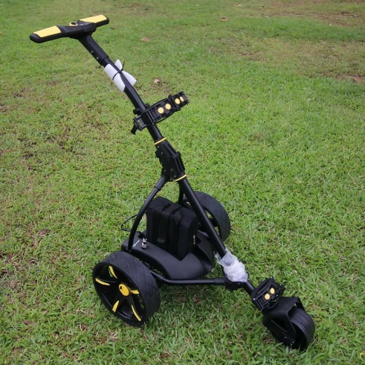

#### Smart Golf Trolley

To implement AGV characteristics into a golf trolley, certain requirements must be met. These include the integration of sensors, such as cameras, motors, wheels, microcontrollers, safety features, emergency buttons, obstacle detection systems, batteries, navigation software. These components collectively constitute the essential elements necessary for transforming a conventional golf trolley into an AGV.

An AGV functions as a hardware robot with human-like intelligence, possessing visual perception, and motorized limbs for responsive actions. Sensors and cameras are vital for an AGV golf trolley to detect objects and be aware of its surroundings. The golf trolley responds to sensor feedback by adjusting its movements, avoiding obstacles in its path, or following a pre-mapped course on the golf course.

Obstacle avoidance is one of the crucial safety features of an AGV-like robots. There are two types of obstacle avoidance technology. Most commonly, physical limit switches are used detect collision of the robot. When the robot hits onto an object on the front bumper and the back bumper, limit switches bumpers will be trigger and send a signal to microcontrollers to notify there is an object collision. Microcontrollers will then cut off the power of the motor to avoid any further movement until a user acknowledges the warning prompt message. Second type of obstacle avoidance is by using Lidar sensors to detect objects in a certain range. When an object is closed to the robot, Lidar sensor can detect it and send a signal to microcontrollers to do the same safety procedure as abovementioned in using limit switches bumpers.

To enable robot to see things like human do, vision devices such as camera or Lidar sensor is used to give sight to the robots. Lidar sensors on the AGV are not limited to obstacle avoidance. It is also used to scan the mapping of the surroundings layout. Auto-constructed map is produced on the software and shown on the GUI interface for users to acknowledge. The Lidar mapping shows all of the physical objects such as walls, containers, boxes and miscellaneous objects surrounding the Lidar, Figure 2.2 below shows an example of Lidar mapping. The lines illustrated on the map represents objects and walls surroundings with local cartesian coordinates of the AGV. The distance between each point on the map represents 1m distance on the real-world map layout. By applying the cartesian coordinates on the map, AGV is able to record its own position in the space and how much distance it should move according to the instruction given by the users. Lidars are usually placed on top and bottom of the AGV. Bottom Lidar consist of front bottom and back bottom Lidar. Top Lidar assist in mapping the layout of the room space. Bottom Lidars are usually used for obstacle detections.

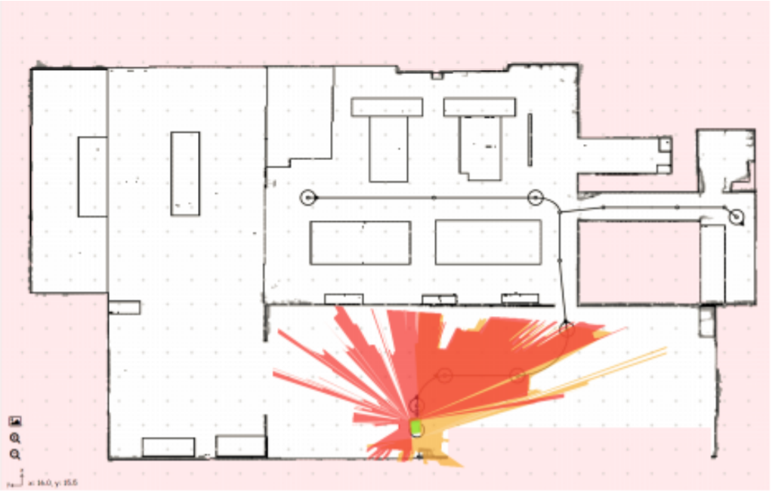

Figure 2.2 Lidar Mapping

On the other hand, digital cameras provide a clearer image of the real-life vision to the robot compared to Lidar sensor. Typically, Lidar sensors emits constant light waves into robot’s surrounding environment, then bounces off surrounding objects and return to the sensor. The time taken for the light wave to hit and bounce back to the sensor is used to calculate the distance of the objects from the robot. A single digital camera is not able to determine the distance of the object. 2D image can be visualized by using one single camera, it is mainly used in locating position of objects on a flat surface. If third axis, z-axis is involved in the engineering solution, 2 cameras are used at the same time to compute the distance of the object.

There are wide range of Lidar sensors option to choose from the market. From low-end to high-end, from low price to high price. Most common brands of Lidar sensors that can be found on the market are SICK, OMRON, RPLIDAR and etc. The lower end Lidar sensors such as RPLIDAR tends to have smaller detection range on white objects of 40 m, while 10 m on black objects. The angular resolution and detection angle of RPLIDAR has a typical value of 0.391° and 360° respectively. On the other hand, the higher end of the SICK Lidar sensor tends to have its aperture angle of 270° with 0.33° angular resolution. Comparing both most common used Lidar sensor, SICK tends to have higher sensitivity in angular resolution. Which provides more accurate result of the position of the objects in the scanned room.

Lidar sensors are costly and fragile. It can be easily defect by dropping it on the floor or scratches on the screen of the Lidar. Hence, due to budget restrictions, Lidar sensors are replaced with ultrasonic sensors and camera in this research, this saves the costs of this project and makes the automated golf trolley to be more cost-effective which serves the same purpose as Lidar sensor.

Limit switch bumpers are not sufficient to carry out a complete safe obstacle avoidance operation, hence the smart golf trolley is also equipped with an ultrasonic sensor to detect objects in front before collisions.

Most of the AGV-like products, such as smart baby stroller, white cane, and smart luggage often uses strong sensor technology and complex software with GUI interface to allow users to input their instructions, due to budget limitations, at the same time, to make this research to be cost-effective, to reduce the cost of one unit of smart golf trolley compared to the ones imported from overseas which is costly, simple sensors and software are being integrated in this research not to just reduce the cost but to opt for alternative method which serves the same purpose as compared to those commercial ones.

#### Navigation Software

Robot Operating System (ROS) is a very powerful operating system for robotic applications in the industrial. ROS is an open-source software development kit for robotics applications. ROS promotes research and prototyping by providing standard software platform to developers across industries. ROS is commonly being used to teach robotics from single-student projects to multi-institution collaborations and large-scale competition. Automobile Mobile Robot (AMR) and AGV runs ROS inside to connect and communicate between electrical components at the same time.

There are various tools, libraries, and capabilities for developers and student to use in their robotic applications. More time can be conserved to focus on more effective task rather than reinventing the existing codes, drivers and encoders. With the advantage of open-source, ROS provides more cost-effective and promotes more invention without paying a single cent. Moreover, ROS users do not need to concern on copyrights issues when using ROS in their projects. This can bring much convenience to students as final year project students tends to use external source program or operating system for their projects with limited budgets. ROS can be used in multi environment, from indoor to outdoor, home to automotive, underwater to space, consumer to industrial. More flexibility of platform compatibility offered by ROS as it can support on Linux, Windows and macOS. (Open Robotics, 2021).

A ROS package is a directory or folder structure that contains all the necessary files and information related to a specific component or module of a robotic system. ROS Node is a process that performs computation in a ROS-based robotic system. ROS Node communicate with sensors and motors by publishing and subscribing to ROS Topic, using services or action. ROS Node is responsible for task such as data processing, motor control, decision making and many more. OS Publisher is a component within a ROS node that publishes data on a specific ROS topic. ROS Publisher maps information to any other ROS nodes that are subscribed to the same ROS Topic. ROS Subscriber is a component within a ROS Node that subscribes to a data on a specific ROS topic. ROS Subscriber receives and processes data published on that ROS Topic by one or more ROS Publishers. For instance, a mapping ROS Node may subscribe to the "scan" topic to create a map of the robot's surroundings. A ROS service is a synchronous request-response communication mechanism between ROS Nodes. It allows one node to request a specific task or data from another node, which provides a response when the task is completed. Services are defined by service messages, which specify the request and response data structures. A ROS Action Server is a more flexible and asynchronous communication mechanism compared to ROS Services. It allows a ROS Client to send a goal to a ROS Server, and the ROS Server can provide feedback and eventually a result. Actions are useful for tasks that can take a long time, like navigation or manipulation. ROS Active Client is a component within a ROS node that interfaces with a ROS Action Server. It can send goals to the ROS Server, monitor progress through feedback messages, and cancel goals if necessary. ROS Active Clients are commonly used when interacting with ROS Action Servers. (docs.ros.org).

ROS will not be the only option for users to choose from for teaching a robot. PyRobot, Orca, Yet Another Robot Platform (YARP), Open-Real-time Control System (OROCOS), genom3, Mobile Robot Programming Toolkit (MRPT) are also available for users to consider building their robotic applications. Most of the abovementioned robot operating system uses C++ programming style to build their robotic applications. While ROS can be programmed using python, C++, C and many other programming languages. ROS is more flexible, more accessible, more user-friendly compared to abovementioned platforms. Hence, in this project, ROS is being used in the research of smart golf trolley application to allow communication between the sensors and motor being used in the smart golf trolley.

In 1987, AGV is programmed using a simulation tool via SIMTOOL. The SIMTOOL is able to line input drivers with default text capability, manual override and text editing of SIMTOOL generated data elements and code, and programming function keys. SIMTOOL is a layout assistant driven by graphics and rule based. The simulation tool will be mapped with the layout of the room space, to achieve AGV’s position in the layout and the operation that is needed to perform and position that the AGV is required to reach. (Mark K. Brazier, 1987).

As technology improves, more AGV uses μC/OS−II real-time operating system to control the AGV. μC/OS−II operating system consists of a task control block OS, a code of tasks and a stack of tasks. A stack pointer and points to the task that is required to execute with interrupts. μC/OS−II operating system uses Real-Time Operating System, also known as RTOS, which consists of executive, kernel and microkernel. Kernel is the heart of the OS. It is a collection of software subroutines that allow a single CPU, under the direction of a multitasking clock which is interrupt driven to execute a several process in pseudo parallel. Kernel contains Objects, Services and Scheduler. Objects in RTOS helps developers create applications for real time embedded systems. Kernal Objects commonly includes tasks, semaphores and message queues. Kernel Services is an operation of the Kernel that perform on an object such as timing, interrupt handling, and resource management. Kernel Scheduler helps RTOS to manage multitasks, it enables RTOS to execute a task at a specific timing or when an interrupt is triggered. Scheduler is able to handle multitasking. (Mark K. Brazier, 1987).

#### Recent Development of Sensors and Navigation

Smart baby stroller is a motorized version of the traditional ones. There are some other cool technologies offered by the company such as temperature monitoring, wheels safety lock, baby sound detections, humidity monitoring. These technologies promote high quality sleep of the baby, provide comfortable space, ensure cleanliness, reduce the cost of guardian’s energy, health of the baby and security. (Saisai Li, Bowen Sun, 2018).

The smart white cane uses Global Positioning System GPS technology to notify the blind’s guardian or parents the position of the blind. The smart white can is also able to detect objects in 1 m range to avoid collision on an obstacle. With these technologies on the smart white cane, it can help solve the problem faced by the blind by telling the distance of the obstacle from the blind man and also tell people where the blind man is via GPS. The smart white cane also uses Raspberry Pi as its microcontroller to inform the blind man about the obstacle in front, it gives the blind more knowledge about the environment and the blind’s surroundings which enables them to make decision much more quickly. A buzzer and a vibration motor are used to notify the blind about the obstacle in front, so that the blind man acknowledges the obstacle faster before the collision. The obstacle detection is aided with an ultrasonic sensor. It will tell the Raspberry Pi microcontroller about the obstacle information facing by the blind man. Moreover, the ultrasonic sensor is paired with a raspberry pi camera module and open cv for obstacle detection. When an object is detected, Raspberry Pi will identify and intimated to the user about what the object is via message through headset. The smart white cane implements IoT technology for guardian or parents to locate the blind man when they are at distant via GPS. The smart white cane can be paired with a Bluetooth headset to help blind man to find their way via voice commands. A Micro Electromechanical System (MEMS) based gyroscope is implemented as the smart white cane’s navigation system, so that it can fix the position of the sensor while detecting the objects which are placed down even when a person moves his/her hand while holding the cane. A piezoelectric beeper is being used to produce an alarm to notify the blind man when an object approaches, and the movement should be aware. The overall system architecture of the smart white cane is shown in Figure 2.6 below. (Subbiah, 2019).

Figure 2.6 Smart White Cane System Architecture

Another great example of autonomous IoT invention is the smart luggage. Which uses integrates microcontroller, GPS module, GSM module, and IoT platform, to perform an incredibly efficient and reliable system for the smart luggage. The microcontroller plays an important role in processing GPS data which is then sent to the IoT platform via Global System for Mobile Communication (GSM) module. The platform will receive and process the data to display a geographical depiction of the position of the luggage. The Arduino microcontroller is equipped with GPS NEO-6M GPS module and GSM module SIM900L module to obtain the position of the luggage accurately. Figure 2.7 shows a block diagram of luggage tracking system. Before executing the physical prototype, Proteus software is used to simulate the system design. The simulation of the circuit is shown as Figure 2.8 below. (Sakshi Jain, April 2023).

Figure 2.7 Block Diagram of Luggage Tracking System

Figure 2.8 Smart Luggage Proteus Simulation Circuit

### Summary

Considering the safety and health issue of golfers, simple navigation algorithms and safety features are implemented on the golf trolleys. By doing so, automated golf trolleys with such simple function can be a great option for golfers to purchase with its high affordability and cost-effectiveness. Automated golf trolley is also a great option for golfers that suffer from long-term health issue from carrying the golf bag, which decreases the performance of the golfers in their game. With the assistance of navigation algorithm implemented on automated golf trolley, it can satisfy and solve health issue of old golfer’s problems where most of their energy are consumed to bring the golf bag in the golf course. Localizing the automated golf trolley can reduce the cost of the automated golf trolley as it does not require to ship from overseas and spare parts used can be found and replaced easily on the Malaysia market.

## METHODOLOGY AND WORK PLAN

### Introduction

The smart golf trolley in this project is designed to be autonomous, which involves implementation of microcontrollers. sensors and various electrical circuits and mechanical components. In order to allow smart golf trolley featured with automatic adjustment of the motor speed and object avoidance, an autonomous methodology comes with the microcontroller, where programs are burned into the microcontroller to control the speed of the motor, meanwhile, receiving the actual speed of the motor at its current state, and regulate the motor when the speed is increased or decreased from the preset value. Combination of hardware and software leads to smart. In another words, smart is defined by the combination of electrical, mechanical, and programming. Electrical circuit of the power distribution to all electrical components and the wiring of the sensors and motor to the microcontroller is one of the crucial pillars of SMART. Sensors such as ultrasonic sensor, motor driver and encoder, limit switch, remote control contributes to the electrical part of the golf trolley. A basic golf trolley structure is already one of the mechanical mechanisms. Installing limit switch bumper is also one of the extra features of mechanical mechanisms. Furthermore, suspension, motor shaft, and golf trolley supporting structures plays an important role in mechanical side of the golf trolley. In order to allow both electrical and mechanical to communicate, receive and send signals between each other, it is necessary to have microcontrollers to link all of the components together with the assistance of a program. A program consists of a sequence of code of instructions which act as the brain of the golf trolley to control the smart golf trolley operations.

#### Work Plan

Table 3.1 Gantt Chart

|  |  |  |  |  |  |  |  |  |  |  |  |  |  |  |  |
| --- | --- | --- | --- | --- | --- | --- | --- | --- | --- | --- | --- | --- | --- | --- | --- |
| **Gantt Chart** | | | | | | | | | | | | | | | |
| **No.** | **Project Activities** | **W1** | **W2** | **W3** | **W4** | **W5** | **W6** | **W7** | **W8** | **W9** | **W10** | **W11** | **W12** | **W13** | **W14** |
| **M1** | Problem Formulation & Project Planning |  |  |  |  |  |  |  |  |  |  |  |  |  |  |
| **M2** | Literature Review |  |  |  |  |  |  |  |  |  |  |  |  |  |  |
| **M3** | Navigation Development & Preliminary Testing |  |  |  |  |  |  |  |  |  |  |  |  |  |  |
| **M4** | Report Writing |  |  |  |  |  |  |  |  |  |  |  |  |  |  |

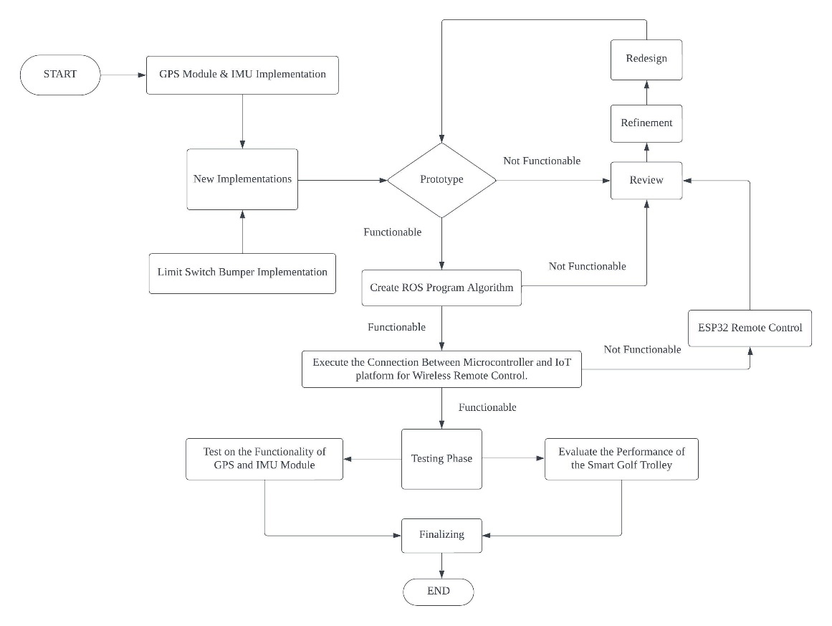Figure 3.1 Smart Golf Trolley Development Flow Chart

In the initial phase of development, data retrieval from the GPS and IMU modules is initiated through programming. This involves gathering coordinates from the GPS module and comparing them with the golfer's coordinates to determine the distance between the smart golf trolley and the golfer, thereby deciding the distance required to move by the smart golf trolley towards the golfer. Simultaneously, the IMU module is employed to acquire heading data, which is then compared with the golfer's heading to ascertain if the trolley requires rotation to align with the golfer's heading. Once these essential data points are successfully obtained from the GPS and IMU modules, relevant coding libraries of GPS and IMU modules will be integrated into the ROS (Robot Operating System) program algorithms. Subsequently, these stabilized modules will be installed on the existing prototype. Any functional issues encountered with these modules prompt a meticulous review of the methodology and, if necessary, a redesign of the approach.

As the project progresses, ROS algorithms are generated to establish seamless communication between sensors and motors. Failures in this communication demand a thorough review and potential revision of the methodology or exploration of alternative options for any unforeseen challenges or setbacks in the functionality of ROS algorithms.

Following the successful integration of a stabilized GPS, IMU modules, and ROS algorithms, connections between microcontrollers and an IoT platform will be established. This enables golfers to assume control of the smart golf trolley through smartphone IoT applications or a local area network server. In the event of a failure in establishing a connection with the IoT platform, a direct connection of an ESP32 device with the smart golf trolley will be considered, thereby enabling wireless control by golfers who use the ESP32 as a remote control. The ESP32 serves as a suitable alternative to a smartphone, offering equivalent functionality. Continuous refinement of the methodology and prototype ensure precise calibration of the smart golf trolley.

Before entering the testing phase, a comprehensive assessment of the stability of the module, ROS algorithms, and the connection with the remote-control platform will be conducted. The testing phase encompasses two key modules. Firstly, the GPS and IMU modules undergo calibration and testing to validate their accuracy in measuring distance and heading differences between the smart golf trolley and the golfer. Additionally, the smart golf trolley is subjected to real-world testing on golf terrain to evaluate its performance under unexpected conditions. Dummy weights are strategically placed on the trolley to assess its movement. The resulting performance data is methodically organized into a table for in-depth analysis and necessary adjustments.

Lastly, as the development of the smart golf trolley nears its conclusion, all documentations and wiring connections on the trolley are finalized and meticulously documented. This step is considered imperative for the successful completion of the project and its readiness for practical use.

### Requirement/ Specification/ Standards

* Able to move in all four directions using wireless remote controls, front, back, left, and right.
* Able to detect physical collisions and stop immediately using limit switch bumpers.
* Able to control the motor speed during inclination and declination.

#### Mechanical Components in Smart Golf Trolley

Object avoidance is one of the significant safety features in AGV. AGV should stop when a collision on an object occurs. This can be achieved by installing a physical limit switch bumper at front and back of the AGV. When the collision occurs, limit switch will be triggered and sends a signal to the microcontroller in electrical part of the smart golf trolley. The limit switch bumper will be installed at the front of the smart golf trolley as shown in Figure 3.2 below.

Figure 3.2 Limit Switch Bumper Installation

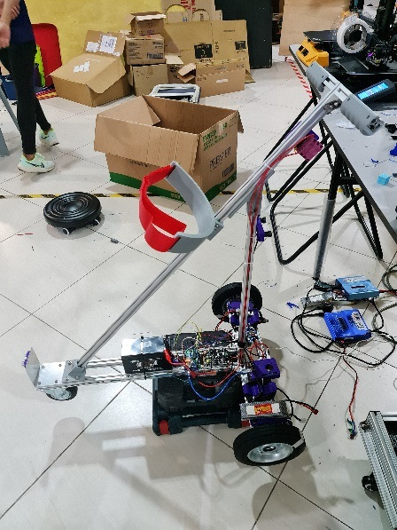

Last but not least, the smart golf trolley structure is constructed using aluminium profiles. Connected using L brackets and bolts. Although the structure is rigid, but there are some restrictions on the installing angles, due to the nature of the aluminium profile happens to be a rigid, linear structure, it is only able to install in certain angles at 90°, 180°, and 45°.

#### Electronic and Electrical Components in Smart Golf Trolley

All electrical components are well connected to the microcontroller. The power distribution to all electrical components is well distributed with terminals to and step-up and step-down converters. This is to ensure that all electrical components receive rated voltage and current to avoid damages to the components.

The motor is being controlled by a motor driver 2-channel Cytron Motor Driver as shown in Figure 3.3 below. Motor driver equipped with maximum current rating of 30 A and voltage ranged between 5-30V. Moreover, the motor rotary encoder used on smart golf trolley is E38S6G5-400B-G24N. With DC voltage rating of 5-24V as shown in Figure 3.4. Motor encoder is working aside with the driver to obtain current motor speed information and sends the signal to microcontroller. The motor speed will be regulated to ensure constant speed in microcontroller in the electrical part.

Figure 3.3 2 Channels 10Amp 5V-30V DC Motor Driver

Figure 3.4 Motor Rotary Encoder E38S6G5-400B-G24N

Ultrasonic sensor is essential to replace the pricy Lidar sensor. The model of ultrasonic sensor selected is HC-SR04 as shown in Figure 3.5 below. It can work at DC voltage of 5 V, and 15 mA current. The furthest detecting range is 4 m, and minimum distance of 2 cm. It is equipped with 15° degree measuring angle. The working frequency of the ultrasonic sensor is 40Hz. The ultrasonic sensor will be placed at the front of the prototype as shown in Figure 3.6 below.

Figure 3.5 Ultrasonic Sensor HC-SR04

Figure 3.6 Installation of Ultrasonic Sensor

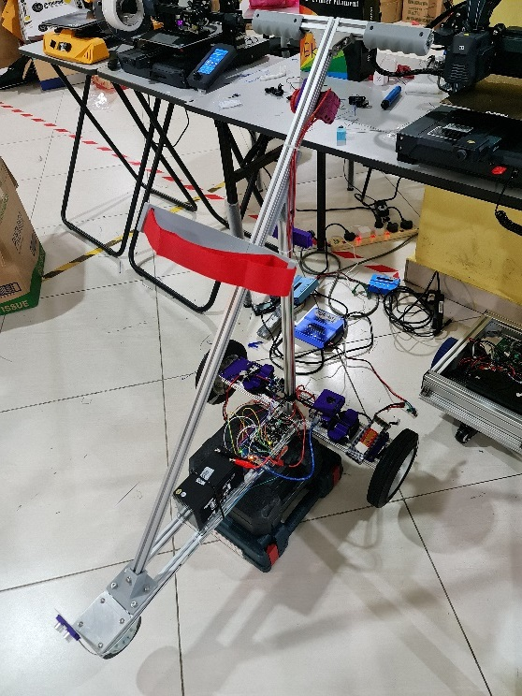

Smart golf trolley is equipped with IMU GY-521 MPU6050 6DOF accelerometer and gyroscope sensor as shown in Figure 3.7 below. A hybrid sensor with the combination of accelerometer and gyroscope which will be implemented on the smart golf trolley. With such sensor, it can obtain the linear acceleration and angular velocity of the smart golf trolley motion. This sensor is required to ensure the linear motion and curvature motion is moving according to the instruction input. The IMU is also able to retrieve smart golf trolley’s angular difference between smart golf trolley and the golfer. The angle heading difference can be achieved by subtracting the heading of the smart trolley relative to the origin and the angle heading of the golfer relative to the Earth origin.

Figure 3.7 Accelerometer and Gyroscope Sensor

The GPS sensor model is Cytron GY-NEO6MV2 Flight Control GPS Module as shown in Figure 3.8 below. It is best operated from 3.3 V to 5 V system, which is compatible with the Arduino board and Raspberry Pi. It is communicated using UART TTL, with 9600 bps baud rate. The GPS sensor enables the smart golf trolley to retrieve its coordinates, to compare with the position of the golfer. The distance between the smart golf trolley and the golfer can be determined by a simple distance formula (3.1) as shown below.

Figure 3.8 Cytron GY-NEO6MV2 Flight Control GPS Module

(3.1)

where

= *x* - coordinate of smart golf trolley

= *x* - coordinate of golfer

= *y* - coordinate of smart golf trolley

= *y* - coordinate of golfer

#### Programming in Smart Golf Trolley

Robot Operating System, ROS, is a very strong robot program that enables the AGV to run multiple tasks at the same time to control the smart golf trolley. At the beginning stage of the development of smart golf trolley, it is important to simulate the smart golf trolley in a golf terrain world with uneven surfaces and unexpected conditions. ROS offers Gazebo simulation tool for developers to simulate the smart golf trolley before it is tested on the real-life terrain. ROS is able to compile multiple python codes that send and receive information from all the sensors and instruments and communicate between each other to control the smart golf trolley. All necessary python codes can be run all at once using one single command. By doing so, smart golf trolley is able to react with the information retrieved from all the sensors installed. In this case, ROS2 with Ubuntu 23.04 is being used to program the smart golf trolley. All necessary python code programs are burned into the ROS, a launch file is created to launch all python codes all at once to control the smart golf trolley. Movement of the motors, information retrieved by sensors, are all monitored and controlled by the ROS by linking all python codes together to allow all electronic components communicate well together with each other.

#### Following Mode

Besides controlling the smart golf trolley manually with direction buttons, smart golf trolley can be controlled via ‘Following Mode’ as well. Microcontroller is equipped with GPS module, IMU module, Bluetooth module and WiFi module. Connection between the microcontroller and the mobile phone of the golfer can be achieved via Wifi or Bluetooth connection to retrieve the location and heading of the mobile phone which in turn represents the location and position of the golfer. GPS module installed on the microcontroller enable microcontroller to receive its location. The distance between the smart golf trolley and the golfer can be determined by computing the difference between both locations of the smart golf trolley and the mobile phone. IMU module is used to collect information regarding the heading of the smart golf trolley. The difference between both heading allow smart golf trolley to rotate its direction until the same heading in regard to the mobile phone can be achieved. With complete information of the distance and heading difference between the smart golf trolley and the golfer, smart golf trolley is able to determine the direction of movement to follow the golfer wherever he/she goes. Ultrasonic sensor is being used to keep a short distance between the smart golf trolley and the golfer. So that the smart golf trolley is able to stop when golfer is near smart golf trolley, this allows golfer to load and unload stuff from the smart golf trolley without collision with the smart golf trolley.  (Hackster.io)

#### Testing and Analysis

At the end of the development, it is crucial to test the prototype with the autonomous components installed. Testing phase is significant to ensure that all the data retrieved and sent by the sensors are accurate and trustable. Program burned into the microcontroller must be able to communicate with the sensors installed. Serial monitor is brought up to analyse on the output data of all the sensors. Operations of the smart golf trolley such as forward, backward, left, and right are tested using the remote controller on a golf terrain to ensure that the mechanical part of the smart golf trolley is able to operate normally without any issue under all unexpected condition on the golf terrain.

Dummy weights will be placed on the smart golf trolley with increasing weight gradually, the time taken for the smart golf trolley to reach maximum velocity is recorded. Stability of the samrt golf trolley is also observed throughout the test to explore the maximum weight the smart golf trolley can withstand before losing its stability. Maximum and minimum linear velocity of the smart golf trolley is essential to be tested with and without the dummy weights. At the same time, angular velocity will be tested with and without the dummy weights on the smart golf trolley to find out the optimum angular velocity when making a turn to avoid loads collapsing from the smart golf trolley to ensure the safety of the golfers. The velocity of the smart golf trolley is obtained from both IMU and motor encoder. Both data are compared and analyze for further calibration of sensor purpose. The results are then compared to the manual measuring of smart golf trolley’s velocity to check the sensor’s percentage error. The percentage error shall not exceed more than 20%.

An obstacle will be placed in front of the smart golf trolley to test the functionality of the limit switch bumpers. Limit switch will be triggered once the bumper hits on the obstacle, the safety algorithm should stop immediately to avoid any further potential incident. At the same time, the same obstacle can be used to test the functionality of the ultrasonic sensor. If an object is detected in a specific range, the smart golf trolley should stop immediately as well. Sound will be produced from the smart golf trolley to alert the users, users are required to ackowledge the warning by pressing the acknowledge button on the golf trolley in order for the golf trolley to continue manoeuvre.

### Summary

Exploration of GPS and IMU module is necessary to satisfy the abovementioned methodology to determine the distance and the heading difference between the smart golf trolley and the golfer. By using calculated data above, the smart golf trolley is able to estimate the direction and distance needed to move in order to approach the golfer. ROS algorithms are generated with the modules stated above to allow smooth communication between sensors and motors to operate and control the smart golf trolley movement either in manual directional controlled or following mode. Testing phase will be carried out after the integration of modules and ROS on the smart golf trolley. Final test report form will be generated to test the functionality of the modules and ROS algorithms. Furthermore, the result of smart golf trolley performance evaluation will be tabulated into the test report form for further calibration and documentations. Any non-functional operations will be brought to the stage of review and redesign of the methodology and prototype.

## PREMINARY RESULTS

### Introduction

Due to unstable existing prototype, the performance evaluation on the smart golf trolley could not carry out in this stage. Therefore, IoT platform connections and ROS algorithms are carried out. To satisfy the following mode requirement, connection between microcontroller and Blynk IoT platform is established before implementing any other algorithm. There are multiple IoT platforms on the market as an alternative option. In this project, Blynk provides smartphone apps services that enable users to control the smart golf trolley via mobile phone. By doing so, it provides great convenience as the golfer can control the smart golf trolley via mobile without carrying a bulky laptop or computer along on the golf course. Moreover, partial ROS algorithms have been generated throughout the learning process. Little modifications can be made on the existing ROS algorithms to satisfy this project requirements.

### Blynk Connection

Blynk is an IoT platform which allow users to control multiple devices via its own webpage or via smartphone Blynk apps. Blynk’s user interface is user-friendly, and it is easy to do modification according to the user’s preferences. Blynk user interface provides plenty of interesting widgets to control the operation of the smart golf trolley. For instance, Blynk allow users to control the direction of the smart golf trolley by using the Joystick widget that is similar to the functionality of PS4 or XBOX controller. Moreover, Blynk also allow users to locate the position of the smart golf trolley via map widget that is displayed on the user interface of the Blynk apps. This is useful when the smart golf trolley went missing on the golf course. Blynk is also able to trigger on and off the alarm sound from the smart golf trolley to ease the user in searching for the lost trolley on the golf course. Figure 4.1 and Figure 4.2 below shows Blynk webpage dashboard and mobile dashboard respectively.

Figure 4.1 Blynk Webpage Dashboard

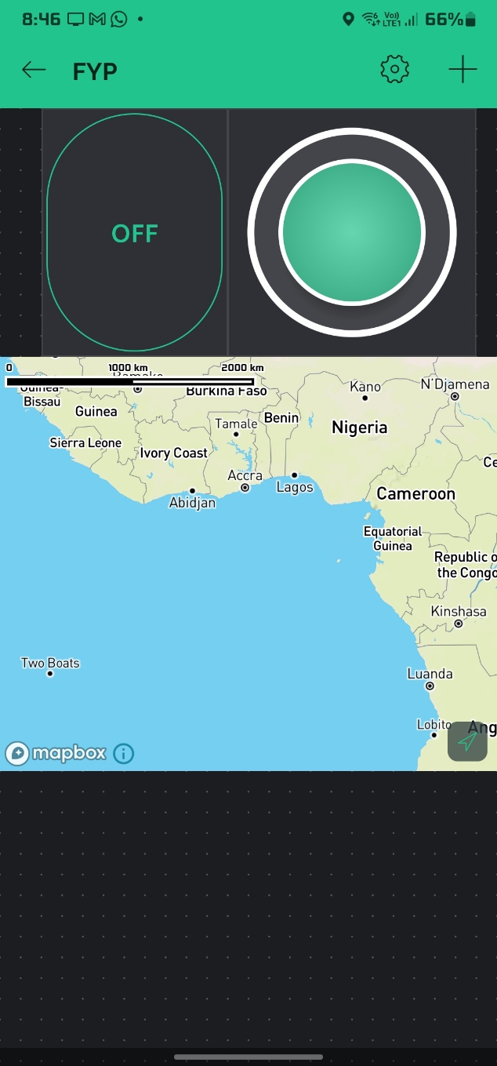

Figure 4.2 Mobile Dashboard

### ROS Algorithm

In the context of robotics and software development, ROS (Robot Operating System) package refers to a fundamental organizational unit within the ROS ecosystem. ROS is an open-source framework designed to facilitate the development of robotic software.

During the learning phase of ROS program, there are some ROS Packages, ROS Nodes, ROS Subscriber, ROS Publisher, ROS Service Client, ROS Service, ROS Active Client, and ROS Action Server have been created on the existing Ubuntu. With abovementioned ROS operations created previously, it is easier to carry out any future modification on the ROS algorithm during the development phase of the smart golf trolley. ROS is necessary for the smart golf trolley to link all electronic components such as sensors and motors, additionally allow communication between them to operate the smart golf trolley. All ROS functions has been established via Oracle Virtual Machine Virtualbox that is equipped with Ubuntu 22.04.2. All ROS functions are shown as below Figure 4.1. “TurtleSim” simulation is one of the robot simulation services provided by ROS to simulate how a robot moves according to the given instruction. Figure 4.2 below shows an example of “TurtleSim” interface in ROS. The turtle in the “TurtleSim” simulation will move either by controlling using keyword or coordination in the given instruction set. “TurtleSim” is able to spawn multiple turtles and control them at the same time as a representation of controlling multiple AGVs or smart golf trolley.

Figure 4.3 ROS Virtual Machine

Figure 4.4 ROS TurtleSim

### Summary

Connection between mobile phone and Blynk IoT platform has been established, additionally, the webpage dashboard and the mobile dashboard has been generated. The dashboard allows users to control the overall operation of the smart golf trolley as well as locating the smart golf trolley position as shown on the Blynk map. The coordinate of the smart golf trolley can be obtained from the GPS module. Furthermore, necessary ROS function has been created, this can ease the development of the ROS algorithm in the next stage when the modules, sensors and motors are ready. “TurtleSim” was used simulate the movement of the robot according to the given instructions in ROS Topic.

## PROBLEMS AND RECOMMENDED SOLUTIONS (OPTIONAL)

### Problems encountered.

Lacking knowledge on ROS2 can be an irritating challenge to compute the navigation algorithm for automated golf trolley. As this may lead to the completion of connections between sensors and motors that reacts towards obstacles.

Furthermore, budget restriction is also one of the challenges that forms a barrier to purchase a better-quality sensor such as Lidar sensor for better performance of the automated golf trolley in layout mapping and obstacle avoidance. Hence, a more affordable sensors such as ultrasonic sensors and camera is the solution to replace the costly Lidar sensor in the process of building the automated golf trolley prototype.

Apparently, communication between two different microcontrollers, Raspberry Pi and Pi Pico, can be challenging as both microcontrollers have to communicate with each other to send signals and receive signals with the least latency in order to satisfy the requirements of automated golf trolley.

Moreover, obtaining the location of the golfer and the smart golf trolley can be challenging using wired communication such as RS485, RS232, Ethernet, or USB Serial.

### Recommended Solutions

To overcome the first problem, attending ROS workshop provided by Dr Danny Ng Wee Kiat is necessary to learn the basic fundamental of ROS regarding on the methods to communicate between sensors and motors to control the overall operation of the smart golf trolley.

Seeking assistance from lecturers and seniors to pass on the knowledge and experience is crucial to overcome this challenge. Raspberry Pi Pico is mainly used to connect with Blynk apps on mobile phones to control the automated golf trolley wirelessly. At the same time, it has to send signals and messages to Raspberry Pi, which is the main microcontroller of the automated golf trolley that controls the overall operation of the golf trolley, for instance, the motor speed, the obstacle sensors detections, limit switch bumpers and etc. This problem can be significant in leading towards the success of the project.

In addition, by using WiFi or Bluetooth, mobile phone can communicate with the smart golf trolley wirelessly via Blynk IoT platform or direct communication with the microcontrollers to control the operation of the smart golf trolley. By doing so, physical long wire connection can be avoided to reduce any obstruction during the movement of the smart golf trolley at the golf course. By establishing such wireless connections, GPS coordination and IMU heading information can be exchanged between the mobile phone and the microcontroller of the smart golf trolley easily.

## REFERENCES

Le-Anh, T. & De Koster, M.B.M. (2006) A review of design and control of automated guided vehicle systems. *European Journal of Operational Research*. 171 (1), 1–23. doi:10.1016/J.EJOR.2005.01.036.

## APPENDICES

Appendix A: Graphs

Appendix B: Tables