**flutter: App Development**

Student Name:

Fathima Bukhari – 100783652

Mohammad Patel - 100822322

Malsini Massachchige – 100854161

Inguer Lara – 100889152

Andrei Kochelev – 100894383

Course Code: INFT-3101-02 - Mobile Development

Institution: Durham College

Date of Submission: December 6, 2024

Contents

Project details 3

App Name and Description 3

App deliverables 4

Deliverable work breakdown 5

App Drawbacks 6

App Improvements 7

Screenshots & Testing 8

Reflections 19

# **Project details**

### **App Name and Description**

Our group is developing a wellness app called SanSun, designed to help users enhance their overall well-being. The app offers features such as tailored healthy recipes for breakfast, lunch, or dinner, accommodating dietary restrictions like gluten-free or vegan options. Users can also track their mood to gain insights into their mental health and monitor their meditation sessions to promote mindfulness. With a focus on simplicity and ease of use, our goal is to provide a user-friendly experience that supports individuals in managing their wellness journey and improving their overall health and happiness.

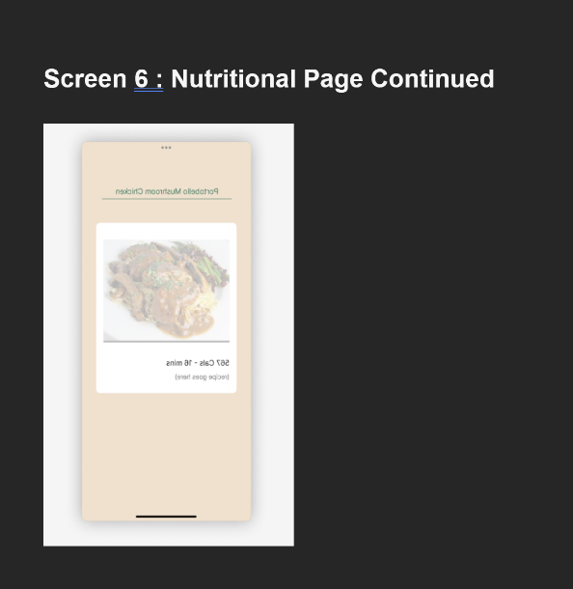

### **Deliverable work breakdown**

Inguer Lara/ Malsini Masachchige: **UI/UX Designer**

* + Designs the app’s interface and user experience, ensuring consistency and aesthetic appeal.
  + Prepares wireframes and mockups for approval before implementation.
  + Manages style guides, color schemes, and interactive elements.

Andrei Koshelev Mohammed Patel: **Backend/Functionality Developer**:

* + Focuses on implementing the core functionalities of the app.
  + Ensures that each screen and feature works as intended.
  + Works closely with the UI/UX Designer to integrate front-end and back-end elements.

Fathima Bukhari: **Project Manager**

* + Oversees the project’s timeline and checkpoints.
  + Coordinates meetings and manages the division of tasks.
  + Takes the lead on report compilation and submission.

### **App Drawbacks**

**UI Design challenges**

**Designing a user-friendly and visually appealing interface was a challenge. Certain UI components didn’t align with the intended design, resulting in an inconsistent user experience. This was especially problematic when adapting the app for different screen sizes and resolutions.**

**We enhanced the UI design by refining our design to ensure consistency across all screens, resulting a more user-friendly and visually appealing app. To achieve this, we incorporated Flutter libraries that helped the UI development process and helped us create a cohesive and aesthetically pleasing experience.**

**User Account Creation and Deletion**

Implementing features for creating and deleting user accounts presented challenges, particularly in handling the final email and username strings to ensure they were usable within the app. We encountered issues with validation logic, ensuring unique usernames, and handling error scenarios gracefully.

As a team, we identified the issue with the user account deletion and creation stemmed from the use of a JSON file. Since we were developing the app in Flutter, the methods for handling data operations differed significantly from other programing languages that we are familiar with

**User integration**

Integrating features such as managing user data into the app's codebase caused complications. This made debugging and implementing changes more time-consuming.

### **App Improvements**

To improve this app, we could have provided users with unique meditation sounds tailored to their selected mood. For example, if the user chose a mood such as "sad" or "happy," we could have adjusted the meditation sound themes to better suit their emotional state. Additionally, we could have incorporated a dynamic dashboard theme that adapts to the selected mood, enhancing the user experience.

In addition, instead of using a JSON file to store user data, we could have implemented a PostgreSQL database. This would have made the backend more secure and manageable, providing a more robust and scalable solution for handling user information.

# Screenshots & Testing

**Screen 1 Home screen:** This is the first screen the user will see. This is where existing users can login. Existing users can also click the “Forgot Password?” link that takes them to the forgot password screen (Screen 3). In addition, on this page, new users can click the button on the bottom to make an account which takes them to the create account screen (Screen 2).

**Screen 2 create account:** This screen can be accessed after clicking the create account button one screen 1. Here new users can create an account by entering a valid name, email and password. On this page there is validation done for having a valid email address and when confirming it validates if the passwords are matching. The user must also check the terms and privacy without doing so the account will not be made. Once an account is made it stores it in a JSON file by using the create account fucntion.

**Screen 3 Forgot Password:** This screen can be accessed once you click the “Forgot Password” link on the screen 1. This is where an existing user can change their password by entering their email. This screen uses the update function to update the JSON where the users’ credentials are stored to update the password.

**Screen 4 Dashboard:** This is the dashboard. Once a user logs in using valid credentials it will take them to their dashboard. It will welcome the user with their name and the date. In the Dashboard the user can check different wellness features by clicking on the different widgets such as mediation time, healthy recipes and insight. Users can also click on the gear on the bottom of the page to access the setting page.

**Screen 5 Meditation time:** On this screen, users can choose different themes (Space, Tropical and Water) and meditate. Depending on the theme different meditation music will play. When the user presses the start button it will start the music and a 10-minute mediation timer.

**Screen 6 Healthy recipes:** When clicking the “Healthy Recipes” Widget on the dashboard users will be redirected here to a page with different healthy recipes. They can filter through recipes depending on their needs. The different options are Breakfast, Lunch, Dinner and for dietary restrictions there are Gluten free and Vegan recipes.

**Screen 7 Happiness Insight:** When clicking the “Happiness Insight” Widget on the Dashboard page users will be brought to this screen. Here they can track their mood throughout the day. The mood is documented in a JSON file and in the users account with the time and date displayed on the screen.

**Screen 8 Setting:** This is the settings page this screen is accessed after the user clicks the setting icon on the bottom of the Dashboard screen. The user can do different things here depending on what they click. Logout will log the user out and take them back to the login page (Screen 1). Account will show their account details to update their account (Screen 9). Delete account will take them to Screen 10 to confirm deletion. Send feedback (Screen 11) allows the user to leave app reviews.

**Screen 9 Update account:** This screen has the user’s information prefilled in each entry box, but they can change it and click the update button to update their information. The update button uses the update function to update the JSON file with the users’ credentials.

**Screen 10 Delete Account:** After clicking delete on the setting page the user will be sent to this screen with a warning message to confirm their deletion. After clicking the delete button, the account will be deleted. The delete button will trigger the delete account function where the JSON with users information will be deleted.

**Screen 11 Feedback:** After clicking the feedback option in settings users will be redirected here where they can leave an app review by using a 1–5-star rating and in the textbox, they can write their own user feedback. The review will then be posted on the screen.

# Reflections

#### **Fathima Bukhari:**

**Creating this application with my team member has been an amazing learning experience. One of the key lessons I gained was how to collaborate effectively as a group. My role in this in this team was project manager. In this role, I was responsible for ensuring we met deadlines on time and adhered to all the project criteria. This experience as a project manager helped me take on significant responsibility and maintain the team’s organization.**

**Working on this app also allowed me to deepen my knowledge of Flutter. For example, I learned how to create and use various functions and how to work with a JSON file to store user data. Performing these tasks in Flutter is slightly different from other programming languages, which helped my understanding of app development.**

**Additionally, I gained insight into how much effort, time, and teamwork is required to build an application. It requires a great deal of creativity, original ideas, and thorough testing to bring everything together.**

**Overall, this has been an incredible learning experience, and I am excited to continue building more apps in the future.**

#### **Mohammad Patel:**

Working on this app has been a journey of growth and learning for me. It’s been exciting to bring together different technologies, like Flutter for the front end and JSON for data storage, while also addressing real-world challenges.

This project pushed me to expand my technical skills and dive deeper into problem-solving, especially when it came to figuring out how to append data efficiently without overwriting existing files. Collaborating with my team taught me a lot about communication and finding a balance between implementing individual ideas and aligning them with the project’s overall goals.

Looking back, I’m proud of the progress I’ve made, but I also see areas for improvement, like refining my ability to plan for potential challenges and testing more thoroughly during development. This experience has made me more confident in tackling future projects.

#### **Malsini Masachchige:**

**Creating the wellness app with my team members was a great learning experience. It allowed me to deepen my understanding of Flutter and Dart while also working closely with my team members. I worked on the UI design and worked on the back end of the app as well, I made sure to contribute to all the screens of the app, with special attention to the healthy recipes screen and the dashboard.**

**We ran into some challenges along the way, one of which was how to maintain the user’s state for each session. We solved that issue by doing some research and deciding on a having a JSON file to save each user’s information. This project enhanced my skills in Flutter and Dart and really improved my collaboration skills within a team environment.**

#### **Inguer Lara:**

My experience with this project was fantastic. My role in the project was as a UI/UX Designer. While designing the app, I had a lot of fun and learned many new things about Flutter. The initial design was created using Canva to illustrate how our app could look. However, we encountered challenges when trying to implement those designs in Flutter.

To address these challenges, our team conducted research on UI/UX design principles in Flutter and watched tutorials on how to implement elements like backgrounds, colors, and icons in an app. Overall, this group project has been an excellent learning experience, and I thoroughly enjoyed collaborating with my team

Andrei Koshelev:  
While working on this project, our team created a wellness app "SanSun" based on Flutter. I was assigned to work on the logical part for the "login" and "create an account" pages, the information for which was added to JSON files. I also added a dynamic display based on user selection (choosing a mood and displaying it on the same page (selection of mood type, date and time)) and a dynamic display of feedback left by the user with the ability to select a rating for the review. Among the difficulties that arose, it can be said that the main problem was the correct append of the data for JSON files, which Mohammad helped me with. As for the acquired skills, I would note that working on this project prompted me to further study various ways of interacting with data from JSON files and its correct display in the application itself, which our team was working on.