Lab 5 – Flutter Introduction  
Andrei Koshelev  
100894383  
  
3101-02  
INFT  
  
Durham College  
Mohammad Shamas  
  
  
Thursday, November 7th, 2024

**Table of Contents:**Cover Page …………………………………………….............................................. p. 1  
Table of Contents ........................................................................................................ p. 2  
Q1: Topic Overview ............................................................................................. pp. 3 - 5

Definition ............................................................................................................... p. 3

Importance of the Handling Gestures in mobile app development ........................ p. 3

Comparison Between Handling Gestures and Future .......................................... pp. 3

Advantages and Limitations of Using Handling Gestures in Flutter .............. pp. 4 - 5

Q2: Example Implementation............................................................................... pp. 5 - 11

#1 Code Example ............................................................................................ pp. 5 - 8

#2 Code Example........................................................................................... pp. 8 - 11

Q3: Real-World Scenario................................................................................... pp. 11 - 12

References .................................................................................................................. p. 13

**Q1: Topic Overview**  
**Handling Gestures – Flutter**

**Definition**  
 Touch gestures are movements on the device screens performed by the user and are intended to command specific mobile application enabled features. In Flutter, taps, drags and scrolls are captured and handled using GestureDetector which helps to move between pages, enlarge content or interact with controls (Gorin, 2024). For instance, you can have a ‘tap’ gesture act as a button to a new screen or a ‘swipe’ may erase an entry. It makes the UI more fluid and interactive rather than having to deal with only static buttons.  
 **Importance of the Handling Gestures in mobile app development**  
 The manipulation of gestures is a key element in the construction of mobile apps in that it gives the app the ability to be easily understood and easily reach for. This way, not just is a very functional user interface constructed for the app with easy interface features but the interface experience is what complements with the increasing and evolving standards of today's users – the users are used to the gestures. Gestures create dynamic interactivity with the applications as movements of various kinds are incorporated which can also give the apps a lift in their usability making them feel more polished.  
 **Comparison Between Handling Gestures in Flutter and React Native**   
 Besides Flutter, React Native also allow for the deposition of films among several others into the design. However, Flutter’s approach is more flexible than this procedure because it is more about GestureDetector and the way it offers different gestures which can further be adjusted easily. While on the other hand, React Native framework also expects developers to use some hand motions when writing code since the language allows for their attachment (Flutter, 2024).

**Advantages and Disadvantages of Using Handling Gestures in Flutter  
Advantages:**

**•** **Reduced UI Clutter:** Gestures gradually eliminate repetitious manipulative actions like taps or button presses. GeeksforGeeks as well adds that when excessive UI lines get reduced it becomes easier to interact with the user as such a visually attractive app maintains its operations. This is extremely beneficial, especially in mobile software with a limitation in space as shown in mobile application design (GeeksforGeeks, 2023).  
**• Enhanced User Experience:** Gesture usage provides a better way to present a mobile app by allowing users to enjoy it and feel natural while working with the application. It is also an essential consideration for any newly developed product as user satisfaction is achieved only in users who are happy with the system (Gorin, 2024). In short, this feature assists in over-commitment in applications or enhances the enjoyment of existing ones beyond the normal satisfaction limits.  
**• Cross-Platform Flexibility:** When a developer creates applications with Flutter, it becomes easier for them to include gestures in their works irrespective of the types of devices. When it comes to utilizing gestures in Flutter, it is underlined that such an approach facilitates one’s work, prevents developers from working on it longer than necessary, and presents the user with immense static devices (Flutter, 2024).

**Disadvantages:**

**• Performance Concerns:** The Implementation of gestures mechanism is very expensive and certain complex gestures such as multitouch or swipe animations impose very high overhead due to extra memory allocation and high CPU requirements, and this especially hurt the performance of old gadgets. Heavy gesture-based features can even slow down the application and degrade performance, especially when working with low level devices enforcing a less responsive quality (GeeksforGeeks, 2023).  
**• Learning Curve:** The development of even simple advanced gestures can often end up being quite difficult, especially for developers who lack the experience. Implementing fingerprint combinations or any custom characteristics in the way the touch is sensed may necessitate some more learning together with testing. In Flutter GestureDetector, such things like mastering increased/fine gestures always require practice and necessitate knowledge of gesture physics and performance mechanics of modern mobile devices (Gorin, 2024).  
**• Compatibility Issues:** There can be a situation where gesture sensitivity can be very high and other times it isn’t, because the device dictates it differently as a result different users can have a very different experience. The Flutter documentation highlights that achieving the same level of responsive gestures can be hard because it may be dependent on the device that is being used in terms of its sensitivity, screen size, and how far the target mad will visualize a particular gesture (Flutter, 2024).

**Q2: Example Implementation  
#1 Code Example:**  
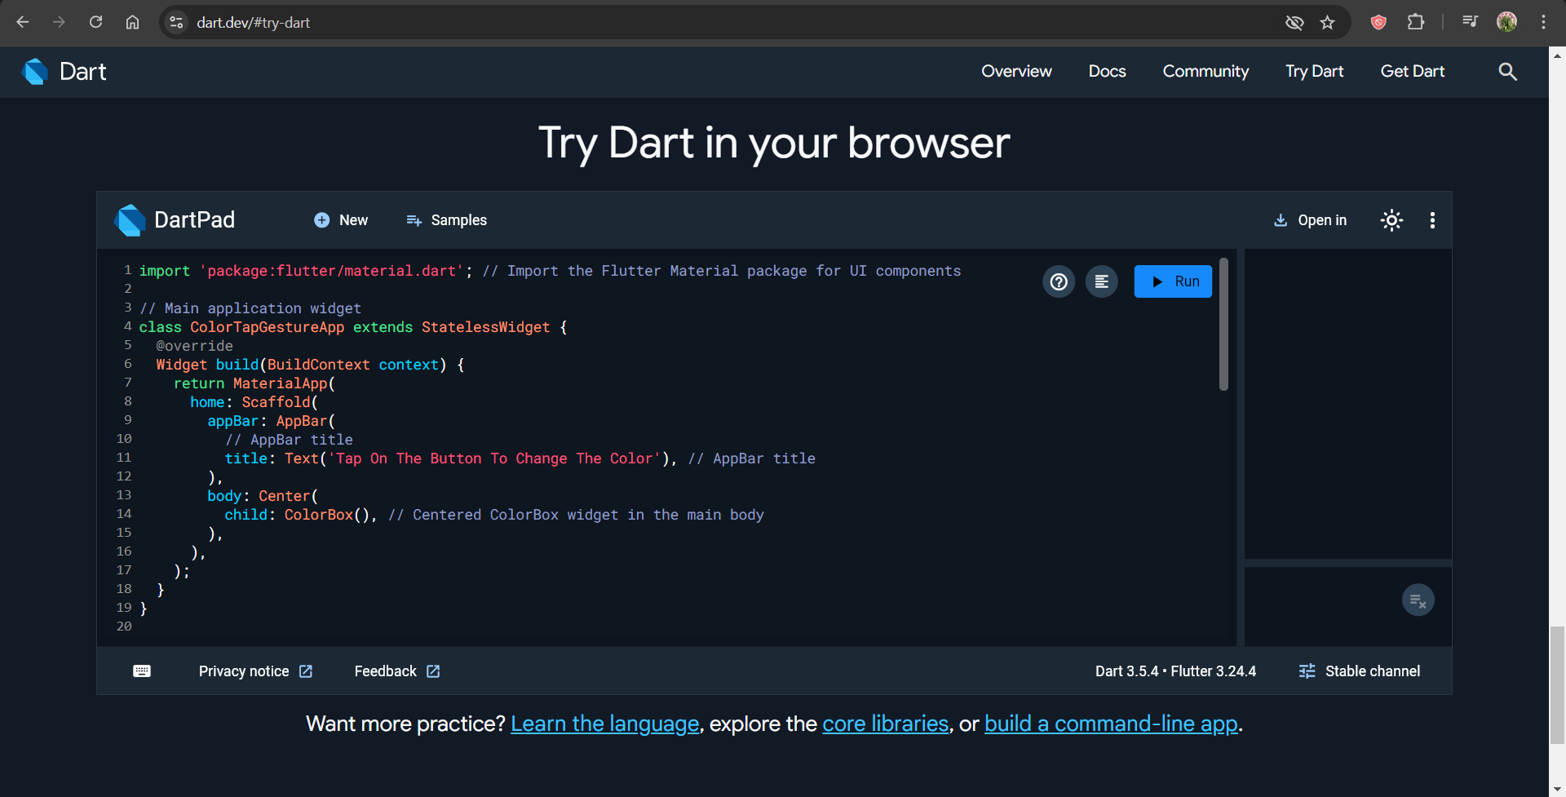  
**Q3: Real-World Scenario**

In an application that most likely gives users the opportunity to watch image slideshows, sometimes people would need to look at something closer and let’s say view an image in a closer range, or outside the limits. Thus, they would rather interact with the existing content by focusing on some areas only or enjoying the sight, strolling and section hunting. Working with that defines how to process pinching, also hitting objects that can be dragged or otherwise moved in a smooth sweeping motion is expected to deliver greater user satisfaction. In applications where, for example, the beauty of the image functionality is important, such as photo books, apartments sales, and online commerce looking for clothes, using gestures is the best way to increase interaction.

**References:**

GeeksforGeeks. (2023, March 17). *Flutter: Advantages, Disadvantages and Future Scopes*. https://www.geeksforgeeks.org/flutter-advantages-disadvantages-and-future-scopes/  
Gorin, M. (2024, November 5). *The Power of Touch in Flutter: A Guide to Gesture Handling*. Medium. https://maxim-gorin.medium.com/the-power-of-touch-in- flutter-a-guide-to- gesture-handling-3f4239bc6c7f  
Flutter Dev. (2024, June 6). *Taps, Drags, and Other Gestures.* https://docs.flutter.dev/ui/interactivity/gestures