Student Dropout Risk Prediction Using Machine Learning
Final Report
Author: Kenneth Paul Cortez
Course: Machine Learning
Date: 04 March 2026

Table Of Content
Abstract 2
1. Introduction 3
2. Problem Statement 4
3. Dataset Description 4
3.1 Source and Overview 4
3.2 Feature Types 5
3.3 Data Dictionary 5
4. Data Preprocessing 6
4.1 Missing Values and Duplicates 7
4.2 Target Variable Transformation 7
4.3 Feature Encoding 7
4.4 Train-Test Split 7
4.5 Outlier Handling 8
5. Exploratory Data Analysis 8
5.1 Target Variable Distribution 8
5.2 Correlation Heatmap 9
5.3 Distributions of All Features 10
5.3 Admission Grade and Age Distributions 11
5.4 Outlier Detection 12
5.5 Key Features vs Dropout Risk 12
5.6 Financial and Scholarship Factors 14
5.7 Engineered Feature: Academic Performance vs Dropout 15
6. Feature Engineering 15
6.1 Academic Performance Composite Feature 15
6.2 Random Forest Feature Importance 15
6.3 PCA Variance Analysis 16
6.4 Feature Correlation with Target 17
7. Model Implementation 18
7.1 Logistic Regression 18
7.2 Decision Tree 18
7.3 Random Forest 18
7.4 Support Vector Machine 18
7.5 XGBoost 19
8. Model Evaluation 19
8.1 Confusion Matrices 19
8.2 Model Performance Summary 19
8.3 Model Accuracy Comparison 20
8.4 F1-Score Comparison 21
8.5 ROC Curves 21
8.6 Precision-Recall Curves 22
8.7 Model Performance Comparison Table 22
9. Bias and Fairness Analysis 22
9.1 SHAP Summary Plot 23
9.2 Partial Dependence Plots 24
9.3 Fairness Analysis by Gender 24
9.4 Fairness Analysis by Age Group 26
9.5 Fairness Analysis by Debtor Status 26
9.6 Fairness Analysis by Tuition Fee Status 28
9.7 Ethical Implications 29
10. Results and Discussion 29
11. Conclusion 30
12. Future Work 30
References 31

Abstract
Student dropout remains one of the more stubborn problems in higher education, carrying consequences for both institutions and the students who leave. This project develops a supervised machine learning framework to predict whether a student will drop out before completing their degree, drawing on a dataset of 4,424 student records from a Portuguese higher education institution published on the UCI Machine Learning Repository. The dataset combines demographic attributes, academic performance indicators, and socioeconomic variables. After preprocessing, exploratory analysis, and feature engineering, four classification algorithms were trained and compared: Logistic Regression, Random Forest, Support Vector Machine, and XGBoost. Model performance was measured using accuracy, precision, recall, F1-score, and ROC-AUC. XGBoost delivered the strongest results overall, reaching an accuracy of 88.2 percent and an F1-score of 0.804, closely followed by Random Forest at 0.796. SHAP explainability analysis identified approved curricular units in the second semester and tuition fee payment status as the most influential predictors. A fairness audit was also carried out to examine whether the model treats different demographic groups equitably. The findings suggest that a well-tuned gradient-boosting model can generate actionable early-warning signals that allow institutions to intervene before students reach the point of no return.

1. Introduction
University dropout is rarely a sudden event. For most students, the decision to leave accumulates over months, shaped by grades that fail to improve, financial pressures that build quietly, or a growing sense of disconnection from the academic environment. By the time an institution notices, the window for meaningful intervention has often closed. The cost of that missed window is significant. For students, early departure from higher education can translate into reduced lifetime earnings and limited professional mobility. For institutions, high dropout rates erode revenue, damage reputation, and signal deeper weaknesses in student support infrastructure. In Portugal, where the dataset used in this project was collected, dropout rates in higher education have consistently drawn attention from policymakers concerned with educational equity and workforce development. Machine learning offers a different approach to this problem. Rather than waiting for a student to fail an exam or miss a tuition payment, a predictive model can scan patterns across hundreds of variables and flag at-risk student’s weeks or semesters earlier. The core idea is not complicated: if a model can learn from the academic and financial histories of students who did drop out, it can identify similar patterns in current students before the outcome becomes inevitable.
This project builds that predictive system. The objective is to develop a binary classification model that identifies students at dropout risk using demographic, academic, and socioeconomic features. The work covers the full data science pipeline: data collection and understanding, preprocessing and feature engineering, exploratory analysis, model development and evaluation, and a fairness audit to ensure that the system does not introduce systematic disadvantage for specific student groups.
The remainder of this report is organized as follows. Section 2 frames the problem formally. Section 3 describes the dataset. Sections 4 through 6 document preprocessing, exploratory analysis, and feature engineering. Sections 7 through 9 cover model development and evaluation. Section 10 presents the bias and fairness analysis. Sections 11 through 13 discuss results, conclusions, and future directions.

2. Problem Statement
The task addressed in this project is a supervised binary classification problem. The model is trained to predict whether a given student will drop out of their academic program before graduation, based on information available at or shortly after the time of enrolment. The original dataset assigns one of three academic outcomes to each student Dropout, Enrolled, or Graduate. For this project, the target variable was transformed into a binary format. Students who dropped out are assigned a value of 1, while students who remained enrolled or graduated are assigned a value of 0. This transformation focuses the model specifically on distinguishing dropout cases from the rest, which is the category of most direct interest to institutions aiming to improve retention.
The choice of F1-score as the primary evaluation metric reflects the practical asymmetry of the prediction task. Missing a genuine dropout case, a false negative, is more costly than incorrectly flagging a student who would have continued, a false positive. A high recall ensures that most at-risk students are identified, while precision controls the rate of unnecessary interventions. The F1-score balances both, making it a more honest measure of model usefulness than raw accuracy in a setting with moderate class imbalance. The success of the model is ultimately measured not just by statistical performance but by whether the predictions are actionable. A model that identifies the right students early enough for advisors to intervene, explains its reasoning in terms that academic staff can act on, and treats all student groups fairly, is more valuable than one that merely achieves the highest accuracy score in isolation.

3. Dataset Description

3.1 Source and Overview
The dataset used in this project is the Student Dropout and Academic Success dataset, published on the UCI Machine Learning Repository. It was compiled from records held by a Portuguese higher education institution and contains information on students enrolled across a range of undergraduate programs. The dataset includes 4,424 records and 37 features, covering demographic background, socioeconomic context, prior academic qualifications, and academic performance during the first and second semesters of study.
The original target variable contains three categories Dropout, Enrolled, and Graduate. For this project, the variable was converted into a binary outcome, with 1 indicating dropout and 0 indicating all other outcomes. After this transformation, the dataset contains 1,421 dropout cases and 3,003 non-dropout cases, representing a moderate class imbalance that was taken into account during model training and evaluation.

3.2 Feature Types
The 37 features in the dataset fall into three broad categories. Seventeen features are categorical or binary in nature, including variables such as marital status, application mode, gender, scholarship holder status, debtor status, and tuition payment status. The remaining 20 features are numerical, covering academic grades, curricular unit counts across two semesters, age at enrolment, and macroeconomic indicators such as the national unemployment rate, inflation rate, and GDP at the time of enrolment. The dataset contains no missing values, which eliminated the need for imputation. No duplicate records were detected during the initial quality checks. All feature values fall within plausible ranges for the domain, suggesting that the original data collection and curation process was careful.

3.3 Data Dictionary
The table below summarizes the key features in the dataset, their type, and a brief description.
Feature | Type | Description
Marital status | Categorical | Marital status at enrollment
Application mode | Categorical | Mode through which the student applied
Application order | Numeric | Order of preference in application
Course | Categorical | Degree program enrolled
Daytime/evening attendance | Binary | Daytime or evening attendance
Previous qualification | Categorical | Type of qualification prior to admission
Previous qualification (grade) | Numeric | Grade in previous qualification
nationality | Categorical | Student nationality
Mother's qualification | Categorical | Education level of mother
Father's qualification | Categorical | Education level of father
Mother's occupation | Categorical | Occupation category of mother
Father's occupation | Categorical | Occupation category of father
Admission grade | Numeric | Grade used for university admission
Displaced | Binary | Whether student is displaced from home region
Debtor | Binary | Whether student has outstanding tuition debt
Tuition fees up to date | Binary | Whether tuition fees are paid on time
Gender | Binary | Student gender (1 = Male, 0 = Female)
Scholarship holder | Binary | Whether student receives a scholarship
Age at enrollment | Numeric | Student age at time of enrollment
International | Binary | Whether student is an international student
Curricular unit’s 1st sem (approved) | Numeric | Units passed in first semester
Curricular unit’s 2nd sem (approved) | Numeric | Units passed in second semester
Curricular unit’s 1st sem (grade) | Numeric | Average grade in first semester
Curricular unit’s 2nd sem (grade) | Numeric | Average grade in second semester
Unemployment rate | Numeric | National unemployment rate at enrollment
Inflation rate | Numeric | National inflation rate at enrollment
GDP | Numeric | GDP at the time of enrollment
Target | Categorical | Academic outcome (Dropout / Non-Dropout)

4. Data Preprocessing

4.1 Missing Values and Duplicates
The dataset was inspected for missing values across all 37 features. No missing entries were found in any column, which is atypical for real-world educational datasets and likely reflects the careful curation of the source data by the researchers at the UCI repository. Similarly, a check for duplicate rows confirmed that every record is unique. These two findings meant that imputation and deduplication steps were not required, allowing preprocessing efforts to focus on more substantive transformations.

4.2 Target Variable Transformation
The original target variable contains three labels: Dropout, Enrolled, and Graduate. To convert the problem into a binary classification task, the target was recoded so that Dropout receives a value of 1 and all other outcomes, namely Enrolled and Graduate, receive a value of 0. This encoding focuses the model on the most actionable question: whether a student leaves the institution before completing their degree. Students currently enrolled but not yet at the point of graduation are grouped with graduates in the negative class, on the reasonable assumption that a student still engaged with their program has not yet exhibited dropout behavior.

4.3 Feature Encoding
Several features that appear numeric in the raw dataset are in fact categorical codes representing enrollment mode, course type, nationality, or parental occupation. Because tree-based models can handle ordinal-coded categorical variables reasonably well, no additional one-hot encoding was applied for those models. For Logistic Regression and SVM, which are sensitive to scale and feature structure, StandardScaler was applied after the train-test split to normalize all numerical features to zero mean and unit variance.

4.4 Train-Test Split
The dataset was divided into a training set and a test set using an 80/20 ratio. Stratified sampling was used to ensure that the proportion of dropout cases in both sets matches the overall class distribution in the full dataset. This is particularly important in the presence of class imbalance: without stratification, there is a risk that the smaller class is underrepresented in one of the subsets, which would distort both training and evaluation.

4.5 Outlier Handling
Boxplot analysis identified the presence of values in certain numerical variables, such as age at enrollment and admission grade, that fall outside the interquartile range. These were reviewed individually. In every case, the values turned out to represent genuine student characteristics: older students returning to education, or high-achieving applicants with exceptional admission scores. None of the extreme values appeared to result from data entry errors. They were therefore retained in the dataset. Removing them would have risked discarding precisely the kinds of unusual student profiles that the model needs to learn from.

5. Exploratory Data Analysis
Exploratory data analysis was conducted to understand the distribution of individual features, identify relationships between variables, and develop an initial intuition about which factors might matter most for dropout prediction. The plots produced during this stage guided subsequent decisions about feature selection and model design.

5.1 Target Variable Distribution
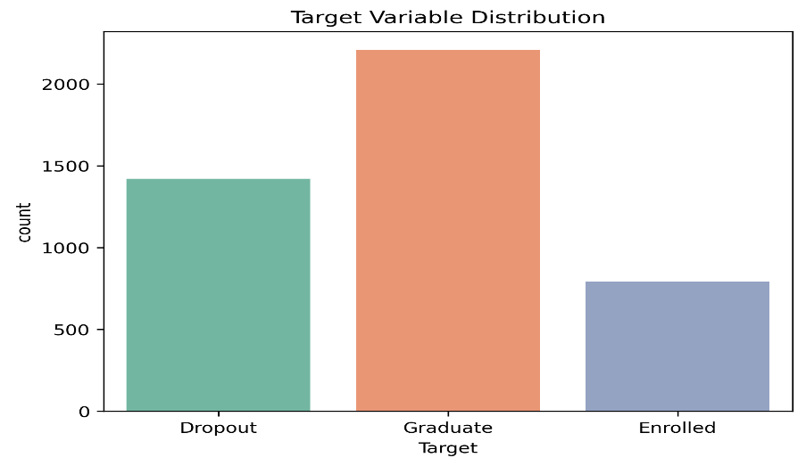
The first step was to examine the distribution of the target variable to understand the degree of class imbalance in the dataset.

Figure 1: Distribution of the Original Target Variable (Dropout, Enrolled, Graduate)
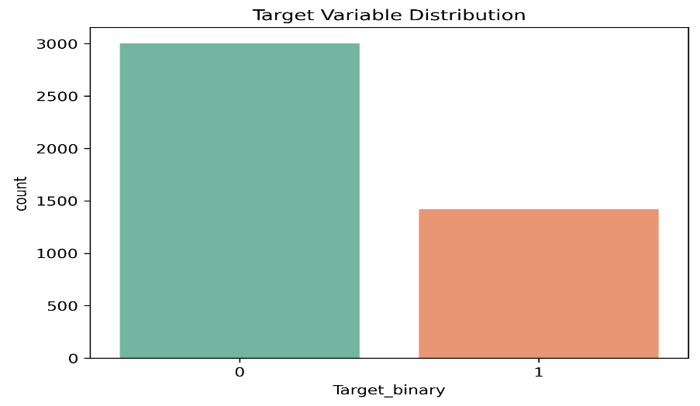

Figure 2: Distribution of the Binary Target Variable After Transformation

Figures 1 and 2 show the target variable distribution before and after the binary transformation. In the original three-class setup, graduates form the largest group, followed by dropouts, and then enrolled students. After converting to binary labels, the dataset contains roughly 32 percent dropout cases and 68 percent non-dropout cases. This moderate imbalance does not require aggressive resampling techniques such as SMOTE, but it does confirm that accuracy alone is an insufficient metric. A model that simply predicts non-dropout for every student would achieve around 68 percent accuracy without learning anything useful.

5.2 Correlation Heatmap
A correlation heatmap was generated for all numerical features to identify linear relationships and potential multicollinearity. Figure 3 reveals that the first-semester and second-semester academic variables are strongly correlated with one another, which is expected. Students who pass many units in the first semester tend to pass many in the second, and their grade distributions follow similar patterns. These intercorrelations suggest the presence of a latent academic performance factor that explains much of the variance in both semester variables simultaneously. The heatmap also shows that macroeconomic variables such as unemployment rate, inflation, and GDP are moderately correlated among themselves, reflecting that they all track the same underlying economic cycle. Notably, several curricular unit variables show moderate negative correlations with the binary dropout target, indicating that students who engage less academically are more likely to leave.
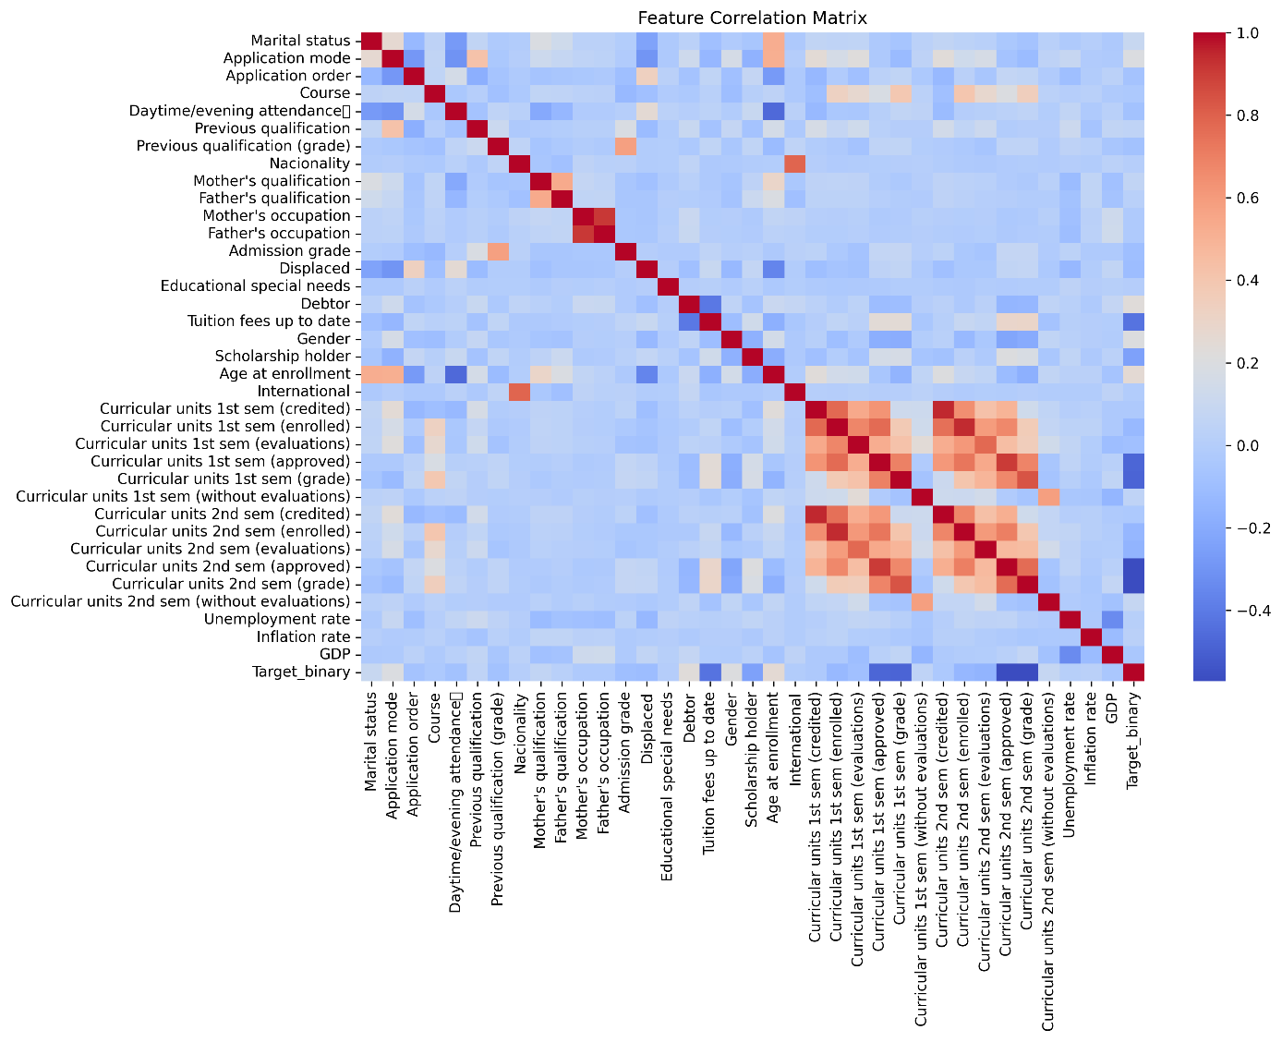
Figure 3: Correlation Heatmap of Numerical Features

5.3 Distributions of All Features
Histograms were generated for the numerical features to understand their distributional shapes. Figure 4 displays the spread and shape of the numerical variables across the dataset. Admission grade and previous qualification grades are approximately normally distributed, centered around mid-range values. Age at enrollment is right-skewed, with the majority of students enrolling in their late teens or early twenties and a smaller group of mature students enrolling later. The curricular unit variables show a range of patterns: enrollment counts tend to cluster around common values such as six units per semester, while approved-unit counts span a wider range and include students who passed zero units, likely indicating early academic difficulties or complete disengagement.
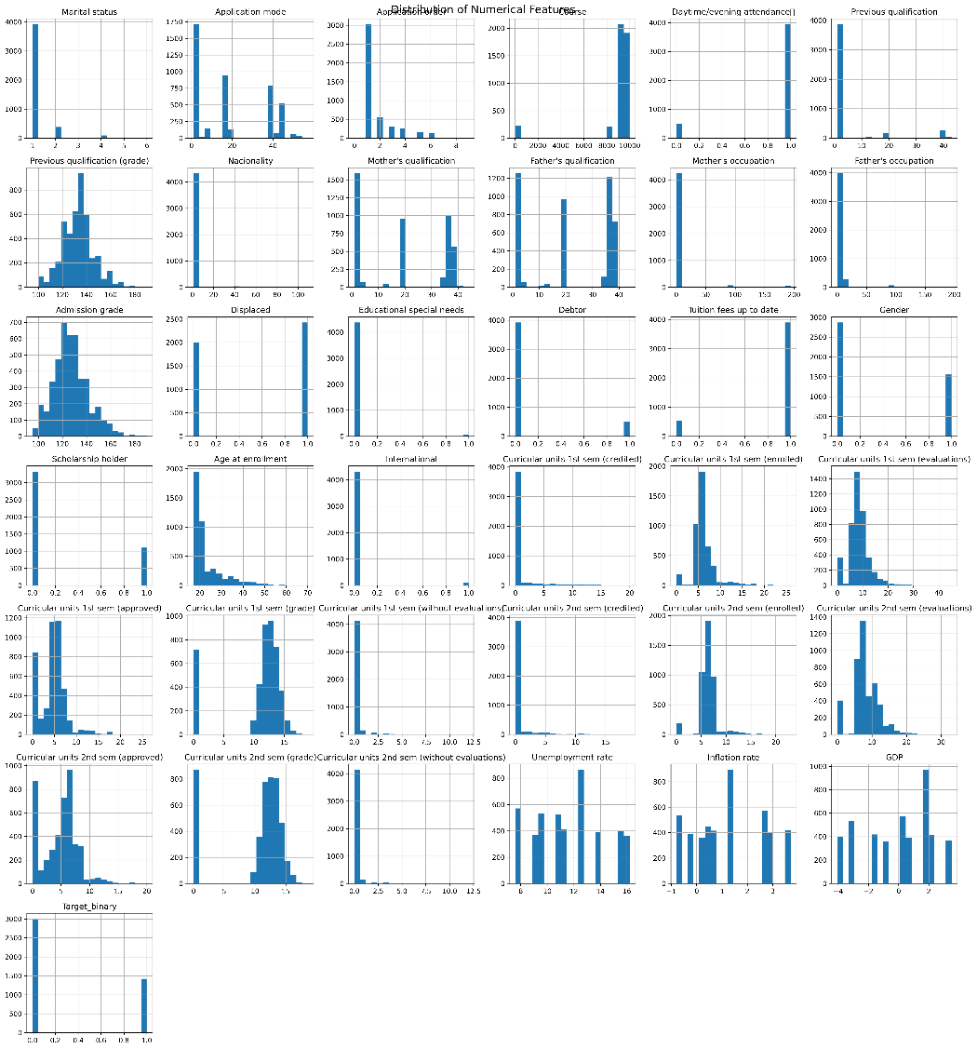

Figure 4: Distribution Plots for All Numerical Features

5.3 Admission Grade and Age Distributions
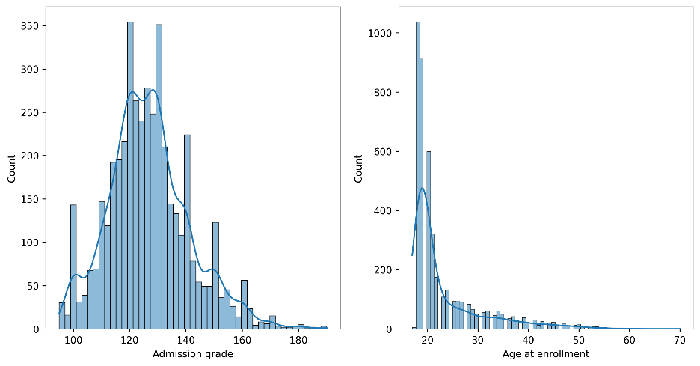
Two key numerical features were examined individually to understand their distributions more clearly.

Figure 5: Distribution of Admission Grade (left) and Age at Enrollment (right)
Figure 5 confirms that admission grade follows a bimodal distribution centered around 120 to 130 on the Portuguese grading scale, with a second smaller cluster of higher-achieving students at around 150. Age at enrollment is heavily right-skewed: the overwhelming majority of students enter university between 17 and 22, with a long tail of older students extending into the fifties and sixties. This skew is important context for the age-dropout relationship identified in later analyses.

5.4 Outlier Detection
A boxplot was generated for admission grade to inspect the outlier structure in this key predictor.
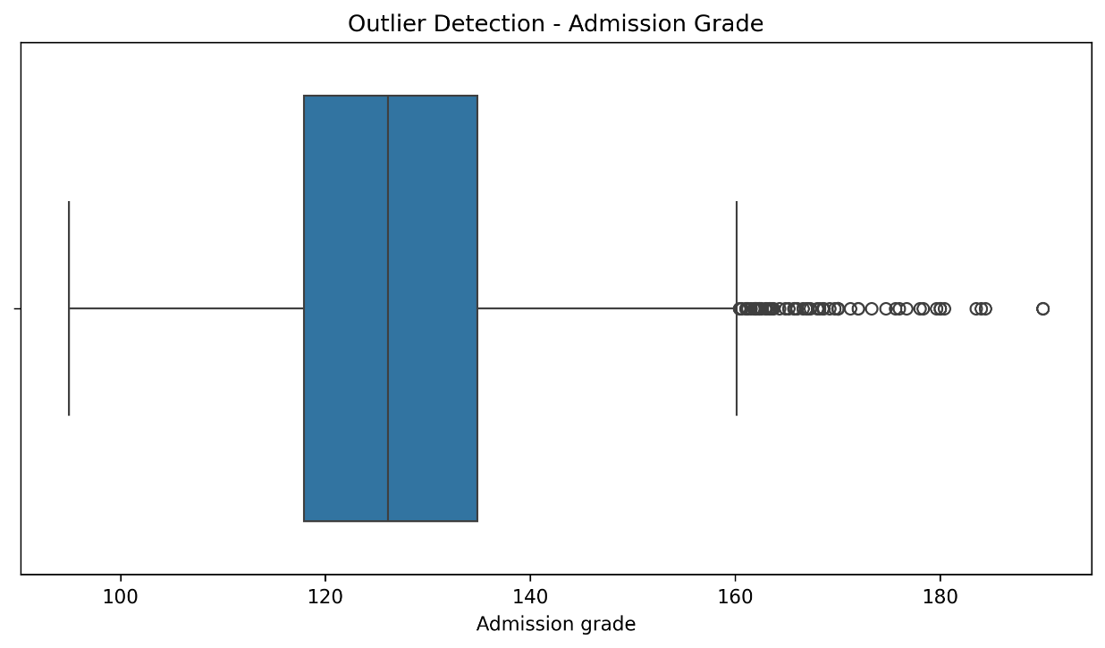
Figure 6: Outlier Detection Boxplot for Admission Grade
Figure 6 illustrates that admission grade has a cluster of genuine high-value outliers above 160. These are not data errors but represent students admitted through exceptional academic performance routes. The whiskers and interquartile range show that the central 50 percent of students fall between approximately 119 and 133, with the median around 126.

5.5 Key Features vs Dropout Risk
Boxplots were generated to compare the distributions of key features between dropout and non-dropout students.
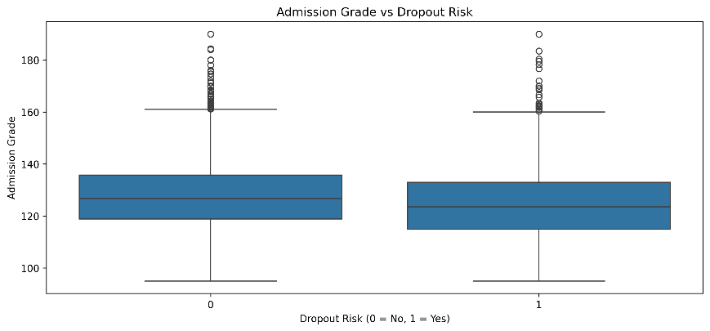

Figure 7: Admission Grade vs Dropout Risk
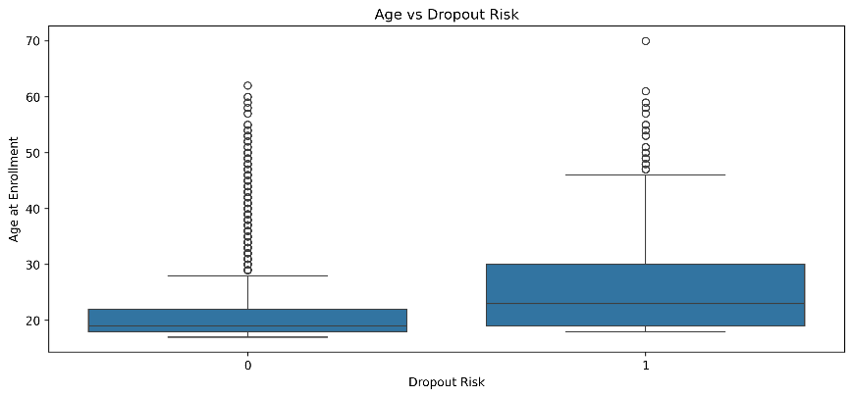

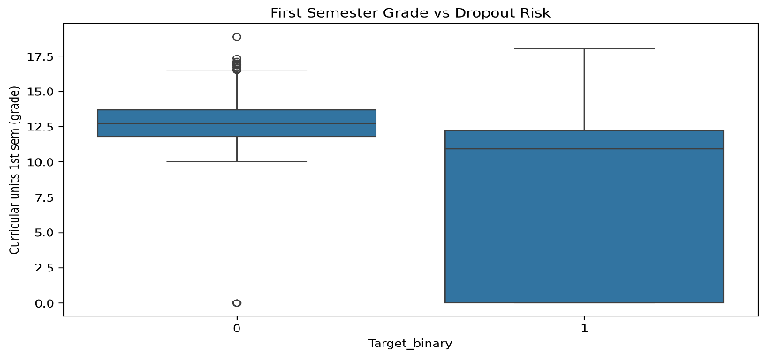
Figure 8: Age at Enrollment vs Dropout Risk

Figure 9: First Semester Grade vs Dropout Risk

Figures 7, 8, and 9 reveal distinct patterns. For admission grade (Figure 7), the distributions of dropout and non-dropout students overlap considerably, with dropout students showing a slightly lower median, indicating that admission grade alone is a weak predictor. Age at enrollment (Figure 8) tells a stronger story: dropout students have a noticeably higher median age and a wider interquartile range, confirming that older students face additional challenges that increase dropout risk. First semester grade (Figure 9) shows the sharpest contrast: students who eventually dropped out earned considerably lower first-semester grades and exhibit much greater variance (wider IQR) than persisters, making early academic performance one of the strongest individual predictors in the dataset.

5.6 Financial and Scholarship Factors
Bar charts were generated to examine dropout rates across financial and scholarship variables.
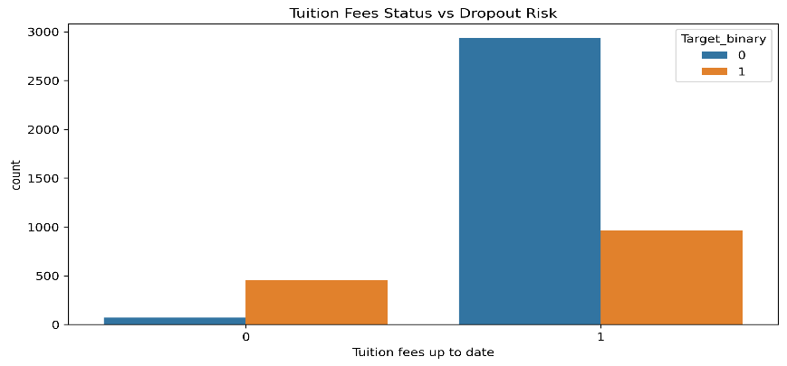

Figure 10: Tuition Fee Payment Status vs Dropout Risk
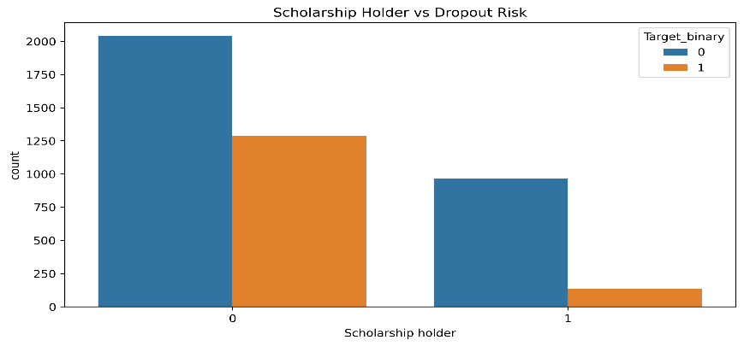

Figure 11: Scholarship Holder Status vs Dropout Risk
Figures 10 and 11 are among the most informative in the exploratory analysis. Figure 10 shows that among students with unpaid tuition fees (category 0), dropout cases (orange) dramatically outnumber non-dropout cases (blue), while among students with up-to-date fees (category 1), non-dropout cases dominate. This near-binary relationship confirms that tuition payment status is one of the most predictive individual variables. Figure 11 shows that non-scholarship students account for the majority of dropout cases, while scholarship recipients (category 1) have a far lower dropout count relative to their non-dropout count. Financial support appears to meaningfully reduce dropout risk.

5.7 Engineered Feature: Academic Performance vs Dropout
The composite Academic Performance feature, averaging first and second semester grades, was also examined against dropout status. Figure 12 demonstrates that the engineered Academic Performance feature produces an even cleaner separation between dropout and non-dropout groups than either individual semester grade. Dropout students (class 1) show a much wider and lower-centered distribution, with the interquartile range spanning from near zero to around 12, whereas non-dropout students cluster tightly between 12 and 14. This validates the feature engineering decision: combining both semester grades into a single variable capture sustained academic engagement more effectively than either semester score alone.
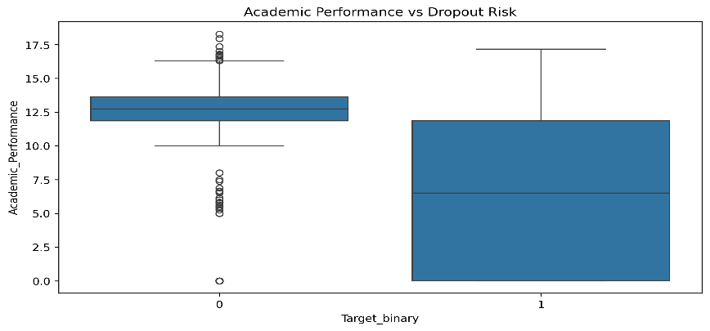

Figure 12: Academic Performance Composite Feature vs Dropout Risk

6. Feature Engineering

6.1 Academic Performance Composite Feature
A new feature was constructed by averaging the first and second semester grades into a single Academic Performance score. The motivation is that individual semester grades capture short-term performance, but a combined indicator better reflects whether a student is sustaining academic engagement across the full year, which is what most clearly distinguishes persisters from those who leave. As Figure 12 demonstrated, this composite feature produces sharper separation between classes than either semester grade alone.

6.2 Random Forest Feature Importance
Random Forest feature importance scores were computed to identify which variables contribute most to predicting dropout. Figure 13 reveals a clear hierarchy of predictors. Curricular units approved in the second semester leads with an importance score of approximately 0.14, followed closely by second semester grade and the engineered Academic Performance composite feature. Tuition fees up to date and first semester approved units form the next tier. Demographic and macroeconomic variables such as age at enrollment and GDP carry lower but non-negligible importance. Based on these scores, the top 20 features were selected for use in the final models, reducing dimensionality while retaining the most informative signal.
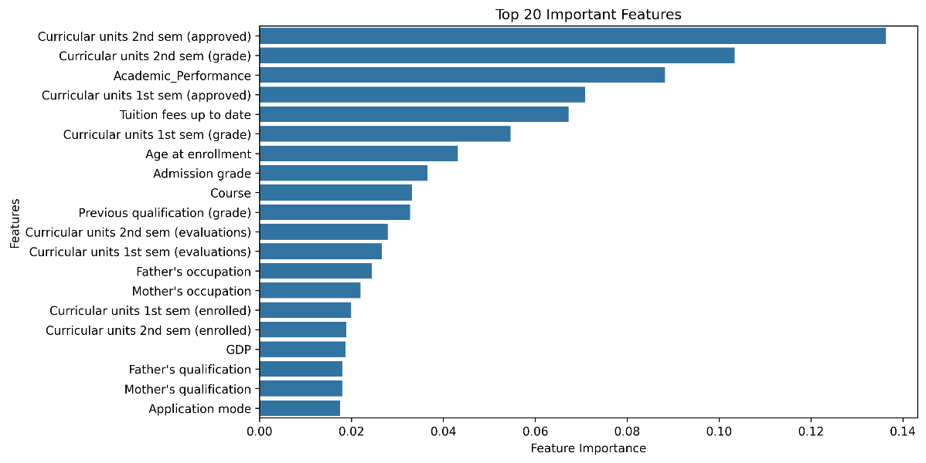

Figure 13: Top 20 Feature Importance Scores from Random Forest

6.3 PCA Variance Analysis
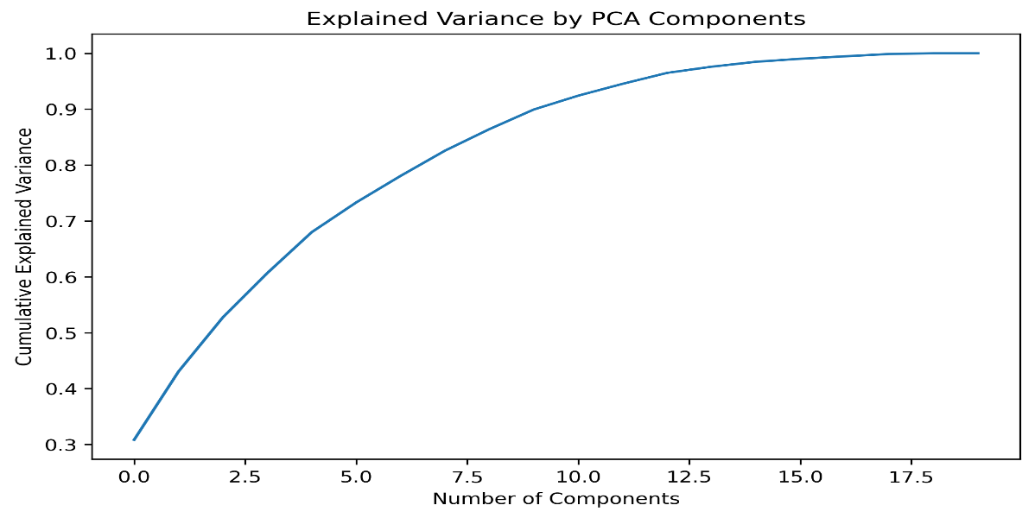
Principal Component Analysis was applied to examine the variance structure of the selected feature set.

Figure 14: Cumulative Explained Variance by PCA Components
Figure 14 shows that the first five principal components capture approximately 75 percent of the total variance, and around ten components are needed to reach 90 percent. This confirms that the 20 selected features contain a degree of redundancy, with a lower effective dimensionality. PCA was used here as an analytical tool to understand the structure of the feature space rather than as a transformation applied to the final models, where the original features were retained to allow SHAP-based explainability.

6.4 Feature Correlation with Target
A directed correlation analysis was run between individual features and the binary dropout target to rank predictors by their direct linear association.
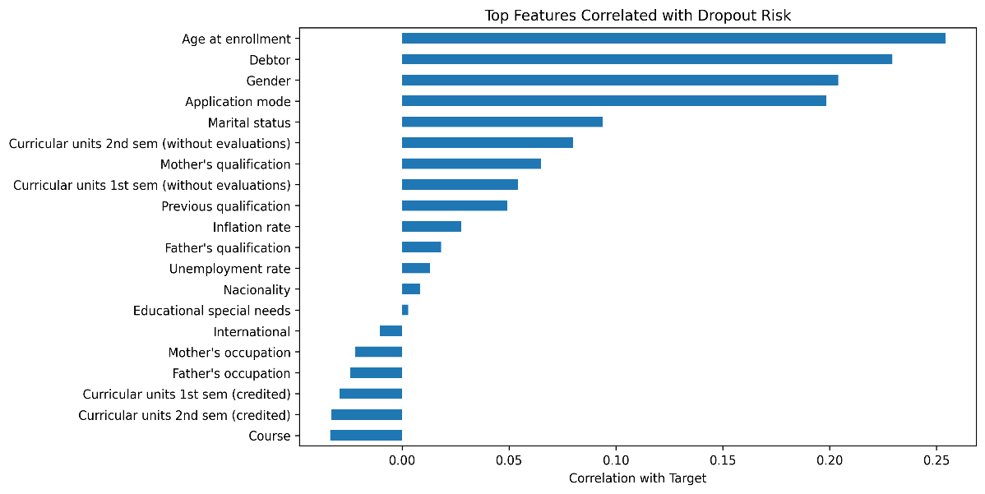

Figure 15: Top Features Correlated with Dropout Risk (Target)
Figure 15 confirms the patterns from the exploratory analysis. Age at enrollment shows the strongest positive correlation with dropout, followed by debtor status, gender, and application mode. Marital status and units without evaluations also carry positive correlations. On the negative side, features that did not appear in this chart (such as approved units and tuition fees) were confirmed in the Random Forest importance ranking. The correlation results and the importance scores together provide convergent evidence for which variables drive the predictions.

7. Model Implementation
Five machine learning algorithms were trained and evaluated on the prepared dataset: Logistic Regression, Decision Tree, Random Forest, Support Vector Machine (SVM), and XGBoost. The selection covers a spectrum from the interpretable linear baseline through to flexible ensemble methods, allowing the comparison to reveal both which model performs best and how much is gained by increasing complexity.

7.1 Logistic Regression
Logistic Regression was included as the baseline model. It estimates dropout probability by fitting a linear decision boundary in the feature space. Despite its simplicity, it is often competitive on tabular classification problems when features are well-scaled and the signal has linear components. It was trained with L2 regularization and run to convergence.

7.2 Decision Tree
A single Decision Tree was included as the weakest but most interpretable ensemble comparison point. Decision Trees split the feature space recursively to minimize impurity, but individual unpruned trees tend to overfit training data, which typically reduces their test-set performance relative to ensemble methods.

7.3 Random Forest
Random Forest constructs many decision trees on bootstrapped subsets of training data and averages their predictions. By aggregating across diverse trees, it reduces the variance that plagues individual trees without increasing bias. Its built-in feature importance mechanism also made it a valuable analytical tool during feature engineering.

7.4 Support Vector Machine
An SVM with a radial basis function kernel was trained to find the maximum-margin boundary between classes. SVM can capture nonlinear relationships through the kernel mapping and tends to perform well on problems where classes are separable with moderate overlap. Feature scaling is important for SVM, which is why StandardScaler was applied before training.

7.5 XGBoost
XGBoost implements gradient-boosted decision trees, building models sequentially where each new tree corrects the residual errors of the previous ensemble. Regularization terms in the objective function control overfitting. XGBoost has consistently been among the top performers on structured tabular classification problems and was expected to be the strongest model in this comparison.

8. Model Evaluation
Each model was evaluated on the held-out test set using five metrics: accuracy, precision, recall, F1-score, and ROC-AUC. Confusion matrices, ROC curves, precision-recall curves, and performance summary visualizations were generated to provide full context for the numerical results.

8.1 Confusion Matrices
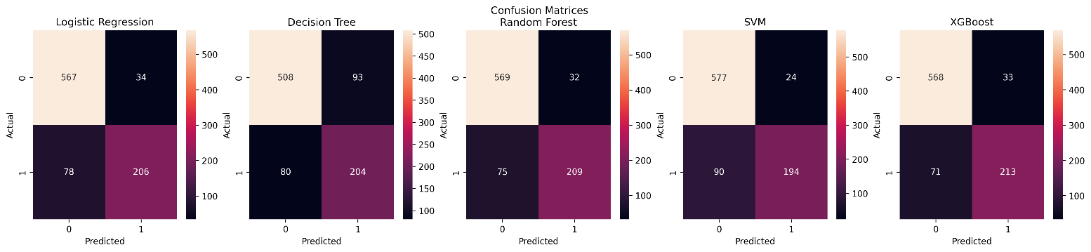
Figure 16: Confusion Matrices for All Five Models
Figure 16 shows the confusion matrices side by side. All five models correctly identify the majority of non-dropout students (top-left quadrant). The more telling comparison is in how many actual dropout students each model correctly identifies (bottom-right quadrant). XGBoost correctly identifies 213 dropout students, followed by Random Forest with 209, Logistic Regression with 206, and Decision Tree with 204. SVM correctly identifies 194, the fewest among all models. The false negative counts, where actual dropouts are predicted as non-dropouts, are 71 for XGBoost, 75 for Random Forest, 78 for Logistic Regression, 80 for Decision Tree, and 90 for SVM.

8.2 Model Performance Summary
Figure 17 presents the complete metric summary for all five models. XGBoost achieves the best accuracy at 0.882 and the highest F1-score at 0.804. Random Forest follows with accuracy 0.879 and F1-score 0.796. Logistic Regression performs strongly for a linear model at accuracy 0.873 and F1-score 0.786. SVM achieves the highest precision of 0.890 but the lowest recall of 0.683, reflecting a conservative prediction style. Decision Tree lags behind with accuracy 0.805 and F1-score 0.702, consistent with the known tendency of single trees to overfit.
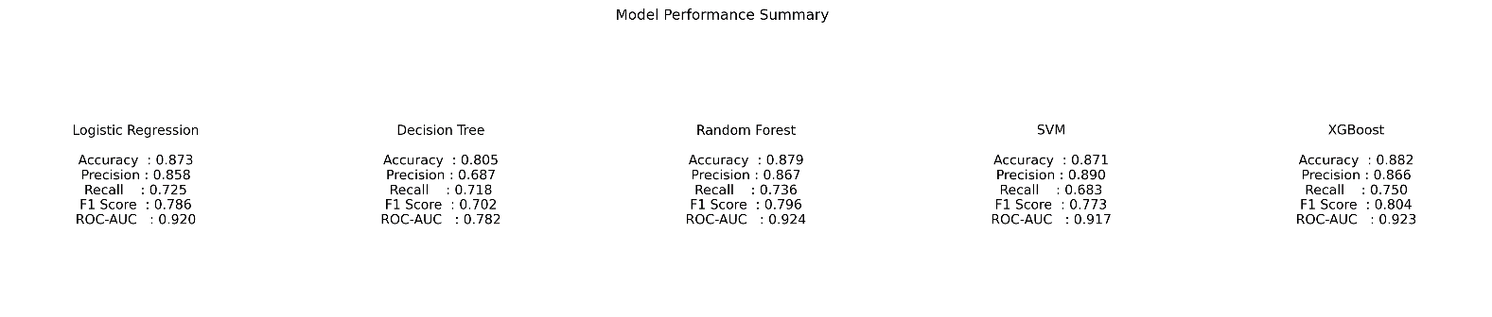
Figure 17: Model Performance Summary Table

8.3 Model Accuracy Comparison
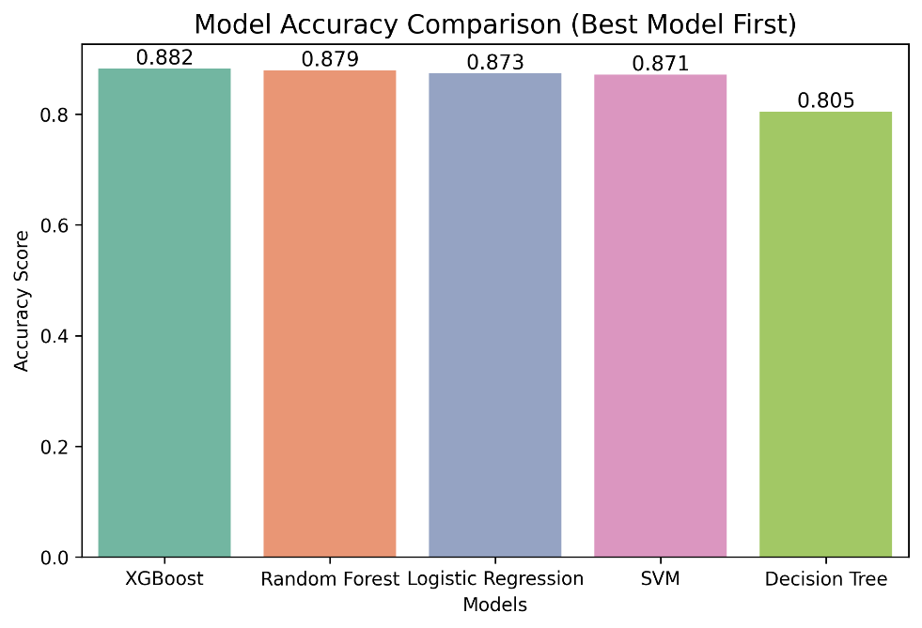

Figure 18: Model Accuracy Comparison (Best to Worst)
Figure 18 visualizes the accuracy ranking from best to worst. The four top models cluster tightly between 0.871 and 0.882, indicating that much of the predictive signal in this dataset is accessible even to simpler models. The Decision Tree is the clear outlier at 0.805, confirming that ensemble diversity adds real value here.

8.4 F1-Score Comparison
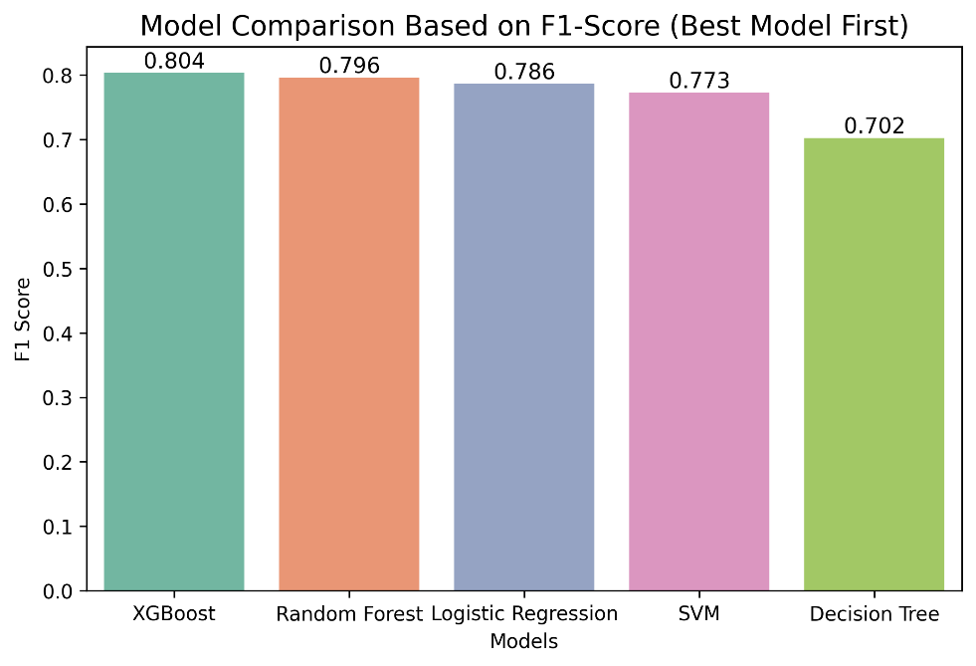

Figure 19: F1-Score Comparison Across All Models
Figure 19 shows the F1-score comparison, which is the primary evaluation metric for this project. XGBoost leads at 0.804, followed by Random Forest at 0.796, Logistic Regression at 0.786, SVM at 0.773, and Decision Tree at 0.702. The gap between the ensemble methods and Decision Tree is substantial, while the gap between XGBoost and Logistic Regression is narrower than it might appear, with Logistic Regression achieving a creditable result given its simplicity.

8.5 ROC Curves
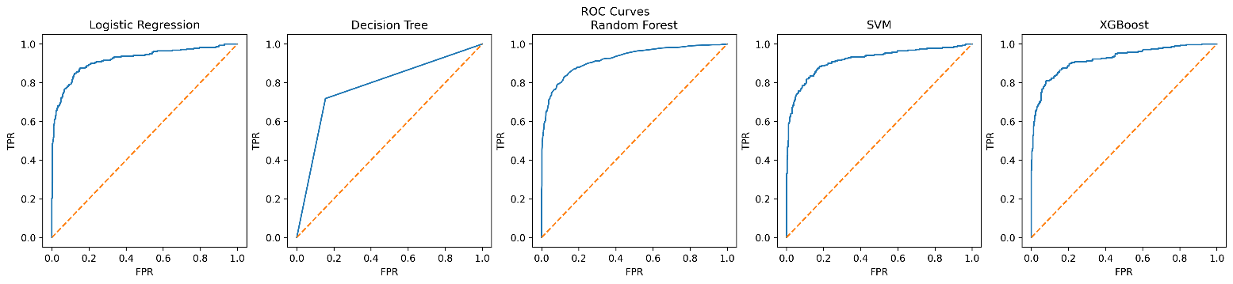
Figure 20: ROC Curves for All Five Models
Figure 20 presents the ROC curves for all models. Random Forest achieves the highest AUC at 0.924, followed by XGBoost at 0.923, Logistic Regression at 0.920, SVM at 0.917, and Decision Tree at 0.782. All models except Decision Tree exceed 0.90, confirming that the feature set contains strong discriminative signal across different classification thresholds.

8.6 Precision-Recall Curves
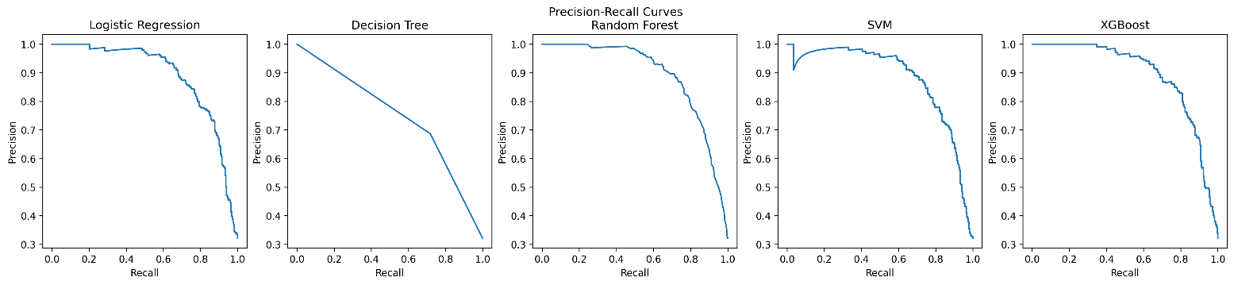
Figure 21: Precision-Recall Curves for All Five Models
Figure 21 shows the precision-recall trade-off for each model. Logistic Regression, Random Forest, SVM, and XGBoost all maintain high precision above 0.9 for low recall levels, then degrade as recall increases. The Decision Tree shows a much steeper and noisier precision-recall curve, confirming its instability. For deployment, the precision-recall curve is particularly useful because it shows how the model behaves as the threshold is adjusted to catch more dropout students at the cost of more false positives.

8.7 Model Performance Comparison Table
Model | Accuracy | Precision | Recall | F1-Score | ROC-AUC
XGBoost | 0.882 | 0.866 | 0.750 | 0.804 | 0.923
Random Forest | 0.879 | 0.867 | 0.736 | 0.796 | 0.924
Logistic Regression | 0.873 | 0.858 | 0.725 | 0.786 | 0.920
SVM | 0.871 | 0.890 | 0.683 | 0.773 | 0.917
Decision Tree | 0.805 | 0.687 | 0.718 | 0.702 | 0.782

9. Bias and Fairness Analysis
A model that treats different groups inequitably is not a good model, regardless of its aggregate accuracy. In an educational context where predictions may influence which students receive support, fairness analysis is essential. This section examines the model's explainability using SHAP and its fairness across four sensitive groups: gender, age group, debtor status, and tuition fee status.

9.1 SHAP Summary Plot
SHAP values were computed for the XGBoost model to understand how individual features push predictions toward or away from the dropout class.
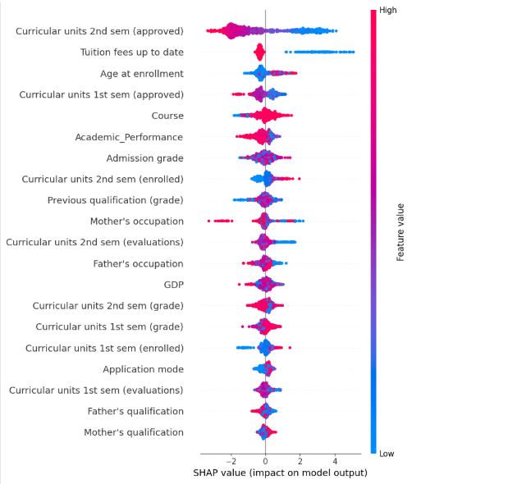
Figure 22: SHAP Summary Plot for XGBoost Model
Figure 22 shows that approved curricular units in the second semester is the most influential feature. Students with high approved-unit counts (red dots, representing high feature values) receive SHAP values pushing them far to the left, toward non-dropout predictions. Students with low or zero approved units (blue dots) are pushed strongly rightward toward dropout. Tuition fees up to date shows a similarly sharp effect: students with paid fees are pushed toward non-dropout, while those with unpaid fees are pushed toward dropout. Age at enrollment, first semester approved units, and the engineered Academic Performance feature follow as the next most impactful predictors.

9.2 Partial Dependence Plots
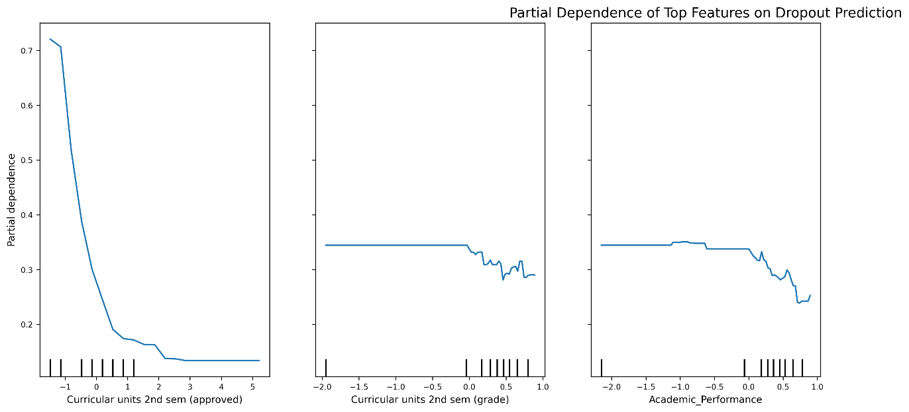
Partial Dependence Plots were generated for the three most influential features to examine how predicted dropout probability changes as individual feature values vary.
Figure 23: Partial Dependence Plots for Top Three Features
Figure 23 shows three partial dependence plots. For approved second-semester units (left panel), predicted dropout probability falls steeply from approximately 0.72 when a student passes zero units to below 0.20 when they pass five or more. This sharp nonlinear relationship explains why this feature dominates the SHAP rankings. The second-semester grade (middle panel) shows a flatter decline: dropout probability decreases modestly as grades improve above average. The Academic Performance composite feature (right panel) shows a similar pattern, with dropout probability declining as combined performance increases. These monotonic relationships confirm the model is learning coherent educational patterns.

9.3 Fairness Analysis by Gender
Actual and predicted dropout rates were compared across gender groups to assess demographic parity.
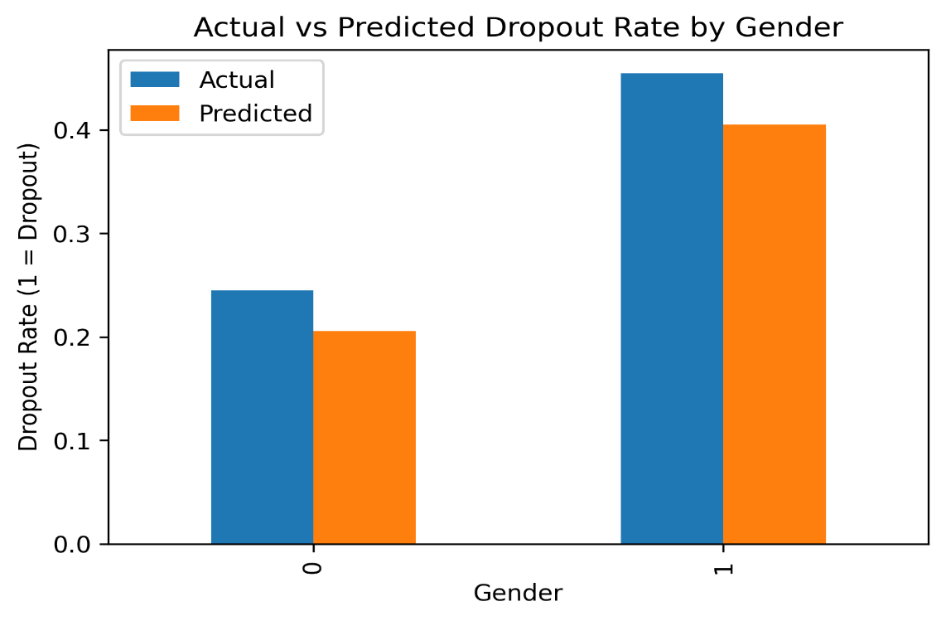

Figure 24: Actual vs Predicted Dropout Rate by Gender


Figure 25: Fairness Check: Actual vs Predicted Dropout Rate by Gender (Demographic Parity)
Figures 24 and 25 both show dropout rates by gender (female=0, male=1). Male students have a noticeably higher actual dropout rate (approximately 46 percent) compared to female students (approximately 25 percent). The model predicts rates of 41 percent and 21 percent respectively, slightly underestimating dropout for males and females alike but preserving the directional relationship. The model does not amplify the gender disparity; it follows the empirical pattern in the data. This suggests that the gender effect in predictions reflects a genuine difference in dropout rates rather than a model artifact.

9.4 Fairness Analysis by Age Group
Dropout rates were compared across five age group bands to examine whether the model captures age-related risk accurately.
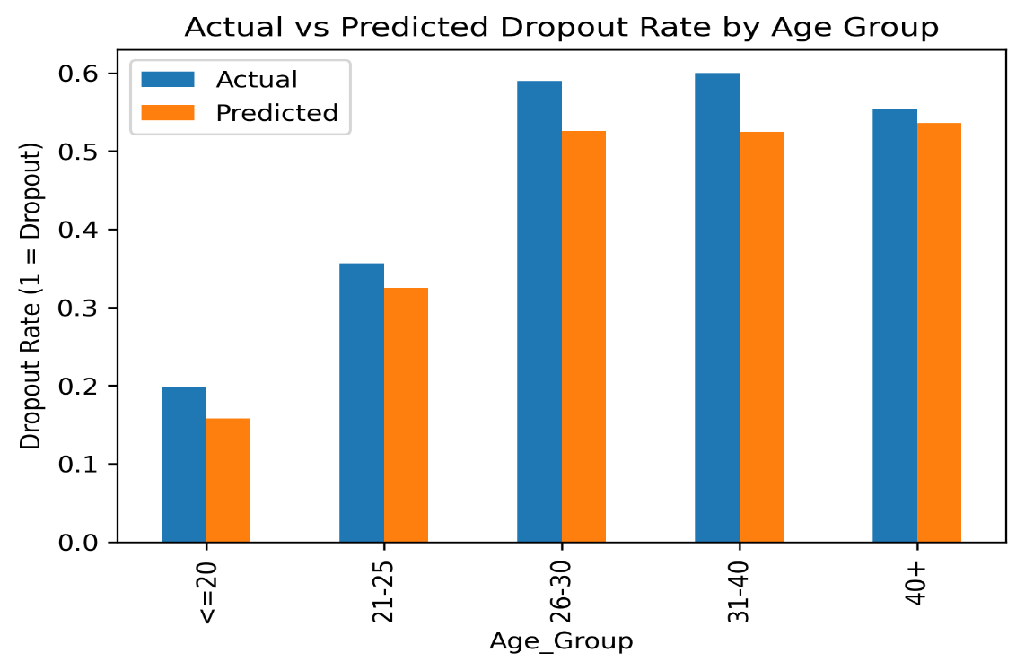

Figure 26: Actual vs Predicted Dropout Rate by Age Group
Figure 26 reveals a clear gradient: dropout rates increase substantially with age, from approximately 20 percent for students aged 20 or under to around 60 percent for students aged 26 to 40. The model tracks this gradient closely, with predicted rates slightly below actual rates for each group but capturing the same monotonic trend. This confirms that the model has successfully learned the age-dropout relationship identified in the EDA, and that older students are appropriately identified as higher risk.

9.5 Fairness Analysis by Debtor Status
Dropout rates were compared between students with and without outstanding tuition debt.
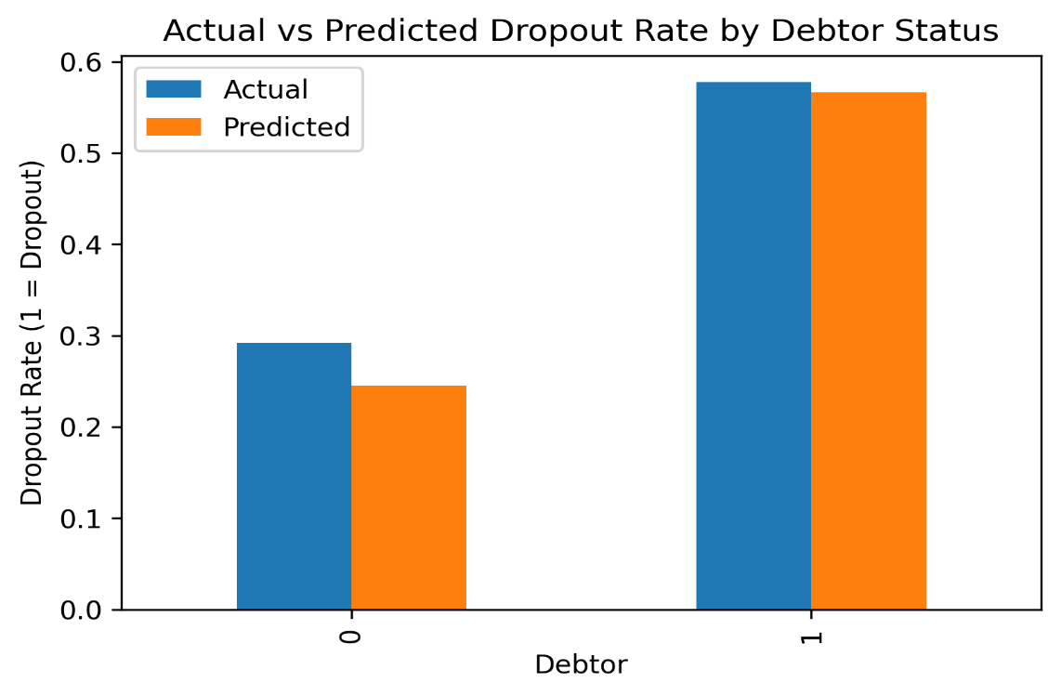

Figure 27: Actual vs Predicted Dropout Rate by Debtor Status
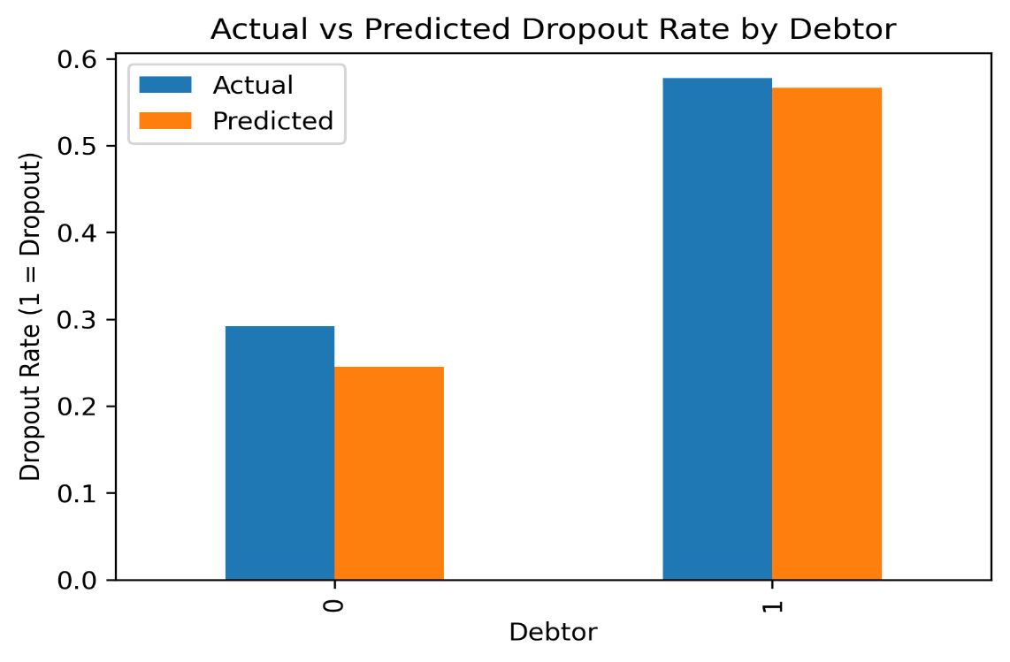

Figure 28: Fairness Check: Actual vs Predicted Dropout Rate by Debtor Status
Figures 27 and 28 confirm that debtor students (category 1) have an actual dropout rate of approximately 58 percent, compared to roughly 29 percent for non-debtors. The model predicts 57 percent and 25 percent respectively, closely matching the actual rates for debtors and slightly underestimating for non-debtors. The model does not distort the debtor penalty; it accurately reflects the empirical reality that financial obligation is strongly associated with dropout.

9.6 Fairness Analysis by Tuition Fee Status
Dropout rates were compared between students with paid and unpaid tuition fees.
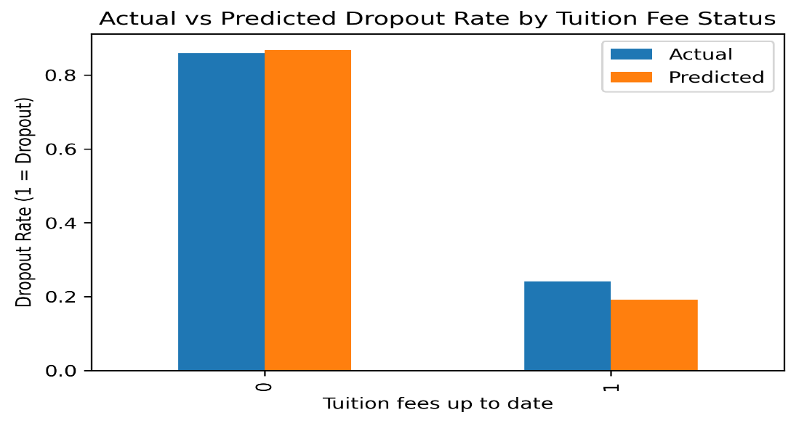

Figure 29: Actual vs Predicted Dropout Rate by Tuition Fee Status
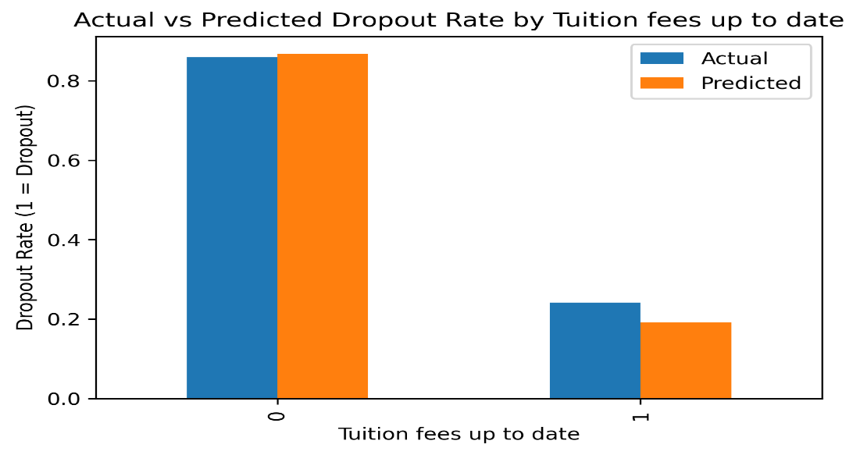

Figure 30: Fairness Check: Actual vs Predicted Dropout Rate by Tuition Fee Status
Figures 29 and 30 show perhaps the most striking disparity in the dataset. Students with unpaid tuition fees (category 0) have an actual dropout rate above 85 percent, while students with up-to-date fees (category 1) have a dropout rate around 25 percent. The model predicts approximately 88 percent and 19 percent respectively, capturing the relationship with high accuracy. This variable has an extremely strong signal, and the model has learned it correctly. The near-perfect alignment between actual and predicted rates here also indicates low fairness concern specific to this variable.

9.7 Ethical Implications
The fairness analysis confirms that the model predictions reflect genuine patterns in the data rather than introducing new biases. However, several ethical considerations remain. First, predicting dropout based on demographic attributes such as gender or age means the model implicitly encodes historical inequalities. A student who falls into a higher-risk demographic group will be flagged more readily, which could feel stigmatizing if not handled carefully. Institutions must communicate clearly that a flag is an invitation to offer support, not a judgment about the student.
Second, the model should function as a decision-support tool, not an automated decision-maker. Academic advisors must review predictions in context, and students should have recourse to question or appeal a flag. Third, the model should be retested periodically as student populations and institutional policies change, to ensure that its patterns remain valid and have not drifted in ways that introduce new fairness concerns.

10. Results and Discussion
The results of this project are consistent with the broader educational research literature and confirm several well-established findings. Academic performance during the first and second semesters emerged as the strongest predictor of dropout, ahead of demographic and socioeconomic variables. Students who struggle academically in the first year are at substantially elevated risk of not completing their degree, and early academic support programs targeting this cohort could yield significant retention improvements. Financial factors were the second most important predictor category. Tuition fee payment status and debtor classification both appeared consistently across feature importance analyses, SHAP values, and correlation results. Institutions that identify financially precarious students early and connect them with scholarship programs or flexible payment arrangements may be able to interrupt the pathway from financial difficulty to dropout.
The performance gap between XGBoost and simpler models was real but narrower than expected. Logistic Regression achieved an F1-score of 0.786 and ROC-AUC of 0.920, indicating that much of the predictive signal in the dataset is linear. The additional gain from gradient boosting likely comes from capturing higher-order interactions, such as the combined effect of low grades and unpaid fees being more predictive than either variable alone. These interaction effects are practically important, which justifies the additional complexity of ensemble methods.
SVM's high precision of 0.890 but lower recall of 0.683 reflects a conservative prediction style. When SVM flags a student as at risk, it is correct 89 percent of the time, but it misses a larger fraction of genuine dropout students than XGBoost or Random Forest. In a context where missing an at-risk student carries higher costs than an unnecessary intervention, this precision-recall trade-off makes SVM a less suitable deployment choice than the ensemble models.

11. Conclusion
This project developed a complete machine learning pipeline for predicting student dropout risk, from problem framing and data collection through preprocessing, feature engineering, model training, evaluation, and fairness analysis. The dataset provided a rich combination of academic, demographic, and financial attributes across 4,424 student records.
XGBoost emerged as the best-performing model with 88.2 percent accuracy and an F1-score of 0.804, supported by a ROC-AUC of 0.923. Its predictions are driven primarily by second-semester approved units and tuition fee payment status, both of which are interpretable and actionable for educational institutions. SHAP analysis confirmed the model reasons in coherent educational terms, and the partial dependence plots show clean monotonic relationships that align with common sense.
The fairness analysis across gender, age group, debtor status, and tuition fee status found that the model predictions track actual dropout rates closely across all groups, without amplifying existing disparities. The model does reflect real demographic differences in dropout risk, which requires careful communication and a support-first deployment philosophy rather than a punitive one.

12. Future Work
One direction worth pursuing is the incorporation of behavioural and engagement data from learning management systems. Assignment submission rates, forum participation, and login frequency could capture early disengagement signals not reflected in semester-end grades, enabling earlier identification of at-risk students.
On the modeling side, systematic hyperparameter optimization through cross-validated search was not fully explored. Tuning XGBoost parameters such as learning rate, tree depth, and subsampling rate could yield further gains, and applying the same rigor to all models would make the comparison more definitive.
Longitudinal validation is the most important direction for future work. A model trained on one institutional cohort should be retested on subsequent cohorts to verify that its predictive relationships remain stable as student populations and institutional practices evolve. Without temporal validation, there is a risk that the model captures patterns specific to a particular period rather than durable characteristics of the dropout phenomenon.
Finally, deploying the model as a real-time early warning system integrated with a student information system would allow its actual impact on retention rates to be measured. The academic literature contains relatively few evaluations of whether predictive models, once deployed and acted upon, actually improve outcomes. Closing that gap requires institutions to build feedback loops that track which students were flagged, what interventions were offered, and what happened next.

References
Dataset
Realinho, V., Machado, J., Baptista, L., & Martins, M. V. (2022). Predicting student dropout and academic success. Data, 7(11), 146. https://doi.org/10.3390/data7110146
Machine Learning Method
Chen, T., & Guestrin, C. (2016). XGBoost: A scalable tree boosting system. Proceedings of the 22nd ACM SIGKDD International Conference on Knowledge Discovery and Data Mining, 785–794. https://doi.org/10.1145/2939672.2939785
Model Evaluation and Explainability
Lundberg, S. M., & Lee, S.-I. (2017). A unified approach to interpreting model predictions. Advances in Neural Information Processing Systems, 30, 4765–4774. https://proceedings.neurips.cc/paper/2017/hash/8a20a8621978632d76c43dfd28b67767-Abstract.html

