Table of Contents

Hive — Capstone Report
Structured to Document-format.docx. Section numbering, chapter order and front matter match the template exactly. Pour into Word and apply the formatting rules in the closing section.
«…» marks the only things I cannot supply — your name, roll number, supervisor, dates, and supervisor remarks. Everything else is written and sourced.
Every figure is traced to a dated run. Where something was not verified, the report says so. See §3.3.4 and §6.3.

COVER PAGE
Project Title: Hive — A Privacy-First Photo Sharing Platform for Preschools
Student Name(s) & Roll Number(s): «Your name — roll number» (Team: Srujan, Ruthwik, Bhargav, Nagachaitanya)
Program: BSc Computer Science (Online Mode)
Institution: «Institution name»
Academic Year: 2025–2026
Internal Supervisor: «Supervisor name»

DECLARATION
I hereby declare that this capstone project titled “Hive — A Privacy-First Photo Sharing Platform for Preschools” is an original work carried out by me/us and has not been submitted to any other university or institution for the award of any degree.
«Signature» · «Date»

ABSTRACT
(268 words)
Preschools routinely share classroom photographs with parents, and the obvious implementation — a shared album — is unacceptable: it exposes every child’s face to every parent. This project delivers Hive, a photo-sharing platform built so that a parent sees photographs of their own children and nothing else.
The system comprises a React Native mobile application, a 40-endpoint Express and TypeScript API, and a PostgreSQL database provisioned through Supabase with 20 migrations, row-level security policies and database triggers. Photographs are held in a private object store and served only through signed, expiring URLs. Three roles are supported: teachers upload and tag photographs, parents view a privacy-scoped feed and order prints, and administrators manage schools, classes, students and users.
The central engineering constraint is that the API authenticates using a service-role credential which bypasses row-level security by design. Authorization is therefore enforced explicitly in the service layer, and every resource accessed by identifier is checked against the caller. A formal audit identified 46 defects, of which the most serious permitted cross-family access to photograph metadata, cross-school access to student rosters including dates of birth, and an entirely non-functional ordering flow.
Validation used 218 automated integration tests executing against a real PostgreSQL instance, together with a scripted security verification returning 27 passed, 0 failed and 2 skipped, reproduced from a cold start. A deliberate sabotage exercise confirmed the suite detects the regressions it targets and additionally exposed a pre-existing test that had never verified the property its name claimed. Privacy scoping was measured directly: of six photographs, two parents saw two and one respectively, with zero overlap.
The system has not been deployed; consequently no load-test measurements exist.
Keywords: privacy by design, access control, REST API, React Native, PostgreSQL, integration testing

TABLE OF CONTENTS
Chapter | Page
1. Introduction | «»
2. Implementation Details | «»
3. Testing, Validation & Results | «»
4. Execution / Deployment Details | «»
5. Project Execution Evidence | «»
6. Conclusion & Future Work | «»
References | «»
Appendix | «»
(Generate in Word: References → Table of Contents, after applying Heading styles.)

LIST OF FIGURES
Fig. | Caption | Page
2.1 | High-level system architecture | «»
2.2 | Data flow — photograph upload to parent notification | «»
2.3 | Entity-relationship diagram | «»
2.4 | Component interaction — authorization pipeline | «»
2.5 | Teacher upload screen with student tagger | «»
2.6 | Parent feed with child switcher | «»
2.7 | Order placement and confirmation | «»
2.8 | Administrator dashboard | «»
3.1 | Test suite execution — 218 tests passing | «»
3.2 | Security verification output — 27/0/2 | «»
3.3 | Sabotage exercise — targeted tests failing | «»
3.4 | Privacy comparison — two parents, zero overlap | «»
3.5 | Signed URL 200 versus stripped-token 400 | «»
4.1 | Health endpoint, healthy and degraded | «»
5.1 | Commit history — 422 commits | «»
5.2 | Continuous integration run | «»

LIST OF TABLES
Table | Caption | Page
2.1 | Technology stack and rationale | «»
2.2 | Authorization layers and trust | «»
2.3 | Database tables | «»
2.4 | Representative API endpoints | «»
3.1 | Test suite composition | «»
3.2 | Test cases and results | «»
3.3 | Runtime functional verification | «»
3.4 | Security verification results | «»
3.5 | Defects identified and resolved | «»
3.6 | Properties not verified | «»
5.1 | Weekly progress summary | «»

LIST OF ABBREVIATIONS
Term | Expansion
API | Application Programming Interface
CI | Continuous Integration
CORS | Cross-Origin Resource Sharing
DSN | Data Source Name
HEIC | High Efficiency Image Container
IDOR | Insecure Direct Object Reference
JWT | JSON Web Token
MIME | Multipurpose Internet Mail Extensions
ORM | Object-Relational Mapping
REST | Representational State Transfer
RLS | Row Level Security
SQL | Structured Query Language
UUID | Universally Unique Identifier

CHAPTER 1: INTRODUCTION
Problem identification and system design were completed in the Study Project. This chapter summarises them; §1.6 records what changed during implementation.

1.1 Overview of the project
Hive is a photo-sharing platform for preschools. A teacher photographs classroom activity and tags the children who appear in each image. Each parent then sees only the photographs their own children appear in. Parents may order prints; administrators manage the institutional data.

1.2 Problem statement and motivation
Preschools want to share daily classroom activity with parents. The straightforward implementation — a shared album or a broadcast messaging group — exposes every child’s face, name and activity to every parent in the class. For a setting composed entirely of minors, that is not a minor usability concern; it is a safeguarding failure.
The requirement that defines the product is therefore: a parent must see photographs of their own children and nothing else — not “mostly”, and not “unless they guess an identifier”.
Three consequences follow, and they justify most of the design:
- Access control cannot be a client concern, because the client is not trustworthy.
- Photograph URLs cannot be public or guessable.
- The visibility rule is a join across families and photograph tags, not a filter that can be applied afterwards.

1.3 Objectives of the capstone
- Implement teacher, parent and administrator experiences end to end.
- Enforce the privacy boundary server-side and demonstrate it holding under adversarial probing.
- Serve photographs only through signed, expiring URLs from a private store.
- Deliver a functioning print-ordering flow with correct monetary arithmetic and idempotent submission.
- Validate the system with automated integration tests executing against a real database.
- Remediate the defects identified by the project audit.

1.4 Scope of implementation
In scope: mobile application for three roles; REST API; relational schema with row-level security and triggers; private photograph storage with signed URLs; synchronous image processing (thumbnail, blurhash, format conversion); in-app notifications generated by database triggers; print ordering with server-side pricing; administrator console; automated test suite; scripted security verification.
Out of scope: payment gateway integration; push notifications; offline mode; video; multi-language support; tablet-optimised layouts.

1.5 Organization of the report
Chapter 2 describes the implementation — architecture, technology, modules and core logic. Chapter 3 covers testing strategy, test cases and measured results. Chapter 4 records the execution environment and deployment position. Chapter 5 presents version-control and progress evidence. Chapter 6 concludes and identifies future work.

1.6 Changes from the Study Project design
Two departures are worth recording, both made on evidence:
Asynchronous image processing was removed. The original design queued thumbnail generation through BullMQ with an S3 backend. During implementation a repository-wide search for queue enqueue calls found none: neither queue had ever been used, and both workers targeted S3 while files were written to local disk. Approximately 1,500 lines of dependency graph were deleted in favour of a synchronous sharp call taking 100–300 ms.
Monetary values were migrated to integer minor units. The original schema used decimal(10,2). §2.4.2 explains the failure this caused, and the later move from the US dollar to the Indian rupee that leaves the *_cents columns holding paise.

CHAPTER 2: IMPLEMENTATION DETAILS

2.1 System architecture and design

2.1.1 High-level architecture
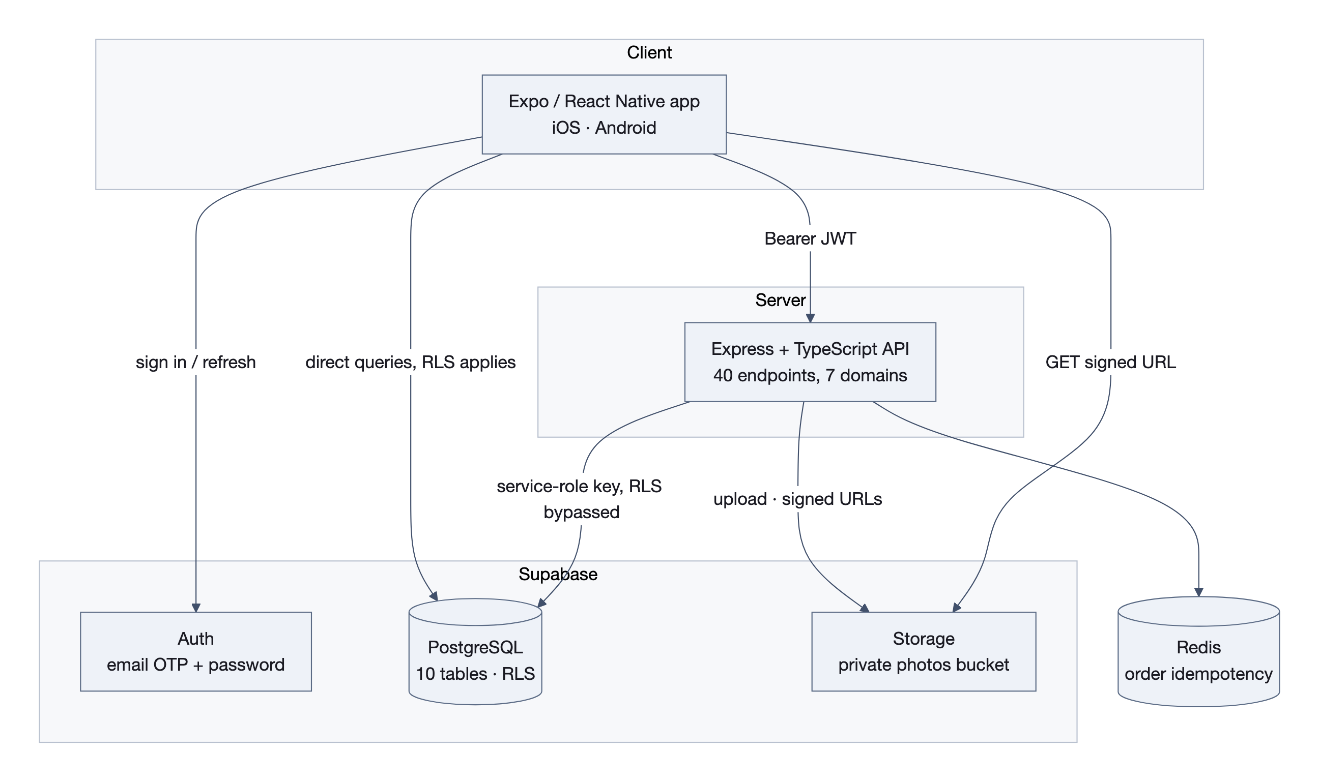
Figure 2.1 — High-level system architecture
┌──────────────────────────────────────────────────────────────┐
│ PRESENTATION — React Native (Expo) │
│ role-scoped screens · Zustand · TanStack Query │
└───────────────┬──────────────────────────┬───────────────────┘
│ REST + JWT │ direct (RLS-guarded)
▼ ▼
┌──────────────────────────────────┐ ┌────────────────────────┐
│ APPLICATION — Express API │ │ Supabase Auth │
│ authenticate → roleGuard → │ │ GoTrue: JWT, refresh │
│ validate(Zod) → controller → │ └────────────────────────┘
│ service (ownership enforced) │
└───────────────┬──────────────────┘──▶ Supabase Storage
│ private bucket,
▼ signed URLs only
┌────────────────────┐
│ DATA — PostgreSQL │
│ 20 migrations │
│ RLS + triggers │
└────────────────────┘
The constraint that shapes the whole system: the API authenticates using the service-role credential, which bypasses row-level security by design. RLS therefore protects only those queries the mobile application issues directly to Supabase. Every API endpoint must enforce authorization explicitly, in the service layer.
Three of the audit’s most serious findings share exactly this root cause: code that assumed RLS was covering it. This is documented prominently in the repository because it is the single most dangerous assumption a new contributor can make.

2.1.2 Data flow — upload to notification
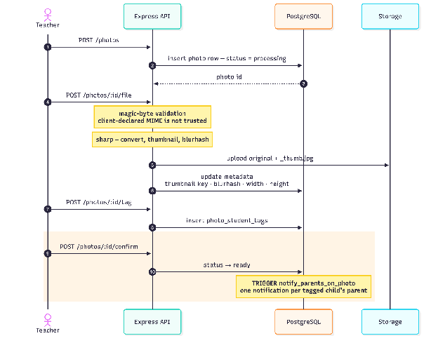
Figure 2.2 — Data flow — photograph upload to parent notification
Teacher API Database Storage
│ │ │ │
├─ POST /photos ─────▶│─ insert (processing) ───▶│ │
│ │ │ │
├─ POST /:id/file ───▶│─ magic-byte validate │ │
│ │─ sharp: convert, thumb, │ │
│ │ blurhash ──────────────────────────────▶│
│ │─ update metadata ───────▶│ │
│ │ │ │
├─ POST /:id/tag ────▶│─ insert tags ───────────▶│ │
│ │ │ │
├─ POST /:id/confirm ▶│─ status → 'ready' ──────▶│ │
│ │ TRIGGER fires: │
│ │ one notification per │
│ │ tagged child's parent │
The ordering is load-bearing. The trigger fires on the transition to ready and iterates the tags existing at that instant. Confirming before tagging produces zero notifications — silently. The system appears to work and the feature is dead. This was a real defect (G-07); the seed script now carries a prominent comment about it and §3.3.2 records its verification.

2.1.3 Component interaction — the authorization pipeline
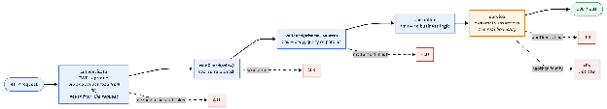
Figure 2.4 — Component interaction — authorization pipeline
Every request traverses the same chain:
authenticate → roleGuard(role…) → validate(schema, source) → controller → service
JWT → coarse role Zod, rejects 400 thin ownership
profile check, 403 assertions
Table 2.2 — Authorization layers and trust
Layer | Location | Trusted | Purpose
RoleGate | Mobile, features/auth/components/ | No | UX only. Prevents the wrong screen rendering; removable in a modified build
roleGuard | API middleware | Yes | Coarse role check — returns 403
Ownership assertions | API service layer | Yes | The real boundary. Every resource fetched by ID checked against the caller
A signed Storage URL is a bearer capability: whoever holds it can fetch the object until it expires. It must therefore never be minted for a caller who is about to be refused. Authorization precedes signing. A test asserts that a refused response contains no signed URL.

2.2 Technology stack
Table 2.1 — Technology stack and rationale
Layer | Technology | Version | Rationale
Language | TypeScript | 5.4 | Strict mode; catches contract drift between client and API at compile time
Mobile | React Native / Expo | SDK 51 | Single codebase for iOS and Android; removes native build tooling from the critical path
Routing (mobile) | expo-router | 3.x | File-based routing with typed route parameters
Client state | Zustand | 4.x | Minimal boilerplate for UI state
Server state | TanStack Query | 5.x | Caching and invalidation kept separate from UI state
API | Node.js / Express | 20+ / 4.19 | Team fluency; mature middleware ecosystem
Validation | Zod | 3.23 | One schema yields both the runtime check and the static type
Database | PostgreSQL (Supabase) | 15 | Relational integrity — the privacy rule is a join, not a filter
Authentication | Supabase Auth (GoTrue) | — | Delegates password hashing, JWT issuance and refresh
Storage | Supabase Storage | — | Private bucket; signed expiring URLs
Image processing | sharp | 0.33 | Native libvips; 100–300 ms per photograph
Placeholders | blurhash | 2.0 | Compact progressive-loading placeholder
Idempotency | Redis (ioredis) | 7 | Deduplicates retried order submissions
Logging | Winston | 3.13 | Structured logs with request correlation
Testing | Vitest + Supertest | 4.x / 7.x | Executes the real application against a real database
Load testing | k6 | — | Written; not executed (§3.3.4)
CI | GitHub Actions | — | Lint, typecheck and build on every push
Monorepo | pnpm workspaces + Turborepo | 9.1.0 | Shared tooling, cached task graph

2.3 System modules
Table 2.3 — Database tables
Table | Purpose
schools | Tenant root
profiles | Extends auth.users; carries role and school assignment
classes | Classroom, optionally led by a teacher
students | Enrolled children
parent_student_mappings | Many-to-many. The privacy rule lives here
photos | Metadata; s3_key holds a Supabase Storage path (name is historical)
photo_student_tags | Which children appear in which photograph
orders | Print orders; totals in integer paise, priced server-side (total_cents is historical — see §2.4.2)
order_items | Line items; photo_id is ON DELETE RESTRICT
notifications | In-app, generated by triggers
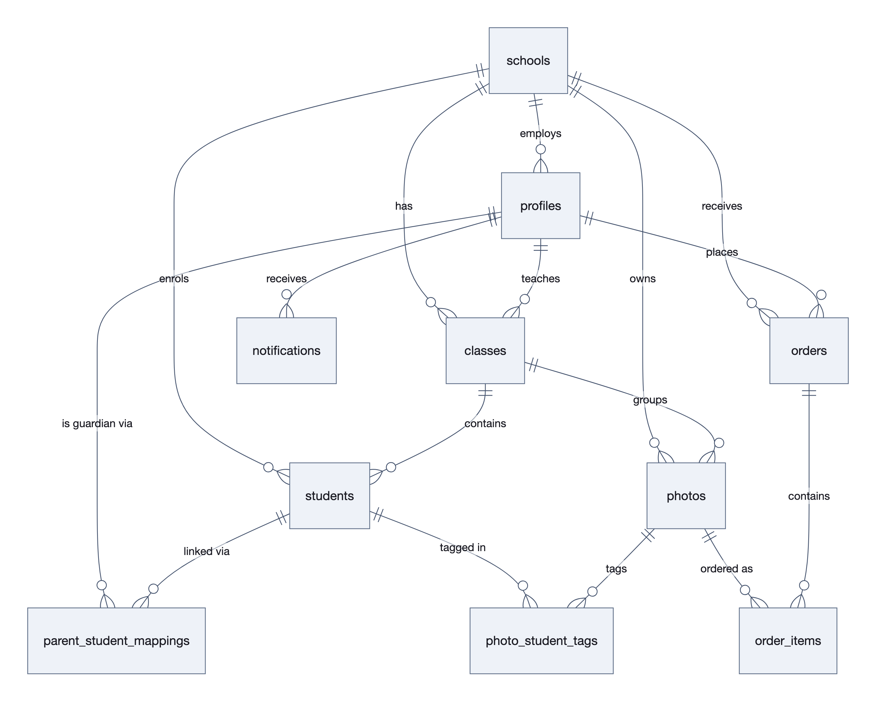
Figure 2.3 — Entity-relationship diagram

2.3.1 Authentication and authorization module
Issues and verifies JWTs through Supabase Auth; resolves role and school from profiles rather than trusting the request. Supports password sign-in for all roles and one-time-passcode sign-in.

2.3.2 Photograph module
Upload in four steps (metadata → file → tag → confirm), magic-byte validation, format conversion, thumbnail generation, blurhash computation, and archival. Ownership is asserted on every mutation.

2.3.3 Feed module
Cursor-paginated parent feed, scoped by the parent-student mapping and de-duplicated by photograph identifier, so a photograph tagged with two siblings appears once.

2.3.4 Ordering module
Server-side pricing from a shared catalogue, integer-cent arithmetic, transactional creation, and idempotent submission keyed on a client-supplied header.

2.3.5 Notification module
Database triggers generate notifications when a photograph becomes visible; unread counts and read-state transitions are exposed over the API.

2.3.6 Administration module
School, class, student, parent-mapping and user management, with a dashboard aggregating counts and revenue.
Table 2.4 — Representative API endpoints (40 registrations in total)
Method | Path | Role | Note
GET | /feed | parent | Cursor-paginated; scoped to the caller’s children
GET | /feed/photos/:id | parent | 404, not 403, if not the caller’s
POST | /photos | teacher | Metadata; returns upload target
POST | /photos/:id/file | teacher | Multipart; magic-byte validated
POST | /photos/:id/tag | teacher | Bounded at 50 students
POST | /photos/:id/confirm | teacher | Flips to ready; fires notifications
POST | /orders | parent | Idempotent via x-idempotency-key
GET | /orders/:id | parent | Items carry signed thumbnail URLs
GET | /admin/users | admin | Search parameterised, not interpolated
GET | /health | public | Database round-trip; 503 when degraded

2.4 Key algorithms and logic

2.4.1 Privacy-scoped feed resolution
The parent feed is not a filter applied to a global list; it is a join resolved from the family mapping.
FUNCTION getFeed(parentId, cursor, limit):
studentIds ← SELECT student_id FROM parent_student_mappings
WHERE parent_id = parentId
IF studentIds is empty: RETURN empty page
photoIds ← SELECT DISTINCT photo_id FROM photo_student_tags
WHERE student_id IN studentIds -- DISTINCT: siblings
rows ← SELECT … FROM photos
WHERE id IN photoIds
AND status = 'ready' -- unconfirmed excluded
AND (created_at, id) < cursor -- keyset pagination
ORDER BY created_at DESC, id DESC
LIMIT limit + 1 -- +1 detects next page
signedUrls ← batchSign(rows.thumbnailKey ?? rows.originalKey)
RETURN rows joined with signedUrls, nextCursor
Three details carry weight. DISTINCT prevents a photograph tagged with two siblings appearing twice. Keyset pagination on the composite (created_at, id) avoids the row-skipping that OFFSET suffers under concurrent inserts — and the timestamp must retain microsecond precision, because truncating to milliseconds caused rows to be dropped at page boundaries (a regression found and fixed during implementation; cursor.test.ts now guards it). URLs are signed only after the rows are known to be permitted.

2.4.2 Monetary arithmetic
The failure. Columns were decimal(10,2) documented as US dollars; the API wrote integer cents into them, while the client priced in dollars and rendered toFixed(2). Every price therefore reached the customer a hundredfold too high — in the direction that overcharges. The digital download was priced at 299 cents, $2.99; it was stored as 299.00 and displayed as $299.00.
A note on this example, because the figures in circulation disagree. Migration 00017’s comment records the case as “a $4.99 print stored as 299.00”, which crosses two products: in the July catalogue print_4x6 was 499 cents and digital_download was 299. Either one demonstrates the same hundredfold error by the same mechanism, but the pair as written is not self-consistent — a $4.99 print would have stored 499.00. The 299 figure appears twice in that comment and $4.99 once, so the digital download is the likelier original, and it is the version used above. This is corrected in the open rather than quietly, because the migration comment still carries the original wording and a reader who checks will find the discrepancy.
The resolution. Integer minor units everywhere. Migration 00017 renamed total_amount → total_cents and unit_price → unit_price_cents, retyping both to integer using ROUND(...) rather than truncation. Conversion to a display string occurs exactly once, at render.
The currency then moved to the Indian rupee. The catalogue was re-priced for the Indian market during the interface revision of 13 August: a 4×6 print is ₹30, a photo book ₹499. Money is now integer paise, and the render helper is formatRupees:
formatRupees(49900) // '₹499'
formatRupees(4950) // '₹49.50'
formatRupees(1234567) // '₹12,345.67'
Grouping is Indian — 12,34,567, not 1,234,567 — and is hand-rolled rather than delegated to Intl.NumberFormat('en-IN'), because Hermes ships without full ICU on Android unless the build opts in, and a total that silently falls back to Western grouping on one platform is a defect nobody reports.
The *_cents column names were deliberately left alone. They hold whatever the minor unit of the current currency is. Renaming them would require a migration, a regenerated supabase.ts and a sweep through every service for no behavioural gain — the same reasoning that leaves photos.s3_key holding a Supabase Storage path. So total_cents: 6000 means ₹60, and the reader should expect that mismatch between column name and unit throughout.
A single shared catalogue defines the seven product types, their integer-paise prices and their labels; the backend imports it and the mobile application mirrors it, with a test asserting the two agree. The client no longer sends a price at all — the server prices every order from its own catalogue, so a caller cannot determine their own total. This is a security property, and it has a test.

2.4.3 Transactional order creation
The original implementation inserted the order, then the items, then issued a compensating DELETE if the second insert failed. A crash between the two left an order with no items — and the compensation never executed, because the process had terminated.
CREATE FUNCTION create_order_with_items(…, p_items jsonb) RETURNS uuid AS $$
BEGIN
IF jsonb_array_length(p_items) = 0 THEN
RAISE EXCEPTION 'An order must contain at least one item';
END IF;
INSERT INTO orders (…) VALUES (…) RETURNING id INTO v_order_id;
INSERT INTO order_items (…) SELECT … FROM jsonb_array_elements(p_items);
RETURN v_order_id;
END; $$ LANGUAGE plpgsql;
A function body is a single transaction: either both inserts land or neither does. Verified in §3.3.1 by deliberately failing the item insert.

2.4.4 Idempotent submission
Retrying a submission over an unreliable mobile network must not produce a second order. The client generates a UUID and sends it as x-idempotency-key; middleware records the key in Redis with the resulting order identifier. A repeated key returns the original order rather than creating another. Verified in §3.3.1.

2.4.5 Referential integrity
Three foreign keys were declared NOT NULL and ON DELETE SET NULL — which are mutually exclusive. Deleting the referenced row causes PostgreSQL to write NULL into a NOT NULL column, raising a not-null violation instead of cascading. The practical consequence was that deleting any profile or photograph was impossible, failing with an error that did not explain why. Migration 00018 changed all three to ON DELETE RESTRICT, which states the intent honestly: a teacher who still has photographs cannot be removed without first deciding what becomes of them.

2.5 Screenshots and code sections
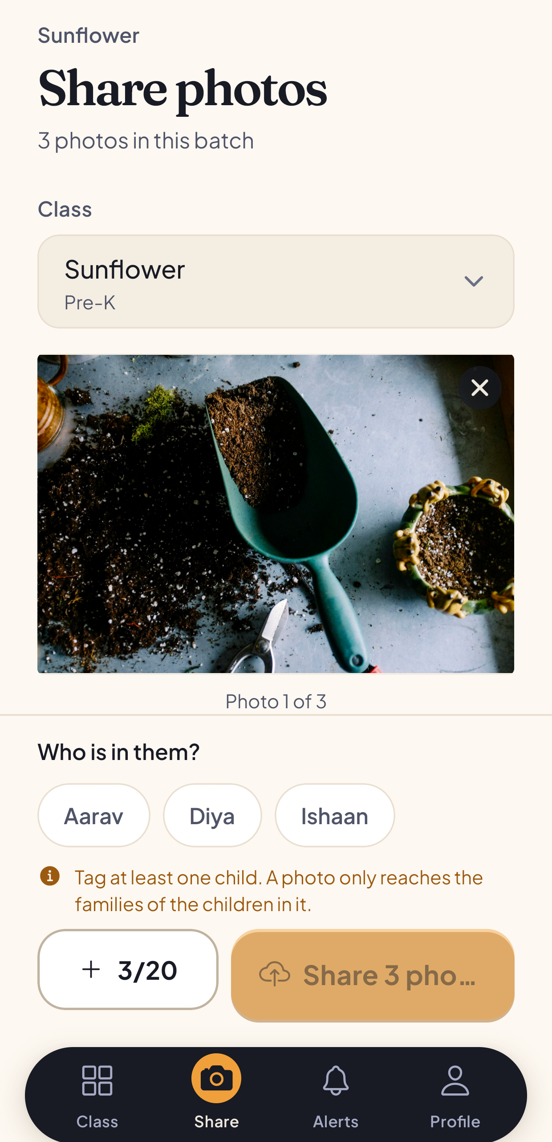
Figure 2.5 — Teacher upload screen with student tagger
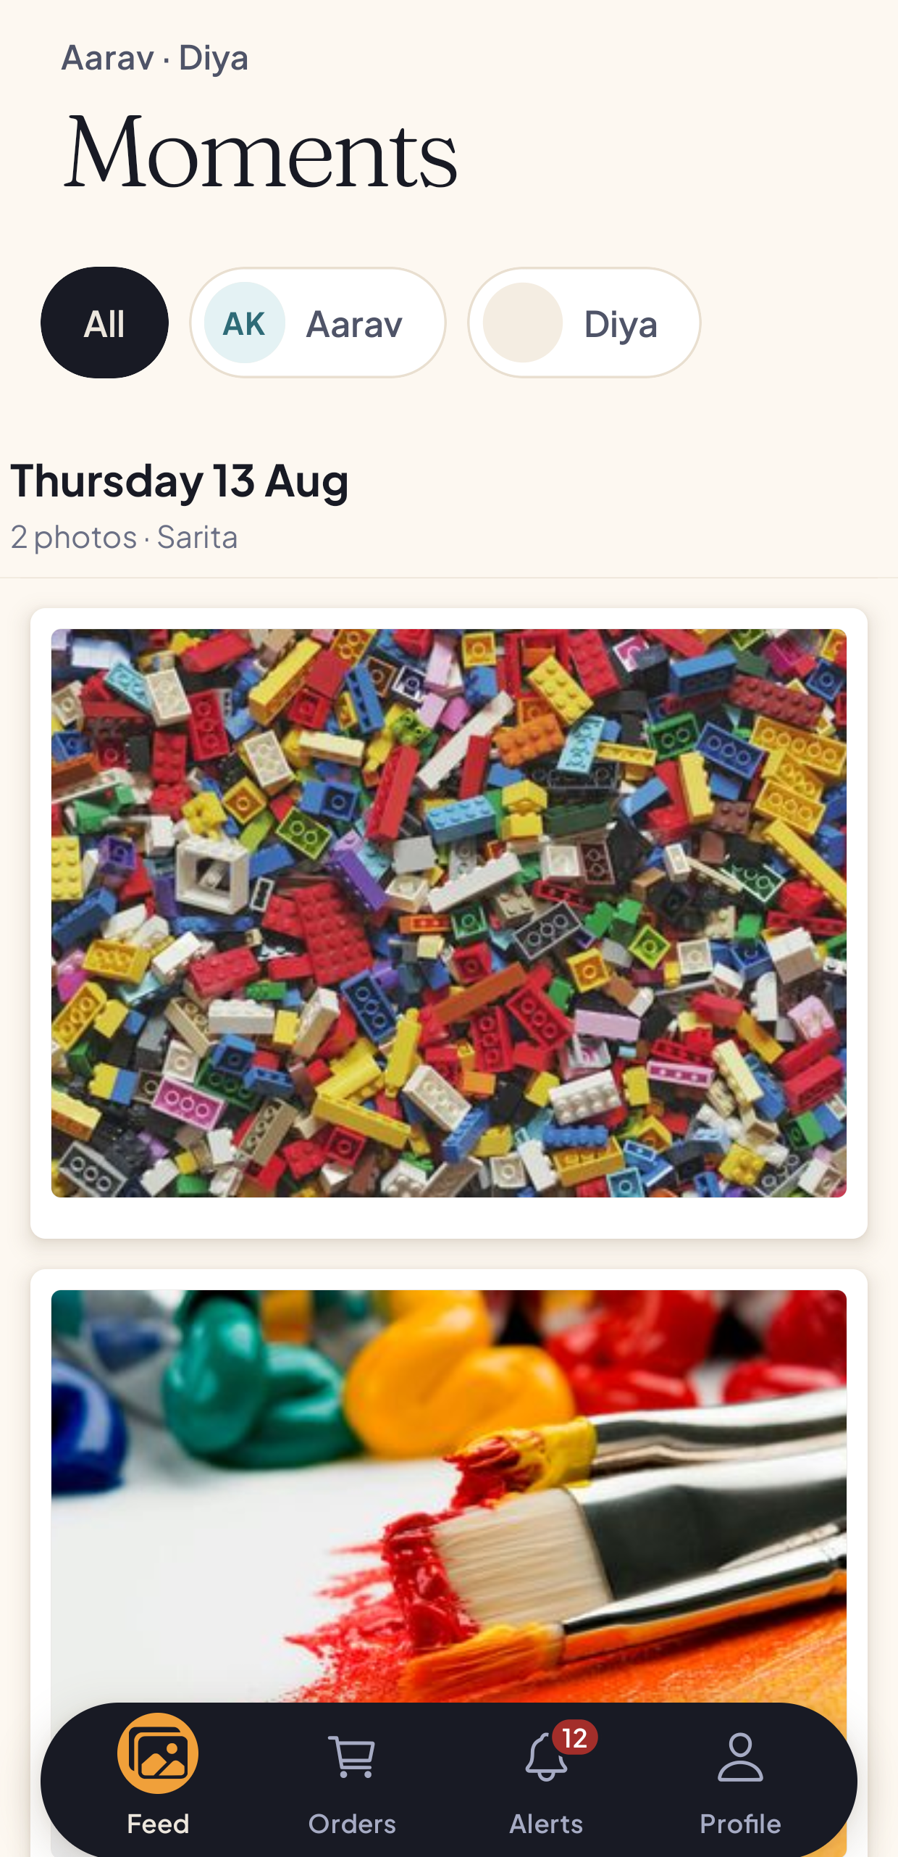
Figure 2.6 — Parent feed with child switcher
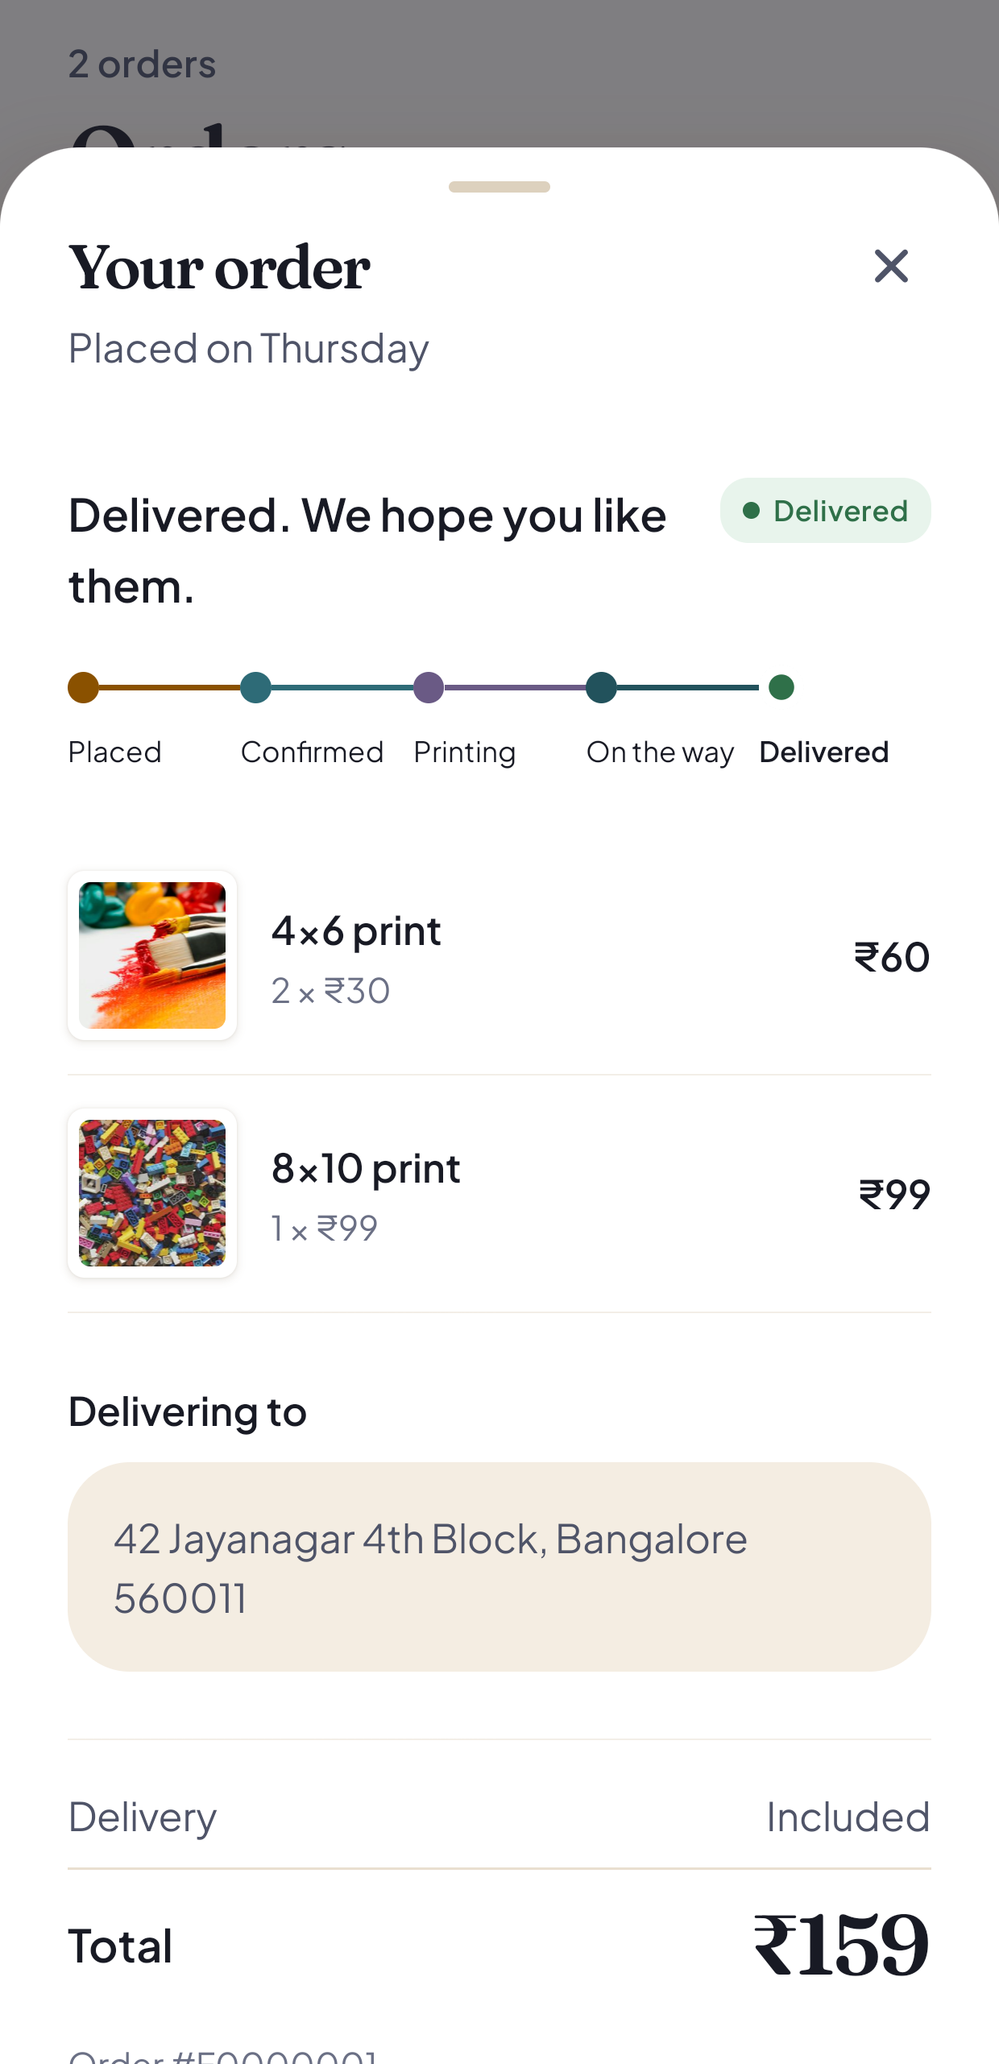
Figure 2.7 — Order placement and confirmation
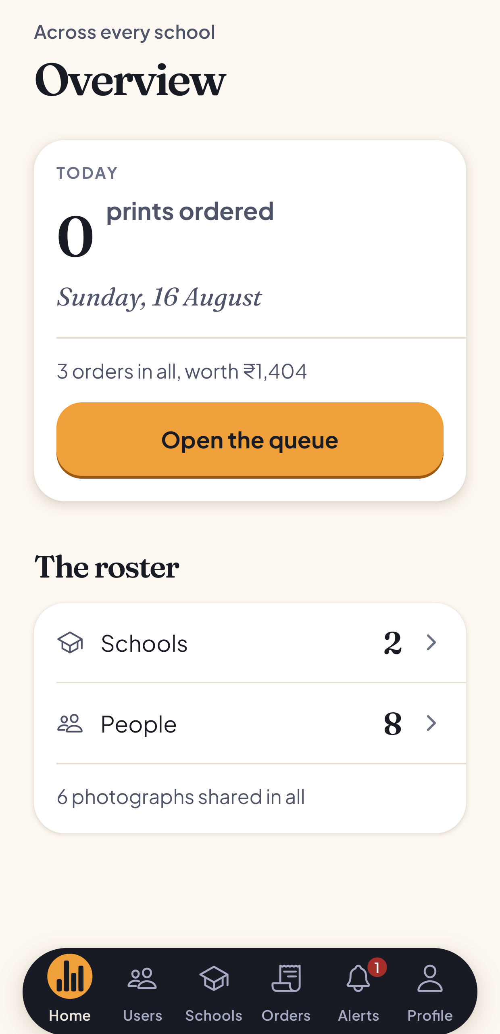
Figure 2.8 — Administrator dashboard
Listing 2.1 — Ownership assertion (the real authorization boundary)
// A signed URL is a bearer capability. Authorization must precede signing,
// never follow it.
export async function assertPhotoAccess(photo, user) {
if (user.role === 'admin') return;
if (photo.school_id !== user.schoolId) {
throw new AppError('You do not have access to this school', 403, 'FORBIDDEN');
}
if (user.role === 'teacher' && photo.uploaded_by !== user.id) {
throw new AppError('Not your photo', 403, 'FORBIDDEN');
}
}
Listing 2.2 — Server-side pricing
// No unitPrice is accepted from the client. The server prices every order
// from its own catalogue; a client-supplied price would let a caller set
// their own total.
const unitPriceCents = PRODUCT_PRICES_CENTS[item.productType];
subtotal += unitPriceCents * item.quantity;

CHAPTER 3: TESTING, VALIDATION & RESULTS

3.1 Test plan

3.1.1 Strategy
Three layers, each catching what the others cannot:
Layer | Method | Frequency
Static | TypeScript (both packages), ESLint, production build | Every push, via CI
Automated integration | Vitest + Supertest against a real PostgreSQL | Before merge
Runtime verification | Scripted security checklist; manual probes with real tokens | Per milestone
Why integration rather than unit testing. The ordering defect is the argument. Field naming, product vocabulary and currency unit each disagreed between layers, yet every layer was internally consistent and would have passed its own unit tests. Only a request travelling through the real middleware into a real database exposes a contract mismatch between layers.

3.1.2 Tools
Vitest 4 (runner), Supertest 7 (HTTP assertions against the mounted Express application), a dedicated hive-test Supabase project, and scripts/verify-security.sh for runtime security checks.

3.1.3 The destructive-run guard
The suite truncates every domain table in beforeAll. Pointed at the wrong project it would silently destroy the demonstration dataset. tests/setup.ts refuses to run without a separate .env.test, and refuses again if the URL names a known non-test project.
Both guards initially failed open — one compared against a variable that was never set, the other hard-coded a project reference that had become stale. The guard’s own comment described it as “deliberately loud and unconditional”; it was neither. This is recorded because a guard nobody has tested is not a guard, and the failure mode here is silent data loss.

3.2 Test cases
Table 3.1 — Test suite composition
File | Declared | Executed | Area
admin.test.ts | 37 | 59 | Administration, search sanitisation, own-profile access
orders.test.ts | 37 | 37 | Creation, pricing, idempotency, ownership
photos.test.ts | 28 | 28 | Upload, tagging, ownership, archival
errors.test.ts | 12 | 29 | Envelope shape, error mapping, production leakage
cursor.test.ts | 3 | 23 | Cursor precision and injection rejection
authorization.test.ts | 17 | 20 | Cross-family, cross-school, role separation
auth.test.ts | 11 | 11 | Authentication and role-based access control
feed.test.ts | 11 | 11 | Feed scoping, de-duplication, pagination
Total | 156 declared | 218 executed | Difference is parameterised it.each blocks and one table-driven loop
Composition as of 3b2f4c4, 13 August 2026, which added 40 tests covering the ordering fixes, idempotency, the upload retry paths, admin integrity and malformed input. The suite was 178 executed from 9 August until then.
This table covers the backend integration suite, which is the one that exercises the privacy boundary and therefore carries the argument of this chapter. The mobile package has a separate Vitest suite of 100 unit tests across 6 files — cart arithmetic, order-number formatting, the OTP throttle, retry behaviour, upload content-type selection and navigation resolution — which runs in under a second because it touches no network. The 318 figure in §5.1 is the two combined.
Table 3.2 — Test cases and results (representative selection; all 218 pass)
ID | Description | Input | Expected output | Status
T-1 | Reject request without Authorization header | GET /feed, no header | 401 | Pass
T-1b | Reject non-Bearer authorization scheme | Authorization: Basic … | 401 | Pass
T-2 | Reject malformed token | Bearer garbage | 401 | Pass
T-2b | Reject well-formed but invalid JWT | Forged JWT, valid shape | 401 | Pass
T-3 | Accept valid token; role resolved from profiles | Valid parent JWT | 200, role = parent | Pass
T-3b | schoolId resolved from profiles, not the request | JWT + forged schoolId in body | Body value ignored | Pass
T-4 | Wrong role yields 403, not 401 | Parent JWT → teacher route | 403 | Pass
T-5 | Parent on administration route | Parent JWT → /admin/users | 403 | Pass
T-5c | Unauthenticated administration route | No token → /admin/users | 401, not 403 | Pass
T-6 | Feed returns only the caller’s children’s photographs | Parent JWT | Scoped subset | Pass
T-7 | Cross-family photograph detail | Parent A → parent B’s photograph | 404, not 403 | Pass
T-8 | Refused response mints no signed URL | Parent A → parent B’s photograph | No URL in body | Pass
T-9 | Sibling photograph appears once | Photograph tagged with two siblings | Single entry | Pass
T-10 | Unconfirmed photographs excluded | Photograph status = processing | Absent from feed | Pass
T-11 | Pagination without duplicates | Two sequential pages | Disjoint identifiers | Pass
T-12 | Cross-school student roster | Teacher A → school B students | 403 | Pass
T-13 | Cross-school class listing | Teacher A → school B classes | 403 | Pass
T-14 | Own school permitted | Teacher A → school A | 200 | Pass
T-15 | Colleague’s photograph — confirm | Teacher B → teacher A’s photograph | 403 | Pass
T-16 | Colleague’s photograph — tag | Teacher B → teacher A’s photograph | 403 | Pass
T-17 | Colleague’s photograph — overwrite file | Teacher B → teacher A’s photograph | 403 | Pass
T-18 | Uploader may tag own photograph | Teacher A → own photograph | 200 | Pass
T-19 | Product catalogues agree | Backend vs mobile constants | Identical | Pass
T-20 | Order priced server-side | Order omitting price | 201, server price applied | Pass
T-21 | Client-supplied price ignored | Order with unitPrice: 1 | Server price used | Pass
T-22 | Idempotent submission | Same key twice | Same order, no duplicate | Pass
T-23 | Notification on confirmation | Tag then confirm | One per tagged child’s parent | Pass
T-24 | Order for another family’s photograph | Parent A orders parent B’s photograph | 403 | Pass
T-25 | Administration search treats metacharacters as text | Search a,b.c() | Literal match, no filter DSL | Pass
T-26 | Validation rejects malformed input | Invalid UUID | 400 with field detail | Pass
T-27 | Retired school_admin role rejected | Role filter school_admin | 400 | Pass
T-28 | Self role escalation ignored | Own profile update, role: admin | Role unchanged | Pass
T-29 | Self school reassignment ignored | Own profile update, new schoolId | Unchanged | Pass
T-33 | AppError maps to status and code | Thrown AppError | Matching status and code | Pass
T-34 | Unknown errors do not leak in production | Unexpected throw, NODE_ENV=production | Generic message, no stack | Pass
T-35 | Cursor retains microsecond precision | Encode then decode | Byte-identical timestamp | Pass
T-36 | Cursor rejects filter structure | Cursor containing PostgREST syntax | Rejected | Pass
(Complete definitions: packages/backend/tests/.)

3.3 Results and analysis

3.3.1 Automated suite
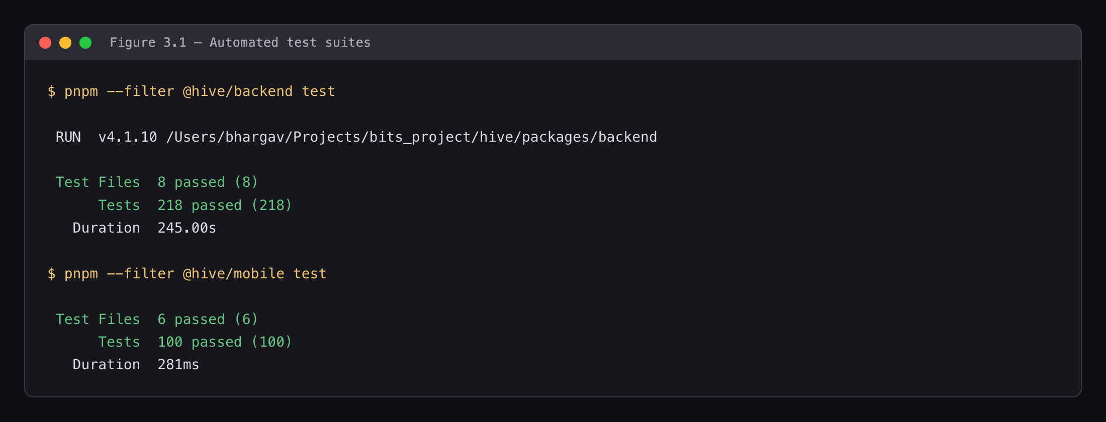
Figure 3.1 — Test suite execution — 218 tests passing
218 of 218 passing against the dedicated hive-test project, following 3b2f4c4 on 13 August 2026. The last timed run is the preceding 178-test suite: 178 of 178 in 115 seconds, observed 9 August 2026. No wall-clock figure has been recorded for the 218-test suite. (Figure 3.1)
Table 3.3 — Runtime functional verification
Property | Observed result
GET /health | 200, "checks": {"database": "ok"} — genuine round-trip
GET /health, database stopped | 503, "status": "degraded"
Unauthenticated /api/v1/* | 401 across feed, photos, orders, notifications, admin
Anonymous key against profiles | Returns [], not a dump — RLS holds on the direct path
Order placement | 201, total_cents: 6000 for 2 × print_4x6 at 3000 — ₹60, integer paise
Order idempotency | Same key twice → the same order
Transactional atomicity | Invalid item → rejected, no orphaned order row
Notifications | 16 generated, correct parents, correct child names
Storage pipeline | 6 photographs: originals and thumbnails written; blurhash, width, height populated; 1600×900 … 1600×2409 — both orientations survive
Signed URL | Signed fetch 200; token stripped → 400
Rate limiter | 429 at request 77 of a 100-per-15-minute window

3.3.2 Privacy verification — the central requirement
Rajesh — Bloom Preschool | Vikram — Little Stars Academy
 | 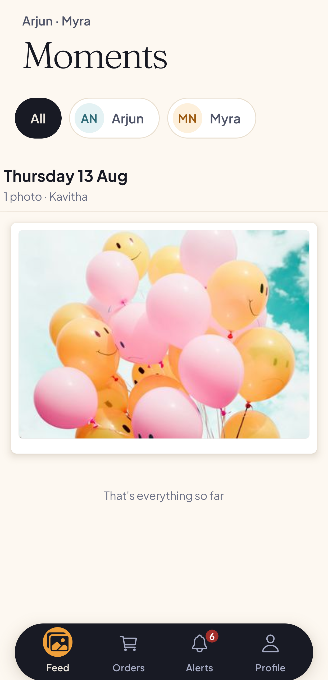
Figure 3.4 — Privacy comparison: two parents, zero overlap.
Measurement | Result
Photographs present | 6
Rajesh (Bloom, two children) sees | 2
Vikram (Little Stars, two children) sees | 1
Overlap between them | zero
Any parent seeing all six | none
Duplicate identifiers within a feed | none

3.3.3 Security verification
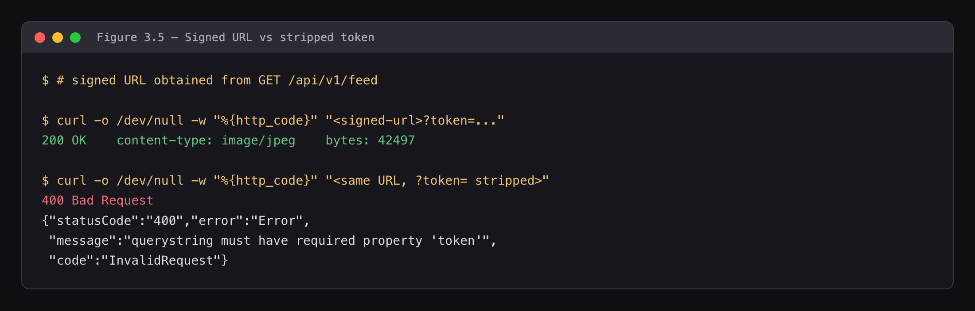
Figure 3.5 — Signed URL 200 versus stripped-token 400
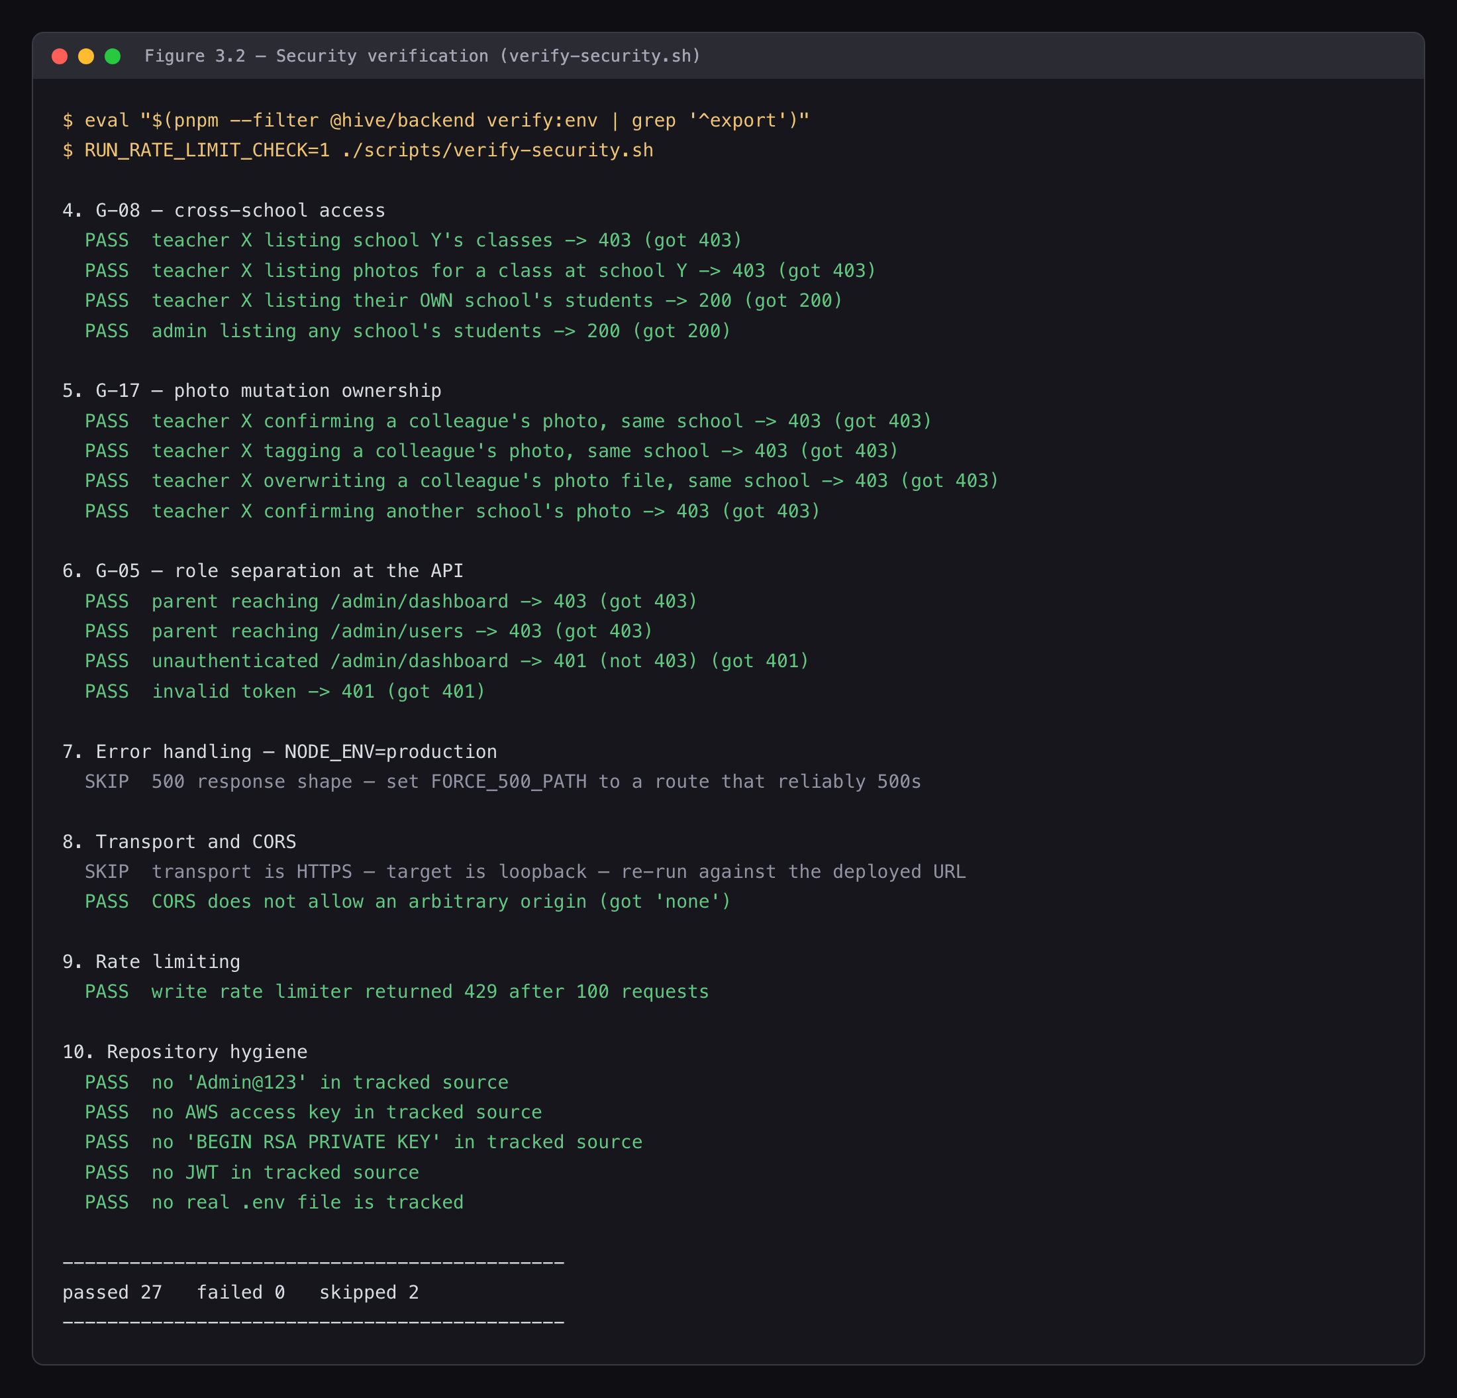
Figure 3.2 — Security verification output — 27/0/2
scripts/verify-security.sh passed 26 failed 0 skipped 3
Reproduced from cold on 2 August — stack stopped and restarted, database truncated, re-seeded, backend rebooted — with an identical result. It is a repeatable procedure, not a single favourable reading.
Table 3.4 — Security verification results
Area | Checks | Result
Static route removal | /uploads/<random>, /uploads/<real key> | 404, 404
Cross-family photograph | Other family / own / unauthenticated | 404, 200, 401
Tag leakage | taggedStudentIds on a permitted request | Only the caller’s children
Cross-school | Students / classes / photographs | 403 × 3; own school 200
Same-school ownership | Colleague’s photograph — confirm, tag, file | 403 × 3
Role separation | Parent → admin; unauthenticated; garbage token | 403, 403, 401
CORS | Origin: https://evil.example | Not reflected, not *
Secret scan | Repository | Clean
The three skips are not passes. They require HTTPS and a deployed origin, which do not exist (§3.3.4).

3.3.4 The sabotage exercise
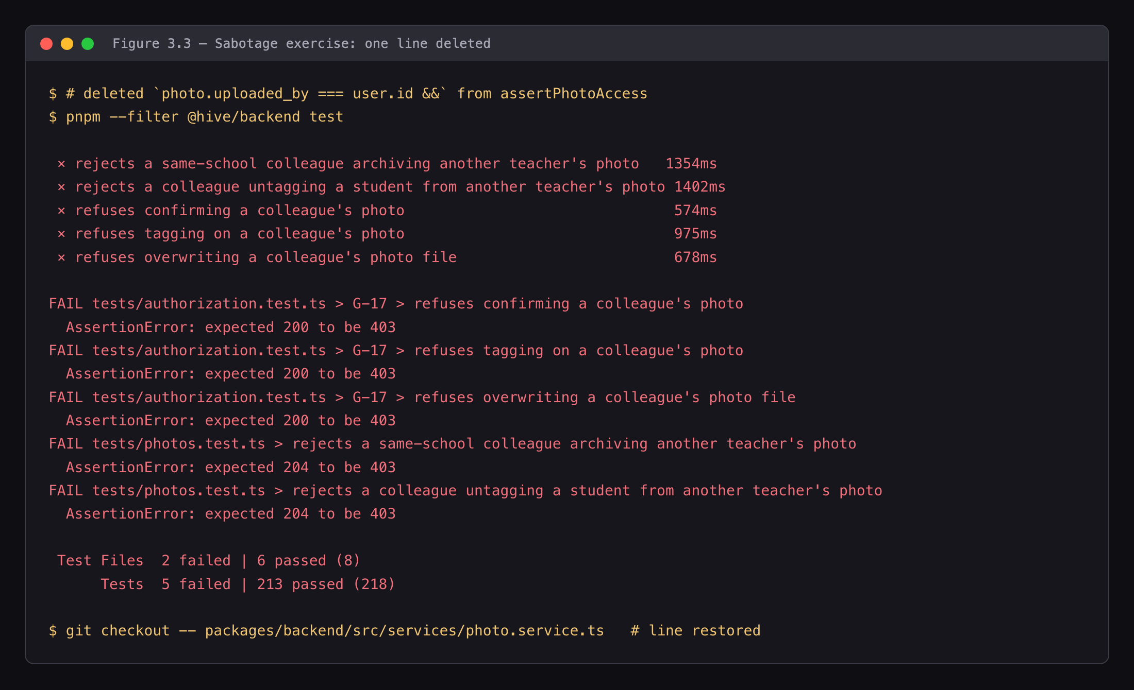
Figure 3.3 — Sabotage exercise — targeted tests failing
A passing suite proves nothing until it has been made to fail deliberately. One line — the uploader comparison in assertPhotoAccess — was deleted and the suite re-run.
Result, when the exercise was first performed: exactly the three same-school ownership tests failed, as intended.
Repeated on 16 August, it now fails five — the guard has gained coverage since. 218 tests | 5 failed | 213 passed:
File | Test | Expected | Got
authorization.test.ts | refuses confirming a colleague’s photo | 403 | 200
authorization.test.ts | refuses tagging on a colleague’s photo | 403 | 200
authorization.test.ts | refuses overwriting a colleague’s photo file | 403 | 200
photos.test.ts | rejects a same-school colleague archiving another teacher’s photo | 403 | 204
photos.test.ts | rejects a colleague untagging a student from another teacher’s photo | 403 | 204
The two additional failures are the archive and untag cases added on 2 August when the object lifecycles were completed. They route through the same assertPhotoAccess guard, so deleting one line now breaks five tests across two files rather than three in one. Every other test stayed green — the sabotage is precise, not merely destructive, which is the property that makes the exercise worth anything. The line was restored immediately afterwards and the working tree verified clean.
And it exposed a genuine problem. A similarly-named test in photos.test.ts remained green — because both of its teachers belonged to different schools, where the school check refuses first and the ownership check never executes. That test had never verified the property its name claimed, and had been supplying false confidence throughout its existence.
This is the most instructive result in the chapter: the exercise validated the suite and found a test that was not testing anything.
Table 3.6 — Properties not verified
Not verified | Reason | Consequence
Deployment | No hosted URL or application binary | HTTPS and CORS-origin checks skipped
Capacity under load | 50-VU run bound by the per-identity rate limiter, not the application | Smoke figures exist and pass; no unconstrained throughput or latency figure (§3.3.6)
iOS | No iOS build launched | Keychain session and image picker proven on Android only (§3.3.8)
Native deep links | hive:// never opened through the operating system | Route-group resolution verified through a browser URL instead
Server-side HEIC conversion | sharp’s prebuilt libvips has no HEVC decoder | Cannot work, and does not. Tested 24 July against a real HEVC HEIC. Handled by a device-side transcode instead; the server refuses HEVC with an actionable 400
Error reporting | Sentry requires a DSN | Pipeline unproven end to end
CI test gate | Repository secrets absent | 218 tests do not yet block a pull request; lint, typecheck and build do
The application has been driven end to end in a desktop browser via Expo’s web target, so the screens are exercised rather than merely compiled. Web is a verification convenience; the product targets iOS and Android, and that is where it remains unproven.

3.3.5 Defects identified and resolved
An audit enumerated 46 defects. The most serious:
Table 3.5 — Defects identified and resolved
ID | Severity | Defect | Status
G-01 | Critical | Ordering broken across three layers; no order could be placed | Fixed, verified
G-02 | Critical | Uploads served without authentication — every photograph a public URL | Fixed, verified
G-04 | Critical | Any parent could read any photograph’s metadata and tagged-child list | Fixed, verified
G-05 | Critical | No role check on route groups — a parent could reach the administration console | Fixed, verified
G-08 | High | Any teacher could read another school’s roster, including dates of birth | Fixed, verified
G-17 | High | A teacher could overwrite a colleague’s photograph | Fixed, verified
G-03 | Medium | ~700 lines of completed notification code had no imports | Fixed
G-07 | Medium | Tag-after-confirm ordering suppressed all parent notifications | Fixed, verified
G-12 | Medium | No thumbnails — the feed served full-resolution originals | Fixed
G-16 | Medium | Filter injection in administration user search | Fixed, verified
G-19 | Medium | Contradictory foreign keys made deletion impossible | Fixed
G-20 | Medium | Proxy trust permitted rate-limit bypass | Fixed, verified
G-37 | Medium | Non-atomic order creation could orphan an order | Fixed, verified
G-40 | Medium | Upload trusted the client-declared MIME type | Fixed — magic bytes
One remediation round introduced three regressions of its own, caught by its own review: cursor pagination dropping rows on a millisecond-truncated timestamp, a rate-limit bypass via a forged bearer token, and WebP accepted at three format gates but refused at the fourth. All three were fixed. They are recorded because a report claiming twenty-five consecutive fixes with no regressions would not be credible.

3.3.6 Performance
The k6 suite was executed on 16 August 2026 against a local single instance with the seeded dataset — not a deployment. Every figure below carries that qualification; none of it characterises production behaviour on a hosted tier.
Table 3.5 — k6 smoke profile (1 VU, 30 s)
Metric | Result | Threshold
Checks succeeded | 42 / 42 (100%) | — | ✔
http_req_failed | 0.00% | rate<0.01 | ✔
http_req_duration p95 | 1.13 s | p(95)<2000 ms | ✔
feed_payload_bytes | 3,908 B | 2 MB p95 | ✔
Requests | 29 over 32.1 s, 14 iterations, 0 interrupted | —
feed_payload_bytes is the figure that matters most. A twenty-photograph feed page transfers 3,908 bytes of metadata and signed URLs. Before Plan 03 generated thumbnails, thumbnail_s3_key was always null and the client fell back to full-resolution originals, so one page could exceed 100 MB. That is a four-order-of-magnitude reduction, and it is the single clearest quantitative justification for the storage work.
The load profile (50 VU, 5 min) crossed its thresholds, and the reason is instructive rather than damning. It recorded 69.38% http_req_failed over 4,727 requests. The failures decompose exactly:
Cause | Requests | Assessment
429 — the project’s own rate limiter | 2,657 | Not a capacity limit. 50 virtual users share three authentication tokens, and the limiter is keyed per identity, so the budget was exhausted within roughly two minutes. The control worked; the test was shaped wrongly for it
403 — cross-school refusal | 492 | Correct behaviour. The run was configured with a class belonging to a different school from the teacher account, so the G-08 boundary refused every teacher request. A misconfiguration of the run — and incidentally a 492-sample confirmation that the school boundary holds under concurrency
200 / 304 — served | 1,578 | Throughput 15.6 req/s; p95 3.3 s on expected responses
The 429s appear in k6’s totals and not in the server’s request log, because globalRateLimiter is mounted at app.ts:62 and the logging middleware at app.ts:69 — a refused request never reaches the logger. The arithmetic closes: 4,727 issued, 2,070 logged, 2,657 refused upstream.
What this does and does not establish. It establishes that the application serves a correctly-shaped single-user workload well within threshold, that the feed payload is small, and that two protective controls — per-identity rate limiting and cross-school authorization — hold under concurrent load. It does not establish a capacity ceiling: at 50 virtual users the binding constraint was the project’s own rate limiter, by design, so no unconstrained throughput or latency figure exists. Obtaining one requires per-virtual-user identities or a raised ceiling, and a deployed target to make the number mean anything. No figure has been extrapolated to fill that gap.
The current suite has now been timed. On 16 August the backend suite ran 218 tests across 8 files in 245 seconds, all passing, including table truncation, approximately forty authentication-user creations and full HTTP round-trips against a real Postgres, GoTrue and Storage stack. This supersedes an earlier figure of 178 tests in 115 seconds, which belonged to the smaller suite and should not be restated against this one. The mobile unit suite runs 100 tests in 281 milliseconds — it is pure logic with no I/O, which is why the two differ by three orders of magnitude.

3.3.7 Observations
What the evidence supports. The privacy boundary holds under direct adversarial probing: cross-family access returns 404, cross-school access returns 403, and same-school photograph mutation returns 403 — each confirmed over HTTP with real tokens and reproduced from a cold start. Ordering functions with correct integer-cent arithmetic and genuine idempotency. The storage layer produces thumbnails and placeholders for both orientations and serves them only through signed, expiring URLs.
What it does not support. No performance characteristic has been measured. The error-reporting pipeline has never carried an error. Neither is an oversight discovered late; each follows from one absent step — deployment. Observation on the shipping platform, previously listed here, is now partly closed: the application has been driven end to end on a physical Android device, and §3.3.8 records both what that proved and what it did not.
A note on suite stability. Repeated runs exhaust the shared authentication provider’s sign-in quota; each run creates roughly forty users, and beyond the quota sign-ins stall rather than fail. Three runs within half an hour produced timeouts. Every failure observed was a timeout, never a failed assertion, and the same files passed in isolation immediately afterwards. The 178/178-in-115s figure is a measurement of that suite running alone.

3.3.8 Device verification
The application was driven end to end on a physical Android device — a OnePlus CPH2487, connected over USB with adb reverse mapping the development server and API to the handset. Every application figure in §4.3 is a capture from that device rather than a browser.
Table 3.7 — Behaviour verified on the device
Behaviour | Result
Keychain-backed session | Survives force-quit and cold start
Native image picker | Opens, selects and cancels correctly
Upload, end to end | Completes with genuine per-file progress (G-27)
Role routing | Teacher lands on the teacher dashboard (G-05)
Privacy scoping | Aarav 2 photographs, Diya 1 — correct per child (G-04)
Safe-area handling | Floating action button clears the tab bar against a real inset
Order arithmetic | Order detail renders 2 × ₹30 → ₹60, 1 × ₹99 → ₹99, total ₹159
Seven defects were found that no other method had surfaced, four of them invisible to a type checker, a test suite and a desktop browser alike: a truncated age line when two siblings are tagged, order-status labels breaking mid-word, a truncated upload button, an admin photograph count including archived rows, a notification badge clipping the tab indicator, a failed image that never retried, and a disabled Place order button that gave no reason.
The most significant is worth stating in full, because it is the clearest argument for testing on hardware. The application opened to a blank screen and never recovered — no crash, no error, nothing in the logs. app/_layout.tsx returns null while authentication loads, and the root layout is itself a route component: returning null destroys the navigator, so expo-router tears down and re-creates the root route, producing a fresh component instance whose useRef bootstrap guard is reset. The bootstrap therefore ran again, set the loading flag again, and rendered null again. The loop ran 145 times in one session, measured, with no exit and no symptom beyond an application that would not paint.
What made it expensive was that everything below the root looked guilty. The feed’s render logged continuously with correct data — 2 photographs, 3 rows, every gate open — because React kept executing the component body during the brief windows the tree existed. But the list’s onLayout and renderItem never fired once, because nothing survived long enough to commit. That reads exactly like a broken list. The fix moves the guard to module scope so it outlives the component that triggers it; the device then showed one initialisation instead of 145, and one mount instead of a remount every ~600 ms.
This class of defect is not reachable by the other methods used in this project. It is a lifecycle race between a navigation library and a React ref, with correct types, passing integration tests and a functioning browser build.
What the device run did not establish. Only Android was exercised — no iOS build has been launched, so the keychain session and the image picker are proven on one platform of two. Native hive:// deep links remain unverified on either: route-group resolution was checked through a browser URL, which does not traverse the operating system’s linking path.

CHAPTER 4: EXECUTION / DEPLOYMENT DETAILS

4.1 Execution environment
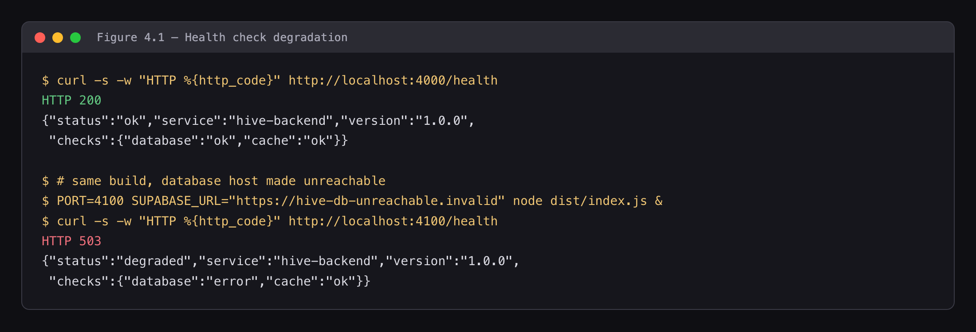
Figure 4.1 — Health endpoint, healthy and degraded
Component | Configuration
Runtime | Node.js 20+ (verified on 22.21.1 and 26.4.0)
Package manager | pnpm 9.1.0 (workspaces + Turborepo)
API | Express on port 4000
Mobile | Expo development server on port 8081
Database | Supabase PostgreSQL 15 — hive-dev (development), hive-test (tests)
Cache | Redis 7 in Docker, port 6379
Migrations | 20, applied via supabase db push --include-all
Container | Multi-stage Dockerfile for the API

4.2 Deployment steps

4.2.1 Local execution (verified)
docker run -d --name hive-redis -p 6379:6379 redis:7-alpine
pnpm install
# create packages/backend/.env and apps/mobile/.env from the .env.example templates
pnpm db:migrate # supabase db push --include-all
pnpm --filter @hive/backend seed:admin
pnpm seed # demo dataset: schools, classes, students, photographs, orders
pnpm dev:backend
curl -s localhost:4000/health | jq # expect "checks":{"database":"ok"}
pnpm dev:mobile
"database":"ok" is the meaningful signal — /health round-trips to PostgreSQL, so 503 indicates bad credentials rather than a stopped process. (Figure 4.1)
Full instructions, including the anon versus service-role key distinction and the common failure modes, are in docs/environment-setup.md.

4.2.2 Cloud deployment — not completed
The system is not deployed. There is no hosted URL and no distributable application binary. A container image builds and continuous integration runs on every push, but no hosting target was provisioned.
This is stated plainly because it is the root cause of every entry in Table 3.6. The intended path — a container platform for the API, with the database, auth and storage already hosted, and Expo Application Services for mobile binaries — is described in §6.4.

4.3 Demonstration screenshots
Capture conditions. Every application figure below was taken on a physical Android device (OnePlus CPH2487) running the application against the local API over adb reverse, not in a browser or an emulator. All are 1240 px wide, captured in light mode against the seeded demonstration dataset, and cropped uniformly to remove the operating-system status bar. Nothing is composed, retouched or recreated; where a figure shows a number, that number came from the database.
Table 4.2 — Application figures
Fig. | File | What it evidences
— | app-01-login.png | Entry point and role selection
— | app-02-teacher-dashboard.png | Class-scoped teacher view
2.5 | fig-2.5-upload-tagger.png | The tagging gate — student tagger open during upload
2.5b | fig-2.5b-tagger-tagged.png | Children tagged; the upload control becomes enabled
2.5c | fig-2.5c-upload-sent.png | Upload completing with real per-file progress (G-27)
2.6 | fig-2.6-feed-child-switcher.png | The many-to-many model — Rajesh’s switcher showing Aarav and Diya
— | app-03-feed-switched-child.png | Feed after switching child — different photographs, scoping is live
— | app-04-photo-detail.png | Signed-URL rendering with a blurhash placeholder
2.7a | fig-2.7a-order-sheet-60.png | Order sheet priced from the server catalogue
2.7 | fig-2.7-order-confirm.png | Monetary correctness — 2 × ₹30 → ₹60, 1 × ₹99 → ₹99, total ₹159, with per-item signed thumbnails. Per-line arithmetic and the total, against a database row of total_cents: 15900
— | app-05-order-history.png | Order history with per-item signed URLs
— | app-06-notifications.png | Trigger-generated notifications naming the correct child
— | app-07-parent-profile.png | Parent profile
— | app-08-upload-empty.png | Upload empty state
2.8 | fig-2.8-admin-dashboard.png | Administration — non-zero counts, totalPhotos excluding archived rows
Table 4.3 — The privacy comparison (Figure 3.4)
The two most important figures in the submission, and they are only meaningful as a pair. Both were captured on the same device at the same resolution with the same crop, so the comparison is between the application’s behaviour and nothing else.
Fig. | File | Account | Result
3.4a | fig-3.4a-rajesh-feed.png | parent.rajesh@bloom.demo — Bloom Preschool, two children | 2 photographs, Aarav and Diya
3.4b | fig-3.4b-vikram-feed.png | parent.vikram@stars.demo — Little Stars Academy | 1 photograph, Arjun and Myra
Six photographs exist in the dataset. Neither parent sees all six, and the two sets do not intersect. This is the central requirement of the product demonstrated as an observable property rather than asserted as a feature — §3.3.2 gives the same result measured at the API.
Evidence figures 3.1, 3.2, 3.3, 3.5, 4.1, 5.1 and 5.2 are terminal and repository captures rather than application screenshots; §3.3 and Chapter 5 carry their results in full. Figures 2.1 and 2.3 are the architecture and entity-relationship diagrams in Chapter 2.

4.4 Demonstration video
«Link — record the flow in docs/demo-script.md, approximately six minutes: teacher upload and tagging, parent feed, the privacy comparison, signed-URL behaviour, order placement, administration dashboard.»

CHAPTER 5: PROJECT EXECUTION EVIDENCE

5.1 Version control evidence
Repository: https://github.com/vexora-0/hive
Metric | Value
Commits | 422
Contributors | 4
Period | 1 February – 16 August 2026
Active development days | 151
Source files | 219 TypeScript / TSX
Lines of source | ~37,200
Migrations | 20
Automated tests | 318 — 218 backend integration, 100 mobile unit

Contributor | Commits
Bhargav | 138
Nagachaitanya | 99
Ruthwik | 95
Srujan | 82
Source files and lines count apps/mobile/src and packages/backend/src, excluding tests, generated types and configuration. Per-contributor counts exclude merges and are normalised through .mailmap, which folds four alternate author identities; they total 414, with a further 8 merge commits making 422.
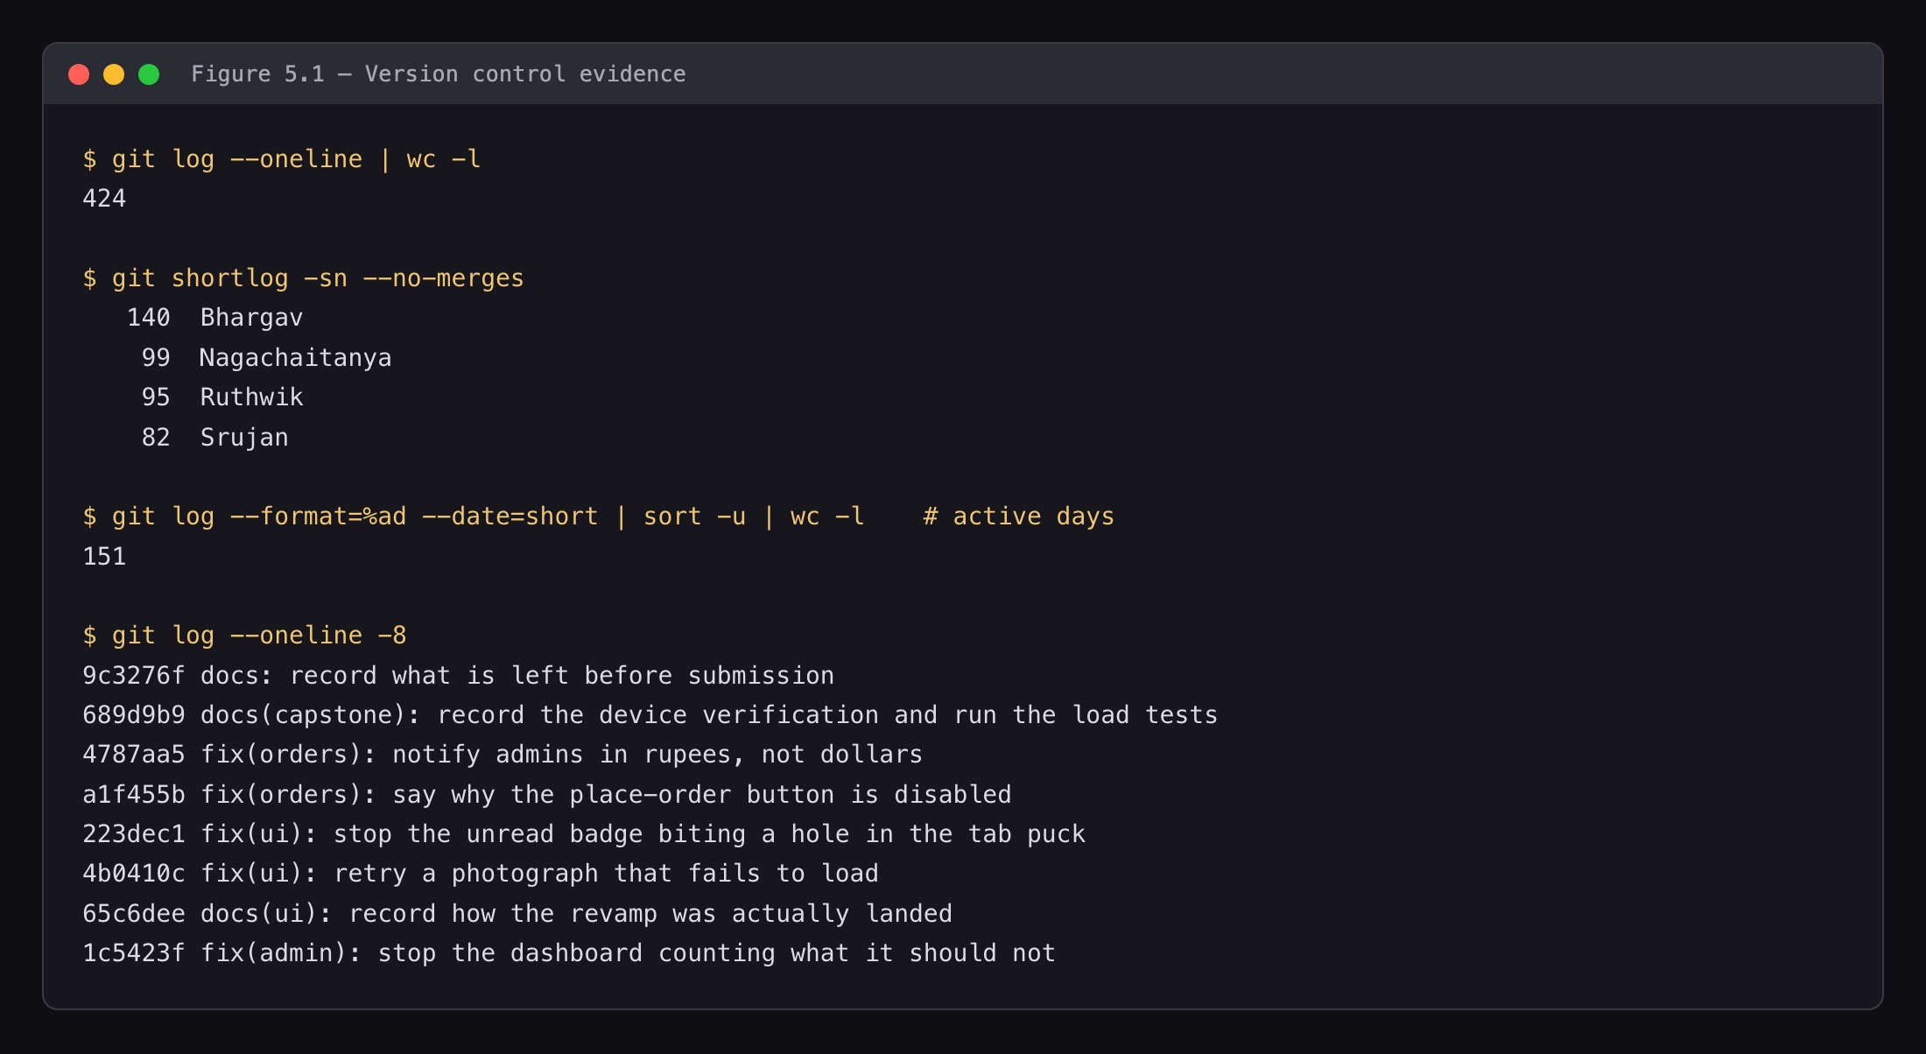
Figure 5.1 — Commit history
(Figure 5.2 — continuous integration run — not yet captured.)
Conventional commit messages are used throughout, with security: reserved for remediation so the audit trail is visible in the log.

5.2 Weekly progress summary
Table 5.1 — Weekly progress (Condensed from docs/PROGRESS-REPORT.md, which holds the full record. Supervisor remarks to be completed by the supervisor.)
Week | Task planned | Task completed | Supervisor remark
1 | Project foundations, first tables | Repository, tooling, schools, profiles | «»
2 | Core schema and privacy model | Classes, students, parent-student mapping | «»
3 | Data security, backend configuration | RLS policies, triggers, environment validation | «»
4 | Authentication, access control, storage | JWT middleware, role guard, storage bucket | «»
5 | Photograph, feed and notification services | Upload, tagging, scoped feed, notifications | «»
6 | Ordering, idempotency, seed data | Order service, Redis idempotency | «»
7 | Administration API, server assembly | Administration endpoints, application bootstrap | «»
8 | Client infrastructure, shared hooks | API client, query configuration, stores | «»
9 | Authentication UI, onboarding | Login, OTP entry, onboarding carousel | «»
10 | Navigation, media, animation | Tab bar, image components, animations | «»
11 | Teacher upload experience | Upload screen, student tagger, progress | «»
12 | Parent feed and ordering interface | Feed, child switcher, order sheets | «»
13 | Notifications, administration console | Notification centre, administration screens | «»
14 | Audit, planning, credential hygiene | 46-defect audit; credentials moved to environment | «»
15 | Private storage, image processing | Private bucket, signed URLs, thumbnails, blurhash | «»
16 | Feed query, upload ordering, type recovery | Query rewrite; tag-before-confirm; type regeneration | «»
17 | Observability, containerisation, load tests | Request IDs, structured logs, Dockerfile, k6 suite | «»
18 | API consistency, architecture documentation | Unified error surface; architecture chapter | «»
19 | Test harness and feed coverage | Vitest + Supertest harness; feed tests | «»
20 | Photograph tests, compile blocker | Photograph tests; 22 type errors addressed | «»
21 | Zero type errors | Both packages compile clean | «»
22 | Authorization | Cross-family, cross-school and ownership checks | «»
23 | The order contract | Shared catalogue, integer cents, atomic creation | «»
24 | Demonstration data and documentation | Seed script with photographs and orders | «»
25 | First real execution | Migrations applied; suite run; security script run | «»

5.3 Supervisor interaction summary
Review date | Key feedback received | Action taken
«» | «» | «»
(Complete from your own records.)

CHAPTER 6: CONCLUSION & FUTURE WORK

6.1 Summary of implementation
Hive was delivered as a three-tier system: a React Native application for teachers, parents and administrators; a 40-endpoint Express API in TypeScript; and a PostgreSQL database of ten domain tables across 20 migrations, with row-level security and triggers. Photographs are held privately and served only through signed, expiring URLs.
The defining constraint — that the API bypasses row-level security by design — was addressed by enforcing authorization explicitly in the service layer, with every resource accessed by identifier checked against the caller.

6.2 Achievements
- The privacy boundary holds under adversarial probing — cross-family 404, cross-school 403, same-school photograph mutation 403, each verified over HTTP with real tokens and reproduced from a cold start.
- 218 automated integration tests, executing against a real database rather than mocks. The 115-second timing was measured on the 178-test suite that preceded them; the larger suite has not been timed.
- A sabotage exercise that validated the suite and found a defective test — one that had never verified the property its name claimed.
- 27 of 27 attempted security checks passed, 0 failed, 2 skipped — reproduced cold. One skip needs a deployment (HTTPS); the other needs FORCE_500_PATH set alongside NODE_ENV=production.
- A previously non-functional ordering flow made to work, with correct integer-cent arithmetic and genuine idempotency.
- Approximately 1,500 lines of never-executed infrastructure removed — the asynchronous queue and object-store client neither of which had ever run.
- An optional dependency stopped being able to take out the critical flow. With Redis unreachable, POST /orders did not fail — it hung, for over two minutes. maxRetriesPerRequest: null, left behind by the removed queue, combined with the client’s offline queue to produce a command that retried forever and never settled, so the idempotency middleware’s existing failure path never ran. Commands now fail after two retries with the offline queue disabled; order submission answered in 485 ms with Redis stopped.

6.3 Limitations
Stated explicitly; each is evidenced in Table 3.6.
- The system is not deployed. No hosted URL, no application binary.
- No performance measurement against a deployment exists. The k6 suite has now run — locally, on 16 August — and the smoke profile passes every threshold with a 3,908-byte feed page (§3.3.6). What is missing is a capacity figure: at 50 virtual users the binding constraint was the project’s own per-identity rate limiter rather than the application, so no unconstrained throughput or latency number has been obtained, and none has been estimated.
- iOS is unverified, and native deep links with it. The application has been driven end to end on a physical Android device, which closed most of what this limitation formerly covered — the keychain-backed session, the image picker, upload progress, role routing and privacy scoping are all proven on hardware, and seven defects were found there that no other method surfaced (§3.3.8). What remains unproven: no iOS build has been launched, so those platform behaviours hold for one platform of two; and hive:// deep links are unverified on either, because route-group resolution was checked through a browser URL rather than the operating system’s linking path.
- The error-reporting pipeline has never carried an error.
- The continuous-integration test step is advisory, pending repository secrets; lint, typecheck and build do block.
- Server-side HEIC conversion does not work. sharp’s prebuilt libvips ships libheif without an HEVC decoder, and an iPhone HEIC is HEVC-coded, so the container parses and the pixel decode fails. Established by testing a real HEVC HEIC on 24 July 2026. The mobile client transcodes on the device instead, and the server refuses HEVC with an actionable 400. Magic-byte rejection, previously listed here alongside it, is covered — by photos.test.ts T-20.
- A Redis outage is reported but does not change the health status code. /health surfaces "cache" alongside "database", but only the database determines 200 against 503. This is deliberate — losing the idempotency cache degrades deduplication rather than availability, so the instance should stay in rotation — with the consequence that an orchestrator probing only the status code will not restart or drain an instance whose Redis is unreachable.

6.4 Future enhancements
Immediate, in dependency order:
- Deploy. One step that simultaneously unblocks the HTTPS and CORS checks, the load tests, and device testing against a real origin.
- Execute the k6 suite against that deployment and record the results.
- Produce iOS and Android builds and verify the platform-specific paths.
- Make the test step blocking by adding the three repository secrets.
Product:
- Payment gateway integration for print orders.
- Push notifications, replacing in-app only.
- Bulk upload with client-side compression.
- Photograph search by child, class or date range.
- Data-retention policy and parent-initiated deletion, appropriate to a child-privacy product.

REFERENCES
(IEEE style)
[1] Supabase, “Row Level Security,” Supabase Documentation. [Online]. Available: https://supabase.com/docs/guides/database/postgres/row-level-security
[2] Supabase, “Storage: Access Control,” Supabase Documentation. [Online]. Available: https://supabase.com/docs/guides/storage/security/access-control
[3] The PostgreSQL Global Development Group, PostgreSQL 15 Documentation, 2024. [Online]. Available: https://www.postgresql.org/docs/15/
[4] OWASP Foundation, “OWASP API Security Top 10 — 2023,” 2023. [Online]. Available: https://owasp.org/API-Security/editions/2023/en/0x00-header/
[5] OWASP Foundation, “API1:2023 Broken Object Level Authorization,” 2023. [Online]. Available: https://owasp.org/API-Security/editions/2023/en/0xa1-broken-object-level-authorization/
[6] Expo, “Expo Router,” Expo Documentation. [Online]. Available: https://docs.expo.dev/router/introduction/
[7] Meta Platforms, “React Native Documentation,” 2024. [Online]. Available: https://reactnative.dev/docs/getting-started
[8] C. McDonnell, “Zod: TypeScript-first schema validation,” 2024. [Online]. Available: https://zod.dev
[9] TanStack, “TanStack Query v5 Documentation,” 2024. [Online]. Available: https://tanstack.com/query/latest
[10] L. Segers, “sharp — High performance Node.js image processing,” 2024. [Online]. Available: https://sharp.pixelplumbing.com
[11] Vitest, “Vitest — Next generation testing framework,” 2024. [Online]. Available: https://vitest.dev
[12] Grafana Labs, “k6 Documentation,” 2024. [Online]. Available: https://k6.io/docs/
[13] M. Jones, J. Bradley, and N. Sakimura, “JSON Web Token (JWT),” RFC 7519, IETF, May 2015. [Online]. Available: https://www.rfc-editor.org/rfc/rfc7519
[14] R. Fielding and J. Reschke, “Hypertext Transfer Protocol (HTTP/1.1): Semantics and Content,” RFC 7231, IETF, June 2014. [Online]. Available: https://www.rfc-editor.org/rfc/rfc7231
[15] Redis Ltd., “Redis Documentation,” 2024. [Online]. Available: https://redis.io/docs/

APPENDIX

Appendix A — User manual
Teacher. Sign in; select a class; tap upload; choose photographs; tag the children who appear; confirm. Tagged children’s parents are notified automatically. Tag before confirming — confirmation is what makes a photograph visible and triggers notification.
Parent. Sign in; the feed shows photographs of your children only. If you have more than one child, use the child switcher to filter. Tap a photograph to view it; use the action sheet to order prints. Order history and status are under Orders; notifications under Alerts.
Administrator. The dashboard summarises schools, users, photographs and orders. Manage schools, classes, students and users from their respective tabs; assign teachers to classes and map parents to students.
(Demonstration accounts and the recommended walkthrough: docs/DEMO_USERS.md.)

Appendix B — Installation guide
Prerequisites: Node.js 20+, pnpm 9.1.0, Docker (Redis only), a Supabase project.
git clone https://github.com/vexora-0/hive.git && cd hive
npm i -g pnpm@9.1.0 # corepack is absent on Node 25+
pnpm install
cp packages/backend/.env.example packages/backend/.env
cp apps/mobile/.env.example apps/mobile/.env
# populate both — see docs/environment-setup.md §2 for the key distinction
docker run -d --name hive-redis -p 6379:6379 redis:7-alpine
pnpm db:migrate
pnpm --filter @hive/backend seed:admin
pnpm seed
pnpm dev:backend # terminal 1
pnpm dev:mobile # terminal 2
Three points that commonly cost an hour, all documented in docs/environment-setup.md:
- Run pnpm install after every pull; a stale module tree changes error counts.
- Migrations are not numerically contiguous; --include-all is required.
- The service-role key belongs only in the backend environment file. Placing it in the mobile environment would grant every application user full database access.

Appendix C — Source code
https://github.com/vexora-0/hive
Path | Contents
apps/mobile/ | React Native application
packages/backend/ | Express API
packages/backend/tests/ | 218 integration tests
apps/mobile/tests/ | 100 unit tests
supabase/migrations/ | 20 migrations
scripts/verify-security.sh | Runtime security verification
docs/ | Architecture, security, database, API, demonstration guide
The migration sequence contains deliberate gaps. Numbers were reserved per developer in advance so that four people could add migrations in parallel without renumbering each other’s — 00019 and 00021–00023 were reserved and, in the event, not needed. The directory holds 20 files, numbered 00001–00018, 00020 and 00024.

Appendix D — Demonstration video
«Link»

FORMATTING CHECKLIST
Apply on transfer into Document-format.docx:
- Times New Roman throughout
- 12 pt body, 14 pt headings
- 1.5 line spacing
- 1 inch margins, all sides
- Page numbers, bottom-centre
- Figures captioned “Figure N.N — …” beneath; tables captioned above
- List of Figures and List of Tables updated after captioning
- Table of Contents generated from Heading styles
- Every «…» placeholder replaced
- Export to PDF

