Induction Heater

1. Idea:

* DC to AC inverter using Royer’s Oscillator, the coil in LC tank creates a fast changing magnetic field that creates Eddy Currents in a metal causing it to gain heat due to increased movement of particles?

1. Key Components:
   * LC tank (oscillator made of a coil and a capacitor)
   * N-channel mosfets to turn power on and off creating an AC wave
   * Choke coils limiting the current to acceptable levels
   * Fast switching diodes (I used Schottky’s)
   * Strong power supply
   * RADIATORS – circuit is using a lot of power so it’s projecting a lot of HEAT
2. Circuit:

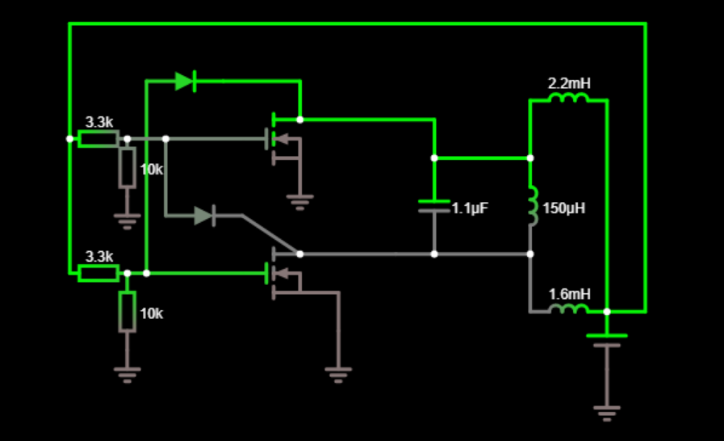

Theory Reads:

* <https://www.rmcybernetics.com/science/diy-devices/diy-induction-heater>

Theory Notes:

* Due to the fact that no two mosfets or any electronic devices can have exactly similar conducting specifications, both mosfets do not turn on together, rather one of them turns ON first.
* USE THE SAME 2 MOSFETS in order for it to work properly
* Power loss due to Eddy Currents increase proportional to the square of the frequency (higher frequency = more heat?)
* Too high frequency (so a very low value Capacitor and/or coil) will give huge current with very low voltage
* Too low frequency (requires high voltage which puts strain on gate resistors)