Customer Churn Analysis Report

This report presents the exploratory data analysis and data preparation steps undertaken to predict customer churn using various data sets. It includes data collection, visualisation, and cleaning processes, providing a foundation for developing a predictive model.

# Data Identification and Collection

The following data sets were identified as relevant for predicting customer churn:  
- Customer Demographics  
- Transaction History  
- Customer Service Interactions  
- Online Activity  
- Churn Status  
These data sets provide comprehensive insights into customer behaviour and engagement.

# Exploratory Data Analysis

Exploratory data analysis was conducted to uncover patterns and insights that could inform predictive modelling. Key findings include demographic trends, spending patterns, and the impact of customer service interactions on churn.

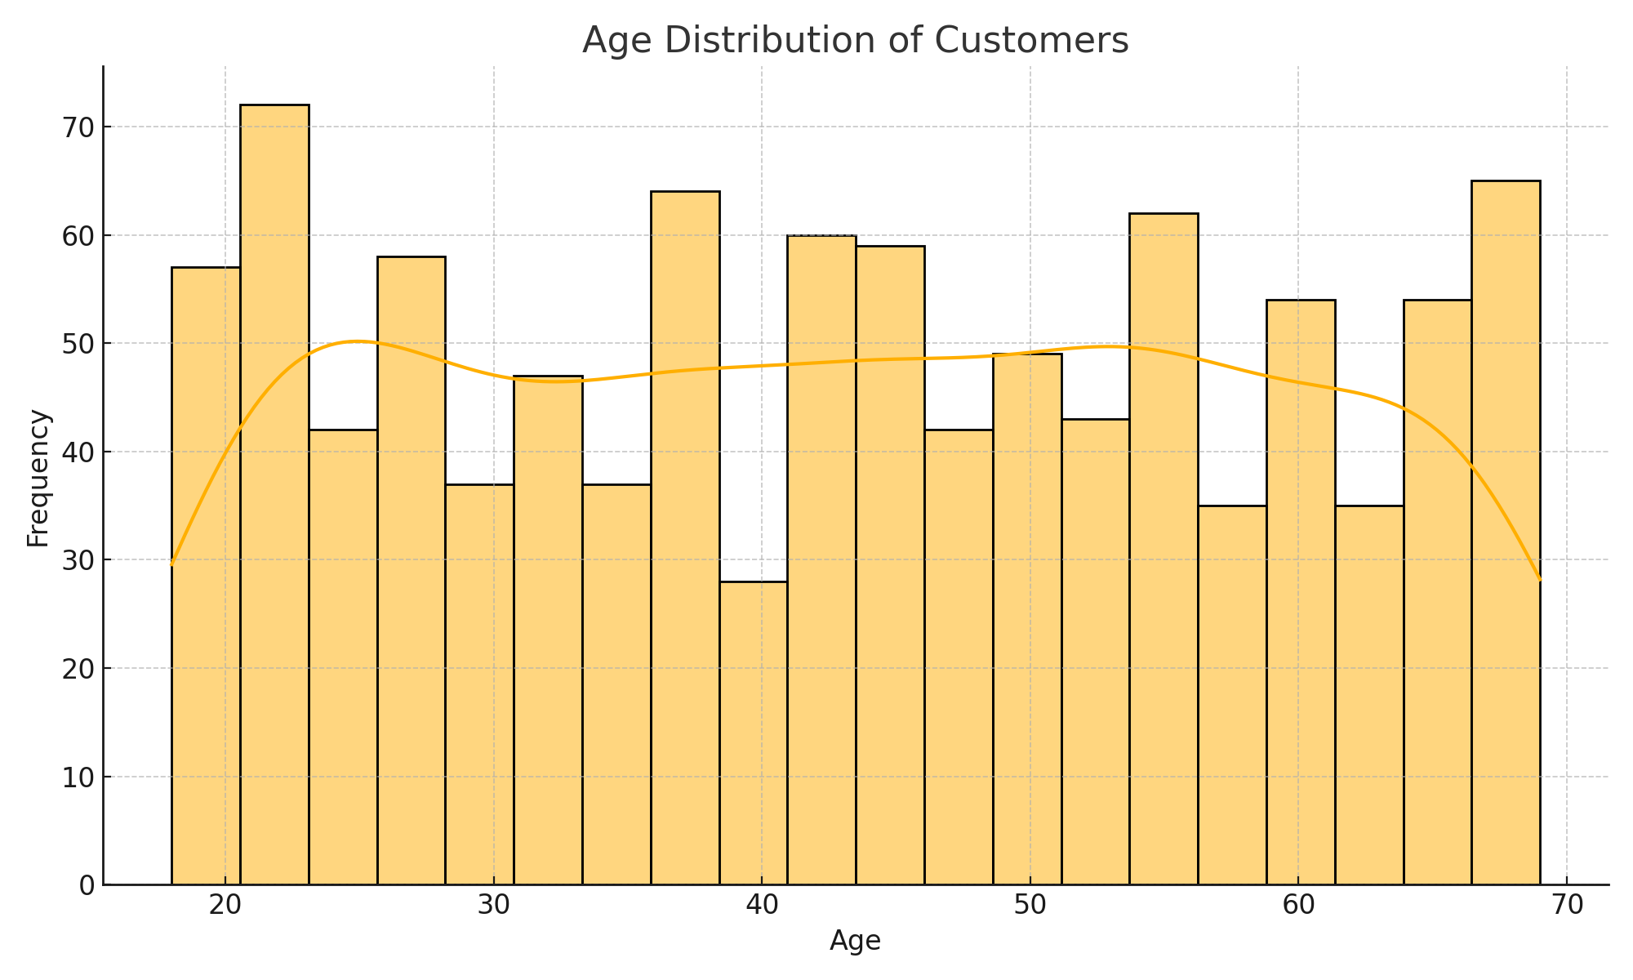

## Figure 1: Age Distribution of Customers

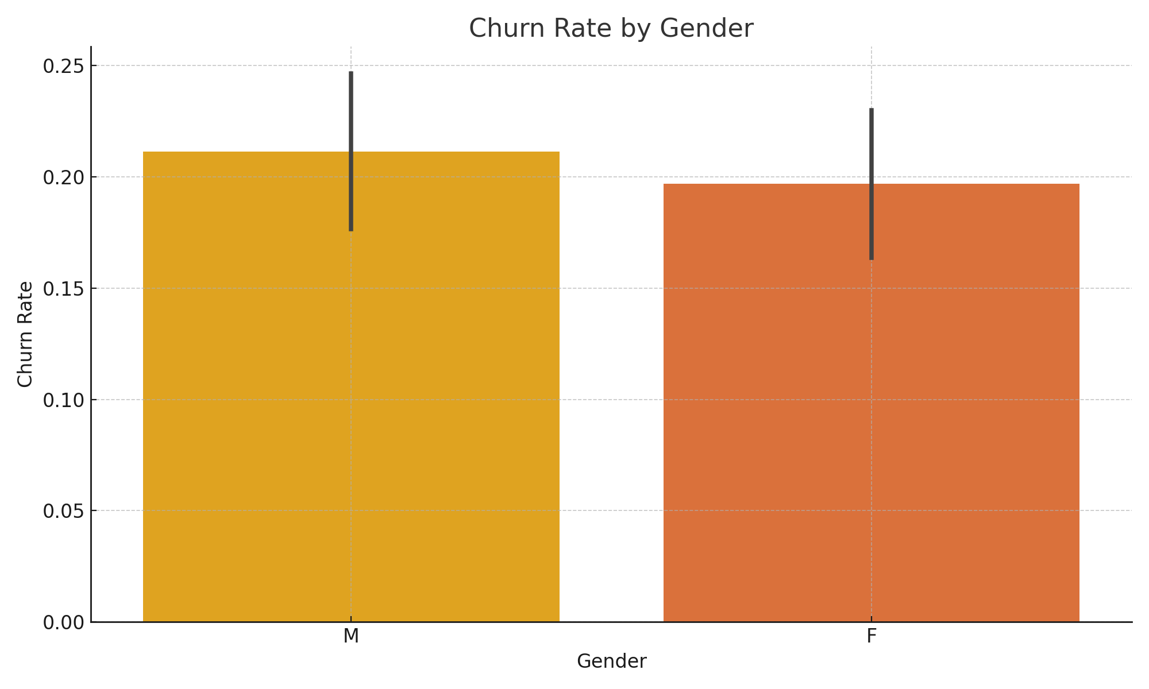

## Figure 2: Churn Rate by Gender

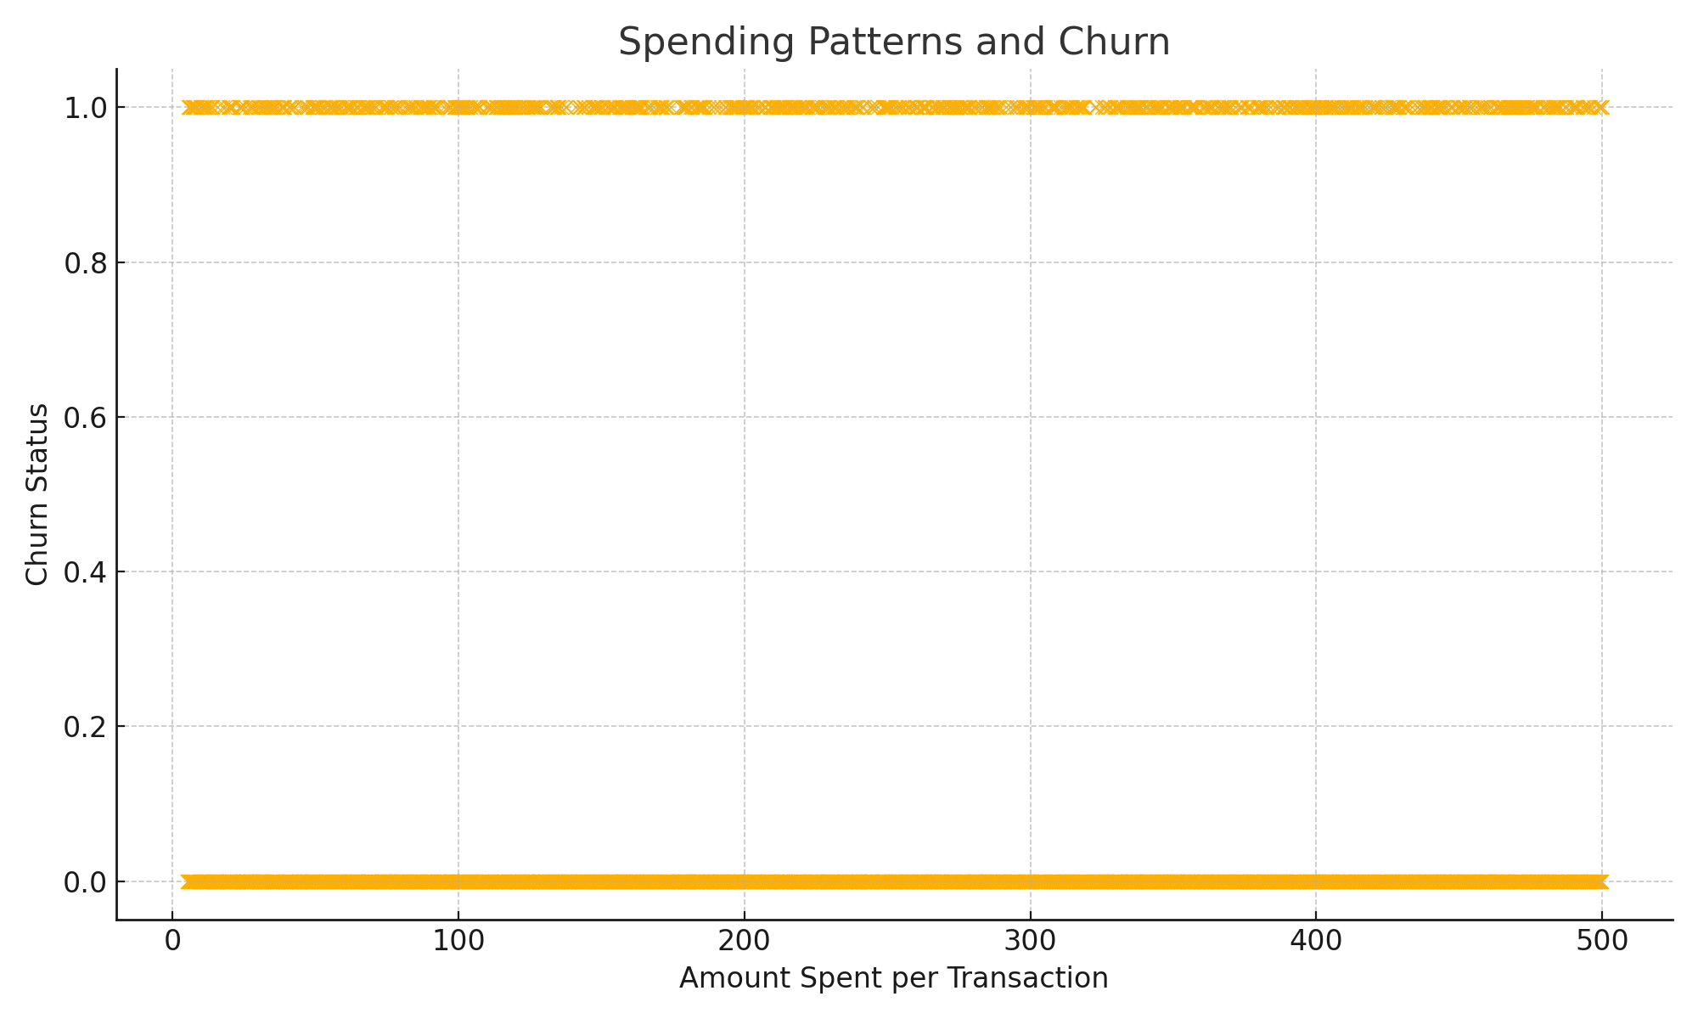

## Figure 3: Spending Patterns and Churn

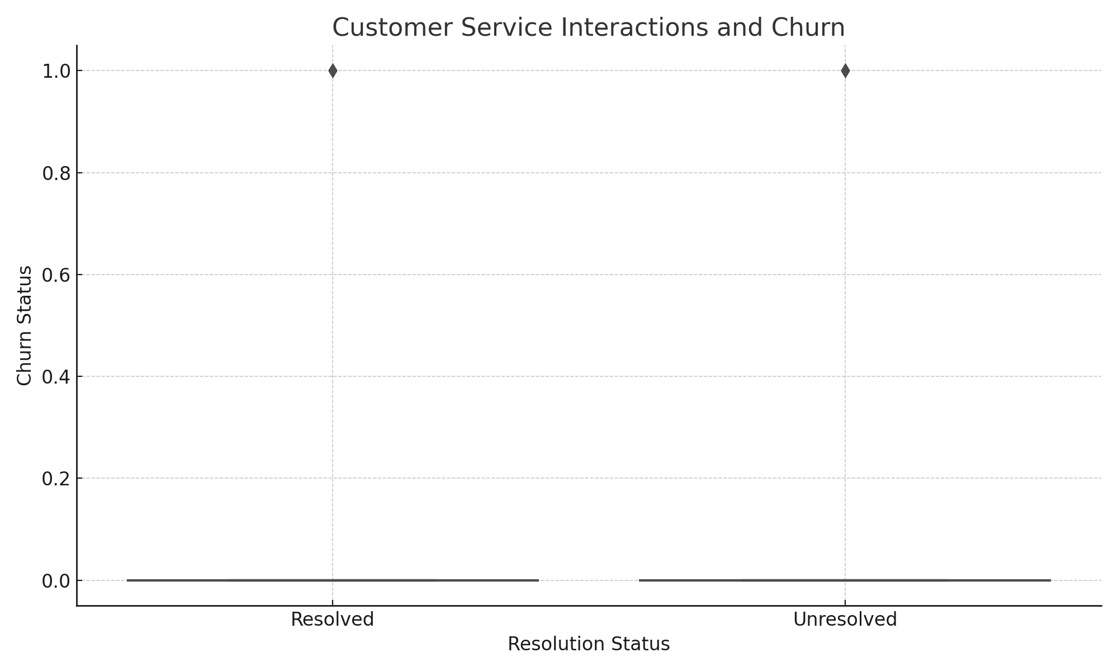

## Figure 4: Customer Service Interactions and Churn

# Data Cleaning and Preparation

Data cleaning involved handling missing values, detecting and addressing outliers, and normalising/standardising numerical features. Categorical features were encoded using one-hot encoding to prepare the data for machine learning algorithms.