***Chapter1: Introduction to Laravel***

1. Laravel is a php framework
2. Composer: is a tool or php dependency to install library
3. To use Laravel: we need xampp, php,achech ,
4. –prefer-disk: get the last Laravel
5. Disk= distribute
6. composer create-project laravel/laravel khmernews --prefer-dist: create folder
7. MVC: is a pattern
8. M= model, v= view, c= controller
9. Process MVC in Laravel: Rout send user’s request to controller, controller check it in model it has or not if it has, model will send it to the controller and controller will send it to the view.
10. php artisan serve: command run php
11. view in folder resource,
12. controller in folder HTTp and HTTp in folder app,
13. Handle.php in folder exceptions and folder exceptions in folder app
14. Models in folder app and folder model has user.php
15. .gitignore, packages.php, services.php in folder cache and cache in folder bootstrap
16. App.php in folder bootstrap
17. Userfactory.php in folder factories and factories in folder database
18. databaseSeeder.php in folder seeders and seeder in folder database
19. web.config in folder public
20. folder rout below folder resource and above folder storage
21. database.php in folder config
22. php artisan serve - -port=3000: change port
23. php artisan make:controller PostController: create file in folder controller
24. php artisan make:controller ProductController –api: create file in folder controller and it divide crud
25. php artisan make:model Post: create file in folder model
26. php artisan make:model Product -m: create file in folder migrations :database folder
27. php artisan make:migration create_posts_table: create table in folder migrations
28. store = function for create
29. show = select one
30. destroy = delete
31. index()= select all
32. php artisan migrate: create table in database
33. php artisan migrate:rollback: delete table in database
34. php artisan migrate:refresh: add attribute in table

back end: php artisan serve

front end: npm run serve

open vscode and open terminerl run: php artisan serve

1. insert data in table

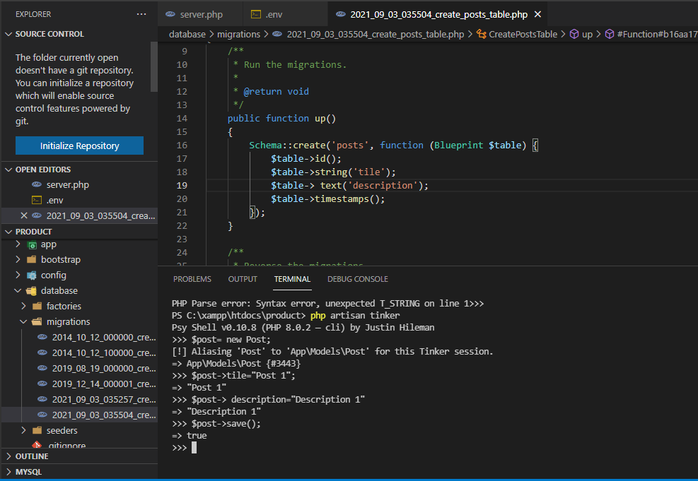

1. php artisan make:model Post
2. php artisan make:model Product -m
3. php artisan make:migration create_post_table make new table
4. php artisan migrate use with databse
5. php artisan migrate:rollback use for delete
6. composer create-project laravel/laravel khmerload --prefer-dist use for create folder
7. php artisan serve
8. 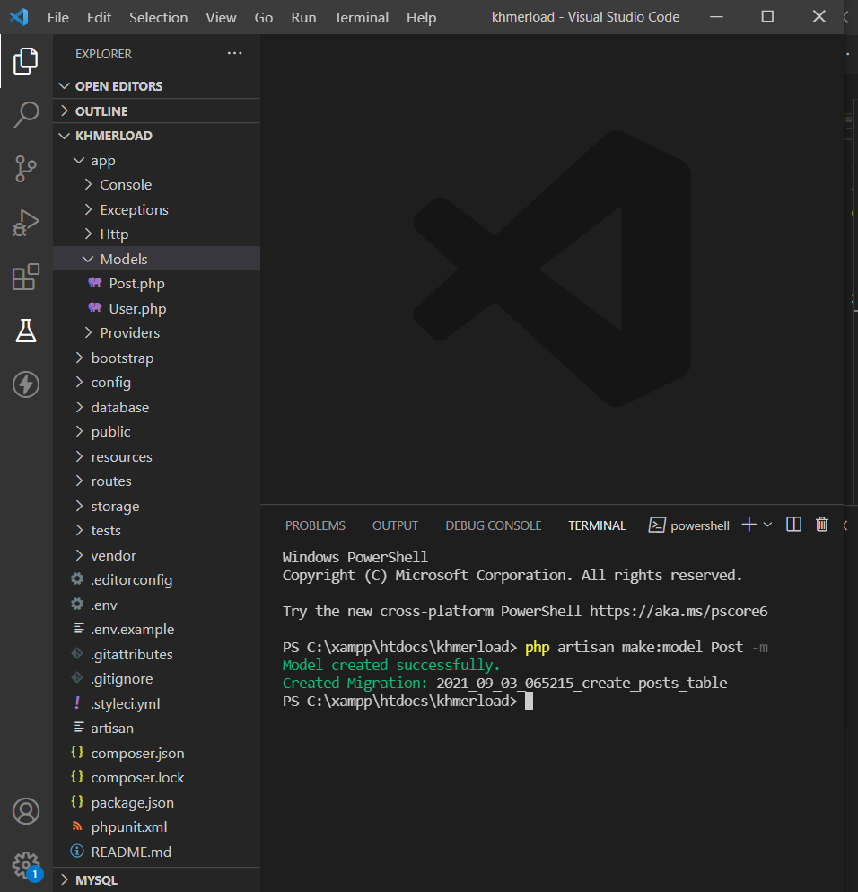
9. 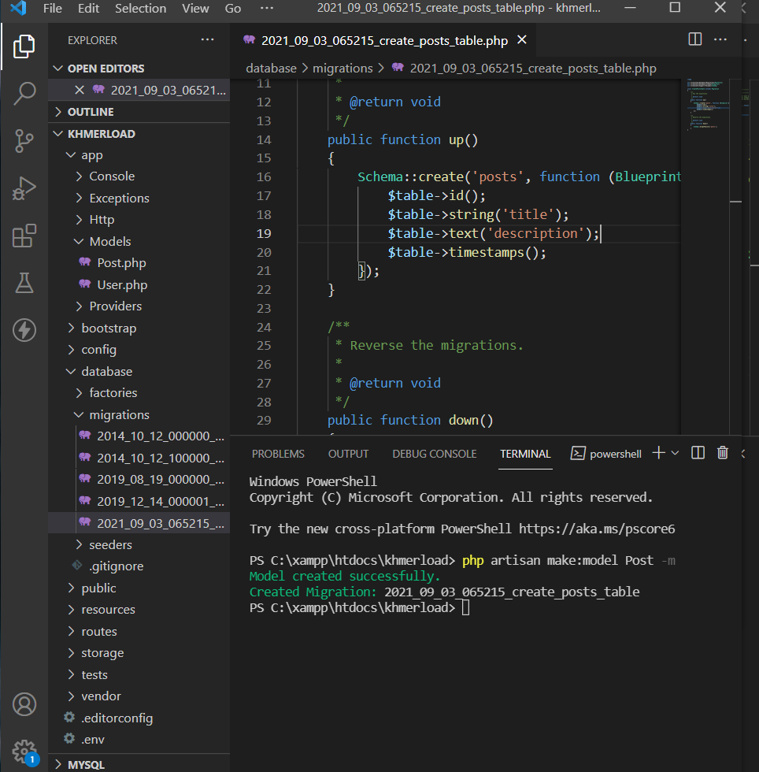
10. 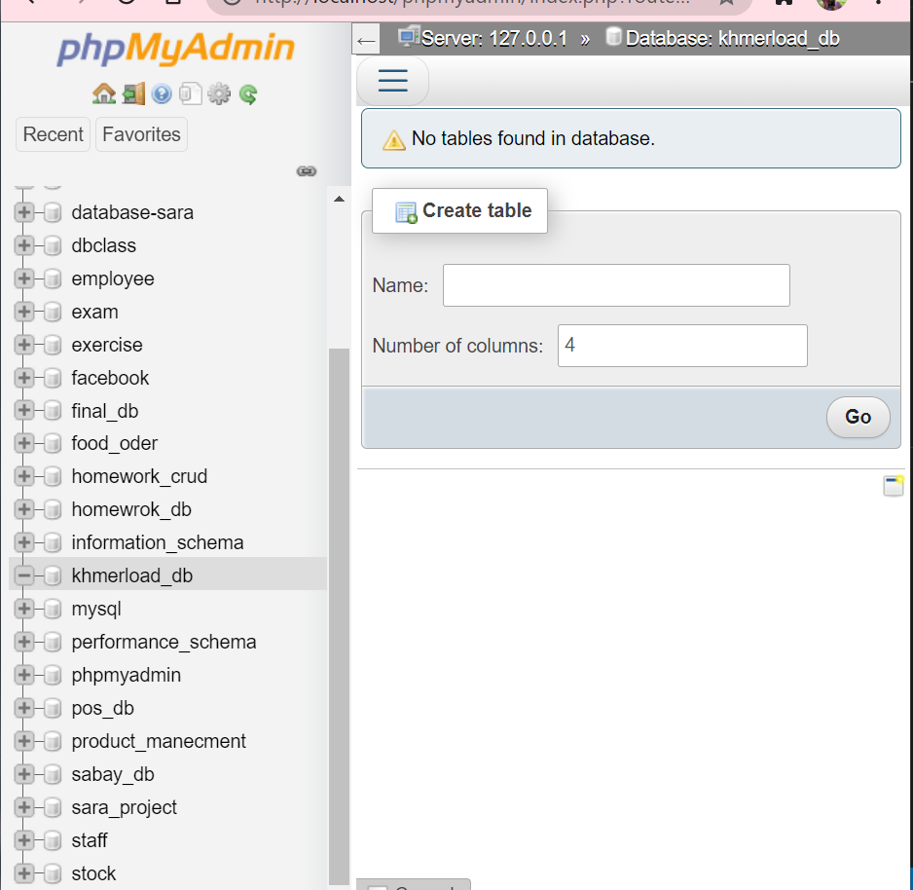
11. 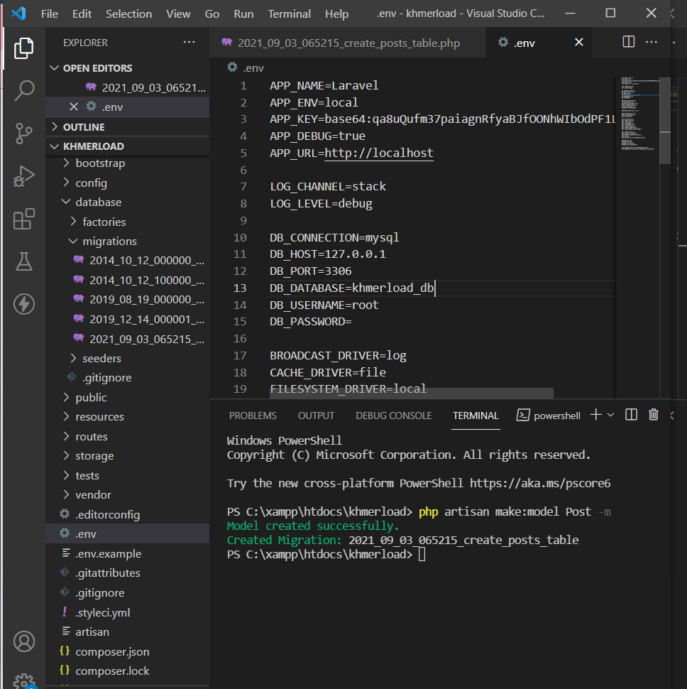
12. 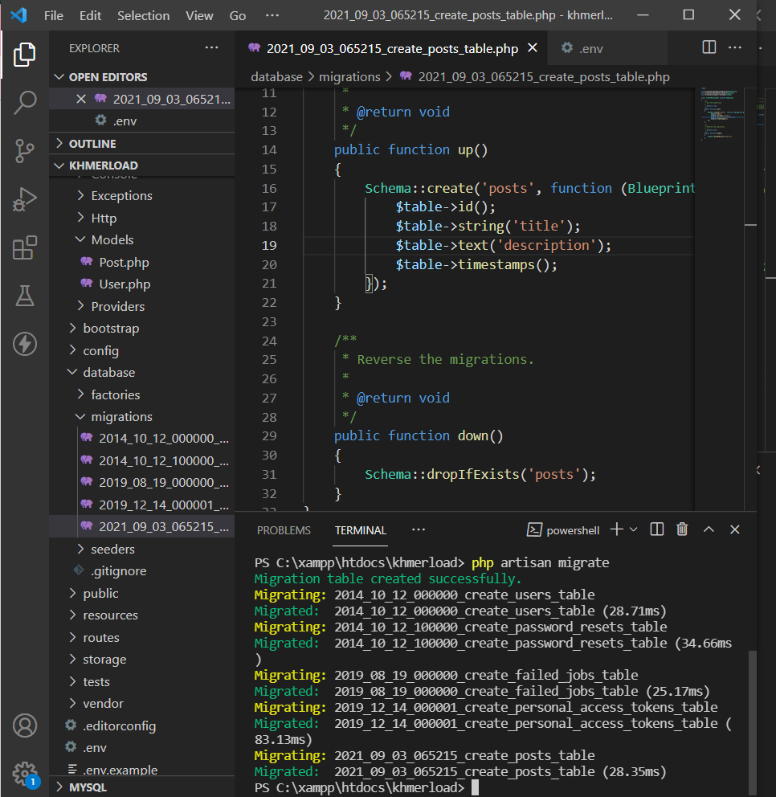
13. 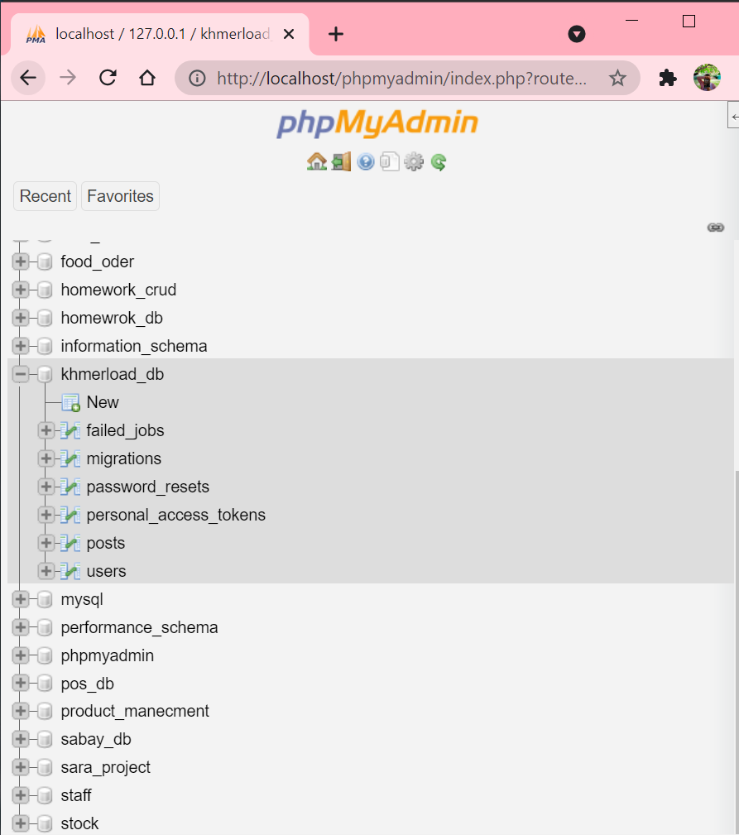
14. migreate make table and delete table
15. 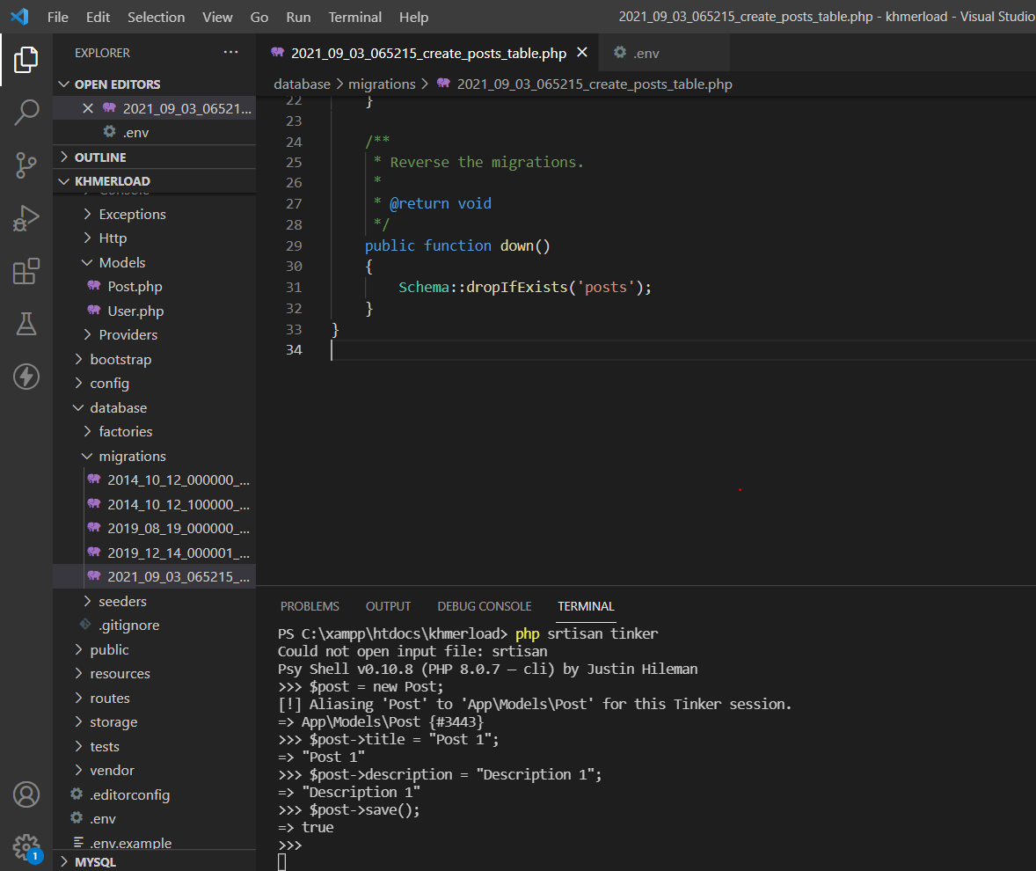
16. 
17. 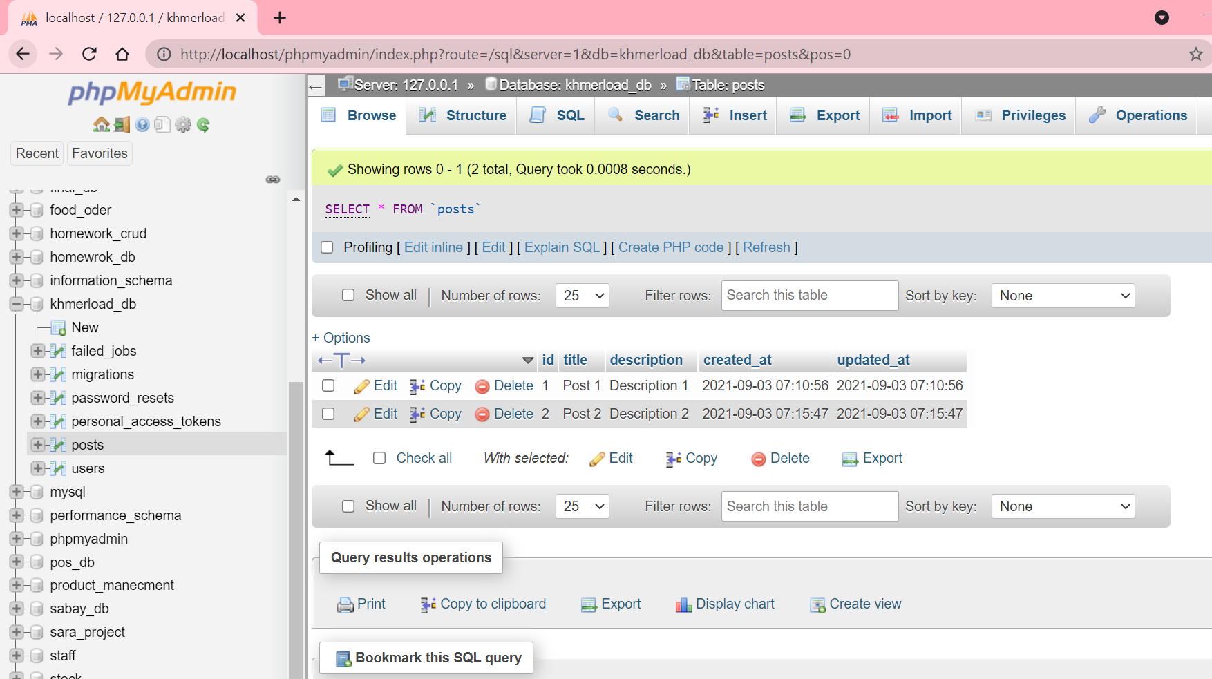
18. 
19. 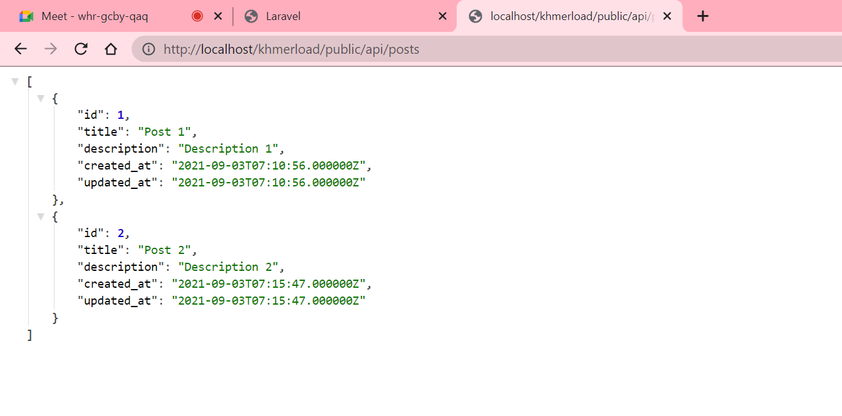
20. 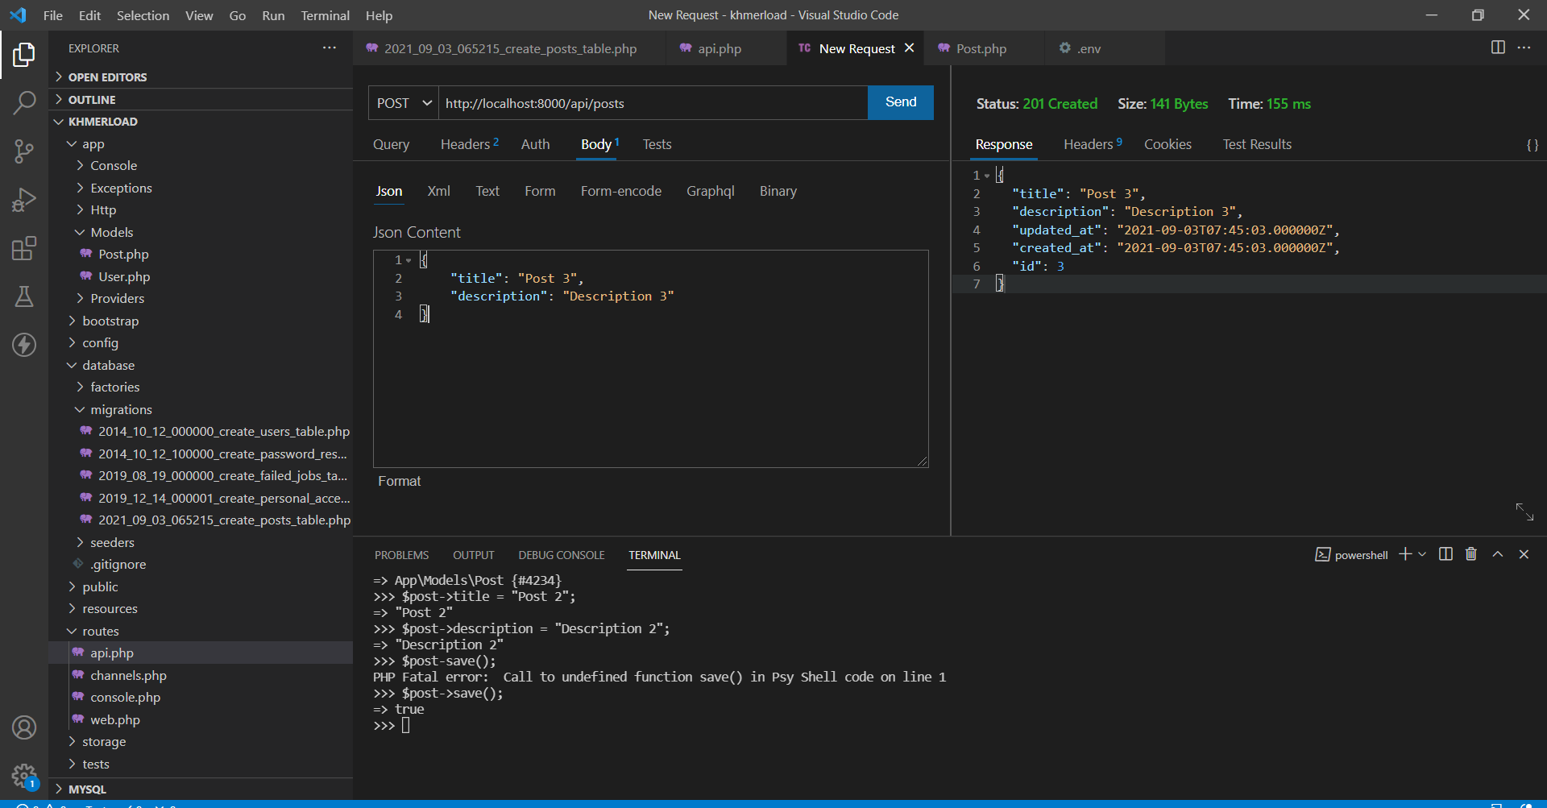
21. 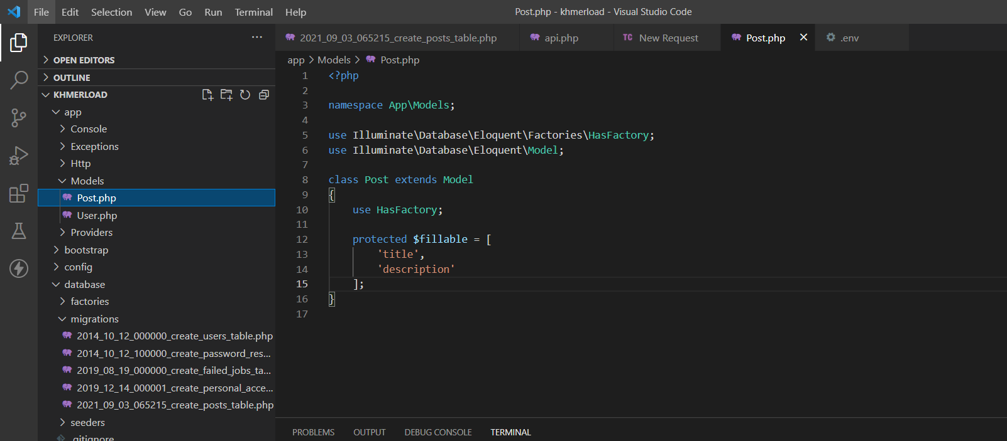
22. 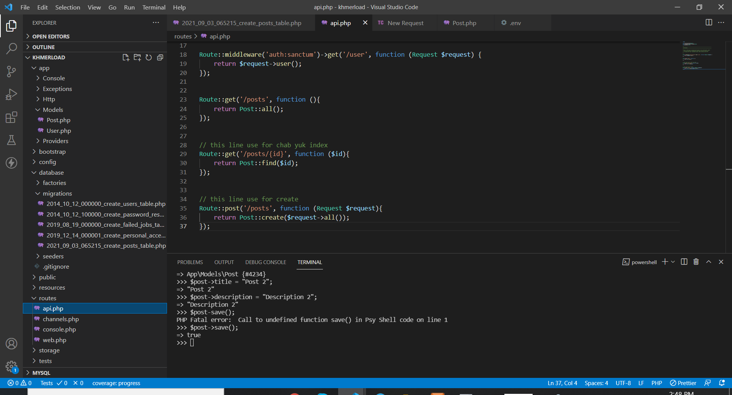
23. 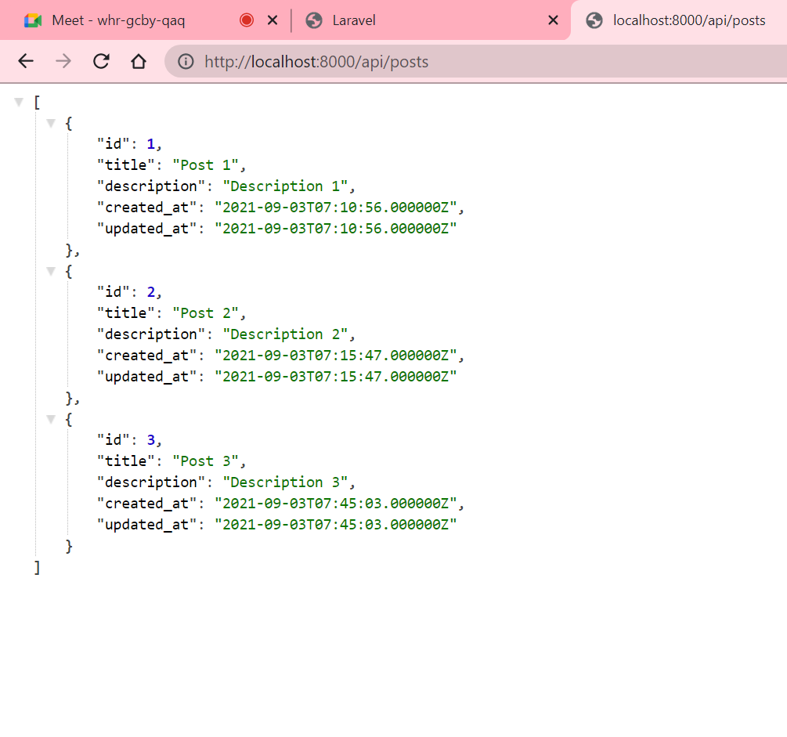
24. Command use for create new table : php artisan make:model Customer -m
25. Command use to config table in to database : php artisan migrate
26. Command use for create controller with api function : php artisan make:controller CustomerController –api
27. Command use for create resource : php artisan make:resource CustomerResource
28. Command use for make folder seeder: php artisan make:seeder PostSeeder

1. Model + Table : php artisan make:model Sample -m

2. Add table column (see in folder migration)

3. Allow field in Model : protected $fillable = [...];

after : php artisan migrate

4. Create controller : php artisan make:controller SampleController --api

5. use model in Controller and CRUD API

6. Use Controller in routes - api.php and call all function

7. Test it in Thunder Client or postman

8. Create resource : php artisan make:resource SampleResource

9. choose the column to collect data in Resource file

10: use Resource in Controller in index() & show()

11. Create Seeder: php artisan make:seeder SampleSeeder

12. use DB & Faker and call in function run() to insert data with faker

13. Call Seeder in DatabaseSeedeer : $this->call([ ...]);

