Vergel P. Galdoen
C334_IT

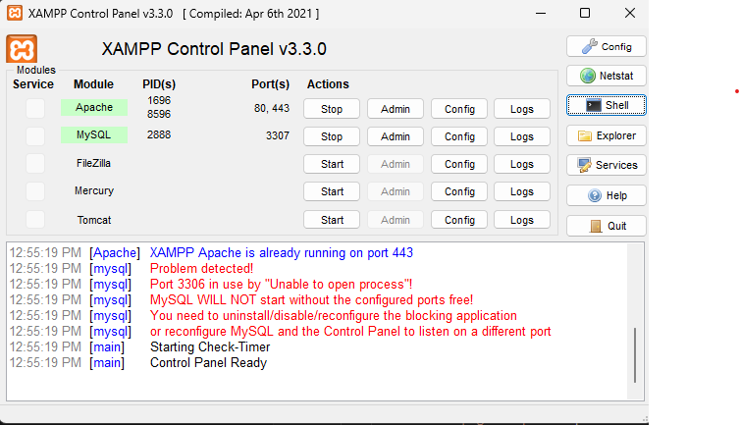
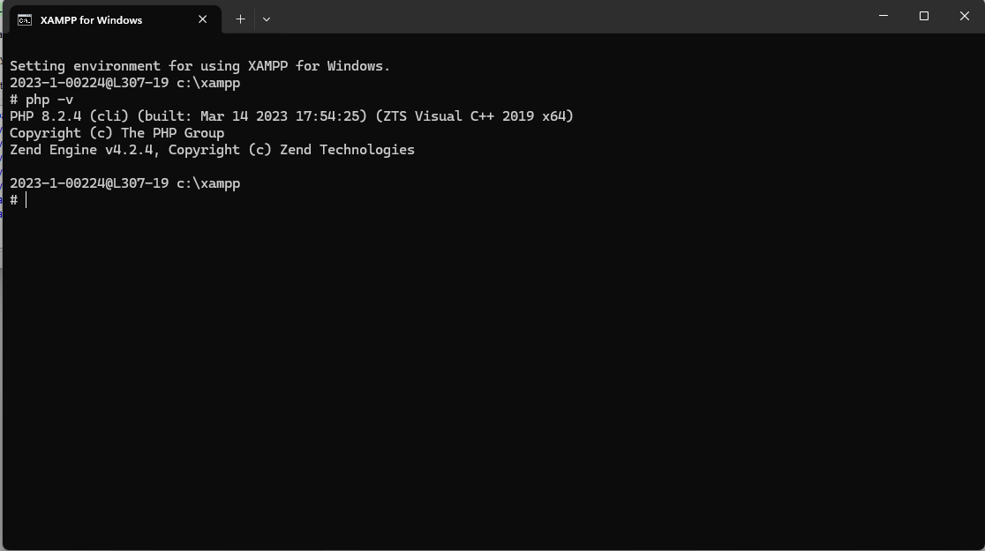
<!doctype html>
<html lang="en">
<head>
<meta charset="utf-8">
<meta name="viewport" content="width=device-width,initial-scale=1">
<title>PHP Dynamic Tutorial</title>
<style>
body{font-family:Inter,Segoe UI,Arial;margin:0;background:#f9fafb;color:#111}
header{background:#2563eb;color:#fff;padding:1.5rem;text-align:center}
main{max-width:1000px;margin:auto;padding:1.5rem}
section{background:#fff;padding:1.2rem;margin-bottom:1rem;border-radius:12px;box-shadow:0 4px 8px rgba(0,0,0,0.05)}
pre{background:#0f172a;color:#f8fafc;padding:1rem;border-radius:8px;overflow-x:auto}
code{font-family:ui-monospace,monospace}
.nav{display:flex;gap:1rem;flex-wrap:wrap;margin-bottom:1rem}
.nav a{background:#2563eb;color:#fff;padding:.5rem 1rem;border-radius:8px;text-decoration:none}
form{display:grid;gap:.5rem}
input,button{padding:.6rem;border-radius:6px;border:1px solid #ccc}
button{background:#2563eb;color:#fff;border:none;cursor:pointer}
</style>
</head>
<body>
<header>
<h1>Dynamic PHP Examples</h1>
</header>
<main>
<div class="nav">
<a href="?page=concat">Concatenate</a>
<a href="?page=math">Math</a>
<a href="?page=loops">Loops</a>
<a href="?page=constants">Constants</a>
<a href="?page=superglobals">Superglobals</a>
<a href="?page=form">Form</a>
</div>
<section>
<?php
$page = $_GET['page'] ?? 'concat';
if($page==='concat'){
$x="Hi"; $y=" How are you"; $z=$x.$y;
echo "<h2>Concatenation</h2><pre><code>Output: $z</code></pre>";
}
elseif($page==='math'){
$a=10;$b=3;
$result="Sum: ".($a+$b)." | Random: ".rand(1,100);
echo "<h2>Math Functions</h2><pre><code>$result</code></pre>";
}
elseif($page==='loops'){
$out="";
for($i=1;$i<=5;$i++){ $out.="Item $i "; }
$fruits=['Mango','Banana','Apple'];
foreach($fruits as $f){ $out.=$f." "; }
echo "<h2>Loops</h2><pre><code>$out</code></pre>";
}
elseif($page==='constants'){
define('STORE','Paynex Demo');
echo "<h2>Constants</h2><pre><code>".STORE."</code></pre>";
}
elseif($page==='superglobals'){
$server=$_SERVER['SERVER_NAME'];
$method=$_SERVER['REQUEST_METHOD'];
echo "<h2>Superglobals</h2><pre><code>Server: $server | Method: $method</code></pre>";
}
elseif($page==='form'){
if($_SERVER['REQUEST_METHOD']==='POST'){
$name=htmlspecialchars($_POST['name']);
$qty=(int)$_POST['qty'];
echo "<h2>Form Result</h2><pre><code>Hello, $name! You ordered $qty item(s).</code></pre>";
} else {
echo "<h2>Form Handling</h2>
<form method='post'>
<input name='name' placeholder='Your name' required>
<input name='qty' type='number' min='1' value='1' required>
<button>Submit</button>
</form>";
}
}
?>
</section>
</main>
</body>
</html>

