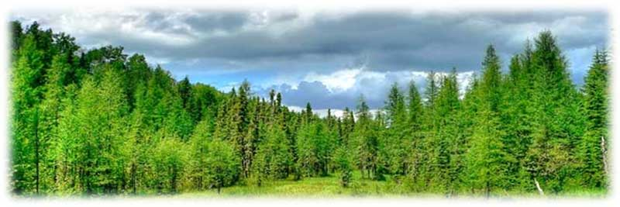

***Forest :***

* Total Forest area of West Bengal during 2014-15 is 11,879 sq.km. which is 13.38 per cent of total geographical area of this State where as in India Total Forest area is 771.821 thousand sq. km. covering 23.48 percent of total geographical area.
* Total Reserve Forest in West Bengal is 7054 sq.km. which is around 59 per cent of

Total Forest area where as in India Total Reserve Forest is 425.494 thousand sq.km. which is 55 percent of Total Forest area. Total area under Protected Forest and Un-classed Forest in West Bengal is 3772 sq.km. and 1053 sq.km covering around 32 percent and 9 percent of Total Forest Area respectively. In India, the said figures are 214.986 thousand sq.km. and 131.341 thousand sq. km. which are around 28 percent and 17 percent of Total Forest Area respectively.

* In 2015, very dense forest, moderately dense forest, open forest and scrub cover 17 percent, 25 percent, 57 percent and 1 percent respectively of total forest cover area in West Bengal.
* Total IFS cadre strength in West Bengal is 126 and the same for WBFS is also126.
* There are 762 Forest Beats in West Bengal spread over 474 Ranges in 58 Forest divisions and 18 Circles.
* Forestry sector accounts for 1.61 percent of total Gross State Domestic Product of West Bengal at current prices during 2014-15.
* South 24 Parganas district contributes maximum (around 11 per cent) in Gross State Domestic Product from Forestry sector in West Bengal at current prices.
* Total Revenue realization from Forestry sector in West Bengal during 2014-15 is Rs.
  1. crores out of which Rs. 91.96 crores comes from Timber and Poles.
* Total Government Expenditure of Forest Department (both Plan and Non-Plan) of West Bengal during 2014-15 is Rs. 410.61crores. Total Plan Expenditure (State Plan, Centrally Sponsored and Central Sector Schemes combined) is around 34 percent in 2014-15.

* West Bengal is the pioneer state in initiating the movement of Joint Forest Management (JFM) in India. Accordingly, 4312 numbers of Joint Forest Management Committees (JFMC) has been created as on 31st March, 2015 in this State covering area of 5.82 lakh hectares and total number of members is 4.98 lakhs.
* In 1996, Eco-Development Committees (EDC) were constituted seeking co-operation of the fringe people for protection and development of Wildlife Protected Areas (Sanctuaries and National Parks). There are 107 Eco-Development Committees as on 31st March, 2015 in the State with total number of members as 22.63 thousand.
* The object of formation of Self Help Groups (SHG) in Forest Fringe Villages, taken up in different districts involving the eligible and willing JFMC and EDC members, was to open alternative sources of assured income on sustainable basis. There are 2384 Self Help Groups formed as on 31st March, 2015 comprising of total number of 27506 members out of which around 75 percent are female. Total number of exclusively Women SHG in West Bengal is 1605.
* There are 6 National Parks and 15 Wildlife Sanctuaries covering areas of 1981.4817 sq.km. and 1488.7246 sq.km respectively in this State along with 2 TigerReserves, 1 Biosphere Reserves and 2 Elephant Reserves in West Bengal as on 31st March, 2016.
* Prior to the enactment of the Forest (Conservation) Act, 1980 the recorded forest lands were vulnerable to diversion for different non-forestry activities. In order to check further depletion of the forest cover and to protect the forests, Government of India enacted the Forest (Conservation) Act, 1980 and amended it from time to time. As a result the quantum of diversion of forest land for non-forestry purposes has been reduced appreciably. Net diversion of Forest land for Non-forest use in West Bengal is only 6.31 hectares during 2014-15.
* As on 31st March, 2016, about 8440 hectares of forest land have been distributed to 43876 *Patta-holders* in West Bengal.
* The gradual increase in population builds pressure on the forest land for agriculture and other purposes. Consequently, forest land faces a constant menace of encroachment. After the Forest (Conservation) Act, 1980 came into force; the problem was checked to a considerable extent. As on 31st March, 2015 the amount of encroachment of forest land is 13779.489 hectares.
* During 2014-15, total 11169.71 hectares of land in West Bengal is under various afforestation programmes.
* During 2015-16, total Fish production in West Bengal is 1671.41 thousand MT mounting around 3 percent from 1617.32 thousand MT in 2014-15. In West Bengal, major portion of fish production comes from Inland Fishery. In 2015-16, out of total fish production 178.20 thousand MT is Marine and 1493.21 thousand MT is Inland.
* During 2015-16, Earnings from Forest Tourism in West Bengal (i.e. Rs.431 lakh) have been increased by 12.09 percent with respect to previous year (i.e. Rs. 384.50 lakh) whereas number of tourists has been increased by 13.67 percent.
* Housing Department has taken up E.W.S. Housing Scheme (“Amar Bari” renamed as “Gitanjali” wef 2011-12), for construction of dwelling units for Economically Weaker Section (EWS) of people where special emphasis has been given to the people living in the Forest Areas such as Jangal Mahal, Hill areas of Darjeeling and AILA affected areas of Sundarban. During 2015-16, 2674 number of units under EWS Housing Scheme “Gitanjali” has been completed.

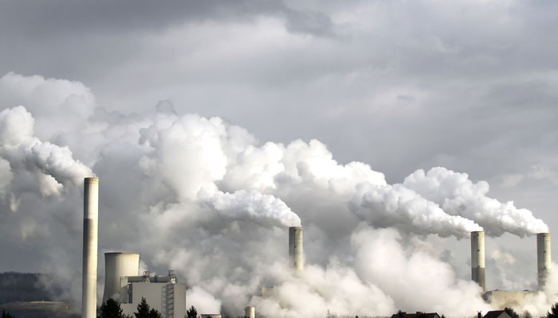

***Environment :***

* West Bengal Pollution Control Board regularly monitors ambient air quality through various monitoring stations throughout the state by some major parameters like Nitrogen Dioxide (NO2), Sulphur Dioxide (SO2), ParticulateMatter (size <10µm) (PM10 ), Particulate Matter (size <2.5µm) (PM2.5)etc. During 2015-16, in Kolkata (Behala), annual averages for NO2, SO2, PM10 and PM2.5 are 47.63 μg/m3, 4.47μg/m3, 139.93 μg/m3 and 67.73 μg/m3; in Howrah(HMC) the said figures are 76.50 μg/m3,12.63 μg/m3, 192.33 μg/m3 and 104.00 μg/m3 while standard values (annual) in industrial, residential, rural and other areas for these respective parameters are 40 μg/m3, 50 μg/m3, 60 μg/m3 and 40 μg/m3 respectively.
* West Bengal Pollution Control Board also monitors the quality of both surface and ground water on a regular basis through a statewide network. Viewing the objective of usage of the water bodies, the WBPCB conducts water monitoring of rivers, lakes, reservoirs and canals on monthly basis through various monitoring stations. The Board monitors water quality for physicochemical and bacteriological parameters like Biochemical Oxygen Demand (BOD), Chemical Oxegen Demand (COD), Dissolved Oxygen (DO), Faecal Coliform (FC), Total Coliform (TC), Boron, Sodium, Ammonia-N, pH, Conductivity, Total Dissolved Solids (TDS), Total suspended Solids (TSS), Total Kjeldahl Nitrogen (TKN), etc. The toxic heavy metal concentrations like copper, arsenic, mercury, lead etc. are also monitored from time to time.
* The WBPCB monitors river water quality of different rivers of North Bengal, Rarh Bengal and South Bengal, e.g., through11 stations on river Ganga, 9 on river Damodar, 2 on river Rupnarayan, 2 on river Dwarka, 1 on river Barakar, 2 on river Mahananda, 1 on river Teesta etc. In case of river Ganga, BOD is generally higher than the permissible limit (3mg/litre) in the monitoring stations like Baharampore, Dakshineswar, Garden Reach etc. while Do is higher than the permissible limit (4mg/litre) in all the monitoring stations.
* Natural lakes, sweet water reservoirs and ponds are turning out to be extremely important surface water resources considering the looming water crisis. The WBPCB monitors water quality of Rabindra Sarobar at Kolkata, Senchal and Mirik Lakes at Darjeeling, Sagardighi Lake at Coochbehar, Sahebbandh Lake at Purulia, Dudhpukur Lake at Tarakeswar (3 monitoring Stations) etc.
* Different canals in West Bengal like Noai canal, Khardah canal in 24 Parganas (N) are also monitored by the WBPCB regularly.
* The most stressed sweet water reserve in our country is the ground water reserve. Uncontrolled urbanization has an adverse impact on groundwater. The WBPCB monitors ground water quality through various monitoring stations located at Barrackpoore Municipality, Barasat Municipality, Behala (Kolkata), Basirhat Municipality, Dankuni (near Coal Complex), Dhapa (Kolkata), Durgapur Town, Englishbazar (Malda), Hot spring at Bakreshwar, Kolkata Leather Complex, Kalyani Industrial Area (Nadia), Kharagpur Industrial Area etc. All the parameters are measured in lean period, i.e., in the month of April to assess the worst scenario of groundwater. During April 2016, presence of Arsenic has been traced at Barasat Municipality, Kalyani Industrial Area (Nadia) and SDO office of Krishnanagar.
* It is observed that ground water in almost all districts of West Bengal contains chemical contaminants like arsenic, fluoride, chloride, iron etc. Among several impurities present in water, the contaminants like arsenic and fluoride is more disastrous to the human health and hygiene than the other ones. Total 83 Blocks under 8 districts of West Bengal are affected with Arsenic Contamination above permissible limit (> 0.05 mg/l). Similarly 43 Blocks under 7 districts of West Bengal are affected with Fluoride Contamination above permissible limit (> 1.5 mg/l). Moreover 57 Blocks in 4 districts of West Bengal are affected with Salinity in ground water above permissible limit (Chloride > 250 mg/l or TDS > 500 mg/l)).
* Noise can produce an undesired physiological effect to an individual. The WBPCB has taken up several effective initiatives such as noise pollution monitoring during Kali Puja-Diwali, installation of 10 continuous real time noise monitoring stations at various locations in Kolkata and other places, e.g., at New Market (Municipal Corporation), Patauli, SSKM Hospital, Goalpark, Head Quarter (WBPCB), Birati (Neelanchal), R. G. Kar Hospital, Tollygunj, Bag Bazar and Taratala.
* Bio-medical Waste (BMW) generated at different Health Care Units (HCU) is either treated by the Common Bio-medical Waste Treatment Facilities or through the own treatment facilities of the HCUs. Presently there are 6 numbers Private owned Common Bio-medical Waste Treatment Facilities in West Bengal and their collective quantity of BMW treated and disposed of during 2015 is 22811 kg. /day. There are 7 Health Care Units located across the districts of the State having own Bio Medical Waste Treatment Facility.
* As on 17th September, 2016 the number of Red (having high pollution potential), Orange (having moderate pollution potential), Green (having least pollution potential) and Bio-medical industrial units in the State are 8346, 21013, 11620 and 6714 respectively.

* In 2015-16, total number of hazardous waste generating units in operation across the districts of West Bengal is 958 and total amount of waste generation throughout the state is 143200.923million tonnes per annum out of which, about 37 percent are disposable, 4 percent are incinerable while the rest 59 percent are recyclable in nature.
* During 2015-16, total consumption of chemical fertilizer in West Bengal is 1615653 MT out of which N, P and K are 52 percent, 28 percent and 20 percent respectively while consumption of fertilizer per thousand hectares is 2996.18 MT.
* As per Census 2011, 58.8 percent of households use latrine within premises whereas 38.6 percent of households use open latrine.
* As on 31st December, 2015 total number of Slaughter Houses in Municipal Areas of West Bengal are 51 out of which 30 Slaughter Houses run by Municipality / MC and the rest run by private personnel having Trade License.
* As on 31st December, 2015 4522 number of Mobile Towers exist in Municipal Areas of West Bengal controlled by different Mobile companies, viz., BSNL, AIRTEL, VODAFONE, RELIANCE, TATA etc.
* During 2015-16, 10907173 numbers of person are affected due to natural disaster out of which approx. 98 percent are due to flood and the rest portion are due to landslide, earthquake, fire and erosion. Total 1292430.70 hectares sown areas have been damaged because of natural disaster out of which about 99 percent are from flood.
* During 2015-16, total number of working coal mines under Coal India Ltd. In West Bengal are 72 among which 53 are underground, 12 are opencast and the rest are mixed coal mines. Total coal production against these mines are 23718.449 thousand MT.
* Production and Consumption of Coal (non-coking) in West Bengal are 293.90 and 286.56 lakh tonnes in 2014-15.
* As per Census 2011, 33.1 percent of households use firewood, 25.6 percent use crop residue, 10 percent use cow dung cake, 18 percent use LPG and 2.1 percent uses kerosene and 7.9 percent uses coal, lignite, charcoal as fuel for cooking purposes.

* As per Census 2011, in West Bengal 54.5 percent of households use electricity as

primary source of lighting where 43.5 percent uses kerosene and 1.2 percent uses solar energy.

* During 2015-16, Solar Energy and Biomass harnessed so far in West Bengal (outside Sundarban) are 6.5 MW and 2.5 MW respectively. Upto 2017(12th Plan), the said figures in the pipeline for West Bengal are 30MW and 240MW respectively.
* During 2015-16, total consumption of electricity in West Bengal is 22990.852 MU among which about 39 percent, 15 percent and 29 percent are for domestic, commercial and industrial purposes.
* During 2015-16, total consumption of electricity in Kolkata (CESC area) is 9201 million KWH.
* During 2015-16, surplus (+) power supply in West Bengal is 2091.13 MU, i.e., amount of excess power supply with respect to availability is 5.24%.
* Consumption of Petroleum Products has been increased steadily over the years (i.e. from 2008-09 to 2015-16) but there is a slight decrease in the said figure against 2014-15. Consumption of LPG, Motor Gasoline (Petrol), Kerosene is1226, 655 and 736 thousand tonnes and that of High Speed Diesel Oil is 2955 thousand tonnes during 2015-16 in West Bengal.
* During 2015-16, gross generation and power sold in 5 Thermal Power Plants of West Bengal Power Development Corporation in West Bengal are 19963 MKWH and 17798 MKWH respectively. Though consumption of coal at Thermal Power Plants has been decreased in 2015-16 w.r.t. previous year but consumption of oil has been increased by 52%.

**\*\*\*\*\*\*\*\*\***