*'''  
2021.2.2FromIvicxDS:openCV;E3B sobel算子  
'''***'''  
A=  
a b c  
d e f  
g h i  
Gx=  
-1 0 1  
-2 0 2 *A  
-1 0 1  
Gy=  
-1 -2 -1  
0 0 0 *A  
1 2 1  
输出边界信息  
'''**import cv2*#读取格式为BGR*import numpy  
  
def showPicture(name,picture):  
 *#图像的显示,也可以显示多窗口* cv2.imshow(name,picture)  
 *#在键盘中按任意键退出显示并向后执行语句  
 #cv2.waitKey(1000)表示只显示1秒* cv2.waitKey(0)  
 cv2.destroyAllWindows()  
  
img=cv2.imread(**"image/kernel2.jpg"**,cv2.IMREAD_GRAYSCALE)  
sobelx=cv2.Sobel(img,cv2.CV_64F,1,0,ksize=3)*#水平方向轮廓  
#sobel(img,图像的深度,水平，竖直方向,算子的大小)*sobelx=cv2.convertScaleAbs(sobelx)  
*#绝对值让负数转换，得到轮廓的整体信息*sobely=cv2.Sobel(img,cv2.CV_64F,0,1,ksize=3)*#竖直方向轮廓  
#sobel(img,图像的深度,水平，竖直方向,算子的大小)*sobely=cv2.convertScaleAbs(sobely)  
*#绝对值让负数转换，得到轮廓的整体信息*sobelxy=cv2.addWeighted(sobelx,0.5,sobely,0.5,0)*#按照权重相加xy*res=numpy.hstack((sobelx,sobely,sobelxy))  
showPicture(**""**,res)

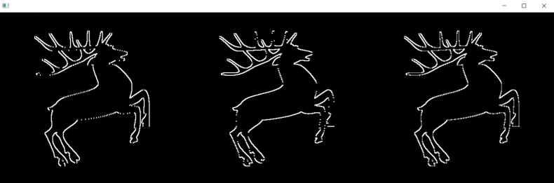

*'''  
2021.2.2FromIvicxDS:openCV;E3B Scharr和laplacian算子  
'''***'''  
Scharr算子:  
Gx=  
-3 0 3  
-10 0 10 *A  
-3 0 0  
Gy=  
-3 -10 -3  
0 0 0 *A  
3 10 3  
相较于sobel算子对变化更敏感  
laplacian算子:  
G=  
0 1 0  
1 -4 1  
0 1 0  
【二阶导】  
更敏感但容易受到噪点影响  
'''**import cv2 *# 读取格式为BGR*import numpy  
  
  
def showPicture(name, picture):  
 *# 图像的显示,也可以显示多窗口* cv2.imshow(name, picture)  
 *# 在键盘中按任意键退出显示并向后执行语句  
 # cv2.waitKey(1000)表示只显示1秒* cv2.waitKey(0)  
 cv2.destroyAllWindows()  
  
  
img = cv2.imread(**"image/x1.jpg"**, cv2.IMREAD_GRAYSCALE)  
  
sobelx=cv2.Sobel(img,cv2.CV_64F,1,0,ksize=3)  
sobely=cv2.Sobel(img,cv2.CV_64F,0,1,ksize=3)  
sobelx=cv2.convertScaleAbs(sobelx)  
sobely=cv2.convertScaleAbs(sobely)  
sobelxy=cv2.addWeighted(sobelx,0.5,sobely,0.5,0)  
  
scharrx=cv2.Scharr(img,cv2.CV_64F,1,0)  
scharry=cv2.Scharr(img,cv2.CV_64F,0,1)  
scharrx=cv2.convertScaleAbs(scharrx)  
scharry=cv2.convertScaleAbs(scharry)  
scharrxy=cv2.addWeighted(scharrx,0.5,scharry,0.5,0)  
  
laplacian=cv2.Laplacian(img,cv2.CV_64F)  
laplacian=cv2.convertScaleAbs(laplacian)  
  
res=numpy.hstack((sobelxy,scharrxy,laplacian))  
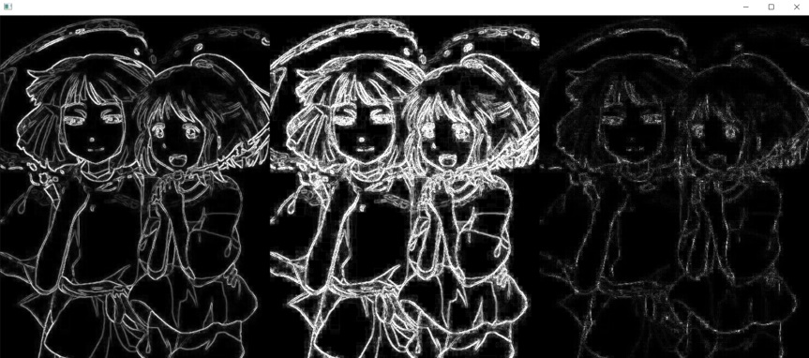showPicture(**""**,res)