**Improved Evolutionary Solutions to the Game of**

**Mastermind Using an Entropy-based Scoring Method**

By J.J. Merelo, Pedro Castillo, Antonio Mora, and Anna Esparcia-Alcazar

Summarized by Vince Fasburg and Josh Thomas

# Introduction

Solving the MasterMind puzzle consists of discovering a hidden combination by using hints which tell you how close your guess combination is to the hidden combination. One player hides a combination of κ symbols of length ʟ that the other player has to discover by playing combinations coded in the same alphabet and with the same length. The hints that are provided first include the number of symbols in the guessed combination that are in the correct position. These are usually represented as black or red pegs. The hints also include the number of symbols that have been guess correctly but are in the wrong position which are usually represented as white pins. The first player then continues to make new guesses and obtains new hints. This continues until the correct combination is guessed. A score is then given based on the number of guesses made where a higher score is worse. In the actual board game, the symbols in the alphabet are usually colored pegs with κ = 6 colors and combination length ʟ = 4 as shown in Figure 1 below.

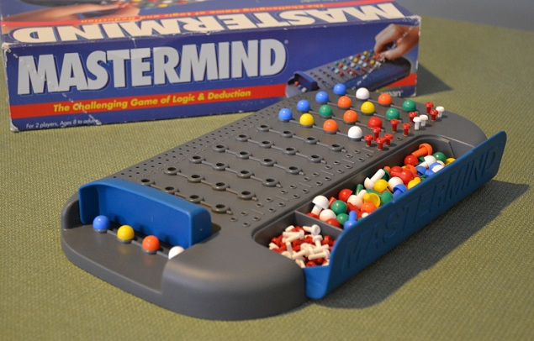

Figure : MasterMind Board Game Example

Although this problem is easy for a computer with a combination size of 4 and an alphabet size of 6, the problem becomes increasingly difficult with the increase of either of these variables. This paper first optimized the implementation of previous evolutionary methods used for the game of MasterMind. They then studied the behavior of an entropy-based score. With these two strategies, new solutions were developed that are competitive and in some cases beat the best solutions created so far.

# Using entropy for combination scoring

In order to measure how well a certain combination is going to perform, a score is assigned to each eligible combination. This score usually reflects how well a particular combination will be able to reduce the search space once played. The main rationale being that a scoring method that quickly reduces the search space will eventually reveal a single eligible combination. The set of eligible combinations must first be divided into a series of partitions which are created based on how closely related each combination is in terms of common colors and color positions in the combination. A partition is a subset of the set of eligible combinations. The entropy-based scoring method computes the entropy of each partition. Entropy can be defined as the amount of randomness or the amount of disorder found. This method then chooses the partition with the maximum entropy. The idea is that combinations with high entropy also have a high amount of information which could help in extracting the maximum amount of information from the hidden combination in the form of hints with red and white pegs. There will almost always be a set of combinations which have the same score and are thus in the same partition. In this case one of the combinations can be chosen either randomly or by lexicographical order.

# ????

# ????

# Conclusion

The goal of this paper was to establish a new state of the art in order to obtain better solutions to the game of MasterMind and complete it in faster time. They did not, however, manage to achieve both goals. While the results were better the method is considerably slower. The main result, which was to obtain a better player at MasterMind was achived mainly by using an entropy-based scoring method. For future work, additional improvements could be made to decrease the time it takes to solve the puzzle. A potential thought is to look into using multi-threaded applications. This would speed up the application, but would also greatly change the actual algorithm so it would need to be carefully looked into.