Attention-Based Deep Multi-Instance Learning for Detecting Bioactive Conformers in Receptor- and Alignment-Independent Conformational-Ensemble-Based 3D-QSAR Pipeline
Abstract:
Multi-instance learning (MIL) has demonstrated competitive performance in molecular activity prediction, including QSAR modeling. In molecular MIL, each compound is represented by its conformational ensemble, and the model predicts the biological activity while assigning an importance score to each conformer. The analysis of these conformer-level scores is known as key instance detection (KID). The highest-scoring conformer, that is, the key instance, is assumed to contribute the most to the predicted activity and is therefore interpreted as biologically relevant. Herein, we challenge this assumption in the context of receptor-independent and alignment-independent, conformer-ensemble-based three-dimensional (3D) QSAR modeling of beta-secretase 1 (BACE1) inhibitory activity. We introduce MILKID, a specialized MIL framework for evaluating and interpreting the KID. MILKID uses attention-based deep learning for conformer-level importance estimation, defines a KID evaluation protocol and metrics, and investigates the chemical relevance of KID.
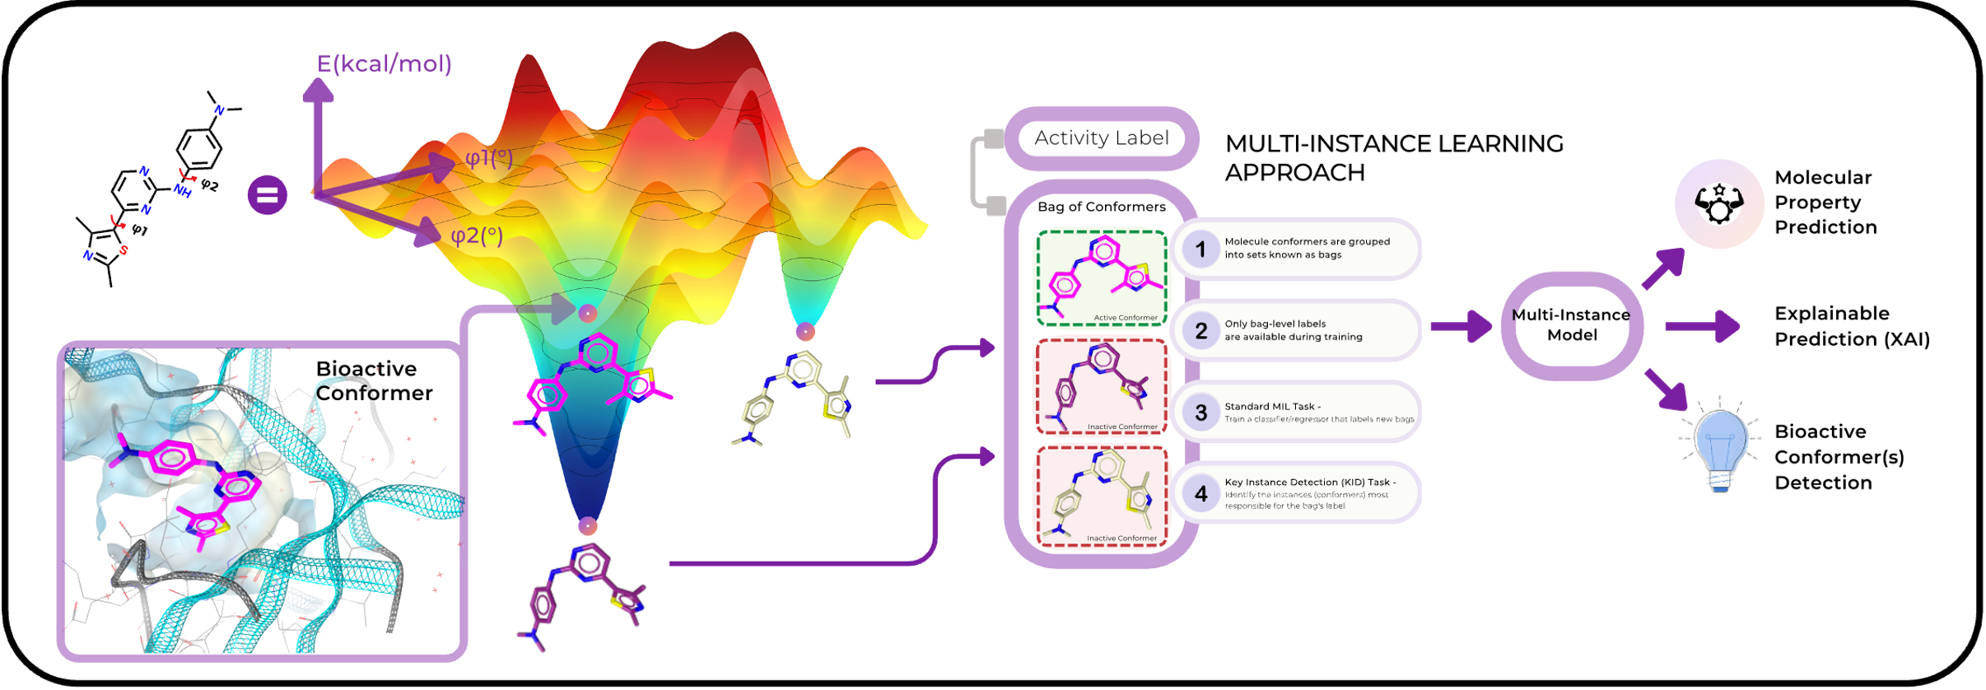
- Introduction

Bioactive Conformer Detection: The Context
Protein-ligand interactions depend on the target-bound conformation adopted by the ligand, which is referred to as the bioactive conformer. Consequently, the bioactive conformer provides a structural basis for rationalizing ligand potency. This principle underlies 3D-QSAR, introduced by Cramer et al. [1].
The 3D-QSAR methods aim to correlate a molecular 3D structure with its biological activity. Receptor-independent (RI) 3D-QSAR methods, unlike receptor-dependent (RD) approaches [31, 32], establish these correlations solely from ligand-derived 3D representations without explicitly encoding target information. As a result, the bioactive conformer, its binding pose, and its binding mode remain unknown and must therefore be inferred. Consequently, identifying the bioactive conformers is critical for RI 3D-QSAR methods, as several hypotheses may appear equally plausible, whereas others may not be biologically sensible.
Early RI 3D-QSAR methods, such as Comparative Molecular Field Analysis (CoMFA) [1], emerged in the late 1980s. They utilize 3D descriptors derived from grid-based molecular fields generated by aligning training-set molecules to a reference compound [14] or a pharmacophore [15]. Model performance and its interpretation, in turn, are shaped by the chosen molecular alignment protocol [9]. These approaches also require selecting a representative conformer for each compound. Such estimates are usually based on the minimum-energy geometry, which depends on the chosen force field and solvation model [36]. However, this is not always a reliable approximation, as ligands may undergo conformational changes upon binding and, therefore, do not necessarily bind in their lowest-energy geometry [81]. Alternative options include a docking-derived pose or a conformer selected based on similarity to an experimental pose, both of which are receptor-informed assumptions [37]. As a result, the factors mentioned can lead to variation in the predictive performance and explainability of the alignment-dependent RI 3D-QSAR model [13].
Alignment-independent RI 3D-QSAR methods do not require explicit ligand superimposition. Instead, they rely on roto-translation invariant descriptors or embeddings [3–8]. However, these encodings remain geometry-dependent, and a representative conformer must be selected to build a model. Moreover, enforcing the roto-translation invariance of the encoding often complicates feature-based model explainability, as discussed in ref. [67].
4D-QSAR [11, 12] methods lift the need for selecting a representative conformer and explicitly account for the molecular conformational ensemble. The ensemble typically comprises multiple local-minimum geometries sampled across the molecule’s potential energy surface (PES) [16]. Information from multiple molecular conformers is then aggregated into a single feature vector for downstream regression or classification tasks. However, the aggregation scheme in this scenario is predefined, meaning that it is heuristic; for example, conformers may be weighted by their Boltzmann populations at thermal equilibrium. Moreover, most 4D-QSAR-compliant descriptors remain alignment-dependent [12].

MIL for Bioactive Conformer Detection
Similar to 4D-QSAR methods, Multi-Instance Learning (MIL) [35] algorithms can utilize conformational ensembles as input. In the MIL formalism, a molecular conformational ensemble is referred to as a bag, with the conformers within it termed instances. An experimental label, such as binding affinity or activity, is assigned to the entire bag, whereas individual conformers remain unlabeled. In contrast to 4D-QSAR, MIL maintains conformer-level granularity during training by preserving instance-level descriptors [38] or embeddings [39]. This, in turn, allows data-driven strategies, such as support vector machines with multiple-instance kernels [40] or attention-based deep learning architectures [41, 42], to dynamically identify the conformer(s) responsible for the observed biological activity. These model-selected conformers may receive higher relative instance-importance scores, such as attention weights, and thus contribute more to the aggregated molecular representation used for the prediction. We subsequently referred to the conformers with the highest model-derived importance scores as key instances.
MIL-optimized conformer weighting consequently offers a conformer-level explanation of model predictions, yielding data-driven hypotheses about bioactive conformer(s) while addressing the feature-based interpretability limitations of the roto-translation invariant encodings.

MILKID: Modeling Framework
Various approaches [69,70], including MIL, have been explored for QSAR modeling using conformational ensembles. Here, we propose MILKID, an end-to-end MIL framework for constructing 3D-QSAR models and assessing both their accuracy and the relevance of their KID in a receptor- and alignment-independent modeling context.
The overall MILKID inference workflow is shown in Figure 1A, while the model architecture is depicted in Figure 1B. Each molecule is represented as a bag of conformers, that is, its conformational ensemble. Each conformer is encoded using 3D roto-translation invariant descriptors. The MIL model takes the resulting bag as input and outputs (i) a molecule-level prediction and (ii) conformer-level relative importance scores, which reflect the influence of each conformer on the prediction. The model-derived conformer weighting is then analyzed in a post hoc KID evaluation protocol, as depicted in Figure 1C. We demonstrated this framework on a structurally diverse set of BACE1 ligands with experimentally determined bioactive poses (i.e., bioactive conformers) spanning five major and eight minor congeneric series. This diversity at the series level represents a key extension of our findings compared to those of previous studies.

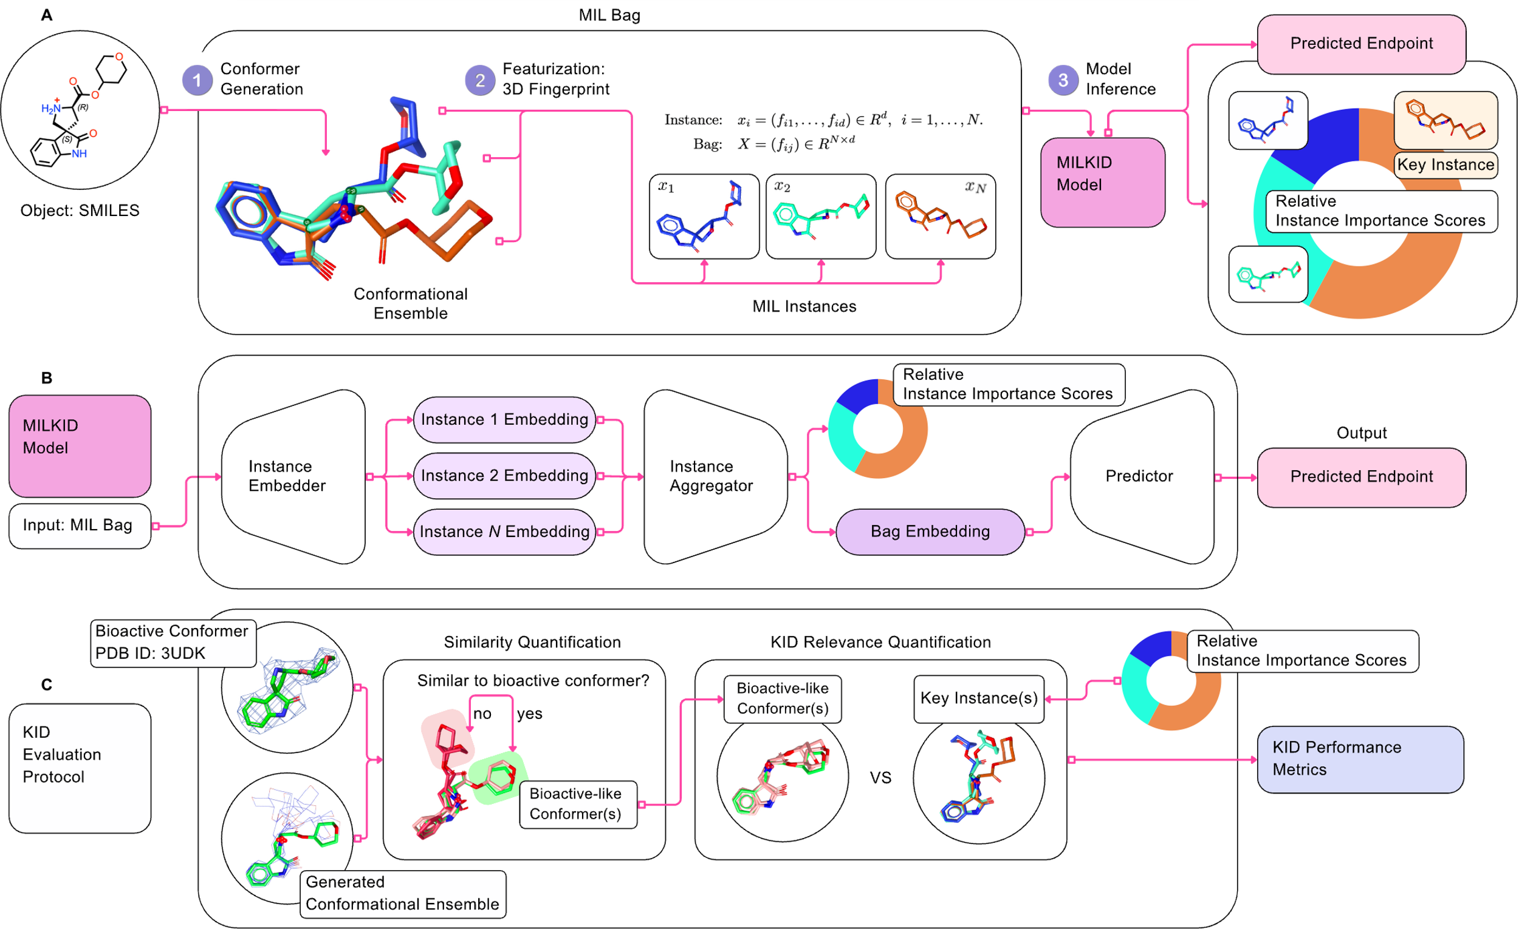
Figure 1. Overview of the MILKID Framework. (A) MILKID model inference workflow: conformers are futurized and assembled into bags that serve as input to a trained MILKID model. The model predicts the molecule-level endpoint (pIC50) and provides conformer-level attention scores, which are interpreted as relative instance importance. (B) Model architecture: conformer descriptors are processed by an instance encoder, aggregated into a bag-level representation via an attention-based MIL pooling layer, and used for the final bioactivity prediction. (C) Post hoc KID evaluation protocol: attention-ranked conformers are compared with experimentally observed bioactive poses to assess whether the model assigns high importance to bioactive-like conformers. KID performance is then quantified using top-k (k=1, 3, 5) recovery metrics.
- Related work
Here, we focus on MIL studies that explicitly define KID as a model-validation task and assess the biological relevance of key instances qualitatively and quantitatively.
Dietterich et al. [35] were the first to formalize an MIL framework for molecular activity prediction. Specifically, they observed that for MIL to be successful, the data must satisfy a constraint known as the standard MI assumption: a positive bag — here, an active molecule represented by multiple conformers — must contain at least one positive instance, that is, a bioactive-like conformer. A bioactive-like conformer is analogous to, but distinct from, the experimental pose (bioactive conformer), as defined in Section 3.2. Although the KID task was implicit in the original MIL formulation, its role as an explicit model validation task was established only in subsequent studies.
Fu et al. [17] first formalized KID as an explicit model validation task in the MIL-based RI 3D-QSAR context. They applied MILES [18] to develop a binary classification model using alignment-independent 3D pharmacophore fingerprints as conformer-level descriptors. In addition to bag-level prediction, they assessed whether the bioactive conformers inserted into the bags were among the MILES-derived key instances. However, this qualitative protocol did not assess whether the MIL model could de novo retrieve a bioactive-like conformer from the bag. Yet the scope of the study was limited by the experimental structural data available for the GSK-3β dataset the authors used.
Zhao et al. [19] further formalized the qualitative evaluation of KID relevance using experimental GSK-3β structural data. They rigidly fit key instances into receptor grids derived from co-crystal structures and compared the obtained poses with native ones. Additionally, the authors retrieved the model-derived binding mode using pharmacophore fingerprints shared by key instances, as well as the key-instance-derived bioactive shape using ROCS [71].
The adoption of the attention mechanism [73] in MIL marked a methodological advancement toward quantitative KID analysis. In the formulation of Ilse et al. [72], attention acts as a trainable permutation-invariant pooling operator that aggregates instance embeddings into a bag-level representation while assigning attention weights, that is, relative importance scores, to individual instances. These weights enable a quantitative assessment of the extent to which the model prioritizes bioactive-like conformers.
Chuang and Keiser [74] demonstrated this concept on a synthetic classification benchmark. Biaryl ligands with at most one rotatable bond were represented as conformer bags and labeled positive when at least one conformer satisfied a predefined torsion-angle criterion for bidentate coordination, i.e., contained at least one bioactive-like conformer. This design provided a hidden conformer-level ground truth, which was used only for KID evaluation. KID was quantified by ranking the conformers according to their attention weights and measuring the top-k recovery rate, defined as the fraction of molecules for which at least one bioactive-like conformer was ranked among the top-k key instances.
Zankov et al. [42] further assessed attention weights to quantify KID performance using ChEMBL [75] regression activity data. They relaxed the bioactive-like criterion from a single torsion angle to a root-mean-square deviation (RMSD) comparison between the generated conformers and the bioactive ones. They also introduced a random ranking baseline for the top-k recovery metric to assess whether key instances were identified beyond chance. However, the influence of KID evaluation hyperparameters, such as the RMSD threshold used to define bioactive-like conformers, on KID performance has not been thoroughly examined.
- Materials and Methods

Data Set
The BACE-1 dataset, originally collected and described by Subramanian et al. [45], comprises 1544 synthetic inhibitors with experimentally measured inhibitory activity against β-secretase 1 (BACE-1), ⎯ which is an aspartyl protease involved in amyloid precursor protein (APP) processing [82]. The dataset structure is illustrated in Figure 2.
The BACE_X_IC50 subset consists of 205 inhibitors with both co-crystal structures and half-maximal inhibitory concentration (IC50) values. The BACE_IC50 subset contains 1270 molecules with reported IC50 values; although their binding modes are not reported, they were approximated by aligning them to structural analogs from BACE_X_IC50. The BACE_X subset comprises the remaining 69 co-crystallized inhibitors without associated IC50 labels. However, 44 of these have alternative activity labels, such as the inhibition constant (Ki) or dissociation constant (Kd).
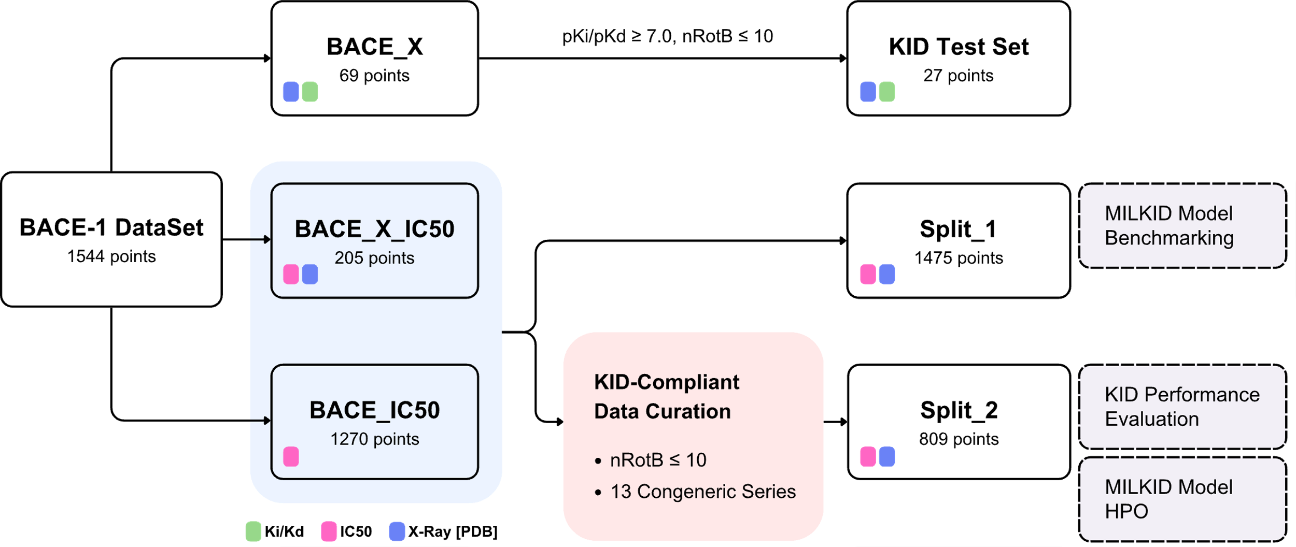
Figure 2. BACE-1 subset-split mapping scheme.
The BACE_X_IC50 and BACE_IC50 subsets were used to train the MILKID models and select the most predictive ones, as assessed through an internal validation procedure. From these subsets, we defined two data splits:
- Split_1 reproduced the original data split reported by Subramanian et al. [45] (1475 data points), enabling direct comparison with previously published 3D alignment-dependent and -independent models, and was used as is.
- Split_2 (809 data points) was used for 3D-fingerprint selection, MILKID model hyperparameter optimization (HPO), and KID analysis. The KID Test Set was held out for external evaluation and consisted of BACE_X compounds that met two criteria: pKi or pKd > 7.0 and fewer than 10 rotatable bonds (nRotB).
Split_2 Construction and Preprocessing:
- Compounds from the BACE_X_IC50 and BACE_IC50 subsets containing more than 10 rotatable bonds were filtered out.
- The remaining compounds were manually assigned to the congeneric series (CS). CS were retained only if they included at least one compound with an associated bioactive conformer and spanned an activity range of >3 log units.
- Their charge states were standardized using Open Babel with the -h option to generate the dominant protonation state at pH 7.4 [49] and, where necessary, adjusted to ensure consistent charge assignments within each series.
This procedure yielded 13 congeneric series comprising 809 ligands; their names and summary statistics are reported in Table S2.
Split_2 Partitioning:
- The compounds were then encoded with Morgan fingerprints (radius = 2, 2048 bits) and clustered using the Butina algorithm with a Tanimoto similarity cutoff of 0.75. This divided each CS into two or more clusters of closely related compounds.
- The resulting clusters within each CS were then assigned to either the training or validation set. This ensured that each CS was represented in both the training and validation sets. Additionally, the validation set was enriched with active compounds containing bioactive conformers to support the subsequent KID evaluation.
This procedure resulted in an 80/20 Split_2 partition comprising 647 training compounds (286 active, 361 inactive; 39 experimental poses, 13 CS) and 162 validation compounds (93 active, 69 inactive; 53 experimental poses, 13 CS). The corresponding t-SNE projections supporting both the CS assignment and the train/validation set assignment within Split_2 are shown in Figure 3.
A 2D baseline using Morgan fingerprints (radius = 2, 2048 bits) and a Light Gradient Boosting Machine (LightGBM) regressor [83] was employed to compare the performance of the predefined Split_2 partition with that obtained from repeated randomized cross-validation. The results are presented in Table S3.
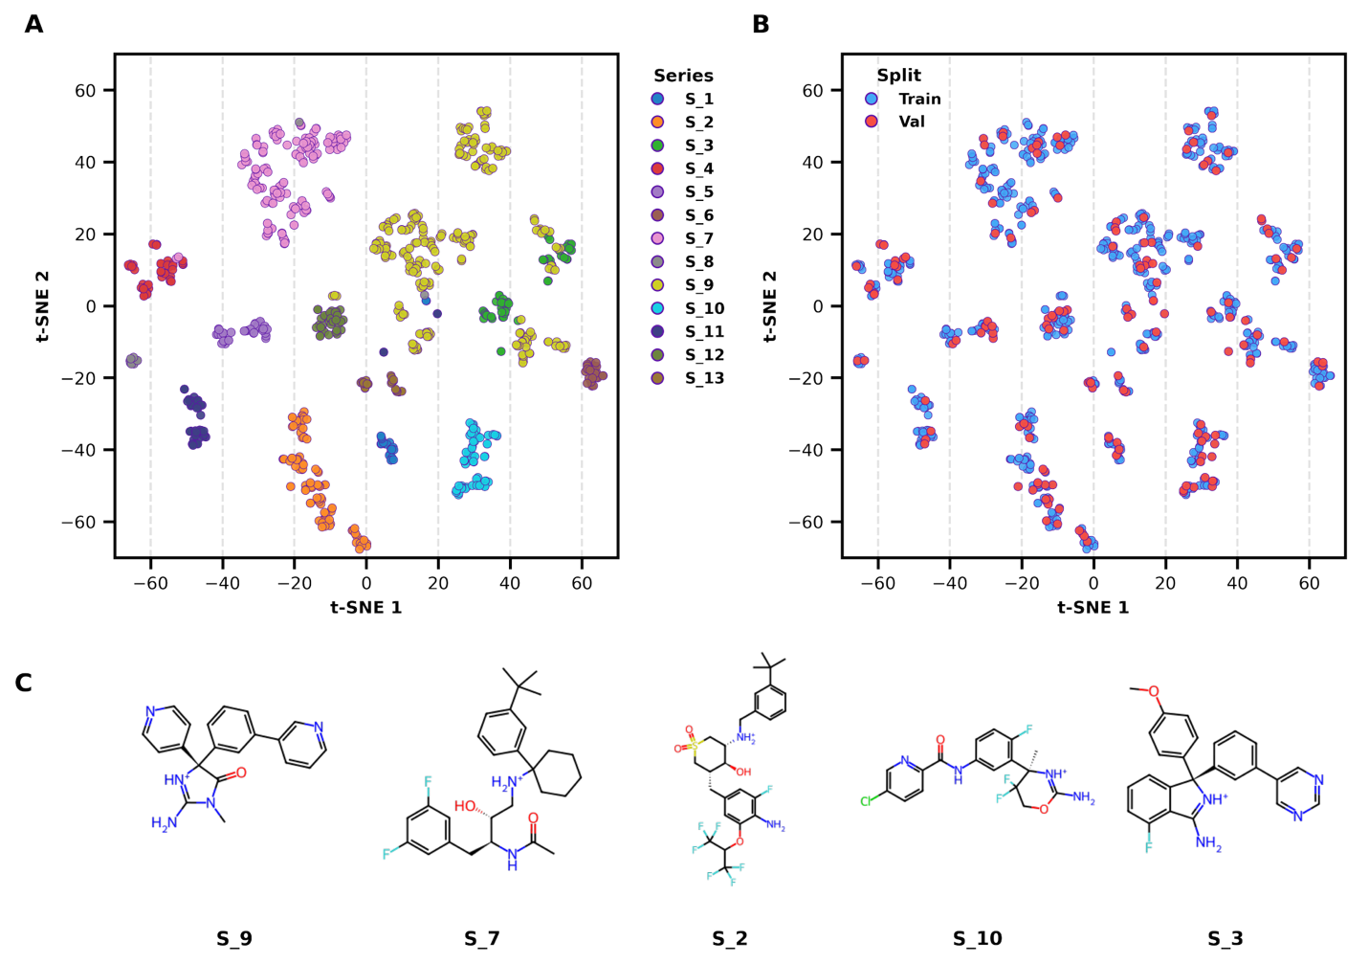

Figure 3. t-SNE (Morgan fingerprints) projection of the Split_2 training and validation sets. (A) Chemical space colored by the congeneric series. (B) The same projection colored by split assignment. (C) Medoid representatives of the five major congeneric series with color tags.

MIL Bag Composition and Analysis
Bag Composition:
- For each molecule represented as an isomeric SMILES, we generated up to 200 conformers using the iCon conformer generator [76] as implemented in LigandScout [77], with an RMSD pruning threshold of 0.5 Å and an energy window of 6 kcal/mol.
- We represented each conformer by a 348-dimensional 3D descriptor vector, obtained by concatenating GETAWAY [57], ElectroShape [56], and USRCAT [66] fingerprints computed with scikit-fingerprints [55]. Fingerprint selection and postprocessing procedures are described in the Supporting Information.
Bag Analysis:
- For molecules with a known bioactive conformer, each generated conformer was compared with the corresponding reference bioactive conformer using two heavy-atom rigid alignment metrics. RMSD quantifies the average positional deviation between mapped atoms in Å, whereas the Crippen O3A [78] overlay score additionally accounts for the Wildman-Crippen atom contributions to logP and molar refractivity [79]. The O3A scores were further normalized within each bag to obtain comparable values across the bags.
- Conformers were classified as bioactive-like if they satisfied a predefined alignment metric threshold T: RMSD ≤ T or normalized O3A ≥ T.
- The success rate of the conformer generation step was defined at the dataset level as the fraction of molecules for which at least one bioactive-like conformer was generated (successful bags). Only successful bags were considered for subsequent KID evaluation, in accordance with the standard MI assumption described above.
- The witness rate was defined on the successful bags as the fraction of bioactive-like conformers within each bag.
The per-molecule distribution of the generated conformers and the witness rates obtained for Split_2 are presented in Figure 4. The similarity-metric threshold T, i.e., the bioactive-like criterion, was treated as a hyperparameter during the KID performance evaluation. In addition, the witness rate was used to estimate the random baseline for the top-k recovery rate.

MIL Algorithm
The MIL model is a permutation-invariant regression network over conformer ensembles. Each molecule is represented as an unordered bag of its conformers, and the model predicts a single molecule-level activity (pIC50). A molecule $b$ is a set of conformer descriptor vectors, and the network outputs a scalar prediction:
$X_{b}=\{ x_{b,1},…,x_{b,N_{b}} \}, x_{b,n}∈R^{F}, {\hat{y}}_{b}∈R$ (1)
The forward pass consists of three stages (Figure 1B): (1a) a shared encoder maps each conformer to a feature vector, (1b) self-attention contextualizes conformers within each bag, (2) a hierarchical cluster–instance attention module aggregates the variable-size set of conformers into a single bag representation, and (3) a predictor maps this representation to the bag-level output. For batching, bags are padded to the same size, and a binary mask ensures that padded conformers are ignored during both attention and aggregation.
Instance encoder. A shared encoder maps each conformer descriptor independently to a $D$ = 256 latent embedding, so the stage is permutation-equivariant. It is a pre-LayerNorm residual MLP with $L$ = 3 SwiGLU-gated feed-forward blocks and LayerScale residual scaling $γ_{l}$:
$h^{0}=W_{in} x_{b,n}, h^{l}=h^{l-1}+γ_{l}⊙FFN(LN(h^{l-1})), e_{b,n}=h^{L}$ (2)
$FFN(u)=W_{2}\left(SiLU(W_{1}^{g}u)⊙W_{1}^{v}u\right)$ (3)
Contextualizer. A single masked multi-head self-attention block (2 heads, no positional encoding) lets conformers within the same bag exchange information, yielding contextualized embeddings $z_{b,n}$:
$\tilde{e}=e+γ_{a}⊙MHA(LN(e)), z_{b,n}=\tilde{e}+γ_{f}⊙FFN(LN(\tilde{e}))$ (4)
where $x_{b,n}∈R^{F}$ is the descriptor of conformer $n$ in molecule $b$; $h^{l}$ the hidden state after residual block $l$ (of $L$ = 3); $e_{b,n}$ and $z_{b,n}$ the per-conformer and contextualized embeddings (dimension $D$ = 256); $γ$ the per-channel LayerScale vectors; $W_{in}$, $W_{1}$, $W_{2}$ learned weight matrices; LN is LayerNorm, MHA masked multi-head self-attention, SiLU the sigmoid-linear unit, and $⊙$ the element-wise product.
Conformer clustering. Before aggregation, the $N_{b}$ conformers of each bag are partitioned into $K_{b}≤6$. Each cluster $C_{b,k}$ is summarized by the mean of its member embeddings:
cb,k=1|Cb,k|n∈Cb,k​zb,n (5)
Hierarchical attention aggregator. A single learnable pooling query first cross-attends over the cluster tokens to score clusters, then a refined query cross-attends over the individual conformers. Both stages use temperature-scaled scaled-dot-product cross-attention; attention is averaged over 4 heads and renormalized over valid elements. The cluster-stage attention is
$β_{b,k}=\underset{k}{softmax}​\left(\frac{(qW_{Q})(c_{b,k}W_{K})^{⊤}}{τ\sqrt{d}}\right)$ (6)
The updated cluster-stage query representation and the cluster-context vector are concatenated and projected to form the refined query:
qb'=Wr qbclus ; k​βb,k cb,k (7)
The refined query then produces the per-conformer attention; the raw instance attention is gated by the cluster mass of each conformer’s cluster $k(n)$ and renormalized:
$α_{b,n}^{raw}=\underset{n}{softmax}​\left(\frac{(q_{b}^{'}W_{Q}^{'})(z_{b,n}W_{K}^{'})^{⊤}}{τ\sqrt{d}}\right), α_{b,n}^{ref}∝α_{b,n}^{raw} β_{b,k(n)}$ (8)
where $q$ is the learned pooling query token and $q_{b}^{'}$ the cluster-refined query; $W_{Q}$, $W_{K}$ (and $W_{Q}^{'}$, $W_{K}^{'}$) the query and key projections; $τ$ the learned attention temperature and $d$ the per-head dimension; $β_{b,k}$ the attention over clusters and $α_{b,n}$ the attention over conformers; $c_{b,k}$ the mean token of cluster $C_{b,k}$; and $k(n)$ the cluster that contains conformer $n$.
A complementary cluster-uniform weighting spreads each cluster’s score evenly over its members, and the final attention is a fixed convex mixture of the two ($λ$ = 0.7):
$α_{b,n}^{clus}=\frac{β_{b,k(n)}}{|C_{b,k(n)}|}$ (9)
$α_{b,n}=normalize\left((1-λ) α_{b,n}^{clus}+λ α_{b,n}^{ref}\right)$ (10)
The bag representation is the attention-weighted sum of the contextualized conformer embeddings:
rb=n​αb,n zb,n (11)
Predictor. A residual pre-LayerNorm SwiGLU MLP head (2 blocks) with a final linear layer maps the bag representation to the scalar activity:
${\hat{y}}_{b}=f_{ϕ}(r_{b})$ (12)
Active-prototype memory. The memory $M$ is a non-trainable bank of active-conformer prototypes that supplies the aggregator with a data-driven query; it is built and used in three steps. (i) Candidate selection. After each training forward pass, every active bag (experimental $pIC50≥7.0$) contributes the embeddings of its $m_{c}$ highest-attention conformers to the epoch’s candidate set (re-ranked by a leave-one-out attention-ablation impact so that only prediction-driving conformers are kept):
$C_{e}=\left\{ z_{b,n} : y_{b}≥7.0, n∈top-m_{c}(α_{b,⋅}) \right\}$ (17)
(ii) Bank rebuild. Once per epoch, the bank is rebuilt from $C_{e}$ using training data only, so no label information can leak from the validation or test sets. Candidates are L2-normalized, grouped by congeneric series, and each series is clustered into at most four clusters; every cluster $G_{j}$ with at least three members yields one count-weighted, unit-norm prototype (at most 64 in total):
pj=normalize​1|Gj|z∈Gj​z (18)
(iii) Query construction and injection. For a bag with contextualized embeddings $z$, the builder scores each prototype by its best-matching conformer (max cosine over conformers), softmax-weights the top-eight prototypes into a prototype-context vector $u_{b}$, and maps the concatenation of the bag summary ${\overset{‾}{r}}_{b}$ and this context through a small MLP (LayerNorm → Linear $2D​→​D$ → tanh) to an external query:
sj=maxncos(zb,n,pj), aj=softmaxj∈top-8(sj/τq), ub=j​aj pj (19)
$q_{b}^{ext}=tanh(W_{q} [{\overset{‾}{r}}_{b} ; u_{b}]+b_{q}), g_{b}=clip(\max_{j}s_{j}, 0, 1)$ (20)
The aggregator conditions its learned pooling query on this external query via a gated linear projection and blends the resulting attention with the base (learned-query) attention using the weight $w$:
${\tilde{q}}_{b}=q_{b}^{CLS}+g_{b} W_{ext} q_{b}^{ext}, α_{b,n}=(1-w) α_{b,n}^{base}+w α_{b,n}^{active}$ (21)
where $w(e)$ is the blend weight at epoch $e$, ramped from the focus-trigger epoch $e_{focus}$ to $w_{max}$ over $R$ epochs; $C_{e}$ the epoch’s candidate set (the top-$m_{c}$ highest-attention conformers of bags with $y_{b}≥7.0$); $p_{j}$ the prototypes formed by clustering candidate groups $G_{j}$; $u_{b}$ the prototype-context vector and $q_{b}^{ext}$ the resulting external query; $g_{b}$ the per-bag relevance gate; and $α^{base}$, $α^{active}$ the base- and active-query attentions blended by the curriculum weight $w$.
Here $g_{b}$ is a per-bag relevance gate: a bag that resembles no active prototype receives $g_{b}≈0$ and is left unchanged, whereas a strong prototype match steers the query toward the memory’s bioactive conformers. The normalized attention weights $α_{b,n}$ are retained as conformer-level importance scores for the key-instance detection (KID) analysis of Section 3.4.
Training objective. The network is trained by minimizing the mean-squared error (MSE) between predicted and experimental pIC50 values, plus a cluster-preservation regularizer applied by the aggregator. Each mini-batch is balanced across the congeneric series, and the training loss is importance-weighted ($w_{b}$, self-normalized) to undo the resulting oversampling:
L=b​wb (yb-yb)2b​wb+Lclus (13)
The regularizer combines a within-cluster compactness term and a between-centroid separation term, computed on L2-normalized embeddings ${\hat{z}}_{b,n}$ with unit centroids ${\overset{‾}{c}}_{b,k}$ and a maximum-similarity margin $s_{max}$:
$L_{clus}=η (w_{c} Ω_{comp}+w_{s} Ω_{sep})$ (14)
$Ω_{comp}=\underset{k}{mean}\underset{n∈C_{k}}{mean}∥{\hat{z}}_{b,n}-{\overset{‾}{c}}_{b,k}∥^{2}, Ω_{sep}=\underset{k≠k^{'}}{mean}[ReLU(cos({\overset{‾}{c}}_{b,k},{\overset{‾}{c}}_{b,k^{'}})-s_{max})]^{2}$ (15)
where $y_{b}$ and ${\hat{y}}_{b}$ are the experimental and predicted pIC50; $w_{b}$ the per-molecule series-importance weight; $L_{clus}$ the cluster-preservation regularizer with coefficients $η$, $w_{c}$, $w_{s}$; ${\hat{z}}_{b,n}$ and ${\overset{‾}{c}}_{b,k}$ the L2-normalized conformer embeddings and unit cluster centroids; and $s_{max}$ the maximum allowed inter-centroid cosine similarity.
Training procedure. Optimization uses AdamW with decoupled weight decay (excluded on biases and normalization parameters) and separate learning rates for the encoder, contextualizer, aggregator, predictor, and active-query builder. Training proceeds in two regimes governed by a validation loss (Figure 5). In the base phase, the full network is trained end-to-end on the objective of Eqs. (13) – (15); from a warm-up epoch, the active-prototype memory begins accumulating candidate conformers from training batches, while the active query stays off (query weight $w$ = 0). When the validation loss plateaus (no improvement above $δ$ = 0.005 for 3 epochs) and the memory holds enough prototypes, the training enters the focus phase: the backbone is frozen by scaling the encoder and predictor learning rates by 0.01, while the aggregator and active-query builder keep training at full rate, so refinement concentrates on instance selection. At the same time, the active query is switched on, and its blend weight is ramped linearly from 0 to $w_{max}$ over $R$ epochs:
$w(e)=w_{max}⋅clip​\left(\frac{e-e_{focus}}{R}, 0, 1\right)$ (16)
The focus phase runs for a minimum number of epochs and then stops at the next validation-loss plateau. Variable-size bags are padded and masked; each mini-batch is balanced to contain all congeneric series and the training loss is importance-weighted (Eq. 13) to remove the oversampling bias. The reported model is the checkpoint with the lowest validation loss among epochs of the focus phase.
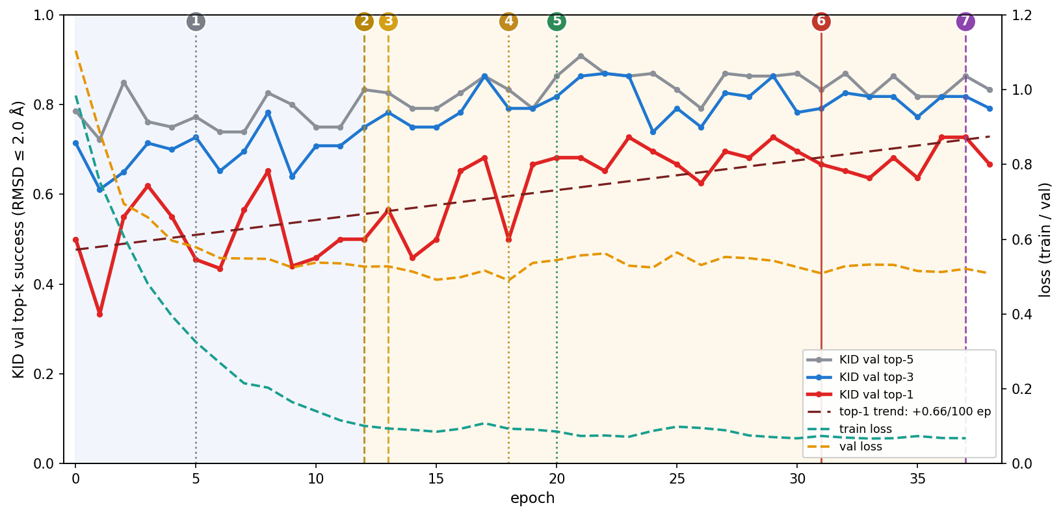
Figure 4. Training dynamics of the MIL model: KID validation top-1/3/5 pose-recovery success (RMSD ≤ 2 Å, left axis) and train/validation loss (right axis) over epochs. Shading marks the base phase (blue) and the active-query focus phase (yellow); the dashed dark-red line is the top-1 linear trend. Averaged over epochs, KID top-1 rises from 0.50 (active query off, epochs 0–12) to 0.65 (active query on, epochs 13–38). The numbered markers denote: (1) epoch 5: the active-prototype bank begins collecting candidate conformers (warm-up; active-query steering off). (2) epoch 12: the curriculum triggers on the validation-loss plateau; the backbone (encoder and predictor) learning rate is cut ×0.01 while the aggregator keeps training. (3) epoch 13: active-query steering engages; the query weight w ramps 0 → 0.8 over epochs 13–17. (4) epoch 18: the global validation-loss minimum, excluded from selection by the minimum-epoch guard. (5) epoch 20: the minimum-epoch guard is passed, and model selection becomes eligible. (6) epoch 31: the selected model — lowest validation loss among epochs ≥ 20. (7) epoch 37: the focus phase stops (trigger epoch 12 plus 25 minimum focus epochs).

KID Evaluation
- Molecule KID Eligibility Criteria: KID performance was evaluated only for successful bags, that is, those with at least one bioactive-like conformer. Additionally, we constrained the analysis to compounds with experimental pIC50 ≥ 7.0 and an absolute prediction error ≤ 1 log unit to focus on the best-case examples: potent, well-predicted compounds.
- To quantify KID performance, conformers within each molecular bag were ranked by their attention weights (i.e., relative importance scores). The KID was evaluated using the top-k retrieval rate, as defined in Formula 1 in the Supporting Information.
- A random-selection baseline was analytically computed using the hypergeometric distribution. For each eligible molecule, the probability of retrieving at least one bioactive-like conformer in the top-k random draws without replacement was calculated using Equations 2 and 3 in the Supporting Information.
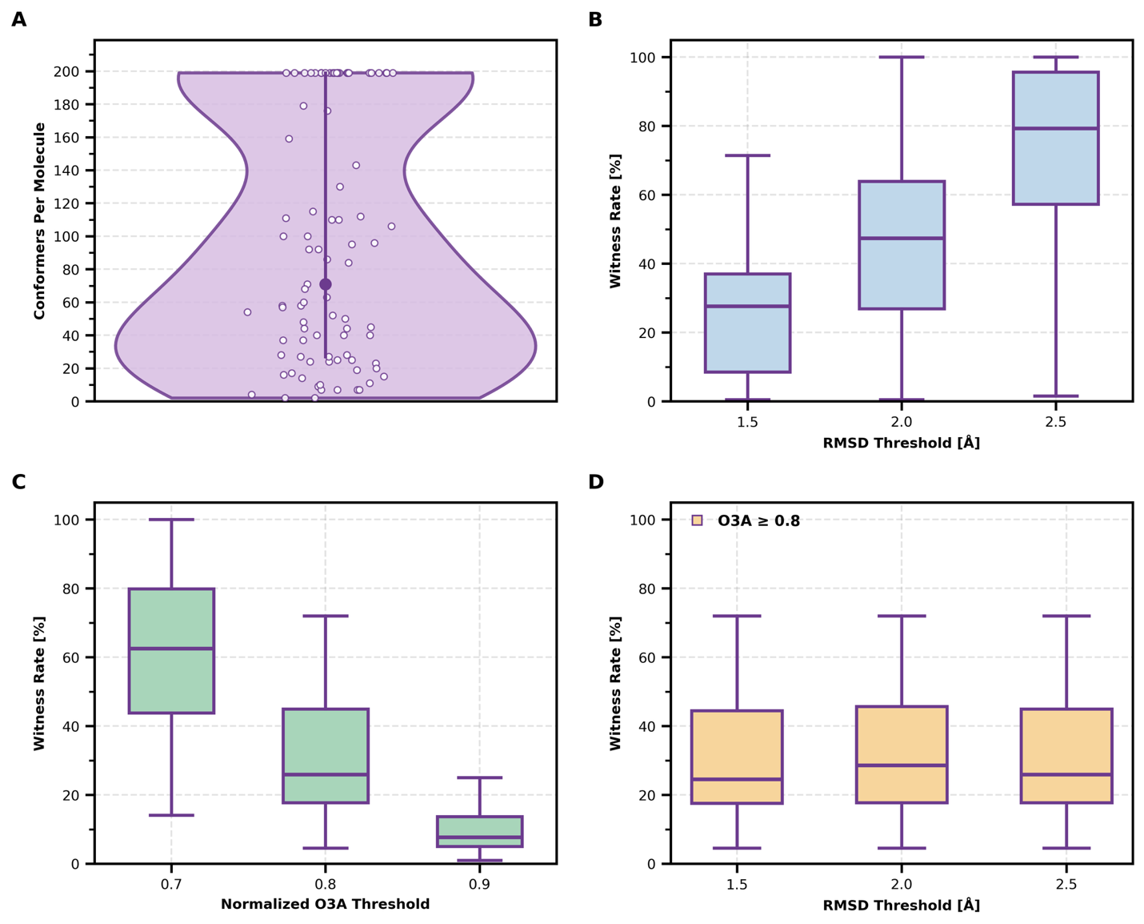
Figure 5. Bag-composition statistics for Split_2 molecules with available bioactive conformers. (A) Violin plot: distribution of the number of generated conformers per molecule. (B-D) Witness-rate distribution for different metrics and thresholds. (B) RMSD metric. (C) O3A metric (D) Combination of O3A > 0.8 with different thresholds using the RMSD metric.
- Results and Discussion
The results are presented as follows. We first evaluate the predictive performance of the proposed MILKID model and benchmark it against the methods reported in [45]. We then assess KID performance on the validation set of models trained on Split_2 as well as on an external KID Test Set. Finally, we analyze and discuss the observed KID results.
Use cases:
- Correct prediction – correct attention – consistent over CS
- Correct prediction – incorrect attention – check over CS1, compare with CS2 -> maybe “bioactive pattern” was mixed with another CS]
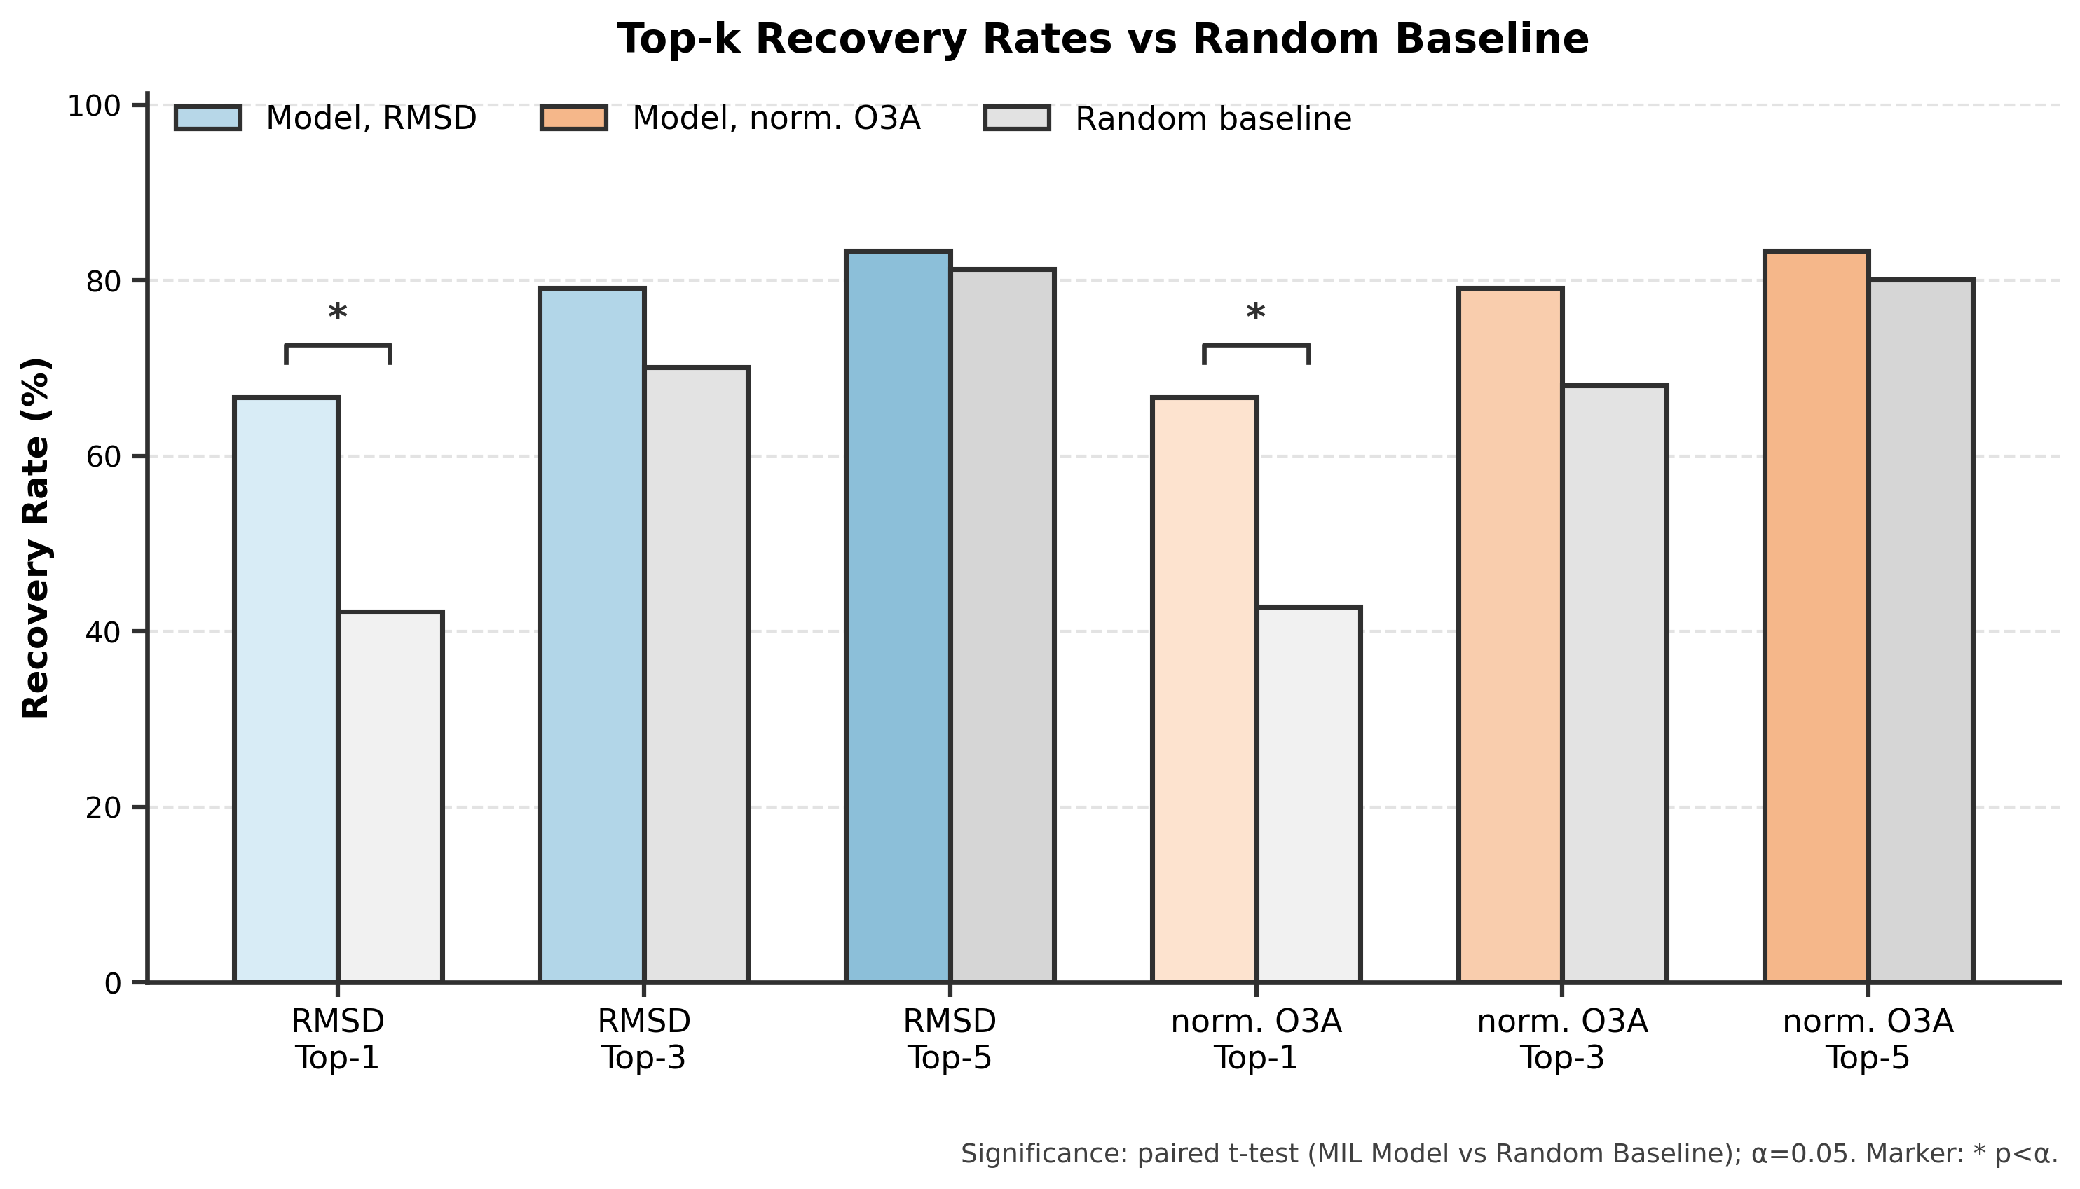
Figure 6. KID Performance Metrics on validation set. (train and test in SI).

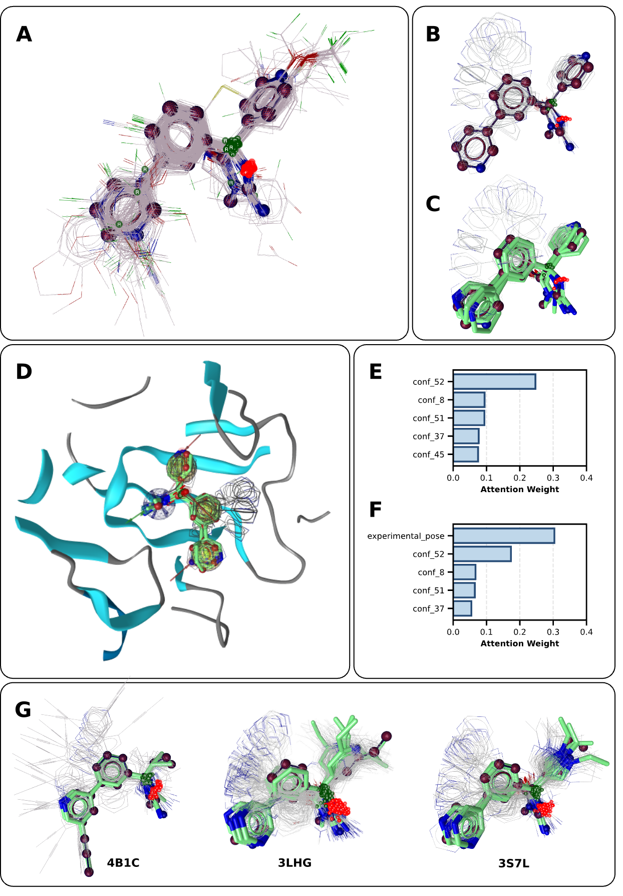
Figure 7. (MIL worked as we expected) Interpretation of KID results in the context of RI 3D-QSAR. (A) Bioactive conformers aligned to the reference crystal structure 2QP8; the co-crystallized ligand from 3IN3 is highlighted in red (ball-and-stick representation). (B) Conformational ensemble of 3IN3, with the experimental (bioactive) pose shown in ball-and-stick representation. (C) Most highly attended conformers of 3IN3 identified by the MIL model. (D) Conformational ensemble of 3IN3 aligned to a structure-based pharmacophore model. (E–F) Comparison of the most attended conformers for two bags corresponding to the same molecule, in the presence (E) and absence (F) of a known bioactive pose. (G) Additional examples from the validation set within the same congeneric series, illustrating consistency of attention-driven conformer selection.
References:
- Cramer, R. D., Patterson, D. E., & Bunce, J. D. (1988). Comparative molecular field analysis (CoMFA). 1. Effect of shape on binding of steroids to carrier proteins. Journal of the American Chemical Society, 110(18), 5959–5967. https://doi.org/10.1021/ja00226a005
- Klebe, G., Mietzner, T., & Abraham, U. (1994). Molecular similarity indices in a comparative analysis (CoMSIA) of drug molecules to correlate and predict their biological activity. Journal of Medicinal Chemistry, 37(24), 4130–4146. https://doi.org/10.1021/jm00050a010
- Pastor, M., Pickett, S., Clementi, S., Mclay, I., & Cruciani, G. (2000). GRid-INdependent descriptors (GRIND): a novel class of alignment-independent three-dimensional molecular descriptors. Journal of Medicinal Chemistry, 43(17), 3233–3243. https://doi.org/10.1021/jm000941m
- Turner, D. B. (2000). The EVA spectral descriptor. European Journal of Medicinal Chemistry, 35(4), 367–375. https://doi.org/10.1016/s0223-5234(00)00141-0
- Gasteiger, J., Steinhauer, L., Schuur, J., Steinhauer, V., Sadowski, J., & Selzer, P. (1996). Chemical Information in 3D Space. Journal of Chemical Information and Computer Sciences, 36(5), 1030–1037. https://doi.org/10.1021/ci960343+
- Qi, J., Feng, C., Shi, Y., Yang, J., Zhang, F., Li, G., & Han, R. (2024). FP-Zernike: An Open-source Structural Database Construction Toolkit for Fast Structure Retrieval. Genomics, Proteomics & Bioinformatics,22(1). https://doi.org/10.1093/gpbjnl/qzae007
- Kuzminykh, D., Zhebrak, A., Kadurin, A., Nikolenko, S., Zhavoronkov, A., Polykovskiy, D., Baskov, I., & Shayakhmetov, R. (2018). 3D Molecular Representations Based on the Wave Transform for Convolutional Neural Networks. Molecular Pharmaceutics, 15(10), 4378–4385. https://doi.org/10.1021/acs.molpharmaceut.7b01134
- Wiercioch, M. (2019). Exploring the Potential of Spherical Harmonics and PCVM for Compounds Activity Prediction. International Journal of Molecular Sciences, 20(9), 2175. https://doi.org/10.3390/ijms20092175
- Pandey, G., & Saxena, A. K. (2006). 3D QSAR Studies on Protein Tyrosine Phosphatase 1B Inhibitors: Comparison of the Quality and Predictivity among 3D QSAR Models Obtained from Different Conformer-Based Alignments. Journal of Chemical Information and Modeling, 46(6), 2579–2590. https://doi.org/10.1021/ci600224n
- Cubillán, N., Marrero-Ponce, Y., Alvarado, Y. J., Barigye, S. J., Valdes-Martini, J. R., Ariza-Rico, H., & García-Jacas, C. R. (2015). Novel global and local 3D atom-based linear descriptors of the Minkowski distance matrix: theory, diversity–variability analysis and QSPR applications. Journal of Mathematical Chemistry, 53(9), 2028–2064. https://doi.org/10.1007/s10910-015-0533-3
- Hopfinger, A. J., Duraiswami, C., Albuquerque, M., Tokarski, J. S., Wang, S., Jin, B., & Madhav, P. J. (1997). Construction of 3D-QSAR Models Using the 4D-QSAR Analysis Formalism. Journal of the American Chemical Society, 119(43), 10509–10524. https://doi.org/10.1021/ja9718937
- Bak, A. (2021). Two Decades of 4D-QSAR: A Dying Art or Staging a Comeback? International Journal of Molecular Sciences, 22(10), 5212. https://doi.org/10.3390/ijms22105212
- Vitorović-Todorović, M. D., Cvijetić, I. N., Juranić, I. O., & Drakulić, B. J. (2012). The 3D-QSAR study of 110 diverse, dual binding, acetylcholinesterase inhibitors based on alignment independent descriptors (GRIND-2). The effects of conformation on predictive power and interpretability of the models. Journal of Molecular Graphics and Modelling, 38, 194–210. https://doi.org/10.1016/j.jmgm.2012.08.001
- Zhou, Z., & Madura, J. D. (2004). CoMFA 3D-QSAR Analysis of HIV-1 RT Nonnucleoside Inhibitors, TIBO Derivatives Based on Docking Conformation and Alignment. Journal of Chemical Information and Computer Sciences, 44(6), 2167–2178. https://doi.org/10.1021/ci049893v
- Brogi, S., Papazafiri, P., Roussis, V., & Tafi, A. (2013). 3D-QSAR using pharmacophore-based alignment and virtual screening for discovery of novel MCF-7 cell line inhibitors. European Journal of Medicinal Chemistry, 67, 344–351. https://doi.org/10.1016/j.ejmech.2013.06.048
- Hawkins, P. C. D. (2017). Conformation Generation: The State of the Art. Journal of Chemical Information and Modeling, 57(8), 1747–1756. https://doi.org/10.1021/acs.jcim.7b00221
- Fu, G., Liu, H., Patel, R. Y., Nan, X., Doerksen, R. J., Daga, P. R., Chen, Y., & Wilkins, D. E. (2012). Implementation of multiple-instance learning in drug activity prediction. BMC Bioinformatics, 13(Suppl 15). https://doi.org/10.1186/1471-2105-13-s15-s3
- Chen, Y., Bi, J., & Wang, J. Z. (2006). MILES: Multiple-Instance Learning via Embedded Instance Selection. IEEE Transactions on Pattern Analysis and Machine Intelligence, 28(12), 1931–1947. https://doi.org/10.1109/tpami.2006.248
- Zhao, Z., Chen, Y., Elokely, K. M., Liu, S., Fu, G., Wilkins, D. E., & Doerksen, R. J. (2013). Drug activity prediction using multiple-instance learning via joint instance and feature selection. BMC Bioinformatics, 14(Suppl 14). https://doi.org/10.1186/1471-2105-14-s14-s16
- Fatima, S., Ali, S., & Kim, H.-C. (2023). A Comprehensive Review on Multiple Instance Learning. Electronics, 12(20), 4323. https://doi.org/10.3390/electronics12204323
- Wang, X., Yan, Y., Tang, P., Bai, X., & Liu, W. (2016). Revisiting Multiple Instance Neural Networks. https://doi.org/10.48550/arxiv.1610.02501
- Shazeer, N. (2020). GLU Variants Improve Transformer. Cornell University. https://doi.org/10.48550/arxiv.2002.05202
- An, B., Tan, F., Li, C., Hu, Y., Hu, C., Zhang, R., Wang, Z., Lyu, J., & Chen, C. (2020). Repulsive Attention: Rethinking Multi-head Attention as Bayesian Inference. Cornell University. https://doi.org/10.48550/arxiv.2009.09364
- Clark, K., Khandelwal, U., Manning, C. D., & Levy, O. (2019, January 1). What Does BERT Look at? An Analysis of BERT’s Attention. https://doi.org/10.18653/v1/w19-4828
- Vaswani, A., Shazeer, N., Parmar, N., Uszkoreit, J., Jones, L., Gomez, A., Kaiser, L., & Polosukhin, I. (2017). Attention Is All You Need. https://doi.org/10.48550/arxiv.1706.03762
- Vedani, A., Dobler, M., & Zbinden, P. (1998). Quasi-Atomistic Receptor Surface Models: A Bridge between 3-D QSAR and Receptor Modeling. Journal of the American Chemical Society, 120(18), 4471–4477. https://doi.org/10.1021/ja973976t
- Vedani, A., Mcmasters, D. R., & Dobler, M. (2000). Multi-conformational Ligand Representation in 4D-QSAR: Reducing the Bias Associated with Ligand Alignment. Quantitative Structure-Activity Relationships, 19(2), 149–161. https://doi.org/10.1002/1521-3838(200004)19:2<149::aid-qsar149>3.0.co;2-9
- Hasegawa, K., Arakawa, M., & Funatsu, K. (2003). Simultaneous determination of bioactive conformations and alignment rules by multi-way PLS modeling. Computational Biology and Chemistry, 27(3), 211–216. https://doi.org/10.1016/s0097-8485(02)00055-4
- Appell, M., Dunn, W. J., Reith, M. E. A., Miller, L., & Flippen-Anderson, J. L. (2002). An Analysis of the Binding of Cocaine Analogues to the Monoamine Transporters Using Tensor Decomposition 3-D QSAR. Bioorganic & Medicinal Chemistry, 10(5), 1197–1206. https://doi.org/10.1016/s0968-0896(01)00389-3
- Hasegawa, K., Arakawa, M., & Funatsu, K. (2000). Rational choice of bioactive conformations through use of conformation analysis and 3-way partial least squares modeling. Chemometrics and Intelligent Laboratory Systems, 50(2), 253–261. https://doi.org/10.1016/s0169-7439(99)00063-5
- Goodford, P. J. (1985). A computational procedure for determining energetically favorable binding sites on biologically important macromolecules. Journal of Medicinal Chemistry, 28(7), 849–857. https://doi.org/10.1021/jm00145a002
- Lu, S., Yuan, H.-L., Yang, P., Zhang, L., Lu, T., Liu, H.-C., Gao, Y.-P., Sun, S.-L., & Chen, Y.-D. (2011). Combined Pharmacophore Modeling, Docking, and 3D-QSAR Studies of PLK1 Inhibitors. International Journal of Molecular Sciences, 12(12), 8713–8739. https://doi.org/10.3390/ijms12128713
- Dunn, W. J., Duraiswami, C., Hopfinger, A. J., & Catana, C. (1996). Solution of the conformation and alignment tensors for the binding of trimethoprim and its analogs to dihydrofolate reductase: 3D-quantitative structure-activity relationship study using molecular shape analysis, 3-way partial least-squares regression, and 3-way factor analysis. Journal of Medicinal Chemistry, 39(24), 4825–4832. https://doi.org/10.1021/jm960491r
- Hasegawa, K., Arakawa, M., & Funatsu, K. (2003). Simultaneous determination of bioactive conformations and alignment rules by multi-way PLS modeling. Computational Biology and Chemistry, 27(3), 211–216. https://doi.org/10.1016/s0097-8485(02)00055-4
- Dietterich, T. G., Lathrop, R. H., & Lozano-Pérez, T. (1997). Solving the multiple instance problem with axis-parallel rectangles. Artificial Intelligence, 89(1–2), 31–71. https://doi.org/10.1016/s0004-3702(96)00034-3
- Gürsoy, O., & Smieško, M. (2017). Searching for bioactive conformations of drug-like ligands with current force fields: how good are we? Journal of Cheminformatics, 9(1). https://doi.org/10.1186/s13321-017-0216-0
- Shirali, A., Stebliankin, V., Karki, U., Shi, J., Chapagain, P., & Narasimhan, G. (2025). A comprehensive survey of scoring functions for protein docking models. BMC Bioinformatics, 26(1). https://doi.org/10.1186/s12859-024-05991-4
- Fu, G., Doerksen, R. J., Wilkins, D. E., Liu, H., Patel, R. Y., Chen, Y., Nan, X., & Daga, P. R. (2012). Implementation of multiple-instance learning in drug activity prediction. BMC Bioinformatics, 13(S15). https://doi.org/10.1186/1471-2105-13-s15-s3
- Zhao, Z., Doerksen, R. J., Elokely, K. M., Chen, Y., Liu, S., Wilkins, D. E., & Fu, G. (2013). Drug activity prediction using multiple-instance learning via joint instance and feature selection. BMC Bioinformatics, 14(S14). https://doi.org/10.1186/1471-2105-14-s14-s16
- Doran, G., & Ray, S. (2013). A theoretical and empirical analysis of support vector machine methods for multiple-instance classification. Machine Learning, 97(1–2), 79–102. https://doi.org/10.1007/s10994-013-5429-5
- Chuang, K., & Keiser, M. (2020). Attention-Based Learning on Molecular Ensembles. https://doi.org/10.48550/arxiv.2011.12820
- Zankov, D. V., Baskin, I. I., Polishchuk, P., Nikonenko, A. V., Nugmanov, R. I., Varnek, A., Madzhidov, T. I., & Matveieva, M. (2021). QSAR Modeling Based on Conformation Ensembles Using a Multi-Instance Learning Approach. Journal of Chemical Information and Modeling, 61(10), 4913–4923. https://doi.org/10.1021/acs.jcim.1c00692
- Zhu, Y., Hwang, J., Adams, K., Liu, Z., Nan, B., Stenfors, B., Du, Y., Chauhan, J., Wiest, O., Isayev, O., Coley, C., Sun, Y., & Wang, W. (2023). Learning Over Molecular Conformer Ensembles: Datasets and Benchmarks. https://doi.org/10.48550/arxiv.2310.00115
- Gu, Y., Kang, H., Li, J., Zheng, S., & Zhang, B. (2023). Employing Molecular Conformations for Ligand-based Virtual Screening with Equivariant Graph Neural Network and Deep Multiple Instance Learning. Mdpi Ag. https://doi.org/10.20944/preprints202305.1658.v1
- Subramanian, G., Pande, V., Ramsundar, B., & Denny, R. A. (2016). Computational Modeling of β-Secretase 1 (BACE-1) Inhibitors Using Ligand Based Approaches. Journal of Chemical Information and Modeling, 56(10), 1936–1949. https://doi.org/10.1021/acs.jcim.6b00290
- Bajorath, J. (2016). Molecular Similarity Concepts for Informatics Applications. Methods in Molecular Biology (Clifton, N.J.), 1526, 231–245. https://doi.org/10.1007/978-1-4939-6613-4_13
- Wang, S., Witek, J., Riniker, S., & Landrum, G. A. (2020). Improving Conformer Generation for Small Rings and Macrocycles Based on Distance Geometry and Experimental Torsional-Angle Preferences. Journal of Chemical Information and Modeling, 60(4), 2044–2058. https://doi.org/10.1021/acs.jcim.0c00025
- Butina, D. (1999). Unsupervised Data Base Clustering Based on Daylight’s Fingerprint and Tanimoto Similarity: A Fast and Automated Way To Cluster Small and Large Data Sets. Journal of Chemical Information and Computer Sciences, 39(4), 747–750. https://doi.org/10.1021/ci9803381
- O’Boyle, N. M., Banck, M., James, C. A., Morley, C., Vandermeersch, T., & Hutchison, G. R. (2011). Open Babel: An open chemical toolbox. Journal of Cheminformatics, 3(7). https://doi.org/10.1186/1758-2946-3-33
- https://www.pikairos.eu/software/eyemol/
- Friedrich, N.-O., Meyder, A., Rarey, M., Sommer, K., De Bruyn Kops, C., Kirchmair, J., & Flachsenberg, F. (2017). High-Quality Dataset of Protein-Bound Ligand Conformations and Its Application to Benchmarking Conformer Ensemble Generators. Journal of Chemical Information and Modeling, 57(3), 529–539. https://doi.org/10.1021/acs.jcim.6b00613
- Adams, K., & Coley, C. (2025). The impact of conformer quality on learned representations of molecular conformer ensembles. https://doi.org/10.48550/arxiv.2502.13220
- Wildman, S. A., & Crippen, G. M. (1999). Prediction of Physicochemical Parameters by Atomic Contributions. Journal of Chemical Information and Computer Sciences, 39(5), 868–873. https://doi.org/10.1021/ci990307l
- Schulz-Gasch, T., Schärfer, C., Rarey, M., & Guba, W. (2012). TFD: Torsion Fingerprints As a New Measure To Compare Small Molecule Conformations. Journal of Chemical Information and Modeling, 52(6), 1499–1512. https://doi.org/10.1021/ci2002318
- Adamczyk, J., & Ludynia, P. (2024). Scikit-fingerprints: easy and efficient computation of molecular fingerprints in Python. https://doi.org/10.48550/arxiv.2407.13291
- Armstrong, M. S., Morris, G. M., Cooper, R. I., Richards, W. G., Finn, P. W., Moretti, L., & Sharma, R. (2010). ElectroShape: fast molecular similarity calculations incorporating shape, chirality and electrostatics. Journal of Computer-Aided Molecular Design, 24(9), 789–801. https://doi.org/10.1007/s10822-010-9374-0
- Consonni, V., Pavan, M., Todeschini, R., & Gramatica, P. (2002). Structure/response correlations and similarity/diversity analysis by GETAWAY descriptors. 2. Application of the novel 3D molecular descriptors to QSAR/QSPR studies. Journal of Chemical Information and Computer Sciences, 42(3), 693–705. https://doi.org/10.1021/ci0155053
- Kingma, D., & Ba, J. (2015). Adam: A Method for Stochastic Optimization. Cornell University. https://doi.org/10.48550/arxiv.1412.6980
- Wang, X., Yan, Y., Tang, P., Bai, X., & Liu, W. (2016). Revisiting Multiple Instance Neural Networks. https://doi.org/10.48550/arxiv.1610.02501
- Touvron, H., Verbeek, J., El-Nouby, A., Caron, M., Izacard, G., Synnaeve, G., Cord, M., Joulin, A., Grave, É., Bojanowski, P., & Jeǵou, H. (2021). ResMLP: Feedforward networks for image classification with data-efficient training. Cornell University. https://doi.org/10.48550/arxiv.2105.03404
- Shafiq, M., & Gu, Z. (2022). Deep Residual Learning for Image Recognition: A Survey. Applied Sciences, 12(18), 8972. https://doi.org/10.3390/app12188972
- Vig, J. (2019). A Multiscale Visualization of Attention in the Transformer Model. Cornell University. https://doi.org/10.48550/arxiv.1906.05714
- Kim, B., Choi, H., Lee, D.-G., Jang, H., & Kim, S. (2023). How to Use Dropout Correctly on Residual Networks with Batch Normalization. Cornell University. https://doi.org/10.48550/arxiv.2302.06112
- Yang, K., Guzmán-Pérez, A., Gao, H., Hopper, T., Eiden, P., Palmer, A., Jaakkola, T., Jin, W., Coley, C., Swanson, K., Jensen, K., Settels, V., Mathea, M., Kelley, B., & Barzilay, R. (2019). Analyzing Learned Molecular Representations for Property Prediction. Cornell University. https://doi.org/10.48550/arxiv.1904.01561
- Langford, J., & Pineau, J. (2012). Proceedings of the 29th International Conference on Machine Learning (ICML-12). Cornell University. https://doi.org/10.48550/arxiv.1207.4676
- Schreyer, A. M., & Blundell, T. (2012). USRCAT: real-time ultrafast shape recognition with pharmacophoric constraints. Journal of Cheminformatics, 4(1). https://doi.org/10.1186/1758-2946-4-27
- Sliwoski, G., Butkiewicz, M., Meiler, J., & Lowe, E. W. (2012). BCL::EMAS — Enantioselective Molecular Asymmetry Descriptor for 3D-QSAR. Molecules, 17(8), 9971–9989. https://doi.org/10.3390/molecules17089971
- Rodríguez-Pérez, R., & Bajorath, J. (2019). Interpretation of Compound Activity Predictions from Complex Machine Learning Models Using Local Approximations and Shapley Values. Journal of Medicinal Chemistry, 63(16), 8761–8777. https://doi.org/10.1021/acs.jmedchem.9b01101
- Axelrod, S., & Gómez-Bombarelli, R. (2023). Molecular machine learning with conformer ensembles. Machine Learning: Science and Technology, 4(3), 035025. https://doi.org/10.1088/2632-2153/acefa7
- Zhu, Y., Hwang, J., Adams, K., Liu, Z., Nan, B., Stenfors, B., Du, Y., Chauhan, J., Wiest, O., Isayev, O., Coley, C., Sun, Y., & Wang, W. (2023). Learning Over Molecular Conformer Ensembles: Datasets and Benchmarks. In arXiv (Cornell University). Technische Universitat Dresden. https://doi.org/10.48550/arxiv.2310.00115
- Hawkins, P. C. D., Skillman, A. G., & Nicholls, A. (2006). Comparison of Shape-Matching and Docking as Virtual Screening Tools. Journal of Medicinal Chemistry, 50(1), 74–82. https://doi.org/10.1021/jm0603365
- Ilse, M., Tomczak, J., & Welling, M. (2018). Attention-based Deep Multiple Instance Learning. In arXiv (Cornell University). Technische Universitat Dresden. https://doi.org/10.48550/arxiv.1802.04712
- Obama, B. O. (2025). Attention Is All You Have. In Research Square. Research Square. https://doi.org/10.21203/rs.3.rs-6745861/v1
- Chuang, K., & Keiser, M. (2020). Attention-Based Learning on Molecular Ensembles. In arXiv (Cornell University). Technische Universitat Dresden. https://doi.org/10.48550/arxiv.2011.12820
- Gaulton, A., Bellis, L. J., Bento, A. P., Chambers, J., Davies, M., Hersey, A., Light, Y., Mcglinchey, S., Michalovich, D., Al-Lazikani, B., & Overington, J. P. (2011). ChEMBL: a large-scale bioactivity database for drug discovery. Nucleic Acids Research, 40(D1), D1100–D1107. https://doi.org/10.1093/nar/gkr777
- Poli, G., Seidel, T., & Langer, T. (2018). Conformational Sampling of Small Molecules With iCon: Performance Assessment in Comparison With OMEGA. Frontiers in Chemistry, 6, 229. https://doi.org/10.3389/fchem.2018.00229
- Wolber, G., & Langer, T. (2004). LigandScout: 3-D Pharmacophores Derived from Protein-Bound Ligands and Their Use as Virtual Screening Filters. Journal of Chemical Information and Modeling, 45(1), 160–169. https://doi.org/10.1021/ci049885e
- Tosco, P., Balle, T., & Shiri, F. (2011). Open3DALIGN: an open-source software aimed at unsupervised ligand alignment. Journal of Computer-Aided Molecular Design, 25(8), 777–783. https://doi.org/10.1007/s10822-011-9462-9
- Wildman, S. A., & Crippen, G. M. (1999). Prediction of Physicochemical Parameters by Atomic Contributions. Journal of Chemical Information and Computer Sciences, 39(5), 868–873. https://doi.org/10.1021/ci990307l
- Landrum, G. 2010. “RDKit.” Q2. https://www.rdkit.org/.
- Perola, E., & Charifson, P. S. (2004). Conformational Analysis of Drug-Like Molecules Bound to Proteins: An Extensive Study of Ligand Reorganization upon Binding. Journal of Medicinal Chemistry, 47(10), 2499–2510. https://doi.org/10.1021/jm030563w
- Barman, A., & Prabhakar, R. (2014). Computational Insights into Substrate and Site Specificities, Catalytic Mechanism, and Protonation States of the Catalytic Asp Dyad of β -Secretase. Scientifica, 2014(2), 1–11. https://doi.org/10.1155/2014/598728
- Shi, Y., Ke, G., Soukhavong, D., Lamb, J., Meng, Q., Finley, T., Wang, T., Chen, W., Ma, W., Ye, Q., Liu, T.-Y., Titov, N., & Cortes, D. (2020). lightgbm: Light Gradient Boosting Machine. R Foundation. https://doi.org/10.32614/cran.package.lightgbm

