HIT140 Assessment 3 – Predicting FIFA World Cup 2026 Results with Linear Regression
Darwin Group 27: Max Turner (S______), Quentin Qiu (S______), Stephen K Kenyi (S______). Code & data: <GitHub URL>
1. Data and methods
We compiled two datasets in Python from all 104 matches of the 2026 World Cup. Results (score after extra time, excluding shoot-outs) came from openfootball and were cross-checked against eloratings.net (all 208 team scores agree). Every explanatory variable is available before kick-off: pre-tournament FIFA ranking (Wikipedia/FIFA), Transfermarkt average player market value, average age and World Cup participations, host status, the pre-match Elo rating, and the mean goals scored/conceded in each team's previous 10 internationals. Because the form window includes pre-tournament fixtures, a team's first match uses pre-tournament statistics rather than imputed values. Skewed variables (rank, value) were log-transformed. Model 2.1 uses team1-minus-team2 differences; Model 2.2 pairs a team's own attack with its opponent's defence, so the models share no variable (limit 4). Models were fitted with statsmodels OLS and validated with repeated 5-fold cross-validation (20 repeats); competing scikit-learn algorithms were compared on identical folds.
2. Linear Regression 2.1 – goal difference (n = 104)
Explanatory variables: elo_diff, log_rank_diff, log_value_diff, gf10_diff, ga10_diff, age_diff, wc_exp_diff, host_diff. Goal difference averaged 0.48 (SD 2.02, range −4 to +6). In the EDA, value (r = 0.68), rank (−0.63) and Elo (0.63) differences correlated most strongly with goal difference, but also with each other (VIF up to 7).
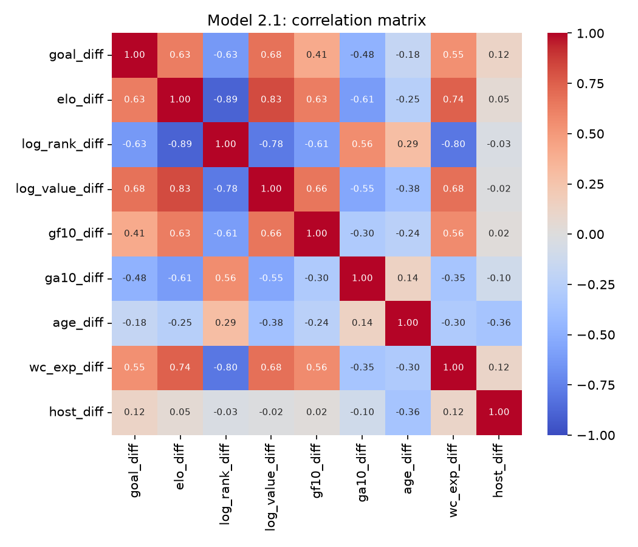
variable | coef | std_err | p_value | std_coef | vif
const | 0.171 | 0.151 | 0.260 | nan | nan
elo_diff | -0.001 | 0.002 | 0.595 | -0.099 | 6.981
log_rank_diff | -0.329 | 0.229 | 0.155 | -0.257 | 6.514
log_value_diff | 1.651 | 0.394 | 0.000 | 0.614 | 4.349
gf10_diff | -0.234 | 0.211 | 0.271 | -0.108 | 1.929
ga10_diff | -0.244 | 0.310 | 0.434 | -0.075 | 1.836
age_diff | 0.209 | 0.102 | 0.043 | 0.175 | 1.467
wc_exp_diff | 0.014 | 0.028 | 0.625 | 0.062 | 3.180
host_diff | 0.963 | 0.429 | 0.027 | 0.179 | 1.285
The model explains 53% of variance (adj. R² 0.49, F-test p < 0.001). Squad value difference dominates (b = 1.65 goals per tenfold value advantage, p < 0.001), with significant host (+0.96) and age effects; Elo and rank lose significance once value is included because they measure the same team strength (multicollinearity). Cross-validated R² is 0.38 (RMSE 1.52, MAE 1.23) versus a mean-only baseline RMSE of 2.01. Out-of-fold predictions give the correct winner in 82.5% of decisive matches; the largest errors are blow-outs (Canada 6–0 Qatar, Germany 6–0 Curaçao) and upsets (USA 3–0 Paraguay).
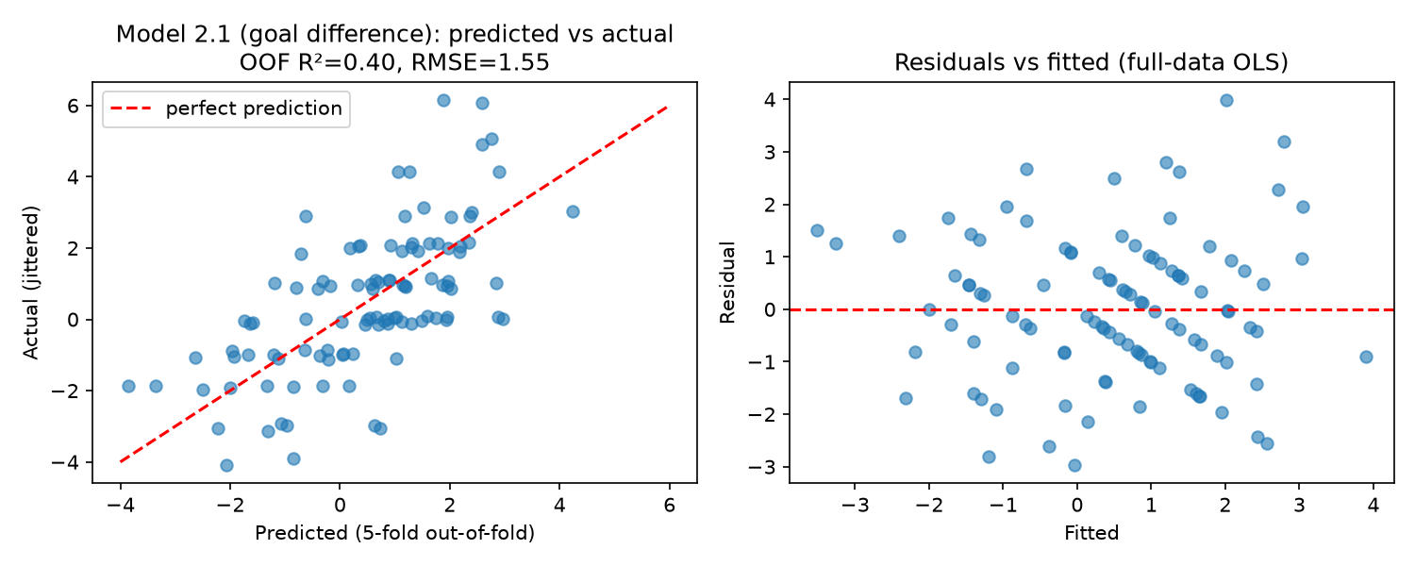
3. Linear Regression 2.2 – goals scored by a team (n = 208)
Explanatory variables: elo_pre, opp_elo_pre, gf10, opp_ga10, log_avg_value, opp_log_avg_value, host, knockout. Teams scored 1.48 goals per match on average (right-skewed counts).
variable | coef | std_err | p_value | std_coef | vif
const | -2.577 | 1.934 | 0.184 | nan | nan
elo_pre | -0.000 | 0.001 | 0.928 | -0.011 | 3.951
opp_elo_pre | -0.002 | 0.001 | 0.091 | -0.213 | 4.483
gf10 | -0.036 | 0.180 | 0.843 | -0.017 | 1.992
opp_ga10 | 0.250 | 0.238 | 0.294 | 0.078 | 1.576
log_avg_value | 1.181 | 0.308 | 0.000 | 0.462 | 4.167
opp_log_avg_value | -0.185 | 0.289 | 0.523 | -0.072 | 3.649
host | 0.552 | 0.324 | 0.090 | 0.103 | 1.043
knockout | -0.158 | 0.215 | 0.464 | -0.052 | 1.464
R² = 0.31 (adj. 0.28, p < 0.001); CV R² = 0.21, RMSE 1.21, MAE 0.95 (baseline RMSE 1.39). The team's own squad value is the key driver (b = 1.18, p < 0.001); a stronger opponent (Elo) and playing at home have borderline effects (p ≈ 0.09); knockout stage has none. A single team's goal count is noisier than goal difference, which explains the lower R².
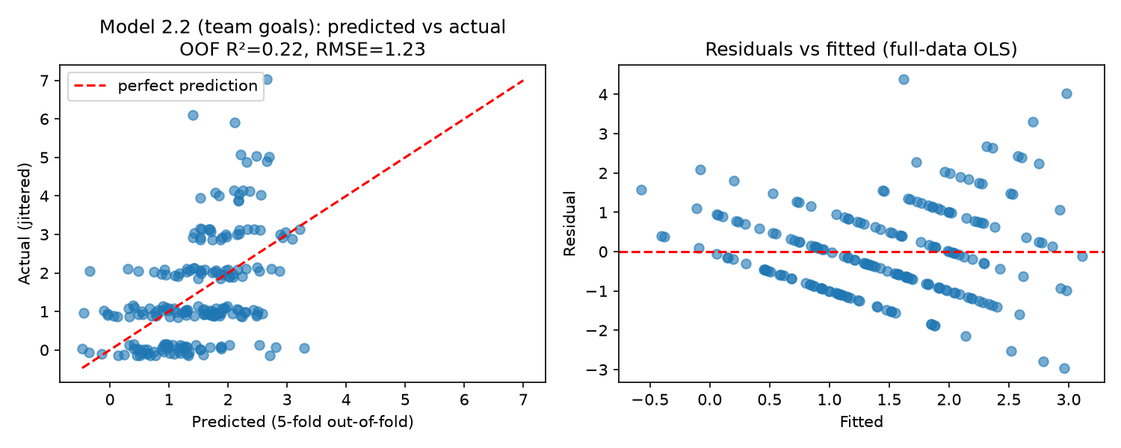
4. Competing models
Repeated 5-fold CV RMSE (lower is better). Regularised linear models match or slightly beat OLS; tree ensembles overfit the small samples, confirming that the relationships are essentially linear.
model | 2.1 R² | 2.1 RMSE | 2.2 R² | 2.2 RMSE
Lasso (alpha CV) | 0.371 | 1.541 | 0.225 | 1.196
ElasticNet (CV) | 0.370 | 1.543 | 0.223 | 1.198
Ridge (alpha CV) | 0.387 | 1.518 | 0.218 | 1.202
Poisson GLM (extension) | nan | nan | 0.210 | 1.202
OLS linear regression | 0.379 | 1.524 | 0.210 | 1.206
Random Forest | 0.341 | 1.569 | 0.178 | 1.230
Gradient Boosting | 0.237 | 1.676 | 0.064 | 1.303
Baseline (predict mean) | -0.052 | 2.013 | -0.042 | 1.390
5. Conclusion and limitations
Pre-match information predicts goal difference moderately well and individual team goals only weakly; squad market value is the most useful single predictor. Limitations: Transfermarkt values are current rather than pre-tournament snapshots; eloratings.net is outside the listed sources; strength proxies are collinear; goal counts are non-normal (a Poisson model performed similarly). Future work could add negative-binomial or ordinal models.

