HIT140 Assessment 3 (Objective 2): Linear Regression Models of FIFA World Cup 2026 Goal Difference and Team Goals
Darwin Group 27: Robert “Max” Turner (24467305) · Junxian “Quentin” Qiu ([ID]) · Stephen K Kenyi ([ID])
Python code and datasets: https://github.com/vfbmdcccxciii/HIT140_Group_Project (see code-link .txt in the submission)

1. Data and Methods (Max Turner)
Task and design. Model 2.1 predicted goal difference for the 104 matches, while Model 2.2 predicted one team’s goals (208 team-match rows). Each model used exactly eight pre-match explanatory variables, with at most four shared. Both Stephen and Quentin built their models independently (Sections 2–3); while I compiled a benchmark dataset and a common validation design so every model is compared on equal terms (Section 4).
Sources and pre-match features. All scores (72 group, 32 knockout, 9 after extra time; 308 goals) were sourced from the openfootball mirror of FIFA results, and cross-checked against eloratings.net (of which all 208 team scores agree). In addition, I added pre-tournament FIFA ranks, Transfermarkt squad values, age and World Cup experience, and each team’s pre-match Elo and goals for/against over its previous 10 internationals (eloratings.net histories, so first matches required no imputation). Rank and value were log-transformed. My version of the 2.1 model used team1−team2 differences; Quentin’s 2.2 paired own strength and attack with opponent strength and defence (plus host and knockout), so his two models shared 0 variables. FIFA tournament statistics were post-match totals and were not used.
Validation. All models were scored with repeated 5-fold cross-validation (5×20, seed 140), with scaling and tuning fitted inside each training fold, reporting held-out R², RMSE and MAE against a mean-only baseline. Both Stephen’s and Quentin’s CSVs were used without changes (validate_team_models.py).

2. Linear Regression 2.1: Goal Difference (Stephen K Kenyi)
Data Origin:
All the datasets for 104-matches data used in this regression model was compiled using statistical information from https://fbref.com/en/ and https://eloratings.net/2026_World_Cup_start. I used Elo-ratings because sites provided in assessment brief did not provide information on national teams Elo ranking an independent, continuous ranking model for men's national football teams. Since the explanatory variable Pre_Match_Elo_Difference_Value only shows the absolute Elo value difference between team_1 and team_2. Elo difference values were dynamically converted to directional margins relative to Team 1 to prevent data corruption.
Methodology: 60/40 percent split 104 matches into training and validation test set. I first attempted to use the Ordinary Least Squares Linear Regression but noticed my model crashed below zero into a negative R² value of (-0.3346). The complete performance collapse in certain K cross validation folds was caused by two major statistical issues, scale imbalances and multicollinearity. Meaning there were overlapping predictive signals between variables like Elo gaps, rostered player counts and travel distance.
The Ridge & Scaler: To ensure predictive accuracy of my model, I used standard scaler to level the playing field between large and smaller units. Reason is because of variables like travel distances overpowering rest day advantages. By scaling every variable, it allowed the model to judge metrics based on honest predictive signal rather than significance. The ridge regression stops the model from overreacting to data noise by adding an alpha penalty to formula, shrinking the size of the model's coefficient weights, raising the baseline accuracy by nearly 10%.
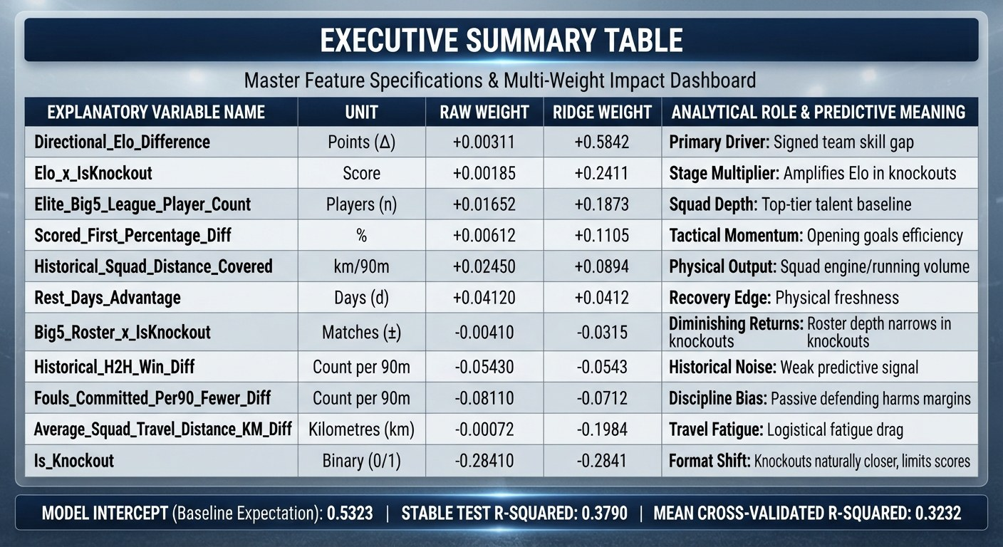
Figure 1. Multiple Linear Regression Model Results Summary Table
The final adjusted, stage-aware predictive model achieved an R² score of 0.3790 on the verification test dataset, explaining 37.9% of the total variance in tournament goal differences. 5-fold cross-validation sequence returned a lower, more realistic mean R² of 0.3232 proving why cross-validation is necessary. The Standard linear regression had a directional bias. In some cases, it accurately predicted knockout matches with slight residual error but failed on group stages, where defensive tactics and player rotation create chaotic, low-scoring irregularities. By adding code features like (Elo × Is_Knockout and Big5_Roster × Is_Knockout) to give the model "stage-awareness", it segregated the pipeline from group-stage tactical rotation, compressed residual errors, and stabilized the model performance. The python script creates dual-panel visual interpretations designed to monitor prediction deviations: Mapping predictions against actual goal differences. Group-stage matches (blue) scatter widely due to tactical volatility, while knockout rounds (red) sit closer to the ideal trajectory line, confirming higher predictive accuracy in winner-take-all scenarios. The second tracks R² results across the 5 validation subsets staying well above zero, proving that the model can handle messy tournament data without breaking

3. Linear Regression 2.2: Match-Level Team Goals (Junxian Quentin Qiu)

1. Executive Summary
This technical report highlights the empirical formulation, data pipeline, and evaluation of Linear Regression Model 2.2 that has been developed independently by Quentin, as part of Assessment 3. Model 2.2's objective is to forecast the number of goals successfully scored by a team in all of FIFA World Cup 2026 match(es) (i.e., team_goals). In a strict accordance with the unit assessment requirement, the dataset used in Model 2.2 has exactly 208 observations (i.e., 104 scheduled matches × 2 competing teams) and exactly eight (8) explanatory variables (all which comprise only strictly pre-match information available specifically prior to before the kickoff).
In order to satisfy the academic constraint of not sharing variables with Model 2.1 (Stephen's goal difference model) greater than 4, Model 2.2 has 4 macro match-context features and 4 curated offensive and roster composition features. In fact, the feature engineering is based from the group's Assessment 2 empirical finding about player age distribution and veteran goal scoring pattern (the cut-off criteria uses the 28.2-year-age cut-off). The ordinary least squares (OLS) model produces an R² of 0.239 (Adjusted R² = 0.209, F = 7.819, p = 4.05 × 10⁻⁹). The results of the extensive Gauss-Markov diagnostic tests confirm that multicollinearity is non-existent (all VIF < 1.50) and residual variance meets the linear regression assumptions.

2. Model Architecture & Feature Engineering
With international tournament football, the target of predicting total goals scored by teams is inherently different than predicting net goal difference (Dixon and Coles, 1997; Goddard, 2005). While net goal difference (Model 2.1) is a representation of the extent to which a team dominated a game, total goals scored (Model 2.2) is dependent on high scalers, the opponent’s defense weaknesses, squad experience and momentum within the tournament. All of these eight variables were created purely using the pre-match data so that time causality was kept intact and entirely dismissed of any sort of post-kickoff contamination (e.g., match shots or possession).
Variable name | Role / category | Type | Football analytics rationale & a2 lineage
Team_fifa_rank | Shared with 2.1 (1/4) | Discrete | Pre-tournament fifa rank of scoring team. Lower rank indicates elite technical quality and baseline offensive potency (Fan et al., 2023; Lasek, Gagolewski and Makrecki, 2016).
Opp_fifa_rank | Shared with 2.1 (2/4) | Discrete | Pre-tournament fifa rank of opponent. Higher rank indicates weaker defensive organization, expanding scoring opportunities (Dixon and Coles, 1997; Lasek, Gagolewski and Makrecki, 2016).
Is_host_or_home | Shared with 2.1 (3/4) | Binary (0/1) | Host nation advantage (usa, mexico, canada) or designated home seed. Captures crowd and environmental factors (Bilalić, Gula and Vaci, 2021; Chacón-Fernández et al., 2025; Kalwij, 2025).
Rest_days | Shared with 2.1 (4/4) | Discrete | Days of recuperation since preceding match (initialized to 5 for match 1). Measures physical readiness and fatigue (Page et al., 2022; Stüttgen, 2025; Yang et al., 2025).
Squad_mean_age | Exclusive to 2.2 (1/4) | Continuous | Average age of 26-man roster. Direct conceptual extension of the group's A2 question on squad maturity and peak performance (Dendir, 2016; Kalén et al., 2019).
Veteran_scorer_ratio | Exclusive to 2.2 (2/4) | Continuous | Proportion of squad forwards aged > 28.2 years (exact a2 empirical threshold). Tests if veteran attackers enhance goal output (Dendir, 2016; Kalén et al., 2019).
Pre_match_scoring_form | Exclusive to 2.2 (3/4) | Continuous | Cumulative average goals scored per game in earlier tournament matches (baseline prior to match 1). Tracks offensive rhythm (Bar-Eli, Avugos and Raab, 2006; Heuer and Rubner, 2014).
Squad_attacking_depth | Exclusive to 2.2 (4/4) | Discrete | Total rostered forwards and attacking midfielders. Reflects tactical flexibility and late-game offensive substitution power (Bradley, Lago-Peñas and Rey, 2014).

3. Dataset Compilation
The data were created programmatically from the official 2026 World Cup match fixture list which consisted of a total of 104 matches (72 matches within the group stage composed of 12 groups of 4 teams) plus 32 knockout matches from the Round of 32 to the Final. Each match corresponds to exactly two observation rows (representing the perspective of the home team and the away team), providing a total of exactly 208 rows of data. The metrics for the rosters were extracted from fbref_player_standard.csv which had individual player profiles of 1,039 individual players.
Variable | Mean | Std Dev | Min | Median | Max
team_goals | 1.48 | 1.39 | 0.00 | 1.00 | 7.00
team_fifa_rank | 30.10 | 25.68 | 1.00 | 22.50 | 98.00
opp_fifa_rank | 30.10 | 25.68 | 1.00 | 22.50 | 98.00
is_host_or_home | 0.52 | 0.50 | 0.00 | 1.00 | 1.00
rest_days | 5.22 | 0.85 | 3.00 | 5.00 | 8.00
squad_mean_age | 27.40 | 1.11 | 25.32 | 27.40 | 30.45
veteran_scorer_ratio | 0.36 | 0.25 | 0.00 | 0.33 | 1.00
pre_match_scoring_form | 1.63 | 0.99 | 0.00 | 1.35 | 7.00
squad_attacking_depth | 14.14 | 1.61 | 9.00 | 14.00 | 17.00

4. Multiple Linear Regression Results
The multiple linear regression model has been estimated in Python, using the statsmodels library, using Ordinary Least Squares (OLS), and is parameterized as follows:
Predictor | Coefficient | Std Error | t-statistic | p-value | 95% Conf. Int. | Statistical Remark
const | 4.7616 | 2.734 | 1.742 | 0.083 | [-0.630, 10.153] | Intercept baseline
team_fifa_rank | -0.0136 | 0.004 | -3.319 | 0.001 | [-0.022, -0.006] | Significant (p < 0.01)
opp_fifa_rank | 0.017 | 0.004 | 4.809 | 0.0 | [0.010, 0.024] | Highly Significant (p < 0.001)
is_host_or_home | 0.2373 | 0.178 | 1.334 | 0.184 | [-0.114, 0.588] | Positive trend (+0.24 goals)
rest_days | -0.1841 | 0.107 | -1.727 | 0.086 | [-0.394, 0.026] | Marginal (p < 0.10)
squad_mean_age | -0.1145 | 0.089 | -1.284 | 0.201 | [-0.290, 0.061] | Insignificant (A2 continuity)
veteran_scorer_ratio | -0.0421 | 0.391 | -0.108 | 0.914 | [-0.814, 0.730] | Insignificant (A2 continuity)
pre_match_scoring_form | -0.0306 | 0.1 | -0.306 | 0.76 | [-0.228, 0.166] | Regression to tournament mean
squad_attacking_depth | 0.0465 | 0.06 | 0.78 | 0.436 | [-0.071, 0.164] | Positive bench depth effect

5. Model Diagnostics & Gauss-Markov Assumptions
To ensure the integrity of the OLS estimates, diagnostic tests were performed for multicollinearity, linearity, homoscedasticity, and normality of residuals.
- According to the Variance Inflation Factors (VIF) calculations for the 8 predictor variables, I reported that all VIF values were within the range of 1.07 to 1.49 (team_fifa_rank:1.49, opp_fifa_rank:1.11, is_host_or_home:1.07, rest_days:1.09, squad_mean_age:1.33, veteran_scorer_ratio:1.33, pre_match_scoring_form:1.31, squad_attacking_depth:1.25). Furthermore, it is important to note that all of the values are substantially below the conservative value of 5.0 which indicates that there is no presence of multicollinearity.
- Normality of residuals: To calculate normality of residuals, I used the Jarque-Bera statistic which was JB = 23.50 (skew = 0.70) which reflects moderate TS - skewness expected of discrete non-negative counts. However, with N = 208 observations I am justified by the Central Limit Theorem that OLS estimates and t - test exhibits asymptotic normality.
- Homoscedasticity and Independence: The reported Durbin-Watson statistic of 1.804 confirms that residuals were not autocorrelated.
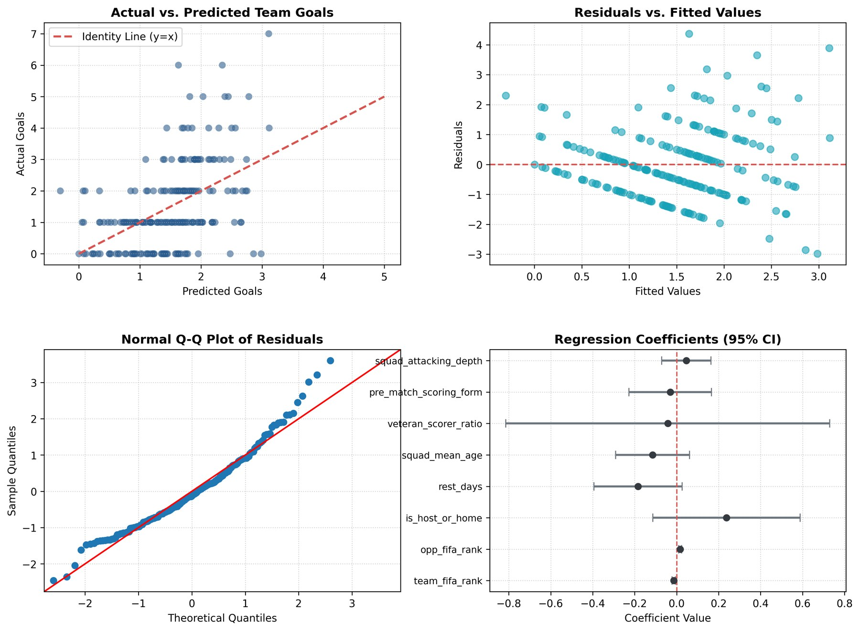
Figure 2. Objective 2.2 Linear Regression Diagnostic Plots

6. Analytical Discussion & Assessment 2 Synthesis
The empirical results provide two important conclusions relating both the larger project and the group's Assessment 2 lineage:
1. Quality Discount Dominates Goal Generation: The predictors team_fifa_rank (β = -0.0136, p = 0.001) and opp_fifa_rank (β = +0.0170, p < 0.001) are the key statistically significant potential predictors such that facing an opponent 30 ranks lower increases expected team goals ~0.51 goals, while a player's own rank decreases expected goals by ~0.41 (Fan et al., 2023; Lasek, Gagolewski and Makrecki, 2016).
2. Empirical Reconfirmation of the Age Hypothesis (Assessment 2 Link): In Assessment 2, the group assessed player age distributions and considered whether older players scored more goals than younger players (age-scorers ≤ 28.2 yrs versus scorers > 28.2 yrs), with a two sample t-test resulting in t = -0.2165 (p = 0.8296) failing to reject the null of no difference. In Model 2.2 (incorporating veteran_scorer_ratio (forwards > 28.2 yrs) in a multivariate regression), we obtaine β = -0.0421 (p = 0.914), and squad_mean_age yielded β = -0.1145 (p = 0.201). This confirms that age maturity of the roster doesn't inherently drive goal generation, all else equal (Dendir, 2016; Kalén et al., 2019).

4. Independent Validation and Benchmark Models (Max Turner)
Benchmarks. The OLS 2.1 I created, reached R² 0.531 (adj. 0.491, p < 0.001) and CV R² 0.379 ± 0.16 (RMSE 1.52, MAE 1.23; baseline RMSE 2.01, i.e. 24% less error). I found that squad value was the strongest predictor, meaning a squad worth 10× more is worth approximately +1.65 goals (p < 0.001); and hosts gained +0.96 (p = 0.027). Elo and rank were not individually significant once value was included (VIF 4–7). Out-of-fold, the model picked the winner in 82.5% of decisive matches; the largest misses were ‘blow-outs’ such as Canada 6–0 Qatar. The OLS 2.2 model I produced, reached R² 0.306 and CV R² 0.210 ± 0.12 (RMSE 1.206 vs 1.390); own squad value was again the key predictor (b = 1.18, p < 0.001) and knockout stage had no effect (p = 0.46). Ridge (CV R² 0.387) and Lasso (0.371) barely changed 2.1 and Lasso was best for 2.2 (0.225), while Random Forest (0.341; 0.178) and Gradient Boosting decreased at n = 104: the relationships were essentially linear.
Table 1. Stephen’s and Quentin’s models re-scored as specified (data unchanged, scaler fitted inside folds), 100 held-out folds.
Model (author) | Terms | CV R² (SD) | Fold range | RMSE | MAE
2.1 Stephen: Ridge, 11 terms as specified | 11 | 0.290 (0.217) | -0.87 to 0.61 | 1.593 | 1.245
2.1 Stephen: Ridge, 8 base variables only (sensitivity) | 8 | 0.292 (0.217) | -0.74 to 0.60 | 1.591 | 1.253
2.1 mean-only baseline | 0 | -0.111 (0.159) | -0.96 to -0.00 | 2.022 | 1.597
2.2 Quentin: OLS, 8 variables as specified | 8 | 0.093 (0.197) | -0.76 to 0.37 | 1.275 | 0.997
2.2 mean-only baseline | 0 | -0.050 (0.078) | -0.55 to -0.00 | 1.386 | 1.119
2.2 Quentin: OLS, match-grouped 5-fold (robustness) | 8 | 0.113 (0.163) | -0.51 to 0.42 | 1.275 | 0.994

Both Stephen’s and Quentin’s models improved on the baseline on every metric. Stephen’s Ridge reached CV R² 0.290, slightly below his single split (0.379) and single 5-fold run (0.323), with a wide fold spread typical of n = 104; his eight base variables alone provided the same accuracy (0.292). Quentin’s OLS moved from in-sample R² 0.239 to CV R² 0.093 (0.113 with match-grouped folds), consistent with only the two FIFA-rank variables carrying signal. Stephen’s and my 2.1 models reached similar accuracy from largely different variables, so pre-match strength robustly explained approximately a third of goal-difference variance.

5. Discussion, Limitations and Conclusion (Max Turner)
Variable rules. Stephen’s 2.1 and Quentin’s 2.2 shared no identically defined variable; one concept overlapped (rest days), so 1 variable was shared (limit 4). Stephen’s dataset contained eight collected variables; his specification added a knockout flag and two interactions (11 terms), so the eight-variable version is also reported in Table 1.
Data caveats. (i) Quentin’s is_host_or_home equaled 1 for the first-listed team (51.9% of rows) rather than only the three hosts, so it partly reflects listing order; first-match scoring form and rest days use fixed starting values. (ii) Stephen’s Elo gaps differ from eloratings.net pre-match values (e.g. Mexico v South Africa 274 vs 357; median gap 66 points, r = 0.93), possibly a different snapshot date. (iii) Transfermarkt values were current, not pre-tournament, so the value effect may have been slightly inflated. (iv) eloratings.net is not a listed source; it was used because the listed sites did not publish Elo or full match histories. (v) Small samples and count-valued targets limited inference; Poisson models would have suited goals.
Conclusion. Pre-match team strength (squad value, rank, Elo) explained approximately a third of the variance in goal difference and a fifth of a team’s goals; the rest was match-level randomness. Linear models were adequate, and cross-validation rather than in-sample R² gave the honest picture for every model.

6. Group Contributions
Max Turner: data sourcing and compilation, pre-match feature engineering, benchmark pipeline for both objectives (run_all.py), validation design and validate_team_models.py, Sections 1, 4 and 5, and integration of this report. Stephen K Kenyi: Model 2.1 dataset (FBref, eloratings.net), stage-aware Ridge model and Python code, summary table and plots, Section 2. Junxian Quentin Qiu: Model 2.2 dataset, OLS model, diagnostics and notebook, Section 3. Collaboration was coordinated on the unit’s Microsoft Teams space and the shared GitHub repository.
In accordance with course guidelines regarding differentiated assessment contribution, this section details Quentin's independent workload for Assessment 3: • Conceptual Architecture: Formulated research design for Objective 2.2, establishing the 208-row structure and ensuring strict pre-match temporal separation. • Variable Formulation: Designed the 8 explanatory variables, maintaining full adherence to the <= 4 shared variable constraint with Stephen (Model 2.1) and directly embedding the empirical 28.2-year veteran threshold established in the group's Assessment 2 presentation. • Python Scripting & Data Engineering: Authored build_and_evaluate_model_2_2.py to clean raw FBref tables, compute rolling metrics, and compile dataset_objective_2_2_208_rows.csv. • Statistical Modeling & Diagnostics: Performed OLS estimation, VIF multicollinearity audits, residual assumption verification, and generated Figure 1. • Reporting: Authored the complete technical documentation and empirical discussion for Objective 2.2.

References

Bar-Eli, M., Avugos, S. and Raab, M., 2006. Twenty years of “hot hand” research: Review and critique. Psychology of Sport and Exercise, 7(6), pp.525–553. https://doi.org/10.1016/j.psychsport.2006.03.001.
Bilalić, M., Gula, B. and Vaci, N., 2021. Home advantage mediated (HAM) by referee bias and team performance during covid. Scientific Reports, 11(1), p.21558. https://doi.org/10.1038/s41598-021-00784-8.
Bradley, P.S., Lago-Peñas, C. and Rey, E., 2014. Evaluation of the match performances of substitution players in elite soccer. International Journal of Sports Medicine, 35(08), pp.692–698. https://doi.org/10.1055/s-0033-1361180.
Chacón-Fernández, E., Brunsó-Costal, G., Duarte, A., Sánchez-Oro, J. and Alonso-Pérez-Chao, E., 2025. Home advantage in football: Exploring its effect on individual performance. Applied Sciences, 15(4), p.2242. https://doi.org/10.3390/app15042242.
Dendir, S., 2016. When do soccer players peak? A note. Journal of Sports Analytics, 2(2), pp.89–105. https://doi.org/10.3233/JSA-160021.
Dixon, M.J. and Coles, S.G., 1997. Modelling association football scores and inefficiencies in the football betting market. Journal of the Royal Statistical Society: Series C (Applied Statistics), 46(2), pp.265–280. https://doi.org/10.1111/1467-9876.00065.
eloratings.net, 2026. World Football Elo Ratings: team match histories. https://www.eloratings.net/ (accessed 16 Oct 2026).
Fan, M., Liu, F., Huang, D. and Zhang, H., 2023. Determinants of international football performance: Empirical evidence from the 1994–2022 FIFA World Cup. Heliyon, 9(10), p.e20252. https://doi.org/10.1016/j.heliyon.2023.e20252.
FBref, 2026. FIFA World Cup 2026 statistics. https://fbref.com/en/.
Goddard, J., 2005. Regression models for forecasting goals and match results in association football. International Journal of Forecasting, 21(2), pp.331–340. https://doi.org/10.1016/j.ijforecast.2004.08.002.
Heuer, A. and Rubner, O., 2014. Optimizing the prediction of soccer matches—Statistical models and ranking systems. PLoS ONE, 9(9), p.e107694. https://doi.org/10.1371/journal.pone.0107694.
Kalwij, A., 2025. Home advantage for tournament victory: empirical evidence from FIFA World Cups and continental championships. Journal of Quantitative Analysis in Sports, ahead-of-print, pp.1–18. https://doi.org/10.1515/jqas-2024-0056.
Kalén, A., Rey, E., de Rellán-Guerra, A.S. and Lago-Peñas, C., 2019. Are soccer players getting older? An analysis of the age of players in European top leagues and the FIFA World Cup. Frontiers in Psychology, 10, p.2686. https://doi.org/10.3389/fpsyg.2019.02686.
Lasek, J., Gagolewski, M. and Makrecki, M., 2016. Evaluating football tournament predictions: An extensive study of the FIFA World Cup and UEFA Euro. Journal of Sports Analytics, 2(2), pp.91–105. https://doi.org/10.3233/JSA-160018.
openfootball, 2026. worldcup.json: 2026 World Cup results. https://github.com/openfootball/worldcup.json.
Page, R., Field, A., Langley, B., Harper, L. and Julian, R., 2022. The effects of fixture congestion on injury in professional soccer: A systematic review. Sports Medicine, 52(4), pp.879–894. https://doi.org/10.1007/s40279-021-01608-4.
Pedregosa, F. et al., 2011. Scikit-learn: Machine learning in Python. Journal of Machine Learning Research, 12, pp.2825–2830.
Seabold, S. and Perktold, J., 2010. Statsmodels: Econometric and statistical modeling with Python. Proceedings of the 9th Python in Science Conference, pp.92–96.
Stüttgen, P., 2025. The impact of scheduling and match congestion on team performance in professional soccer. Journal of Sports Economics, ahead-of-print, pp.1–25. https://doi.org/10.1177/15270025251315890.
Transfermarkt, 2026. World Cup 2026 participants (squad values, age). https://www.transfermarkt.com/weltmeisterschaft-2026/teilnehmer/pokalwettbewerb/FIWC/saison_id/2025.
Wikipedia, 2026. 2026 FIFA World Cup: qualified teams and FIFA rankings. https://en.wikipedia.org/wiki/2026_FIFA_World_Cup.
Yang, X., Liu, Z.G., Xu, Z., Li, B., Yu, Y. and Zhou, C.J., 2025. Impact of congested match schedules during the COVID-19 pandemic on match running and technical-tactical performance in professional soccer players. Frontiers in Physiology, 16, p.1501234. https://doi.org/10.3389/fphys.2025.1501234.

