Setup

# Bolt Wi-Fi Module

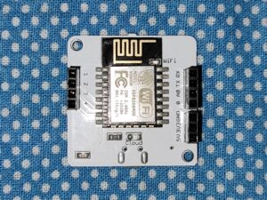

# LM35 Temperature Sensor

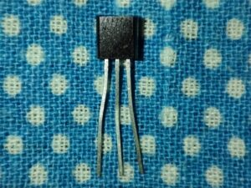

# Female-Male Wire

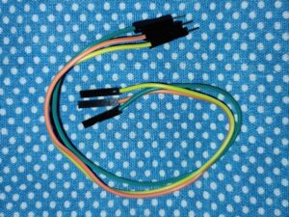

**Step 1:** Setup your Bolt Wi-Fi module.

Register your Bolt Wi-Fi Module on Bolt Application.

1. It should show a stable blue and green light, indicating a proper connection.
2. Login to Bolt Cloud.
3. Here, note down the Device ID and API Key of your Bolt Wi-Fi Module that are present under the Devices and API tabs, respectively.

**NOTE:** Keep the Device ID and API Key somewhere safe, as they have to be used later on in the programming section.

**Step 2:** Make the hardware connections.

**NOTE:** Make sure to do the connections before turning ON the power supply for Bolt Wi-Fi Module.

1. Take the LM35 temperature sensor. The written part should be facing towards you, to ensure proper connections.
2. Starting from Left to Right connect the pins of the sensor to your Bolt Module using Female-Male wires,
   * VCC to 5V
   * Output to A0
   * Ground to GND

**Safety Precaution:** Double check your connections so that there are no loose ends, as it can cause harm to you, the sensor and your module.

