Web application design

COMP 6210 Web Service & Design Methodology

Viliami Fihaki 30000357

17/09/2019

Table of Contents

The Story 2

Methodology – Rapid Application Development 2

High Fidelity Wireframe 2

Mood board 4

Storyboard 5

# The Story

Code Cafe is a new cafe coming to Tauranga that needs a simple website where the owner can change the content of the website. This includes images, text on each page and the menu items. Only the owner can login and do the admin side of the page. Visitors to the site can leave feedback and a rating that needs to be moderated first by the owner before it is displayed on the website. The owner has given you a series of stock images that you are able to use, until the cafe is ready to be opened to the public. Visitors to the site can contact the owner via a contact form.

# Methodology – Rapid Application Development (RAD)

RAD is a suitable methodology regarding websites as it is heavily focused on actions and allows the developers to build prototypes of the project quickly which will end up being useable code for the end product after many iterations.

The phases of RAD consists of:

* Requirements
* Prototyping
* Feedback
* Finalize product

RAD does not require large teams and can be used for teams of 6 or less. Feedback is prioritized and very important within this methodology and allows the client to be able to really define what they want and don’t want.

# High Fidelity Wireframe

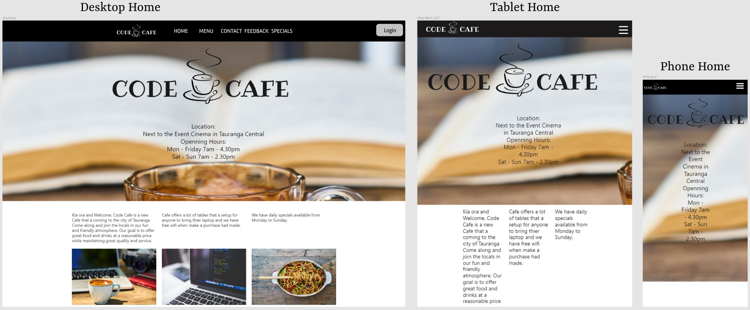

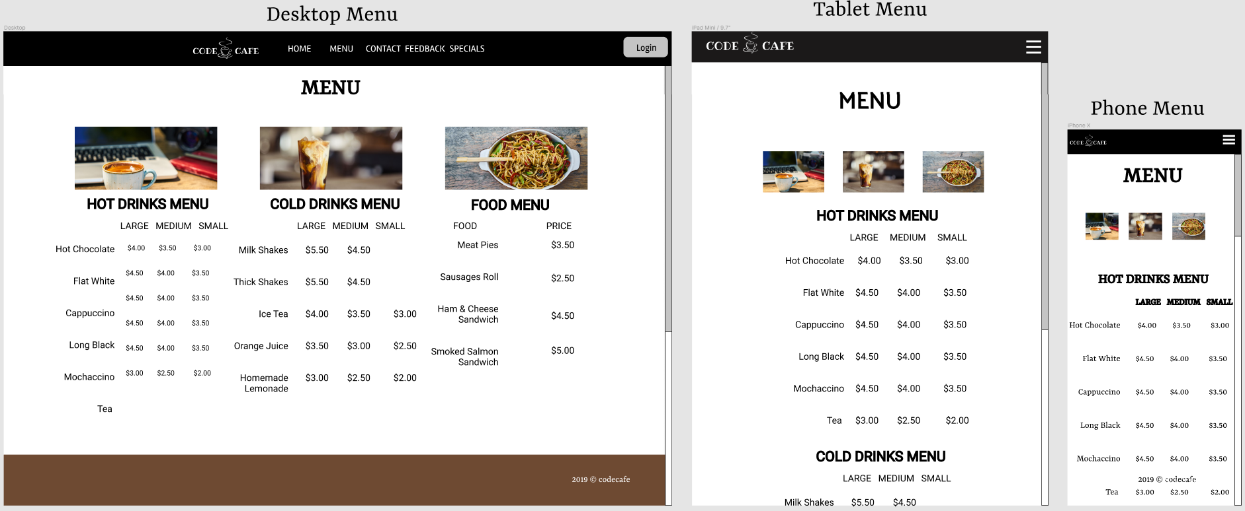

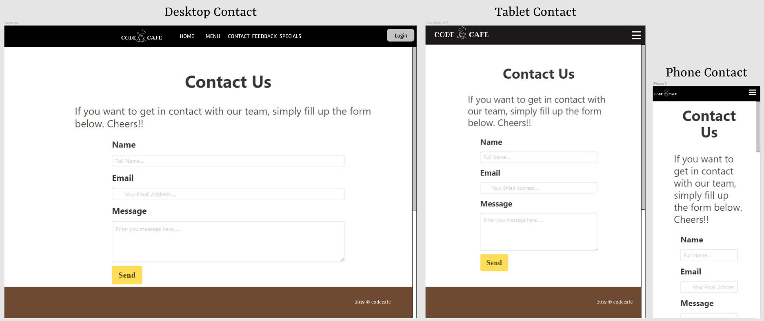

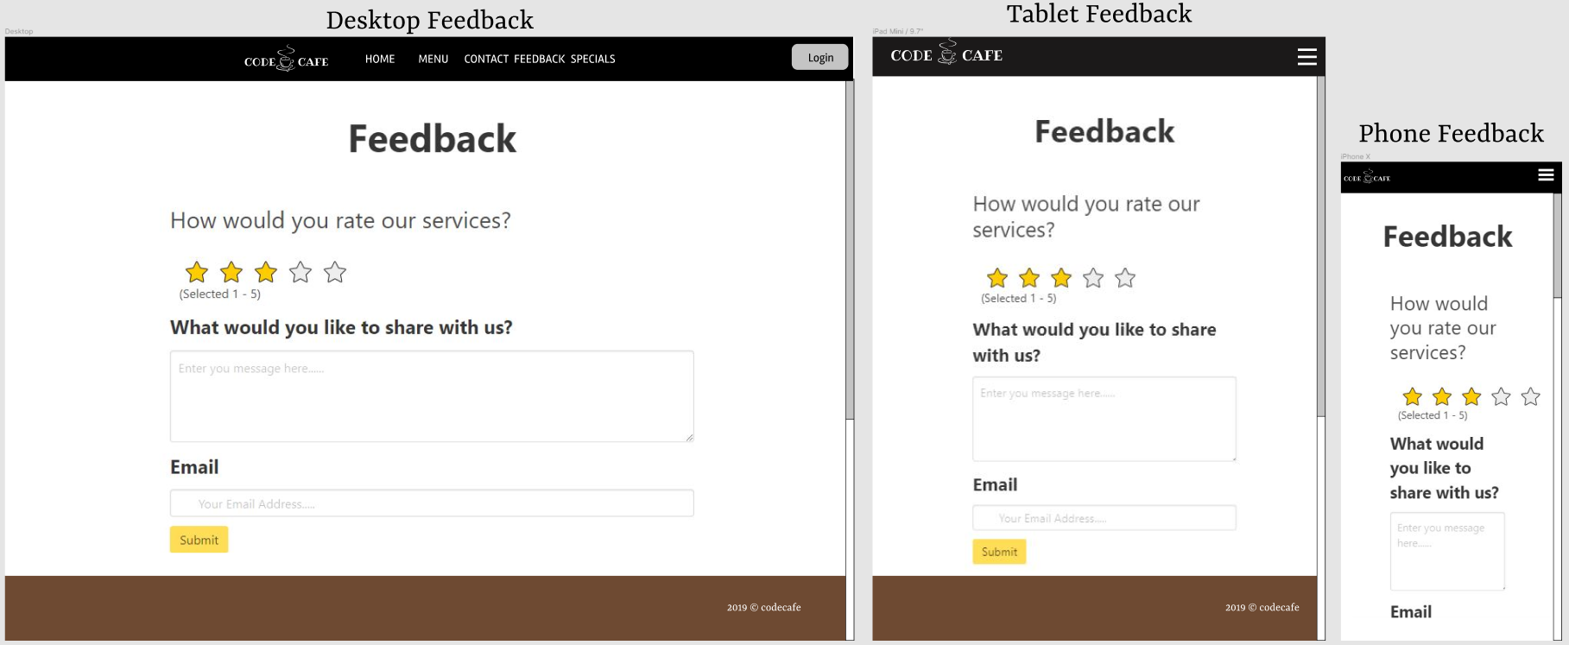

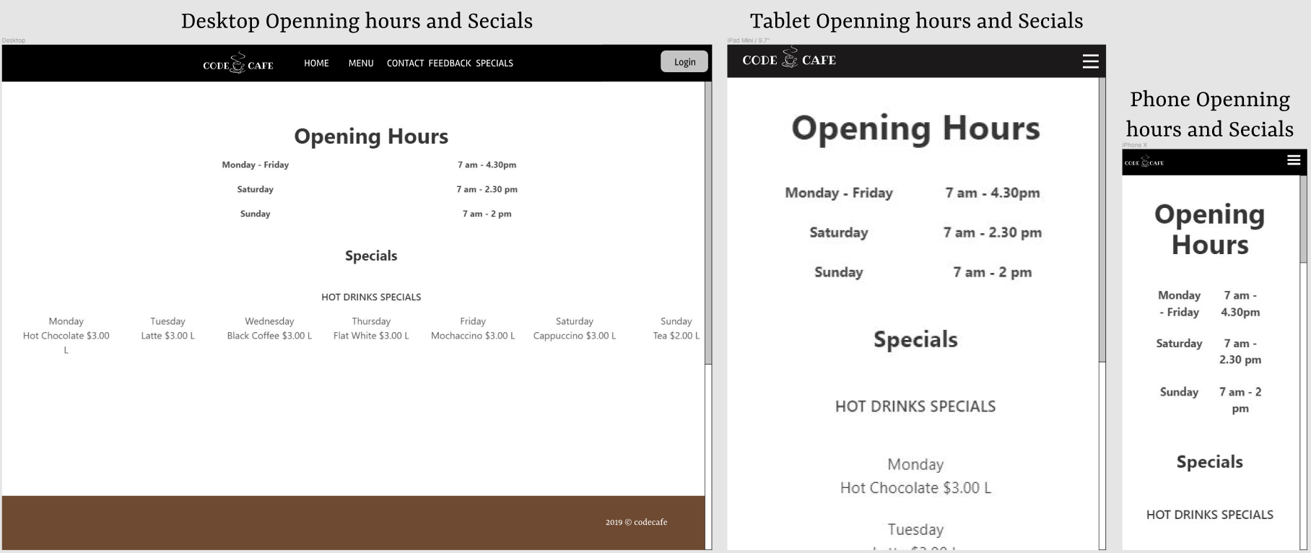

# Mood board

White and Black is the main colour with woody colour brown on the footer.

|  |  |  |  |
| --- | --- | --- | --- |
| White #FFFFFF | Black #000000 | Yellow #FFFF15 | Brown #6E4A32 |
|  |  |  |  |

Roboto font style

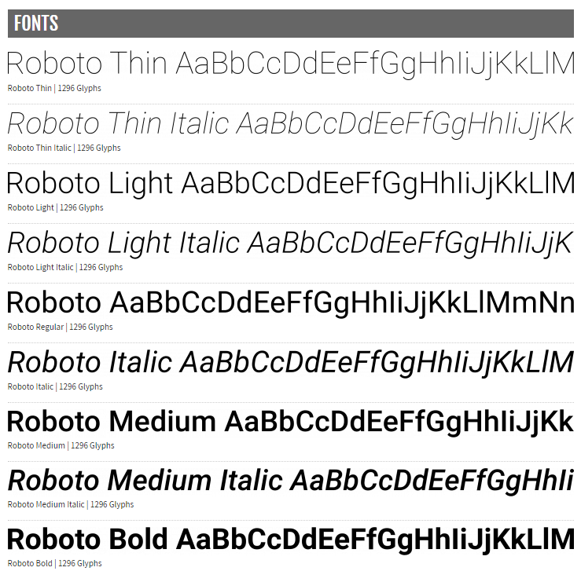

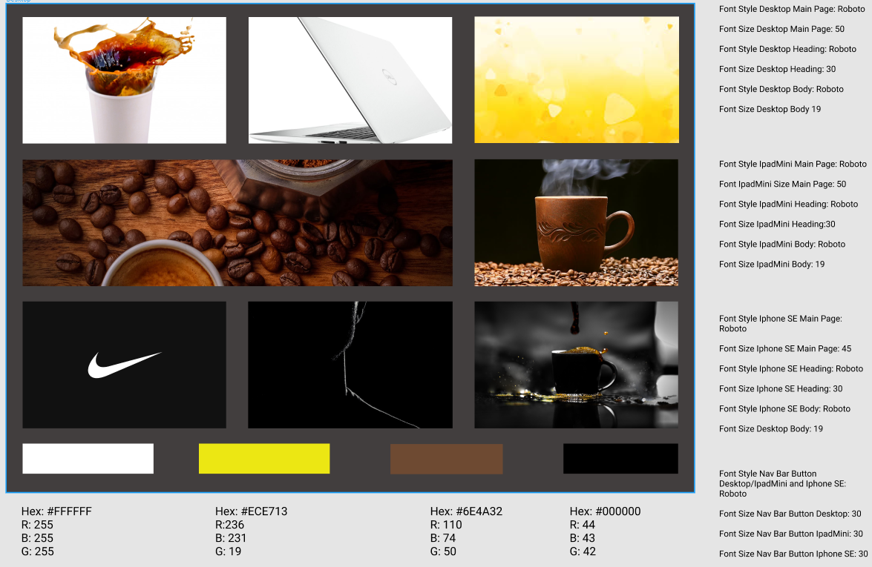

|  |  |
| --- | --- |
| Step 1: Login Button  If click on the login button, it will open up the login page | Step 2: Login Page:  It will ask the owner for username or email and password the click “Login |
|  |  |
| Step 3: If login fail  It will show red star next to the text field that is wrong and a message will pops up and ask you “Try again” | Step: If login in pass  It will take you to the admin page or the back end. |
|  |  |

# Storyboard