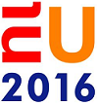Practical notes

Quantum Europe 2016:  
A New Era of Technology

# General information

In the first half of 2016 the Netherlands will hold the Presidency of the Council of the European Union. We are delighted that we will be able to welcome you to the Netherlands during this period. This administrative note contains practical information that will be useful to you during your preparations for and your stay in the Netherlands.

## Programme

The meeting will take place on Tuesday 17 May and Wednesday 18 May 2016.

The official programme of your meeting and details of any other activities following the can be found at <http://eu16.nl/quantumeurope>.

**Optional QuTech lab tour**

On Wednesday afternoon 18 May, an optional lab tour of the QuTech institute in Delft will be organized. Please indicate in the online form if you would like to participate. Buses to Delft will leave from the venue at 14:00 hr. The QuTech lab tour will finish in Delft at approximately 16.30 hr. After the lab tour transport to the Delft Central train station will be arranged. From there direct trains run to Schiphol and Amsterdam.

## Venue

The meetings in the Netherlands in connection with the 2016 EU Presidency will take place at one central venue in Amsterdam. This venue, at Kattenburgerstraat 7, 1018 JH Amsterdam, is situated in the centre of Amsterdam.

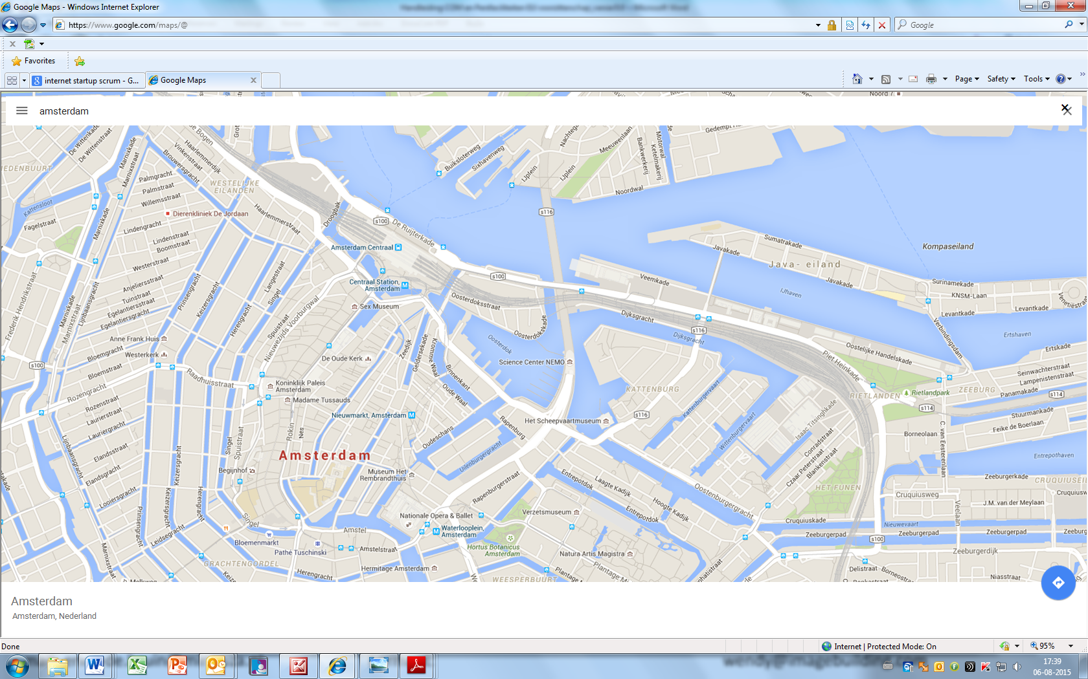

## The Europe building

The building where Quantum Europe 2016 takes place is the Europe building. The entire building is fully wheelchair accessible. Assistance will be available if required. Only people carrying a valid EUNL badge will be allowed access to the venue.

## Security

All necessary security measures in and around the conference venue have been taken in accordance with the National Police and the National Coordinator for Counterterrorism and Security, on the basis of a national threat analysis.

# Registration and accreditation

The venue is accessible only to accredited individuals who can show an EUNL badge. Accreditation is personal and non-transferable. The accreditation badge will afford access to the venue from the day prior to the meeting (specified on registration) until one day after the meeting. The badge must be worn visibly. Even if you leave the venue temporarily, you will need to show your badge to be readmitted.

## Registration

Invitees for the conference will receive the invitation via Eventbrite (with an exception for the speakers, the programme committee members and the hosting committee members; this group will receive a link for finalizing the registration directly, without having to register via Eventbrite first).

Within two weeks after your registration via Eventbrite has been confirmed, an email will be sent to the email address at which you received the invitation containing a link for uploading information to complete your registration. You will be asked to supply the following:

* name and address
* a scan of the holder’s information page of your passport
* a photo

Without this step, your registration process is not complete (even if you did receive a conformation via Eventbrite).

Badges will be issued only to individuals who have successfully completed the registration procedure and received accreditation. There is a limited number of tickets available for the conference and registration is on a first come first serve base, so it is advisable to register as soon as possible. In any case registration must be completed at least two weeks prior to the meeting you wish to attend.

Personal information supplied during registration will be processed in accordance with the Personal Data Protection Act. Depending on the current threat analysis, the accreditation process may include security screening. This will be performed by the Dutch police.

You may have a third party arrange your registration, using the link sent to you. If you wish, you may designate a representative to attend the meeting on your behalf after you have received this link. In this case, the registration tool will allow that person to register for the meeting.

## Accreditation

Accreditation will take place after registration and/or screening. You will be informed accordingly by email. The processing time varies, depending on whether the one who’s doing the registration is the initially invited person. In case the invitation is forwarded, accreditation of the representative will be needed by the organising department which could slow down the process. The process can take one to three weeks, also depending on whether a security screening is required. You will be able to monitor the progress and status of the accreditation process using the registration tool.

You will be able to collect your badge at the entrance to the venue. Showing a copy of this confirmation you have been sent will expedite the process.

The confirmation will also give you free transport on the EU2016 ferry from your hotel or Central Station to the venue (see also section 4).

## ID badges

Participants can collect their badges at the special desk set up in the entrance hall of the Europe building. Unless arranged otherwise, your badge will be available at the desk from one day before the meeting. Badges will only be issued to people who can show a valid ID and confirmation of their registration. Please be aware that it is likely to be busy at the desk, so come in plenty of time.

## Registration desk

A registration desk will be set up in the entrance hall of the Europe building where you can go with any questions concerning registration.

# Accommodation

## Hotel reservation

The organisation of the conference will book and pay for hotel accommodation for all speakers of the conference. All other participants of the meeting are asked to book their own hotel. The invitation includes a link to the booking office for hotel reservations. Select the meeting you will be attending on the booking office’s website. You will then be given a choice of hotels in different price categories. Step-by-step instructions for booking rooms are given on the booking page. You can also find contact details for the booking office here, should you need any assistance or have any questions.

Hotels will take account of Presidency-related bookings in their planning. Given the large number of guests who will be staying in Amsterdam during this period, we urgently advise you to book your accommodation as early as possible.

Transport will be provided by EU2016 ferry from selected hotels. If you opt for alternative accommodation, please be aware that no other direct transport to the venue by boat will be available. You may however use the standard EU2016 ferries carrying passengers to the venue (see Transport to and from venue, section 5).

## Hotel bills

You will be asked to enter credit card details when making a hotel reservation. This card guarantees the reservation. The costs of the hotel accommodation will not be deducted until you check out. Terms and conditions applying in the event of cancellation are clearly stated on the site.

If you are unable or unwilling to enter credit card details, the costs of your hotel accommodation, including breakfast and city tax, will have to be paid in advance by the deadline agreed with the booking office in order to confirm the reservation. Please contact the booking office to arrange this. The reservation will be automatically cancelled in the event that payment is not received by the agreed deadline.

# Arrival and departure

Participants are responsible for organising their own transport to and from Amsterdam.

## Arrival at Schiphol

Amsterdam is only 15 km from Schiphol Amsterdam Airport. There are excellent public transport connections to and from the airport.

Public transport

The Amsterdam Travel Ticket is the easiest all-in-one ticket. The ticket includes a 2nd class return ticket to and from Schiphol Amsterdam Airport by NS train, to any station in Amsterdam. Combined with unlimited travel on all trams, buses, night buses, metros and ferries within Amsterdam. Costs of the ticket:

* 1 day €15
* 2 days €20
* 3 days €25

Points of sale at Schiphol Airport:

* NS Tickets & Service: Main hall, at Schiphol Plaza (open 24/7)
* Holland Tourist Information, Arrival hall 2 (Open every day 7 AM – 10 PM)
* AKO Books & Travel, Arrival hall 4 (Open every day 7 AM – 10 PM)
* AKO Nieuws & Media, Passageway arrival hall 2 (Open every day 6 AM – 10 PM)
* AKO Kiosk Main hall (open 24/7)

Other points of sale:

* GVB Tickets & Info, Stationsplein, opposite Central Station (Open weekdays: 7AM- 9 PM, Saturdays- Sundays 10 AM – 6 PM
* You can also buy the ticket at several hotels in and around Amsterdam

Train: Schiphol railway station is beneath the airport, and is accessed via Schiphol Plaza. The average travelling time to Amsterdam Central Station is 15 minutes. Trains depart for Amsterdam Central on a regular basis. See 4.3 below. For more information, go to: <http://www.ns.nl/en/travellers/home>

A single-use chipcard can be bought from the (yellow colored) machines at the station or at the service desk of the NS (the Dutch Railways). It is recommended to buy a single-use return ticket (costs around €8). You must check in upon entering the station and out upon leaving the station. You can also purchase an e-ticket online in advance and print out the ticket yourself. E-tickets are available at ns.nl/eticket. You are required to show the e-ticket and valid proof of identity when tickets are checked on the train.

Bus*:* The bus station is in front of the arrival and departures hall at Schiphol Plaza. There are several scheduled bus services to Amsterdam.

Taxi: The taxi rank is just outside Schiphol Plaza. A taxi journey to the centre of Amsterdam costs around €40-45.

## Arrival at other airports

### Eindhoven Airport

Public transport

A bus service is available to take passengers directly to Eindhoven Central Station from a stop next to the terminal building. There is a direct rail connection from Eindhoven Central to Amsterdam Central.

For more information on travel to and from Eindhoven Airport, go to:

<http://www.eindhovenairport.com/en/accessiblity/>

### Rotterdam Airport

Public transport

Bus 33 goes from the airport to Rotterdam Central Station, where you can take a direct train to Amsterdam. The total journey time is approximately 90 minutes.

## Arrival at Amsterdam Central Station

Public transport

Travelling within Amsterdam by public transport goes by train, tram, metro, bus and ferry. The most convenient option for visitors is a disposable one-hour card (€2.90) or day card (valid for one to seven days). These tickets can be bought on the tram or bus (cash only), and are valid across the whole network from the time of purchase, allowing you to take as many journeys as you choose within your chosen time-frame. For more information http://en.gvb.nl

Taxi

The taxi rank is at the North side of the Central Station. To get there you walk to the far North end and turn left. At the end of the hall, as soon as you go outside, you will find the taxi stand. Official taxis have a ‘TCA’ sign on the roof.

# To and from the Europe building

The organisers will arrange for special ferries to transport participants from various locations in Amsterdam to the meeting venue. A timetable can be found on the app. The times and frequencies of ferry departures will be coordinated with the meetings. Ferries will run from an hour before to an hour after the meeting.

Your EUNL badge will qualify you for free travel on these EU2016 ferries. If you have not yet picked up your badge, you may use your confirmation of accreditation. Staff will be present at all embarkation points.

## From Amsterdam Central Station

Boat transfers will run from Central Station to the venue.



To walk to the venue from the Amsterdam Central Station follow these signs:

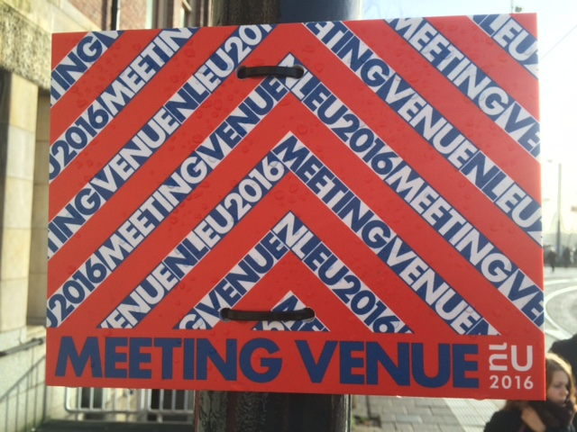

## From hotels

Boat transfers will run from selected hotels to the venue. Information will be available at the hotel.

## From the venue

EU2016 ferries will return to hotels and Central Station from the venue.

## Alternative transport

The organisers will not facilitate any forms of transport other than the boats detailed above. The following information will be useful if you decide to arrange your own transport to and from the venue:

Public transport

Tram, metro and bus services are a quick and easy way of travelling around Amsterdam. The fastest mode of transport depends on your point of departure. For more information, go to: <http://en.gvb.nl/>

Travelling to the Europe Building by bus

To reach the Europe building from Amsterdam Central Station you are advised to take bus 22 or 48 (destination: “Indische Buurt”) from the bus stop opposite the station slightly on the right hand side when exiting the building on the city centre side.

Taxi

TCA is Amsterdam’s official taxi service. You may book a taxi in advance, go to a taxi rank or hail a taxi in the street.

TCA contact details:

tel. +31 (0)20 777 7777, website: [www.tcataxi.nl/en/home.html](http://www.tcataxi.nl/en/home.html)

Car

Please be aware that there are no parking facilities at the meeting venue. There are very few parking spaces in the neighbourhood and all parking must be paid for.

# Schengen – visa

When arriving in the Netherlands, all participants must present a valid passport with the appropriate visa (if required). It is not possible to apply for a visa at the border. Participants who need to apply for a visa must do so in their country of residence.

The Netherlands is part of the Schengen Area. The following website shows which passport holders need to apply for a Schengen visa and provides information about the application process:

<https://www.government.nl/topics/visa-for-the-netherlands-and-the-caribbean-parts-of-the-kingdom/question-and-answer/which-visa-do-i-need-to-travel-to-the-netherlands>

If the nationality of the passport holder is not listed, a Schengen visa is not required to enter the Netherlands. The EU2016 Central Project Team advises participants to obtain their visa well in advance. Applying for a visa is possible as of three months before the start of the meeting. Please keep in mind that issuing a visa can take up to 14 days. Addresses of Dutch embassies, consulates and other representations can be found at:

<https://www.government.nl/topics/embassies-consulates-and-other-representations>

# Facilities and services at the meeting venue

The Europe building will be open from 8:00 to 19:00. The building has an entrance hall, meeting rooms and a lounge. A plan of the venue can be found on the app.

## General information

The Europe building has all the standard facilities of a meeting venue. It also has a lounge with two bars, seating, standing tables and flexible workplaces. The venue’s members of staff will be happy to help you if you have any questions or require any assistance. The building has numerous electrical sockets for charging devices. Smoking is permitted only in designated areas.

## Lockers

A number of lockers will be available. They are located to the left after the entrance hallway.

## Cloakroom

After the security checkpoints there is a cloakroom where you may leave your coat (and bag(s) if necessary) free of charge.

## Quiet room

The building has a quiet room.

## Restaurant/bars

The restaurant can be accessed through the lounge. Lunch will be served here every day between 12:30 and 15:00. The exact time will be coordinated with the programme of your meeting.

Coffee, tea and soft drinks will be available in the lounge. Water is available in all meeting rooms.

# Technical facilities

Only a small number of PCs will be available at the venue. There are however sufficient workspaces with an electrical socket.

## Internet access

High-quality wireless internet will be available throughout the Europe building. Use is free of charge, and the network will give unlimited access to the internet. No security measures (spam filters, firewalls) will be provided for (or against) individual users. The password to the wireless network will be provided at the venue.

## IT service desk/app support

There will be an IT service desk at the Europe building providing technical support. You may also go there if you have any questions about or require assistance with the app.

## Printing

Our aim is to achieve a paperless Presidency. If you nevertheless wish to print, you may do so at the IT service desk.

## Translation services

There will be no translation services during the Quantum Europe 2016 conference.

## Narrowcasting

Information screens in the Europe building will display useful information about meeting schedules and ferry timetables, as well as general information.

# Media

There will be members of the press in the Europe building and they will use the same restaurant. Members of the press will be wearing a yellow badge.

There are seven briefing rooms in the Europe building. Capacity is flexible, as several spaces can be joined together. To reserve a briefing room, please go to the press desk.

# App

All accredited participants will receive a login for the EUNL2016 app, which is available free of charge and is suitable for most devices. It can be downloaded via the app store. We advise you to install the app on your telephone/tablet before travelling to the Netherlands. The app includes a 3D plan of the venue, information on travel to Amsterdam and the venue, information on the cultural programme and FAQs. It will also supply information on the meeting you are attending, including the agenda, a list of attending participants and an overview of side events. A web version of the app is also available.

# Cultural programme

A cultural programme has been put together for the Presidency. This includes the Wall of Life, which can be seen on the street side of the Europe building. The 500 metre-long wall is made of interactive screens on which artists can reflect on what is happening behind the wall. Images of the wall will also be transmitted inside the Europe building.

# General information about the Netherlands and Amsterdam

For more information on attractions and sights in the Netherlands and Amsterdam, please go to [www.vvv.nl](http://www.vvv.nl) (for the Netherlands) and <https://www.iamsterdam.com/en/visiting>.

# Other practical information

Medical assistance

In the event of an emergency or a medical problem, contact the first aid post (EHBO) in the Europe building.

Local hospitals:

VUMC, De Boelelaan 117, 1081 HZ Amsterdam

AMC, Meibergdreef 9, 1105 AZ Amsterdam

Making international calls

The country code for the Netherlands is +31, and the Amsterdam dialling code is (0)20.

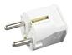Electrical sockets

The power supply is 220-230 volts (plug: two round prongs).

*Local time*

Standard Time Zone: GMT +1

# Contact information

If you have any questions, please send an email to quantumeurope@minez.nl.