Vincent Ryan

8/11/2024

CSD 340 – HTML Basics

Git Link - <https://github.com/vfrtist/BellevueWeb>

First “Failed Markup”:

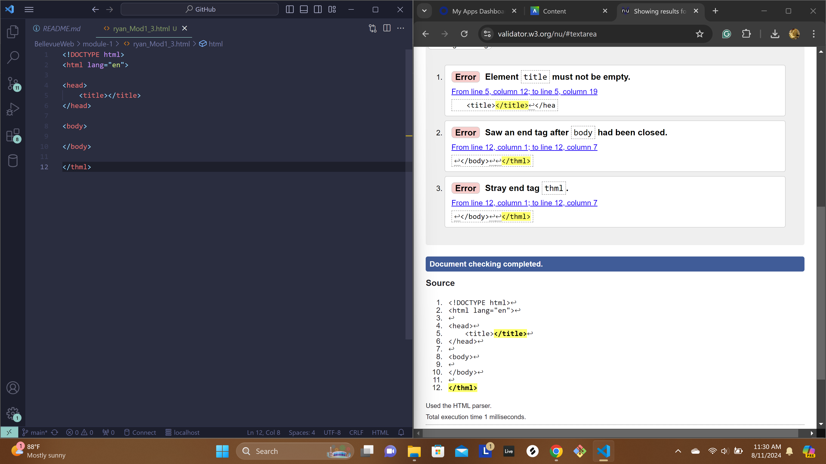

Corrected Markup, note this is using the default block VS code provides by ! + tab:

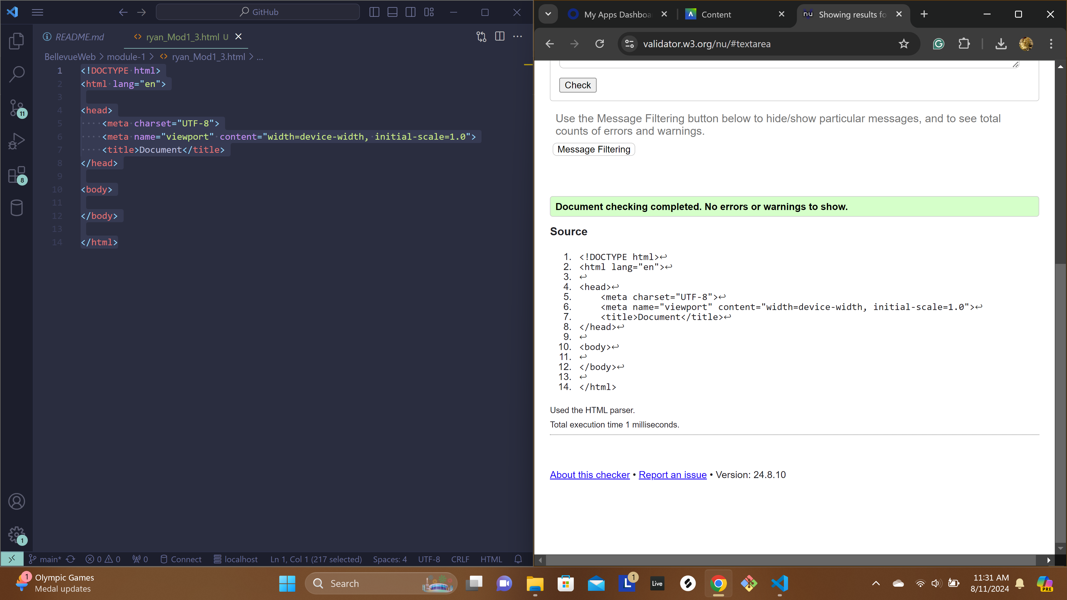

Markup + titles:

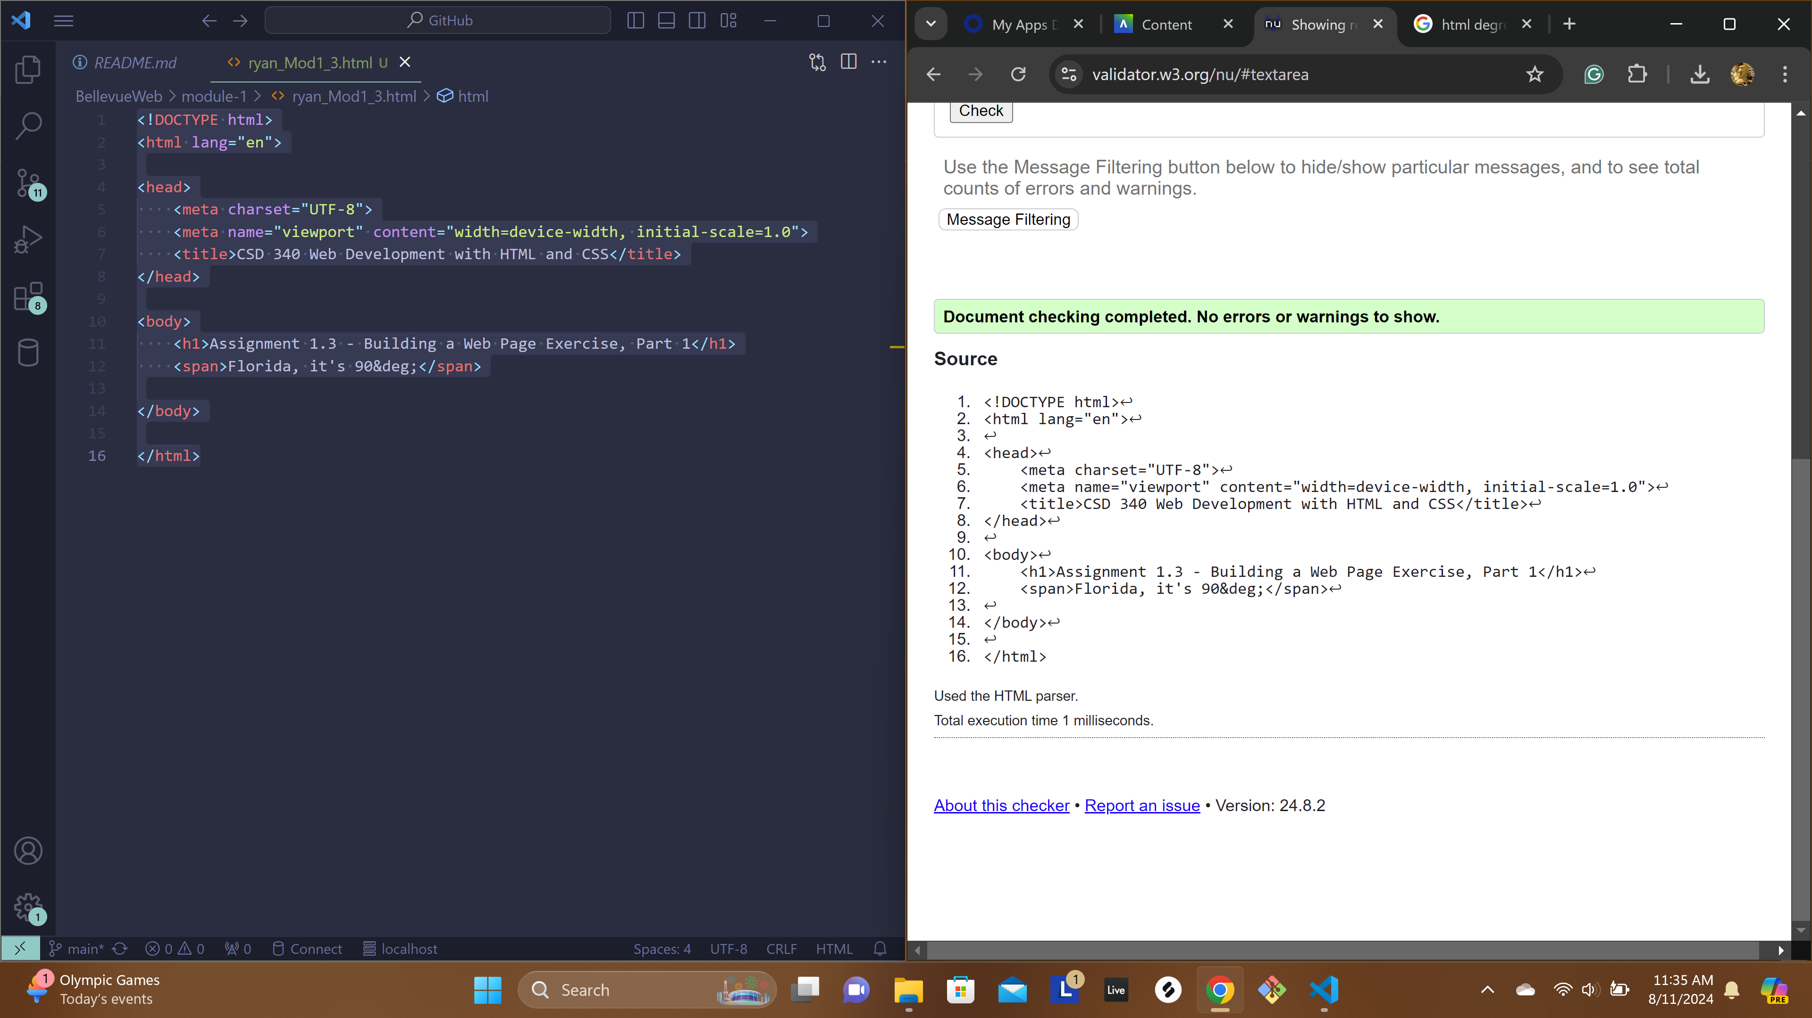

Rendered Webpage:

